**Names: Mbabazi desange cecile**

**ID:22361**

**Apartment Booking System Documentation**

**Table of Contents**

1. [Introduction](https://chat.openai.com/c/c7e46569-5fea-4ebc-87fe-fee98e2b1198#introduction)
2. [User Roles](https://chat.openai.com/c/c7e46569-5fea-4ebc-87fe-fee98e2b1198#user-roles)
3. [Manager Features](https://chat.openai.com/c/c7e46569-5fea-4ebc-87fe-fee98e2b1198#manager-features)
   1. [Add Apartment](https://chat.openai.com/c/c7e46569-5fea-4ebc-87fe-fee98e2b1198#add-apartment)
   2. [View Apartments](https://chat.openai.com/c/c7e46569-5fea-4ebc-87fe-fee98e2b1198#view-apartments)
   3. [View Bookings](https://chat.openai.com/c/c7e46569-5fea-4ebc-87fe-fee98e2b1198#view-bookings)
4. [Client Features](https://chat.openai.com/c/c7e46569-5fea-4ebc-87fe-fee98e2b1198#client-features)
   1. [Search Apartments](https://chat.openai.com/c/c7e46569-5fea-4ebc-87fe-fee98e2b1198#search-apartments)
   2. [Book Apartment](https://chat.openai.com/c/c7e46569-5fea-4ebc-87fe-fee98e2b1198#book-apartment)
   3. [Make Payment](https://chat.openai.com/c/c7e46569-5fea-4ebc-87fe-fee98e2b1198#make-payment)
5. [System Architecture](https://chat.openai.com/c/c7e46569-5fea-4ebc-87fe-fee98e2b1198#system-architecture)
6. [Technologies Used](https://chat.openai.com/c/c7e46569-5fea-4ebc-87fe-fee98e2b1198#technologies-used)
7. [Security](https://chat.openai.com/c/c7e46569-5fea-4ebc-87fe-fee98e2b1198#security)
8. [Future Improvements](https://chat.openai.com/c/c7e46569-5fea-4ebc-87fe-fee98e2b1198#future-improvements)
9. [Conclusion](https://chat.openai.com/c/c7e46569-5fea-4ebc-87fe-fee98e2b1198#conclusion)

**1. Introduction**

The Apartment Booking System is a web-based application designed to facilitate the booking of apartments for both hotel managers and clients. The system allows managers to add apartments, view the apartments they have, and monitor bookings made by clients. Clients can search for available apartments in a specific city, book their desired apartment, and make payments securely.

**2. User Roles**

The system supports two types of users:

* **Manager:** Manages apartments, views the list of apartments they have, and monitors bookings.

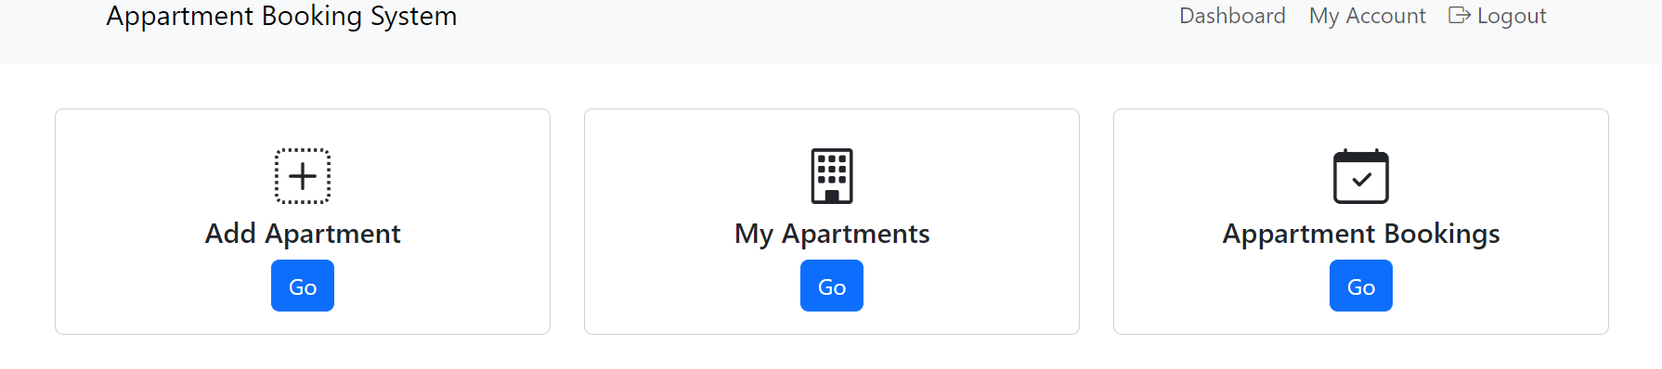

* **Client:** Searches for apartments, books a selected apartment, and makes payments.

**3. Manager Features**

**3.1 Add Apartment**

Managers have the capability to add new apartments to the system. They can provide details such as apartment name, location, description, and pricing.

**3.2 View Apartments**

Managers can view a list of all apartments they have added. The list includes details like apartment name, location, and availability.

**3.3 View Bookings**

Managers have access to a booking history, allowing them to view details of bookings made by clients. This includes the client's information, booked apartment, and booking status.

**4. Client Features**

**4.1 Search Apartments**

Clients can search for available apartments by entering the city name. The system will display a list of apartments in the specified city, along with relevant details such as location and pricing.

**4.2 Book Apartment**

Clients can select their desired apartment from the list and proceed to book it. They will need to provide their contact information and confirm the booking.

**4.3 Make Payment**

After confirming the booking, clients will be prompted to make a secure payment. The system supports Mobile money payment methods, ensuring a smooth and secure transaction process.

**5. System Architecture**

The system follows a client-server architecture. The server handles database operations, business logic, and communication with external payment gateways. The client-side, accessible through web browsers, provides a user-friendly interface for both managers and clients.

**6. Technologies Used**

The system is built using:

* **Backend:** Javascript
* **Database:** Mysql
* **Frontend:** HTML, CSS, JavaScript
* **Payment Integration:** oltranz API for secure payments

**7. Security**

The system ensures data security through spring security, encryption of sensitive information, secure communication channels, and adherence to best practices for web application security.

**8. Future Improvements**

Future enhancements may include email notifications, and additional features for both managers and clients based on user feedback.

**9. Conclusion**

The Apartment Booking System simplifies the process of managing and booking apartments for both hotel managers and clients. Its intuitive design and robust features contribute to a seamless user experience.