Business-oriented Typology and Characterization of Agriculture in SSA

[Melanie Bacou](http://github.com/mbacou) for BMGF

Last updated on 2017-06-20 -- DRAFT, DO NOT USE OR CITE

# Background

This study is a prospective chapter in *AGRA Africa Agriculture Status Report (AASR) 2017*.

The overall objective of the AASR report is to (Hazell, 2017):

1. provide an overview of the smallholder farmers and how they have adapted to the challenges they face as economic actors;
2. explore innovative strategies that can substantially raise the productivity and incomes of smallholder farmers;
3. identify policies and programs that can support the movement of Africa’s farming systems from subsistence-oriented to market-oriented thriving businesses;
4. identify the necessary conditions, appropriate technologies, and institutions that can propel and support smallholder agriculture businesses;
5. examine the past and the present role of public and private sector investment in agriculture and the success factors that can be scaled up to accelerate transformation.

# Methods

The study should provide a context-setting chapter that attempts to characterize, scale, locate, point to prioritization of high-level smallholder commercialization strategies, opportunities and challenges. A proposed approach is to chracterize SHFs and frame business strategies within a 2-by-2 domain framework (low/high rainfed ag potential across low/high market access areas). This approach assumes that agricultural development and adaptation strategies are largely driven by pre-existing bio-physical and spatial conditions.

We propose then focusing on around half a dozen countries for which we have recent/accessible microdata (e.g. LSMS-ISA and maybe AGRA baseline surveys) to look more closely, in the same 2x2 domain framework, at specific farm household and macro characteristics to do two things:

1. Apply some typology to distinguish between say “predominantly-subsistence” focused and “transitioning-commercial” smallholders
2. Report on hh level variables that can provide insight into the scale of potential business development challenges and opportunities in each country.

(#fig:stan-method) Suggested Approach (05/02/2017)

(#fig:stan-method) Suggested Approach (05/02/2017)

Key farm and household-level variables to look at may include:

* Time to Market
* Average yield
* Yield gap
* Average size of land holdings
* Share of land harvested
* Production (amount by crop types)
* Consumption
* Rural households population
* Urban households population
* Rural and urban poverty
* Average household size
* Households by head (Male, Female)
* Average age of the individuals
* Households size
* Education
* Households level income diversification
* Livestock assets
* Ownership of mobile phones
* Households who receive credit
* Households who receive credit from bank or MFI
* Access to extension services
* People in working age (16-64)
* Use of improved technologies and farm management practices
* Average wage rate
* Land rental rate
* Any information on agri-business or agro processing?

# Supporting Datasets

Many (some unpublished and mostly country-level) studies have attempted to derive farmer characteristics and farm typologies across geospatial dimensions (see e.g. [references](./references.html) below). IFPRI in particular generated cross-country comparable household variables (derived from World Bank LSMS-ISA panels, Demographic and Health Surveys, and/or other large-scale household surveys and agricultural census).

A version of this data inventory is also available in [PDF format](https://github.com/mbacou/2017-agra-aasr/blob/master/out/2017-agra-aasr%20Variable%20Inventory%20(rev.%201).xlsx).

## Cross-Country Harmonized Variables

Inventory of recent versions of IFPRI's harmonized household-level variables for sub-Saharan Africa. Some of these variables are also available (summarized) across districts and/or regions and/or gender. Released datasets may be found on [IFPRI Dataverse](https://dataverse.harvard.edu/dataverse/harvestchoice).

### Dataset #1 (Poverty, Land, Climate paper)

This dataset contains 395 variables and 220460 observations. The breakdown across countries and survey years is as follows, and variables are further described in the next table. Many of these variables are also documented in Azzarri, Signorelli, & Bacou (2016).

### Dataset #2 (HarvestChoice Agricultural Snapshots)

My copy of the household-level file is corrupt (would need to contact IFPRI directly) but the variables are similar in the region-level file.

This dataset contains 86 variables. The breakdown across countries and survey years is as follows, and variables are further described in the next table.

### Dataset #3 (Panels for Resilience Study)

This dataset contains 2670 variables and 101333 observations. The breakdown across countries and survey years is as follows, and variables are further described in the next table.

This dataset also includes over 2,000 constructed climatic variables (monthly SPEI, temperature, rainfall, PDSI, etc.). To save space they are not shown in the variable summary below.

### Dataset #4 (SSA Poverty Regressions)

This dataset contains 350 variables and 1650 observations. The breakdown across countries and survey years is as follows, and variables are further described in the next table. This is a district-level dataset (IFPRI holds the hh-level variables).

## Demographic and Health Surveys (harmonized)

IFPRI holds cross-country harmonized variables from the latest DHS. Complete metadata is in a [DHS Google Sheet](https://docs.google.com/spreadsheets/d/1v8DDLgi9lQbS4uKnxYPM83PYC90rijJvjKN4xAntKlE/edit#gid=916658631). We would need to request access to the CHILD and WOMAN recodes, I only have the STRATA summaries.

## Other Country-Level Panel Variables

### Ghana GLSS Rounds

IFPRI/DSG holds 3 rounds (2005, 2008, 2012) of harmonized variables focused on wages and productivity trends. Note: no income/sales was derived, only yes/no dummy variables are available from DSG.

### Nigeria Farm Segmentation Study

Extracted variables from the 2 rounds of GHS are used in the typology below.

# Typology of Farm Holdings

This section is an exploration of smallholdings and smallholder farmers (definition and characteristics) in Ghana, Nigeria and Ethiopia.

## Nigeria

Relevant sources of household-level micro records for Nigeria include:

* 2010 and 2012 Nigeria General Household Survey Panels
* 2003 and 2009/10 Harmonized Nigeria Living Standard Surveys
* DfID's sponsored agricultural survey (1,300 hhlds) (contact Abt Associates)
* Fadama III 2009 Baseline and 2012 Midline Surveys and Fadama's Agricultural Production Surveys (APS) (still not publicly available, see e.g. Girei, Saingbe, Bitrus, & Bassey (2017))
* 2010/11 National Agricultural Sample Survey (NASS) (only a PDF is available)
* 2006 Nigeria Private Farmer Crop Sample Survey
* 2006 Nigeria Private Farmer Livestock Poultry Sample Survey

### Definitions

(more vars to be added as needed)

#### Assets

* $farmarea$ farm size (incl. parcels rented out and fallows)
* $TLU_total$ tropical livestock units (combines all animals)

#### Farming

* $croparea$ cultivated area (ha, annual)
* $cropsales$ annual value of crops and crop byproducts sold (per RIGA method)
$$cropsales=cropsold+agbyprodincimp−reimbursmtn−giftn$$

* $cropvalue$ gross value of crop production (excl. perennials, annual)
$$cropvalue=cropsales+croplost+cropownimp−lostn$$

* $crop1$ net value of crop production (annual)
* $livestock$ net value of livestock production (annual)
* $lstocksold$ gross value of livestock products and byproducts sold (annual)
$$lstocksold=livstrevgrossimp+livstbyprodimp$$

* $agsales$ gross farm sales, i.e. combined value of crop, livestock, and fish products sold
$$agsales=cropsales+lstocksold+fishsold$$

* $agsalespc$ farm sales per adult equivalent
$$agsalespc=\frac{agsales}{equiv}$$

* $cropsales_sh$ commercialization rate for crops, defined as the value of crops and crop products sold over the value of annual crop production (excl. perennial crops)

$$cropsales_sh=\frac{cropsales}{cropvalue}$$

#### Income

* $agrwge$ wage employment in agriculture
* wage employment in non-farm sectors
* $selfemp$ non-farm self employment
* net transfers
* $other$ other sources of incomes
* $totincome1$ total net annual household income (uses $crop1$)
* $aggross$ gross farm income (includes value of own consumption, ag wages and ag rents)
$$aggross=agsales+agrwge+farmrntimp+agrentimp+cropownimp$$

* $totgross$ total gross income (incl. farm income, non-farm income, and transfers)
$$totgross=aggross+nonagrwge+other+privtransfer+pubtransfer+self$$

* $aggross_sh$ share of farm income in total household income
$$aggross_sh=\frac{aggross}{totgross}$$

* $noaggross_sh$ share of non-farm income in total household income

$$noaggross_sh=1−aggross_sh$$

Note that all intermediary *value* variables (income and expenses) have been generated by IFPRI using [FAO RIGA](http://www.fao.org/economic/riga/riga-database/en/) guidelines.

Using these variables we define a **farm holding** as a household matching any of the following conditions:

* has any $farmarea$ or $croparea$
* has any $cropvalue$ or $lstocksold$ or $fishsold$
* owns any livestock $TLU_total$
* collects any other revenue from farming $aggross$

Within the sub-sample of *farm households* we look at the distribution of households across 3 key ("threshold") variables:

* Cultivated/operated area $croparea$ (using breaks at **2 ha** and/or **4 ha** and **excluding farm households with no** )
* Crop commercialization (using breaks at **5%** and **50%** of crop production)
* Share of off-farm income in total hhld income $naggross_sh$ (using breaks at **1/3** and **2/3** of total gross income)

The resulting classes of farm households are labeled as follows:

(#tab:tabclas) Household Classification

Crop Commercialization

Income Diversification

low

medium

high

low

LoCLoD

MeCLoD

HiCLoD

medium

LoCMeD

MeCMeD

HiCMeD

high

LoCHiD

MeCHiD

HiCHiD

### An Aside on Income Diversification

Initial results from the 2 Nigeria GHS panels tend to show very low income diversification among rural farm households. We propose to check these results against income and expenditure aggregates derived by FAO RIGA. RIGA documentation for Nigeria indicates the following aggregate income shares (FAO, 2016) (among rural households only):

Tab. 2 RIGA Income Aggregates, NGHS 2012/2013 (Rural Households)

|  |  |  |  |  |  |  |
| --- | --- | --- | --- | --- | --- | --- |
| Variable | Participants | Participation Rate | Returns to Participation - Participant HHs | Returns to Participation - All HHs | Share of Total Income - All HHs (Mean of Shares) | Share ofTotal Income - All HHs (Share of Means) |
| agr_wge | 40 | 0.01 | 311,337 | 3,515 | 0.01 | 0.01 |
| nonagr_wge | 446 | 0.14 | 731,050 | 104,061 | 0.12 | 0.24 |
| crop1 | 2,490 | 0.75 | 292,214 | 217,792 | 0.71 | 0.51 |
| livestock | 2,538 | 0.76 | 34,194 | 25,848 | 0.05 | 0.06 |
| selfemp | 1,851 | 0.59 | 121,179 | 71,630 | 0.09 | 0.17 |
| transfer | 138 | 0.05 | 9,069 | 408 | 0.00 | 0.00 |
| other | 462 | 0.15 | 42,125 | 6,240 | 0.02 | 0.01 |
| totincome1 | 3,099 | 0.95 | 450,431 | 429,495 | 1.00 | 1.00 |

All income aggregates are *net* of expenses. For this study however *gross* crop and livestock sales and *gross* farm and non-farm incomes would be preferable. These are derived in the codes below [in progress].

### Key Results

The following 3 tables show the count of observations in each class for farm households with cultivated area <= 2ha, between 2 and 4ha, and <= 4ha.

(#tab:countsa) Count of Observations across Classes of Farm Households

$≤$ 2 ha

2-4 ha

$>$ 4 ha

LoC

MeC

HiC

LoC

MeC

HiC

LoC

MeC

HiC

All

LoD

1,740

   92

   92

  182

    8

   14

   75

    4

    3

2528

MeD

   26

   25

   51

    0

    1

    2

    0

    1

    2

 172

HiD

  126

   72

   85

    5

    1

    4

    0

    0

    6

 608

All

1,892

  189

  228

  187

   10

   20

   75

    5

   11

4880

(#tab:countsb) Count of Observations across Classes of Farm Households (below/above 2 ha)

$≤$ 2 ha

$>$ 2 ha

LoC

MeC

HiC

LoC

MeC

HiC

All

LoD

1,740

   92

   92

  257

   12

   17

2528

MeD

   26

   25

   51

    0

    2

    4

 172

HiD

  126

   72

   85

    5

    1

   10

 608

All

1,892

  189

  228

  262

   15

   31

4880

(#tab:countsc) Count of Observations across Classes of Farm Households (below/above 4 ha)

$≤$ 4 ha

$>$ 4 ha

LoC

MeC

HiC

LoC

MeC

HiC

All

LoD

2,011

  117

  121

   75

    4

    3

2528

MeD

   39

   33

   67

    0

    1

    2

 172

HiD

  169

   82

  102

    0

    0

    6

 608

All

2,219

  232

  290

   75

    5

   11

4880

In the next tables we limit categories to farm households **below/above 4ha** (as this approach produces classes with a larger count of observations). Using data from the 2012 Nigeria General Household Survey (GHS) we estimate the proportions of farm households across all categories and the distributions of other key household characteristics (household structure, assets, farm input uses, etc.).

Estimated proportions of farm households across classes and categories are shown in the next graph and table.

Fig. 2 Est. Proportions of Farm Holdings across Categories

Fig. 2 Est. Proportions of Farm Holdings across Categories

(#tab:tab1) Est. Proportions of Farm Holdings across Categories (percent)

4 ha

4 ha

LoC

MeC

HiC

LoC

MeC

HiC

LoD

mean

70.7

4.0

4.6

2.0

0.3

0.1

confint

67.4 - 73.9

3.1 - 5.0

3.4 - 5.8

1.3 - 2.7

0.0 - 0.6

0.0 - 0.2

MeD

mean

1.1

1.2

2.6

0.0

0.0

0.2

confint

0.7 - 1.6

0.7 - 1.6

1.8 - 3.3

0.0 - 0.0

0.0 - 0.1

0.0 - 0.5

HiD

mean

5.9

3.0

4.1

0.0

0.0

0.2

confint

4.6 - 7.2

2.2 - 3.8

3.0 - 5.3

0.0 - 0.0

0.0 - 0.0

0.0 - 0.4

Using the **<= 4 ha** smallholding definition above, we estimate as of 2012:

* there are **33M** households in Nigeria
* **58.8%** (**19.2M**) generate a revenue from farming (wages, rents, crops, livestock, and/or fish)
* **97%** (**16M**) of farm holdings are *small*
* corresponding to a beneficiary population of **107M**
* crop commercialization is low at **12.2%** for smallholdings (below 4 ha) and **17.7%** for larger holdings (over 4 ha) on average. Median rates are much smaller however with **0.07%** for smallholdings and **0.30%** for larger holdings.
* income diversification in farm households is **17%** on average (**18%** for smallholdings and **13%** for larger holdings) (i.e. off-farm income is 17% on average), but medians off-farm incomes are negligible at **0.83%** (**0.63%** for smallholdings and **0.33%** for larger holdings).

Notes: for LCU conversions **1 int$ = 108.23 Naira** (2015)

Fig. 3 Prob. Density of Cultivated Area, Crop Commercialization, and Income Diversification

Fig. 3 Prob. Density of Cultivated Area, Crop Commercialization, and Income Diversification

Fig. 4 Crop Commercialization and Income Diversification along Cultivated Area

Fig. 4 Crop Commercialization and Income Diversification along Cultivated Area

(#tab:tab2a) Crop Commercialization for Farms below/above 4 ha (percent, '000 LCU)

$≤$ 4 ha

$>$ 4 ha

Variable

est.

std. err.

est.

std. err.

(cropsales_sh * 100)

Mean

 12.20

  0.99

 17.68

  4.56

Q25

  0.00

  0.00

  0.06

  0.02

Q50

  0.08

  0.02

  0.30

  0.50

Q75

  1.15

  0.38

  7.90

 23.01

(cropsales/1000)

Mean

 63.74

  5.44

195.50

 49.81

Q25

  0.00

  0.00

 21.08

 10.55

Q50

  8.00

  1.71

 62.03

 21.80

Q75

 54.35

  6.49

193.38

113.64

(#tab:tab2b) Non-Farm Income for Farms below/above 4 ha (percent, '000 LCU)

$≤$ 4 ha

$>$ 4 ha

Variable

est.

std. err.

est.

std. err.

(noaggross_sh * 100)

Mean

 17.59

  1.19

 12.54

  3.29

Q25

  0.00

  0.00

  0.00

  0.02

Q50

  0.63

  0.09

  0.33

  0.12

Q75

  8.07

  3.44

  2.14

  9.73

(noaggross/1000)

Mean

293.92

 16.17

309.64

 61.23

Q25

  0.00

  0.00

  0.00

  5.15

Q50

113.48

  9.70

132.73

 53.38

Q75

363.10

 19.87

393.34

 82.47

The 9 categories of small farm holdings are further characterized in the following graphs and summary tables.

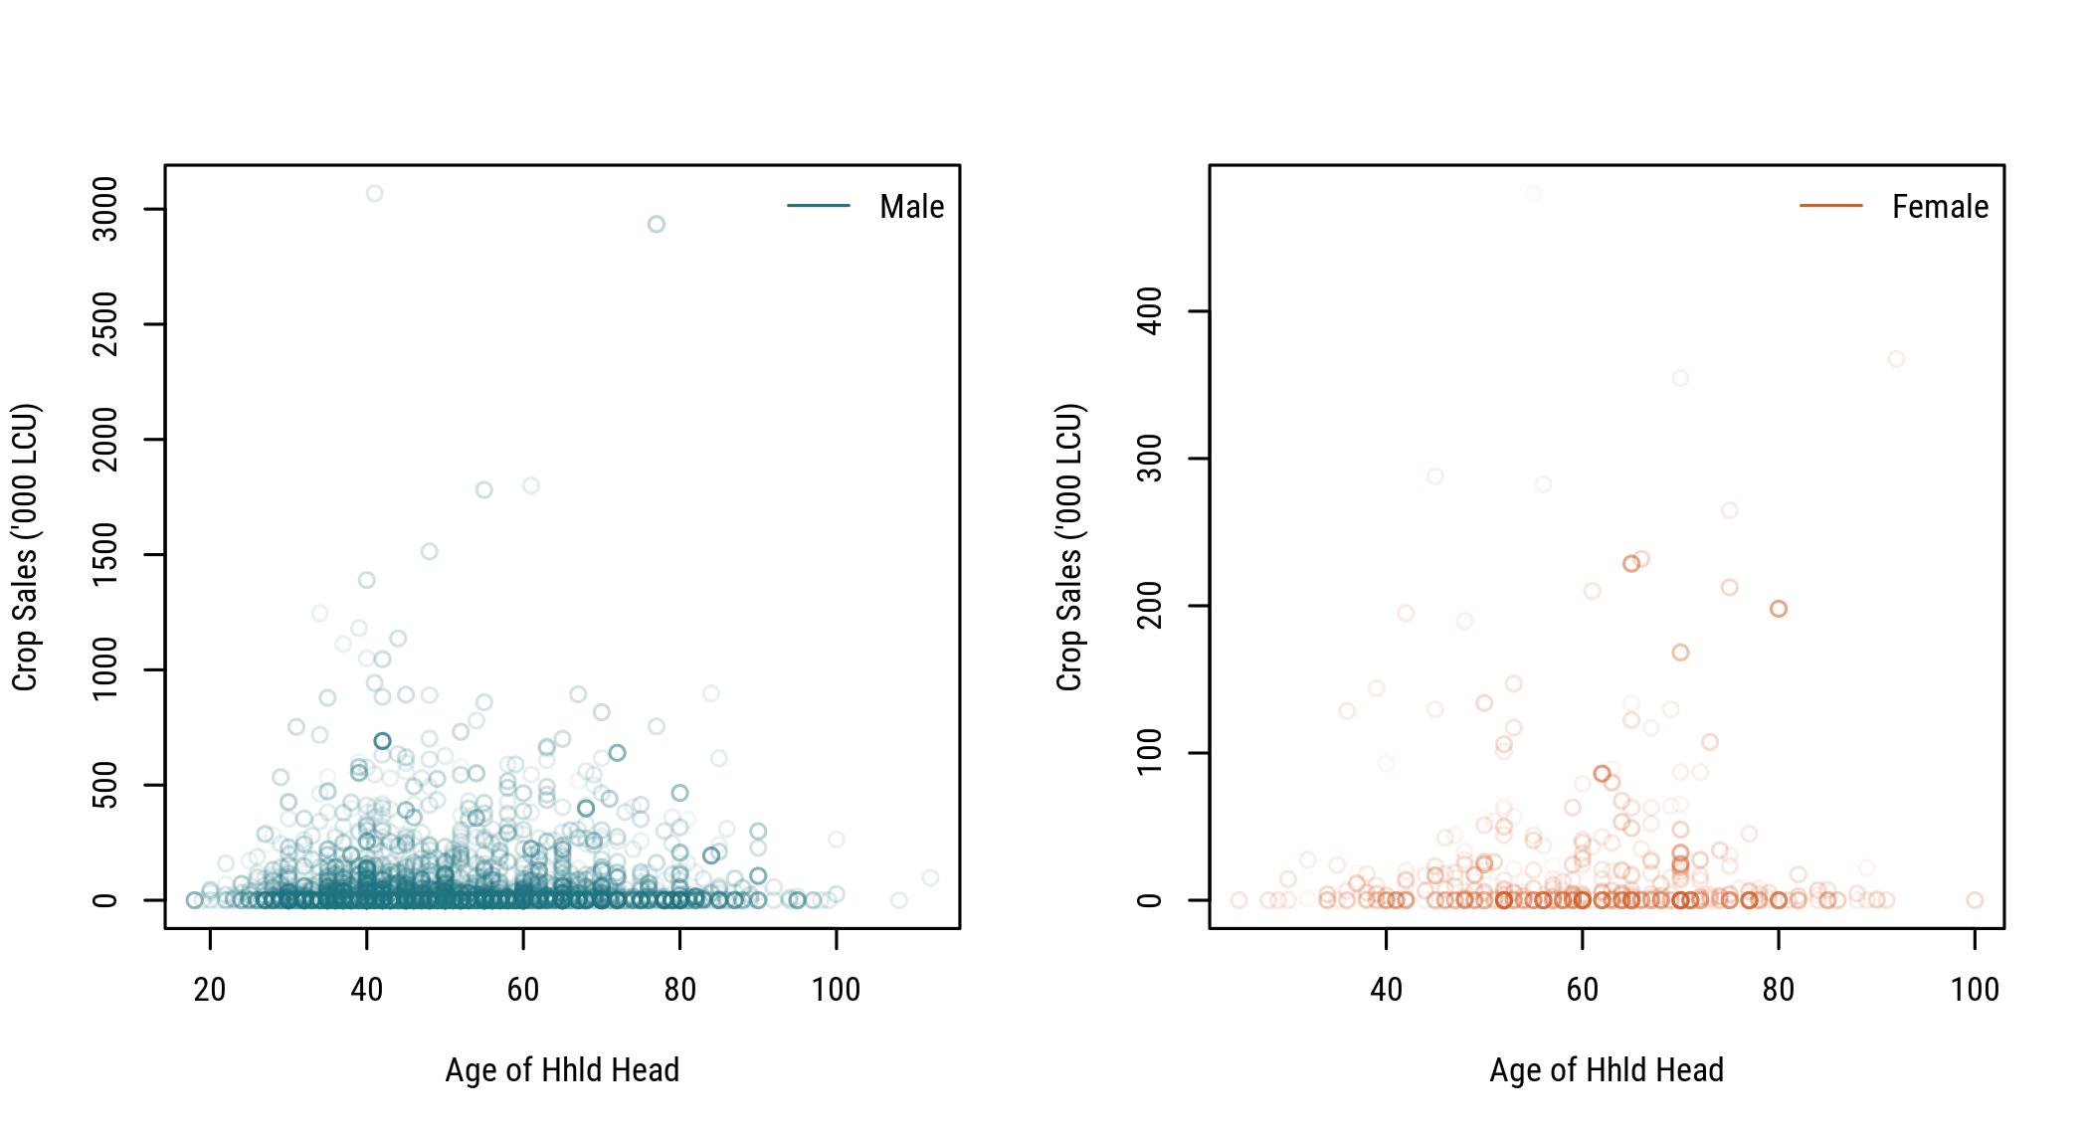

Fig. 5 Crop Commercialization by Age and Gender

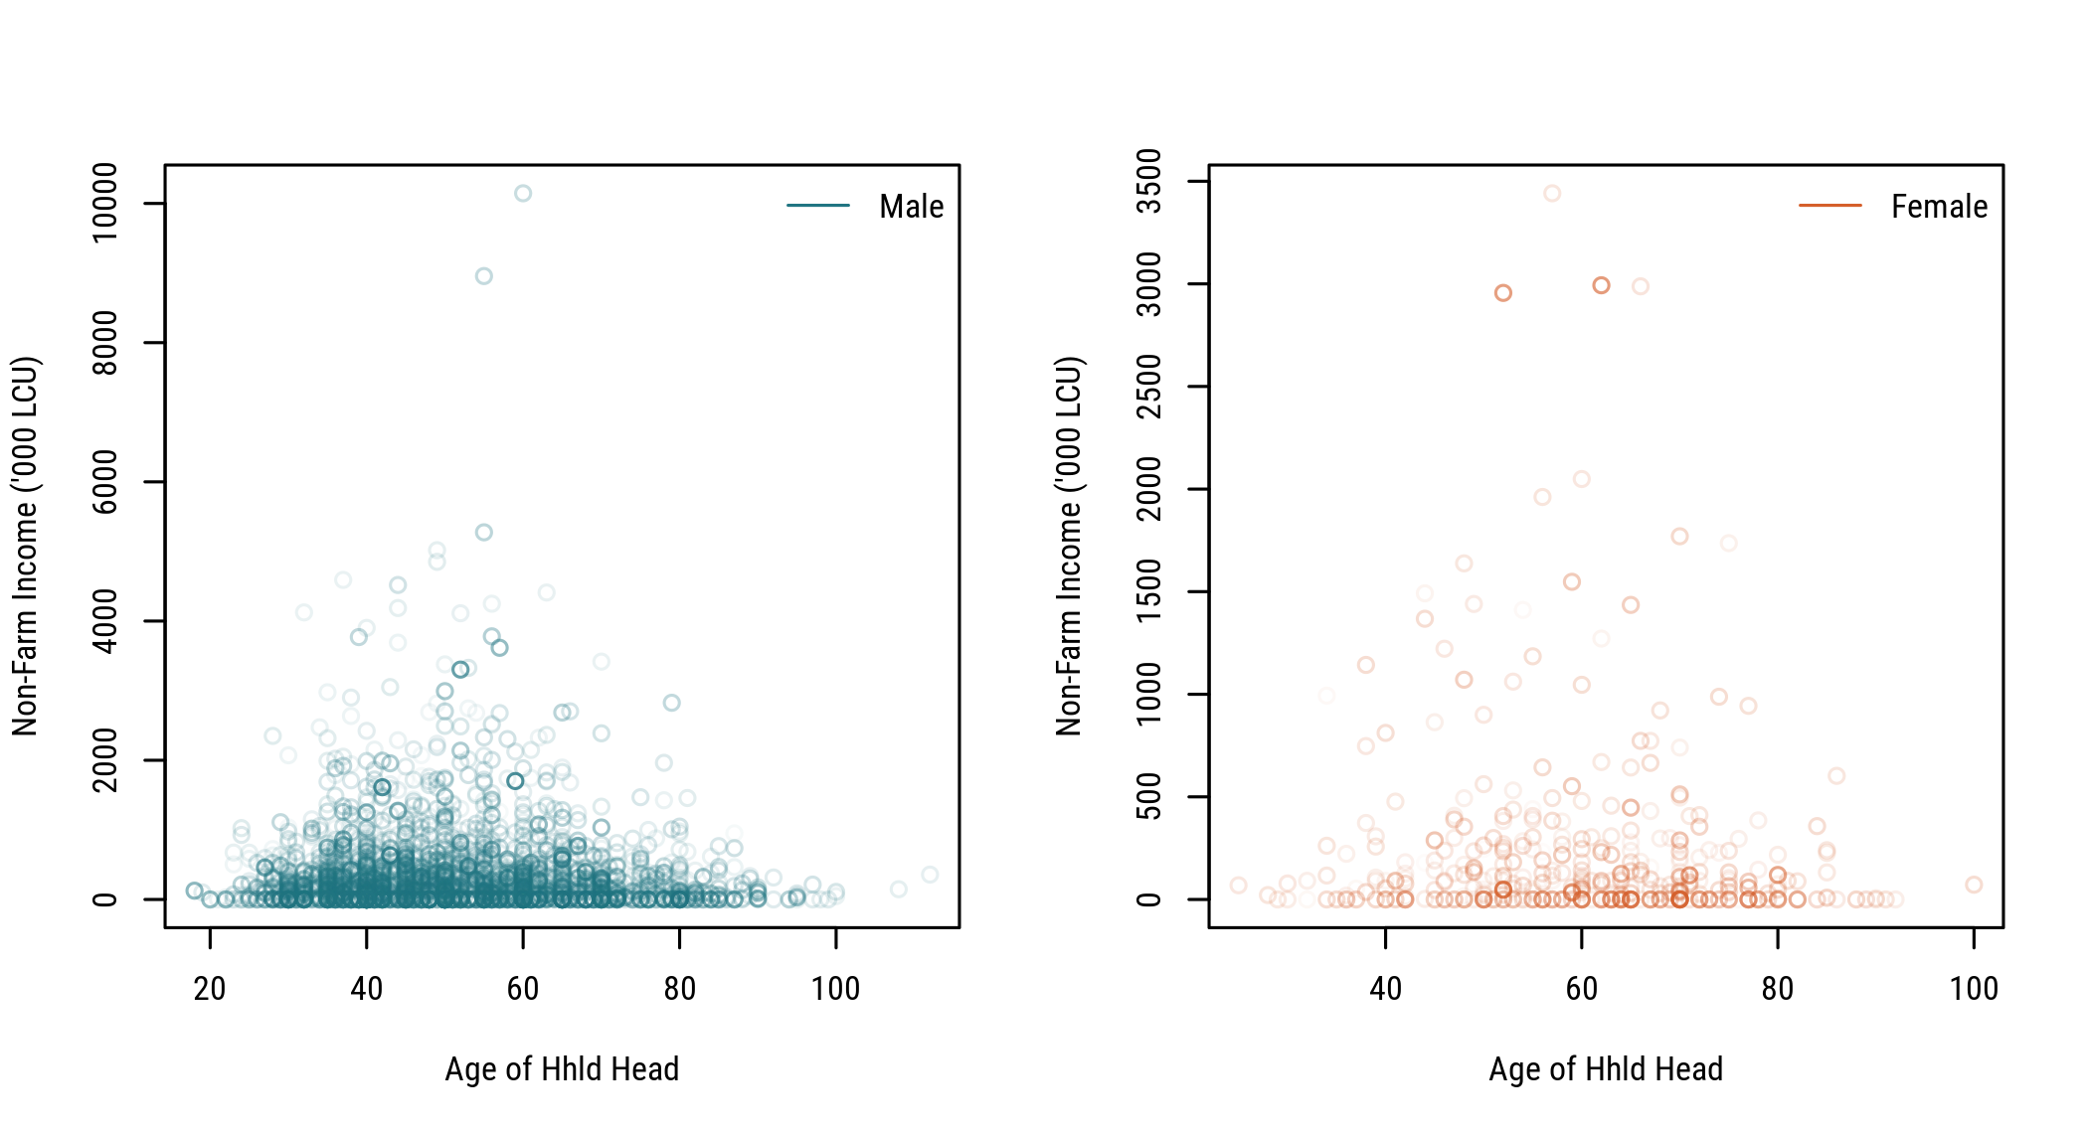

Fig. 6 Income Diversification by Age and Gender

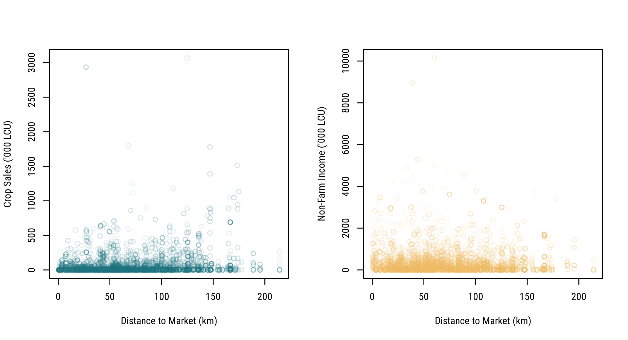

Fig. 7 Crop Commercialization and Income Diversification along Market Access

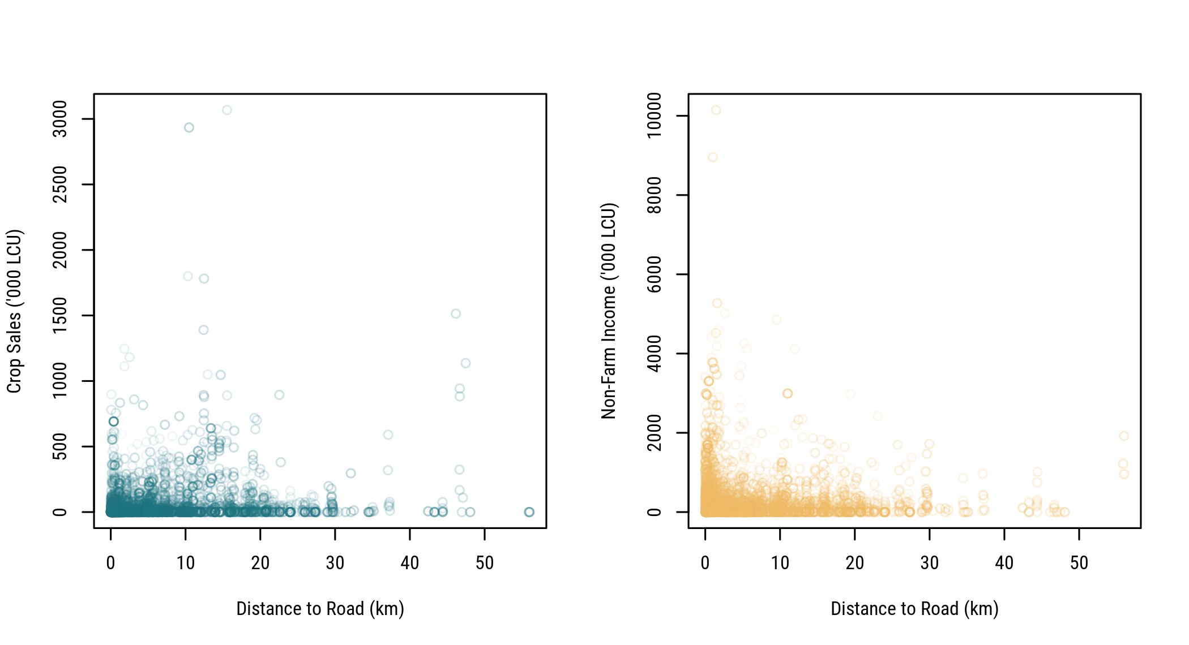

Fig. 8 Crop Commercialization and Income Diversification vs. Distance to Nearest Road

Note that all tables below omit standard errors for clarity.

(#tab:tab3a) Market Access for Small Farm Households across Categories (km, travel time in hrs)

LoCLoD

LoCMeD

LoCHiD

MeCLoD

MeCMeD

MeCHiD

HiCLoD

HiCMeD

HiCHiD

Variable

est.

est.

est.

est.

est.

est.

est.

est.

est.

dist_market

Mean

 66.72

 81.09

 64.74

 86.28

 75.66

 61.76

 75.61

 76.95

 66.44

Q25

 38.63

 51.65

 39.10

 50.83

 51.94

 43.98

 43.20

 48.42

 32.38

Q50

 58.16

 69.39

 59.24

 90.40

 71.85

 57.23

 70.09

 68.50

 53.94

Q75

 91.48

 96.37

 81.78

117.24

 96.54

 74.91

111.13

105.73

 95.70

dist_road2

Mean

  7.61

  4.68

  3.86

  7.75

  4.97

  3.58

  7.80

  7.92

  5.08

Q25

  1.23

  0.53

  0.32

  0.93

  0.49

  0.49

  1.51

  1.44

  0.33

Q50

  4.98

  3.01

  1.37

  5.45

  2.88

  1.41

  6.09

  5.83

  1.07

Q75

 11.36

  8.01

  5.29

 11.66

  8.67

  3.42

 13.39

 10.28

  9.66

mkt50k

Mean

  3.27

  2.37

  2.42

  3.92

  2.90

  2.86

  4.08

  3.54

  2.97

Q25

  2.19

  1.54

  1.38

  2.27

  1.67

  1.49

  2.27

  2.23

  1.58

Q50

  2.91

  2.27

  1.76

  3.18

  2.51

  1.86

  3.23

  2.80

  2.29

Q75

  4.03

  2.94

  3.03

  4.04

  3.16

  2.72

  4.05

  3.84

  3.15

mkt100k

Mean

  3.47

  2.48

  2.58

  4.26

  3.17

  3.00

  5.05

  3.84

  3.41

Q25

  2.22

  1.55

  1.41

  2.38

  1.89

  1.62

  2.48

  2.23

  1.60

Q50

  2.96

  2.25

  2.00

  3.24

  2.63

  2.07

  3.40

  2.97

  2.45

Q75

  4.12

  2.94

  3.11

  4.54

  3.70

  2.93

  4.61

  3.97

  3.39

(#tab:tab3b) Sources of Agricultural Income for Small Farm Households across Categories ('000 LCU, percent)

LoCLoD

LoCMeD

LoCHiD

MeCLoD

MeCMeD

MeCHiD

HiCLoD

HiCMeD

HiCHiD

Variable

est.

est.

est.

est.

est.

est.

est.

est.

est.

(cropvalue/1000)

Mean

 32,136

     73

     33

  2,768

    125

     49

    246

    242

     59

Q25

 12,484

     20

     10

     46

     36

     22

     46

     89

     15

Q50

 26,043

     36

     24

    128

    113

     34

    146

    172

     36

Q75

 45,297

     79

     45

  3,746

    185

     69

    359

    364

     83

(cropsales/1000)

Mean

     49

      0

      0

    263

     40

     12

    216

    220

     49

Q25

      0

      0

      0

      8

      9

      5

     37

     71

     11

Q50

      7

      0

      0

     38

     26

      7

    117

    159

     29

Q75

     50

      0

      0

    404

     51

     14

    295

    287

     60

(lstocksold/1000)

Mean

    225

     81

      8

    335

    132

     13

    595

    106

     15

Q25

      0

      0

      0

      0

      0

      0

      0

      0

      0

Q50

      0

      0

      0

      0

      0

      0

      0

      0

      0

Q75

     48

     27

      5

     30

     43

      7

     64

     10

      7

(agsales/1000)

Mean

    357

     81

      9

    605

    174

     25

    934

    326

     64

Q25

      2

      0

      0

     14

     21

      6

     68

     96

     15

Q50

     36

      0

      0

     84

     50

     11

    249

    211

     44

Q75

    129

     27

      5

    634

     98

     33

    741

    377

     79

agsalespc

Mean

 82,419

 14,910

  1,858

185,677

 35,520

  6,667

270,919

107,205

 18,699

Q25

    388

      0

      0

  4,218

  5,831

  1,190

 21,706

 25,335

  3,370

Q50

  8,008

      0

      0

 19,051

 10,462

  2,586

 58,272

 65,284

  9,448

Q75

 28,274

 11,460

  1,183

178,619

 25,876

  7,386

288,667

121,089

 24,719

(aggross/1000)

Mean

 32,448

    186

     44

  3,131

    264

     64

    970

    400

     78

Q25

 12,609

     46

     13

     60

     72

     25

     84

    153

     18

Q50

 26,207

     75

     32

    239

    135

     44

    295

    307

     47

Q75

 46,155

    129

     53

  4,156

    263

     81

    751

    463

     95

(cropsales_sh * 100)

Mean

      0

      0

      0

     21

     29

     24

     87

     88

     84

Q25

      0

      0

      0

      9

     16

     14

     76

     78

     73

Q50

      0

      0

      0

     18

     31

     22

     91

     94

     93

Q75

      0

      0

      0

     30

     36

     36

     99

     99

    100

(aggross_sh * 100)

Mean

     99

     46

     10

     97

     50

     14

     93

     48

     15

Q25

     99

     36

      3

     95

     41

      6

     89

     41

      7

Q50

    100

     45

      7

    100

     47

     12

    100

     47

     15

Q75

    100

     51

     14

    100

     59

     21

    100

     58

     24

(#tab:tab3c) Land and Livestock Assets of Small Farm Households across Categories (ha, TLU)

LoCLoD

LoCMeD

LoCHiD

MeCLoD

MeCMeD

MeCHiD

HiCLoD

HiCMeD

HiCHiD

Variable

est.

est.

est.

est.

est.

est.

est.

est.

est.

farmarea

Mean

 0.72

 0.23

 0.23

 0.88

 0.44

 0.24

 0.78

 0.52

 0.48

Q25

 0.18

 0.00

 0.02

 0.11

 0.07

 0.04

 0.09

 0.09

 0.06

Q50

 0.46

 0.10

 0.07

 0.55

 0.21

 0.10

 0.43

 0.35

 0.35

Q75

 1.00

 0.25

 0.28

 1.21

 0.47

 0.24

 1.15

 0.78

 0.69

croparea

Mean

 0.71

 0.23

 0.23

 0.88

 0.43

 0.24

 0.78

 0.52

 0.48

Q25

 0.17

 0.00

 0.02

 0.11

 0.07

 0.04

 0.09

 0.09

 0.06

Q50

 0.45

 0.10

 0.07

 0.55

 0.17

 0.10

 0.43

 0.35

 0.33

Q75

 0.99

 0.25

 0.27

 1.21

 0.47

 0.24

 1.15

 0.78

 0.69

catt_numberimp

Mean

 1.56

 0.12

 0.14

 0.13

 0.75

 0.27

 0.87

 0.17

 0.23

Q25

 0.00

 0.00

 0.00

 0.00

 0.00

 0.00

 0.00

 0.00

 0.00

Q50

 0.00

 0.00

 0.00

 0.00

 0.00

 0.00

 0.00

 0.00

 0.00

Q75

 0.00

 0.00

 0.00

 0.00

 0.00

 0.00

 0.00

 0.00

 0.00

pigs_numberimp

Mean

 0.18

 0.07

 0.02

 0.02

 0.00

 0.70

 0.00

 0.00

 0.49

Q25

 0.00

 0.00

 0.00

 0.00

 0.00

 0.00

 0.00

 0.00

 0.00

Q50

 0.00

 0.00

 0.00

 0.00

 0.00

 0.00

 0.00

 0.00

 0.00

Q75

 0.00

 0.00

 0.00

 0.00

 0.00

 0.00

 0.00

 0.00

 0.00

chic_numberimp

Mean

 7.76

 5.86

 5.49

 5.52

 4.23

 4.11

 4.22

 5.40

 4.87

Q25

 0.00

 0.00

 0.00

 0.00

 0.00

 0.00

 0.00

 0.00

 0.00

Q50

 0.00

 0.00

 0.00

 0.00

 2.45

 0.00

 0.00

 0.00

 0.00

Q75

12.00

10.00

 4.43

 8.00

 7.00

 5.41

 0.16

 9.76

 9.00

sheep_numberimp

Mean

 1.78

 0.28

 0.72

 0.40

 0.75

 0.54

 1.11

 0.37

 1.14

Q25

 0.00

 0.00

 0.00

 0.00

 0.00

 0.00

 0.00

 0.00

 0.00

Q50

 0.00

 0.00

 0.00

 0.00

 0.00

 0.00

 0.00

 0.00

 0.00

Q75

 2.00

 0.00

 0.00

 0.00

 0.00

 0.00

 0.00

 0.00

 0.00

goat_numberimp

Mean

 3.14

 1.00

 1.09

 1.33

 2.25

 1.15

 1.16

 1.52

 1.13

Q25

 0.00

 0.00

 0.00

 0.00

 0.00

 0.00

 0.00

 0.00

 0.00

Q50

 0.00

 0.00

 0.00

 0.00

 0.00

 0.00

 0.00

 0.00

 0.00

Q75

 5.00

 0.00

 1.00

 1.00

 4.19

 1.04

 0.42

 3.16

 2.00

TLU_total

Mean

 1.72

 0.36

 0.33

 0.33

 0.79

 0.54

 0.72

 0.34

 0.49

Q25

 0.00

 0.00

 0.00

 0.00

 0.00

 0.00

 0.00

 0.00

 0.00

Q50

 0.42

 0.03

 0.00

 0.03

 0.11

 0.08

 0.00

 0.05

 0.09

Q75

 1.30

 0.15

 0.30

 0.30

 0.46

 0.30

 0.30

 0.50

 0.39

(#tab:tab4) Demographics of Small Farm Households across Categories

LoCLoD

LoCMeD

LoCHiD

MeCLoD

MeCMeD

MeCHiD

HiCLoD

HiCMeD

HiCHiD

Variable

est.

est.

est.

est.

est.

est.

est.

est.

est.

hhsize

Mean

  6.9

  6.2

  6.3

  5.9

  5.7

  6.2

  5.4

  5.4

  6.0

Q25

  5.0

  4.0

  4.0

  3.1

  3.6

  4.8

  3.0

  4.0

  4.0

Q50

  7.0

  6.0

  6.0

  6.0

  5.5

  6.0

  5.0

  5.0

  6.0

Q75

  9.0

  8.0

  8.0

  8.0

  7.0

  8.0

  7.0

  7.0

  7.2

(femhead * 100)

Mean

 10.8

 18.9

 21.1

 13.3

 10.3

 14.3

 12.7

 18.5

 11.0

Q25

  0.0

  0.0

  0.0

  0.0

  0.0

  0.0

  0.0

  0.0

  0.0

Q50

  0.0

  0.0

  0.0

  0.0

  0.0

  0.0

  0.0

  0.0

  0.0

Q75

  0.0

  0.0

  0.0

  0.0

  0.0

  0.0

  0.0

  0.0

  0.0

agehead

Mean

 51.7

 58.0

 54.4

 57.6

 62.0

 56.4

 54.3

 53.8

 53.6

Q25

 40.0

 42.0

 43.0

 45.0

 51.4

 49.0

 41.2

 40.0

 40.0

Q50

 50.0

 58.0

 55.0

 59.0

 60.7

 55.0

 54.6

 53.2

 51.4

Q75

 61.0

 72.0

 64.5

 70.0

 70.0

 65.0

 66.1

 65.0

 65.0

(lithead * 100)

Mean

 55.1

 62.2

 69.3

 49.9

 58.9

 73.5

 53.0

 64.0

 69.7

Q25

  0.0

  0.0

  0.0

  0.0

  0.0

  0.0

  0.0

  0.0

  0.0

Q50

100.0

100.0

100.0

  0.0

100.0

100.0

100.0

100.0

100.0

Q75

100.0

100.0

100.0

100.0

100.0

100.0

100.0

100.0

100.0

eduyears

Mean

  7.1

  8.2

  7.9

  7.5

  8.1

  8.5

  6.3

  8.4

  7.7

Q25

  3.0

  6.0

  4.0

  5.0

  6.0

  6.0

  4.6

  6.0

  3.0

Q50

  6.0

  6.0

  6.0

  6.0

  6.0

  6.0

  6.0

  6.0

  6.0

Q75

 12.0

 12.0

 12.0

 12.0

 10.9

 12.0

  6.0

 12.0

 12.0

numchildren

Mean

  2.9

  2.5

  2.2

  2.1

  1.7

  2.0

  1.7

  2.0

  2.2

Q25

  1.0

  0.5

  1.0

  0.0

  0.0

  0.0

  0.0

  0.0

  0.0

Q50

  3.0

  1.0

  2.0

  2.0

  1.0

  2.0

  1.0

  1.0

  2.0

Q75

  4.0

  3.0

  4.0

  4.0

  3.0

  3.0

  3.0

  3.0

  3.0

equiv

Mean

  5.0

  4.6

  4.7

  4.4

  4.5

  4.7

  3.6

  3.8

  4.3

Q25

  3.5

  2.5

  3.0

  2.5

  2.8

  3.5

  2.0

  2.5

  3.0

Q50

  5.0

  4.5

  4.5

  4.0

  4.5

  4.5

  3.1

  3.5

  4.0

Q75

  6.5

  6.0

  6.0

  5.5

  6.0

  6.0

  4.5

  5.5

  5.5

females

Mean

  3.4

  3.2

  3.2

  2.9

  2.9

  3.2

  2.5

  2.8

  3.0

Q25

  2.0

  1.0

  2.0

  2.0

  1.0

  2.0

  1.0

  1.0

  2.0

Q50

  3.0

  3.0

  3.0

  3.0

  3.0

  3.0

  2.0

  3.0

  3.0

Q75

  5.0

  4.8

  4.0

  4.0

  4.0

  4.0

  3.4

  4.0

  4.0

males

Mean

  3.4

  3.1

  3.1

  3.0

  2.9

  3.1

  2.8

  2.6

  3.1

Q25

  2.0

  1.0

  2.0

  1.0

  1.0

  2.0

  1.0

  1.0

  2.0

Q50

  3.0

  2.2

  3.0

  3.0

  3.0

  3.0

  2.1

  2.0

  3.0

Q75

  5.0

  4.0

  4.0

  4.0

  4.0

  4.0

  4.0

  3.8

  4.0

sh_ed_none

Mean

  5.6

  3.6

  4.1

  8.4

  3.1

  3.2

  5.6

  4.0

  7.5

Q25

  0.0

  0.0

  0.0

  0.0

  0.0

  0.0

  0.0

  0.0

  0.0

Q50

  0.0

  0.0

  0.0

  0.0

  0.0

  0.0

  0.0

  0.0

  0.0

Q75

  0.0

  0.0

  0.0

  0.0

  0.0

  0.0

  0.0

  0.0

  0.0

sh_ed_prim

Mean

 62.1

 57.7

 45.9

 58.8

 43.3

 43.9

 63.5

 61.9

 55.2

Q25

 33.9

 33.3

 20.0

 33.3

 20.0

 15.4

 49.3

 43.4

 33.3

Q50

 66.7

 56.0

 50.0

 57.1

 50.0

 50.0

 66.7

 60.0

 55.7

Q75

100.0

 75.0

 66.7

100.0

 60.7

 66.7

100.0

100.0

 80.7

sh_ed_secu

Mean

 32.1

 38.7

 49.1

 31.5

 53.7

 52.9

 30.9

 34.1

 37.4

Q25

  0.0

 14.2

 22.8

  0.0

 26.1

 25.0

  0.0

  0.0

  0.0

Q50

 25.0

 40.0

 50.0

 25.0

 50.0

 50.0

 25.0

 33.3

 35.2

Q75

 55.6

 60.0

 72.6

 50.0

 80.0

 82.2

 50.0

 50.0

 50.0

(#tab:tab5) Parcels and Input Uses for Small Farm Households across Categories (percent)

LoCLoD

LoCMeD

LoCHiD

MeCLoD

MeCMeD

MeCHiD

HiCLoD

HiCMeD

HiCHiD

Variable

est.

est.

est.

est.

est.

est.

est.

est.

est.

parcels

Mean

  1.9

  2.1

  1.7

  2.3

  2.3

  2.0

  2.0

  2.0

  1.9

Q25

  1.0

  1.0

  1.0

  2.0

  1.0

  1.0

  1.0

  1.0

  1.0

Q50

  2.0

  2.0

  1.0

  2.0

  2.0

  2.0

  2.0

  2.0

  2.0

Q75

  2.0

  3.0

  2.0

  3.0

  3.0

  2.0

  3.0

  3.0

  2.7

(chempest_farms * 100)

Mean

 20.8

 10.5

  2.2

 25.5

 10.3

  2.6

 32.5

 36.0

 22.7

Q25

  0.0

  0.0

  0.0

  0.0

  0.0

  0.0

  0.0

  0.0

  0.0

Q50

  0.0

  0.0

  0.0

  0.0

  0.0

  0.0

  0.0

  0.0

  0.0

Q75

  0.0

  0.0

  0.0

 87.0

  0.0

  0.0

100.0

100.0

  0.0

(chemherb_farms * 100)

Mean

 26.8

 12.0

 11.6

 35.3

 20.5

  8.9

 32.9

 29.8

 21.2

Q25

  0.0

  0.0

  0.0

  0.0

  0.0

  0.0

  0.0

  0.0

  0.0

Q50

  0.0

  0.0

  0.0

  0.0

  0.0

  0.0

  0.0

  0.0

  0.0

Q75

100.0

  0.0

  0.0

100.0

  0.0

  0.0

100.0

100.0

  0.0

(fertorg_farms * 100)

Mean

  4.6

  3.3

  3.7

  0.0

  0.0

  4.2

  2.0

  3.0

 12.6

Q25

  0.0

  0.0

  0.0

  0.0

  0.0

  0.0

  0.0

  0.0

  0.0

Q50

  0.0

  0.0

  0.0

  0.0

  0.0

  0.0

  0.0

  0.0

  0.0

Q75

  0.0

  0.0

  0.0

  0.0

  0.0

  0.0

  0.0

  0.0

  0.0

(fertinorg_farms * 100)

Mean

 48.2

 30.0

 24.7

 16.8

 35.5

 21.1

 21.5

 25.0

 33.8

Q25

  0.0

  0.0

  0.0

  0.0

  0.0

  0.0

  0.0

  0.0

  0.0

Q50

  0.0

  0.0

  0.0

  0.0

  0.0

  0.0

  0.0

  0.0

  0.0

Q75

100.0

100.0

  0.0

  0.0

100.0

  0.0

  0.0

  2.2

100.0

(seedp_farms * 100)

Mean

 27.8

 27.6

 46.7

 25.5

 37.1

 33.7

 28.3

 19.1

 38.1

Q25

  0.0

  0.0

  0.0

  0.0

  0.0

  0.0

  0.0

  0.0

  0.0

Q50

  0.0

  0.0

  0.0

  0.0

  0.0

  0.0

  0.0

  0.0

  0.0

Q75

100.0

100.0

100.0

 30.6

100.0

100.0

100.0

  0.0

100.0

(tractorown_farms * 100)

Mean

  1.2

  2.6

  2.2

  1.0

  1.6

  0.0

  6.7

  2.8

  0.6

Q25

  0.0

  0.0

  0.0

  0.0

  0.0

  0.0

  0.0

  0.0

  0.0

Q50

  0.0

  0.0

  0.0

  0.0

  0.0

  0.0

  0.0

  0.0

  0.0

Q75

  0.0

  0.0

  0.0

  0.0

  0.0

  0.0

  0.0

  0.0

  0.0

intens_idx2

Mean

  1.4

  0.8

  0.9

  0.8

  1.0

  0.7

  1.1

  1.1

  1.3

Q25

  0.3

  0.0

  0.0

  0.0

  0.0

  0.0

  0.0

  0.0

  0.0

Q50

  1.0

  0.5

  1.0

  0.7

  0.8

  0.8

  1.0

  1.0

  1.0

Q75

  2.0

  1.3

  1.0

  1.0

  1.1

  1.0

  2.0

  2.0

  2.0

(#tab:tab6) Poverty Incidence in Small Farm Households across Categories (PPP, percent)

LoCLoD

LoCMeD

LoCHiD

MeCLoD

MeCMeD

MeCHiD

HiCLoD

HiCMeD

HiCHiD

Variable

est.

est.

est.

est.

est.

est.

est.

est.

est.

pcexp_ppp_m

Mean

29.7

26.6

39.7

32.7

39.7

33.5

38.2

54.6

46.2

Q25

13.2

12.6

14.6

13.7

23.0

15.6

18.7

28.2

19.3

Q50

21.6

22.2

24.4

26.4

36.7

26.2

27.3

44.9

30.9

Q75

38.6

30.8

44.0

43.0

49.3

40.1

49.8

68.0

50.0

foodexp_ppp_m

Mean

23.0

18.8

24.1

24.0

27.3

24.7

29.8

39.5

32.4

Q25

10.3

 8.0

 9.9

10.9

16.2

11.7

14.5

17.7

15.2

Q50

17.0

14.9

16.2

18.5

26.3

19.5

21.9

32.0

24.3

Q75

30.4

24.3

27.3

35.8

35.5

31.3

38.3

50.8

33.6

nfoodexp_ppp_m

Mean

 6.6

 7.7

15.6

 8.6

12.4

 8.8

 8.4

15.1

13.8

Q25

 2.2

 3.7

 3.9

 2.3

 4.8

 3.9

 3.6

 6.3

 3.5

Q50

 4.1

 5.0

 6.9

 5.2

 6.9

 7.0

 6.3

 9.1

 7.5

Q75

 7.8

10.0

13.9

11.1

 9.9

10.2

10.1

18.7

13.5

(poor_ppp1 * 100)

Mean

74.3

80.8

71.3

68.4

51.8

64.2

66.3

36.9

59.0

Q25

 0.0

100.0

 0.0

 0.0

 0.0

 0.0

 0.0

 0.0

 0.0

Q50

100.0

100.0

100.0

100.0

37.4

100.0

100.0

 0.0

100.0

Q75

100.0

100.0

100.0

100.0

100.0

100.0

100.0

100.0

100.0

(poor_ppp2 * 100)

Mean

90.6

93.0

82.5

86.1

89.9

91.0

83.9

68.9

83.2

Q25

100.0

100.0

100.0

100.0

100.0

100.0

100.0

 0.0

100.0

Q50

100.0

100.0

100.0

100.0

100.0

100.0

100.0

100.0

100.0

Q75

100.0

100.0

100.0

100.0

100.0

100.0

100.0

100.0

100.0

(povgap_ppp1 * 100)

Mean

38.3

39.5

34.3

33.7

17.5

30.6

27.9

14.6

24.7

Q25

 0.0

17.3

 0.0

 0.0

 0.0

 0.0

 0.0

 0.0

 0.0

Q50

43.1

36.1

35.8

29.6

 0.0

30.5

27.7

 0.0

17.1

Q75

65.2

64.1

61.0

63.2

38.9

58.3

50.2

20.9

48.8

(povgap_ppp2 * 100)

Mean

55.3

57.8

50.5

50.4

38.5

50.0

45.4

29.7

42.3

Q25

36.4

48.3

26.4

27.3

18.5

31.7

17.7

 0.0

15.6

Q50

64.5

60.0

59.9

56.0

35.3

56.5

54.8

24.5

48.2

Q75

78.2

77.6

75.6

77.0

61.8

73.9

68.9

50.6

68.0

(sevpov_ppp1 * 100)

Mean

23.6

23.2

19.6

20.6

 7.7

17.9

14.6

 7.6

13.0

Q25

 0.0

 3.0

 0.0

 0.0

 0.0

 0.0

 0.0

 0.0

 0.0

Q50

18.6

13.1

12.8

 8.7

 0.0

 9.3

 7.7

 0.0

 2.9

Q75

42.5

41.2

37.2

39.9

15.1

34.0

25.2

 4.4

23.8

(sevpov_ppp2 * 100)

Mean

38.6

39.8

34.4

34.5

20.5

32.4

28.9

16.6

26.1

Q25

13.3

23.3

 7.0

 7.4

 3.4

10.0

 3.1

 0.0

 2.4

Q50

41.6

36.1

35.8

31.3

12.5

32.0

30.1

 6.0

23.2

Q75

61.2

60.2

57.2

59.3

38.2

54.7

47.4

25.6

46.2

## Ghana

Relevant sources of household-level micro records for Ghana are the **6 rounds of Ghana Living Standards Surveys** in particular:

* 1998/1999 **GLSS4** (EAs were first stratified into 3 ecological zones (Coastal, Forest, Savannah), and then within each zone further stratification was done into rural or urban areas)
* 2005/2006 **GLSS5** (EAs were first stratified into 10 administrative regions; within each region EAs were further sub-divided into rural or urban areas; EAs were also classified into ecological zones and inclusion of Accra (GAMA) so that the survey results may be presented across 1) Coastal, 2) Forest, and 3) Northern Savannah, and 4) Accra).
* 2012/2013 **GLSS6** (EAs were allocated into 10 regions using probability proportional to population size (PPS), then further divided into urban and rural localities).

In contrast to the latest 2 waves GLSS4 is only representative for 3 (ecology) x 2 (rural/urban) zones.

GLSS collect information on the demographic characteristics of the population, their education, health, employment and time use, migration, housing conditions and household agriculture, with a specific focus on **labour force**, with a labour force module expanded in GLSS6 to include a section on child labour.

Tab. 15 Composition of GLSS Survey Samples

|  |  |  |  |  |  |  |
| --- | --- | --- | --- | --- | --- | --- |
| Survey | Year | Regions | Districts | Sample | Urban | Rural |
| GLSS4 | 1997/98 | 10 | 102 | 5,998 | 2,199 | 3,799 |
| GLSS5 | 2005/06 | 10 | 110 | 8,687 | 3,618 | 5,069 |
| GLSS6 | 2012/13 | 10 | 170 | 16,772 | 7,445 | 9,327 |

RIGA aggregates were used to estimate both crop sales and farm vs. non-farm income. Generally in the RIGA approach the method is (see Carletto, Covarrubias, Davis, Krausova, & Winters (2007)):

* All aggregates are estimated at the household level.
* All income and expenditures are **annualized**.
* All income components are **net of costs**.
* Purchases and sales of **durable goods**, investments and windfall gains are excluded from household income and expenditure calculations since these are not transactions undertaken regularly by households and can result in the significant over- or under-stating of permanent income.
* All aggregates are reported in **local currency units**.
* For each survey, only the **rural** sample is used (to be verified)
* An outlier check was imposed after the construction of the income aggregate to deal with extreme income shares that arose following the aggregation of all income components. After estimating the shares of the seven principal income categories (agricultural wages, non-agricultural wages, crop, livestock, self employment, transfer and other) **observations whose share was greater than or less than 3 (indicating a percentage share of +/- 300%) were dropped from the aggregate**.

Because RIGA income aggregates are *net of costs*, we used the following components instead:

* derived from
* derived from
* (but can also be derived from and )
* derived from

### Cultivated Area

RIGA does not provide annual cultivated area, instead we have measures of land owned, land rented out, and land under sharecropping. IFPRI/HarvestChoice produced pseudo-panel variables and (but the results look a little dubious for GLSS4, see 16 below). Using operated area derived from RIGA instead (i.e. ) does yield higher proportions of households for GLSS4 but lower for GLSS6. In general GLSS4 seems to exhibit poorer data quality.

(#tab:tabcultareahh) Proportions of sampled households with any cultivated area across survey years (mutliple sources shown)

Percent oh Hhlds with Cultivated Area

IFPRI (landcult)

IFPRI (landown)

RIGA

Year

rural

urban

rural

urban

rural

urban

1998

 13.2

  3.7

 37.1

 12.5

 35.9

 11.2

1999

  9.0

  1.1

 34.0

  9.2

 29.5

  9.3

2005

 83.6

 24.4

 56.9

 20.1

 72.5

 32.2

2006

 83.6

 19.6

 51.4

 12.5

 69.8

 17.2

2012

 76.7

 23.5

100.0

100.0

 59.5

 25.7

2013

 78.6

 20.1

 99.6

 97.1

 61.6

 17.3

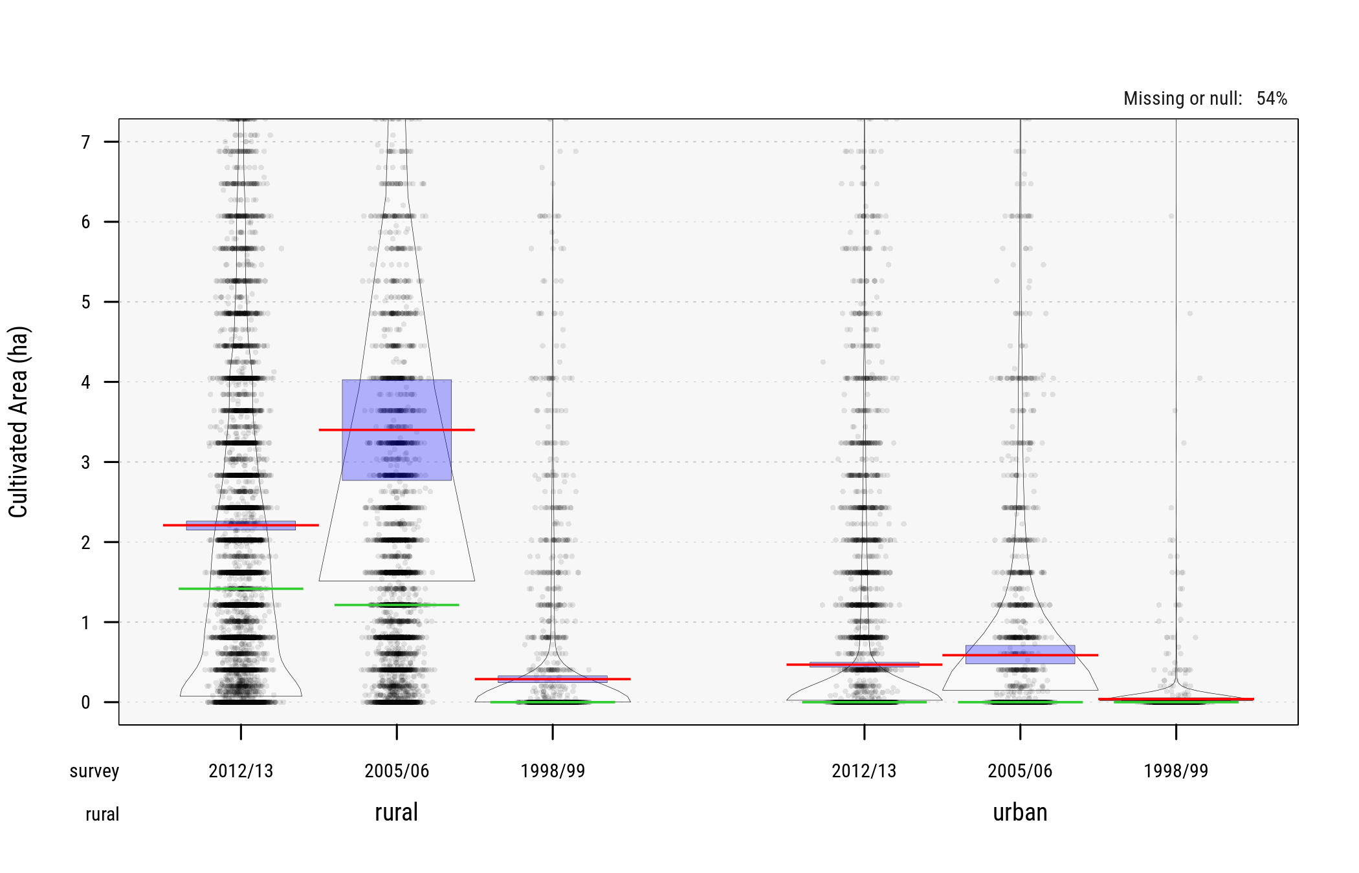

Fig. 9 Cultivated Area (ha). Source: IFPRI 2016

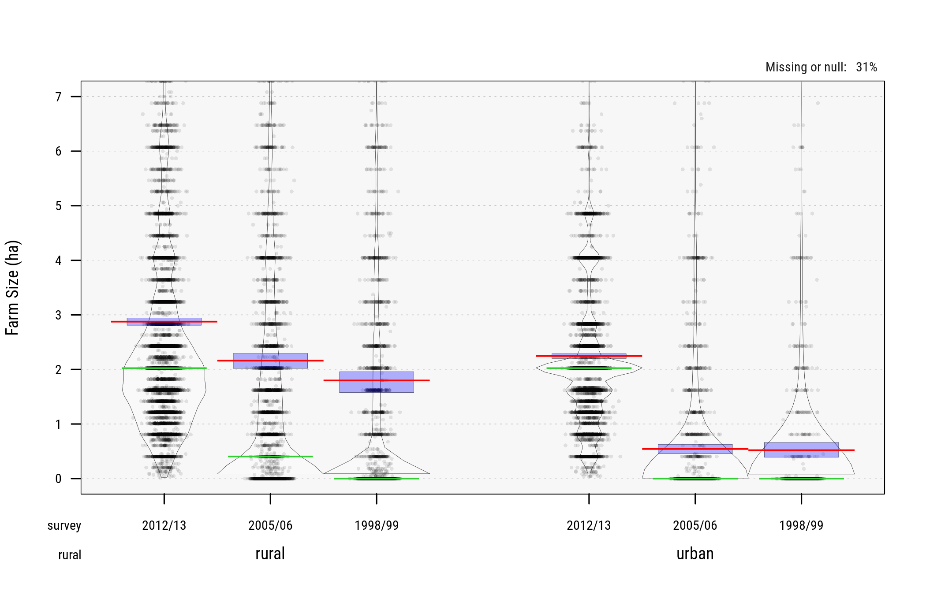

Fig. 10 Farm Size (ha). Source: IFPRI 2016

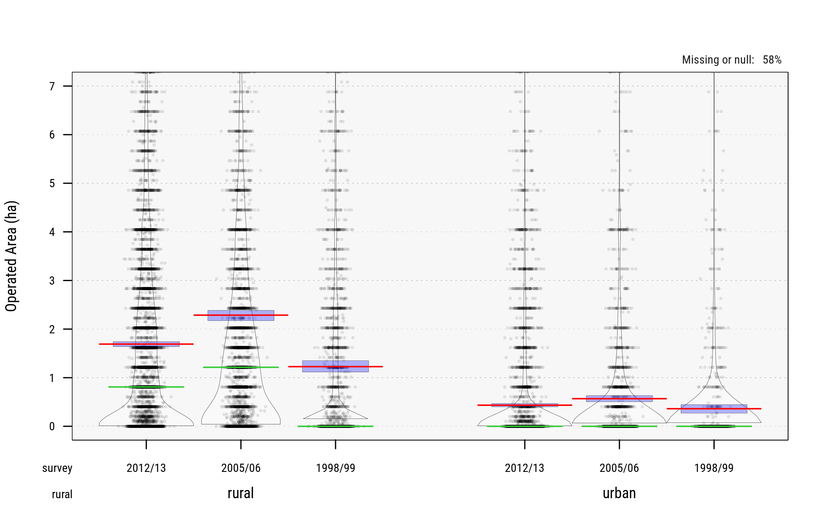

Fig. 11 Operated Area (ha). Source: FAO/RIGA

In the following classification we use **option #3** (FAO/RIGA operated area) across the 3 waves.

(#tab:countsghaa) Count of Observations across Classes of Operated Area

2 ha

2-4 ha

4 ha

N (sample)

2012/13

 5,258

 2,485

 1,725

16,772

2005/06

 2,961

 1,249

 1,152

 8,687

1998/99

 1,865

 1,769

   435

 5,998

All

10,084

 5,503

 3,312

31,457

(#tab:countsghab) Proportions of Observations across Classes of Operated Area (percent of full survey sample)

2 ha

2-4 ha

4 ha

2012/13

31.3

14.8

10.3

2005/06

34.1

14.4

13.3

1998/99

31.1

29.5

 7.3

All

32.1

17.5

10.5

(#tab:countsghac) Proportions of Observations across Classes of Operated Area (percent of selected farm households)

2 ha

2-4 ha

4 ha

All

2012/13

 55.5

 26.2

 18.2

100.0

2005/06

 55.2

 23.3

 21.5

100.0

1998/99

 45.8

 43.5

 10.7

100.0

All

 53.4

 29.1

 17.5

100.0

We further impute cultivated area for households with some amount of crop production and crop sales to ensure internal consistency in the sample (over 5,700 households reported crop sales but no cultivated area). Figure 12 below show cultivated area post-imputation.

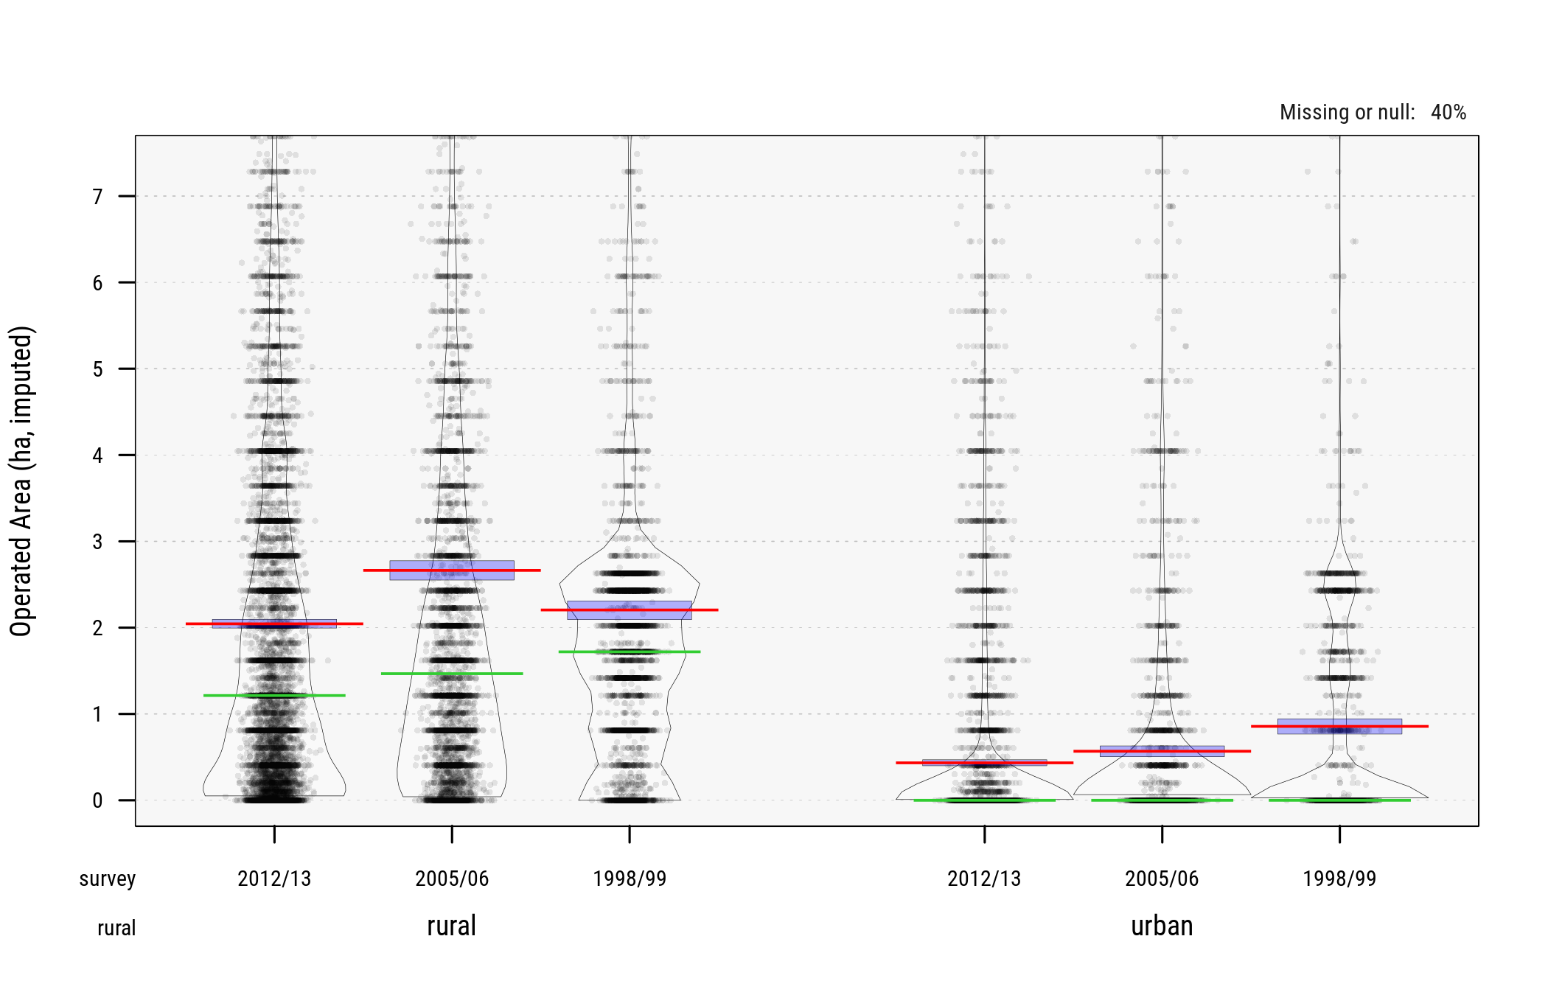

Fig. 12 Cultivated Area (ha) (post-imputation)

### Crop Commercialization

We evaluate multiple sources (and/or proxies) of aggregate household crop sales (again from FAO/RIGA and separately from IFPRI). Generally RIGA reports *gross* crop production, crop sales, and share of crop production sold in , , and respectively. All other relevant variables are listed here:

* -- value of total annual crop production
* -- value total annual crop production sold
* -- value total annual agricultural production
* -- value total annual agricultural production sold
* -- value of total annual livestock production
* -- value total annual livestock production sold
* -- value total annual agricultural production consumed
* -- value total annual agricultural production- miscellaneous uses
* -- share of annual agricultural production sold in total agricultural production
* -- share of annual agricultural production consumed in total agricultural productio
* -- share of annual agricultural production misc in total agricultural production
* -- share of total annual crop production sold in total crop production
* -- share of total annual livestock production sold in total livestock production
* -- gross crop income (crop1)
* -- gross crop income (crop2)
* -- gross livestock income

However the quality of these constructed variables for Ghana tends to vary widely across survey years.

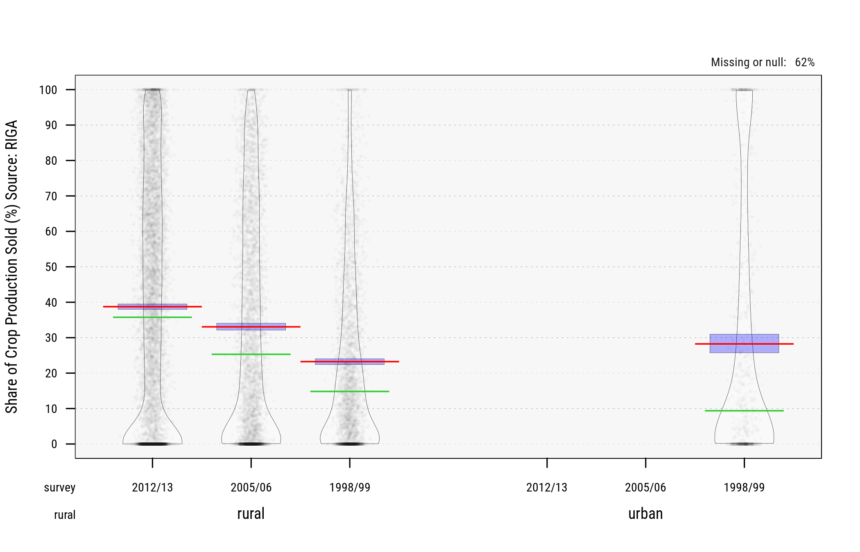

Fig. 13 Sources of Crop Commercialization (FAO/RIGA )

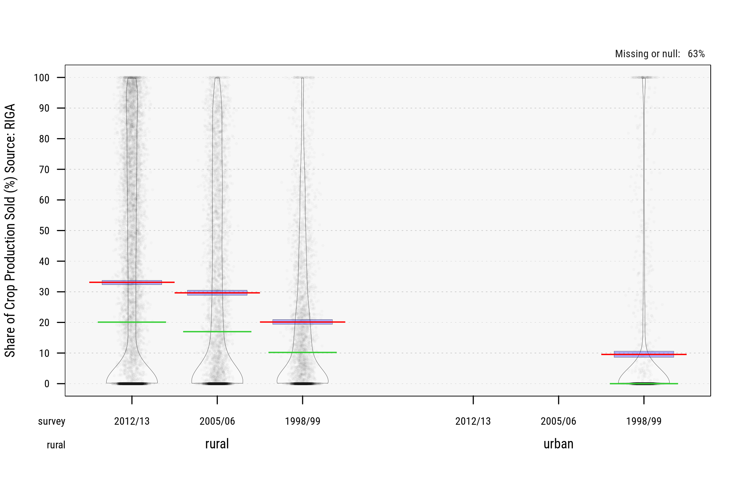

Fig. 14 Sources of Crop Commercialization (FAO/RIGA )

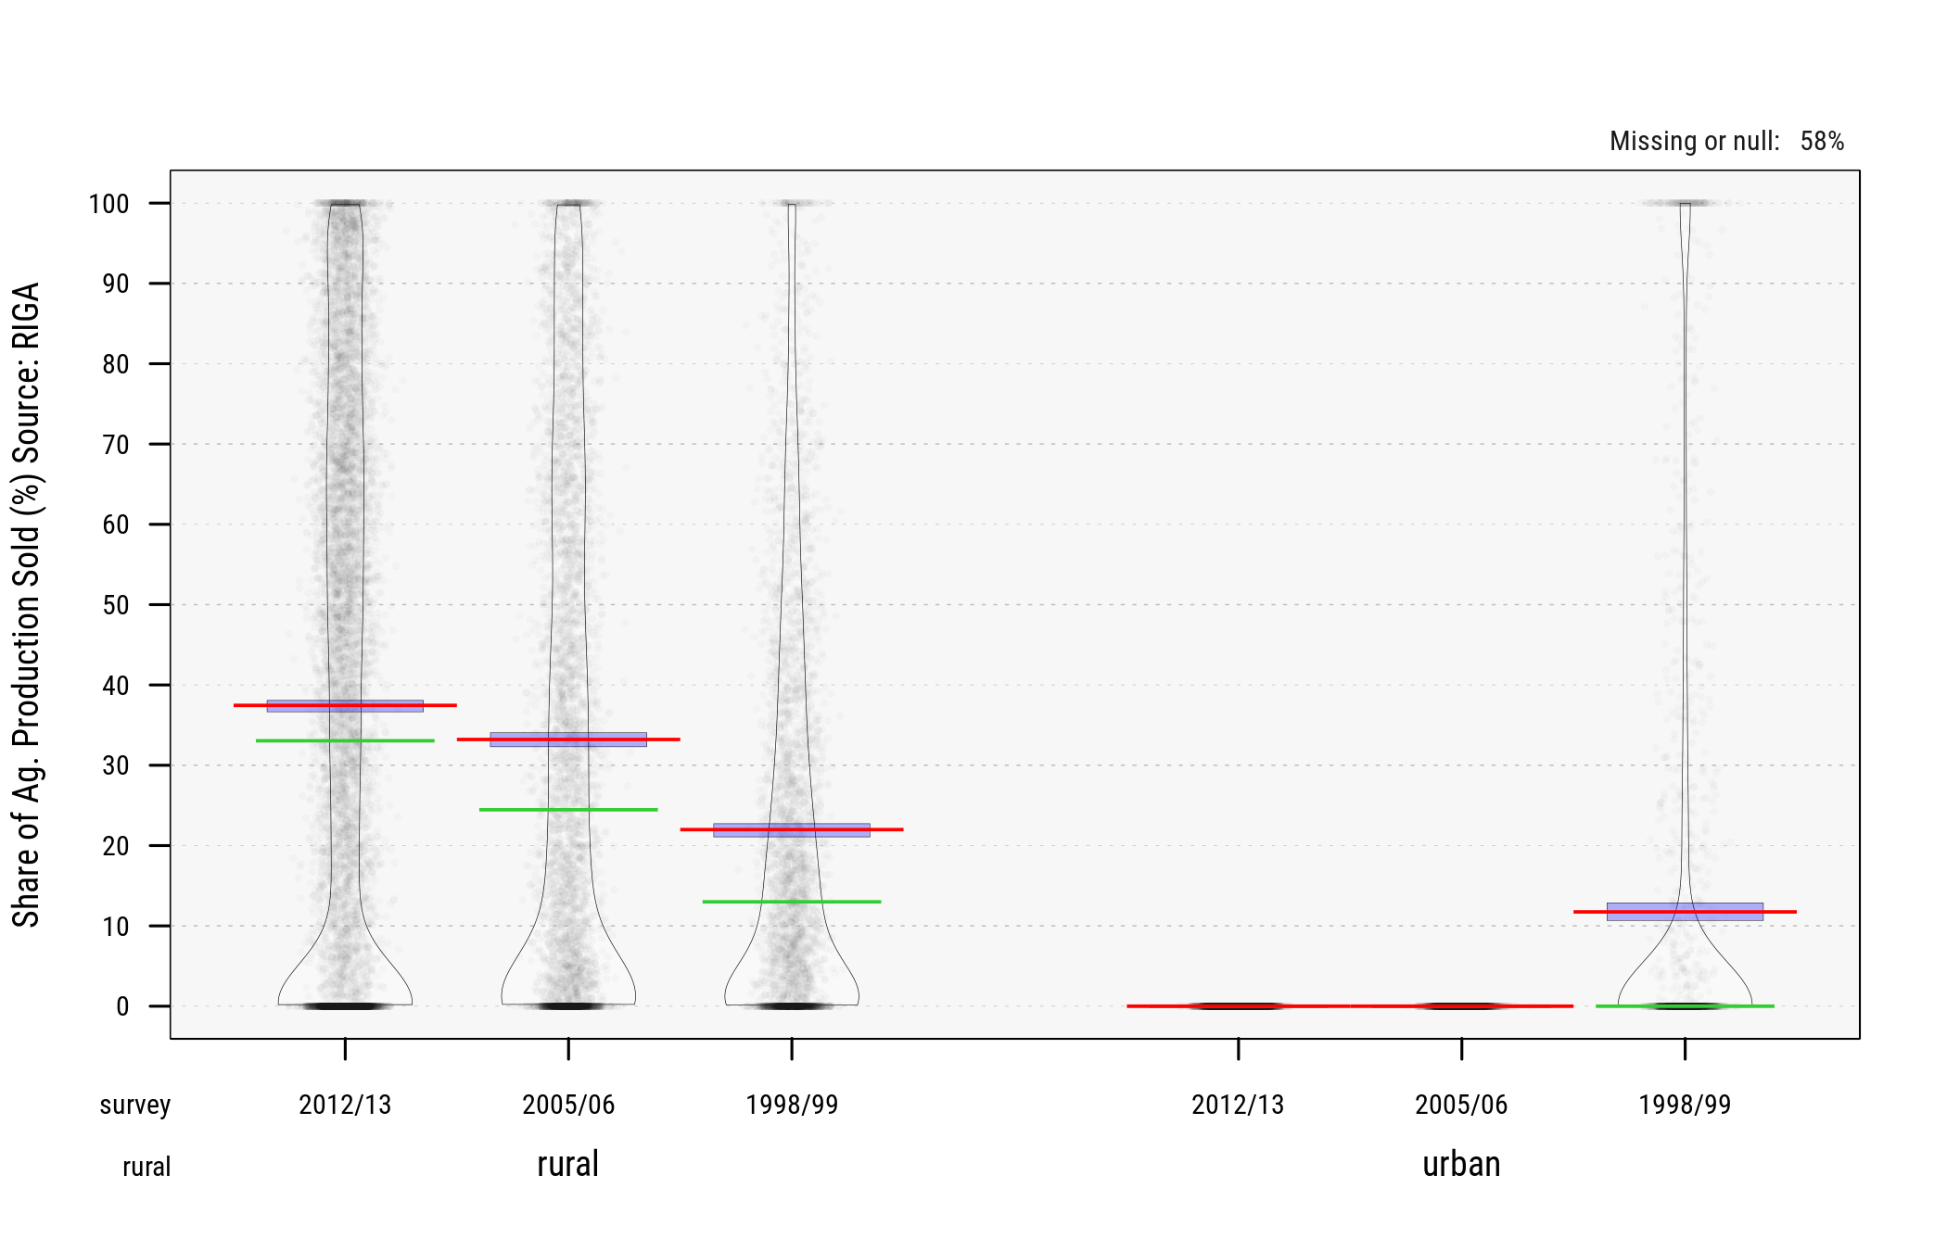

Fig. 15 Sources of Crop Commercialization (FAO/RIGA )

Looking at the pirate plots above (and tables below), sales from agricultural products for urban households seem to have been excluded from RIGA aggregates (though that's not the case for GLSS4) OR urban households have largely abandoned farming over the past 12 years (also possible).

(#tab:ghatblsales) Sales of Crops and Agricultural Products (percent of sampled households) Source: FAO/RIGA)

Hhlds with Gross Ag Income

Hhlds with no Revenue from Farming

Hhlds with Ag. Sales

HHlds with Crop Sales

Share of Crop Sales in Ag Sales

Wave

rural

urban

rural

urban

rural

urban

rural

urban

rural

urban

2012/13

85.8

 1.8

14.2

98.2

68.5

 0.0

58.8

 0.0

85.8

  NA

2005/06

87.4

 2.5

12.6

97.5

73.6

 0.0

64.5

 0.0

87.7

  NA

1998/99

86.7

36.8

13.3

63.2

70.7

23.9

64.8

20.1

91.7

84.0

In the rest of the analysis we use FAO/RIGA share of agricultutal products sold as a *proxy* measure of **crop commercialization**.

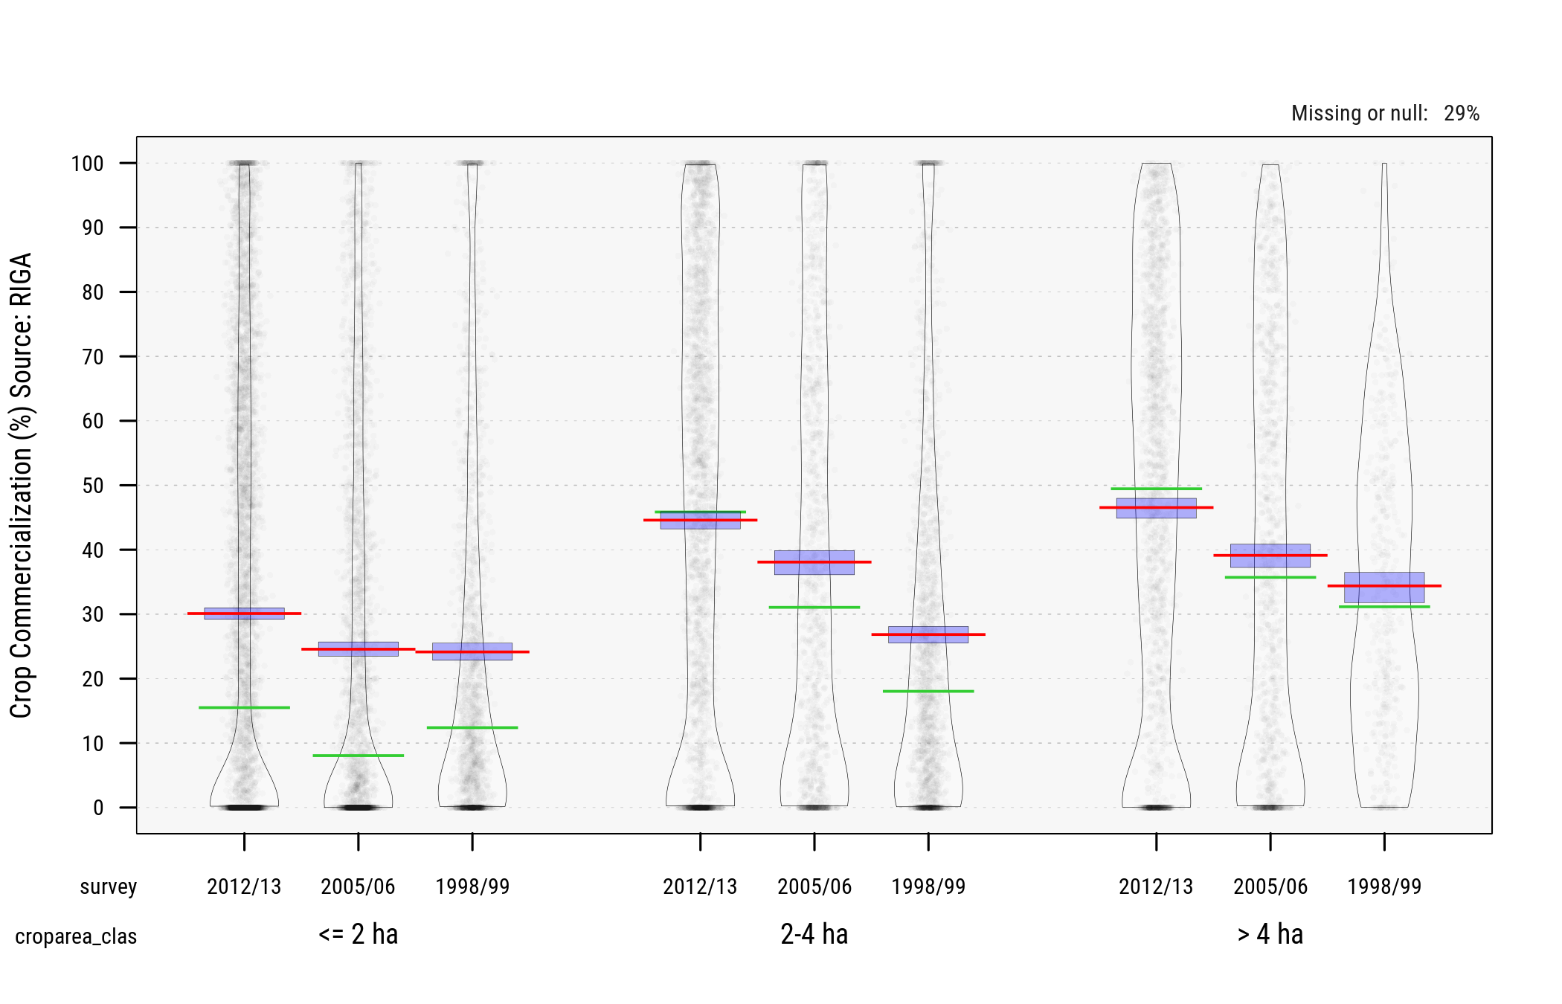

Fig. 16 Crop Commercialization in Farms below/above 4ha of Cultivated Area (FAO/RIGA )

### Income Diversification

Non-farm income was derived from gross RIGA components as:

was imputed to omit negative values. The final distribution of non-farm income in the survey samples is shown below for both rural and urban households

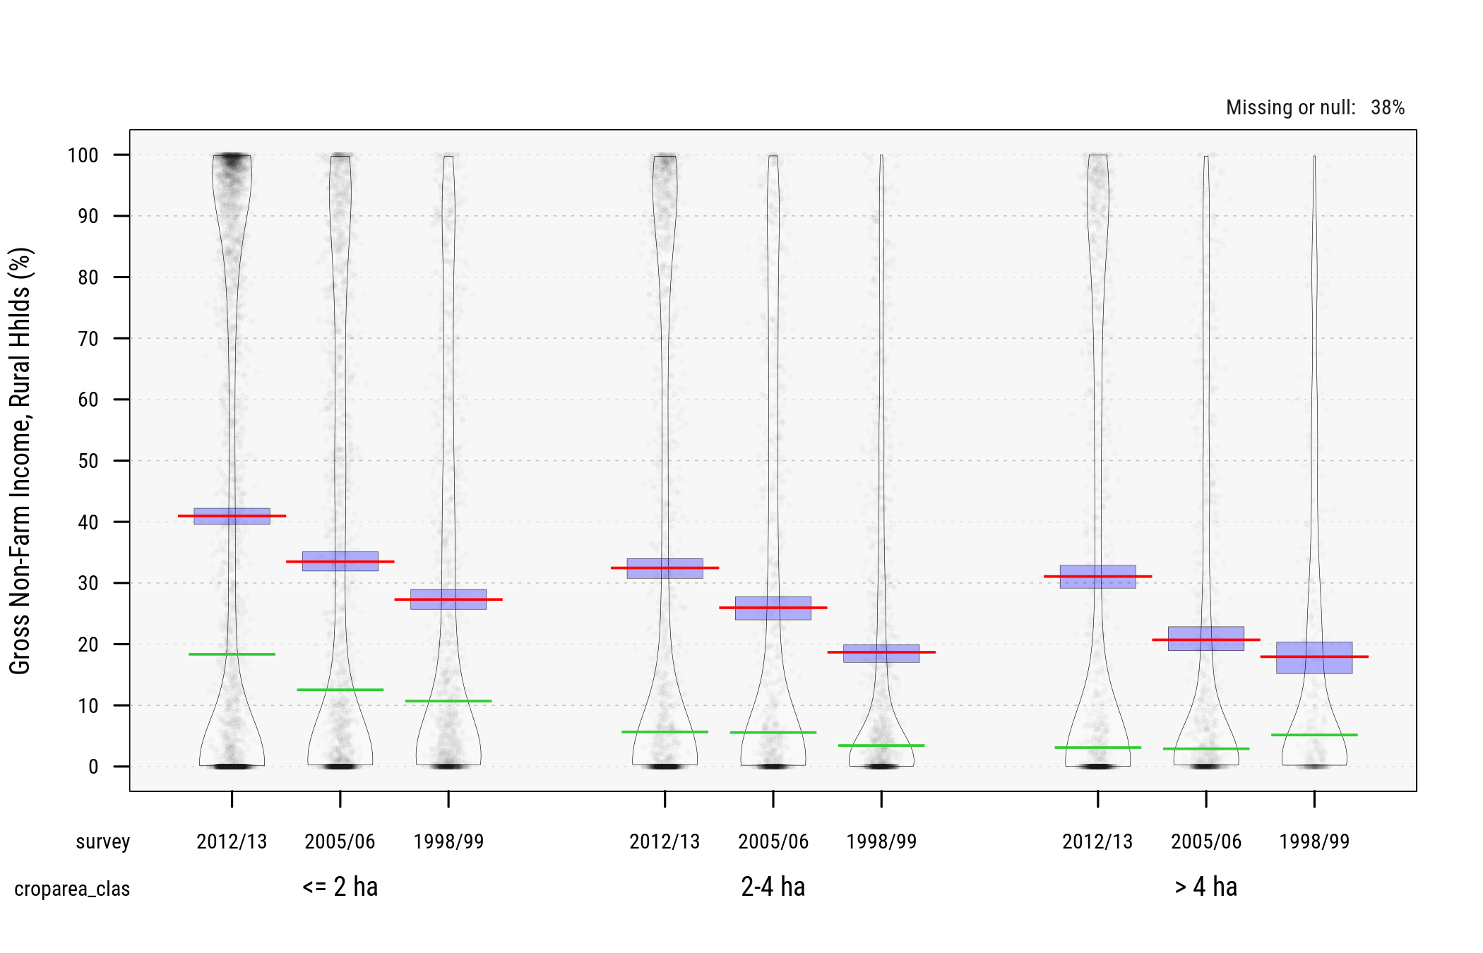

Fig. 17 Gross Rural Non-Farm Income across Survey Waves (percent, ) Source: FAO/RIGA

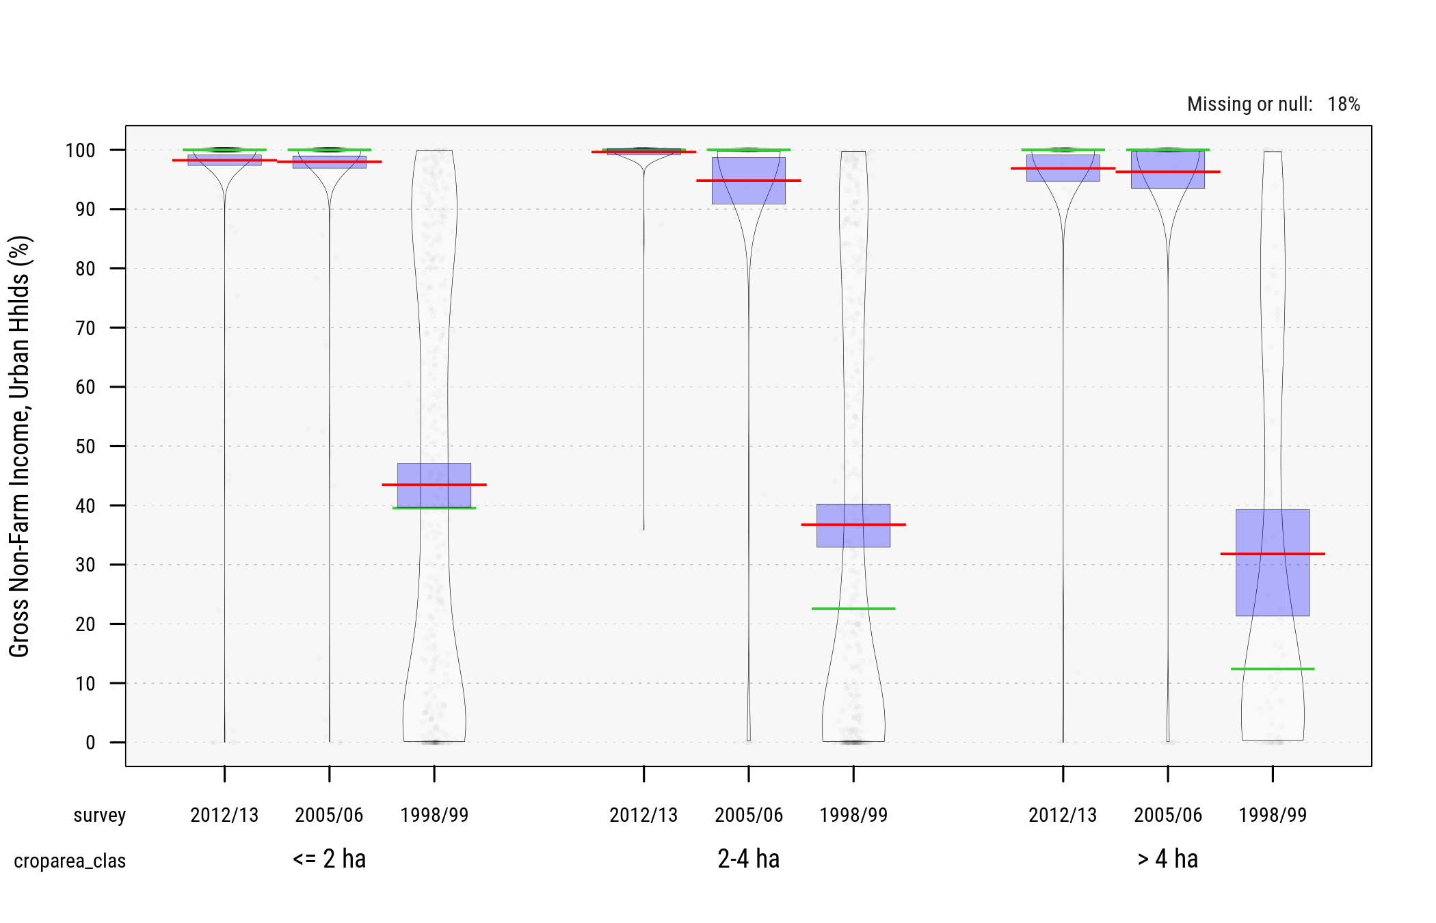

Fig. 18 Gross Urban Non-Farm Income across Survey Waves (percent, ) Source: FAO/RIGA

### Classification of Small Farm Holdings

Within the sub-sample of *farm households* we look at the distribution of households across these three key ("threshold") variables:

* Cultivated/operated area (using breaks at **2 ha** and/or **4 ha** and **excluding farm households with no** )
* Crop commercialization (using breaks at **5%** and **50%** of crop production)
* Share of off-farm income in total hhld income (using breaks at **1/3** and **2/3** of total gross household income)

The tables below show this classification, as proportions of the entire survey samples, and of the selected farm samples.

(#tab:countsa) Count of Observations across Classes of Farm Households

2 ha

2-4 ha

4 ha

Wave

LoC

MeC

HiC

LoC

MeC

HiC

LoC

MeC

HiC

All

2012/13

LoD

   676

   795

   920

   129

   450

   762

    67

   331

   540

 4,768

MeD

   103

   110

   137

    19

    63

    98

     8

    46

    81

   688

HiD

 1,335

   470

   526

   357

   196

   303

   236

   119

   234

 9,615

All

 2,300

 1,375

 1,583

   613

   709

 1,163

   374

   496

   855

16,772

2005/06

LoD

   430

   609

   360

   126

   339

   295

    91

   330

   322

 2,958

MeD

    87

   147

   116

    24

    62

    69

    11

    42

    69

   646

HiD

   757

   184

   168

   151

    65

    89

   153

    43

    61

 4,425

All

 1,377

   940

   644

   330

   466

   453

   285

   415

   452

 8,687

1998/99

LoD

   350

   573

   232

   310

   755

   232

    29

   205

    99

 2,823

MeD

   119

   135

    57

    68

   117

    40

     9

    30

    15

   600

HiD

   194

   143

    56

   120

    73

    53

    17

    20

    11

 2,228

All

   669

   851

   345

   499

   945

   325

    55

   255

   125

 5,998

(#tab:countsb) Proportions of Observations across Classes of Farm Households (percent of full survey sample)

2 ha

2-4 ha

4 ha

Wave

LoC

MeC

HiC

LoC

MeC

HiC

LoC

MeC

HiC

All

2012/13

LoD

 4.0

 4.7

 5.5

 0.8

 2.7

 4.5

 0.4

 2.0

 3.2

28.4

MeD

 0.6

 0.7

 0.8

 0.1

 0.4

 0.6

 0.0

 0.3

 0.5

 4.1

HiD

 8.0

 2.8

 3.1

 2.1

 1.2

 1.8

 1.4

 0.7

 1.4

57.3

All

13.7

 8.2

 9.4

 3.7

 4.2

 6.9

 2.2

 3.0

 5.1

100.0

2005/06

LoD

 4.9

 7.0

 4.1

 1.5

 3.9

 3.4

 1.0

 3.8

 3.7

34.1

MeD

 1.0

 1.7

 1.3

 0.3

 0.7

 0.8

 0.1

 0.5

 0.8

 7.4

HiD

 8.7

 2.1

 1.9

 1.7

 0.7

 1.0

 1.8

 0.5

 0.7

50.9

All

15.9

10.8

 7.4

 3.8

 5.4

 5.2

 3.3

 4.8

 5.2

100.0

1998/99

LoD

 5.8

 9.6

 3.9

 5.2

12.6

 3.9

 0.5

 3.4

 1.7

47.1

MeD

 2.0

 2.3

 1.0

 1.1

 2.0

 0.7

 0.2

 0.5

 0.3

10.0

HiD

 3.2

 2.4

 0.9

 2.0

 1.2

 0.9

 0.3

 0.3

 0.2

37.1

All

11.2

14.2

 5.8

 8.3

15.8

 5.4

 0.9

 4.3

 2.1

100.0

(#tab:countsc) Proportions of Observations across Classes of Farm Households (percent of selected farm households)

2 ha

2-4 ha

4 ha

Wave

LoC

MeC

HiC

LoC

MeC

HiC

LoC

MeC

HiC

All

2012/13

LoD

 7.4

 8.7

10.1

 1.4

 4.9

 8.4

 0.7

 3.6

 5.9

51.3

MeD

 1.1

 1.2

 1.5

 0.2

 0.7

 1.1

 0.1

 0.5

 0.9

 7.3

HiD

14.7

 5.2

 5.8

 3.9

 2.2

 3.3

 2.6

 1.3

 2.6

41.4

All

23.2

15.1

17.4

 5.5

 7.8

12.8

 3.4

 5.4

 9.4

100.0

2005/06

LoD

 8.3

11.7

 6.9

 2.4

 6.5

 5.7

 1.8

 6.3

 6.2

55.8

MeD

 1.7

 2.8

 2.2

 0.5

 1.2

 1.3

 0.2

 0.8

 1.3

12.1

HiD

14.6

 3.5

 3.2

 2.9

 1.2

 1.7

 2.9

 0.8

 1.2

32.1

All

24.5

18.1

12.4

 5.8

 9.0

 8.7

 4.9

 8.0

 8.7

100.0

1998/99

LoD

 8.6

14.1

 5.7

 7.6

18.6

 5.7

 0.7

 5.0

 2.4

68.6

MeD

 2.9

 3.3

 1.4

 1.7

 2.9

 1.0

 0.2

 0.7

 0.4

14.5

HiD

 4.8

 3.5

 1.4

 3.0

 1.8

 1.3

 0.4

 0.5

 0.3

16.9

All

16.3

21.0

 8.5

12.3

23.3

 8.0

 1.4

 6.3

 3.1

100.0

In the next tables we limit categories to farm households **below/above 4ha** (as this approach produces classes with larger counts of observations).

(#tab:countsd) Count of Observations across Classes of Farm Households (farms above/below 4 ha)

4 ha

4 ha

Wave

LoC

MeC

HiC

LoC

MeC

HiC

All

2012/13

LoD

   805

 1,245

 1,682

    67

   331

   540

 4,768

MeD

   122

   173

   235

     8

    46

    81

   688

HiD

 1,692

   666

   829

   236

   119

   234

 9,615

All

 2,913

 2,084

 2,746

   374

   496

   855

16,772

2005/06

LoD

   556

   948

   655

    91

   330

   322

 2,958

MeD

   111

   209

   185

    11

    42

    69

   646

HiD

   908

   249

   257

   153

    43

    61

 4,425

All

 1,707

 1,406

 1,097

   285

   415

   452

 8,687

1998/99

LoD

   660

 1,328

   464

    29

   205

    99

 2,823

MeD

   187

   252

    97

     9

    30

    15

   600

HiD

   314

   216

   109

    17

    20

    11

 2,228

All

 1,168

 1,796

   670

    55

   255

   125

 5,998

(#tab:countse) Proportions of Observations across Classes of Farm Households (farms above/below 4 ha) (percent of full survey sample)

4 ha

4 ha

Wave

LoC

MeC

HiC

LoC

MeC

HiC

All

2012/13

LoD

 4.8

 7.4

10.0

22.3

 0.4

 2.0

 3.2

 5.6

28.4

MeD

 0.7

 1.0

 1.4

 3.2

 0.0

 0.3

 0.5

 0.8

 4.1

HiD

10.1

 4.0

 4.9

19.0

 1.4

 0.7

 1.4

 3.5

57.3

All

17.4

12.4

16.4

46.2

 2.2

 3.0

 5.1

10.3

100.0

2005/06

LoD

 6.4

10.9

 7.5

24.9

 1.0

 3.8

 3.7

 8.6

34.1

MeD

 1.3

 2.4

 2.1

 5.8

 0.1

 0.5

 0.8

 1.4

 7.4

HiD

10.5

 2.9

 3.0

16.3

 1.8

 0.5

 0.7

 3.0

50.9

All

19.7

16.2

12.6

48.5

 3.3

 4.8

 5.2

13.3

100.0

1998/99

LoD

11.0

22.1

 7.7

40.9

 0.5

 3.4

 1.7

 5.6

47.1

MeD

 3.1

 4.2

 1.6

 8.9

 0.2

 0.5

 0.3

 0.9

10.0

HiD

 5.2

 3.6

 1.8

10.7

 0.3

 0.3

 0.2

 0.8

37.1

All

19.5

29.9

11.2

60.6

 0.9

 4.3

 2.1

 7.3

100.0

(#tab:countsf) Proportions of Observations across Classes of Farm Households (farms above/below 4 ha) (percent of selected farm households)

4 ha

4 ha

Wave

LoC

MeC

HiC

LoC

MeC

HiC

All

2012/13

LoD

 8.8

13.7

18.5

41.0

 0.7

 3.6

 5.9

10.3

51.3

MeD

 1.3

 1.9

 2.6

 5.8

 0.1

 0.5

 0.9

 1.5

 7.3

HiD

18.6

 7.3

 9.1

35.0

 2.6

 1.3

 2.6

 6.5

41.4

All

28.7

22.9

30.1

81.8

 3.4

 5.4

 9.4

18.2

100.0

2005/06

LoD

10.7

18.2

12.6

41.5

 1.8

 6.3

 6.2

14.3

55.8

MeD

 2.1

 4.0

 3.6

 9.7

 0.2

 0.8

 1.3

 2.3

12.1

HiD

17.5

 4.8

 4.9

27.2

 2.9

 0.8

 1.2

 4.9

32.1

All

30.3

27.0

21.1

78.4

 4.9

 8.0

 8.7

21.6

100.0

1998/99

LoD

16.2

32.7

11.4

60.4

 0.7

 5.0

 2.4

 8.2

68.6

MeD

 4.6

 6.2

 2.4

13.2

 0.2

 0.7

 0.4

 1.3

14.5

HiD

 7.7

 5.3

 2.7

15.7

 0.4

 0.5

 0.3

 1.2

16.9

All

28.6

44.2

16.5

89.3

 1.4

 6.3

 3.1

10.7

100.0

Using data from the 3 GLSS waves we estimate the proportions of farm households across all categories and the distributions of other key household characteristics (household structure, assets, farm input uses, etc.).

Estimated proportions of farm households across classes and categories are shown in the next graph and table.

### Key Results

Fig. 19 Est. Proportions of Farm Holdings across Cultivated Area and Categories

Fig. 19 Est. Proportions of Farm Holdings across Cultivated Area and Categories

(#tab:tab1) Est. Proportions of Farm Holdings below 4 ha across Categories (2012/13, percent)

Crop Commercialization

Income Diversification

LoC

MeC

HiC

LoD

mean

16.3

34.7

14.3

CI

13.8 - 18.8

30.7 - 38.7

11.6 - 17.0

MeD

mean

4.4

7.3

3.0

CI

3.5 - 5.4

6.1 - 8.5

2.2 - 3.8

HiD

mean

9.3

6.7

3.9

CI

7.3 - 11.4

5.3 - 8.2

2.7 - 5.1

(#tab:tab2) Est. Characteristics of Farm Holdings below 4 ha across Categories (2012/13, percent)

LoCLoD

LoCMeD

LoCHiD

MeCLoD

MeCMeD

MeCHiD

HiCLoD

HiCMeD

HiCHiD

Variable

est.

std. err.

est.

std. err.

est.

std. err.

est.

std. err.

est.

std. err.

est.

std. err.

est.

std. err.

est.

std. err.

est.

std. err.

hhsize_imp

Mean

  4.46

  0.15

  4.72

  0.22

  4.44

  0.16

  4.80

  0.14

  4.91

  0.21

  4.96

  0.19

  4.64

  0.16

  4.75

  0.29

  4.55

  0.32

Q25

  3.00

  0.26

  3.00

  0.51

  3.00

  0.26

  3.00

  0.00

  3.00

  0.42

  3.00

  0.26

  3.00

  0.26

  3.00

  0.51

  2.00

  0.51

Q50

  4.00

  0.26

  4.00

  0.26

  4.00

  0.26

  5.00

  0.26

  5.00

  0.26

  5.00

  0.26

  4.00

  0.26

  5.00

  0.26

  4.00

  0.26

Q75

  6.00

  0.04

  6.00

  0.51

  6.00

  0.26

  6.00

  0.26

  6.00

  0.26

  6.00

  0.26

  6.00

  0.26

  6.00

  0.50

  6.00

  0.12

(100 * femhead)

Mean

 39.89

  3.27

 45.43

  4.88

 33.22

  3.48

 20.94

  1.55

 23.99

  3.10

 27.20

  3.32

 36.20

  3.64

 27.86

  5.85

 39.67

  5.08

Q25

  0.00

  0.00

  0.00

  0.00

  0.00

  0.00

  0.00

  0.00

  0.00

  0.00

  0.00

  0.00

  0.00

  0.00

  0.00

  0.00

  0.00

  0.00

Q50

  0.00

  0.00

  0.00

 25.51

  0.00

  0.00

  0.00

  0.00

  0.00

  0.00

  0.00

  0.00

  0.00

  0.00

  0.00

  0.00

  0.00

  0.00

Q75

100.00

  0.00

100.00

  0.00

100.00

  0.00

  0.00

  0.00

  0.00

 25.51

100.00

  0.00

100.00

  0.00

100.00

  0.00

100.00

  0.00

hhlabor

Mean

  2.07

  0.08

  2.06

  0.13

  2.15

  0.10

  2.28

  0.06

  2.36

  0.11

  2.41

  0.11

  2.25

  0.08

  2.30

  0.17

  2.19

  0.18

Q25

  1.00

  0.00

  1.00

  0.00

  1.00

  0.19

  1.00

  0.26

  2.00

  0.26

  2.00

  0.26

  1.00

  0.26

  1.00

  0.26

  1.00

  0.05

Q50

  2.00

  0.00

  2.00

  0.00

  2.00

  0.00

  2.00

  0.00

  2.00

  0.00

  2.00

  0.00

  2.00

  0.00

  2.00

  0.00

  2.00

  0.00

Q75

  3.00

  0.26

  3.00

  0.26

  3.00

  0.00

  3.00

  0.00

  3.00

  0.00

  3.00

  0.00

  3.00

  0.00

  3.00

  0.26

  3.00

  0.51

(100 * naggross_sh)

Mean

  6.69

  0.50

 49.43

  0.72

 90.74

  0.63

  5.95

  0.34

 48.87

  0.76

 82.19

  0.62

  5.31

  0.68

 50.78

  1.36

 84.04

  1.00

Q25

  0.00

  0.00

 41.14

  1.01

 84.13

  1.43

  0.00

  0.00

 40.16

  1.27

 74.27

  0.53

  0.00

  0.00

 42.06

  1.97

 74.71

  2.06

Q50

  0.00

  0.49

 48.73

  1.54

 94.08

  1.06

  0.95

  0.38

 50.25

  1.51

 82.02

  0.83

  0.00

  0.22

 50.82

  2.67

 87.24

  1.56

Q75

 11.71

  1.66

 57.28

  1.23

 98.24

  0.21

  9.21

  1.00

 55.82

  0.87

 89.60

  0.67

  7.15

  2.19

 59.35

  1.40

 92.68

  1.03

(100 * cropsales_sh)

Mean

  0.96

  0.08

  0.64

  0.12

  0.28

  0.06

 22.31

  0.56

 23.18

  0.86

 24.39

  1.41

 75.77

  1.59

 77.25

  1.89

 76.37

  2.08

Q25

  0.00

  0.00

  0.00

  0.00

  0.00

  0.00

 12.03

  0.57

 14.38

  1.46

 13.05

  1.25

 59.99

  1.62

 59.30

  2.72

 58.90

  2.41

Q50

  0.00

  0.00

  0.00

  0.00

  0.00

  0.00

 19.95

  0.87

 22.82

  1.16

 21.17

  1.94

 72.74

  3.84

 76.16

  3.16

 72.73

  1.90

Q75

  1.77

  0.31

  0.00

  0.26

  0.00

  0.00

 31.51

  1.05

 31.24

  1.20

 36.20

  2.50

 93.60

  2.93

 94.54

  3.32

100.00

  0.00

(#tab:tab3) Land Assets of Farm Holdings below 4 ha across Categories (2012/13, ha)

LoCLoD

LoCMeD

LoCHiD

MeCLoD

MeCMeD

MeCHiD

HiCLoD

HiCMeD

HiCHiD

Variable

est.

std. err.

est.

std. err.

est.

std. err.

est.

std. err.

est.

std. err.

est.

std. err.

est.

std. err.

est.

std. err.

est.

std. err.

landown

Mean

0.4

0.1

0.4

0.1

0.2

0.0

0.6

0.1

0.5

0.1

0.3

0.1

0.4

0.1

0.5

0.1

0.2

0.1

Q25

0.0

0.0

0.0

0.0

0.0

0.0

0.0

0.0

0.0

0.0

0.0

0.0

0.0

0.0

0.0

0.0

0.0

0.0

Q50

0.0

0.0

0.0

0.0

0.0

0.0

0.0

0.0

0.0

0.0

0.0

0.0

0.0

0.0

0.0

0.1

0.0

0.0

Q75

0.4

0.2

0.4

0.3

0.0

0.1

0.8

0.3

0.4

0.3

0.2

0.1

0.4

0.2

0.8

0.2

0.0

0.1

landrent

Mean

0.0

0.0

0.0

0.0

0.0

0.0

0.0

0.0

0.0

0.0

0.0

0.0

0.0

0.0

0.0

0.0

0.0

0.0

Q25

0.0

0.0

0.0

0.0

0.0

0.0

0.0

0.0

0.0

0.0

0.0

0.0

0.0

0.0

0.0

0.0

0.0

0.0

Q50

0.0

0.0

0.0

0.0

0.0

0.0

0.0

0.0

0.0

0.0

0.0

0.0

0.0

0.0

0.0

0.0

0.0

0.0

Q75

0.0

0.0

0.0

0.0

0.0

0.0

0.0

0.0

0.0

0.0

0.0

0.0

0.0

0.0

0.0

0.0

0.0

0.0

croparea_imp

Mean

1.7

0.1

1.6

0.1

1.6

0.1

1.9

0.1

1.9

0.1

1.6

0.1

1.9

0.1

1.7

0.1

1.9

0.1

Q25

0.8

0.2

0.8

0.0

0.8

0.0

1.4

0.2

1.4

0.2

0.8

0.2

1.4

0.1

0.8

0.2

1.4

0.2

Q50

1.7

0.1

1.6

0.1

1.6

0.2

2.0

0.1

1.8

0.2

1.7

0.1

2.0

0.2

1.7

0.2

2.0

0.2

Q75

2.4

0.1

2.4

0.1

2.4

0.0

2.6

0.0

2.4

0.1

2.4

0.2

2.4

0.1

2.4

0.0

2.4

0.1

(#tab:tab4) Est. Production, Sales, and Income of Farm Holdings below 4 ha across Categories (2012/13, Cedis)

LoCLoD

LoCMeD

LoCHiD

MeCLoD

MeCMeD

MeCHiD

HiCLoD

HiCMeD

HiCHiD

Variable

est.

std. err.

est.

std. err.

est.

std. err.

est.

std. err.

est.

std. err.

est.

std. err.

est.

std. err.

est.

std. err.

est.

std. err.

aggross

Mean

1,220,706

   69,959

  862,739

   71,683

  227,703

   23,150

1,755,192

   66,324

1,311,594

   99,482

  738,413

   64,650

2,579,189

  232,899

1,449,433

  134,230

  539,703

   62,253

Q25

  394,700

   57,013

  351,181

   31,430

   35,012

    5,317

  953,933

   58,636

  548,906

   71,061

  212,218

   44,192

  852,035

  139,794

  592,199

  109,429

  113,022

   19,949

Q50

  980,255

   78,263

  583,086

   48,546

   96,000

   12,918

1,503,980

   82,078

  970,584

   80,455

  562,948

   72,038

1,820,000

  252,245

1,097,621

  166,182

  375,414

   74,511

Q75

1,701,314

  142,143

  990,754

   99,047

  293,174

   39,489

2,294,916

   90,271

1,708,727

  236,842

  932,991

   95,378

3,640,000

  325,291

1,810,853

  367,111

  787,157

  123,600

totgross

Mean

1,324,916

   74,207

1,713,951

  137,582

2,879,400

  174,529

1,875,802

   71,098

2,636,957

  197,856

4,725,219

  438,762

2,770,309

  256,199

3,078,843

  319,975

4,165,079

  724,324

Q25

  445,902

   66,393

  688,537

   72,425

  916,538

  128,125

1,026,808

   61,877

1,162,500

  104,521

1,790,436

  287,384

  883,819

  141,362

1,260,564

  174,594

1,399,700

  258,087

Q50

1,042,282

   82,221

1,154,600

  107,405

1,968,078

  174,775

1,627,045

   70,174

1,923,951

  174,790

3,123,308

  192,221

1,870,657

  304,472

2,436,938

  414,988

2,716,256

  345,788

Q75

1,815,559

  157,111

2,144,458

  316,202

3,993,496

  442,777

2,455,356

   87,384

3,323,239

  430,360

5,811,977

  729,117

3,760,381

  416,843

4,405,702

  699,327

4,518,607

  861,669

cropvalue

Mean

1,090,403

   65,076

  790,458

   71,013

  192,792

   20,218

1,612,094

   60,319

1,189,884

   93,415

  654,991

   62,913

1,996,778

  181,682

1,277,132

  126,492

  499,047

   62,703

Q25

  312,776

   42,843

  334,645

   43,170

   30,000

    5,623

  845,053

   58,352

  478,554

   46,368

  173,361

   48,848

  581,013

  102,130

  539,884

  123,978

   87,223

   35,561

Q50

  861,985

   81,705

  561,984

   52,616

   87,511

   14,017

1,382,435

   69,250

  899,730

   80,543

  490,498

   61,483

1,326,247

  159,085

1,023,320

  149,895

  294,813

   61,326

Q75

1,490,011

   94,563

  939,583

   95,652

  230,298

   44,267

2,125,154

   84,992

1,570,981

  162,474

  801,680

   60,827

2,846,904

  354,944

1,484,489

  319,081

  773,981

  128,621

cropsales

Mean

   10,071

    1,214

    7,041

    1,799

      817

      238

  347,324

   18,803

  265,863

   25,369

  140,250

   15,879

1,477,832

  145,055

  979,489

   99,661

  387,478

   56,384

Q25

        0

        0

        0

        0

        0

        0

  100,000

   10,204

   65,750

   15,612

   20,000

    8,975

  314,600

   84,174

  315,811

   77,566

   50,000

   26,545

Q50

        0

        0

        0

        0

        0

        0

  220,000

   10,963

  160,269

   18,145

   69,225

   12,755

1,010,000

  143,118

  779,121

  105,781

  232,397

   55,388

Q75

    5,000

    2,551

        0

        0

        0

        0

  450,000

   29,752

  335,274

   40,998

  168,000

   27,073

1,998,878

  257,566

1,325,468

  190,596

  567,209

   81,219

totlvstprod

Mean

   56,900

   10,271

   28,080

    9,582

   17,416

    4,642

  121,428

   12,667

   97,829

   12,767

   72,848

   10,942

  544,930

  143,213

  172,008

   53,808

   40,054

   10,838

Q25

        0

        0

        0

        0

        0

        0

        0

        0

        0

        0

        0

        0

        0

        0

        0

        0

        0

        0

Q50

        0

        0

        0

        0

        0

        0

   43,883

    8,929

   25,449

   16,683

    6,507

    5,090

    9,600

    7,653

        0

   10,261

        0

        0

Q75

   39,992

   13,979

        0

    3,680

        0

        0

  155,859

   13,416

  152,097

   17,347

   88,800

   16,145

  125,147

   63,115

   87,648

   55,462

   24,444

   14,110

totlivsold

Mean

    3,999

      659

      810

      368

      940

      279

   60,019

    8,149

   39,469

    5,577

   30,980

    4,634

  498,422

  134,112

  136,888

   52,006

   31,429

    8,560

Q25

        0

        0

        0

        0

        0

        0

        0

        0

        0

        0

        0

        0

        0

        0

        0

        0

        0

        0

Q50

        0

        0

        0

        0

        0

        0

        0

    3,571

        0

    3,493

        0

        0

        0

    3,063

        0

    1,953

        0

        0

Q75

        0

        0

        0

        0

        0

        0

   66,671

    8,359

   58,993

   12,810

   32,750

    7,653

   65,667

   50,424

   50,822

   36,866

   20,482

    7,131

Below are estimated distributions of key characteristics for farms below 4 ha as of 2012/13.

Fig. 20 Est. Farm Sizes of Farm Holdings below 4 ha across Categories (2012/13, ha)

Fig. 20 Est. Farm Sizes of Farm Holdings below 4 ha across Categories (2012/13, ha)

Fig. 21 Est. Cultivated Area of Farm Holdings below 4 ha across Categories (2012/13, ha)

Fig. 21 Est. Cultivated Area of Farm Holdings below 4 ha across Categories (2012/13, ha)

Fig. 22 Est. Gross Farm Income of Farm Holdings below 4 ha across Categories (2012/13, '000 Cedis)

Fig. 22 Est. Gross Farm Income of Farm Holdings below 4 ha across Categories (2012/13, '000 Cedis)

## Ethiopia

Relevant sources of household-level micro records for Ethiopia include:

* 2011/12 ERSS (income vars)
* 2013/14 and 2015/16 Ethiopia Socioeconomic Surveys
* 2012/13 Ethiopia’s Agricultural Sample Survey (AgSS) -- but it's difficult to cross-tabulate results from the AgSS (crop production and input uses) with the ERSS' income data
* 2012 ATA Baseline Survey (3,000 hhlds), see (Minot & Sawyer, 2013).

# Agricultural Potential

## Nigeria

[TBD]

For documentation purposes below are code snippets from the 2016 Farmer Segmentation for Nigeria (definitions and characterization of low-high quadrants and livelihood zones).

## Ghana

Using a combination of biophysical and infrastructure geospatial layers available over sub-Saharan African we identify zones of low/high agricultural potential and low/high market access in Ghana. This basket classification is useful to further characterize small farm holders across all 4 quadrants, and for targeting interventions and investments.

The input layers used for Ghana are as follows.

1. **Agricultural Potential** -- this measure was derived from [FAO/IIASA/GAEZ Cereal Suitability Index, 2007](http://www.fao.org/nr/gaez/about-data-portal/agricultural-suitability-and-potential-yields/en/) (rainfed, low-input). Soil suitability classifications are based on knowledge of crop requirements, of prevailing soil conditions, and of applied soil management. In other words, soil suitability procedures quantify to what extent soil conditions match crop requirements under defined input and management circumstances.

Low and high potential areas are further classified as:

* 1-4 values are considered **low suitability**:
  + 1 Land very poorly suited for pasture and at best poorly suited for rainfed crops
  + 2 Land poorly suited for pasture and at best poorly suited for rainfed crops
  + 3 Lands suited for pasture and at best poorly suited for rainfed crops
  + 4 Land suited for rainfed crops and pasture possible
* 5-6 values are considered **high suitability**:
  + 5 Land well suited for rainfed crops and pasture possible
  + 6 Prime land suited for rainfed crops and pasture possible
* 809-0 is **unsuitable**:
  + -809 Protected area
  + -807 Urban area
  + -805 Irrigated area
  + -801 Forest
  + 0 Land not suited for agriculture

This classification is shown below along with a more recent land cover classification layer.

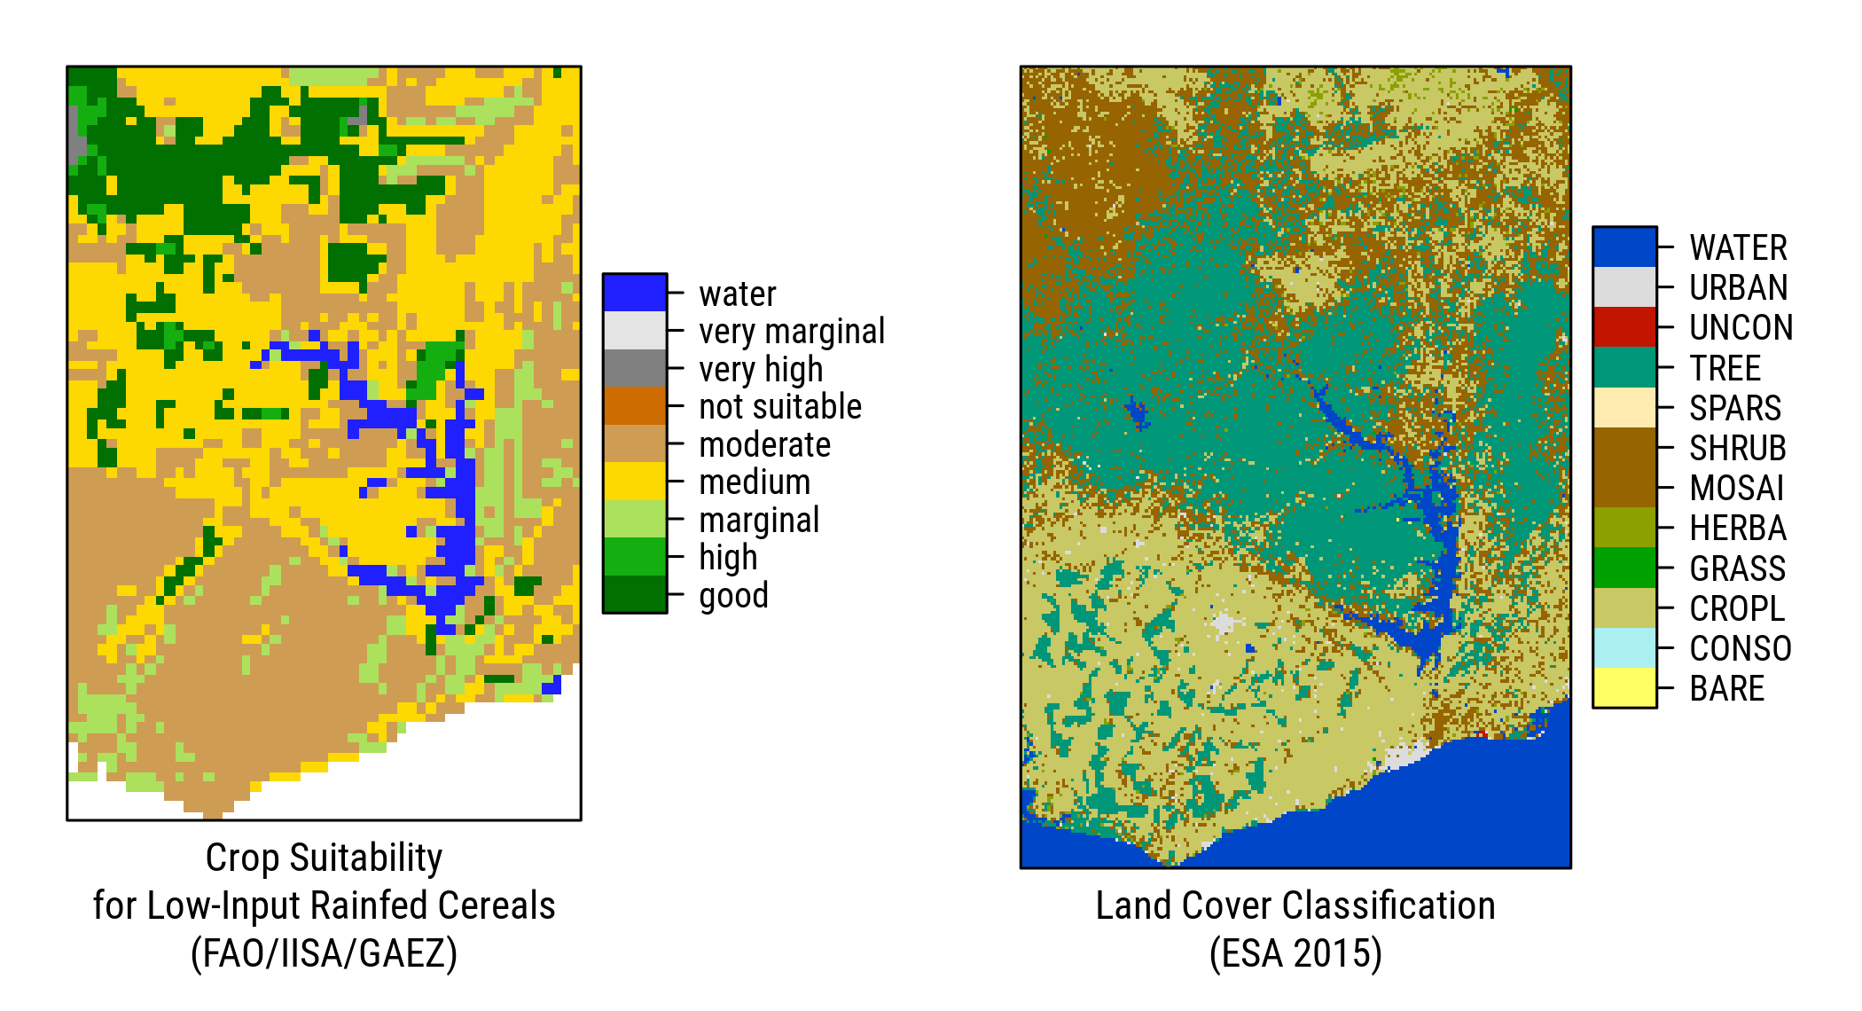

Fig. 23 Crop Suitability for Low-Input Rainfed Cereals. Source: FAO/IIASA/GAEZ, 2015.

Tab. 26 ESA Land Cover Classification

|  |  |  |
| --- | --- | --- |
| Code | Label | Class |
| 10 | CROPL | Cropland, rainfed |
| 11 | HERBA | Herbaceous cover |
| 20 | CROPL | Cropland, irrigated or post-flooding |
| 30 | MOSAI | Mosaic cropland (>50%) / natural vegetation (tree, shrub, herbaceous cover) (<50%) |
| 40 | MOSAI | Mosaic natural vegetation (tree, shrub, herbaceous cover) (>50%) / cropland (<50%) |
| 50 | TREE | Tree cover, broadleaved, evergreen, closed to open (>15%) |
| 60 | TREE | Tree cover, broadleaved, deciduous, closed to open (>15%) |
| 62 | TREE | Tree cover, broadleaved, deciduous, open (15-40%) |
| 100 | MOSAI | Mosaic tree and shrub (>50%) / herbaceous cover (<50%) |
| 110 | MOSAI | Mosaic herbaceous cover (>50%) / tree and shrub (<50%) |
| 120 | SHRUB | Shrubland |
| 122 | SHRUB | Shrubland deciduous |
| 130 | GRASS | Grassland |
| 150 | SPARS | Sparse vegetation (tree, shrub, herbaceous cover) (<15%) |
| 153 | SPARS | Sparse herbaceous cover (<15%) |
| 170 | TREE | Tree cover, flooded, saline water |
| 180 | SHRUB | Shrub or herbaceous cover, flooded, fresh/saline/brakish water |
| 190 | URBAN | Urban areas |
| 200 | BARE | Bare areas |
| 201 | CONSO | Consolidated bare areas |
| 202 | UNCON | Unconsolidated bare areas |
| 210 | WATER | Water bodies |

1. **Market Access** -- Low and high market access areas are defined using a **4 hour** travel time threshold. The source is [IFPRI/HarvestChoice Travel Time to Markets in Africa South of the Sahara, 2016](https://dataverse.harvard.edu/dataset.xhtml?persistentId=doi:10.7910/DVN/YKDWJD) at 5-arc-minute resolution:

* 100 Low access (travel time greater than 4 hours)
* 200 High access (travel time less than or equal to 4 hours)

All layers were resampled to 1km and then we generated dominant classes across Ghana's districts (as household GPS locations are not available in any of the GLSS rounds).

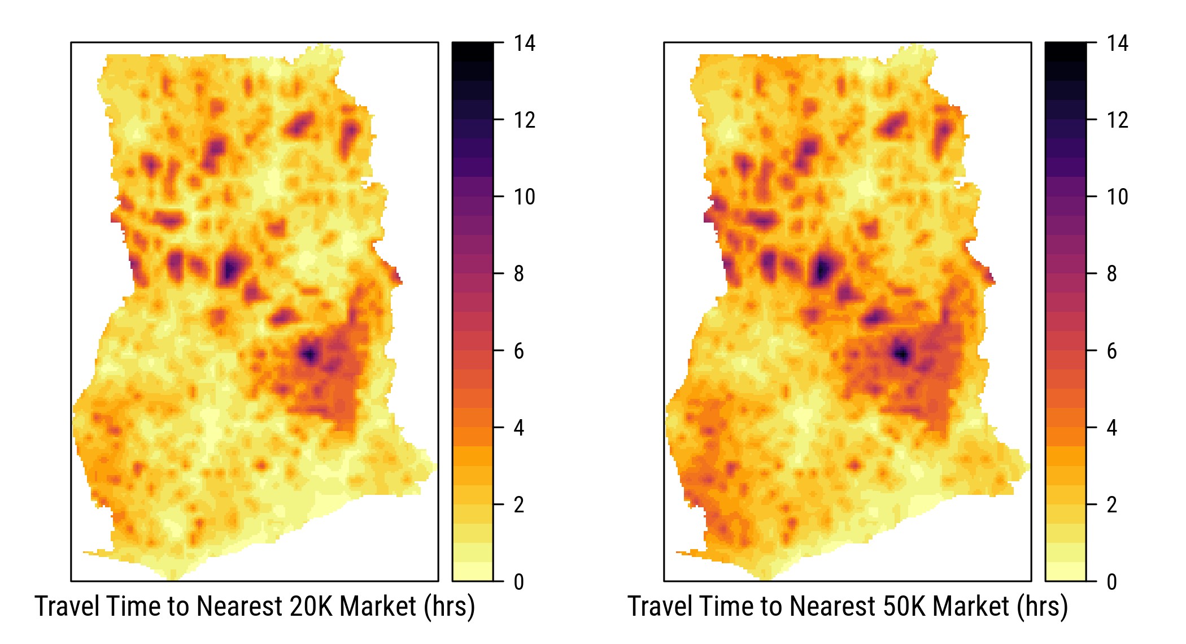

Fig. 24 Travel Time to Nearest 20K and 50K Market. Source: IFPRI/HarvestChoice, 2016.

The resulting cross-classification.

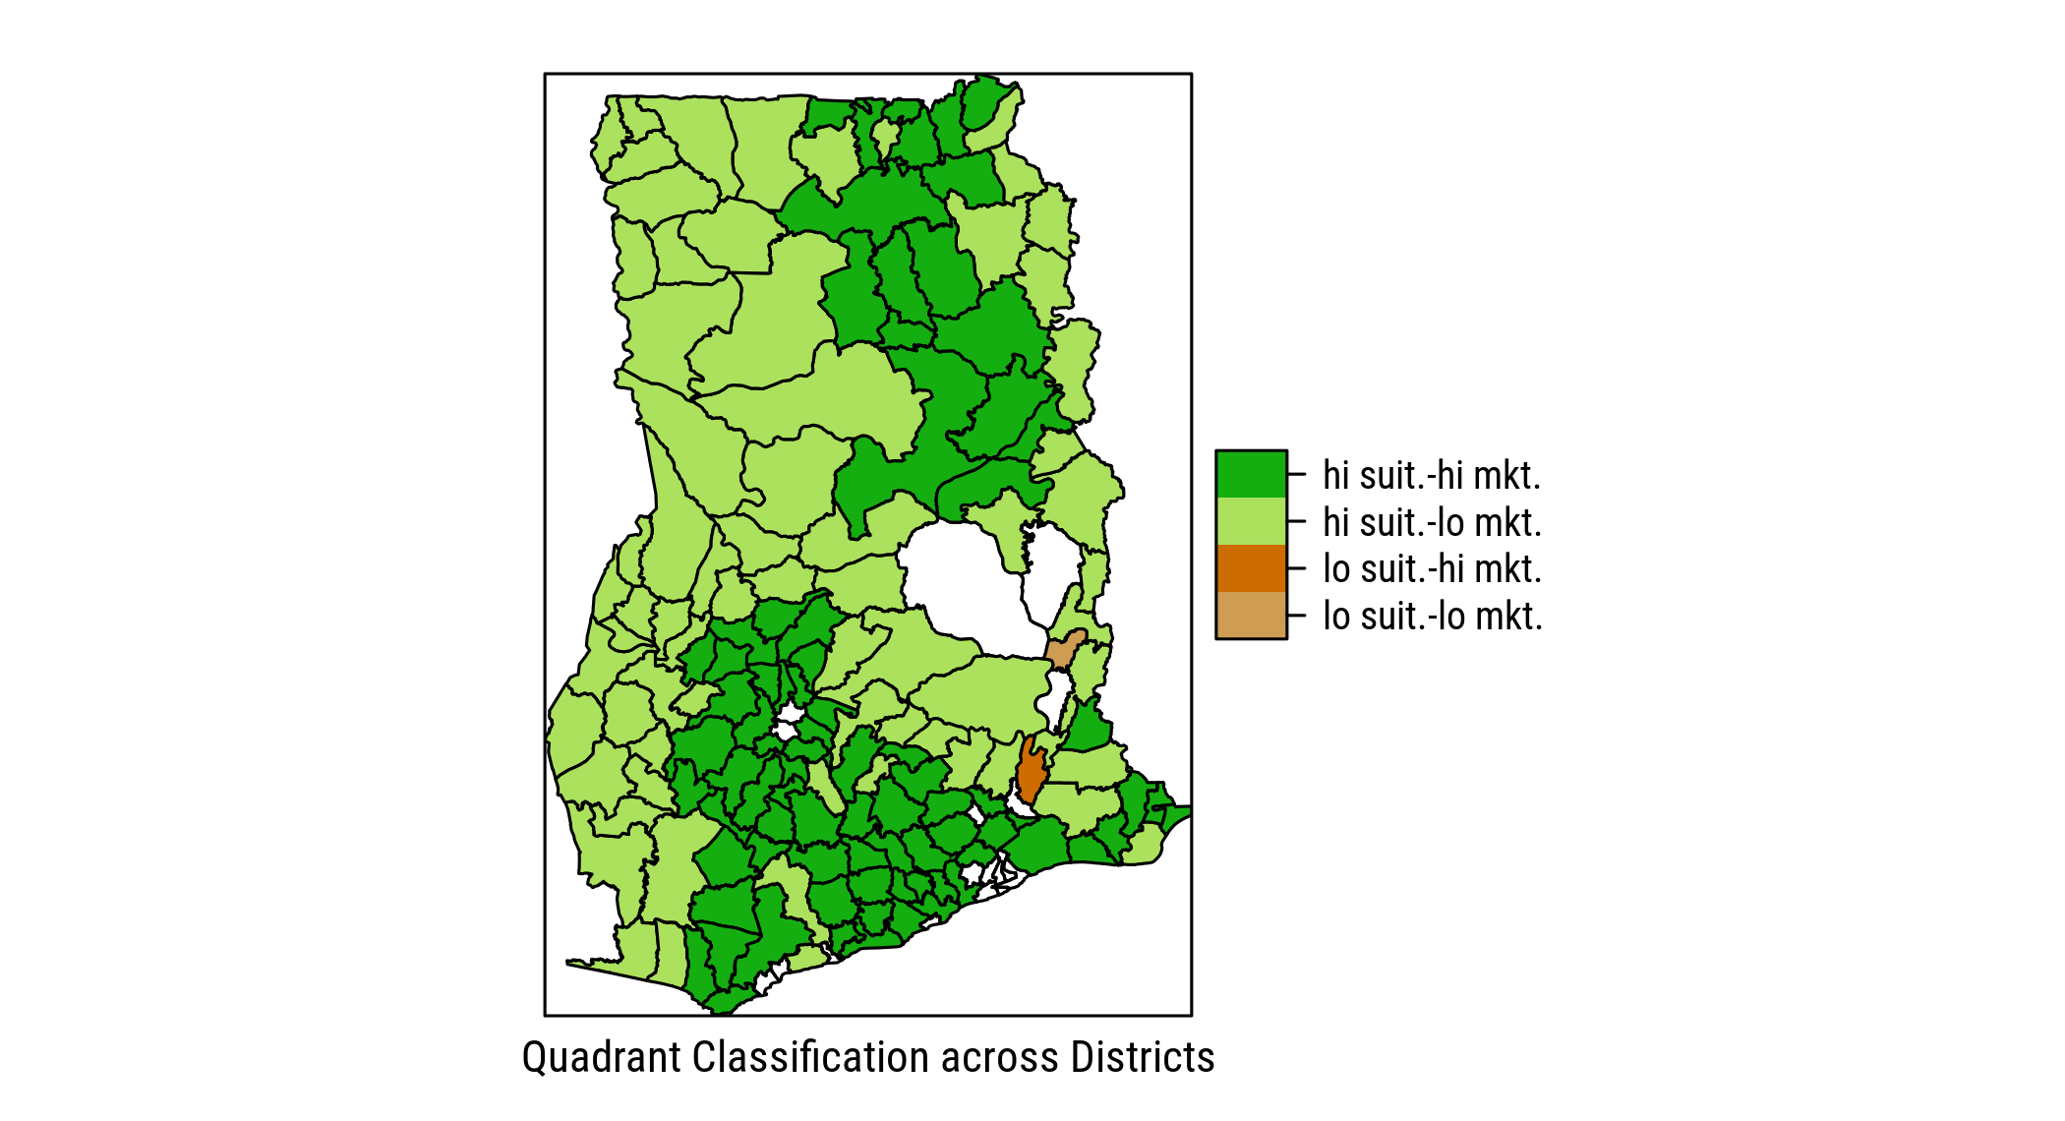

Fig. 25 Quadrant Classification across Districts, Ghana 2012/13. Source: authors.

# Trends in Macro Indicators

Long-term time series of macro-economic indicators across regions. Note that these series are aggregated using WDI country-level indicators. Table 27 below lists all countries included in each region. The raw data is available at [2017-agra-aasr_WDI_ts (corrected).csv](https://github.com/mbacou/2017-agra-aasr/blob/master/out/MB/2017-agra-aasr_WDI_ts%20(corrected).csv).

Fig. 26 Regional Trends in GDP per Capita (1990-2015) Source: WDI.

Fig. 26 Regional Trends in GDP per Capita (1990-2015) Source: WDI.

Fig. 27 Regional Trends in Cereal Yield (1990-2015) Source: WDI.

Fig. 27 Regional Trends in Cereal Yield (1990-2015) Source: WDI.

Fig. 28 Regional Trends in Sectoral Value Added (1990-2015) Source: WDI.

Fig. 28 Regional Trends in Sectoral Value Added (1990-2015) Source: WDI.

Note that India is missing multiple years of agricultural employment statistics. Simple **linear interpolation** is used to impute these missing values.

(#fig:agg-rutt) Trends in Land and Labor Productivity (2000-2014). Source: WDI.

(#fig:agg-rutt) Trends in Land and Labor Productivity (2000-2014). Source: WDI.

The regional aggregation used in the above graphs is provided here.

Tab. 27 Regional Aggregation

|  |  |  |  |  |
| --- | --- | --- | --- | --- |
| Region | Country | ISO2 Code | ISO3 Code | Income Level |
| China | China | CN | CHN | Upper middle income |
| India | India | IN | IND | Lower middle income |
| Rest of East Asia (excl. high income) | American Samoa | AS | ASM | Upper middle income |
| Rest of East Asia (excl. high income) | Cambodia | KH | KHM | Low income |
| Rest of East Asia (excl. high income) | Fiji | FJ | FJI | Lower middle income |
| Rest of East Asia (excl. high income) | Indonesia | ID | IDN | Lower middle income |
| Rest of East Asia (excl. high income) | Kiribati | KI | KIR | Lower middle income |
| Rest of East Asia (excl. high income) | Korea, Dem. Rep. | KP | PRK | Low income |
| Rest of East Asia (excl. high income) | Lao PDR | LA | LAO | Lower middle income |
| Rest of East Asia (excl. high income) | Malaysia | MY | MYS | Upper middle income |
| Rest of East Asia (excl. high income) | Marshall Islands | MH | MHL | Lower middle income |
| Rest of East Asia (excl. high income) | Micronesia, Fed. Sts. | FM | FSM | Lower middle income |
| Rest of East Asia (excl. high income) | Mongolia | MN | MNG | Lower middle income |
| Rest of East Asia (excl. high income) | Myanmar | MM | MMR | Low income |
| Rest of East Asia (excl. high income) | Palau | PW | PLW | Upper middle income |
| Rest of East Asia (excl. high income) | Papua New Guinea | PG | PNG | Lower middle income |
| Rest of East Asia (excl. high income) | Philippines | PH | PHL | Lower middle income |
| Rest of East Asia (excl. high income) | Samoa | WS | WSM | Lower middle income |
| Rest of East Asia (excl. high income) | Solomon Islands | SB | SLB | Lower middle income |
| Rest of East Asia (excl. high income) | Thailand | TH | THA | Upper middle income |
| Rest of East Asia (excl. high income) | Timor-Leste | TL | TLS | Lower middle income |
| Rest of East Asia (excl. high income) | Tonga | TO | TON | Lower middle income |
| Rest of East Asia (excl. high income) | Tuvalu | TV | TUV | Lower middle income |
| Rest of East Asia (excl. high income) | Vanuatu | VU | VUT | Lower middle income |
| Rest of East Asia (excl. high income) | Vietnam | VN | VNM | Lower middle income |
| Rest of South Asia (excl. high income) | Afghanistan | AF | AFG | Low income |
| Rest of South Asia (excl. high income) | Bangladesh | BD | BGD | Low income |
| Rest of South Asia (excl. high income) | Bhutan | BT | BTN | Lower middle income |
| Rest of South Asia (excl. high income) | Maldives | MV | MDV | Upper middle income |
| Rest of South Asia (excl. high income) | Nepal | NP | NPL | Low income |
| Rest of South Asia (excl. high income) | Pakistan | PK | PAK | Lower middle income |
| Rest of South Asia (excl. high income) | Sri Lanka | LK | LKA | Lower middle income |
| Rest of sub-Saharan Africa (excl. high income) | Angola | AO | AGO | Lower middle income |
| Rest of sub-Saharan Africa (excl. high income) | Benin | BJ | BEN | Low income |
| Rest of sub-Saharan Africa (excl. high income) | Botswana | BW | BWA | Upper middle income |
| Rest of sub-Saharan Africa (excl. high income) | Burkina Faso | BF | BFA | Low income |
| Rest of sub-Saharan Africa (excl. high income) | Burundi | BI | BDI | Low income |
| Rest of sub-Saharan Africa (excl. high income) | Cameroon | CM | CMR | Lower middle income |
| Rest of sub-Saharan Africa (excl. high income) | Cape Verde | CV | CPV | Lower middle income |
| Rest of sub-Saharan Africa (excl. high income) | Central African Republic | CF | CAF | Low income |
| Rest of sub-Saharan Africa (excl. high income) | Chad | TD | TCD | Low income |
| Rest of sub-Saharan Africa (excl. high income) | Comoros | KM | COM | Low income |
| Rest of sub-Saharan Africa (excl. high income) | Congo, Dem. Rep. | CD | COD | Low income |
| Rest of sub-Saharan Africa (excl. high income) | Congo, Rep. | CG | COG | Lower middle income |
| Rest of sub-Saharan Africa (excl. high income) | Cote d'Ivoire | CI | CIV | Lower middle income |
| Rest of sub-Saharan Africa (excl. high income) | Eritrea | ER | ERI | Low income |
| Rest of sub-Saharan Africa (excl. high income) | Ethiopia | ET | ETH | Low income |
| Rest of sub-Saharan Africa (excl. high income) | Gabon | GA | GAB | Upper middle income |
| Rest of sub-Saharan Africa (excl. high income) | Gambia, The | GM | GMB | Low income |
| Rest of sub-Saharan Africa (excl. high income) | Ghana | GH | GHA | Lower middle income |
| Rest of sub-Saharan Africa (excl. high income) | Guinea | GN | GIN | Low income |
| Rest of sub-Saharan Africa (excl. high income) | Guinea-Bissau | GW | GNB | Low income |
| Rest of sub-Saharan Africa (excl. high income) | Kenya | KE | KEN | Low income |
| Rest of sub-Saharan Africa (excl. high income) | Lesotho | LS | LSO | Lower middle income |
| Rest of sub-Saharan Africa (excl. high income) | Liberia | LR | LBR | Low income |
| Rest of sub-Saharan Africa (excl. high income) | Madagascar | MG | MDG | Low income |
| Rest of sub-Saharan Africa (excl. high income) | Malawi | MW | MWI | Low income |
| Rest of sub-Saharan Africa (excl. high income) | Mali | ML | MLI | Low income |
| Rest of sub-Saharan Africa (excl. high income) | Mauritania | MR | MRT | Lower middle income |
| Rest of sub-Saharan Africa (excl. high income) | Mauritius | MU | MUS | Upper middle income |
| Rest of sub-Saharan Africa (excl. high income) | Mayotte | YT | MYT | Upper middle income |
| Rest of sub-Saharan Africa (excl. high income) | Mozambique | MZ | MOZ | Low income |
| Rest of sub-Saharan Africa (excl. high income) | Namibia | NA | NAM | Upper middle income |
| Rest of sub-Saharan Africa (excl. high income) | Niger | NE | NER | Low income |
| Rest of sub-Saharan Africa (excl. high income) | Nigeria | NG | NGA | Lower middle income |
| Rest of sub-Saharan Africa (excl. high income) | Rwanda | RW | RWA | Low income |
| Rest of sub-Saharan Africa (excl. high income) | Sao Tome and Principe | ST | STP | Lower middle income |
| Rest of sub-Saharan Africa (excl. high income) | Senegal | SN | SEN | Lower middle income |
| Rest of sub-Saharan Africa (excl. high income) | Seychelles | SC | SYC | Upper middle income |
| Rest of sub-Saharan Africa (excl. high income) | Sierra Leone | SL | SLE | Low income |
| Rest of sub-Saharan Africa (excl. high income) | Somalia | SO | SOM | Low income |
| Rest of sub-Saharan Africa (excl. high income) | South Sudan | SS | SSD | Not classified |
| Rest of sub-Saharan Africa (excl. high income) | Sudan | SD | SDN | Lower middle income |
| Rest of sub-Saharan Africa (excl. high income) | Swaziland | SZ | SWZ | Lower middle income |
| Rest of sub-Saharan Africa (excl. high income) | Tanzania | TZ | TZA | Low income |
| Rest of sub-Saharan Africa (excl. high income) | Togo | TG | TGO | Low income |
| Rest of sub-Saharan Africa (excl. high income) | Uganda | UG | UGA | Low income |
| Rest of sub-Saharan Africa (excl. high income) | Zambia | ZM | ZMB | Lower middle income |
| Rest of sub-Saharan Africa (excl. high income) | Zimbabwe | ZW | ZWE | Low income |
| South Africa | South Africa | ZA | ZAF | Upper middle income |

# References

Note that some of these references are unpublished materials, do not cite.

Alvarez, S., Paas, W., Descheemaeker, K., Tittonell, P., & Groot, J. (2014). Typology construction, a way of dealing with farm diversity: General guidelines for humidtropics. Retrieved from <https://cgspace.cgiar.org/bitstream/handle/10568/65374/typology_guidelines.pdf>

Azzarri, C., Signorelli, S., & Bacou, M. (2016). *Poverty, Land, and Climate in Africa South of the Sahara: an empirical analysis*. International Food Policy Research Institute. Retrieved from <https://github.com/mbacou/2017-agra-aasr/raw/master/refs/Azzarri%20(2016)%20Poverty%2C%20Land.pdf>

Bacou, M., Magalhaes, E., Hazell, P., & Wood-Sichra, U. (2015). *Ethiopia Farm Segmentation Study: Draft report for the Bill and Melinda Gates Foundation*. International Food Policy Research Institute. Retrieved from <https://drive.google.com/open?id=0B1o4EXFzqcCzcUJSYlNfZzF5MGs>

Benin, S., & others. (2016). *Agricultural productivity in Africa: Trends, patterns, and determinants*. (S. Benin, Ed.). International Food Policy Research Institute. <https://doi.org/10.2499/9780896298811>

Carletto, G., Covarrubias, K., Davis, B., Krausova, M., & Winters, P. (2007). *Rural Income Generating Activities Study: Methodological note on the construction of income aggregates*. *Rural Income Generating Activities (RIGA) Project*. Food and Agriculture Organization (FAO). Retrieved from <http://www.fao.org/fileadmin/user_upload/riga/pdf/ai197e00.pdf>

Christen, R. P., & Anderson, J. (2013). *Segmentation of Smallholder Households: Meeting the Range of Financial Needs in Agricultural Families* (No. 85). *Focus Note*. CGAP. Retrieved from <http://www.cgap.org/sites/default/files/Focus-Note-Segmentation-of-Smallholder-Households-April-2013.pdf>

Diao, X., Fang, P., Magalhaes, E., Pahl, S., & Silver, J. and. (2017). Cities and rural transformation: A spatial analysis of rural youth livelihoods in Ghana. In *IFPRI discussion paper* (Vol. 1599). International Food Policy Research Institute. Retrieved from <http://ebrary.ifpri.org/cdm/ref/collection/p15738coll2/id/13105>

Douillet, M., & Toulon, A. (2014). Developing a typology of agricultural holdings for improved policy design: A preliminary case study of Malawi. *Foundation for World Agriculture and Rurality*. Retrieved from <http://www.worldagricultureswatch.org/sites/default/files/documents/malawi_report.pdf>

FAO. (2016). *Components of Income Aggregate: Nigeria General Household Survey 2012-2013*. *Rural Income Generating Activities (RIGA) Project*. Food and Agriculture Organization (FAO). Retrieved from <http://www.fao.org/economic/riga/riga-database/riga-survey/en/>

Girei, A. A., Saingbe, N. D., Bitrus, M. A., & Bassey, I. H. (2017). Revealing the Impact of Fadama III Project on the Income Level of Beneficiary Farmers in Plateau State, Nigeria. *European Journal of Academic Essays*, (4(2): 26-38). Retrieved from <http://euroessays.org/wp-content/uploads/2017/02/EJAE-1611-547.pdf>

Hazell, P. (2013). Comparative Study of trends in Urbanization and Changes in Farm Size in Africa and Asia: Implications for Agricultural Research.

Hazell, P. (2017). *Concept note - Africa Agriculture Status Report (AASR) 2017*. AGRA.

Headey, D., Dereje, M., Ricker-Gilbert, J., Josephson, A., & Taffesse, A. S. (2013). Land Constraints and Agricultural Intensification in Ethiopia: A Village- Level Analysis of High-Potential Areas. *ESSP Working Paper*. Ethiopian Development Research Institute (EDRI) and International Food Policy Research Institute (IFPRI). <https://doi.org/10.1016/j.foodpol.2014.01.008>

Jayne, T. S. (Ed.). (2016). *Africa Agriculture Status Report 2016 - Progress towards Agricultural Transformation in Africa*. AGRA. Retrieved from <https://agra.org/aasr2016/public/assr.pdf>

Jayne, T. S., Chamberlin, J., Traub, L., Sitko, N., Muyanga, M., Yeboah, K., … others. (2015). Africa’s Changing Farmland Ownership: Causes and Consequences. In *Plenary paper presented at the 29th international conference of agricultural economists, milan, italy, august 2015*. Retrieved from <http://pdf.usaid.gov/pdf_docs/PA00KMWX.pdf>

Jayne, T., Yeboah, K., Traub, L., Muyanga, M., Chamberlin, J., & Meyer, F. (2015). How can Agricultural Development Strategies Effectively Reduce Poverty in Africa?: Ag. Learning Lunch seminar, Bill and Melinda Gates Foundation. Seattle. Retrieved from <https://github.com/mbacou/2017-agra-aasr/raw/master/refs/Jayne%20(2015)%20Farmer%20Typology.ppt>

Maxwell, D., Vaitla, B., & Coates, J. (2014). How do indicators of household food insecurity measure up? An empirical comparison from Ethiopia. *Food Policy*. Elsevier. <https://doi.org/10.1016/j.foodpol.2014.04.003>

Minot, N., & Sawyer, B. (2013). *Agricultural production in Ethiopia: Results of the 2012 ATA Baseline Survey*. *Research for Ethiopia’s Agricultural Policy (REAP)*. International Food Policy Research Institute (IFPRI). Retrieved from <http://ebrary.ifpri.org/utils/getfile/collection/p15738coll2/id/127950/filename/128161.pdf>

Roberts, C., Gong, Q. Y., Schnitzer, P., & Azzarri, C. (2014). *Ethiopia agricultural snapshot 2011/12*. Working Paper, HarvestChoice/International Food Policy Research Institute (IFPRI). Retrieved from <https://harvestchoice.org/publications/ethiopia-agricultural-snapshot-201112>

Schnitzer, P., & Azzarri, C. (2014). *Tanzania agricultural snapshot 2007/08*. Working Paper, HarvestChoice/International Food Policy Research Institute (IFPRI). Retrieved from <https://harvestchoice.org/publications/tanzania-agricultural-snapshot-200708>

Willy, D. K., Muyanga, M., Jayne, T., & others. (2015). *Adaptation to Rising Population Density: Voices from Rural Kenya*. *WPS* (Vol. 54/2015). Tegemeo Institute of Agricultural Policy and Development. Retrieved from <https://ideas.repec.org/p/ags/egtewp/208250.html>