## Trends in Macro Indicators (2017.06.17)

Long-term time series of macro-economic indicators across regions. Note that these series are aggregated using WDI country-level indicators. Table 5.1 below lists all countries included in each region. The raw data is available at [2017-agra-aasr_WDI_ts (corrected).csv](https://github.com/mbacou/2017-agra-aasr/blob/master/out/MB/2017-agra-aasr_WDI_ts%20(corrected).csv).

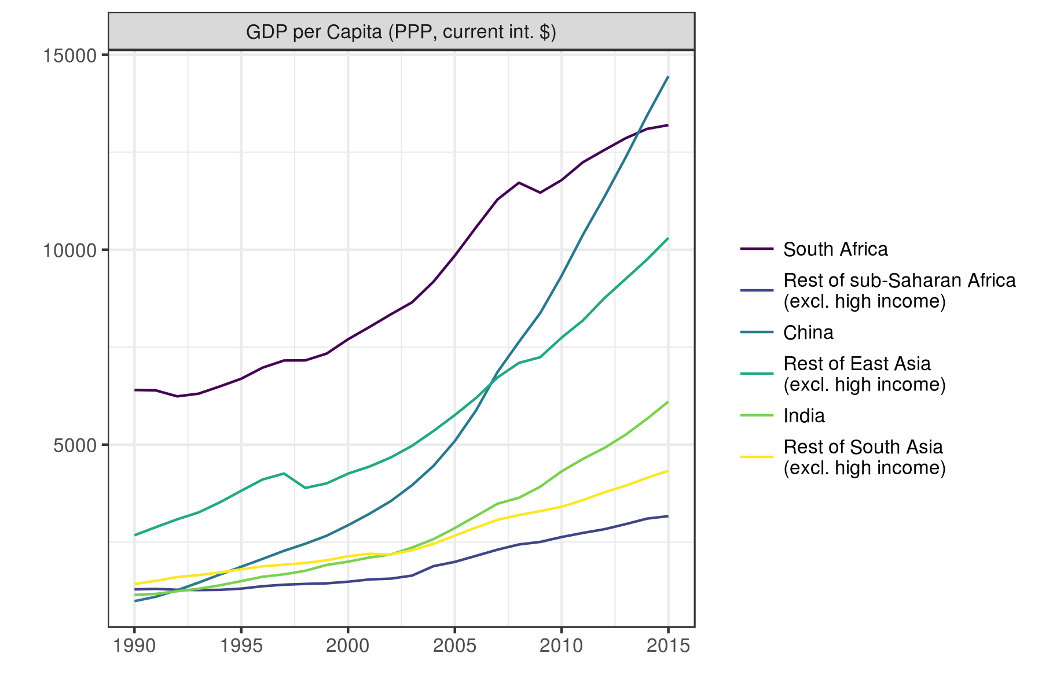

Fig. 5.1: Regional Trends in GDP per Capita (1990-2015) Source: WDI.

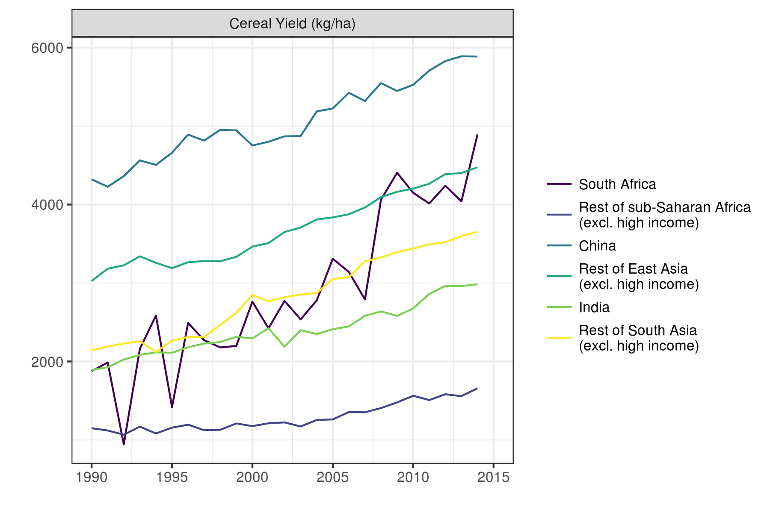

Fig. 5.2: Regional Trends in Cereal Yield (1990-2015) Source: WDI.

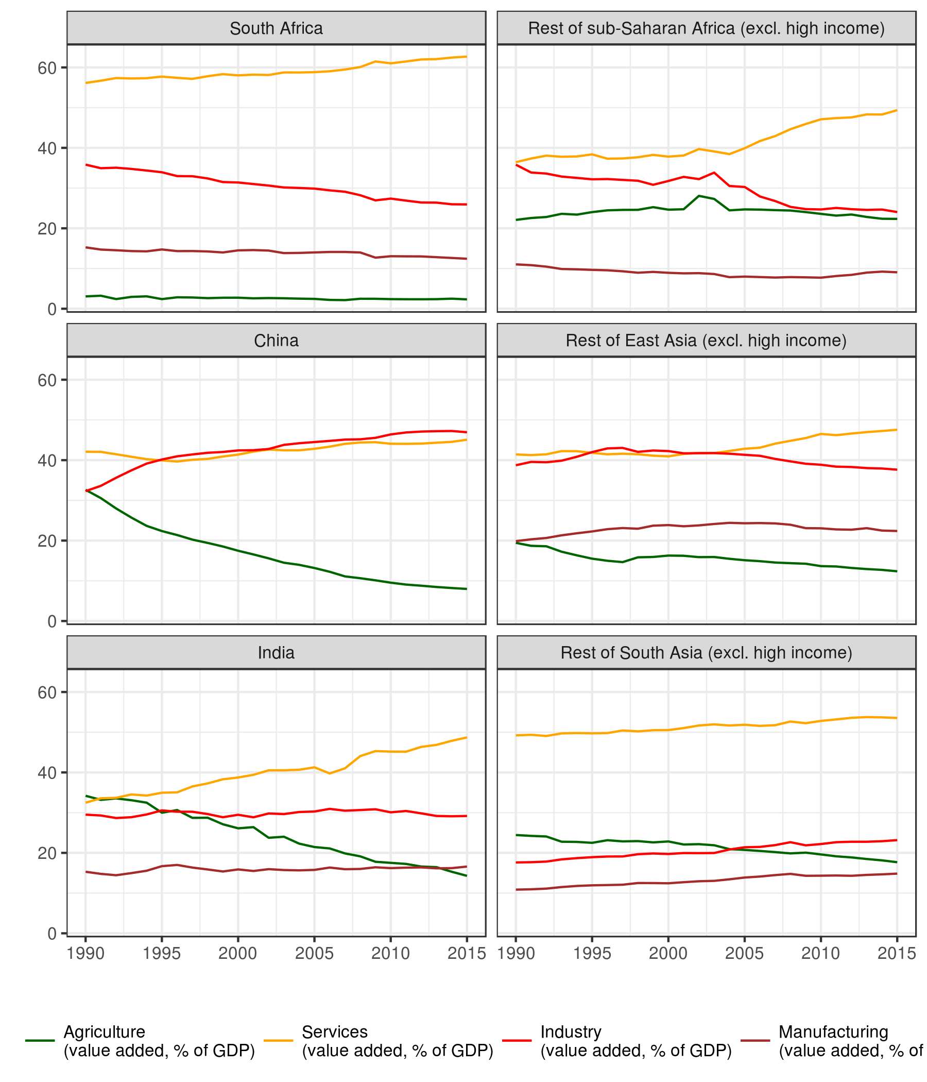

Fig. 5.3: Regional Trends in Sectoral Value Added (1990-2015) Source: WDI.

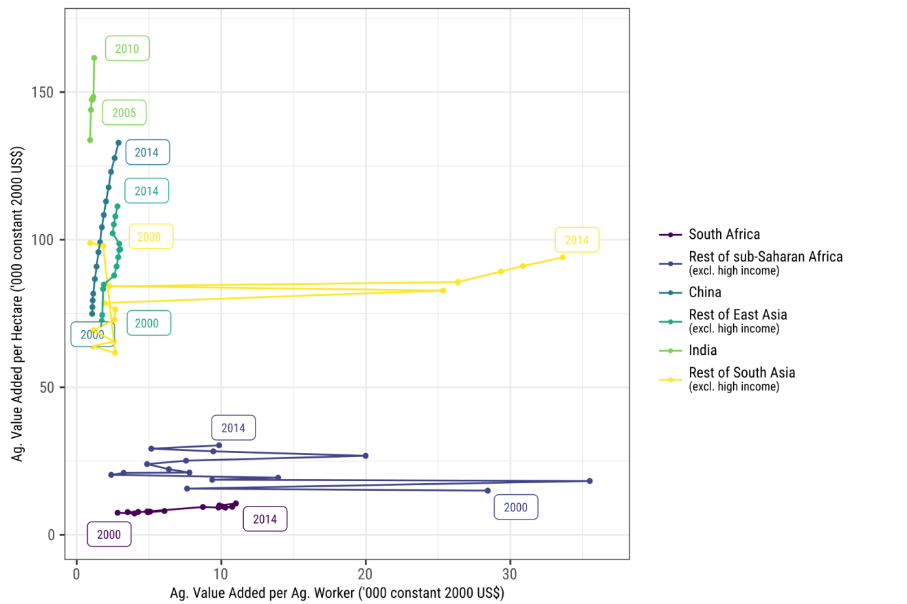

Fig. 5.3: Regional Trends in Land and Labor Productivity (2000-2014). Source: WDI.

Note that India is missing multiple years of agricultural employment statistics. Simple linear interpolation is used to impute these missing values.

The custom regional aggregation used in the above graphs is given here.

Tab. 5.1: Regional Aggregation

| **Region** | **Country** | **ISO2 Code** | **ISO3 Code** | **Income** |
| --- | --- | --- | --- | --- |
| China | China | CN | CHN | Upper middle income |
| India | India | IN | IND | Lower middle income |
| Rest of East Asia (excl. high income) | American Samoa | AS | ASM | Upper middle income |
| Rest of East Asia (excl. high income) | Cambodia | KH | KHM | Low income |
| Rest of East Asia (excl. high income) | Fiji | FJ | FJI | Lower middle income |
| Rest of East Asia (excl. high income) | Indonesia | ID | IDN | Lower middle income |
| Rest of East Asia (excl. high income) | Kiribati | KI | KIR | Lower middle income |
| Rest of East Asia (excl. high income) | Korea, Dem. Rep. | KP | PRK | Low income |
| Rest of East Asia (excl. high income) | Lao PDR | LA | LAO | Lower middle income |
| Rest of East Asia (excl. high income) | Malaysia | MY | MYS | Upper middle income |
| Rest of East Asia (excl. high income) | Marshall Islands | MH | MHL | Lower middle income |
| Rest of East Asia (excl. high income) | Micronesia, Fed. Sts. | FM | FSM | Lower middle income |
| Rest of East Asia (excl. high income) | Mongolia | MN | MNG | Lower middle income |
| Rest of East Asia (excl. high income) | Myanmar | MM | MMR | Low income |
| Rest of East Asia (excl. high income) | Palau | PW | PLW | Upper middle income |
| Rest of East Asia (excl. high income) | Papua New Guinea | PG | PNG | Lower middle income |
| Rest of East Asia (excl. high income) | Philippines | PH | PHL | Lower middle income |
| Rest of East Asia (excl. high income) | Samoa | WS | WSM | Lower middle income |
| Rest of East Asia (excl. high income) | Solomon Islands | SB | SLB | Lower middle income |
| Rest of East Asia (excl. high income) | Thailand | TH | THA | Upper middle income |
| Rest of East Asia (excl. high income) | Timor-Leste | TL | TLS | Lower middle income |
| Rest of East Asia (excl. high income) | Tonga | TO | TON | Lower middle income |
| Rest of East Asia (excl. high income) | Tuvalu | TV | TUV | Lower middle income |
| Rest of East Asia (excl. high income) | Vanuatu | VU | VUT | Lower middle income |
| Rest of East Asia (excl. high income) | Vietnam | VN | VNM | Lower middle income |
| Rest of South Asia (excl. high income) | Afghanistan | AF | AFG | Low income |
| Rest of South Asia (excl. high income) | Bangladesh | BD | BGD | Low income |
| Rest of South Asia (excl. high income) | Bhutan | BT | BTN | Lower middle income |
| Rest of South Asia (excl. high income) | Maldives | MV | MDV | Upper middle income |
| Rest of South Asia (excl. high income) | Nepal | NP | NPL | Low income |
| Rest of South Asia (excl. high income) | Pakistan | PK | PAK | Lower middle income |
| Rest of South Asia (excl. high income) | Sri Lanka | LK | LKA | Lower middle income |
| Rest of sub-Saharan Africa (excl. high income) | Angola | AO | AGO | Lower middle income |
| Rest of sub-Saharan Africa (excl. high income) | Benin | BJ | BEN | Low income |
| Rest of sub-Saharan Africa (excl. high income) | Botswana | BW | BWA | Upper middle income |
| Rest of sub-Saharan Africa (excl. high income) | Burkina Faso | BF | BFA | Low income |
| Rest of sub-Saharan Africa (excl. high income) | Burundi | BI | BDI | Low income |
| Rest of sub-Saharan Africa (excl. high income) | Cameroon | CM | CMR | Lower middle income |
| Rest of sub-Saharan Africa (excl. high income) | Cape Verde | CV | CPV | Lower middle income |
| Rest of sub-Saharan Africa (excl. high income) | Central African Republic | CF | CAF | Low income |
| Rest of sub-Saharan Africa (excl. high income) | Chad | TD | TCD | Low income |
| Rest of sub-Saharan Africa (excl. high income) | Comoros | KM | COM | Low income |
| Rest of sub-Saharan Africa (excl. high income) | Congo, Dem. Rep. | CD | COD | Low income |
| Rest of sub-Saharan Africa (excl. high income) | Congo, Rep. | CG | COG | Lower middle income |
| Rest of sub-Saharan Africa (excl. high income) | Cote d’Ivoire | CI | CIV | Lower middle income |
| Rest of sub-Saharan Africa (excl. high income) | Eritrea | ER | ERI | Low income |
| Rest of sub-Saharan Africa (excl. high income) | Ethiopia | ET | ETH | Low income |
| Rest of sub-Saharan Africa (excl. high income) | Gabon | GA | GAB | Upper middle income |
| Rest of sub-Saharan Africa (excl. high income) | Gambia, The | GM | GMB | Low income |
| Rest of sub-Saharan Africa (excl. high income) | Ghana | GH | GHA | Lower middle income |
| Rest of sub-Saharan Africa (excl. high income) | Guinea | GN | GIN | Low income |
| Rest of sub-Saharan Africa (excl. high income) | Guinea-Bissau | GW | GNB | Low income |
| Rest of sub-Saharan Africa (excl. high income) | Kenya | KE | KEN | Low income |
| Rest of sub-Saharan Africa (excl. high income) | Lesotho | LS | LSO | Lower middle income |
| Rest of sub-Saharan Africa (excl. high income) | Liberia | LR | LBR | Low income |
| Rest of sub-Saharan Africa (excl. high income) | Madagascar | MG | MDG | Low income |
| Rest of sub-Saharan Africa (excl. high income) | Malawi | MW | MWI | Low income |
| Rest of sub-Saharan Africa (excl. high income) | Mali | ML | MLI | Low income |
| Rest of sub-Saharan Africa (excl. high income) | Mauritania | MR | MRT | Lower middle income |
| Rest of sub-Saharan Africa (excl. high income) | Mauritius | MU | MUS | Upper middle income |
| Rest of sub-Saharan Africa (excl. high income) | Mayotte | YT | MYT | Upper middle income |
| Rest of sub-Saharan Africa (excl. high income) | Mozambique | MZ | MOZ | Low income |
| Rest of sub-Saharan Africa (excl. high income) | Namibia | NA | NAM | Upper middle income |
| Rest of sub-Saharan Africa (excl. high income) | Niger | NE | NER | Low income |
| Rest of sub-Saharan Africa (excl. high income) | Nigeria | NG | NGA | Lower middle income |
| Rest of sub-Saharan Africa (excl. high income) | Rwanda | RW | RWA | Low income |
| Rest of sub-Saharan Africa (excl. high income) | Sao Tome and Principe | ST | STP | Lower middle income |
| Rest of sub-Saharan Africa (excl. high income) | Senegal | SN | SEN | Lower middle income |
| Rest of sub-Saharan Africa (excl. high income) | Seychelles | SC | SYC | Upper middle income |
| Rest of sub-Saharan Africa (excl. high income) | Sierra Leone | SL | SLE | Low income |
| Rest of sub-Saharan Africa (excl. high income) | Somalia | SO | SOM | Low income |
| Rest of sub-Saharan Africa (excl. high income) | South Sudan | SS | SSD | Not classified |
| Rest of sub-Saharan Africa (excl. high income) | Sudan | SD | SDN | Lower middle income |
| Rest of sub-Saharan Africa (excl. high income) | Swaziland | SZ | SWZ | Lower middle income |
| Rest of sub-Saharan Africa (excl. high income) | Tanzania | TZ | TZA | Low income |
| Rest of sub-Saharan Africa (excl. high income) | Togo | TG | TGO | Low income |
| Rest of sub-Saharan Africa (excl. high income) | Uganda | UG | UGA | Low income |
| Rest of sub-Saharan Africa (excl. high income) | Zambia | ZM | ZMB | Lower middle income |
| Rest of sub-Saharan Africa (excl. high income) | Zimbabwe | ZW | ZWE | Low income |
| South Africa | South Africa | ZA | ZAF | Upper middle income |