EUI University

EME initiative

Report of:

RC Car Project

Prepared By:

Mahmoud Badr Rabea 336

Adham EL-Serougy 1323

Omar Ayman 1045

Hazem Magdy 1004

Contents

Introduction: 1

Components: 1

Working Principle: 3

System Hardware Design: 5

1. project components layout 5

2. System Schematic: 6

System Software Design 6

1. Static Design 6

1.1. The Layered Architecture 7

1.2. Description For Each Module APIs and Types: 7

2. Dynamic Design 41

2.1. System State Machine 41

Conclusion: 41

# Introduction:

The RC Car with Ultrasonic and LDR Sensors project combines obstacle detection, brightness-based navigation, and a time-controlled start/stop feature. By integrating an ultrasonic sensor, two LDR sensors, interrupt-based switches, a non-preemptive priority-based scheduler with a first delay feature, and a system priority design based on the Gomaa criteria, this project creates an autonomous remote-controlled car. The car can be initiated using one of two switches and will continue moving until either the other switch is pressed or a predefined time of 60 seconds elapses. These additional features enhance the car's functionality, optimize resource utilization, and improve responsiveness. The HCSR04 model is selected as the ultrasonic sensor for accurate obstacle detection.

# Components:

1. RC Car: The RC car serves as the mobile platform for this project, allowing for remote control and autonomous movement based on sensor inputs.

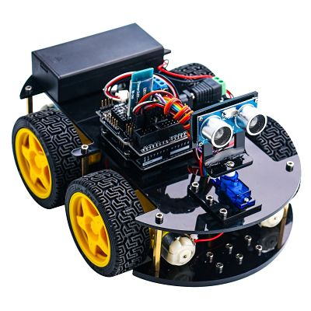

1. HCSR04 Ultrasonic Sensor: The ultrasonic sensor is positioned on the front of the car to detect obstacles within its path. It emits ultrasonic waves and measures the time it takes for the waves to bounce back from obstacles, calculating the distance to the nearest obstacle.

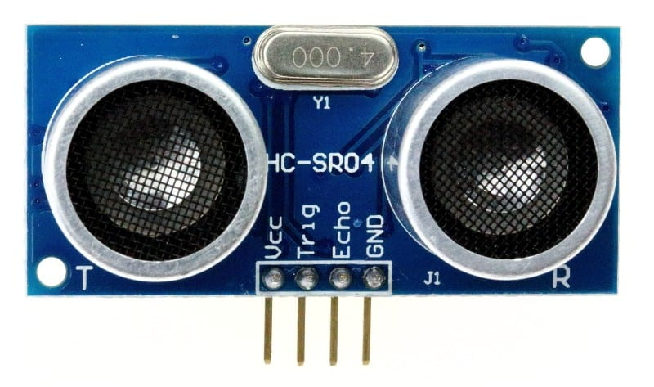

1. LDR Sensors: Two LDR sensors are placed on either side of the car to detect the brightness levels in the surroundings. These sensors change their resistance based on the amount of light falling on them, providing information about the relative brightness on each side.

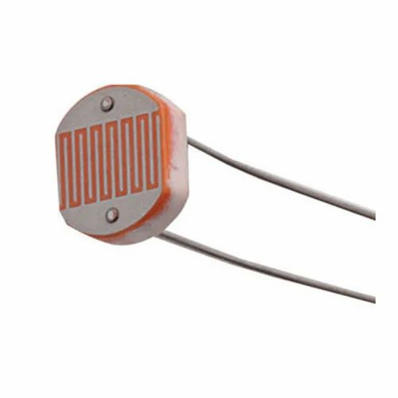

1. Switches: Two switches are incorporated into the system. One switch initiates the car's movement, while the other switch stops it. The movement will also automatically cease after 60 seconds. The switches incorporated into the system are equipped with interrupt functionality. When activated, they generate interrupts that trigger immediate responses, eliminating the need for continuous polling and ensuring quick and reliable interactions.
2. Scheduler: A scheduler is implemented to control the timing of the car's actions. It enables the car to start moving upon the activation of the first switch and to stop when the second switch is pressed or when the predetermined time of 60 seconds has passed. The scheduler implemented in the system utilizes a non-preemptive priority-based approach. It assigns priorities to different tasks within the RC car based on the Gomaa criteria, considering factors such as task importance, dependencies, and resource utilization. The scheduler includes a first delay mechanism, introducing a delay before some tasks at the start of the system that makes the tasks being executed at different time so we can reduce CPU load and optimize task execution.

# Working Principle:

* Start and Stop Mechanism:
* The system is initialized with the car in a stationary state.
* When the first switch is activated, the scheduler triggers the car to start moving.
* The car continues its movement until the second switch is pressed or the 60-second time limit is reached.
* If the second switch is pressed, the scheduler instructs the car to stop immediately.
* If the 60-second time limit is reached before the second switch is pressed, the scheduler automatically stops the car.
* Obstacle Detection and Avoidance:
* While the car is in motion, the ultrasonic sensor continuously emits ultrasonic waves and measures the time taken for them to bounce back.
* If an obstacle is detected within a predetermined distance that is 10 CM, the scheduler communicates with the car to halt its movement and move back until the distance is 30 CM then change its direction with 90 degrees to avoid a collision.
* Non-Preemptive Priority-Based Scheduler:
* The scheduler assigns priorities to various tasks based on their importance and system requirements, following the Gomaa criteria.
* Higher priority tasks, such as obstacle detection and switch handling, are executed before lower priority tasks.
* The non-preemptive nature of the scheduler ensures that a task is completed before a lower priority task interrupts its execution.
* Brightness-Based Navigation:
* The LDR sensors measure the brightness levels on each side of the car.
* The scheduler analyzes the readings from the LDR sensors and determines the side with the higher brightness level.
* The car adjusts its direction towards the side with greater brightness, enabling it to navigate toward well-lit areas autonomously.

# System Hardware Design:

## project components layout

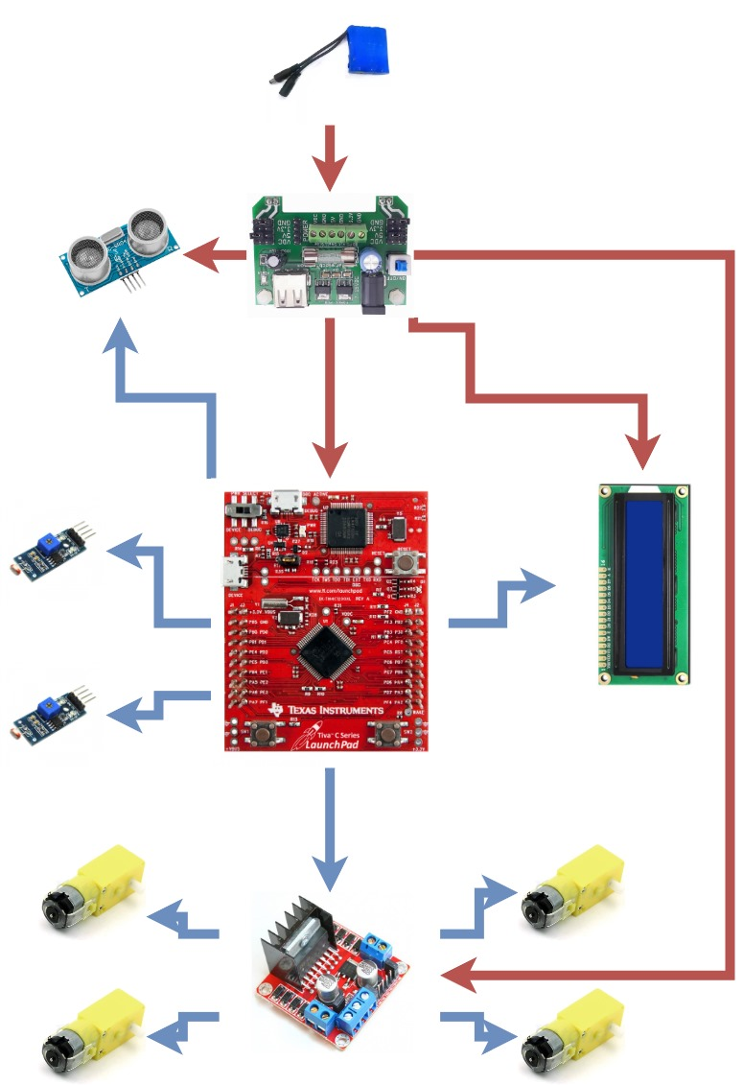

## System Schematic:

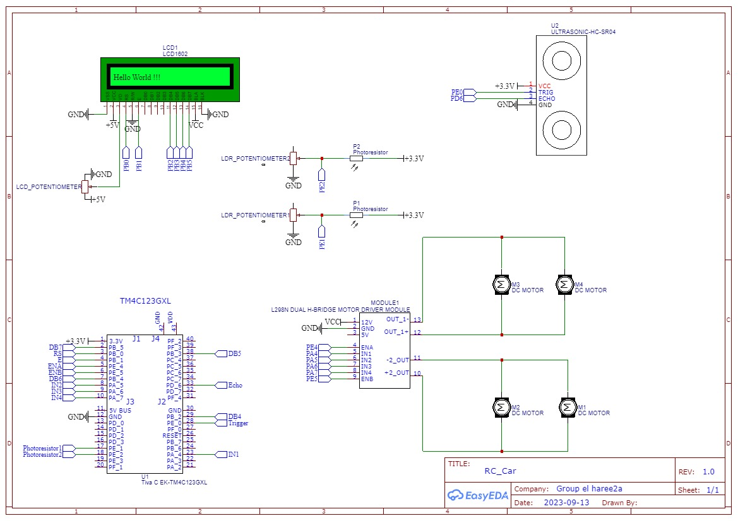

# System Software Design

The main goal of software design is to create a high-quality software system that is reliable, efficient, maintainable, and scalable. We can divide this process into two subprocesses:

## Static Design

The primary goal of static design is to create a well-organized and modular software system that is easy to understand, maintain, and extend. This is achieved by defining a clear hierarchy of components and their relationships, as well as using standard design patterns and principles to ensure consistency and reusability.

Static design is typically done during the early stages of software development, before any code is written. It is often represented graphically using diagrams such as class diagrams, package diagrams, and component diagrams.

Some of the key principles and techniques used in static design include:

### The Layered Architecture

The layered architecture typically consists of three or more layers, with each layer having a clear separation of concerns so that every layer has a specific responsibility.

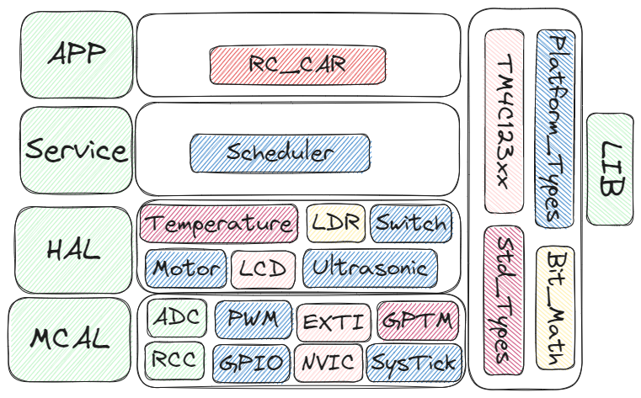

### Description For Each Module APIs and Types:

In this step we define each module APIs that will be used to communicate with the module by the others.

So, we will start with our components starting with MCAL layer to APP layer.

1. MCAL:
   1. RCC

|  |  |
| --- | --- |
| Name | RCC_Prph_t |
| Type | Enum |
| Description | The ID of peripheral |

|  |  |
| --- | --- |
| Name | RCC_PrphClkState_t |
| Type | Enum |
| Description | The peripheral clock state |

|  |  |
| --- | --- |
| Name | RCC_SetPrephralClockState |
| Syntax | ErrorState_t RCC_SetPrephralClockState(RCC_Prph_t Copy_Peripheral, RCC_PrphClkState_t Copy_ClockState) |
| Sync/Async | Synchronous |
| Reentrancy | Non-Reentrant |
| Parameters (in) | Copy_Peripheral: The peripheral to control its clock  Copy_ClockState: The state to be set |
| Parameters (out) | None |
| Return Value | ErrorState_t |
| Description | Enable The clock to a peripheral. |

|  |  |
| --- | --- |
| Name | ErrorState_t RCC_PeripheralSWReset |
| Syntax | ErrorState_t RCC_PeripheralSWReset(RCC_Prph_t Copy_Peripheral) |
| Sync/Async | Synchronous |
| Reentrancy | Non-Reentrant |
| Parameters (in) | Copy_Peripheral: The peripheral to control its clock |
| Parameters (out) | None |
| Return Value | ErrorState_t |
| Description | Do software reset on a peripheral. |

* 1. GPIO

|  |  |
| --- | --- |
| Name | GPIO_Port_t |
| Type | Enum |
| Description | The GPIO Port |

|  |  |
| --- | --- |
| Name | GPIO_Pin_t |
| Type | Enum |
| Description | The GPIO Pin |

|  |  |
| --- | --- |
| Name | GPIO_PinDirection_t |
| Type | Enum |
| Description | The Direction of GPIO Pin |

|  |  |
| --- | --- |
| Name | GPIO_PINMode_t |
| Type | Enum |
| Description | The Mode of GPIO Pin |

|  |  |
| --- | --- |
| Name | GPIO_PinPullUpDown_t |
| Type | Enum |
| Description | The Pull up down state of GPIO Pin |

|  |  |
| --- | --- |
| Name | GPIO_PinState_t |
| Type | Enum |
| Description | The push pull / open drain state of GPIO Pin |

|  |  |
| --- | --- |
| Name | GPIO_PinValue_t |
| Type | Enum |
| Description | The Value of GPIO Pin |

|  |  |
| --- | --- |
| Name | GPIO_PortValue_t |
| Type | Enum |
| Description | The Value of GPIO Port |

|  |  |
| --- | --- |
| Name | GPIO_AltFunc_t |
| Type | Enum |
| Description | The Alternate function of GPIO Pin |

|  |  |
| --- | --- |
| Name | GPIO_OutputCurrent_t |
| Type | Enum |
| Description | The Output drive current of GPIO Pin |

|  |  |
| --- | --- |
| Name | GPIO_Config_t |
| Type | Struct |
| Description | The Configuration structure of GPIO Pin |

|  |  |
| --- | --- |
| Name | GPIO_Init |
| Syntax | ErrorState_t GPIO_Init(const GPIO_Config_t* Copy_Config,u8 Copy_PinNum) |
| Sync/Async | Synchronous |
| Reentrancy | Non-Reentrant |
| Parameters (in) | GPIO_Config_t Array of configuration structure for GPIO  Copy_PinNum Number of Pins to be initialized |
| Parameters (out) | None |
| Return Value | ErrorState_t |
| Description | Initialize the GPIO Pins. |

|  |  |
| --- | --- |
| Name | GPIO_SetPinValue |
| Syntax | ErrorState_t GPIO_SetPinValue(GPIO_Port_t Copy_Port,GPIO_Pin_t Copy_Pin,GPIO_PinValue_t Copy_PinValue) |
| Sync/Async | Synchronous |
| Reentrancy | Non-Reentrant |
| Parameters (in) | Copy_Port The port of pin to set its value  Copy_Pin The pin to set its Value  Copy_PinValue The Pin value |
| Parameters (out) | None |
| Return Value | ErrorState_t |
| Description | Set Value to Digital Pin. |

|  |  |
| --- | --- |
| Name | GPIO_GetPinValue |
| Syntax | ErrorState_t GPIO_GetPinValue(GPIO_Port_t Copy_Port,GPIO_Pin_t Copy_Pin,GPIO_PinValue_t* Copy_PinValue) |
| Sync/Async | Synchronous |
| Reentrancy | Non-Reentrant |
| Parameters (in) | Copy_Port The port of pin to set its value  Copy_Pin The pin to set its Value |
| Parameters (out) | Copy_PinValue The Pin value |
| Return Value | ErrorState_t |
| Description | Get Value of Digital Pin. |

* 1. EXTI

|  |  |
| --- | --- |
| Name | EXTI_Port_t |
| Type | Enum |
| Description | The EXTI Port |

|  |  |
| --- | --- |
| Name | EXTI_Pin_t |
| Type | Enum |
| Description | The EXTI Pin |

|  |  |
| --- | --- |
| Name | EXTI_Detect_t |
| Type | Enum |
| Description | The EXTI Pin Detect type edge or level |

|  |  |
| --- | --- |
| Name | EXTI_TriggerDetect_t |
| Type | Enum |
| Description | The EXTI Pin Trigger Type |

|  |  |
| --- | --- |
| Name | EXTI_Config_t |
| Type | Struct |
| Description | The EXTI Pin Configuration Structure |

|  |  |
| --- | --- |
| Name | EXTI_Init |
| Syntax | ErrorState_t EXTI_Init(EXTI_Config_t* Copy_config,u8 Copy_PinsNum) |
| Sync/Async | Synchronous |
| Reentrancy | Non-Reentrant |
| Parameters (in) | Copy_config Configuration structure  Copy_PinsNum Number of Pins to be configured |
| Parameters (out) | None |
| Return Value | ErrorState_t |
| Description | set the required configuration to number of pins. |

|  |  |
| --- | --- |
| Name | EXTI_SetCallBack |
| Syntax | ErrorState_t EXTI_SetCallBack(EXTI_Port_t Copy_Port, EXTI_Pin_t Copy_Pin,void (*Copy_CallBackFunc)(void)) |
| Sync/Async | Synchronous |
| Reentrancy | Non-Reentrant |
| Parameters (in) | Copy_Port Port of pin to set the callback to  Copy_Pin Pin to set the callback to  Copy_CallBackFunc pointer to the callback function to be set |
| Return Value | ErrorState_t |
| Description | Set the callback function to specific pin. |

* 1. GPTM

|  |  |
| --- | --- |
| Name | GPTM_BlockNum_t |
| Type | Enum |
| Description | GPTM Block number from TIMER0 to WTIMER5 |

|  |  |
| --- | --- |
| Name | GPTM_Conc_t |
| Type | Enum |
| Description | GPTM concatenation type |

|  |  |
| --- | --- |
| Name | GPTM_Channel_t |
| Type | Enum |
| Description | GPTM channel TIMERA or TIMERB |

|  |  |
| --- | --- |
| Name | GPTM_ConState_t |
| Type | Enum |
| Description | GPTM Continuity state Periodic or one shot |

|  |  |
| --- | --- |
| Name | GPTM_Mode_t |
| Type | Enum |
| Description | GPTM operation mode |

|  |  |
| --- | --- |
| Name | GPTM_Count_t |
| Type | Enum |
| Description | GPTM count type Count up or down. |

|  |  |
| --- | --- |
| Name | GPTM_State |
| Type | Enum |
| Description | GPTM state on or off. |

|  |  |
| --- | --- |
| Name | GPTM_Int_t |
| Type | Enum |
| Description | GPTM Interrupt type |

|  |  |
| --- | --- |
| Name | GPTM_EventTrigger_t |
| Type | Enum |
| Description | GPTM Event Trigger error |

|  |  |
| --- | --- |
| Name | GPTM_PWMOutLevel_t |
| Type | Enum |
| Description | GPTM PWM output level |

|  |  |
| --- | --- |
| Name | GPTM_IntState_t |
| Type | Enum |
| Description | GPTM Interrupt State. |

|  |  |
| --- | --- |
| Name | GPTM_Config_t |
| Type | Struct |
| Description | GPTM Configuration structure |

|  |  |
| --- | --- |
| Name | GPTM_Init |
| Syntax | ErrorState_t GPTM_Init(GPTM_Config_t* Copy_Config, TimersNum_t Copy_Number);Copy_Peripheral) |
| Sync/Async | Synchronous |
| Reentrancy | Non-Reentrant |
| Parameters (in) | Copy_Config GPTM configuration structure  Copy_Number Channels Number |
| Parameters (out) | None |
| Return Value | ErrorState_t |
| Description | Initialize the required Timers Channels. |

|  |  |
| --- | --- |
| Name | GPTM_SetState |
| Syntax | ErrorState_t GPTM_SetState(GPTM_BlockNum_t Copy_TimerNum, GPTM_Channel_t Copy_TimerChannel,GPTM_State Copy_State) |
| Sync/Async | Synchronous |
| Reentrancy | Non-Reentrant |
| Parameters (in) | Copy_TimerNum Timer Block Number  Copy_TimerChannel Timer Channel Number  Copy_State State of timer |
| Parameters (out) | None |
| Return Value | ErrorState_t |
| Description | Set the timer state start or stop. |

|  |  |
| --- | --- |
| Name | GPTM_SetPWMOutputLevel |
| Syntax | ErrorState_t GPTM_SetPWMOutputLevel(GPTM_BlockNum_t Copy_TimerNum, GPTM_Channel_t Copy_TimerChannel,GPTM_PWMOutLevel_t Copy_PWMOutput) |
| Sync/Async | Synchronous |
| Reentrancy | Non-Reentrant |
| Parameters (in) | Copy_TimerNum Timer Block Number  Copy_TimerChannel Timer Channel Number  Copy_PWMOutput PWM output type |
| Parameters (out) | None |
| Return Value | ErrorState_t |
| Description | Set the timer PWM mode output type. |

|  |  |
| --- | --- |
| Name | GPTM_SetEventTrigger |
| Syntax | ErrorState_t GPTM_SetEventTrigger(GPTM_BlockNum_t Copy_TimerNum, GPTM_Channel_t Copy_TimerChannel,GPTM_EventTrigger_t Copy_Trigger) |
| Sync/Async | Synchronous |
| Reentrancy | Non-Reentrant |
| Parameters (in) | Copy_Peripheral: The peripheral to control its clock |
| Parameters (out) | None |
| Return Value | ErrorState_t |
| Description | Set the timer Event trigger. |

|  |  |
| --- | --- |
| Name | GPTM_SetTimerLoadValue |
| Syntax | ErrorState_t GPTM_SetTimerLoadValue(GPTM_Config_t* Copy_Config, TimerValue_t Copy_Value) |
| Sync/Async | Synchronous |
| Reentrancy | Non-Reentrant |
| Parameters (in) | Copy_Config GPTM configuration structure  Copy_Value The value to be set |
| Parameters (out) | None |
| Return Value | ErrorState_t |
| Description | Set the load value of the required timer channel. |

|  |  |
| --- | --- |
| Name | GPTM_SetTimerValue |
| Syntax | ErrorState_t GPTM_SetTimerValue(GPTM_Config_t* Copy_Config, TimerValue_t Copy_Value); |
| Sync/Async | Synchronous |
| Reentrancy | Non-Reentrant |
| Parameters (in) | Copy_Config GPTM configuration structure  Copy_Value The value to be set |
| Parameters (out) | None |
| Return Value | ErrorState_t |
| Description | Set the value of the required timer channel. |

|  |  |
| --- | --- |
| Name | GPTM_SetMatchValue |
| Syntax | ErrorState_t GPTM_SetMatchValue(GPTM_Config_t* Copy_Config, TimerValue_t Copy_Value,u16 Copy_MatchPrescaler) |
| Sync/Async | Synchronous |
| Reentrancy | Non-Reentrant |
| Parameters (in) | Copy_Config GPTM configuration structure  Copy_Value Value to be loaded in Timer Register  Copy_MatchPrescaler Prescaler of match counter |
| Parameters (out) | None |
| Return Value | ErrorState_t |
| Description | Load the Match value of timer. |

|  |  |
| --- | --- |
| Name | GPTM_GetTimerValue |
| Syntax | ErrorState_t GPTM_GetTimerValue(GPTM_Config_t* Copy_Config, TimerValue_t* Copy_Value); |
| Sync/Async | Synchronous |
| Reentrancy | Non-Reentrant |
| Parameters (in) | Copy_Config GPTM configuration structure |
| Parameters (out) | Copy_Value Current Value of Timer |
| Return Value | ErrorState_t |
| Description | Get the current value of Timer. |

|  |  |
| --- | --- |
| Name | GPTM_SetInterruptState |
| Syntax | ErrorState_t GPTM_SetInterruptState(GPTM_BlockNum_t Copy_TimerNum, GPTM_Channel_t Copy_TimerChannel, GPTM_Int_t Copy_IntType,GPTM_IntState_t Copy_IntState) |
| Sync/Async | Synchronous |
| Reentrancy | Non-Reentrant |
| Parameters (in) | Copy_TimerNum Timer Block Number  Copy_TimerChannel Timer Channel Number  Copy_IntType Interrupt to set the callback function  Copy_IntState Interrupt state to be set |
| Parameters (out) | None |
| Return Value | ErrorState_t |
| Description | Do software reset on a peripheral. |

|  |  |
| --- | --- |
| Name | GPTM_SetCallBack |
| Syntax | ErrorState_t GPTM_SetCallBack(GPTM_BlockNum_t Copy_TimerNum, GPTM_Channel_t Copy_TimerChannel,GPTM_Int_t Copy_IntType,void(*Copy_CallBackFunc)(void)); |
| Sync/Async | Synchronous |
| Reentrancy | Non-Reentrant |
| Parameters (in) | Copy_TimerNum Timer Block Number  Copy_TimerChannel Timer Channel Number  Copy_IntType Interrupt to set the callback function  Copy_CallBackFunc Pointer to called-back function |
| Parameters (out) | None |
| Return Value | ErrorState_t |
| Description | Set the call back to a specific mode in a specific channel in a specific Timer block. |

* 1. NVIC

|  |  |
| --- | --- |
| Name | NVIC_IRQ_t |
| Type | Enum |
| Description | The Interrupt Request Number |

|  |  |
| --- | --- |
| Name | NVIC_IntState_t |
| Type | Enum |
| Description | The Interrupt Request State |

|  |  |
| --- | --- |
| Name | NVIC_SetInterruptState |
| Syntax | ErrorState_t NVIC_SetInterruptState(NVIC_IRQ_t Copy_IRQ_n,NVIC_IntState_t Copy_State) |
| Sync/Async | Synchronous |
| Reentrancy | Non-Reentrant |
| Parameters (in) | Copy_IRQ_n The Interrupt Request Numbe  Copy_State The Interrupt Request State |
| Parameters (out) | None |
| Return Value | ErrorState_t |
| Description | Set the Interrupt Request state. |

|  |  |
| --- | --- |
| Name | NVIC_SetPendingFlag |
| Syntax | ErrorState_t NVIC_SetPendingFlag(NVIC_IRQ_t Copy_IRQ_n,NVIC_IntState_t Copy_State) |
| Sync/Async | Synchronous |
| Reentrancy | Non-Reentrant |
| Parameters (in) | Copy_IRQ_n The Interrupt Request Numbe  Copy_State The Pending Flag State |
| Parameters (out) | None |
| Return Value | ErrorState_t |
| Description | Set the Interrupt Pending Flag by Software. |

|  |  |
| --- | --- |
| Name | NVIC_GetActiveFlag |
| Syntax | ErrorState_t NVIC_GetActiveFlag(NVIC_IRQ_t Copy_IRQ_n,NVIC_IntState_t* Copy_State) |
| Sync/Async | Synchronous |
| Reentrancy | Non-Reentrant |
| Parameters (in) | Copy_Config GPTM configuration structure |
| Parameters (out) | Copy_Value Current Value of Timer |
| Return Value | ErrorState_t |
| Description | Get the Active Flag State. |

* 1. PWM

|  |  |
| --- | --- |
| Name | PWM_Init |
| Syntax | void PWM_Init(PWM_RegDef_t *PWMx, PWM_InitTypeDef *PWM_Config) |
| Sync/Async | Synchronous |
| Parameters (in) | *PWM_Config: PWM peripheral configuration  *PWMx: PWM module to initialize |
| Parameters (out) | NONE |
| Return Value | void |
| Description | Initialize PWM peripheral |

|  |  |
| --- | --- |
| Name | PWM_Set_Load |
| Syntax | void PWM_Set_Load(PWM_RegDef_t *PWMx, uint8_t Generator, uint16_t Load_Value) |
| Sync/Async | Synchronous |
| Parameters (in) | Load_Value: Value to place in load register  Generator: which generator to modify  *PWMx: PWM module to initialize |
| Parameters (out) | None |
| Return Value | void |
| Description | Set PWM Load Register value |

|  |  |
| --- | --- |
| Name | PWM_Set_Comp |
| Syntax | void PWM_Set_Comp(PWM_RegDef_t *PWMx, uint8_t Channel, uint16_t Comp_Value) |
| Sync/Async | Synchronous |
| Parameters (in) | Comp_Value: Value to place in Comp register  Channel: which channel to modify  *PWMx: PWM module to initialize |
| Parameters (out) | NONE |
| Return Value | void |
| Description | Set PWM Comp Register value |

|  |  |
| --- | --- |
| Name | PWM_Start |
| Syntax | void PWM_Start(PWM_RegDef_t *PWMx, uint8_t Generator) |
| Sync/Async | Synchronous |
| Parameters (in) | Generator: which Generator to modify  *PWMx: PWM module to initialize |
| Parameters (out) | NONE |
| Return Value | void |
| Description | Start PWM Generator |

|  |  |
| --- | --- |
| Name | PWM_Output_Enable |
| Syntax | void PWM_Output_Enable(PWM_RegDef_t *PWMx, uint8_t Channel) |
| Sync/Async | Synchronous |
| Parameters (in) | Channel: which channel to modify  *PWMx: PWM module to initialize |
| Parameters (out) | NONE |
| Return Value | void |
| Description | Enable PWM output for channel |

* 1. ADC

|  |  |
| --- | --- |
| Name | ADC_SequencerInit |
| Syntax | void ADC_SequencerInit(ADC_RegDef_t *ADCx,  ADC_Sequencer_InitTypeDef *Sequencer_Config) |
| Sync/Async | Synchronous |
| Parameters (in) | *ADCx: ADC module to initialize  *Sequencer_Config: Sequencer Configuration |
| Parameters (out) | NONE |
| Return Value | void |
| Description | Initialize ADC Sequencer |

|  |  |
| --- | --- |
| Name | ADC_SequencerConfig |
| Syntax | void ADC_SequencerConfig(ADC_RegDef_t *ADCx,  ADC_Sequencer_ConfigTypeDef *Sequence) |
| Sync/Async | Synchronous |
| Parameters (in) | *ADCx: ADC module to initialize  *Sequence: Sequence for sequencers |
| Parameters (out) | None |
| Return Value | void |
| Description | Set PWM Load Register value |

|  |  |
| --- | --- |
| Name | ADC_SequenceIntEnable |
| Syntax | void ADC_SequenceIntEnable(ADC_RegDef_t *ADCx, uint8_t Sequencer) |
| Sync/Async | Synchronous |
| Parameters (in) | *ADCx: ADC module to initialize  Sequencer: Sequencer to modify |
| Parameters (out) | NONE |
| Return Value | void |
| Description | Enable Sequencer Interrupt |

|  |  |
| --- | --- |
| Name | ADC_SequencerEnable |
| Syntax | void ADC_SequencerEnable(ADC_RegDef_t *ADCx, uint8_t Sequencer) |
| Sync/Async | Synchronous |
| Parameters (in) | *ADCx: ADC module to initialize  Sequencer: Sequencer to modify |
| Parameters (out) | NONE |
| Return Value | void |
| Description | Enable Sequencer |

|  |  |
| --- | --- |
| Name | ADC_SequencerDisable |
| Syntax | void ADC_SequencerDisable(ADC_RegDef_t *ADCx, uint8_t Sequencer) |
| Sync/Async | Synchronous |
| Parameters (in) | *ADCx: ADC module to initialize  Sequencer: Sequencer to modify |
| Parameters (out) | NONE |
| Return Value | void |
| Description | Disable Sequencer |

|  |  |
| --- | --- |
| Name | ADC_StartConversion |
| Syntax | void ADC_StartConversion(ADC_RegDef_t *ADCx, uint8_t Sequencer) |
| Sync/Async | Synchronous |
| Parameters (in) | *ADCx: ADC module to initialize  Sequencer: Sequencer to modify |
| Parameters (out) | NONE |
| Return Value | void |
| Description | Start conversion for processor trigger |

|  |  |
| --- | --- |
| Name | ADC_GetData |
| Syntax | uint16_t ADC_GetData(ADC_RegDef_t *ADCx, uint8_t Sequencer) |
| Sync/Async | Synchronous |
| Parameters (in) | *ADCx: ADC module to initialize  Sequencer: Sequencer to modify |
| Parameters (out) | NONE |
| Return Value | uint16_t |
| Description | Get data from ADC FIFO |

|  |  |
| --- | --- |
| Name | ADC_Clear_Interrupt |
| Syntax | void ADC_Clear_Interrupt(ADC_RegDef_t *ADCx, uint8_t Sequencer) |
| Sync/Async | Synchronous |
| Parameters (in) | *ADCx: ADC module to initialize  Sequencer: Sequencer to modify |
| Parameters (out) | NONE |
| Return Value | void |
| Description | Clear Interrupt Flags of Sequencer |

|  |  |
| --- | --- |
| Name | ADC_IntRegister |
| Syntax | void ADC_IntRegister(ADC_RegDef_t *ADCx, uint8_t Sequencer, void (*pfnIntHandler)(void)) |
| Sync/Async | Synchronous |
| Parameters (in) | *ADCx: ADC module to initialize  Sequencer: Sequencer to modify |
| Parameters (out) | NONE |
| Return Value | void |
| Description | Set Callback function to interrupt |

1. HAL
   1. LCD

|  |  |
| --- | --- |
| Name | LCD_Mode_t |
| Type | Enum |
| Description | LCD Connection Mode 4 or 8 bit |

|  |  |
| --- | --- |
| Name | LCD_Cursor_t |
| Type | Enum |
| Description | LCD Cursor State |

|  |  |
| --- | --- |
| Name | LCD_Font_t |
| Type | Enum |
| Description | LCD Font Size |

|  |  |
| --- | --- |
| Name | LCD_LineNum_t |
| Type | Enum |
| Description | LCD Lines Number |

|  |  |
| --- | --- |
| Name | LCD_Config_t |
| Type | Enum |
| Description | LCD Configuration Structure |

|  |  |
| --- | --- |
| Name | LCD_Init |
| Syntax | ErrorState_t LCD_Init(LCD_Config_t* Copy_Config) |
| Sync/Async | Synchronous |
| Reentrancy | Non-Reentrant |
| Parameters (in) | Copy_Config The LCD Configuration structure |
| Parameters (out) | Copy_Value Current Value of Timer |
| Return Value | ErrorState_t |
| Description | Initialize the LCD module. |

|  |  |
| --- | --- |
| Name | LCD_SendChar |
| Syntax | ErrorState_t LCD_SendChar(LCD_Config_t* Copy_Config,char Copy_Char) |
| Sync/Async | Synchronous |
| Reentrancy | Non-Reentrant |
| Parameters (in) | Copy_Config The LCD Configuration structure  Copy_Char character to be displayed on LCD |
| Parameters (out) | None |
| Return Value | ErrorState_t |
| Description | Display a character on LCD. |

|  |  |
| --- | --- |
| Name | LCD_SendString |
| Syntax | ErrorState_t LCD_SendString(LCD_Config_t* Copy_Config,char *Copy_String) |
| Sync/Async | Synchronous |
| Reentrancy | Non-Reentrant |
| Parameters (in) | Copy_Config The LCD Configuration structure  Copy_String String to be displayed on LCD |
| Parameters (out) | None |
| Return Value | ErrorState_t |
| Description | Display string on LCD. |

|  |  |
| --- | --- |
| Name | LCD_Clear |
| Syntax | ErrorState_t LCD_Clear(LCD_Config_t* Copy_Config) |
| Sync/Async | Synchronous |
| Reentrancy | Non-Reentrant |
| Parameters (in) | Copy_Config The LCD Configuration structure |
| Parameters (out) | None |
| Return Value | ErrorState_t |
| Description | Clear Display of LCD. |

|  |  |
| --- | --- |
| Name | LCD_WriteNumber |
| Syntax | ErrorState_t LCD_WriteNumber(LCD_Config_t* Copy_Config,s64 Copy_Number) |
| Sync/Async | Synchronous |
| Reentrancy | Non-Reentrant |
| Parameters (in) | Copy_Config The LCD Configuration structure  Copy_Number Number to be displayed on LCD |
| Parameters (out) | None |
| Return Value | ErrorState_t |
| Description | Display Number on LCD. |

|  |  |
| --- | --- |
| Name | LCD_GoToXY |
| Syntax | ErrorState_t LCD_GoToXY(LCD_Config_t* Copy_Config,u8 Copy_XPosition,u8 Copy_YPosition) |
| Sync/Async | Synchronous |
| Reentrancy | Non-Reentrant |
| Parameters (in) | Copy_Config The LCD Configuration structure  Copy_XPosition Location on the row  Copy_YPosition Location on the Column |
| Parameters (out) | None |
| Return Value | ErrorState_t |
| Description | Go to specific position on LCD. |

* 1. Switch

|  |  |
| --- | --- |
| Name | Switch_State_t |
| Type | Enum |
| Description | Switch State Pressed or Not |

|  |  |
| --- | --- |
| Name | Switch_Init |
| Syntax | ErrorState_t Switch_Init(GPIO_Port_t Copy_SwPort,GPIO_Pin_t Copy_SwPin,GPIO_PinPullUpDown_t Copy_SwState) |
| Sync/Async | Synchronous |
| Reentrancy | Non-Reentrant |
| Parameters (in) | Copy_SwPort The port of pin switch connected to  Copy_SwPin The pin switch connected to  Copy_SwState The wanted Pull state of Switch |
| Parameters (out) | None |
| Return Value | ErrorState_t |
| Description | Clear Display of LCD. |

|  |  |
| --- | --- |
| Name | Switch_IntConfig |
| Syntax | ErrorState_t Switch_IntConfig(EXTI_Config_t *Copy_Button,void(*Copy_NotificationFunc)(void)) |
| Sync/Async | Asynchronous |
| Reentrancy | Non-Reentrant |
| Parameters (in) | Copy_Button The Interrupt Configuration structure of the Switch  Copy_NotificationFunc The Notification function of the switch Pressing |
| Parameters (out) | None |
| Return Value | ErrorState_t |
| Description | Initialize The interrupt configuration of the Switch. |

|  |  |
| --- | --- |
| Name | Switch_GetStatus |
| Syntax | ErrorState_t Switch_GetStatus(GPIO_Port_t Copy_SwPort,GPIO_Pin_t Copy_SwPin,GPIO_PinPullUpDown_t Copy_SwPullType,Switch_State_t* Copy_SwState) |
| Sync/Async | Synchronous |
| Reentrancy | Non-Reentrant |
| Parameters (in) | Copy_SwPort The port of pin switch connected to  Copy_SwPin The pin switch connected to  Copy_Sw PullType The wanted Pull state of Switch |
| Parameters (out) | Copy_SwState The Switch state Pressed or Not |
| Return Value | ErrorState_t |
| Description | Get the Switch state Pressed or not. |

* 1. Motor

|  |  |
| --- | --- |
| Name | Motor_Init |
| Syntax | void Motor_Init(void) |
| Sync/Async | Synchronous |
| Parameters (in) | NONE |
| Parameters (out) | NONE |
| Return Value | void |
| Description | Initialize Motors |

|  |  |
| --- | --- |
| Name | Motor_Start |
| Syntax | void Motor_Start(void) |
| Sync/Async | Synchronous |
| Parameters (in) | NONE |
| Parameters (out) | NONE |
| Return Value | void |
| Description | Start Motors |

|  |  |
| --- | --- |
| Name | Motor_Set_Speed |
| Syntax | void Motor_Set_Speed(uint16_t Speed, uint8_t Motors) |
| Sync/Async | Synchronous |
| Parameters (in) | Speed: Speed in percentage  Motors: which motor to change speed |
| Parameters (out) | NONE |
| Return Value | void |
| Description | Set Motor Speed |

|  |  |
| --- | --- |
| Name | void Motor_Set_Direction(uint8_t Direction) |
| Syntax | Motor_Set_Direction |
| Sync/Async | Synchronous |
| Parameters (in) | Direction: Forward or Backward |
| Parameters (out) | NONE |
| Return Value | void |
| Description | Set Motor Direction |

|  |  |
| --- | --- |
| Name | Motor_Stop |
| Syntax | void Motor_Stop(void) |
| Sync/Async | Synchronous |
| Parameters (in) | NONE |
| Parameters (out) | NONE |
| Return Value | void |
| Description | Stop Motors |

* 1. Ultrasonic

|  |  |
| --- | --- |
| Name | Ultra_Sonic_init |
| Syntax | void Ultra_Sonic_init(void); |
| Sync/Async | Asynchronous |
| Parameters (in) | NONE |
| Parameters (out) | NONE |
| Return Value | void |
| Description | Function to initialize the GPIO pins required (PE0)  for the trigger (ultra sonic input)  and (PD6 widetimer5 channel A) for echo (ultrasonic output) |

|  |  |
| --- | --- |
| Name | Get_Distance |
| Syntax | void Get_Distance(void); |
| Sync/Async | Synchronous |
| Parameters (in) | u8 captureFlag: flag to indicate that interrupt happened at both edges  u64 risingEdgeTime: to get the echo rising time  u64 fallingEdgeTime: to get the echo falling time  u64 difference: to get the difference between two times  f64 time: to get the whole time according to frequency of CPU |
| Parameters (out) | u64* distance_global: this the required distance from the ultrasonic sensor |
| Return Value | void |
| Description | Function to get the required distance by the ultrasonic sensor by modifying the global pointer and after get the distance from the function then it calls the global pointer to function to execute the required function which address is put in this pointer |

|  |  |
| --- | --- |
| Name | ultrasonic_distance |
| Syntax | void ultrasonic_distance (u64*distance_local,void (*ptr_func_local)(void)); |
| Sync/Async | Asynchronous |
| Parameters (in) | u64*distance_local: to assign the distance saved from global pointer to this local pointer  ptr_func_local: to put required function to be executed after get the distance from ultrasonic |
| Parameters (out) | NONE |
| Return Value | void |
| Description | Function gets the distance which calculated and execute the required function which its name is put in this pointer to function |

* 1. Temperature

|  |  |
| --- | --- |
| Name | Temperature_Init |
| Syntax | void Temperature_Init(void); |
| Sync/Async | Synchronous |
| Reentrancy | Non-Reentrant |
| Parameters (in) | None |
| Parameters (out) | None |
| Return Value | void |
| Description | Function to initialize the built in Temperature Sensor and  enable ADC0 module & Sequencer3. |

|  |  |
| --- | --- |
| Name | Temp_Send_Read |
| Syntax | u32 Temp_Send_Read(void) |
| Sync/Async | Synchronous |
| Reentrancy | Non-Reentrant |
| Parameters (in) | None |
| Parameters (out) | None |
| Return Value | U32 |
| Description | This function returns the Temperature value calculated. |

* 1. LDR

|  |  |
| --- | --- |
| Name | LDR_Init |
| Syntax | void LDR_Init(void) |
| Sync/Async | Synchronous |
| Reentrancy | Non-Reentrant |
| Parameters (in) | None |
| Parameters (out) | None |
| Return Value | Void |
| Description | This function stores the values of the two LDR Sensors in an  array. |

|  |  |
| --- | --- |
| Name | LDR_Read |
| Syntax | void LDR_Read(u32* Arr) |
| Sync/Async | Synchronous |
| Reentrancy | Non-Reentrant |
| Parameters (in) | None |
| Parameters (out) | Arr : The Readings of LDRs |
| Return Value | void |
| Description | This function stores the values of the two LDR Sensors in an  array. |

1. Service
   1. SysTick

|  |  |
| --- | --- |
| Name | STK_ClcSource_t |
| Type | Enum |
| Description | SysTick Clock Source |

|  |  |
| --- | --- |
| Name | STK_IntState_t |
| Type | Enum |
| Description | SysTick Int State. |

|  |  |
| --- | --- |
| Name | STK_Init |
| Syntax | ErrorState_t STK_Init(STK_ClcSource_t Copy_ClockSource, STK_Value_t Copy_Value, STK_IntState_t Copy_IntState) |
| Sync/Async | Synchronous |
| Reentrancy | Non-Reentrant |
| Parameters (in) | Copy_ClockSource SysTick Clock Source  Copy_Value The Top Value of SysTick  Copy_IntState The Initial interrupt state |
| Parameters (out) | None |
| Return Value | ErrorState_t |
| Description | initialize the SysTick with required configuration. |

|  |  |
| --- | --- |
| Name | STK_SetIntState |
| Syntax | ErrorState_t STK_SetIntState(STK_IntState_t Copy_IntState) |
| Sync/Async | Synchronous |
| Reentrancy | Non-Reentrant |
| Parameters (in) | Copy_IntState The interrupt state |
| Parameters (out) | None |
| Return Value | ErrorState_t |
| Description | set the SysTick interrupt state. |

|  |  |
| --- | --- |
| Name | STK_SetCallBack |
| Syntax | ErrorState_t STK_SetCallBack(void (*Copy_CallBackFunc)(void)) |
| Sync/Async | Synchronous |
| Reentrancy | Non-Reentrant |
| Parameters (in) | Copy_CallBackFunc Pointer to SysTick Callback Function |
| Parameters (out) | None |
| Return Value | ErrorState_t |
| Description | Set the SysTick callback function. |

|  |  |
| --- | --- |
| Name | STK_SetValue |
| Syntax | ErrorState_t STK_SetValue(STK_Value_t Copy_Value) |
| Sync/Async | Synchronous |
| Reentrancy | Non-Reentrant |
| Parameters (in) | Copy_Value The Top Value of SysTick |
| Parameters (out) | None |
| Return Value | ErrorState_t |
| Description | Set the SysTick Top Value. |

|  |  |
| --- | --- |
| Name | STK_Delyms |
| Syntax | void STK_Delyms(u32 Copy_Delayms) |
| Sync/Async | Synchronous |
| Reentrancy | Non-Reentrant |
| Parameters (in) | Copy_Delayms Delay in ms |
| Parameters (out) | None |
| Return Value | ErrorState_t |
| Description | used for delay of max 4192 ms. |

* 1. Scheduler

|  |  |
| --- | --- |
| Name | Task_State_t |
| Type | Enum |
| Description | Task State Suspended or Resumed |

|  |  |
| --- | --- |
| Name | Create_Task |
| Syntax | ErrorState_t Create_Task(void(*Copy_TaskFunc)(void),u32 Copy_Periodicity,u32 Copy_FirstDelay,u8 Copy_Priority) |
| Sync/Async | Synchronous |
| Reentrancy | Non-Reentrant |
| Parameters (in) | Copy_TaskFunc Pointer to Task function  Copy_Periodicity Task Periodicity  Copy_FirstDelay Task First delay used to get offset of starting task  Copy_Priority Task Priority with Max 0 and Minimum NUM_OF_TASKS-1 |
| Parameters (out) | None |
| Return Value | ErrorState_t |
| Description | Function used to create Task for user. |

|  |  |
| --- | --- |
| Name | Resunme_Task |
| Syntax | ErrorState_t Resunme_Task(u8 Copy_Priority) |
| Sync/Async | Synchronous |
| Reentrancy | Non-Reentrant |
| Parameters (in) | Copy_Priority Task Priority with Max 0 and Minimum NUM_OF_TASKS-1 |
| Parameters (out) | None |
| Return Value | ErrorState_t |
| Description | Resume task. |

|  |  |
| --- | --- |
| Name | Suspend_Task |
| Syntax | ErrorState_t Suspend_Task(u8 Copy_Priority) |
| Sync/Async | Synchronous |
| Reentrancy | Non-Reentrant |
| Parameters (in) | Copy_Priority Task Priority with Max 0 and Minimum NUM_OF_TASKS-1 |
| Parameters (out) | None |
| Return Value | ErrorState_t |
| Description | Suspend task. |

|  |  |
| --- | --- |
| Name | Delete_Task |
| Syntax | ErrorState_t Delete_Task(u8 Copy_Priority) |
| Sync/Async | Synchronous |
| Reentrancy | Non-Reentrant |
| Parameters (in) | Copy_Priority Task Priority with Max 0 and Minimum NUM_OF_TASKS-1 |
| Parameters (out) | None |
| Return Value | ErrorState_t |
| Description | Delete task. |

|  |  |
| --- | --- |
| Name | Tasks_Sceduler |
| Syntax | void Tasks_Sceduler(void) |
| Sync/Async | Synchronous |
| Reentrancy | Non-Reentrant |
| Parameters (in) | None |
| Parameters (out) | None |
| Return Value | Void |
| Description | Start scheduling tasks. |

1. App

|  |  |
| --- | --- |
| Name | CAR_Init |
| Syntax | void CAR_Init(void) |
| Sync/Async | Synchronous |
| Reentrancy | Non-Reentrant |
| Parameters (in) | None |
| Parameters (out) | None |
| Return Value | Void |
| Description | Initialization of hardware and creation of tasks. |

|  |  |
| --- | --- |
| Name | UltraSonic_Task |
| Syntax | void UltraSonic_Task(void) |
| Sync/Async | Synchronous |
| Reentrancy | Non-Reentrant |
| Parameters (in) | None |
| Parameters (out) | None |
| Return Value | Void |
| Description | Get the Ultrasonic Reading. |

|  |  |
| --- | --- |
| Name | avoid_obstacles |
| Syntax | void avoid_obstacles(void) |
| Sync/Async | Synchronous |
| Reentrancy | Non-Reentrant |
| Parameters (in) | None |
| Parameters (out) | None |
| Return Value | Void |
| Description | A task Implements the logic of obstacles avoid. |

|  |  |
| --- | --- |
| Name | CarStart_Task |
| Syntax | void CarStart_Task(void) |
| Sync/Async | Synchronous |
| Reentrancy | Non-Reentrant |
| Parameters (in) | None |
| Parameters (out) | None |
| Return Value | Void |
| Description | Start Moving the Car. |

|  |  |
| --- | --- |
| Name | CarStop_Task |
| Syntax | void CarStop_Task(void) |
| Sync/Async | Synchronous |
| Reentrancy | Non-Reentrant |
| Parameters (in) | None |
| Parameters (out) | None |
| Return Value | Void |
| Description | Stop Moving the Car. |

|  |  |
| --- | --- |
| Name | Watch_Task |
| Syntax | void Watch_Task(void) |
| Sync/Async | Synchronous |
| Reentrancy | Non-Reentrant |
| Parameters (in) | None |
| Parameters (out) | None |
| Return Value | Void |
| Description | Calculate the elapsed time of the car moving. |

|  |  |
| --- | --- |
| Name | ldr_swing_car |
| Syntax | void ldr_swing_car(void) |
| Sync/Async | Synchronous |
| Reentrancy | Non-Reentrant |
| Parameters (in) | None |
| Parameters (out) | None |
| Return Value | Void |
| Description | A task that Implements the logic of Swing of car. |

|  |  |
| --- | --- |
| Name | LCD_Distancedisplay |
| Syntax | void LCD_Distancedisplay(void) |
| Sync/Async | Synchronous |
| Reentrancy | Non-Reentrant |
| Parameters (in) | None |
| Parameters (out) | None |
| Return Value | Void |
| Description | Display the Distance on LCD. |

|  |  |
| --- | --- |
| Name | LCD_LDRDisplay |
| Syntax | void LCD_LDRDisplay(void) |
| Sync/Async | Synchronous |
| Reentrancy | Non-Reentrant |
| Parameters (in) | None |
| Parameters (out) | None |
| Return Value | Void |
| Description | Display the Difference of the 2 LDRs Reading on LCD. |

|  |  |
| --- | --- |
| Name | LCD_TimeDisplay |
| Syntax | void LCD_TimeDisplay(void) |
| Sync/Async | Synchronous |
| Reentrancy | Non-Reentrant |
| Parameters (in) | None |
| Parameters (out) | None |
| Return Value | Void |
| Description | Display the elapsed Time on LCD |

|  |  |
| --- | --- |
| Name | Temperature_Task |
| Syntax | void Temperature_Task(void) |
| Sync/Async | Synchronous |
| Reentrancy | Non-Reentrant |
| Parameters (in) | None |
| Parameters (out) | None |
| Return Value | Void |
| Description | Get the temperature every 4 Seconds. |

## Dynamic Design

### System State Machine

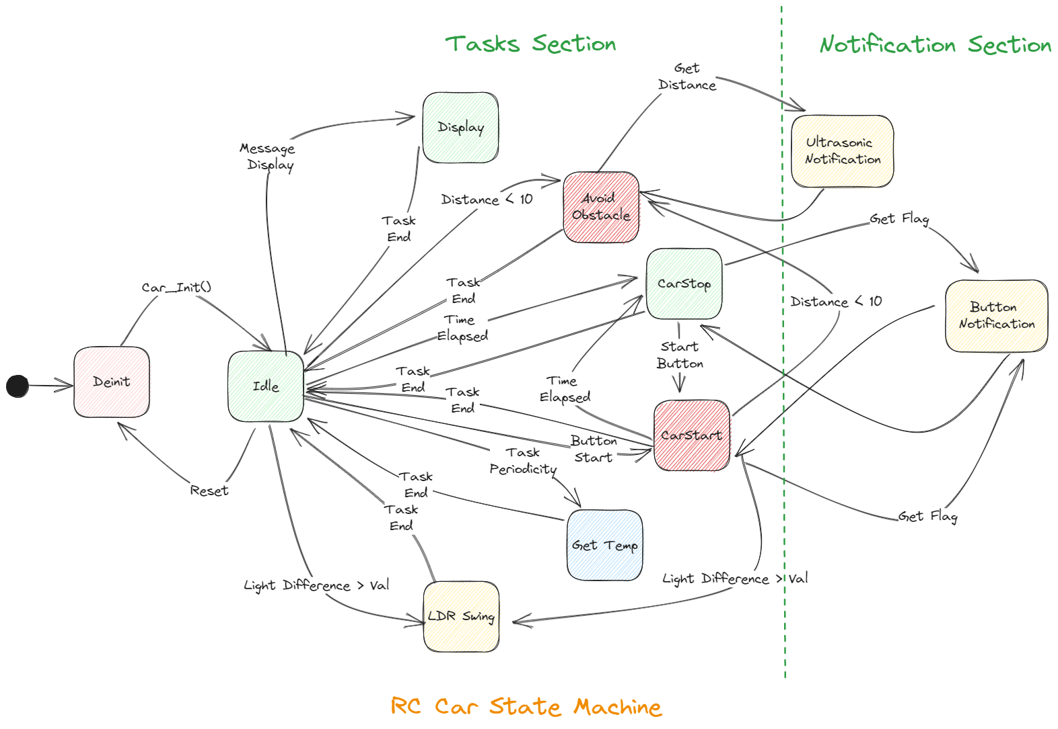

# Conclusion:

The RC Car with Ultrasonic and LDR Sensors project has been enhanced with a time-controlled start/stop feature and a scheduler. This addition allows the car to commence its movement upon the activation of one switch and continue until the other switch is pressed or a predetermined time of 60 seconds elapses. With the integration of the ultrasonic sensor, LDR sensors, and scheduler, the car can autonomously detect obstacles, navigate towards brighter areas, and operate within predefined time constraints. This project demonstrates the application of sensor integration and scheduling techniques in creating an intelligent and time-controlled RC car.