

The algorithm determine min size and max size and avg size and compares them

The results are not logical.

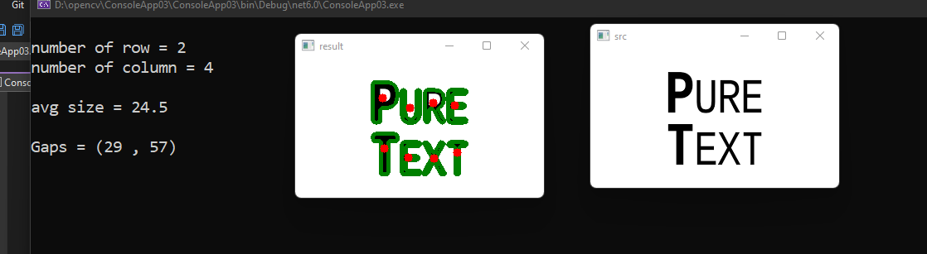

The algorithm determine min size and max size and avg size and compares them

The results are logical, so the error was not discovered.

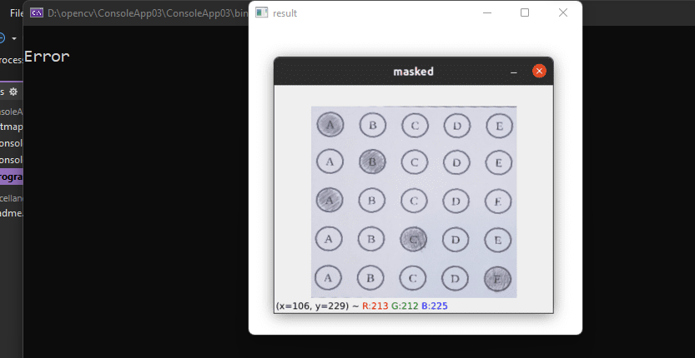

The algorithm determine min size and max size and avg size and compares them

The results are not logical.

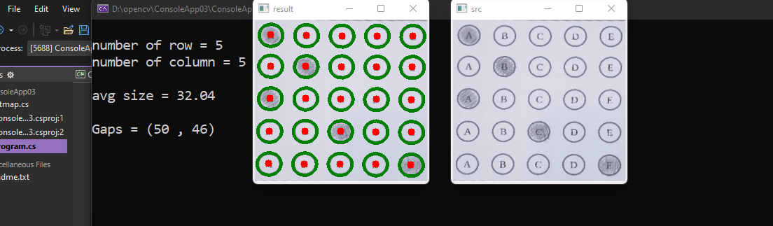

The algorithm determine min size and max size and avg size and compares them

The results are logical.