I’ll demonstrate how to implement manual a bubble sheet template using json .

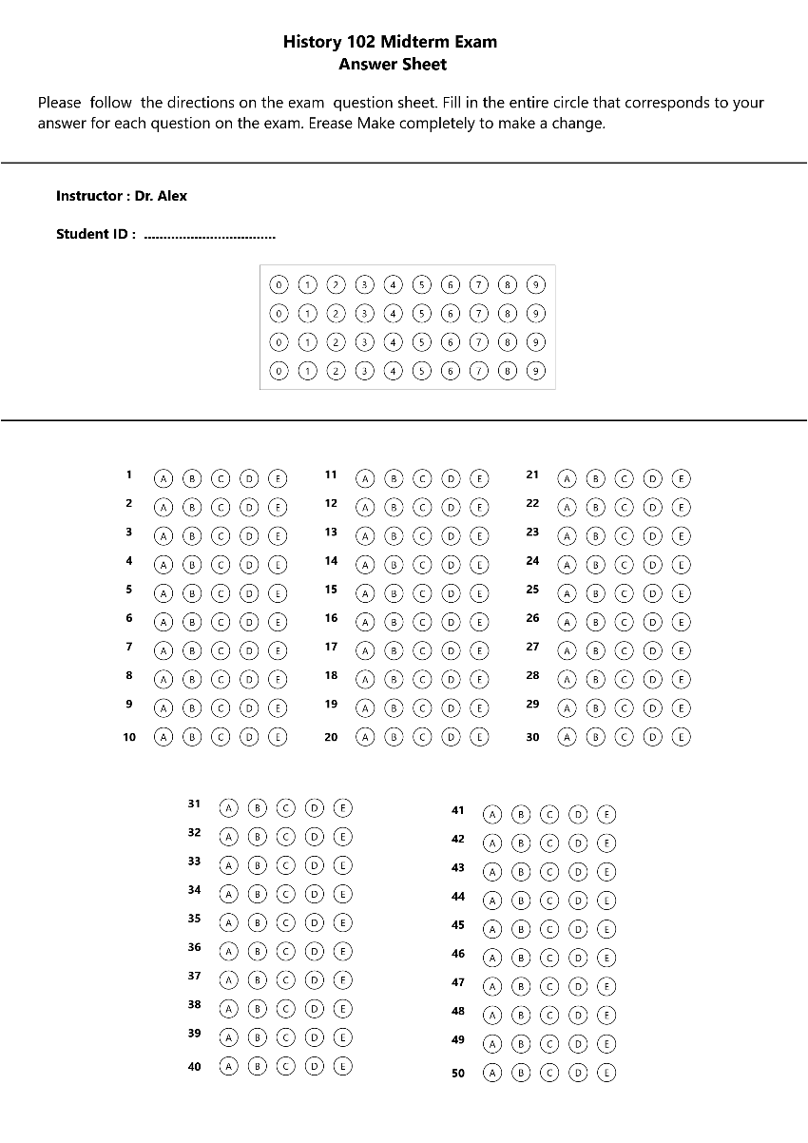

We’ll be using this as our example image as we work through the steps of building our template.

**Step #1:** **Take the blank exam picture without answers**

**Step #2:** **Calculate the new size and then write it down in the json. file**

**As shown in the following code**

"dimensions": [

    1880,

    2507

  ],

The dimensions to which each input image will be resized to before processing

**Step #3:** We calculate the volume of bubble

**For example, we open the image in paint**

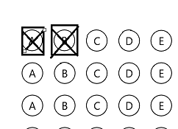

**Then we write the output of the operation in the code as shown**

"bubbleDimensions": [

    40,

    40

  ],

The dimensions of the overlay bubble area

**Step #4: PreProcessors**

If the photo was taken with a mobile phone, or if it has some rotation, it will be processed using four markers within the photo.

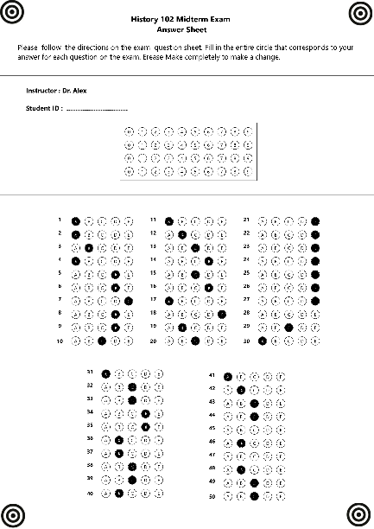

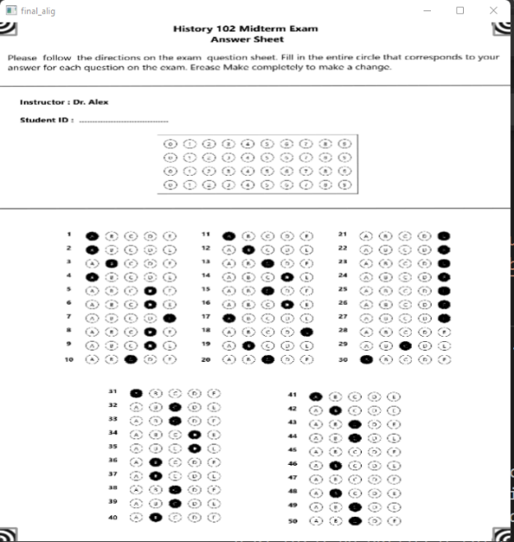

 "preProcessors": [

    {

      "name": "CropOnMarkers",

      "options": {

        "relativePath": "omr_marker.jpg",

        "sheetToMarkerWidthRatio": 17

      }

    }

  ],

**size of the kernel to use for cropping (default for most cases)**

**Step #5: "singles"**

**All questions are placed in order, knowing that these questions have one answer**

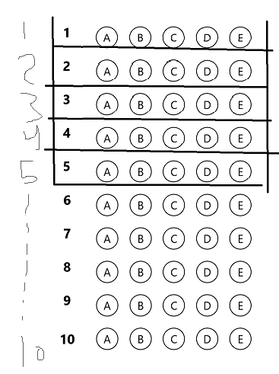

"singles": [

    "q1",

    "q2",

    "q3",

    "q4",

    "q5",

    "q6",

    "q7",

    "q8",

    "q9",

    "q10"]

-All the remaining fields whose readings shall be forwarded directly in the output csv

-If the question has only one answer, it will be added here

-In this example, we have 30 questions that have been put

**Step #6:** **"qBlocks"**

**Each rectangular box you see in the template overlay image is an element of QBlock a QBlock is either a rectangular box, or a grid of such boxes.**

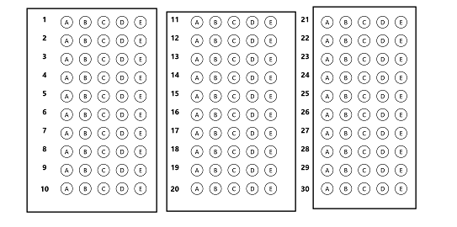

**Boxes**

**-**each box need to define this parameter

1**-** name of the QBlock

2**-** "qType": qTypes are currently

defined **in** template**.**py **in** the map

qtype_data ( "QTYPE_MED"**-** "QTYPE_ROLL"

**-** "QTYPE_INT")

3**-** "orig": the top left

starting point of QBlock

4**-** "bigGaps": (bigGapX, bigGapY)

are the gaps between origins of each box

5**-** "gaps": (gapX,gapY)

are the gaps between

rows **and** cols **in** a box

i**.**e**.** gaps between the bubbles

6**-** "qNos": qNos(nested array)

defines the arrangement of questions

**in** this QBlock

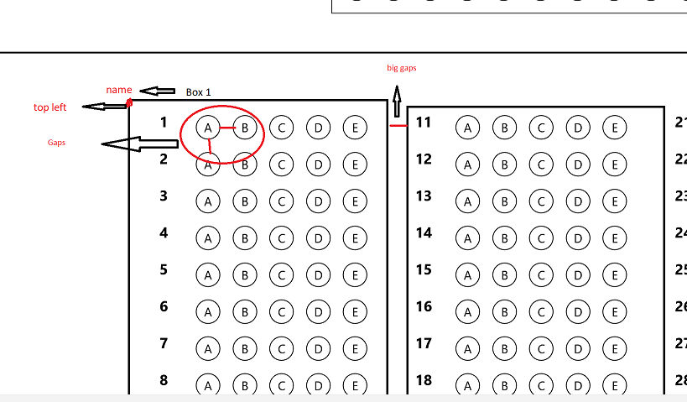

"qBlocks": {

    "Mcq1": {

      "qType": "QTYPE_MCQ5",

      "orig": [

        326,

        1020

      ],

      "bigGaps": [

        524,

        869

      ],

      "gaps": [

        70,

        65

      ],

      "qNos": [

        [

          [

            "q1",

            "q2",

            "q3",

            "q4",

            "q5",

            "q6",

            "q7",

            "q8",

            "q9",

            "q10"

          ]

        ]

      ]

    },

-Every rectangular box you see in the template overlay image is a QBlock element

- a QBlock is either a rectangular box or a grid of such boxes.

- The page should get cropped automatically and show a basic

overlay of the template. Note that we have put "orig":

[366, 1431],which means the overlay will start from [366, 1431]

- the top left starting point of QBlock

-(bigGapX, bigGapY) are the gaps between each fund's assets

- qNos(nested array) defines the arrangement of questions

in this QBlock

-(gapX,gapY) are the gaps between rows and cols in a box i.e. gaps between the bubbles

**Let's try an example and put values for gaps**

 "gaps": [

        50,

        50

      ]

Result

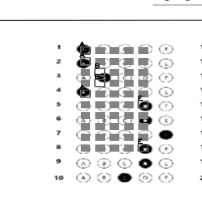

**Let's try same example and put values for gaps**

 "gaps": [

        70,

        65

      ]

Result

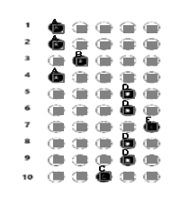

Finally, we get to work tamplate

We will show the complete code together on the same image

{

  "dimensions": [

    1880,

    2507

  ],

  "bubbleDimensions": [

    40,

    40

  ],

  "preProcessors": [

    {

      "name": "CropOnMarkers",

      "options": {

        "relativePath": "omr_marker.jpg",

        "sheetToMarkerWidthRatio": 17

      }

    }

  ],

  "concatenations":{},

  "singles": [

    "q1",

    "q2",

    "q3",

    "q4",

    "q5",

    "q6",

    "q7",

    "q8",

    "q9",

    "q10",

    "q11",

    "q12",

    "q13",

    "q14",

    "q15",

    "q16",

    "q17",

    "q18",

    "q19",

    "q20",

    "q21",

    "q22",

    "q23",

    "q24",

    "q25",

    "q26",

    "q27",

    "q28",

    "q29",

    "q30",

    "q31",

    "q32",

    "q33",

    "q34",

    "q35",

    "q36",

    "q37",

    "q38",

    "q39",

    "q40",

    "q41",

    "q42",

    "q43",

    "q44",

    "q45",

    "q46",

    "q47",

    "q48",

    "q49",

    "q50"

  ],

  "qBlocks": {

    "Mcq1": {

      "qType": "QTYPE_MCQ5",

      "orig": [

        326,

        1020

      ],

      "bigGaps": [

        524,

        869

      ],

      "gaps": [

        70,

        65

      ],

      "qNos": [

        [

          [

            "q1",

            "q2",

            "q3",

            "q4",

            "q5",

            "q6",

            "q7",

            "q8",

            "q9",

            "q10"

          ]

        ]

      ]

    },

    "Mcq2": {

      "qType": "QTYPE_MCQ5",

      "orig": [

        825,

        1020

      ],

      "bigGaps": [

        524,

        869

      ],

      "gaps": [

        70,

        65

      ],

      "qNos": [

        [

          [

            "q11",

            "q12",

            "q13",

            "q14",

            "q15",

            "q16",

            "q17",

            "q18",

            "q19",

            "q20"

          ]

        ]

      ]

    },

    "Mcq3": {

      "qType": "QTYPE_MCQ5",

      "orig": [

        1330,

        1020

      ],

      "bigGaps": [

        524,

        869

      ],

      "gaps": [

        70,

        65

      ],

      "qNos": [

        [

          [

            "q21",

            "q22",

            "q23",

            "q24",

            "q25",

            "q26",

            "q27",

            "q28",

            "q29",

            "q30"

          ]

        ]

      ]

    },

  "Mcq4": {

      "qType": "QTYPE_MCQ5",

      "orig": [

        480,

        1780

      ],

      "bigGaps": [

        524,

        869

      ],

      "gaps": [

        70,

        65

      ],

      "qNos": [

        [

          [

            "q31",

            "q32",

            "q33",

            "q34",

            "q35",

            "q36",

            "q37",

            "q38",

            "q39",

            "q40"

          ]

        ]

      ]

    },

    "Mcq5": {

      "qType": "QTYPE_MCQ5",

      "orig": [

        1148,

        1782

      ],

      "bigGaps": [

        524,

        869

      ],

      "gaps": [

        70,

        68

      ],

      "qNos": [

        [

          [

            "q41",

            "q42",

            "q43",

            "q44",

            "q45",

            "q46",

            "q47",

            "q48",

            "q49",

            "q50"

          ]

        ]

      ]

    }

  }

}

Result

