
Section
Européenne
Logbook

Summary

This is my logbook of the European section. I chose to do this class to improve my English during these 3 years. Nowadays, speaking English for a job is a really good advantage. So I decided to do this class composed of 2 more hours of English a week.

1) TRIP TO LUXEMBOURG

2)THE EUROPEAN ELECTIONS

3) THE CAMBRIDGE EXAM

1) Trip in Luxembourg

At the beginning of the school year, There was a day trip in order to meet the others European students. So we went to Luxembourg on the 13th of October of 2016. We left the high school at 8 AM by bus. We arrived in Luxembourg at half past ten. Then we visited the Mudam museum. It’s a modern art museum. The building was designed by Ming Pei. It was just beautiful and I loved the architecture and also the clarity of the place. The mix of the wood and the iron with the nature was just perfect.

We were at this museum to see the exposition of the pieces of art of Wim Delvoye. This exposition was semi permanent because it was here for approximately one year. Wim Delvoye is a famous Belgian artist. He decided to break the limits of popular cultural, old art, contemporary art, noble art and unclean art. So his works are often made with opposite materials. In the museum, Wim Delvoye created a permanent piece of art: a Chapele to celebrate the opening of the museum.
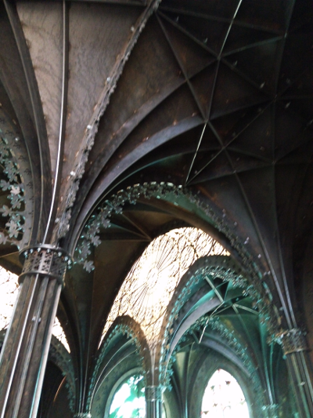
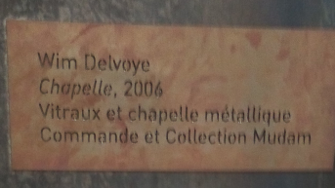
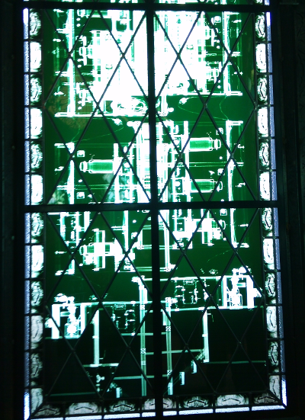
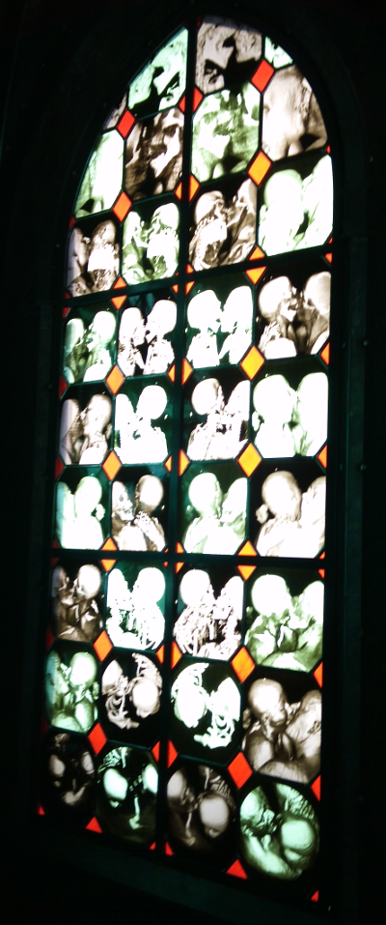
So we were divided into groups to visit the museum. There were a lot of pieces of art but some of them were strange. We saw for example : an ironing board with coat of arms on it, we saw pigs with tattoos on their back, we saw a lot of concrete mixer made with different materials, we also saw sculpted iron luggage, a strange car decorated with lily,, agoal with a stained glass of a bakery.….
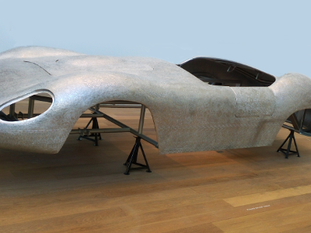
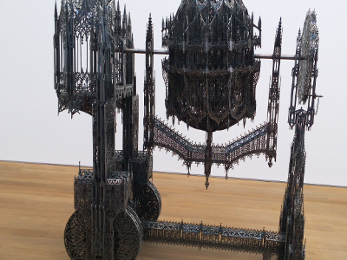
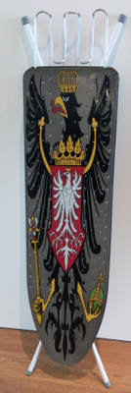
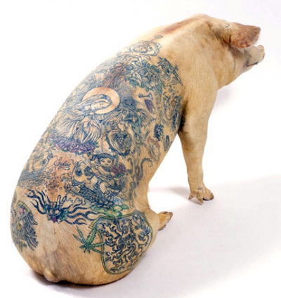

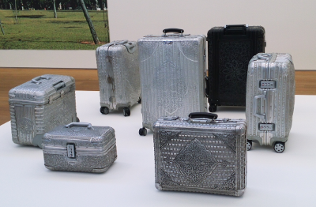
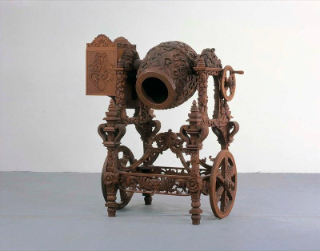
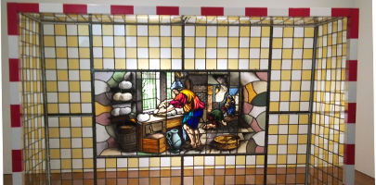

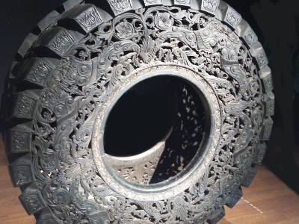

My favorite, I think were the sculpted tires. It was just sublime. This work must have been very long to create It shows that Wim Delvoye can transform a banal object in a fabulous one. To do this work, you must be patient and also very delicate.

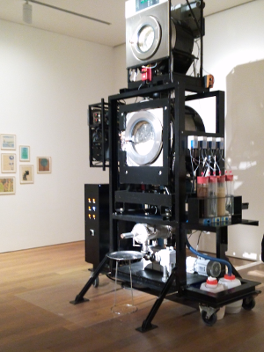
On the contrary, I don’t really like this work : It’s a special machine which reproduces the operation of your body to make excrements. It was very strange and in the room, there was a disagreeable smell.

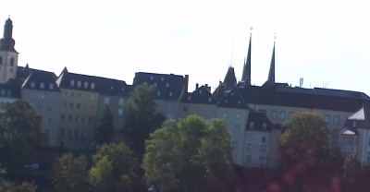

After this visit, we ate around the museum: There are beautiful ruins around it. So after a picnic with friends, we had to leave the museum to begin a big tour around Luxembourg to discover this beautiful city.

We began the visit with the Draï Echelen Museum, this name is because at the top of its tree towers, there are gold acorns. Then, we walked along the Alzette River. After that, we searched the name of the European who was born in 1886 in Luxembourg. After 10 minutes of research, we discovered that he was Robert Schuman. After have seen fortifications, we discovered the motto of Luxembourg: We want to remain what we are, we want to believe in what we see, we want to earn as much money as possible. Then, we discovered that Louis XIV is represented on the pediment because he stayed in Luxembourg city in 1687. We admired Micheal’s church: It’s a quite special church because St Micheal is represented with the Devil. After we moved on to the palace of the grand Dukes. Unfortunately, the monarch wasn’t there because there wasn’t the flag in front of the monument. On the balcony, there was a red lion which represents Luxembourg in coat of arms. After this step, we were quite lost in the town so after approximately 30 minutes, we finally found our way back. We visited the other monuments very fast because we didn’t have much time before going back to France. We finished the trip by the Constitution square: There is a column, and at the top of it, there is “Gaelle Fra” wich is a golden woman which is holding a golden wreath. This monument was erected in memory of all the soldiers who died in the world wars.

So after this few kilometers of discovery, we went to the high school at 5 PM. It was a very good experience for me because I could meet the other students and also discover the city of Luxembourg. It was my first trip abroad.

2)The European election.

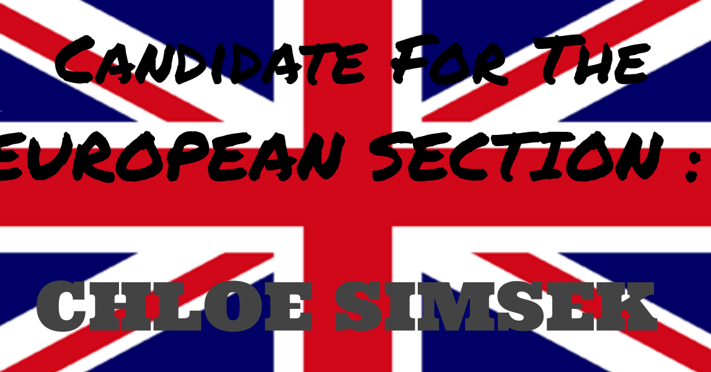

On Thursday the 9th of February, we elected our representant of the European section. It was a huge event because all the European students were here. Each class had a candidate for the European election. And each candidate had to have a campaign, a slogan, a song, a vice president, a diaporama, and the most important; He had to do a speech of 5 minutes for all the students. In my class, the candidate was Chloé Simseck. I helped her to do her diaporama with all her ideas. I also scroll through the diaporama when she talked the day of the election. There were 8 candidates. After all the candidates speaked, we voted. After that, waiting for the results, the school organized a huge snak for everyone. I helped because I served juice, sodas, coke in glasses for the other students. There were also candies, cakes… After this snak, we finally had the results. The winner was Zakari !!
It was a very good election because all the students were together..
3)The Cambridge Exam

At the beginning of the month of March, we took an exam : The Cambridge certificate.

It’s an exam composed of two parts: one is writing and oral comprehension and the other part is an oral of 20 minutes. To succeed, we did training every week with the tests of previous years. I think this training was very useful for me because I could improve my English thank to them. So Now the exam is finish and I just have to wait until next year to have the results.

