**NAME : GROUP X**

**COURSE : EDM1142**

**SPECIALITY : SWE 1**

**Lab 3**

1. Write down the problem statement for a suggested system of relevance.

ANSWER:

Problem: The voting system in our country has endured several cases of fraud and carelessness from our supervisor which lead to the missing of some cards and counting errors hence disadvantaging some parties and advantaging the others which leads to other distortion in the political system.

As a new party is voted in that disorder and riskful manner it will lead to the replacement of some members of the ongoing staff as well as introducing a new system which might create or put things up side down.

The voting takes place mostly at the polls at specific areas hence imposing the voters to make their way there and follow a line which cost them time and transport money including the traffic they might faced during the transport.

1. What is the problem that needs to be solved?

Voting in this country is full of fraud as the unregistration of some votes and bribery. Also counting errors including the time consumption, the carelessness and the easy falling in temptation by the supervisor and the concerned staff which are basicly all normally paid al. Hence resulting in the winning or selection of an unwanted party and leading to a retrorss in the development of the community and their activities.

1. Why is it a problem? (highlight the pains)

The ignoring of this situation will lead to a high level in fraud (as if a voter poses 2 card he can vote separately for the same party) and in the defects in the political staff increasing strike in some zones or the division of the country due to that it may lead to death cases, famine, lost of shelter, increase in the number of refuges.

1. Where is the problem observed? (location, products)

The problem is observed at the levels of the polls and at the administration office where the votes are classified according to the party chosen. Also observed whereby a double vote has been done by voter which already leads to fraud.

1. Who is impacted? (customers, businesses, departments)

It affects the working staff of the precedent president as they could get fired by the incoming president. Also it affects the citizens who might find the new system difficult to manage with and the community development might retrogress.

1. When was the problem first observed?

This is an ongoing issue going back as far as voting is concern in this country and has become more evident as unemployment increases and as strikes are detected in some zone with an increase in the death case this recent years.

1. How is the problem observed? (symptoms)

The problem is observed when several people comes together to claim their duty as citizens, also no great change is observed in the development of the society.

1. How often is the problem observed? (error rate, magnitude, trend)

This problem is faced every time there is a vote going on in the country and a very slow rate in the development of the community and their activities is also observed. Also a high rate of unemployment is observed.

UML Design

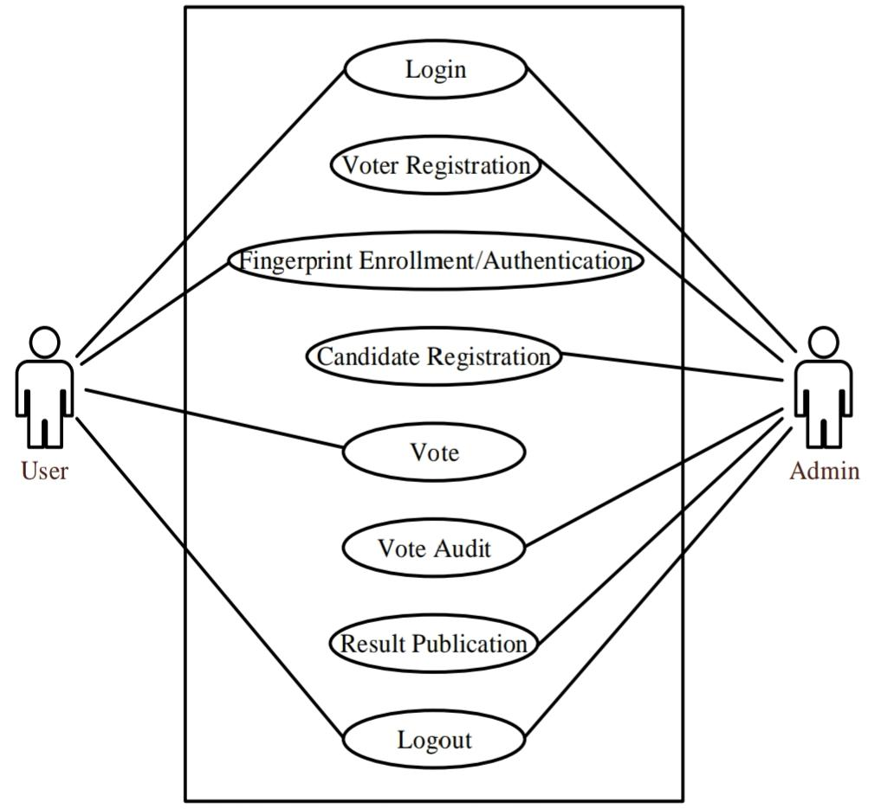Diagrammatic representation of the system using the case system;