Project Overview

Project name : IT Asset Management System

Purpose:
A system for tracking and managing an organization's IT assets, including their assignments, locations, statuses, requests, and maintenance history
.
1. Admin
2. IT Technician
3. Employee
4. Manager / Viewer

Core entities:
Asset
Employee
Branch
User
Asset Request
Assignment
Maintenance Record
Damage Incident
Audit Log

Functional Requirements
FR-01: The system shall allow authorized users to register new IT assets.
FR-02: The system shall allow authorized users to update asset information.
FR-03: The system shall allow authorized users to view, search, and filter registered assets.
FR-04: The system shall allow IT technicians to assign an available asset directly to an employee or in response to an approved asset request.
FR-05: The system shall allow IT technicians to record the return of an assigned asset.
FR-06: The system shall allow IT technicians to record maintenance activities for an asset.
FR-07: The system shall track the current status of each asset.
FR-08: The system shall maintain asset assignment and maintenance history.
FR-09: The system shall allow administrators to manage users and branches
FR-10: The system shall restrict system functions according to user roles and permissions.
FR-11: The system shall allow employees to submit requests for IT assets.
FR-12: The system shall allow employees to request the return or replacement of assigned assets.
FR-13: The system shall allow IT technicians to review, approve, or reject asset requests.
FR-14: The system shall allow employees to view their assigned assets and track the status of their requests.
FR-15: The system shall notify employees when their request status changes and provide pickup instructions when an assigned asset is ready for collection.
FR-16: The system shall allow managers to view reports and summaries about assets, requests, assignments, and maintenance.
FR-17: The system shall allow IT technicians to record asset damage incidents, including damage details, reported employee responsibility, and estimated repair cost.
FR-18: The system shall allow administrators to record and track authorized compensation or deduction decisions related to employee-caused asset damage.

Non-Functional Requirements
NFR-01: The system should have a simple and clear interface..
NFR-02: The system should validate all required input..
NFR-03: The system should protect restricted operations..
NFR-04: The code should follow object-oriented principles..
NFR-05: The system should use appropriate design patterns..
NFR-06: The project should include tests and documentation..

Use Case Analysis

Actor: Employee
Description: An employee who requests, views, returns, and tracks IT asset requests through the system.

Description | Use Case
The employee signs into the system. | Login
The employee views the IT assets currently assigned to them. | View Assigned Assets
The employee submits a request for a new IT asset. | Request IT Asset
The employee requests to return an assigned asset. | Request Asset Return
The employee requests a replacement for an assigned asset. | Request Asset Replacement
The employee tracks the status of submitted requests and views pickup instructions when an asset is ready for collection. | View Request Status
The employee views previous asset requests. | View Request History
The employee signs out of the system. | Logout

Actor: IT Technician
Description: An IT technician who manages IT assets, approves requests, assigns devices, performs maintenance, and updates asset information.

Description | Use Case
The IT technician signs into the system. | Login
The IT technician registers a new IT asset in the system. | Add Asset
The IT technician updates asset information such as serial number, specifications, or status. | Update Asset
The IT technician searches for assets using different criteria. | Search Assets
The IT technician reviews an employee's asset request before making a decision. | Review Asset Request
The IT technician approves or rejects a reviewed asset request. | Approve/Reject Asset Request
The IT technician assigns an available asset directly to an employee or to an approved asset request. | Assign Asset
The IT technician receives a returned asset from an employee. | Receive Returned Asset
The IT technician changes the asset status to Available, Assigned, Under Maintenance, Retired, or Lost. | Change Asset Status
The IT technician records maintenance details for an asset. | Record Maintenance
The IT technician views assignment and maintenance history of an asset. | View Asset History
The IT technician marks an assigned asset as ready for collection and specifies the pickup location or instructions. | Mark Asset Ready for Pickup
The IT technician records asset damage details, reported employee responsibility, and estimated repair cost. | Record Damage Incident
The IT technician signs out of the system. | Logout

Actor: Admin
Description: An administrator who manages users, roles, branches, system settings, and access permissions.

.
Description | Use Case
The administrator signs into the system. | Login
The administrator creates a new system user account. | Add User
The administrator updates user information. | Update User
The administrator disables a user account without deleting its history. | Deactivate User
The administrator assigns a role to a user. | Assign Role
The administrator controls what each role can access or modify. | Manage Permissions
The administrator registers a new company branch. | Add Branch
The administrator updates branch information. | Update Branch
The administrator reviews important actions performed in the system. | View Audit Logs
The administrator views a general summary of users, branches, assets, and requests. | View System Summary
The administrator records an authorized compensation or deduction decision related to an asset damage incident. | Record Compensation Decision
The administrator signs out of the system. | Logout

Actor: Manager / Viewer
Description: A manager who monitors IT assets, employees, requests, and reports without modifying system data.

Description | Use Case
The manager signs into the system. | Login
The manager views all registered IT assets. | View Assets
The manager searches for assets. | Search Assets
The manager views employee information. | View Employees
The manager reviews asset assignments. | View Asset Assignments
The manager reviews employee asset requests. | View Asset Requests
The manager views maintenance records. | View Maintenance History
The manager views system reports and summaries. | View Reports
The manager views recorded asset damage incidents and related costs. | View Damage Incidents
The manager signs out of the system. | Logout

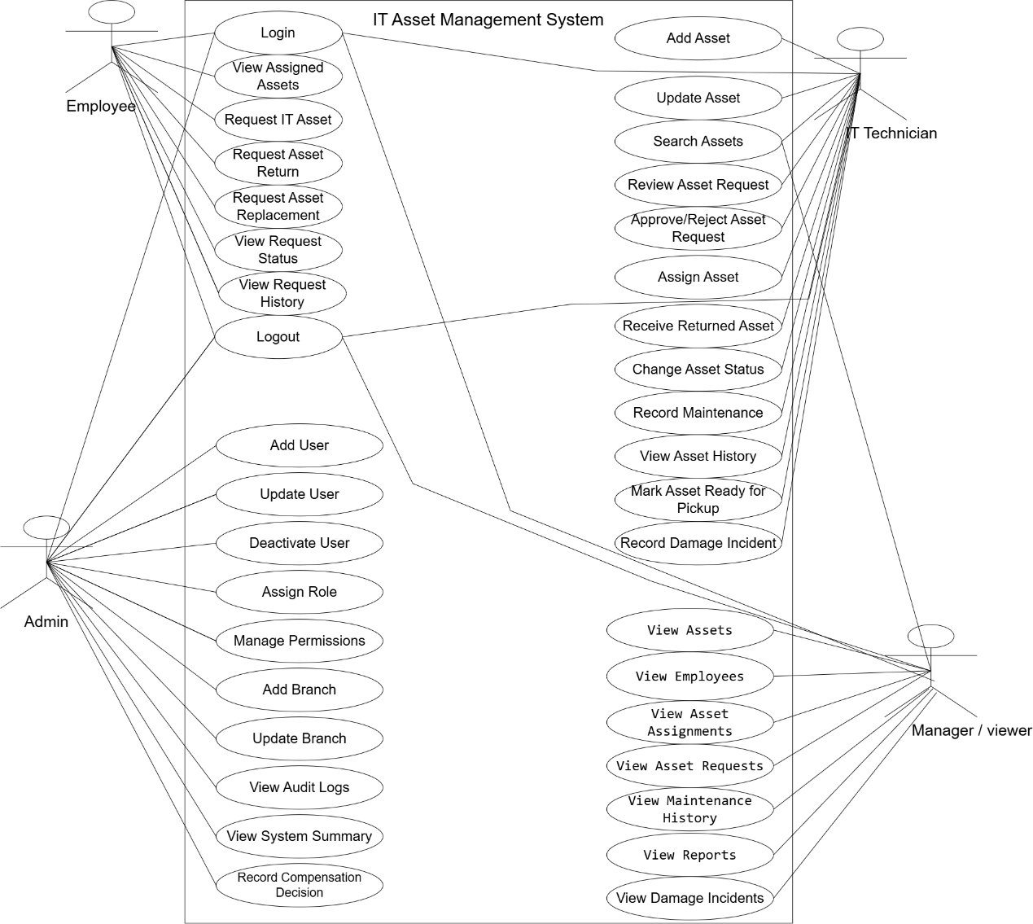

Business Rules

Business Rule | Rule ID
Only assets with the status Available can be assigned. | BR-01
An asset can be assigned to only one employee at a time. | BR-02
An employee cannot have two pending requests for the same asset type. | BR-03
An asset may be assigned directly by an IT technician or through an approved asset request | BR-04
Returned assets must be inspected before becoming available again. | BR-05
Every maintenance operation must be recorded in the asset history. | BR-06
Users can perform only the actions permitted by their assigned roles. | BR-07
Employees can view only their own assigned assets and requests. | BR-08
Assets and users with existing history must be deactivated or retired rather than permanently deleted. | BR-09
Every asset damage incident must be recorded before any compensation or deduction decision is tracked. | BR-10
IT technicians may record damage details but cannot authorize financial deductions. | BR-11
Pickup instructions shall be provided only after an asset has been assigned and marked as ready for collection. | BR-12
Important administrative and asset operations must be recorded in the audit log. | BR-13

System Status Definitions

Asset Request Status:
PENDING - Request submitted and waiting for review.
UNDER_REVIEW - Request is being reviewed by IT.
APPROVED - Request has been approved.
REJECTED - Request has been rejected.
ASSET_ASSIGNED - An asset has been assigned to the request.
READY_FOR_PICKUP - The assigned asset is ready for collection.
COMPLETED - The employee has received the asset.
Asset Status:
AVAILABLE - Asset is available for assignment.
ASSIGNED - Asset is currently assigned to an employee.
UNDER_MAINTENANCE - Asset is undergoing maintenance.
RETIRED - Asset has been removed from active service.
LOST - Asset has been reported lost.

Document History

Description | Date | Version
Initial project overview and requirements | 2026-08-06 | 1.0
Added actor use case analysis | 2026-08-06 | 1.1
Added business rules | 2026-08-06 | 1.2
Added direct asset assignment, damage incident tracking, compensation records, pickup notifications, and system status definitions. | 2026-08-07 | 1.3

