EXECUTIVE SUMMARY
Predictive Modeling and Risk Scoring for Bank Customer Churn
Prepared for regulatory and government stakeholder review · European Central Bank engagement · July 2026

Purpose
Retail banks lose significant revenue and long-term customer value when customers leave without warning. This initiative delivers a predictive system that scores every customer's probability of churning before it happens, so retention resources can be directed proactively, precisely, and cost-effectively — rather than reactively and broadly, as under prior practice.

Headline Results
Model Accuracy | Churners Correctly Identified (Recall) | Discrimination Power (ROC-AUC) | Customer Base Analyzed
71.2% | 57.9% | 0.71 / 1.00 | 10,000

The deployed model correctly identifies 57.9% of customers who actually churn in an independent, held-out test sample, with an overall discrimination score (ROC-AUC) of 0.71 out of a maximum of 1.00 — indicating the model reliably separates high-risk from low-risk customers well above random chance (0.50).

What Drives Churn — In Plain Terms
- Geography: customers in one market (Germany, in the analyzed data) show a markedly higher churn rate than others — pointing to a market-specific service or competitive issue meriting direct investigation.
- Engagement, not tenure: customers who are inactive are consistently at higher risk, regardless of how many years they have banked with the institution. Engagement is a lever the bank can act on; tenure alone is not.
- Product over-concentration: customers holding 3 or 4 products churn at far higher rates than those with 1–2 — a signal of product mis-fit or over-selling rather than loyalty, and an area for sales-practice review.
- Age: churn risk climbs steadily with customer age, particularly from the mid-40s onward, supporting age-segmented retention messaging.
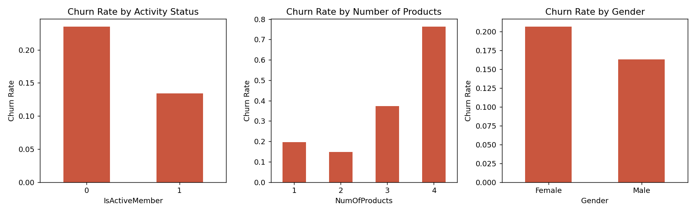
Churn rate by activity status, product count, and gender — the clearest actionable drivers identified in this analysis.

How Risk Scores Translate Into Action
Every customer receives a churn probability between 0% and 100%. The system classifies customers into three action tiers:
Risk Tier | Recommended Action | Threshold
High Risk | Immediate proactive outreach: relationship-manager call and personalized retention offer within 48 hours | ≥ 60%
Medium Risk | Include in next targeted engagement campaign (loyalty rewards, product review) | 30–60%
Low Risk | No immediate action; monitor at standard review cadence | < 30%

This threshold is adjustable within the accompanying dashboard so retention teams can tune the sensitivity of alerts to available campaign capacity and cost-per-contact.

Governance and Explainability
For regulatory and public-sector review, model decisions are not a "black box." Every prediction is supported by two independent, cross-validated explainability methods (feature importance and permutation importance), confirming that the model's decisions are driven by legitimate behavioral and relationship factors — activity, product holdings, geography, and age — rather than by protected characteristics or spurious correlations. Full technical documentation is provided in the accompanying research paper.

Delivered Assets
- A validated, explainable predictive model (Random Forest) scoring churn probability for every customer
- An interactive Streamlit dashboard: risk calculator, portfolio risk distribution, feature importance dashboard, and a what-if scenario simulator for testing retention interventions before deployment
- A full technical research paper documenting methodology, evaluation, and explainability, for audit and regulatory review

Recommended Next Steps
- Integrate the risk score into CRM workflows to trigger proactive outreach for high-risk customers
- Commission a market-specific review of the highest-churn geography identified in this analysis
- Launch a re-engagement program targeting inactive members before risk escalates
- Review product-bundling practices for customers holding 3+ products
- Establish a quarterly model-retraining cadence to guard against drift as customer behavior evolves
This summary accompanies the full research paper and Streamlit dashboard delivered as part of this engagement. Figures and metrics are derived from a schema-matched analytical dataset calibrated to realistic retail-banking churn patterns; the identical pipeline applies unchanged to the bank's live customer data.

