2



Africa before the Agricultural Age, 16,000-9000

# Africa and the World: From Gathering to Farming

From 60,000 years ago down to the tenth millennium BCE, the peoples of Africa, like all human beings everywhere in the world in those times, and like their hominid ancestors of still earlier ages, obtained their food entirely by gathering wild plants and hunting wild animals. They were gatherer-hunters or, as we also say, food-collectors in economy.

Then in the very early Holocene—the most recent geological epoch, lasting from the eleventh millennium BCE down to the present—there appeared, separately and independently in three small regions ofthe world, a series of developments of immense importance for the overall course ofhuman history. In those regions between 9500 and 7000 BCE, people began the first deliberate raising and nurturing of particular sources of food, both plant and animal— they took the first small steps toward creating food-producing, as opposed to food-collecting, ways of life. One of these regions lay in the Middle East, in the crescent of hill and plateau country with Mediterranean climate that stretches from Palestine and Syria eastward through southern Turkey and around into western Iran. A second center of earliest food production emerged in the tropical rainforest zones of southern East Asia. The third center of earliest agricultural invention lay in Africa, in the areas that today comprise the southern half of the eastern Sahara desert but in those days were lands of tropical and semitropical steppe and grassland vegetation.

|  |  |
| --- | --- |
| Why did these developments begin where and when they did? Why were they of such momentous importance to the future directions of history?  The first question we can answer in at least broad terms. The last ice age, an epoch ofworldwide effects, had only recently come to an end. The great glaciations, which spread more than 20,000 years ago across so much ofnorthern Europe and northern North America, had by 10,000 BCE shrunk back till only the most northerly regions of the Northern Hemisphere, such as Greenland and parts of Alaska and Scandinavia, and high mountain ranges, such as the Alps and the Canadian Rockies, still maintained major ice packs. The smaller glaciers on the high equatorial peaks of Africa—Mount Ruwenzori, Mount Kilimanjaro, and Mount Kenya—had shrunk, too; and in many areas all across the globe, major climatic shifts had begun, changing in new and challenging ways the environments in which human beings lived. As a result, over a period of centuries, the kinds and availability of the wild foods people depended on changed, in some regions drastically.  The close of the ice age thus meant that people in many parts of the world increasingly had to seek out new kinds of food resources or pioneer new methods of obtaining sustenance. Most of the human societies of the time either found ways to adapt their older patterns of subsistence to the new situations or evolved new approaches to gathering and hunting that allowed them to persist as still more effective food collectors.  But in the southeastern Sahara, the Middle East, and southern East Asia, certain local communities of 9500—7000 BCE took these processes one step further: they began for the first time to add to their food resources by taking deliberate care of a few of their local animals and plants, tending and protecting them from the dangers of nature. In each area the early domesticates included animals—in the southeastern Sahara, the cow; in the Middle East, the sheep and the goat; and in Southeast Asia, the chicken. The food-producers of each of the three regions began also to cultivate a few of the important plants they had previously collected in the wild form. Among the peoples of the southeastern Sahara, it was the grain crop sorghum that gained first importance, while the Middle Easterners turned to the cultivation of wheat and barley, and the Southeast Asians to the domestication ofrice and, perhaps later, the banana.  Between 8000 and 5000 BCE, peoples in at least three more distinct regions of the world moved separately and independently in the same historical direc- | 27  Africa before the Agricultural Age |



|  |  |
| --- | --- |
| 28  The  Civilizations of Africa | tions. Two ofthese regions were located in sub-Saharan Africa; the third, which may have consisted of several interacting centers of plant domestication, lay in the Americas. In the woodland savannas of West Africa, local communities commenced the shift to a food-producing way oflife before 6000 BCE by changing over from the collecting to the deliberate cultivation of several indigenous African species of yam. Probably almost as early in time, another group of  African peoples, residing far away to the east, in high-rainfall areas of the Ethiopian Highlands, innovated a quite different agriculture based on utilization of the enset plant, which is similar in appearance to the banana plant. Still farther away, in Mesoamerica, the first Native American cultivation, of pumpkins, had emerged before 7000 BCE in northeastern Mexico. By 5000 BCE other crops, most notably maize ("corn" in American English), had begun to be added to the crop repertoire in other parts of Mesoamerica.  Why did these several groupings of peoples in disparate parts of the world respond in similarly distinctive manners, independently of each other, to the changing natural environments of the early Holocene epoch? That remains a question we cannot yet fully answer.  What we can do, however, is commence exploring the historical backgrounds out of which the first African food-producing societies emerged. We must first look more closely at the various worlds in which Africans lived during the several thousand years before 9000 BCE and at the differing foodcollecting economies they practiced in those earlier times. From these considerations we may start to grasp the particular historical circumstances in which at least some ofthe earliest inventors ofagriculture—namely the African communities residing 11,000 years ago in the southeastern Sahara—would have found it useful and worthwhile to add first animal raising and then plant cultivation to their existing subsistence activities. Similarly, we can then seek to understand the subsequent inventions of agriculture in West Africa and the Ethiopian Highlands and perhaps also gain some insight into the alternative, non-agricultural choices followed by African peoples outside those regions.  From the African cases we may in turn be able to draw wider lessons that can fruitfully reshape and deepen our understandings of human motivation and initiative in history. At the same time we will come to better see the fit of African history into the world history of those early eras. |



Geography and Climate in African History African Climate and Vegetation 18,000 Years Ago

|  |  |
| --- | --- |
| In the earlier parts of the last ice age, before about 18,000 years ago, the African continent possessed a variety of climates not all that much different from those we know of today in Africa.  At the heart of the continent, extending on both sides of the equator to about five degrees south and five degrees north latitude, lay a zone of high precipitation. Rainfall, annually totaling more than 1,800 millimeters (70 or more inches), was spread throughout the year, except for a short dry period of one or two months. This rainfall regime supported a far-extended region of tropical rainforest occupying, as it does today, the central Congo Basin of equatorial central Africa as well as a belt of country extending up to 300 kilometers inland along most of the Atlantic coastal regions of West Africa. All across these regions, a dense cover of tall trees formed the predominant ecotype. In a few areas, where sandy soils prevailed, patches of savanna vegetation could also be found deep within the forest zones.  In West Africa to the north ofthe rainforest proper, and in the Congo Basin both to the north and to the south of the forest, lay regions with 1,300 to 1,800 millimeters (about 50 to 70 inches) of rain and a longer dry season of two to four months' length. Before human agricultural activity the natural vegetation of such areas would have been woodland savanna. This kind of environment is characterized by forest of less imposing size and density than the rainforest and with more interspersed areas of grass and bush.  Moving still farther north or south, one would have encountered successively less well watered lands. Immediately north and south ofthe belts ofwoodland savanna lay drier woodland savanna with 800 to 1,300 millimeters (about 30 to 50 inches) of precipitation. Farther north and south could be found still more open savanna, with dry deciduous woodland areas and 400 to 800 millimeters (15 to 30 inches) of rain a year. Next one would have reached steppe country with 150 to 400 millimeters of rain (6 to 15 inches) yearly. North and south of the steppe lands lay still more arid zones of desert steppe and desert.  The northerly African zone of steppe environment formed the long eastwest belt of country known today as the Sahel. To the immediate north of the Sahel, then as now, lay the vast region of desert we call the Sahara. The Sahara in those times was an even more extreme desert than it is today. In contrast, the southern African counterpart of the Sahel and Sahara, the Kalahari region, for | 29  Africa before the Agricultural Age |

|  |  |
| --- | --- |
| 30  The  Civilizations of Africa | the most part actually consisted of steppe country, with only limited areas of desert steppe and true desert occurring along the Atlantic coast and the lower Orange River.  Finally, at the northern and southern extremes of the continent lay still another kind of climate regime. Here could be found two relatively narrow regions of subtropical Mediterranean climate, not unlike that of California, with modest yearly rainfall arriving principally in the cool season of the year. One region of this kind of climate extended across a considerable portion of North Africa; the other occupied coastal areas extending east from the Cape of Good Hope at the southern tip of the continent, in modern-day South Africa. (The vegetation zones of Africa before 16,000 BCE may not have been all that different from those for periods since 2000 BCE, shown on map 9 in chapter 4.)  The eastern side ofAfrica stood then, as it does now, outside the more general climatic pattern of the continent. Through most of the eastern areas, various kinds of savanna environments have long been the rule. Moist woodland savannas occurred in some areas around Lake Malawi and in several stretches of country along the Indian Ocean coast, while drier types of savanna prevailed across many ofthe intervening areas. Most of the vast stretch of land that comprises the interior regions of Somalia and northern Kenya, as is true today, was characterized by a still drier climatic regime with steppe vegetation, while areas of true desert covered parts of far northern Somalia.  In addition, the eastern side of Africa contains several major highland zones, which then as now were strikingly different in climate from the surrounding areas. The largest of these, the immense Ethiopian Highlands, covers a region larger than the whole of France. The region consists of a series of high hilly plateaus cut here and there by deep river gorges and valleys, and much of its varied terrain lies above 1,800 meters (5,900 feet) in elevation, with its highest peak reaching 4,620 meters (15,158 feet).  A second major highland region cuts across central and western Kenya, where its tallest peaks, Mount Elgon and Mount Kenya, reach heights, respectively, of 4,321 meters (14,178 feet) and 5,200 meters (17,058 feet). This highland zone extends southward into modern-day central northern Tanzania and includes such notable features there as the Serengeti Plains and Mount Kilimanjaro, Africa's highest peak at 5,895 meters (19,340 feet).  At the western edge of East Africa, stretching for 600 kilometers north and south along the modern boundary of Congo with Uganda, Rwanda, and Bu- |



|  |  |
| --- | --- |
| rundi, lies a third major area of highlands. Its highest peaks are Mount Ruwenzori at 5,120 meters (16,791 feet), situated on the border of far western Uganda, and Mount Karisimbi in northwestern Rwanda, with its peak at 4,507 meters (14,786 feet).  High and cool and for the most part blessed with substantial yearly rainfall, these various highlands before 18,000 years ago (and more recently, as well) were home to extensive montane forests, principally between the elevations of 1,800 and 3,000 meters. ("Montane" describes highland environments in the tropics, cooler and wetter than the surrounding areas because of their higher altitudes.) Above 3,000 meters (9,800 feet), the forests gave way to cold moorland environments, while grasslands occurred below the mountain forests, in highland areas oflesser rainfall, such as on the Serengeti Plains and in the great, long rift valleys that cut through each of the eastern African highlands.  The rift valleys were formed by long parallel fault lines left over from a period ofintense geological activity from about 8 million to 5 million years ago. If the rifts had stayed geologically active, they would eventually have broken off the eastern side ofAfrica into a small continent of its own. Each rift region consists oflong, narrow stretches ofrelatively deep valley, bordered usually on both sides by higher, mountainous lands. Volcanic activity associated with the rifting has further built up the height ofthe mountains around each rift valley. The floors of the rift valleys often lie at altitudes of1,500 to 2,000 meters themselves, but the mountains on each side extend higher still. Three names are used for these features: Ethiopian Rift for the rift valley that crosses through the eastern and southern Ethiopian Highlands; Western Rift for the system of rift valleys that extends past Mount Ruwenzori for 1,500 kilometers along the west edge of | 31  Africa before the Agricultural Age |

East Africa; and Eastern or Kenya Rift for the Kenyan and northern Tanzanian example of this feature.

Map 2 is our master guide to locating these and other features of African geography. This map identifies the major mountains, basins, rift valley systems, rivers, lakes, and seas that will figure again and again in our story of the African past. Readers may wish to return to it from time to time for a geographical reorientation. (One side point: one rift valley system of Africa, the long northsouth Western Rift, is traced out by the curved line oflakes extending from Lake Rwitanzige on the north through Lakes Ruiru and Kivu to Lake Tanganyika on the south; there was not enough space to fit the words "Western Rift" onto the map.)

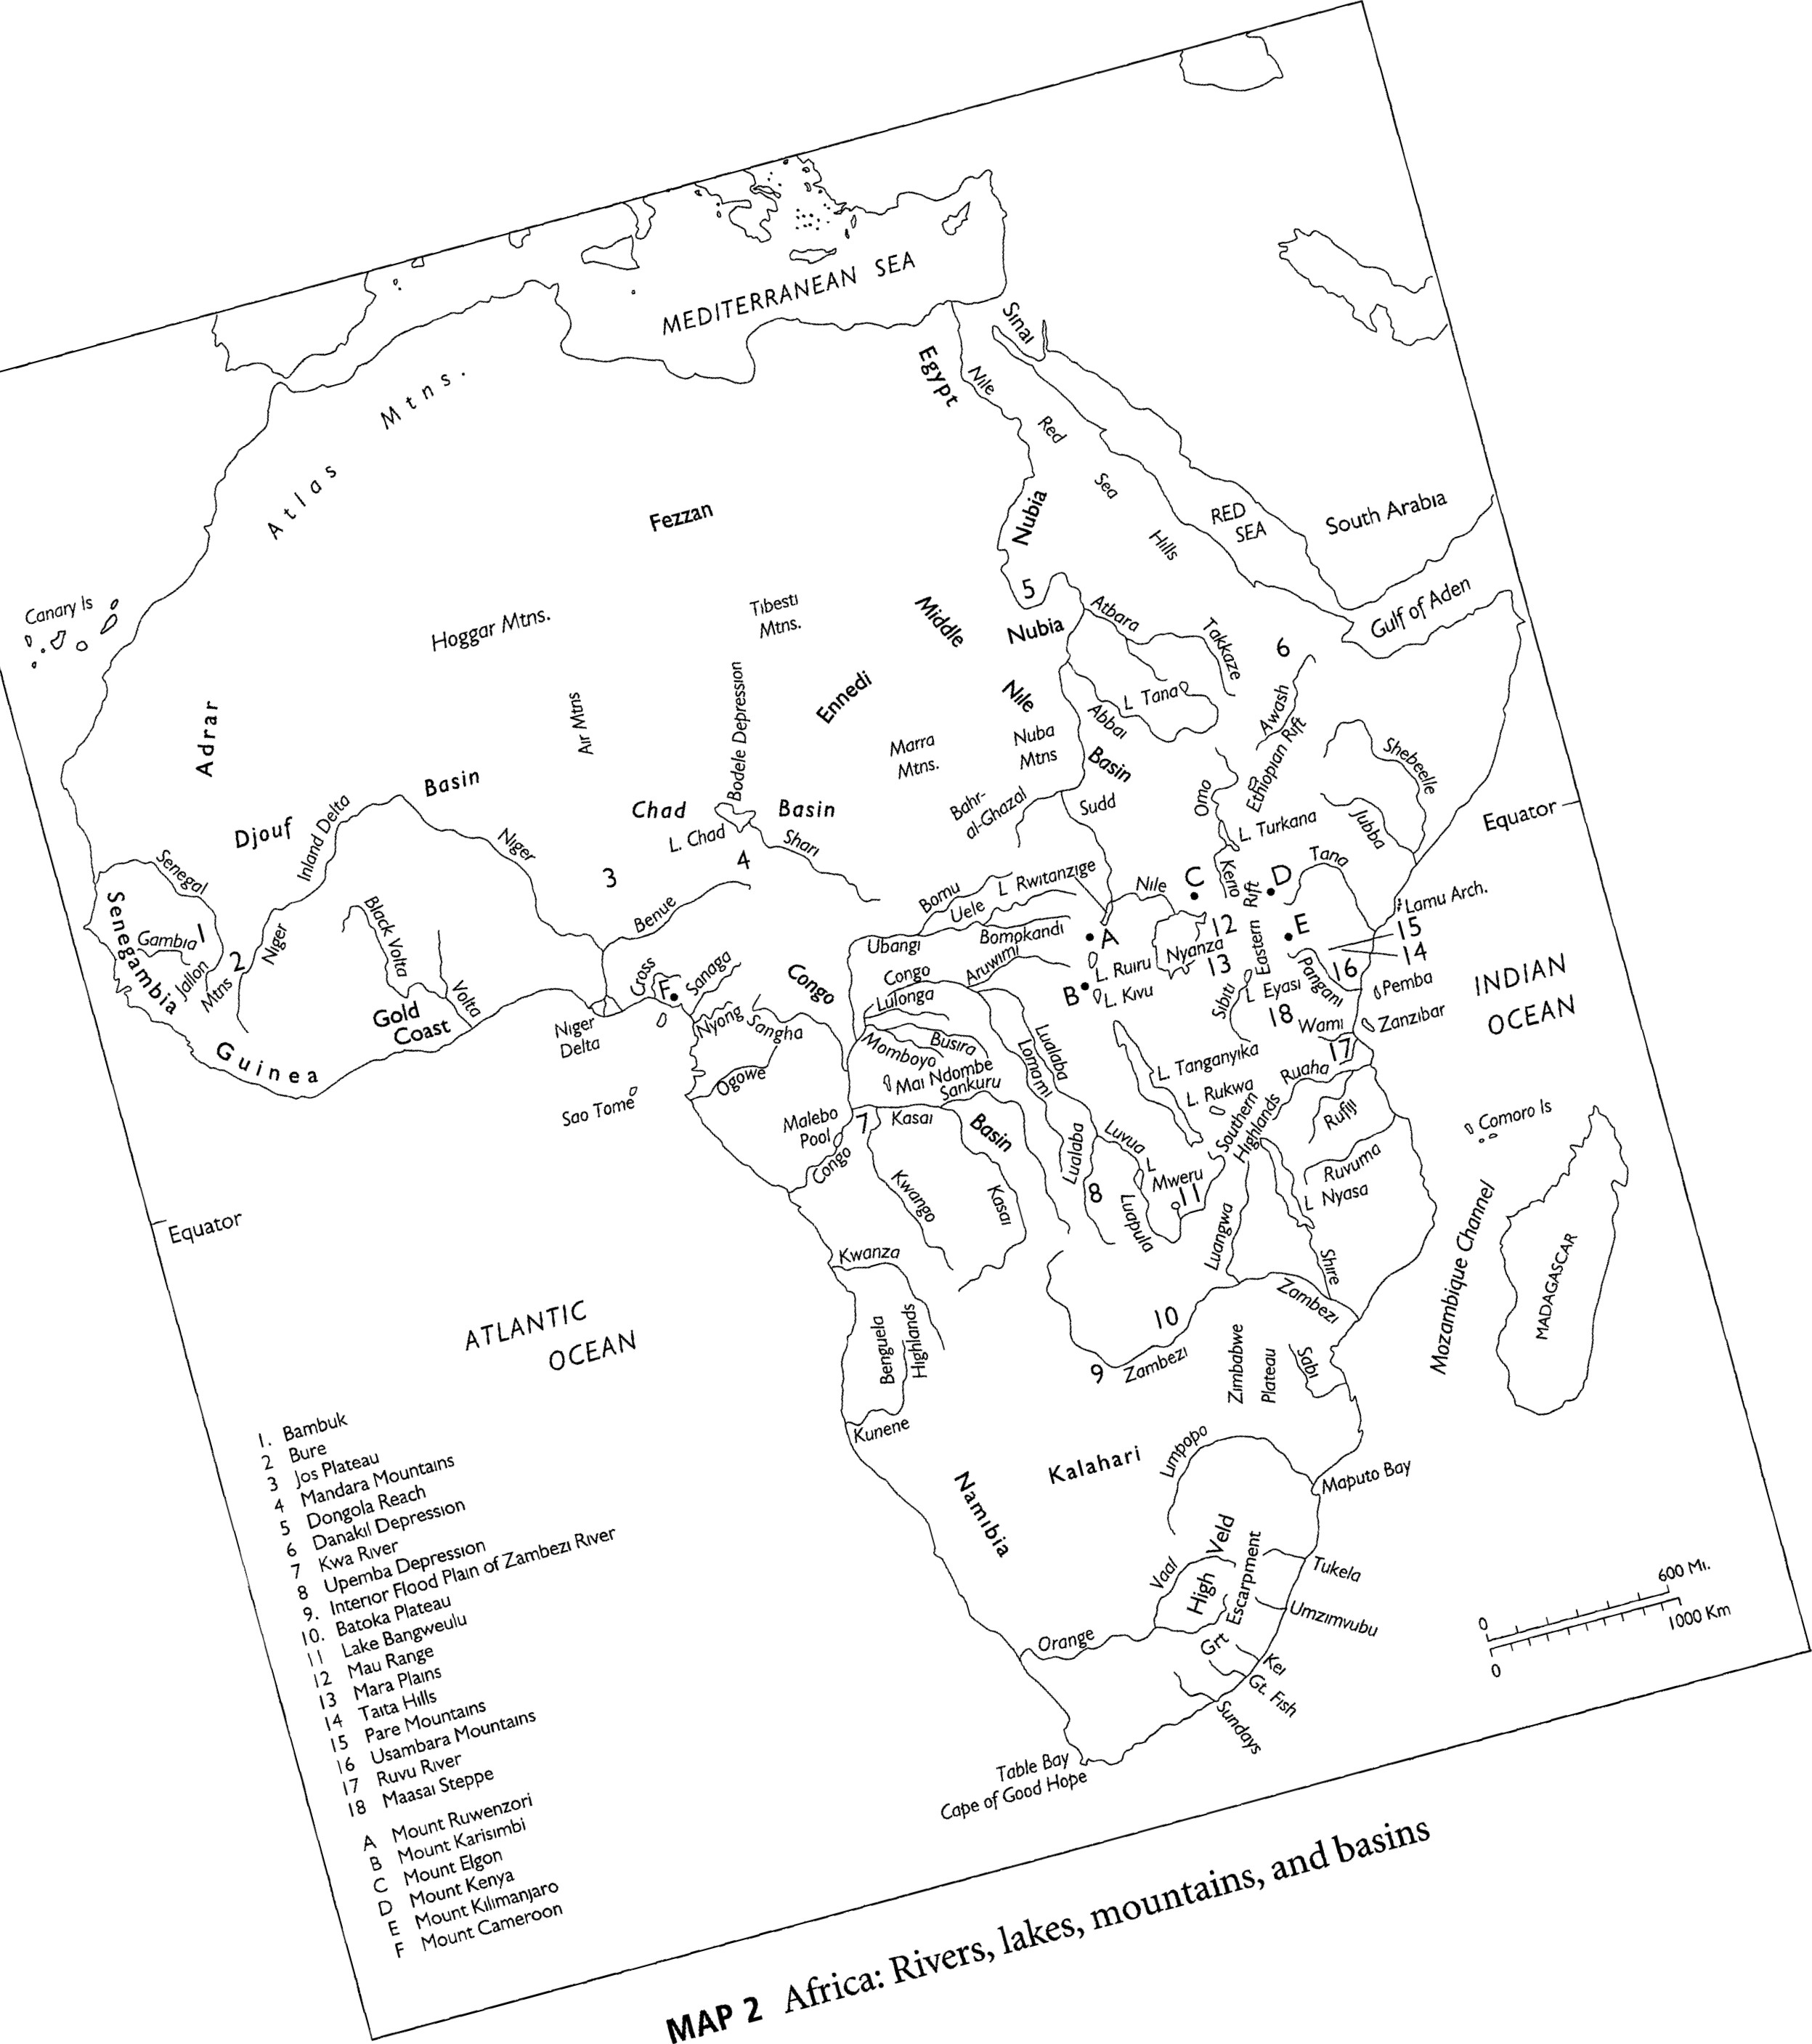

Africa in an Arid Age, 18,000-13,500 Years Ago

|  |  |  |  |  |
| --- | --- | --- | --- | --- |
| Before 16,000 BCE, for reasons not yet clear, the climates of Africa passed through a period of major change, in which rainfall declined almost everywhere. The equatorial and West African rainforests shrank greatly, in most areas giving way to moist woodland savanna environments. The regions that had been moist savanna became lands of drier woodland savanna, while the dry open savanna zones declined to steppe, and the extreme desert ofthe Sahara expanded farther south into the former steppe lands of the Sahel. In northeastern Africa, the forests of the Ethiopian Highlands retreated in a great many areas, giving ground to expanding montane grasslands. Only in some parts of northern Africa did rainfall increase; there the Mediterranean climatic regime shifted southward into some parts of the Sahara desert, bringing with it Mediterranean grassland vegetation and fauna. It was a time of cooler climate as well, with daily Celsius temperatures averaging five or more degrees cooler than at present in some parts of tropical Africa, such that despite the decline in rainfall, the glaciers on the high equatorial peaks spread much farther downslope.  In response to these sweeping changes in climate, new ways ofgathering and hunting began to take shape all across the African continent, with the peoples who created these new livelihoods expanding their territories at the expense of other peoples whose practices no longer fit well with the new conditions oflife.  Four widely separated groupings of African peoples appear to have been the principal initiators of the successful new economies between 16,000 and 9,000 BCE: the Afrasans, the Nilo-Saharans, the Niger-Congo peoples, and the Khoisan. The Afrasans, so named because they spoke languages belonging to the Afrasan language family (also called the Afroasiatic family), were the makers, we believe, of a group of archeological cultures of that period, in which the collecting of wild grasses for food was a key element. The second important early cultural grouping of the time, the Nilo-Saharans, can be associated with what we can call the Middle Nile Tradition. A third key group, the Niger-Congo peoples, may have had archeological links to the West African Microlithic Tradition. The fourth cultural grouping consisted of the communities speaking languages of the Khoisan family; these early Khoisan peoples were makers of what we call the Eastern African Microlithic Tradition.  Their roles as the key economic innovators of the age led to the spread of each of the four distinctive cultural heritages across different large sections of the continent during subsequent eras of African history. Although the original | | | | 33  Africa before the Agricultural Age |
| Equator  ATLANTIC  OCEAN  MAIN VEGETATION BELTS.  Rainforest  Savanna  Steppe  Desert  Mediterranean  Montane | MEDITERRANEAN | SEA  RED  SEA  Equator  INDIAN  OCEAN  600 Ml.  1 000 Km. | | |

MAP 3 Climate and vegetation in Africa, 16,000—11,000 BCE

|  |  |
| --- | --- |
| ideas, beliefs, and cultural practices of those traditions have, of course, been greatly reshaped by the thousands of years of historical change between then |  |
| and now, one can still often discern the cultural debt of later African societies to the ideas and practices of those far-off days. | 35  Africa before |
| Afrasan Civilization | the Agricultural |
| The Invention of Wild Grass Collection | Age |

Across an expanse of lands running from the region of the Nubian Nile eastward through the Red Sea hills to the northern Ethiopian Highlands—and probably not long after 16,000 BCE—an entirely new tack in gathering and hunting, unknown previously in the world, was taken by some of the peoples living in those regions. They began to use the edible parts of certain grasses for food. This new development in subsistence practices manifests itself in the archeological record as a collection of several archeological cultures, which have sometimes been grouped together as the Cataract Tradition. This name comes from the fact that the earliest known sites of this kind of food collecting lay in the areas between the cataracts, or waterfalls, of the Nile River south of Egypt. It appears that the first practitioners of the new type of economy depended in part on sedges, a kind of grass that grows typically in wetland areas. These "nut-grasses" produce tubers underground, which the first Cataract peoples ground into flour and used as food.

The excavated sites of the Cataract peoples consistently reveal communities whose most important stone tools tended to be of two kinds. Numerous grindstones evince the dependence of these peoples on wild grasses for much of the carbohydrate side of their diet. The wealth of medium-sized stone blades in their sites shows that in hunting wild game these peoples tended to rely on spears or other stabbing weapons rather than on bows and arrows. As long as the only grasses utilized were sedges, this economy had little possibility of expanding away from wetland areas along the Nile or in other scattered locales.

Afrasans and the Shift to Wild Grain Collection

But then, certainly before 11,000 and possibly as early as 13,000 BcE—the archeology does not provide sure evidence as yet on this—some ofthe Cataract peoples made a crucial further addition to their subsistence. They began to harvest the seeds of wild grasses other than sedges; they became collectors of wild

grains. They gathered the wild grains, and they threshed and winnowed them for their seed just as the cultivators of domestic grains have done in more recent times. They then either roasted the whole grains or ground them on grind stones into flour, made dough from the flour, and baked the dough in the form of flat breads.

The particular Cataract peoples who invented this new way of using wild of Africa grasses spoke languages of the Afrasan (or Afroasiatic) language family. Just where these early Afrasans lived is not certain, but most probably their lands lay east of the Nile River, in and around the southern Red Sea hills and the northern edge of the Ethiopian Highlands. Now able to exploit the grasses that grew away from wetland areas, the Afrasans soon began to spread their ideas and subsistence practices far and wide across northeastern Africa.

The development of intensive wild grain collection was both a subsistence and a cultural breakthrough. First and foremost, it meant that Afrasan communities now had the ability to obtain a much greater quantity of food than before from the same amount of land. They could still pursue many of the activities of their ancestors; they could hunt the grazing animals that thrived in the grasslands and could still collect wild fruits, nuts, and the like. But to these resources they had added grains, an entirely new and additional source of calories for the diet.

Secondly, by thus enlarging their resource base, the Afrasans gained a longterm demographic advantage over neighboring societies in northeastern Africa that had chosen other, less productive responses to the changed climate and environment. Able to support more people on the same amount of land and thus able to slowly increase its population, the usual local community of Afrasan grain collectors would have been several times the size of the individual gathering and hunting bands typical among their neighbors. As many as several hundred people might have considered themselves part of the local Afrasan community.

Soon, too, the expanding Afrasan settlements would more and more have impinged on nearby lands, cutting into the resource base available to their various neighbors and creating a new kind of food crisis for those peoples. Such developments undoubtedly led to numerous instances of small-scale local conflict. We need to be quite clear, though, that probably nowhere in the world in those times did people fight large, violently bloody wars. That kind ofbehavior usually had to await the emergence of the first states thousands of years later. But when the expansion of an Afrasan community did lead to actual fighting

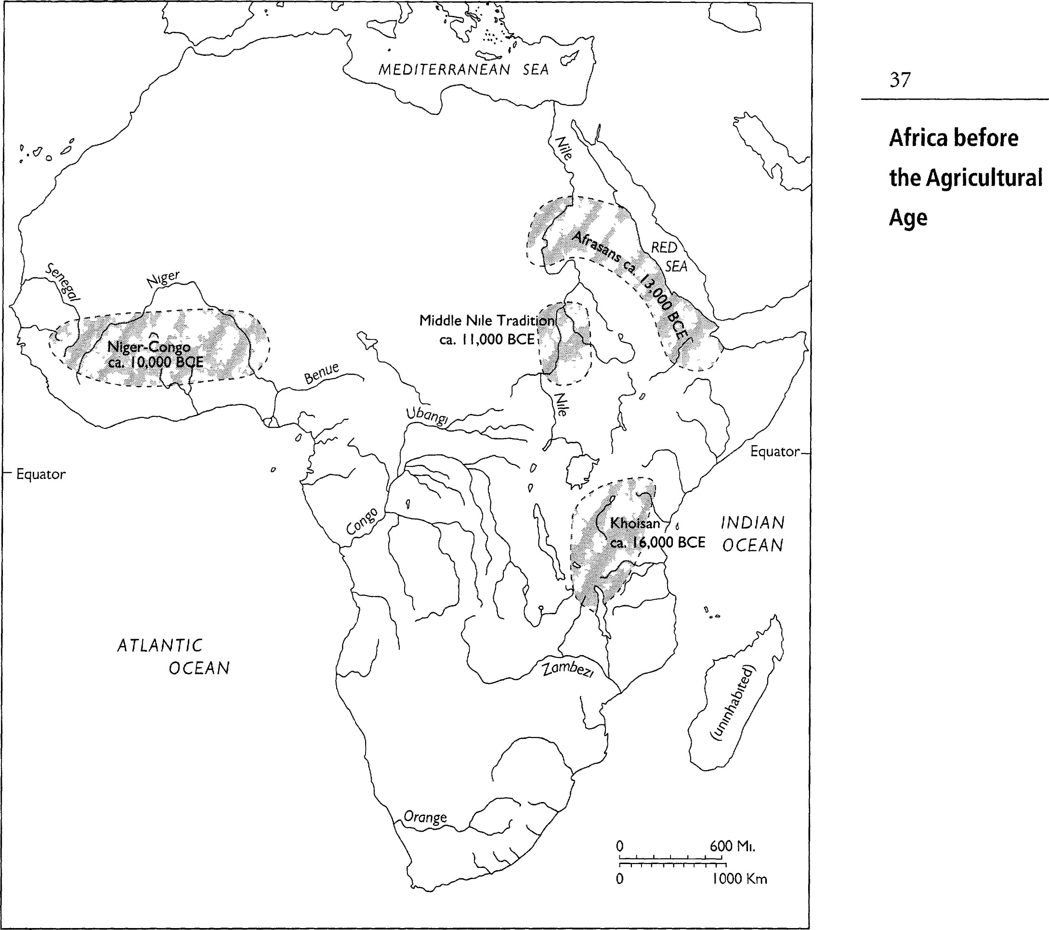

MAP 4 Proposed early lands of Afrasan, Middle Nile, Khoisan, and NigerCongo traditions

over resources, the local advantage in numbers would recurrently have favored the Afrasans.

At the same time, the economy ofthe early Afrasans offered a way out ofthe food crisis that their expansion had brought about: the new economy carried with it the ideas and practices of wild grain collection. Faced with an expanding Afrasan presence in their territories, neighboring communities must frequently have found it most practical to assimilate to the Afrasan example— adopting wild grain collection, assimilating into the Afrasan societies over the  longer term, and coming themselves to speak Afrasan languages. In short, the development of technology for wild grain collecting led in time to a far-flung spread of the culture, ideas, and languages of the Afrasan peoples who had piof Africa oneered that kind of economy.

The evidence of language shows that at least two groupings of communities arose early among the Afrasans. One of these, the Southern Afrasan peoples, have long been inhabitants of the Ethiopian Highlands. It was they who most likely adapted the ideas ofwild grain collection to the cooler grasslands of that region sometime before 11,000 BCE. In contrast, the second group, the Erythraites, consisted of those Afrasans who continued to reside between the Red Sea and the Nile. Among the Erythraites the bow and arrow may have become an additional tool of importance in the eras after the initial breakup of the proto-Afrasan society. (We will encounter other instances of the prefix proto-, which in this context means "ancestral"; the proto-Afrasans were the original, ancestral Afrasan society.)

By the twelfth millennium BCE at the latest, wild grass and grain collecting had taken hold as far north as northern Egypt. One offshoot of this cultural complex, the Mushabian culture, then spread across the Sinai Peninsula from Africa into Palestine and Syria. There the Mushabian communities established themselves as neighbors of peoples belonging to the Geometric Kebaran culture, already long present in Palestine and Syria. Out of the interactions between these two cultures a new mixed culture, the Natufian, strongly committed to the practices of wild grain collection, then emerged between 11,000 and 10,000 BCE.

|  |  |
| --- | --- |
| have been brought into Palestine-Syria by the Mushabian communities; alternatively, some later, as yet archeologically unidentified movement of people may have taken Semitic from Africa into far southwestern Asia. other offshoots of the Afrasan family, the Chadic and Berber language groups, about which we will learn more in later chapters, moved westward after 9000 BCE from the farther eastern Sahara to parts of the central Sahara and North Africa.  Society and Customs of Ancient Afrasans | 39  before the Agricultural Age |

At each stage in the northward spread of these ideas, Afrasan-speaking communities, we suspect, were the prime movers in the resulting subsistence transformations. As we have seen, the Afrasan language family, contrary to widely held presumptions, originated not in Asia but in Africa, in the regions between the Nubian Nile and the northern Ethiopian Highlands. From there the early Afrasan societies expanded both southeastward into the Horn of Africa and northward up the Nile and the Red Sea hills. The arrival along the lower Nile of the ancient Egyptian language, a member of the Afrasan family, ultimately traces back to these northward movements. The earliest ancestral form of the Semitic languages, another subgroup of the Afrasan family, may What sorts of social and political institutions existed among the early Afrasan wild grass and wild grain collectors? What do we know of their material culture? What kinds of beliefs did they hold? What can we say about their arts and musical traditions? Even in the current rudimentary state of our knowledge, these are questions to which we can begin to offer a few sketchy answers. Far removed in time as we are from those peoples, we cannot describe culture in detail for any of the particular Afrasan societies that resided in northeastern Africa between 16,000 and 9000 BCE. What does remain for our discovery today are a few of the broadly shared ideas, practices, and beliefs of those societies. But it is just those sorts of features of culture—shared by a wide variety of societies because of their common historical roots or because of millennia of cultural interaction and shared historical experience—that define civilizations. In this instance they define what we may call ancient Afrasan civilization.

(Table 1 at the end of chapter 3 presents summaries of the culture features commonly found, at the later period of around 5000 BCE, among peoples of the various African civilizations, including the Afrasan. Table 2, also at the end of chapter 3, lists peoples and societies dealt with in this book, arranged according to their language and historical relationships.)

Afrasan communities, from perhaps as early as the changeover to wild grain collection after 13,000 BCE, belonged to numerous clan-based communities. By a "clan," we mean a social grouping whose constitutional basis is its claim to a common descent from a founding ancestor who lived many generations earlier in time. Whether this claim to an often distant and diffuse kinship is real or fictive is not the point. Clans tend, in fact, more often than not, to include many people whose ancestors came from different backgrounds and were adopted into the group at different points in the past. What matters is one's ability to claim a particular clan descent and have one's claim accepted by other members of the clan. Afrasan clans from the beginning were most likely patrilineal.

Each Afrasan clan community was headed by a hereditary ritual leader. Among one major grouping of the Erythraite peoples, the Cushites, this religious leader was anciently called the *wap'er. (The asterisk signifies that this is  what we believe the word's approximate pronunciation to have been.) We do not yet know the original Afrasan word for this office, although we suspect it was probably not *wap'er. But for the sake of convenience we will continue to of Africa use the Cushitic word.

The *wap'er was by no means a political chief, that is to say, a leader who was accorded significant political authority. Decisions affecting a whole clan probably were reached instead through extended discussion in large community meetings. If any secular leadership had to be authorized, as in the rare instance of war, it would have been temporary, sanctioned by the community only for as long as the emergency lasted. Still, the *wap'er must often have been able, because of his or her religious authority, to exert great influence on the course of community deliberations.

What kind of religious beliefs characterized the early period ofAfrasan civilization? Because of the many thousand years of history that lie between then and now and, more significantly, because of the several major transformations in belief that have taken hold among Afrasan communities over the intervening millennia—all of which we will learn about in due course—it is more difficult to piece together the religious ideas ofthe ancient Afrasan Tradition than those ofthe other ancient African civilizations. key themes stand out, however.

First, the ancient Afrasans, it seems, centered their ritual observances around a clan deity. Each clan had its own particular deity to whom its members owed allegiance. The role of the clan *wap'erwas to preside over the community rituals directed toward that deity and to act for the community as the intercessor and interpreter of the deity. This conception of spirit survived in later millennia as a relict feature of belief in two far separated regions where Afrasan-speaking peoples resided:

* among Omotic peoples in far southwestern Ethiopia, with it remaining the key focus of religion for some even today; and
* among certain ofthe ancient Semitic peoples of the Palestinian region, notably, but not only, the ancient Hebrews, whose god Yahweh was, in origin, as modern biblical scholars have shown, just such an ethnically restricted deity.

|  |  |
| --- | --- |
| The ancient Afrasans, in other words, were neither monotheists nor polytheists in their conceptions of spirit. Their kind of belief system, in which a person gives allegiance to the community's own god while still accepting that other gods exist, is called henotheism.  A second theme with which all philosophy and religion must deal is the problem of evil. By that phrase we mean the only too common experience for us all—that the good can suffer and the evil prosper, that the rain falls on both the just and unjust. The ancient Afrasan worldview commonly attributed bad happenings to the activities of harmful spirits. All across the Afrasan-speaking world of later times, from the Omotic peoples to the Semites of southwestern Asia, this kind of belief can be found. The demons driven out of sick or mad people by Jesus were examples of this kind of spirit. The jinn of Arabic literature, as in the story of Aladdin's lamp, are the attenuated remnants of this ancient Afrasan view of evil.  One other custom, the circumcising of boys, very likely goes back to the earliest eras of the Afrasan cultural tradition, to well before 9000 BCE. Nearly universal among the later cultural heirs of the early Afrasans, circumcision probably originated as a ritual marking the passage of boys from juvenile to adult status. A comparable female genital cutting, clitoridectomy, was practiced widely among Afrasan societies of later times, but it was less universally known and most probably was a later development than circumcision. The early Afrasan grain collectors who moved across Sinai into Palestine, in all likelihood, brought the practice of male circumcision with them. The modern-day presence of this custom in Judaism and as a subsidiary cultural aspect of Islam—two religions started by people who spoke languages of the only Asian branch ofAfrasan, Semitic—undoubtedly traces back to this ancient aspect of Afrasan civilization. Interestingly, the Afrasan-speaking societies in far southwestern Asia, unlike the rest of the Afrasans, began at some point to circumcise male children just after birth rather than in adolescence.  About the arts in the ancient Afrasan civilization, we can as yet say very little. Most of that small and uncertain knowledge concerns music and dance. Music probably followed a single melodic and rhythmic line. We suspect from the widespread cultural patterns of later Afrasan-speaking societies that early Afrasan dance performance principally used swaying body movements and various kinds of footwork. Drums were most emphatically not part of early Afrasan musical traditions. Stringed instruments, such as lyres, were widely used among later Afrasan peoples by the fifth to third millennia BCE, but | 41  Age |



## of Africa

FIG. 5 Flat-roofed rectangular house

Depicted here is a particular version of this house style, built by some of the more recent cultural heirs of the early Afrasans, who lived in East Africa in the past 2,000 years.

whether such instruments can be traced back to the really early Afrasan societies, before 9000 BCE, is not yet known.

Nor is a great deal known as yet about the residential patterns favored by peoples of the Afrasan civilization. We suspect that at early periods, at least among the communities of the Erythraite group, the typical house is likely to have been rectangular in floor plan, with a flat roof. But how the larger communitywas laid out—whether, for instance, people might have lived in villages or in neighborhoods of scattered households—remains unclear.

# Nilo-Saharan Peoples and the Middle Nile Archeological Tradition

To the west and south of the early Afrasans, in the region around the middle stretches of the Nile River, lay another distinctive grouping of peoples belonging to the era between 16,000 and 9000 BCE. Speakers of languages of the NiloSaharan family, they pursued a livelihood that included both the hunting of large game and a certain amount of fishing where the environment allowed it. Their toolmaking tradition, notable for the emphasis it placed on the fashioning of stone blades, has been called the Middle Nile Tradition (see map 4). The sizes and shapes of many of these blades indicate that the early Nilo-Saharans, like the Afrasans, used spears in their hunting. Not until much later times did bows and arrows appear among their descendants, and even then the preferred weapon usually appears to have remained the spear.

The environments in which the early Nilo-Saharans thrived differed sharply from those of their contemporaries, the Afrasans, and were separated from them by a wide stretch of then uninhabitable Sahara desert, extending 300—400 kilometers farther south than it does today. The Nilo-Saharan lands consisted of extensive plains, punctuated in several areas by isolated ranges of hills. Characterized by tropical steppe vegetation on the north and tropical deciduous savanna to the south, these environments provided the necessary graz- Age ing and browsing for the many species of antelope and other large herbivores on which the hunting activities of the Middle Nile peoples depended.

We know a good deal about the Nilo-Saharan cultures of the period after 9000 BCE, but little about them before that date. Our archeological information is confined to their stone tools, and the language evidence for those eras has yet to receive the kind of study it deserves. The residential patterns of the earliest Nilo-Saharans, the kinds of dwellings they built, their social institutions, and so forth—of these we have as yet little useful knowledge. Only in the matter of religion can we venture some conclusions about their cultural lives, and even these are tentative.

The early Nilo-Saharan communities, it is thought, held to a nontheistic belief system, similar to that known among a few modern-day Nilo-Saharan peoples, such as the Uduk, whose languages belong to the Koman branch of that family. In this religion spiritual power and spiritual danger do not reside in a deity but are expressed by an animating force. In the modern Uduk language this force is called arum. It is a force, concentrating in our livers, that makes us and animals alive; it is also the source of our anger, our fears, and our affections. Human beings restrain the arum within themselves through their receptive consciousness, called by the Uduk kashira', which is understood to reside in our stomachs. In the modern-day Uduk version of this belief system, there also exists disembodied arum, the residue of lives, animal and human, that have been lived in the past. The arum of people properly buried is reconstituted safely in communities underground. But there are also wandering arum, the residuum of people lost in the wild and never properly buried, and of animals killed by hunters. This animating force in its disembodied aspect, when not properly dealt with through ritual and religious observances, can be the source of danger and harm to people. Its effects, in other words, explain the problem of evil.

The longer-term historical significance of this ancient Nilo-Saharan Tradition lies in its contributions after 9000 BCE to the emergence ofthe Sudanic civilization. That civilization was built up by people who indeed spoke NiloSaharan languages, but who were to develop livelihoods and cultural ideas far different from those of their Middle Nile ancestors.



# Niger-Congo Civilization

Early Niger-Congo Peoples and Their Subsistence Economy

## of Africa

Far to the west of northeastern Africa, in West Africa, the characteristic development of the period from 16,000 to 9000 BCE was the emergence, especially in the greatly expanded woodland savanna environments of that period, of a new tool technology, to which we may give the name West African Microlithic Tradition. The term "microlithic" describes a tool kit in which the typical stone tools are small, finely made points and other shapes, most of them no more than two or three centimeters in length. Most of the makers of the various varieties of this West African Microlithic complex probably belonged to societies speaking early languages of the Niger-Congo language family (see map 4).

From the beginning Niger-Congo hunters made and used the bow and arrow in their activities. We know this not yet directly from the archeology, but from the fact that an ancient word, *-ta, for the bow can be reconstructed all the way back to proto-Niger-Congo, the language ancestral to all the hundreds of Niger-Congo languages spoken today. Bows and arrows are typically the weapons of microlithic toolmakers, and so this inference is not a surprising one. It seems also probable that the Niger-Congo hunters began developing poisons to be placed on their arrowheads fairly early, in this way considerably enhancing the effectiveness of their hunting.

From a relatively early period, a second major element of Niger-Congo subsistence was the intensive collection of wild yams. Indigenous yams, belonging to several species of the genus Dioscorea, were common plants of the open areas within the woodland savanna zones of West Africa. These plants, which form large edible tubers under the ground and whose leaves are suitable as greens, became a major source of carbohydrates in the diet, greatly increasing the productivity of food-collecting activities for the early Niger-Congo societies. (When North Americans use the word "yam," they mean a different plant altogether, the sweet potato, a crop domesticated long ago by Native Americans of South America.)

A third major element of early Niger-Congo livelihood was the pioneering

of fishing technology. Fishing, which seems to us today such an obvious source of food, appears to have been first taken up by human beings in most parts of the globe between 16,000 and 9000 BCE, although it may have been practiced in the regions of the upper Nile River far more anciently than that. Niger-Congo communities may have been some of the first peoples to develop the technique of fishing by hook and line, their hooks having been carved from bone, shell, or hard wood. Another early fishing technique of Niger-Congo peoples may have Age been the use of special baskets to scoop unsuspecting fish from the water.

Niger-Congo communities, of course, pursued a wide range of other gathering and hunting practices. Various wild greens probably formed one important category of plant food for them, and they would have hunted a variety of game in the savannas and savanna woodlands.

Early Niger-Congo Society

In contrast to our relatively meager knowledge about the early Afrasan civilization, we know a good deal about the nonsubsistence portions of culture among the early Niger-Congo peoples. Some ofthese features we can trace back to the earliest Niger-Congo communities. Other characteristic features of Niger-Congo civilization emerged in later periods and then spread more widely.

Niger-Congo communities from an early period appear to have been clan based, with the clan in early times forming the primary wider social and political grouping of people. Descent was reckoned matrilineally, with goods and office inherited through one's mother or the brother of one's mother. We can therefore call early Niger-Congo descent groups matriclans; additionally, most probably they were matrilocal and uxorilocal. That is to say, women continued to live in their mother's villages, and when a man and a woman married, the man was expected to move to his wife's village, rather than the other way around. The man probably also had to perform bride-service for the bride's family—working and contributing for a time to the household of the bride's family—before being allowed to marry her. This custom remained a widely found feature down to recent times, turning up here and there all across the Niger-Congo parts ofAfrica wherever unstratified, egalitarian, and matrilineal social systems still persisted.

A hereditary position of clan chief seems to be an old feature of NigerCongo clans. Although having community ritual responsibilities like the

*wap'er of Afrasan civilization, the Niger-Congo kin chief operated within an entirely different religious framework and sometimes had a degree of political authority not available to the *wap'er. In the later agricultural eras, the chief was responsible, for instance, for allocating land to newcomers wanting to settle in the clan's or lineage's territory. The chief was also expected to adjudicate disputes within the community, to preside over community ceremonial occaof Africa sions, and to act as a spokesperson in communal dealings with other people.

We suspect that Niger-Congo peoples from early times, like the Afrasans, practiced male circumcision as a rite of passage from child to adult status. In recent centuries this custom could be found in a great many Niger-Congo societies scattered as far west as Senegambia and as far east as Cameroon. How girls may have been initiated into adulthood in early Niger-Congo civilization is not yet known. A smaller number of Niger-Congo societies in West Africa did practice clitoridectomy in recent eras, but we remain unsure how old this custom may actually have been. There is no reason at present to think that circumcision among the early Afrasans had any historical connection to the presence of circumcision among the early Niger-Congo peoples.

The typical residential unit in early Niger-Congo civilization may have been a relatively compact village, containing probably somewhere in the range of 100—200 inhabitants. Typically, people belonging to one clan or to one particular lineage within the clan would have formed the core element in a village. It would have been their village. But attached to that core population would have been other people, especially the husbands from other clans who had married women of the village. The village might also include a few families or individuals who had moved from other areas and had been allowed to settle and become part of village life. If such people stayed on, over the long term their children or grandchildren would gradually come to be accepted as members of the local clan or lineage.

We cannot be sure about the layout of the earliest Niger-Congo villages, but one notable pattern became especially favored in the rainforest areas of West Africa after about the sixth millennium BCE. In this pattern the village consisted of a single street, with the houses set out along each side of that street. If such a village fronted on a river, then the riverbank area formed the street, and the village comprised a single row of houses on the side of the street away from the stream. The houses in these villages had a rectangular floor plan and ridge roofs covered with woven palm matting. (Figure 15 in chapter 3 shows an example of this kind of house.)

Technology and Artistry among the Early Niger-Congo Peoples

The Niger-Congo villages supported a range of skilled craft activities. Weaving techniques were especially well developed among Niger-Congo peoples by the sixth and fifth millennia BCE. Just how much earlier these skills can be traced back is not clear. Mats for sleeping and preparing food and a variety of baskets comprised the most notable woven items for everyday, practical use. As we have Age already seen, woven palm matting provided one favored kind of roofing material. The weaving of raffia cloth, a soft luxuriant textile fashioned from the fibers ofthe raffia palm, does not go back to the earliest periods ofNiger-Congo history, but it became a widely diffused technology during the past 6,000 years. A probably much older Niger-Congo cloth-making technique that did not involve weaving was the fashioning ofbarkcloth. This cloth was made by removing and pounding out sheets of bark taken from certain species of trees.

Wood carving, using stone adzes and stone knives, was another welldeveloped field of village technology dating from early times. Before 6000 BCE, Niger-Congo peoples had become skilled boat builders, carving out from single large logs the canoes they needed for fishing and for traveling by stream through the forested areas.

Even earlier, the skills of the wood-carver created a particularly NigerCongo contribution to world art history. From probably their earliest periods, Niger-Congo peoples carried on a powerful tradition of figure sculpture in wood. Almost everywhere the ideas of Niger-Congo civilization spread, wood sculpting spread, too, with the artists drawing on this tradition to develop and elaborate an immense variety of regional styles and expressive motifs. The artists of those times, it should be noted, were not alienated individuals pursuing their own tangents of self expression, but people who expressed themselves through the socially sanctioned forms and motifs of their community. It is important to note, by the way, that up until recent centuries, this has been the role of artists everywhere in the world, not just in Africa.

One rather personal art form also seems to go back to the earliest eras in Niger-Congo civilization. A particular kind of tight, intricate hair braiding, especially for women, remains a characteristic feature of adornment all across the vast areas of the continent inhabited today by peoples of Niger-Congo historical roots. In the past five centuries this kind of hair styling has been taken to the New World, where in the United States it is called cornrows.

In music and dance, too, Niger-Congo civilization gave rise to distinctive



## of Africa

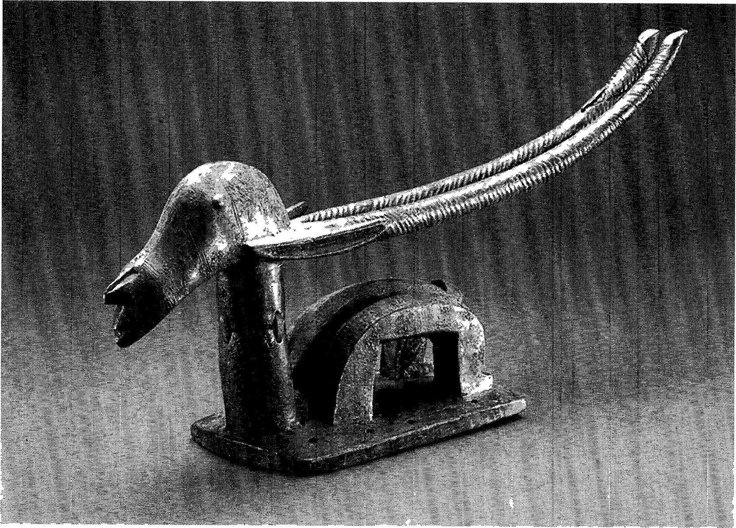

FIG. 6 Chiwara sculpture, Mali

Artists working in the ancient Niger-Congo tradition of wood sculpture have evolved a great variety of styles and motifs all across the Niger-Congo parts of Africa. Chiwara, a stylized antelope, is a centuries-old type of wooden figure, most often sculpted in headdress form for ceremony and dancing in the Mali region. Its origins go back probably well before the period of the Mali empire. A number of other examples of Niger-Congo sculpture, not only in wood but also in terra-cotta and brass, are depicted in subsequent chapters.

types of expression. Percussion and polyrhythmic performance characterized both. From the earliest period of Niger-Congo history, drums were the characteristic instruments of Niger-Congo music. For at least the last several thousand years, highly developed types of drumming, involving drums of different pitches beaten simultaneously to different intertwining rhythmic schemes, have been a common and widespread feature of such music. What people often think of as typically African music turns out to be typically Niger-Congo music, quite different both in conception and fundamental forms from the musics of other African civilizations. In this music lie the historical roots of the modern-day genres of ragtime, jazz, and rhythm and blues, as well as rock and roll. Drum making, by the way, was another early important skill ofthe ancient Niger Congo woodworkers.

Dances were vigorous and energetic exercises, relying on multiple move- ments of the body much more than on footwork. In special dance performances at celebrations and festival times, elaborate masks and costumes, the facial parts carved from wood, were often worn by dancers. Here again we see Age the importance of the early Niger-Congo woodworking tradition.

Religion and Medicine in Niger-Congo Civilization

As for Niger-Congo religion, it proves useful once again to divide our considerations into two questions: how did Niger-Congo religion conceive of the realm of spirit, and how did it deal with the problem of evil?

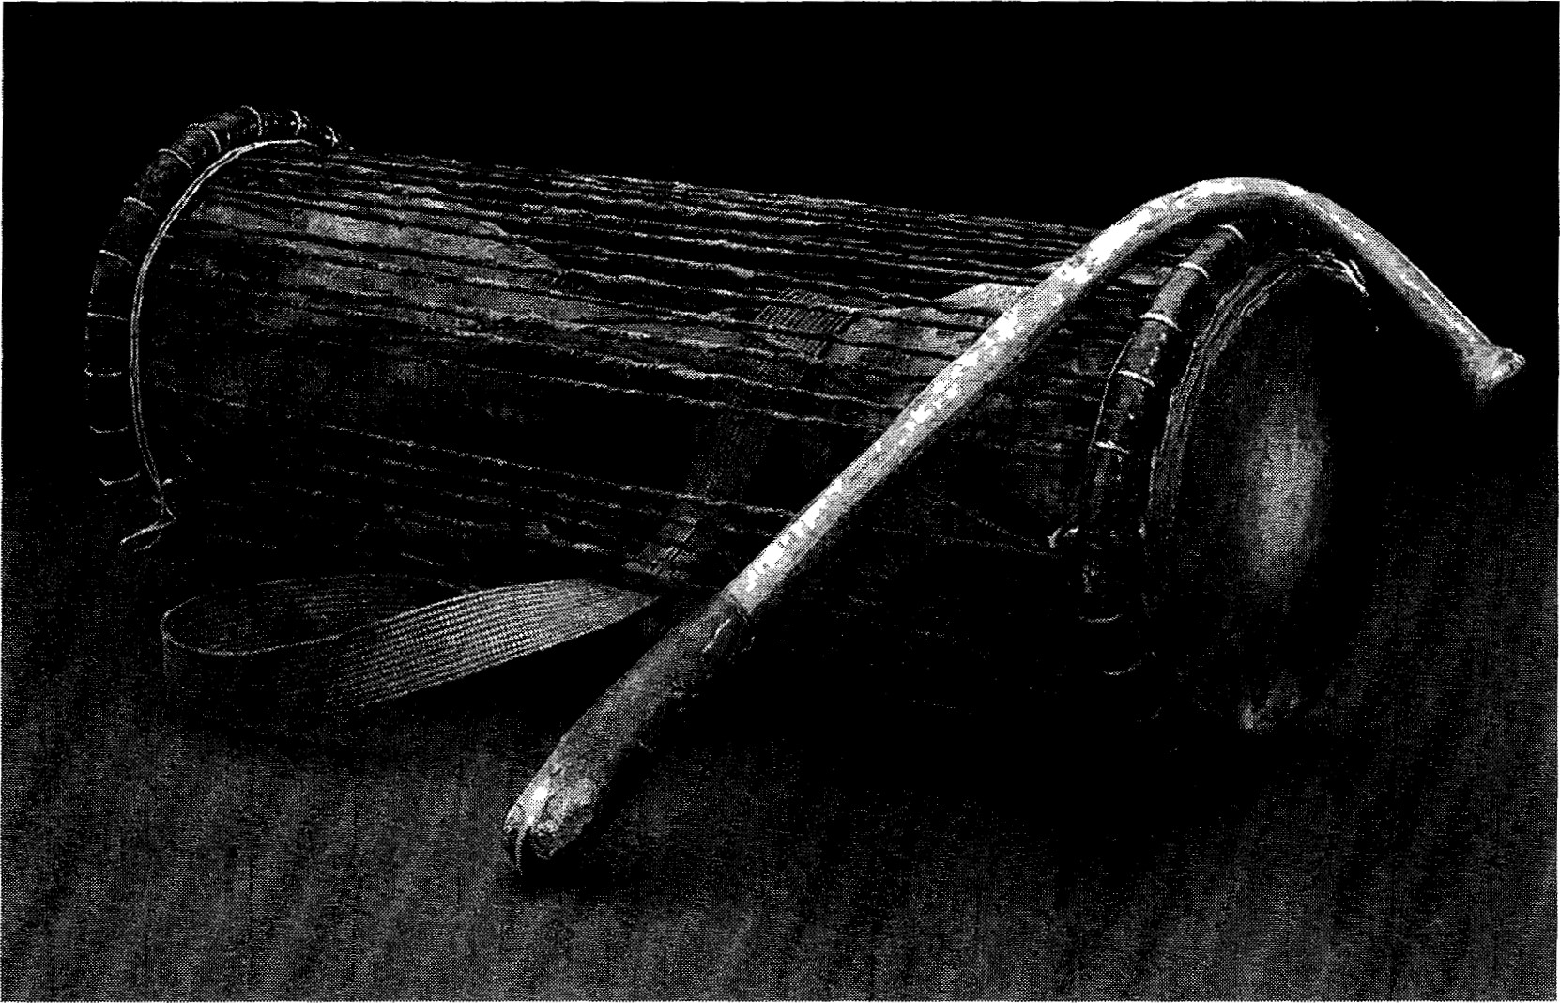

FIG. 7 Tension drum and drumstick

The drummer played this particular early West African style of Niger-Congo drum by wrapping an arm around the middle of it and holding the drumstick with the other hand. By squeezing down with the arm on the strings running between the two ends of the instrument, the musician could raise the pitch of the instrument.

Niger-Congo religion recognized a series of levels of spirit. At the apex of the system, but of little direct consequence in everyday religion, there was God as a distant figure, who was the First Cause or Creator. This particular concept  can with certainty be traced back to the sixth millennium BCE, and its historical origins appear to lie much further back in Niger-Congo history.

A second kind of spirit dwelt within a particular territory and was believed able to

of Africa influence events there; we can call it therefore a territorial spirit. The domain of such a spirit might be a particular river, as among peoples living in an area, like the Niger Delta, abounding in rivers. Or its domain might be the drainage basin of a particular stream, as we know was true in the kingdom of Kongo 500 years ago, or some other definable expanse of land.

But the really crucial spirits for religious observance and ritual belonged to a third category. These were the ancestors. The ancestors were not worshiped; rather, they were venerated. They deserved and required respect and remembrance. They could greatly affect the lives of people here and now; and people prayed to them and made offerings to them. The ancestors came first to people's minds in times of crisis or of blessing.

In early Niger-Congo thought, evil had two principal causes. It could result from neglect of the ancestors or from the actions of an ancestor spirit who had been an evil or malicious person when alive. Or it could be due to the malice, hate, or envy of a living person, whose malicious will manifested itself in "witchcraft." By witchcraft we mean the use of medicines and spells to bring harm to others.

We must be careful in our use of the terms "witch" and "witchcraft" to translate the various words applied to this set of beliefs in the different NigerCongo languages. For modern-day Americans, witchcraft conjures up Halloween images of ugly hags flying on broomsticks. In late medieval thought, a different, nastier image, of agents of the devil, was imposed on people, usually women, believed to be witches. Neither of these ideas has any validity for our understanding of Niger-Congo views. There was no devil in Niger-Congo belief systems. "Witches" were simply individuals driven by malice, hate, or envy, and they could be men or women. But the consequences oftheir activities could be dire indeed.

People in Niger-Congo civilization faced with undeserved evil happenings, with persistent or bad illness, or with personal or family misfortune turned for help to a kind of specialist, the doctor-diviner. Often called in English by the unsavory and inaccurate term "witch-doctor," this man or woman was in actuality a person knowledgeable about medicines derived from natural sources, some truly efficacious and some only thought to be, and a person skilled in reading people. (In the southern United States, the role of the conjure man or conjure woman had its historical roots in this Niger-Congo cultural position.) The job of the doctor-diviner was to divine the underlying cause of bad happenings—to diagnose whether the malice of an enemy or the failure to look properly after the ancestors was at fault—and to prescribe remedies. One of the Age remedies might be identifying and expelling the witch from the society; hence the English translation of the African words for this person as "witch-doctor."

# Khoisan Civilization

Khoisan Peoples and the Eastern African Microlithic Tradition

A fourth major grouping of African societies of the period between 16,000 and 9000 BCE formed the Khoisan civilization. Spread in those eras from the southern edges of the Ethiopian Highlands in the north to the Zambezi region in the south (see map 4), the peoples of this cultural tradition spoke languages of a fourth African language family, Khoisan, and prospered by engaging in what can be described as eclectic types of gathering and hunting. They pursued a great variety of game, hunting small animals as often or more often than large ones, and they collected a great variety of wild plant foods, these latter resources actually providing by far the greater portion oftheir diet. Later on, during the seventh and sixth millennia BCE, Khoisan peoples spread their culture and language south and west of the Limpopo River, rapidly expanding all across the areas that today compose the countries of South Africa, Botswana, and Namibia (see chapter 3 for more on this era of history).

The various regional toolmaking styles practiced by the Khoisan can all be grouped together archeologically as the Eastern African Microlithic, or Wilton, Tradition. Almost all their stone implements, as befits a microlithic technology, were very small, consisting of small crescent shapes, points, and so forth. And like the otherwise very different makers of the West African Microlithic Tradition, the Khoisan communities from an early period came to depend on the bow and arrow in their hunting and independently developed a variety of arrow poisons to enhance their effectiveness as hunters.

Interestingly, one moderately large stone implement did have a notable presence in the Eastern African Microlithic tool kit. This item, consisting of a stone fashioned into a doughnut shape with a hole bored in the middle of it, was used as a weight on a digging stick. Its presence in the tool kit shows that the Khoisan peoples had begun to add edible tubers to their diet, bringing into use a new category of plant food.

 The Eastern African Microlithic Tradition of the Khoisan may actually have begun to take shape before the era of drier African climates between 16,000 and 11,500 BCE. The specific antecedents of the Eastern African Miof Africa crolithic Tradition can be traced back to toolmaking developments of as early as 20,000 BCE in what is today eastern Zambia. These changes, toward an increasingly microlithic tool kit, emerged initially, it appears, as an adaptation to that region's drier woodland savanna areas of 700—1,000 millimeters of rain a year, an environment with relatively low populations of larger game, and with few of the antelopes that congregate in large herds. By hunting a great variety of small animals and expanding the range ofplant foods collected, the peoples who developed this approach more than overcame the deficiency of large animals.

In so doing, they fashioned an approach to gathering and hunting that was extraordinarily resilient and long-lived. The great shift to drier climates before 16,000 BCE appears, if anything, to have enhanced the viability of this kind of food-collecting economy. The willingness of Khoisan peoples, with their Eastern African Microlithic tool technology, to utilize all kinds of food resources made them equally well able to increase the productivity of food collecting in more open savanna and in steppe areas of eastern Africa, too. Armed with the new approaches, techniques, and attitudes, the Khoisan cultural tradition spread within a period of no more than 1,000 to 2,000 years after 16,000 BCE

FIG. 8 Bored stone weight for a digging stick

This kind of tool was made and used by peoples of the Eastern African Microlithic Tradition. Its presence in their tool kit shows that they had added a new type of food, plant tubers that grew under the ground, to their diet.

across much of the eastern side of Africa, from the Zambezi to the south edges of the Ethiopian Highlands.

Social Practices among the Early Khoisan 

The local social and residential unit ofthe early Khoisan societies took the form of a band. Ranging in size usually from perhaps 25 up to 50 people, the band tended at its core to consist of a group of people relatively closely linked to each Age other by birth or marriage, although it might also include others not so closely tied. No formal structures of kinship, such as clans or lineages, appear to have existed; people reckoned their family connections bilaterally, recognizing both their fathers' and their mothers' families as equally important relations.

The band was a moderately mobile group, which in some regions needed to move its whole settlement to a different locale each season, but in other regions might not have reason to move at all. The typical settlement would have consisted of a loose arrangement of small hemispherical houses, each simple to build and therefore no great loss if one had to move and build again somewhere else. Judging from later practice, each band would have had a recognized territory in which it would have first rights at gathering and hunting. Depending on the climate, the territory could range from 400 or 500 up to 4,000 or more square kilometers especially in resource-poor areas.

Each band belonged to a wider grouping of neighboring bands speaking the same language. The yearly patterns of social interaction, the mobility of people, and the relative ease with which people could change from one band to another meant that such a grouping of bands might together cover a considerable expanse of land. Different bands would meet together at particular times of the year at places with dependable water and food resources, holding dances and trading the irregular surpluses of their gathering and hunting. These occasions were important for sustaining cooperative relationships with other bands and allowed people to establish wider circles of friends and acquaintances than their own small band. This social dimension was especially important for marriage, because people normally had to seek their matrimonial partners in other bands.

No hereditary leadership can be reconstructed for the early Khoisan peoples. The close kin connections within the band usually provided an adequate basis for cooperation in so small a group. Irresolvable differences, if they did arise, could often be relieved by some people's moving away to join another nearby band or to form a band of their own.

Arts and Religion in Khoisan Civilization

Music and dance in Khoisan civilization, as far back as we can trace, followed a  single rhythmic beat. In dance, footwork had the key importance, and only restrained movement of the body took place. String instruments of several kinds were typical features of the Khoisan musical traditions during the last several of Africa millennia and may date to relatively early times. The single-string musical bow may have been the earliest such instrument played by the Khoisan, but four- or five-string instruments, which used hollow gourds as resonators, also appear to be of considerable antiquity among the Khoisan. Drums, however, were entirely unknown to Khoisan peoples before the last 2,000 years and were never used by them.

The Khoisan, like the earliest Nilo-Saharans, adhered to a nontheistic religious outlook. Their beliefs recognized the existence of an impersonal condition of spirit, a force that existed outside human beings as well as in some animals. In the thought of the particular Khoisan peoples who have lived in southern Africa since 5000 BCE, this force could be tapped by means of the trance-dance and used to heal sickness and to relieve social and individual stress and conflict. In this procedure a person recognized for special religious talents, a kind of shaman whom we may call a trance-healer, dances until he or she goes into a state of trance, which might last for many hours. The trancehealers were not full-time specialists, as were the doctor-diviners of the NigerCongo civilization. Ifno trance dance was being performed, and that means the great majority of the time, the healer held no special position and engaged in the usual pursuits of everyone else, in hunting if a man and gathering if a woman, and in leisure-time activities.

This particular aspect of religion had a fundamental tie to the characteristic art form of Khoisan civilization, rock painting. This kind of artistry, its canvasses being the bare walls of rock shelters or caves, occurs widely through the old areas of Khoisan civilization, from Tanzania to Zimbabwe to Namibia and South Africa. Where suitable rock surfaces did not exist, as in the plains of central South Africa, the artists expressed themselves through rock engravings. The most spectacular and best preserved examples of rock painting, found in South Africa, have been shown by recent scholarship to depict the religious experiences of the trance-healers. The healers themselves, it seems, were the artists.

|  |  |
| --- | --- |
| We cannot be certain that the practices ofthe trance-dance as found among the southern African Khoisan go back to the early times of Khoisan civilization. The often differing imagery and different emphases in the rock art outside South Africa tell us that the idioms and metaphors, even if not the fundamental themes, in Khoisan religion did change and develop over the long run of their history. The rituals of that religion, including the trance-dance, surely evolved also.  In far southern Africa a tradition of rock painting existed long before the spread of Khoisan-speaking peoples into those regions at around 6000 to 5000 BCE. The earliest known examples of this earlier tradition date to more than 26,000 years ago. How the later Khoisan rock art tradition and this older artistry affected each other remains to be studied. | the Agricultural  Age |

## Summing Up the Period 16,000—9000 BCE in Africa

The cultural foundations of two of the four major civilizations of later African history—the Afrasan and the Niger-Congo—were laid in the period between 16,000 and 9000 BCE. A third, Sudanic civilization, emerged after that period, but its historical roots in part trace back to the more ancient Middle Nile Tradition of the early Nilo-Saharan peoples. The fourth tradition of great importance since 9000 BCE, Khoisan, first began to take shape probably even before 16,000.

These were far from the only African peoples of those times. In South Africa and Namibia, other communities, known archeologically as the Albany culture, persisted as principally large game hunters until around the seventh millennium BCE, when their way of life was finally displaced by the eclectic gathering and hunting livelihood of Khoisan civilization. In the vast Congo Basin of western and central equatorial parts of Africa, another long-lived and distinctive cultural tradition predominated, represented in the archeology by the Lupemban and the later Tshitolian cultures. The peoples who created this tradition were the ancestors, we believe, of the scattered modern-day gathererhunter communities ofthat region, the BaTwa (commonly called "Pygmies" in European languages). We will have more to say about the BalWa, in particular, in later chapters. But it was the Afrasan, Sudanic, and Niger-Congo peoples, and to a lesser extent the Khoisan, whose cultural heirs most powerfully shaped the later ages of African history.

### NOTES FOR READERS AND TEACHERS

Issues and Questions

 Chapter 2 focuses on certain developments in livelihood and culture in Africa between 16,000 and 9000 BCE. One set of questions we may ask of these developments concerns the deep levels of historical cause and effect—the encounter of humans and nature. These questions relate directly or indirectly to subsistence, to how of Africa people got their food:

* In what notable ways did human beings of the period before 9000 BCE successfully deal with the different African environments?
* In what sorts of ways did the natural environments shape the choices people made?
* Why did some cultural traditions expand across vast new territories?

Answering these questions means learning about specific new developments of the period:

* What new successful approaches to acquiring food appeared in this period?
* When and where did they appear?
* What made them "successful"?

Ifwe look to other areas ofhistorical change, to matters ofcustom and belief, the questions we consider have a different focus, emphasizing the content and great diversity ofthe early African cultural traditions. Here readers may find it useful to take a comparative perspective:

* How did the three major early widespread African civilizations—Afrasan, Niger-Congo, and Khoisan—differ from each other and from early NiloSaharan peoples of the middle Nile in viewing the realm of the spirit and the problem of evil?
* How did they differ in their ideas of kinship and in the kinds of social and residential units they lived in?
* How did they differ in the kinds of individual roles of leadership and authority they each recognized?
* How did they differ in various aspects of material culture?

What is most difficult for us to do for the earliest periods is to capture a sense of the flow and movement that characterize all history. The evidence we most commonly uncover relates to the elements of life and custom that long persisted. So we must always try to ask the following question, even if we cannot always answer it:

|  |  |
| --- | --- |
| Points of Contention  The idea of grouping together several of the early wild-grass-collecting cultures of |  |
| northeastern Africa under the rubric of the Cataract Tradition can be a contentious issue. "Cataract" is used here as a loosely applicable term, implying the broad re- | the Agricultural |
| semblances among the cultures of the region but not requiring one to accept that a single origin accounts for them all.  The basic case for tracing the origins of the Afrasan (Afroasiatic) languages and cultures back to wild-grass-collecting societies residing in the southeastern Sahara appears in a recent, but not very accessible, publication: | Age |

* What kinds of change or development over the long term, large or small, can we discern in either customs or the material pursuits of life?

Ehret, C. "Who Were the Rock Painters? Linguistic Evidence for the Holocene Populations of the Sahara." In A. Muzzolini and J.-L. LeQuellec, eds., Rock Art and the Sahara, in Proceedings of the International Rock Art and Cognitive Archaeology Congress. Turin: Museo d'Arte Prehistorica, 1999.

The old Western and Middle Eastern presumption that the Afrasan (Afroasiatic) language family originated in Asia can simply no longer be sustained, now that we have large amounts offirst-rate data from the African branches ofthe family. But this newer evidence is still almost unknown to most scholars of the Semitic and ancient Egyptian languages, with the consequence that an unbalanced understanding of the family continues to prevail in many quarters. Unfortunately, the outdated view of Afrasan as having an Asian origin continues to affect not only popular thinking but also the interpretations of scholars in other fields, such as biological anthropology, who study Africa.

Some readers are disturbed by the idea that the Semitic and Egyptian languages are related, because they think such a relationship would make Egyptian an Asian language. Of course, that is not so. Semitic alone, among all the divisions of the family, consisted in earlier times of languages of the far southwest corners of Asia, spoken even then right next to Africa. All the rest of the divisions are entirely African, and the only reasonable interpretation of this evidence is that Semitic was a solitary Asian offshoot of the family, brought into Asia long ago by immigrants from Africa.

A related presumption, also widely held, that the Afrasan family of languages expanded because its speakers acquired livestock and cultivation, similarly turns out to be unsubstantiated, once the full evidence ofthe African languages is considered. We can indeed reconstruct back to the proto-Afrasan language a number of words dealing with the use of grasses as food in some form—words such as those for "flour" and "grindstone," among several others. But not a single proto-Afrasan word is di-

agnostic of cultivation. That is, there are no words that mean "to cultivate, to weed," "cultivated field," or the like. Similarly, there are no proto-Afrasan words diagnostic of the raising of livestock. A few old root words for "sheep" or "goat" do ap58  pear in more than one branch of the Afrasan family, but a critical analysis of the semantic or phonological histories of each shows one of two things. Either the name for the animal spread by borrowing from one branch to the other—showing that the Civilizations

animal itself spread long after the proto-Afrasan period—or the word originally reof Africa ferred to a species of antelope and shifted to the meaning "sheep" or "goat" at some later point in history. The evidence, in other words, strongly requires the protoAfrasan use of wild grasses for food, but it consistently shows that cultivation and herding arose in later times.

The issue of whether the Khoisan languages can be demonstrated to belong to a single family remains contentious. I take the view that we will eventually be able to demonstrate this relationship in a satisfactory manner. The languages attributed to the Khoisan family share a number of similar deep features of structure and phonology, many unique to them, as well as more basic vocabulary words than is often recognized to be the case. But even without claiming certainty about the relatedness of the Khoisan languages as a whole, we would have to argue from the historical side that a common, long-lived, East African Microlithic cultural tradition persisted all across a large portion of the eastern side of Africa between about 16,000 and 3000 BCE, with related stone tool industries and artistic traditions.

One small, but diverse, set of related Niger-Congo peoples, the Kordofanian group, distantly connected in language to the rest of the Niger-Congo family, has been left out of our story here. The Kordofanian communities have resided for thousands of years in the Nuba Mountains of the southwestern Middle Nile Basin. Their location reflects a prior stage of history before the rise of the Niger-Congo civilization, possibly dating before 15,000 years ago. During this stage either the ancestral Kordofanian people diverged from their Niger-Congo relatives by moving eastward from West Africa, or else the ancestral Niger-Congo people diverged from the Kordofanian by spreading west to West Africa. How the Kordofanian group fits into the wider frame of African history will be an interesting problem for future historians and archeologists to consider.