machine condition checklist program

Developed By:
m.balakrishnan b.tech IT

Program :

//machine condition checklist program
//developed by balakrishnan.m
import java.awt.*;
import java.io.File;
import java.io.FileWriter;
import javax.swing.*;
import java.awt.event.*;
public class Machine_conditioncheck
{
public
Machine_conditioncheck() { // collect the information from the empolye
JFrame fr = new JFrame("Machine Condition");
fr.setLayout(null);
fr.setSize(600,500);
fr.setResizable(false);
fr.setDefaultCloseOperation(JFrame.EXIT_ON_CLOSE);
JLabel la = new JLabel("Your Name :");
la.setBounds(10,10,100,20);
JTextField jtff = new JTextField();
jtff.setBounds(130,10,150,20);
JLabel lao = new JLabel("ID Number :");
lao.setBounds(10,30,90,20);
JTextField jtfo = new JTextField();
jtfo.setBounds(130,30,50,20);
JLabel laoo = new JLabel("Shift :");
laoo.setBounds(10,50,60,20);
JTextField jtflaoo = new JTextField();
jtflaoo.setBounds(130,50,60,20);
JLabel lath = new JLabel(" MachinePressor :");//this is the parameter
lath.setBounds(10,70,150,20);
//First check box
JCheckBox cbbgg = new JCheckBox();
cbbgg.setBounds(130,95,20,20);
JLabel jcbla = new JLabel("10 PSI");
jcbla.setBounds(160,95,50,20);
//Second checkbox
JCheckBox jcblaat = new JCheckBox();
jcblaat.setBounds(130,120,20,20);
JLabel jcblaa = new JLabel("20 PSI");
jcblaa.setBounds(160,120,50,20);
//Third check box
JCheckBox jcblas = new JCheckBox();
jcblas.setBounds(130,140,20,20);
JLabel jlass = new JLabel("30 PSI");
jlass.setBounds(160,140,50,20);
JLabel mv = new JLabel("MachineVoltage :");//Second parameter
mv.setBounds(10,170,150,20);
//first circul button
JRadioButton jrbmv = new JRadioButton();
jrbmv.setBounds(130,190,20,20);
JLabel mvla = new JLabel("1 V");
mvla.setBounds(160,190,30,20);
//second circul button
JRadioButton jrbmvv = new JRadioButton();
jrbmvv.setBounds(130,210,20,20);
JLabel mvlav = new JLabel("2 V");
mvlav.setBounds(160,210,30,20);
JLabel mc = new JLabel("MachineProbleam :");//Third parameter
mc.setBounds(10,230,150,20);
JTextArea jtfmc = new JTextArea();
jtfmc.setBounds(130,250,450,100);
jtfmc.setBorder(BorderFactory.createLineBorder(Color.BLACK,1));
//save button if you pressed
JButton bu = new JButton("Save");
bu.setBounds(400,430,80,20);
bu.addActionListener(new ActionListener(){
public void actionPerformed(ActionEvent ae){
try{
File file = new File("/home/gg/Desktop/"+jtff.getText()+"_Signed"+".txt");///home/g/Desktop
boolean ch = file.exists();
if(ch == true)
{
JOptionPane.showMessageDialog(fr,"Machine Check list Signed\nContinue Your Work");
}
else{
file.createNewFile();
}
boolean chs=file.exists();
if(chs==true){
FileWriter fw = new FileWriter(file);//write the user information.create the text file
fw.write("Name :");
fw.write(jtff.getText()+"\n");
fw.write("ID Number:");
fw.write(jtfo.getText()+"\n");
fw.write("Shift : ");
fw.write(jtflaoo.getText()+"\n"+"\n");
if(cbbgg.isSelected()){
fw.write("Measion pressor :"+"10 psi"+"\n"+"\n");
}
if(jcblaat.isSelected()){
fw.write("Machine Pressor :"+"20 PSI"+"\n"+"\n");
}
if(jcblas.isSelected()){
fw.write("Machine Pressor :"+"30 PSI"+"\n"+"\n");
}
fw.write("Machine Voltage :"+"\n");
if(jrbmv.isSelected()){
fw.write("1 V"+"\n"+"\n");
}
if(jrbmvv.isSelected()){
fw.write("2 V"+"\n"+"\n");
}
fw.write("Machine Probleam :"+"\n");
fw.write(jtfmc.getText());
fw.close();
fr.dispose();
}
}
catch (Exception e){
JOptionPane.showMessageDialog(fr," error");
e.printStackTrace();
}
}
});
fr.add(bu);fr.add(mc);fr.add(jtfmc);fr.add(jrbmvv);fr.add(mvlav);fr.add(jrbmv);fr.add(mvla);fr.add(mv); fr.add(jcblas);fr.add(jlass);fr.add(jcblaat);fr.add(lath);fr.add(jcbla);fr.add(jcblaa);fr.add(cbbgg);fr.add(laoo);
fr.add(jtflaoo);fr.add(lath);fr.add(la);fr.add(jtff);fr.add(lao);fr.add(jtfo);
fr.setVisible(true);
}
public static void main(String args[])
{

new Machine_conditioncheck();
}
}

output :

This is the index of the Application.

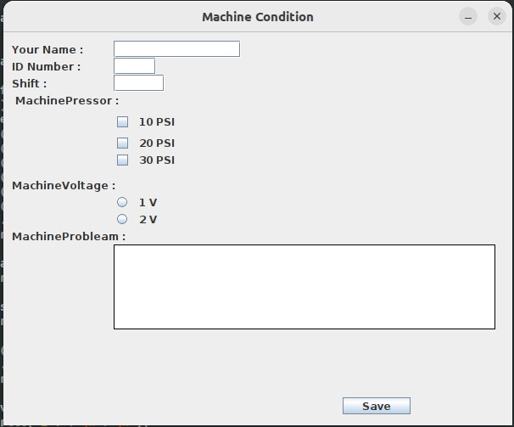

First Empoly Enter the data. The file saved the Desktop location of the (empolyname.txt).
Example:
balakrishnan.txt

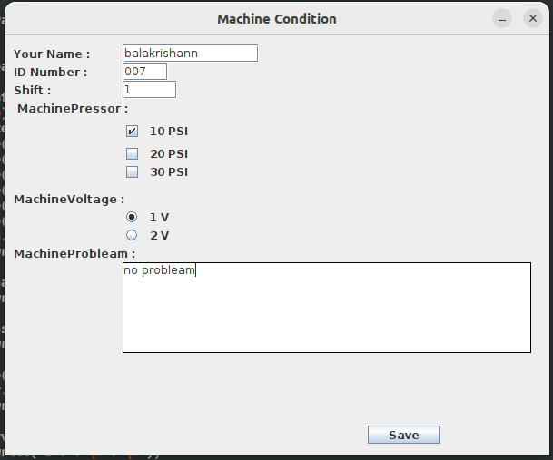
same empoly enter the data in second time the error message is throwing.

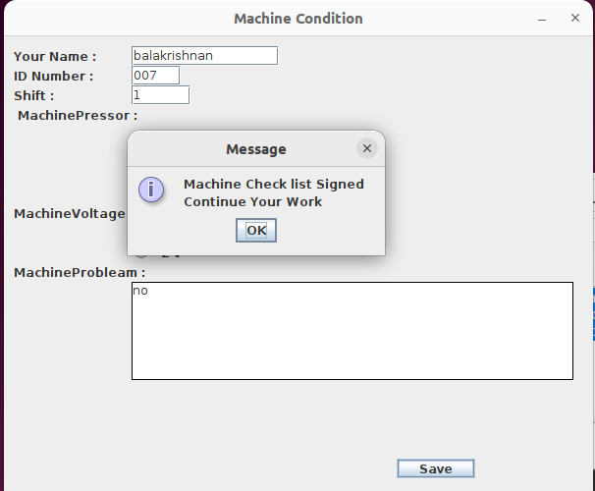

other empolyes enter the data it's stored the .txt file in the desktop.

