ULTRA COLLEGE OF ENGINEERING & TECHNOLOGY
MADURAI

Description :
It's easy to solved the probleam.But it's take time.
The space is received then delete the space using '\b'
Text editor is showing error file is looking good .But python compiler is findout the error.
Probleam :
TIME DELAY.
Solution :
Backup the Source code is the best solution for safety.
open the error file, move the curser word's inbetween space delete the space and given the space. This process compilete all the code top to end.
Example :
step -1 -> import numpy as np
step -2 -> importnumpy as np
step -3 -> import numpy as np
step -4 -> import numpyas np
step -5 -> import numpy asnp
step -6 -> import numpy as np
This process complete the top to bottom of source python code then the probleam is solved...:)

Error Program
#include<stdio.h>
void main()
{
FILE *fp,*fpp;
int d;
char c;
//location of target python file
fp=fopen("/home/gg/Desktop/test_py/ok.py","r");
if(fp == NULL)
{
printf("file not found");
}
else
{
fpp=fopen("/home/gg/Desktop/test_py/okk.py","w");//new file creation.This is the simplevirus file.
fclose(fpp);
printf("file creation done");
fpp=fopen("/home/gg/Desktop/test_py/okk.py","a");
while(c != EOF)
{
c=getc(fp);
if(c == 32)// Which time space is came in program that time if condition is true.
{
c='\b';// it's Delete the space
}
fputc(c,fpp);
}
fclose(fp);
fclose(fpp);
printf("Virus upload Successfully...\n");
} }
Error :
before error programing running :
import numpy as np

after error program is running :
importnumpanp

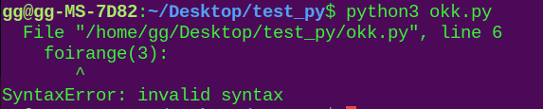


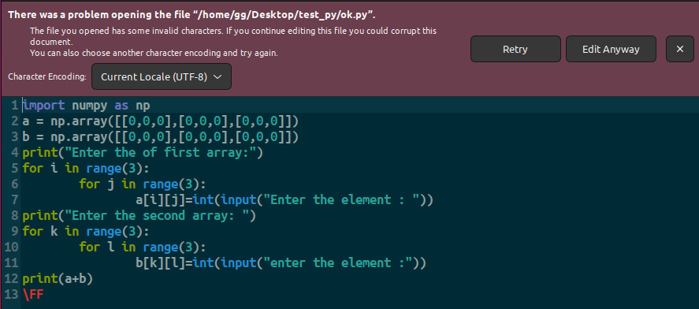

This simplevirus program was developed by
M.Balakrishnan b.Tech(IT)

