# D User Manual

### D.1 Download Eclipse

This toolkit requires Eclipse installation as a pre-requisite and is tested with the Eclipse kepler standard version 4.3.2.

Go to the page <https://www.eclipse.org/downloads/> and download the Eclipse standard version, if there is no existing installation.

### D.2 Installation instructions for the Toolkit

To install any plug-in using an update site open Eclipse go to Help -> Install New Software.

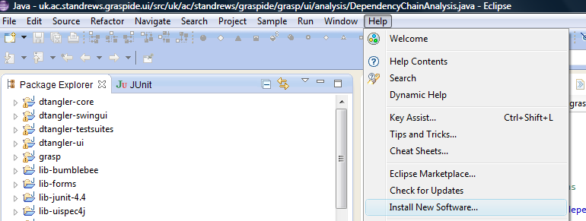

Figure D 1 Install plug-in menu

This toolkit installation involves installing the Xtext, Zest and GraspADLToolkit plug-ins. Their respective update sites and the corresponding installation instructions are briefly outlined in the following sections.

#### D.2.1 Install Xtext plug-in

This toolkit is tested with Xtext and Xtend version 2.5.3 using the update site <http://download.eclipse.org/modeling/tmf/xtext/updates/composite/releases/>.

Go to the page <http://www.eclipse.org/Xtext/download.html> for detailed installation instructions and use the update site mentioned in the page for Xtext installation.

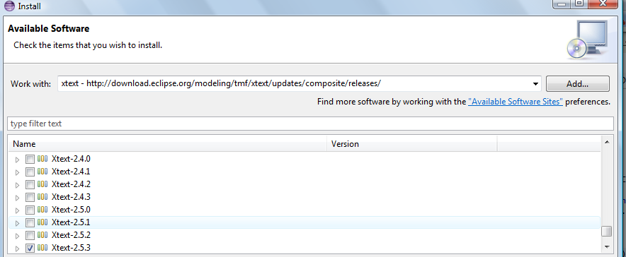

Figure D 2 Install Xtext plug-in window

Enter the update site URL in the work with text box and choose Xtext and Xtend for installation.

#### D.2.2 Install Zest plug-in

This toolkit is tested with the Zest plug-in version 1.5.1 using the update site URL <http://download.eclipse.org/tools/gef/updates/releases/>.

Go to the page <https://projects.eclipse.org/projects/tools.gef/downloads> for detailed installation instructions and install the Zest visualisation toolkit using the update site URL in the page.

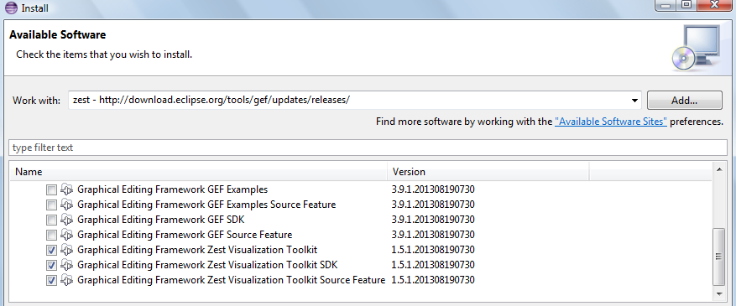

Figure D 3 Install Zest plug-in window

#### D.2.3 Install Grasp plug-in

The user could use the update site or manual installation to install Grasp toolkit.

Enter the update site URL <https://raw.githubusercontent.com/mbalamaruthu/GraspADL/master/site.xml> in the *work with text box* and choose GraspADLToolkit for installation. Alternative to update site is to copy the grasp plug-in jars to plugins directory of the Eclipse installation.

Restart Eclipse after the installation of all plug-ins.

### D.3 User Manual

#### D.3.1 Create Grasp Example Project

Go to File -> New -> Other

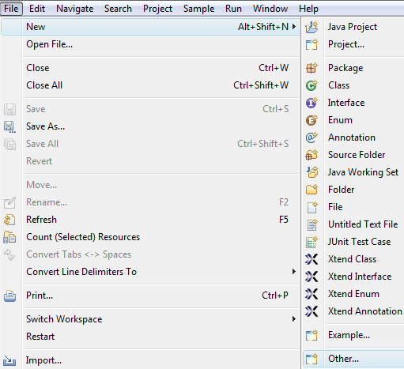

Figure D 4 Create new Grasp - initial menu

Choose Grasp -> Grasp Examples and proceed to create Example Project.

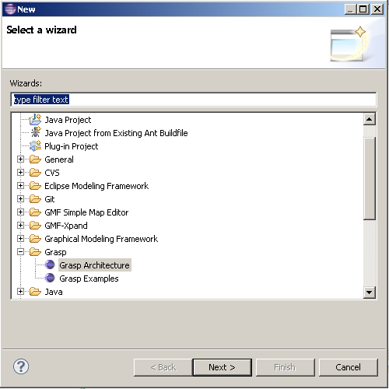

Figure D 5 Create new Grasp window

#### D.3.2 Create Grasp Architecture

Create a General Project (File -> New -> Other -> General -> Project) or select an existing project under which new architecture specification has to be created.

Go to File->New->Other and Choose Grasp Architecture to create new Grasp architecture

#### D.3.3 Perform on demand validations, code generation, visualisation and dependency analysis

Right click on the code editor context and choose the respective menu

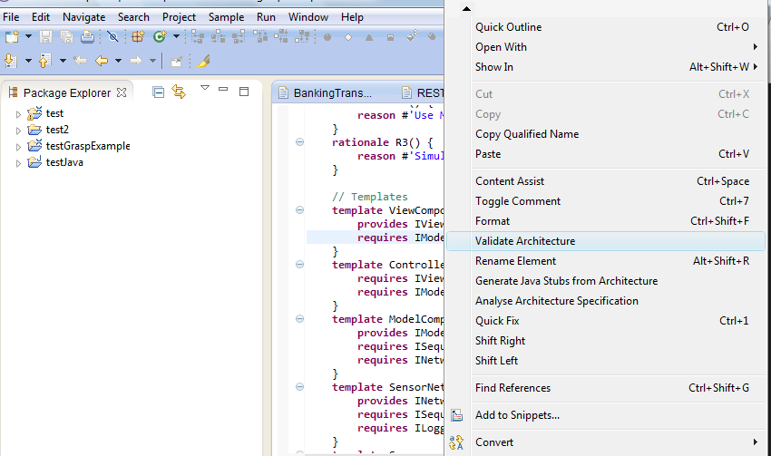

Figure D 6 Validate Architecture context menu

Choose the menu option

* *Validate Architecture* to perform on demand validations
* *Generate Java Stubs from Architecture* to perform code generation
* *Analyse Architecture specification* to perform dependency analysis
* *Open Architecture Visualiser* to open the visualisation tool

#### D.3.4 Open Grasp preferences page

Go to Window -> Preferences

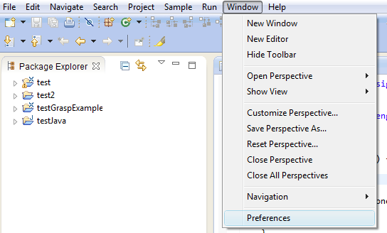

Figure D 7 Open Preferences page menu

Expand *GraspDSL* to view the preferences settings available for Grasp

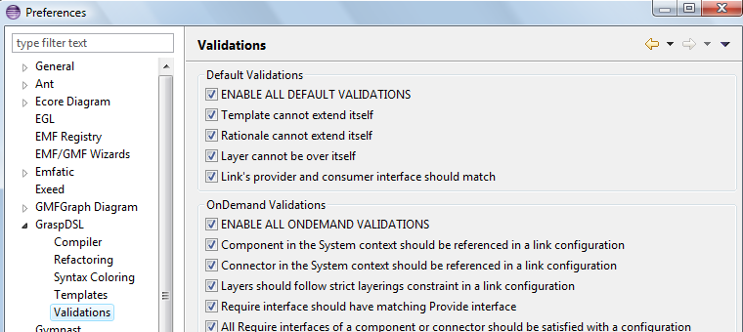

Figure D 8 Validation preferences window

#### D.3.5 Add code templates

Go to preferences page Window -> Preferences

Select Templates preference option under GraspDSL 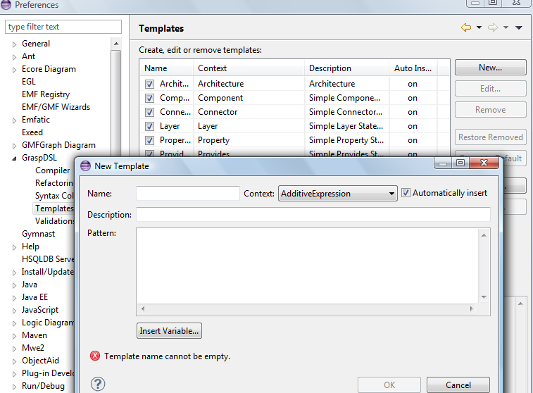

Figure D 9 New code template window

Click *New* to add a new template. Enter the template pattern inside pattern text area and choose the context where this code template should appear in the code editor. Select existing code templates and click edit to view or edit the existing template options.

#### D.3.6 Use code completion and code templates

Press *Ctrl + Space* to view the code completion and templates option available for auto completion.

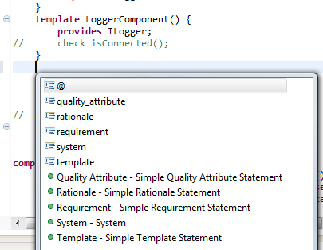

Figure D 10 Invoke code assist

Code completion options are (such as @, quality_attribute) shown at the top and Code templates (such as Quality Attribute – Simple Quality Attribute Statement, Rationale – Simple Rationale Statement) are shown after the code completion options but with a green icon at the left.