**1. Introduction**

**Project- WebSite TroubleShooter**

**WEBSITE TROUBLESHOOTER** is basically an expert system which helps end users to solve various issues related to websites. Most of the users are not very much familiar with technical level of website related issues like why images are not showing on website? Why page is not working? If we take these error in the technical form than these types of errors are called as like ERROR401, ERROR402, ERROR403, ERROR404 etc. So in this system we are just focusing on main concept to solve various types of issues that are related to Websites, HTML Pages errors, and other common errors that occurs on the websites. The project is open source & is under the Apache License, Version 2.0. It could prove to be the time effective solution for the end users. This project will work on all major platforms including Windows, Ubuntu OS, Mac OSx etc.

**1.1 Expert System**-A set of programs that manipulate the encoded knowledge to solve a problem of particular domain that normally requires human expertise. Knowledge is obtained by expert sources such as expert’s journals, articles, databases. Examples- Dendral, Prospector, Mycin.

**1.2 Characteristics**

1. Knowledge
2. Reasoning how and why
3. Symbolic representation
4. Meta knowledge

**1.3 Applications**

1. Medical diagnosis
2. Diagnosis of software development
3. Forecasting crop damage
4. Diagnosis of complex electronic and electro mechanical systems.
5. Planning experiments in biology, chemistry and molecular theory
6. Identification of compounds structure.
7. Location of faults in computer and communication systems
8. Design of VLSI systems
9. Military applications ranging from battlefield assessment to ocean survelligence
10. Application related to space planning and exploration

**1.4 Difference between human expert and an expert system**

|  |  |  |
| --- | --- | --- |
|  | Human Expert | Expert System |
| Time Availability | Not available for all the time | Available for all the time |
| Geographic Availability | Should be present Locally | Can be anywhere |
| Safety | No replacement of human expert is possible | An expert system can be replaced |
| Speed | Can be variable | Consistent |
| Performance | Can be variable | Consistent |
| Cost | No initial cost but periodic cost | Only initial cost ;no periodic cost |

**1.5 Expert System Architecture**

Expert system architecture is of two types:

1.5.1 Production System architecture

1.5.2 Non-Production System architecture

**1.5.1 Production System architecture**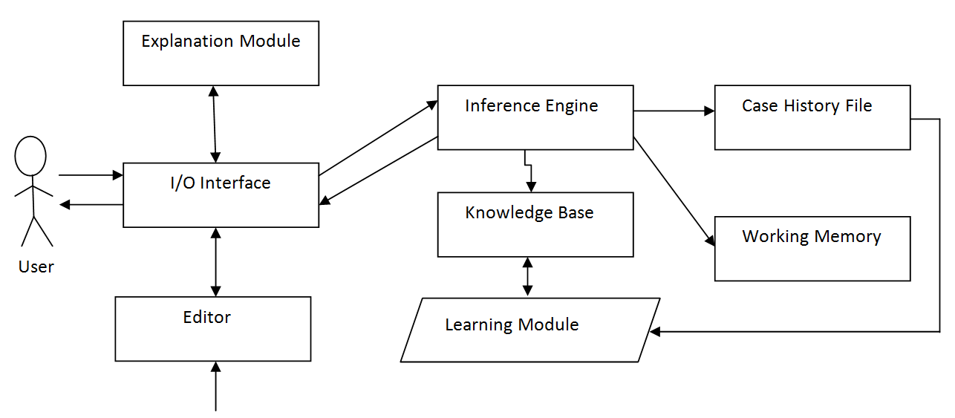

Figure 1: Production System Architecture

**Explanation Module** – The explanation module provides the user with an explanation of the reasoning process when requested. This is done in response to a how query or why query.

To respond to a how query, the explanation module traces the chain of rules fired during a consultation with the user. The sequences of rules that led to the conclusion is then printed for the user in an easy to understand human-language style. This permits the user to actually see the reasoning process followed by the system in arriving at the conclusion. If the user does not agree with the reasoning steps presented, they may be changed using the editor.

To respond to a why query, the explanation module must be able to explain why certain information is needed by the inference engine to complete a step in reasoning process before it can proceed

**I/O Interface:** The input-output interface permits the user to communicate with the system in a more natural way by permitting the use of simple selection menus or the use of a restricted language which is close to a natural language. This means that the system must have special prompts or a specialized vocabulary which encompasses the terminology of the given domain of expertise.

**Editor:** To change /add new/delete rules from knowledge base.

**Inference Engine:** The inference engine accepts user input queries and responses to questions through the I/O interface and uses this dynamic information together with the static knowledge (the rules and facts) stored in the knowledge base.

**Knowledge Base: The** knowledge base contains facts and rules about some specialized knowledge domain. Each fact and rule is identified with a name (a1, a2. . . r1, r2, . . .).Variables are identified as a symbol preceded by a question mark.

**Learning Module: In** learning module, things learnt from experience can be made rule using editor.

**Case History File:** Case History of previous conclusions can be placed using this.

**Working Memory:** The actual physical memory area for performing computations.

**1.5.2 Non-Production System architecture:** Instead of rules these systems employ more structured representation schemes like Semantic (Associative) Networks, Frames, Tree Structures (Decision trees) or even Neural Networks.

Some of the Non Production System Architectures are

**1.5.2.1 Semantic (Associative) Network Architectures**

Semantic n/w representations are not a popular form of representation for standard ES's.More often these n/w representations are used in natural language or computer vision systems or in conjunction with some other form of representation. They are useful in depicting hierarchical knowledge structures where property inheritance is common.

Here the nodes represent objects, attributes, concepts or other basic entities and the arcs which are labeled describe the relationship between the nodes they connect.

Example: CASNET (Causal Associative Network) is used to diagnose and recommend treatment for glaucoma, one of the leading causes of blindness.

**1.5.2.2 Frame Architecture**

Frames are structured sets of closely related knowledge such as on object or concept name, the objects main attribute and there corresponding values and possibly some attached procedures. The attributes, values and procedures are stored in specified slots and facets of the frame.

Individual frames are linked together in a network much like nodes in an associative n/thus frames have many of the features of associative n/w's like property inheritance and default reasoning.

Example: PIP (Present Illness Program) was used to diagnose patients using low costs, easily obtained information.

**1.5.2.3 Decision Tree Architect**

Knowledge for ES may be stored in the form of a decision tree when the knowledge can be structured in a top to bottom manner. Initial & Intermediate nodes in the tree correspond to the identities of the objects. Attribute values for an object determine a path to a leaf node in tree which contains the objects identification.

The KB which is the decision tree for an identification system can be constructed with a special tree building editor or with a learning module. New nodes or branches can be added to the tree when additional attributes are needed to further discriminate among new objects.

**1.5.2.4 Black Board System Architecture**

Blackboard architectures refer to a special type of KBS which uses a form of opportunistic reasoning. It uses both forward & backward chaining and chooses them dynamically at each stage in the problem solution process. Blackboard systems are composed of 3 functional components:

1. Knowledge Sources

2. Blackboard

3. Control Information

Example: HEARSAY a speech understanding system.

**1.5.2 .1 Analogical Reasoning Architectures**

ES's based on analogical architectures solve new problems like humans, by finding a similar problem solution that is known and applying the known solution to the new problem, possibly with some modifications.

This would require a large KB having numerous problem solutions and other previously encountered situations or episodes.

**2. Technology to be used**

**Website Troubleshooter** Expert System is developed in a **PROLOG.** Prolog is a general purpose logic programming language associated with artificial intelligence and computational linguistics.

Prolog has its roots in first-order logic, a formal logic, and unlike many other programming languages, Prolog is declarative: the program logic is expressed in terms of relations, represented as facts and rules. A computation is initiated by running a query over these relations.

The language was first conceived by a group around Alain Colmerauer in Marseille, France, in the early 1970s and the first Prolog system was developed in 1972 by Colmerauer with Philippe Roussel. Prolog was one of the first logic programming languages and remains the most popular among such languages today, with many free and commercial implementations available. While initially aimed at natural language processing, the language has since then stretched far into other areas like theorem proving, expert systems, games, automated answering systems, ontologies and sophisticated control systems. Modern Prolog environments support creating graphical user interfaces, as well as administrative and networked applications.

**2.1 Advantages of Prolog**

* It has built-in list handling, very useful for representing sequences, trees, and so on.
* It is easy to read and write programs which build structures.
* add( complex(A,B), complex(C,D),

complex (E,F)

) :-

E is A+C,

F is B+D.

* Most Prologs nowadays should be able to handle structures of at least 30Kbytes in size.
* Although Prolog is not a complete implementation of logic, it is much closer to it than C, and is more like mathematical notation.
* It is easy to build tables and databases while a program is running, as I did with memo fib. You don't need a lot of programming effort.

You can reason about programs as algebraic objects. When writing a predicate, begin with a definition that is obviously correct, but inefficient. Then apply transformations that preserve its effect while making it more efficient.

The **WEBSITE TROUBLESHOOTER** will includes series of questions that are basically according to user demand i.e. error that user want to solve with this expert system. Series of questions will be asked from user as per user’s requirement then this system will gives certain output related to issue. End User’s request is act as a input, if user is necessary part of this system. If anybody wants to get certain output then they must give certain input. Input is basically is an issues or a problem that user wants to solve. Final answer given by system will the solution of user’s problem.

**3. Requirement Analysis**

This phase define the requirement of the software i.e. it defines the tools and equipment’s which are used for the development of the software. Following are the hardware and software requirements for building this application:

**HARDWARE**

Processor 1.70 GHz and Above

Main Memory 512 MB.

Disk Space 100 MB.

Keyboard ANY

Mouse ANY

Monitor ANY

**SOFTWARE**

Operating System Windows,Linux.

Software Notepad

Complier SWI Prolog

* 1. **Feasibility Study of the Project**

At this stage the client’s or the user’s needs are analyzed, information about the project is gathered and the requirements of the system are collected and analyzed. The user’s expectation for the system implementation is studied and the proposed solution is offered.

**a) Technical Feasibility: -** If we talk about the technical feasibility of this project then it requires the resources and the technology to be available. This project requires PHP and MySQL software for the frontend and backend respectively which are very easily available. Moreover the requirements of the hardware are also low.

**b) Economic Feasibility:-** As per the cost considerations, this project requires a low cost to build up including the hardware and the software cost. The cost of implementation is also fair enough to implement this application.

**c) Operational Feasibility: -** As the project is made keeping in mind the various requirements of the user, it is nearly sure that it must be used by the user if developed and implemented and will not give any large problems on the site of implementation.

**5. Need and Significance of the project**

* This project is going to help the end users who are not very much familiar with WWW.
* This project will help the developers and designers to solve various types of issues related to Webserver.
* This project will also help the Developer to find solution related to various FTP issues and File Manager Issues.
* This project thus is not the benefit of one member, it is the benefit of the community.
* This project will also provide solution of various types of problems that are associated WEBSITE HOSTING (CPanel => Control Panel) like Database Issues, Access Rights etc.

**6.Methodology/ Planning of Work**

The project will be follow the bottom up approach. First the page will shown on the home page of the system where you have to choose category according to your problem then after selecting a category then a new page will be shown that contains series of questions that are basically Muliple Choice Questions you have to give answer of these questions after series of questions certain output will shown on that page, which will be the solution of user’s problem.

**6.1 Modular Structure of Website Troubleshooter**

WEBSITE TROUBLESHOOTER

Safari

Internet Explorer

Firefox

Chrome

Figure 2. Modular Structure of WEBSITE TROUBLESHOOTER

**6.2 Flow Chart of WEBSITE TROUBLESHOOTER**

Start

Enter Name

Select Browser

Series of Questions

Yes No

Answer

Result

End

Figure 3. Flow Chart of WEBSITE TROUBLESHOOTER

**7. Snap Shots**

**FRONT PAGE/HOME PAGE**

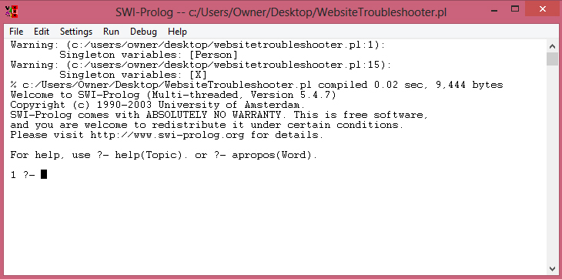

Figure 4. Front page

**START QUERY.**

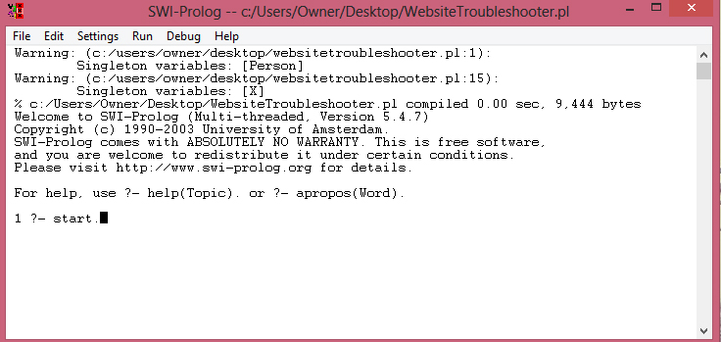

Figure 5. Start Query

**NOW ASK SERIES OF QUESTIONS BY EXPERT SYSTEM**

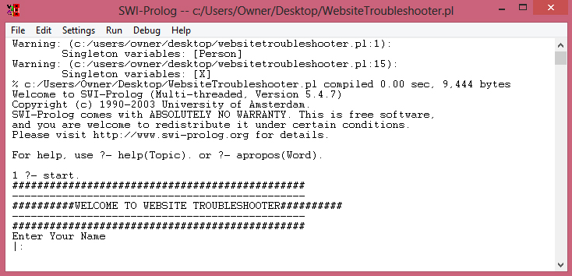

Figure 6. Series of Questions

**SERIES OF QUESTIONS BY EXPERT SYSTEM**

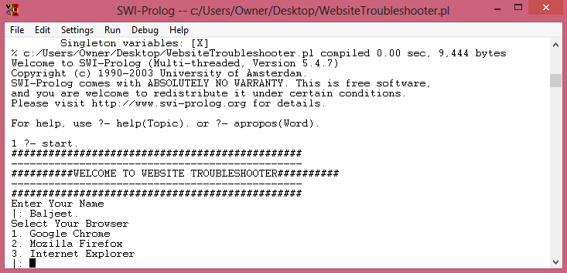

Figure 7. Select The Browser

**SERIES OF QUESTIONS BY EXPERT SYSTEM**

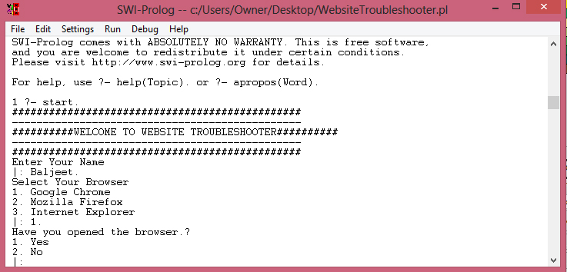

Figure 8. Select The Category

**SERIES OF QUESTIONS BY EXPERT SYSTEM**

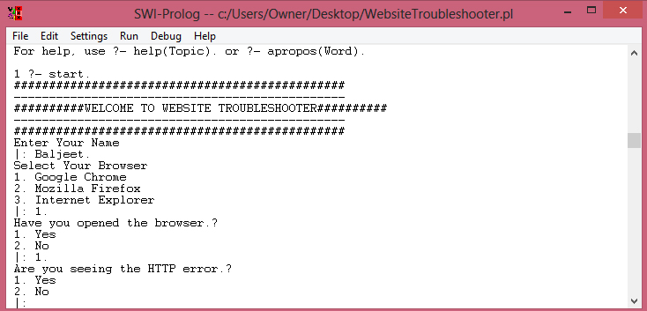

Figure 9. Select The Category

**SERIES OF QUESTIONS BY EXPERT SYSTEM**

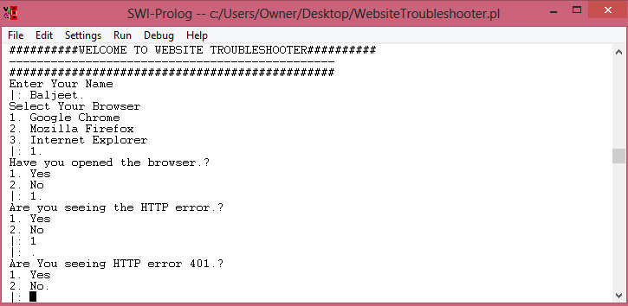

Figure 10. Answer To Symptoms Of Depression

**SERIES OF QUESTIONS BY EXPERT SYSTEM**

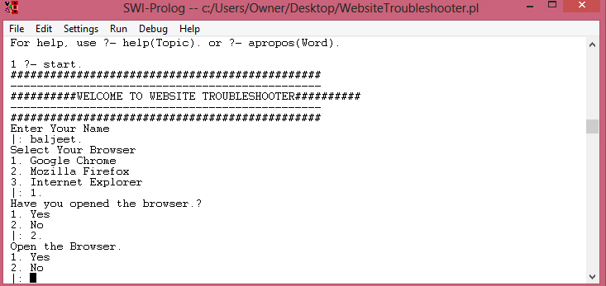

Figure 11. Answer To Symptoms Of Depression

**SERIES OF QUESTIONS BY EXPERT SYSTEM**

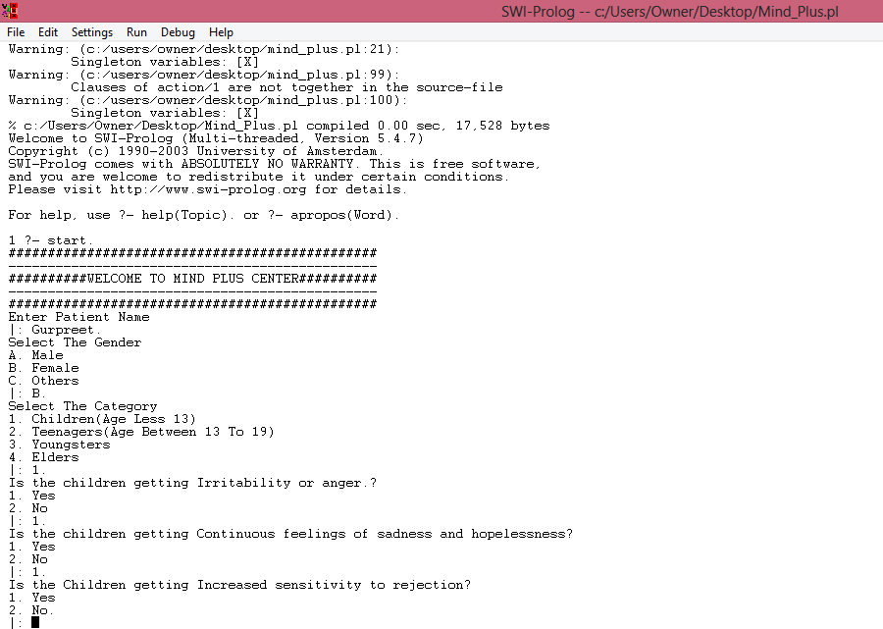

Figure 12. Answer To Symptoms of Depression

**SERIES OF QUESTIONS BY EXPERT SYSTEM**

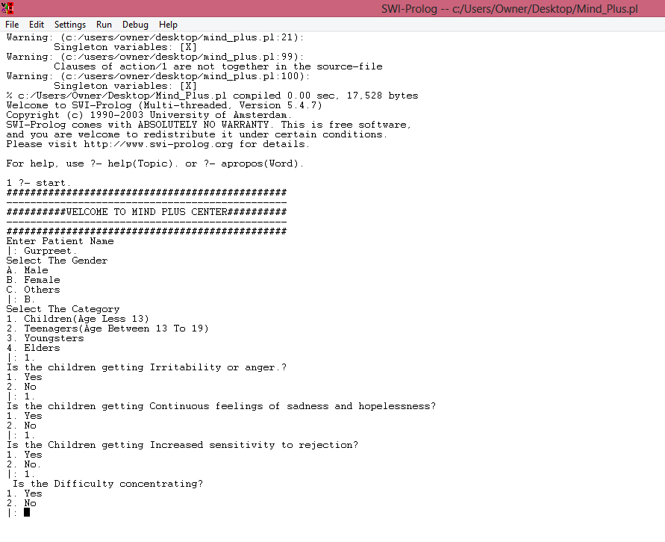

Figure 13. Answer To Symptoms of Depression

**8. Conclusion**

We wanted to create a simple tool that will help the beginners to find the solutions regarding

common errors that occurs while browsing internet. Most of the users are not very much familiar with technical level of website related issues like why images are not showing on website? why page is not working? If we take these error in the technical form than these types of errors are called as like ERROR401, ERROR402, ERROR403, ERROR404 etc. So in this system we are just focusing on main concept to solve various types of issues that are related to Websites, HTML Pages, CSS, JAVASCRIPT and many more scripting languages.

**9. Bibliography**

1. [www.google.com](http://www.google.com)
2. <http://www.webmd.com/depression>
3. <http://www.csupomona.edu/~jrfisher/www/prolog_tutorial/contents.html>
4. <http://en.wikipedia.org/wiki/Prolog>
5. <http://www.csupomona.edu/~jrfisher/www/prolog_tutorial/pt_framer.html>
6. <http://www.learnprolognow.org/>
7. <http://kti.mff.cuni.cz/~bartak/prolog/>