Software Proposal
Nkanyezi Learning Management System (LMS)
v1.2 — Revised proposal for Work-Integrated Learning (WIL) Assessment

Introduction
Initials: N
Student responsible: Nhlakanipho Mbambo
Student Number: 224641362
Student email address: 224641362@tut4life.ac.za
Institution: Tshwane University of Technology
Qualification: National Diploma in Computer Science
Host Organisation: SpecCon Holdings (Pty) Ltd
Host Mentor: Shadrack Mahlangu
Website: https://www.portal.nkanyezionline.co.za

Contents

1. Name of the Project
Nkanyezi Learning Management System (LMS) — a role-based web platform for digital attendance, learner progress tracking, facilitator administration, and SETA-aligned rollout planning, developed for the Training Department of SpecCon Holdings (Pty) Ltd, trading as Nkanyezi Academy.

2. Domain Analysis

2.1 General Field of Business
The project sits within the South African skills-development and occupational-training industry. Organisations in this field are typically accredited training providers that deliver learnerships and skills programmes on behalf of Sector Education and Training Authorities (SETAs), under the framework set out by the South African Qualifications Authority (SAQA) and the National Qualifications Framework (NQF). Training providers are contracted by corporate clients or SETAs to place, train, and assess learners (often unemployed youth) against registered qualifications and unit standards, while maintaining strict administrative and compliance records.

2.2 Terminology and Glossary
- SETA — Sector Education and Training Authority; regulates and part-funds workplace skills development.
- SAQA / NQF — South African Qualifications Authority / National Qualifications Framework; governs qualification registration and levels.
- Learnership — a structured work-based learning programme combining theoretical and practical training, leading to a registered qualification.
- Learner — a participant enrolled on a learnership or skills programme.
- Facilitator — the staff member who delivers training content, monitors attendance, and supports learners.
- Rollout Plan — a scheduling document that maps training content, assessments, and workplace activities against the qualification's unit standards over the duration of the learnership.
- Attendance Register — the record (traditionally paper-based) used to confirm a learner's physical presence at training sessions.
- Stipend — a monthly allowance paid to learners on a learnership, subject to attendance and progress approval.
- WIL — Work-Integrated Learning; the structured workplace placement component of a student's diploma.

2.3 The Business Environment
Training providers operate under continual oversight: SETAs and corporate funders require accurate, auditable attendance and progress records to release funding and stipends, and to support accreditation renewal. Because funding and accreditation are tied to demonstrable compliance, administrative accuracy is not a secondary concern for the business — it is a condition of continued operation.

2.4 Tasks and Procedures Currently Performed
- Facilitators manually complete and file paper attendance registers for each session.
- Facilitators manually compile learner progress notes and feedback, typically in Word or Excel documents.
- Rollout plans are drafted manually against qualification unit standards, largely by copying and adapting previous plans.
- Administrators manually collate attendance and progress data to support stipend approvals and SETA/client reporting.

2.5 Customers and Users
- SETAs and corporate clients — external stakeholders who fund learnerships and require compliance reporting.
- Learners — the trainees whose attendance, progress, and feedback are tracked.
- Facilitators — deliver training and are the primary daily users of attendance and progress tools.
- Training administrators / managers — oversee multiple facilitators, learnerships, and reporting obligations.

2.6 Competing Software
General-purpose Learning Management Systems such as Moodle, Totara, and TalentLMS are widely used internationally, but they are built primarily around e-learning content delivery, quizzes, and course completion tracking. They do not natively support GPS-verified, in-person attendance capture, SETA-aligned rollout plan generation, or stipend-linked progress workflows specific to the South African learnership model. The organisation's own legacy tracking system is outdated and largely spreadsheet-based, with no real-time reporting capability. This gap — administrative tooling purpose-built for South African learnership compliance — is the opportunity the proposed LMS addresses.

2.7 Similarities to Other Domains
The proposed system shares characteristics with two adjacent domains: corporate workforce/time-and-attendance management systems (location-verified check-ins, real-time dashboards) and conventional e-learning LMS platforms (progress tracking, learner records, reporting). The Nkanyezi LMS combines patterns from both, tailored to the compliance and reporting requirements of SETA-funded learnerships.

3. Define the Problem
During my Work-Integrated Learning placement I was exposed to several departments, including the Training Department (as a Facilitator Assistant) and the IT Department (Systems Support and Software Development). I spent the majority of my placement within the Training Department, and it was there that I identified the difficulty this project addresses.
Through discussions with facilitators, direct observation of daily operations, and requirements gathering, it became clear that the department relies heavily on repetitive manual administrative processes — many required for SETA compliance, others a consequence of an outdated learner-tracking system. Paper-based documentation is still used to manage learners and their learnerships, covering attendance registers, learner management, facilitator reporting, learner feedback, and rollout planning.
This manual approach creates measurable inefficiencies. A facilitator responsible for a learnership of approximately 100 learners must manually prepare and later review attendance registers to identify patterns or irregularities — manageable for groups of five to ten learners, but increasingly impractical as class sizes grow. The branch where I completed my placement spends approximately R5,000 per month on paper reams alone, and paper registers remain vulnerable to being misplaced, lost, or damaged, producing incomplete or unreliable attendance records.
The same difficulty extends to learner feedback and progress management: facilitators must manually collect, analyse, and maintain this information, delaying visibility into learner performance and making it harder to identify learners who need additional support. Rollout planning is similarly repetitive and error-prone when compiled manually.
Collectively, these inefficiencies reduce facilitator productivity, increase administrative overhead, affect the accuracy of learner data, and limit the department's ability to respond proactively to learner needs. This is both the difficulty to be solved and the opportunity: automating these repetitive processes through a centralised, real-time digital platform stands to directly improve facilitator productivity and data accuracy.

4. Define the Scope

4.1 Precise Problem Statement
This project is scoped to design and build a role-based web application — the Nkanyezi LMS — covering GPS-verified attendance capture, real-time facilitator and administrator dashboards, automated learner feedback generation, and a SAQA-aligned rollout plan creator for the Training Department at SpecCon Holdings. Explicitly out of scope for this WIL prototype are: full e-learning content delivery (video lessons, quizzes), automated stipend payment processing, and direct system-to-system integration with external SETA reporting portals — these are noted as candidates for future work beyond the current qualification's timeframe.

4.2 Integrated Result-Based Management (IRBM)
Element | Description
Inputs | Facilitator and administrator time, existing learner records, qualification/unit standard requirements, GPS coordinates of training venues, and current paper-based registers used as a baseline.
Activities | Digitising attendance capture with GPS verification; building real-time dashboards; automating learner feedback generation; building the rollout plan creator; migrating learner data into a central database.
Outputs | A working three-tier LMS application (admin, facilitator, and learner portals), supporting documentation, test plans, and generated reports.
Outcomes | Reduced administrative time per facilitator, more accurate and timely attendance and progress data, faster feedback turnaround, and reduced paper expenditure.
Impact | Improved SETA/client compliance and accreditation standing, better-supported learners through earlier identification of at-risk cases, and cost savings that can be redirected to training delivery — contributing to improved training outcomes for the learners and the broader community the programme serves.

4.3 Assess, Think, Envision, Plan
Assess — What is the current situation? The Training Department relies on manual, paper-based attendance registers, spreadsheet-based progress tracking, and manually compiled rollout plans and feedback, with no centralised or real-time reporting.
Think — What caused it? Who is involved? The situation stems from an outdated legacy tracking system and the absence of purpose-built digital tooling for South African learnership compliance. Facilitators, training administrators, learners, and ultimately SETAs and corporate clients are all involved or affected.
Envision — What are we going to achieve? A centralised, real-time, role-based digital platform that automates attendance capture, progress monitoring, feedback generation, and rollout planning, reducing administrative overhead and improving data accuracy.
Plan — How, with whom, when, with what resources? The system will be built in phases across the WIL project timeline (proposal, modelling, UI design, database and integration, final deliverable), working with the Training Department and host mentor as primary stakeholders, using Node.js/Express, PostgreSQL, and Microsoft Azure hosting resources already available within the organisation.

5. Vision and Objectives

5.1 Vision
To replace paper-based, manually intensive training administration with a centralised, real-time, and location-verified digital platform that gives facilitators and administrators immediate visibility into learner attendance and progress, freeing facilitators to spend more time supporting learners rather than completing repetitive administrative tasks.

5.2 Objectives (SMART)
- Deliver a working GPS-verified digital attendance module, replacing paper registers for at least one pilot learnership group, within the current WIL project timeline.
- Provide facilitators and administrators with a real-time dashboard reflecting attendance and progress data with no more than a few seconds' delay, measurable through direct comparison against manual reporting turnaround.
- Reduce the time facilitators spend compiling learner feedback by automating draft generation from attendance and progress data, targeting a measurable reduction in manual compilation time per feedback cycle.
- Implement a rollout plan creator that generates a SAQA-aligned draft plan from qualification/unit standard input, reducing manual drafting effort for a new learnership rollout.
- Achieve a fully integrated three-tier prototype (UI, application logic, and PostgreSQL database) deployed to Azure App Service and demonstrated with test cases by the final WIL deliverable deadline.

6. Users of the System
Role | Responsibilities in the System
Learner | Logs in to capture GPS-verified attendance, and views their own attendance history and progress feedback.
Facilitator | Monitors assigned learners' attendance and progress via the facilitator dashboard, generates and sends learner feedback, creates and modifies rollout plans, and manages training materials.
Administrator / Training Manager | Manages learner and facilitator records (add/update/remove), assigns facilitators to learnerships, views organisation-wide dashboards, and generates compliance and progress reports.
System Administrator | Manages user accounts and access control, monitors system availability, and maintains the underlying database and hosting configuration.

7. Mandatory Functions
At minimum, the system must support standard Create, Read, Update, and Delete (CRUD) operations against the underlying database for all core entities, specifically:
- Add/Register — new learners, facilitators, learnerships, attendance records, feedback entries, rollout plans, and training materials.
- Update — learner and facilitator details, learnership assignments, attendance corrections, rollout plan content, and materials.
- Delete/Remove — learners, facilitators, materials, or records that are no longer valid, subject to role-based permissions and audit considerations.

8. Functional Requirements
The functional requirements below represent the negotiated agreement between the Training Department, the host mentor, and the developer as to what the system must do to solve the identified problem.

8.1 Inputs and Outputs
- Input: learner GPS coordinates at the moment of check-in. Output: a confirmed or rejected attendance record, based on proximity to the registered venue.
- Input: learner and facilitator demographic and enrolment data captured by administrators. Output: stored learner/facilitator records available across the admin, facilitator, and learner portals.
- Input: attendance and progress history for a learner. Output: a generated feedback draft that a facilitator can review, edit, and send.
- Input: qualification and unit standard details for a learnership. Output: a structured, editable rollout plan aligned to those unit standards.
- Input: training materials (documents, slides) uploaded by facilitators. Output: materials stored in Azure Blob Storage and made available to learners via secure, time-limited links.

8.2 Computations Performed
- Distance calculation between a learner's submitted GPS coordinates and the registered venue coordinates, validated against a 50-metre proximity threshold.
- Aggregation of attendance and progress records into summary statistics for the dashboard (e.g. attendance rate per learner/group, flags for at-risk learners).
- Categorisation logic that groups learners by performance/attendance pattern to tailor automatically generated feedback.

8.3 Timing and Synchronisation of Events
- Attendance check-ins are validated and recorded in real time at the moment of submission.
- Dashboard summary statistics are served from database views refreshed on a scheduled or on-demand basis to balance real-time relevance with database load.
- Feedback emails are generated on facilitator request and sent (and logged) synchronously via the Resend email service.
- Session state is persisted server-side so that a facilitator's or administrator's login session survives application restarts or scaling events.

9. Non-Functional Requirements

9.1 Authentication (Login / Logout)
The system uses session-based authentication. Users log in with a username/email and password; credentials are validated server-side and a session is established and persisted in the PostgreSQL-backed session store. Role-based access control restricts each user to the functions appropriate to their role (learner, facilitator, administrator, system administrator). Login attempts are rate-limited to reduce the risk of brute-force attacks, and users can explicitly log out to terminate their session.

9.2 Availability
The application is hosted on Azure App Service with the database hosted on Azure Database for PostgreSQL Flexible Server, targeting high availability during business hours when facilitators and learners are actively capturing attendance and accessing dashboards. HTTPS/SSL is enforced for all traffic, session data persists across application restarts via a database-backed session store, and rate limiting on API routes protects availability against excessive or abusive request volumes.

10. Use Case
The diagram below summarises the primary interactions between each user role and the system. Each use case represents a complete, self-contained interaction the user has with the system — from initiating the action to receiving a result — rather than an internal computation or a manual, off-system task.
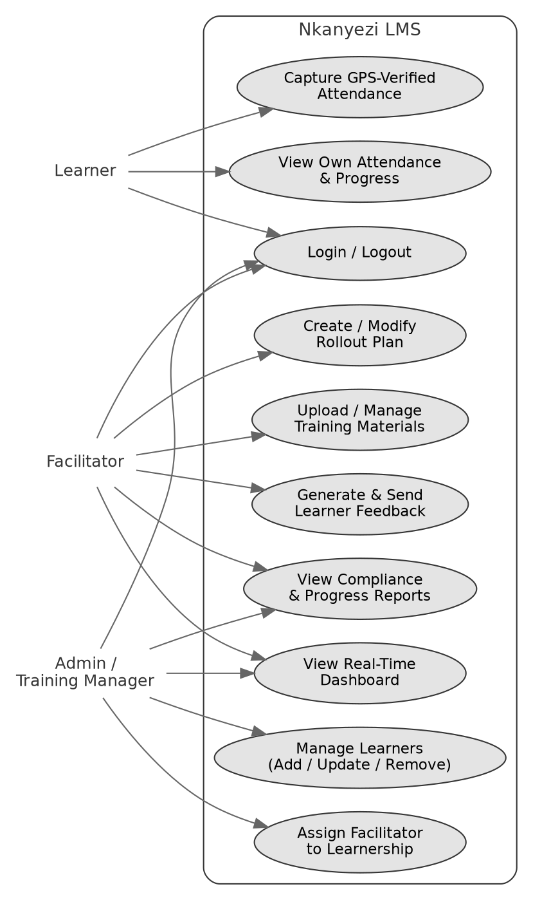

10.1 Example Use Case: Capture GPS-Verified Attendance
- The learner opens the Nkanyezi LMS learner portal and logs in.
- The learner selects "Check In" for the current training session.
- The system requests the device's current GPS coordinates.
- The learner grants location access and the coordinates are submitted to the system.
- The system compares the submitted coordinates to the registered venue location within a 50-metre threshold.
- If within range, the system records the attendance as confirmed and displays a success message to the learner.
- If out of range, the system rejects the check-in and displays an explanatory message, prompting the learner to move closer to the venue.
- The learner may then view their updated attendance history within the same session.

11. Tools and Technologies to be Used
Category | Technology
Frontend | HTML5, CSS3, JavaScript
Backend | Node.js, Express.js
Database | PostgreSQL
Version Control | Git and GitHub
Cloud Hosting | Microsoft Azure
File Storage | Azure Blob Storage (SAS URL access)
Domain & Email Service | Xneelo (domain) & Resend (transactional email)
Application Hosting | Azure App Services
Database Hosting | Azure Database for PostgreSQL — Flexible Server

Why Were These Tools Chosen?
The technical approach was designed to align closely with the existing development environment used at SpecCon. The organisation primarily develops applications using Microsoft-based technologies, including ASP.NET frameworks and C#. However, the proposed LMS prototype follows a different technical direction, with JavaScript selected as the primary development language.
This decision was intentional: JavaScript was an area where I identified an opportunity to strengthen my own technical skills. Developing the prototype in JavaScript allowed me to gain practical experience while still building a system capable of meeting the functional requirements of the proposed solution.
The project remains based on standard JavaScript rather than frameworks such as React or Next.js, because the current scope of the prototype does not require the additional complexity these frameworks introduce. A lightweight approach using plain JavaScript provides sufficient functionality for the required features while maintaining simplicity, performance, and ease of development.

Appendix A: System Documentation
The Entity Relationship Diagram (ERD) below provides a visual representation of the database structure, illustrating the relationships between the system's entities and how data is organised. It maps out the database tables, their attributes, and the relationships between them to support effective data management, consistency, and scalability.
