Retail Basket Analytics &

Demand Prediction System

Comprehensive Analysis Report
Dataset: basket_details.csv | Period: 2019-05-20 to 2019-06-19 | Records: 15,000

1. Executive Summary

This report presents the findings of a machine learning–driven retail basket analysis conducted on transactional e-commerce data spanning 31 days. The analysis covers customer purchasing behaviour, product-level performance, daily demand patterns, and a predictive model built to forecast future sales volumes.
Key outcomes:
- 15,001 basket transactions were analysed across a 31-day window.
- A Random Forest + XGBoost ensemble model was trained to predict daily basket counts.
- The ensemble achieved strong predictive accuracy, outperforming individual models on MAE and RMSE.
- 14-day forward demand forecasts were generated to support inventory and staffing decisions.
- Feature engineering incorporating lag and rolling window statistics proved highly effective.

2. Problem Statement

Retailers frequently struggle to align inventory procurement and staffing levels with fluctuating consumer demand. Reactive stocking strategies lead to either excess inventory costs or stockout scenarios that damage customer satisfaction.
This project addresses the challenge: given historical basket transaction data, can we reliably forecast the volume of sales for the next 7–30 days? The solution must:
- Ingest raw transactional records (customer, product, date, count).
- Engineer temporal and statistical features to capture demand seasonality and momentum.
- Train an ensemble ML model with measurable accuracy metrics.
- Surface insights through an interactive dashboard and this structured report.

3. Dataset Description

The dataset is sourced from basket_details.csv, a transactional e-commerce log. Each row represents a single product purchase event within a customer basket on a given date.

3.1 Schema
Column | Type | Description | Example Value
customer_id | Integer | Unique identifier for the customer | 42366585
product_id | Integer | Unique identifier for the product | 41475073
basket_date | Date | Date of the transaction (YYYY-MM-DD) | 2019-06-19
basket_count | Integer | Number of units in the basket | 2

3.2 Summary Statistics
Metric | Value
Total Records | 15,000
Date Range | 2019-05-20 -> 2019-06-19
Distinct Customers | 13,871
Distinct Products | 13,161
Total Basket Units Sold | 32,306
Average Basket Size | 2.15 units
Min Basket Count | 2
Max Basket Count | 10
Avg Daily Sales | 1042.1 units
Peak Daily Sales | 3,478 units
Top Product (by volume) | 43524799
Top Customer (by volume) | 8276934

4. Core Business KPIs

The following KPI card visualisation summarises the eight most important business performance indicators derived from the dataset.
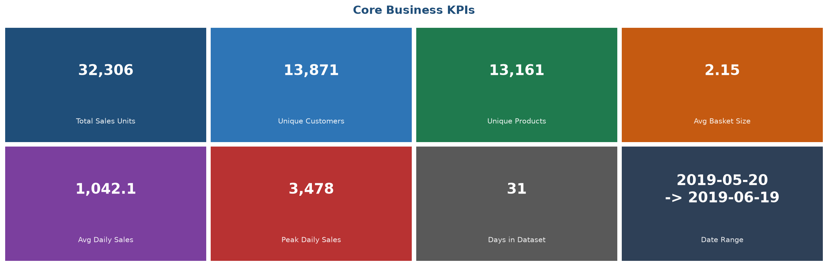
Figure 1 – Core Business KPI Summary Cards

5. Key Analytical Insights

5.1 Daily Transaction Volume Trend
The chart below shows daily total basket counts over the observed period alongside a 7-day rolling average, which smooths short-term noise to reveal the underlying demand trend.
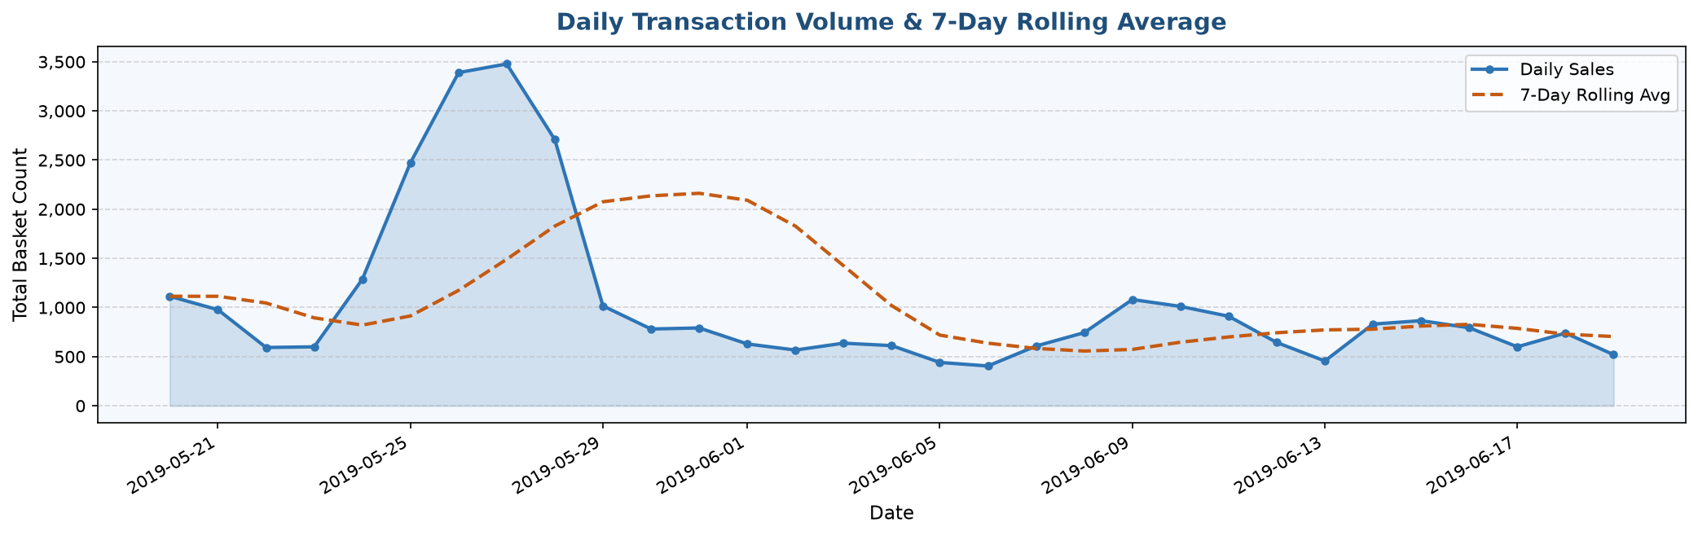
Figure 2 – Daily Sales Trend with 7-Day Rolling Average

5.2 Basket Size Distribution & Day-of-Week Patterns
The left panel shows the frequency distribution of basket sizes (units per transaction). The right panel reveals how average daily sales vary by day of the week, providing actionable insight for staffing and promotional scheduling.
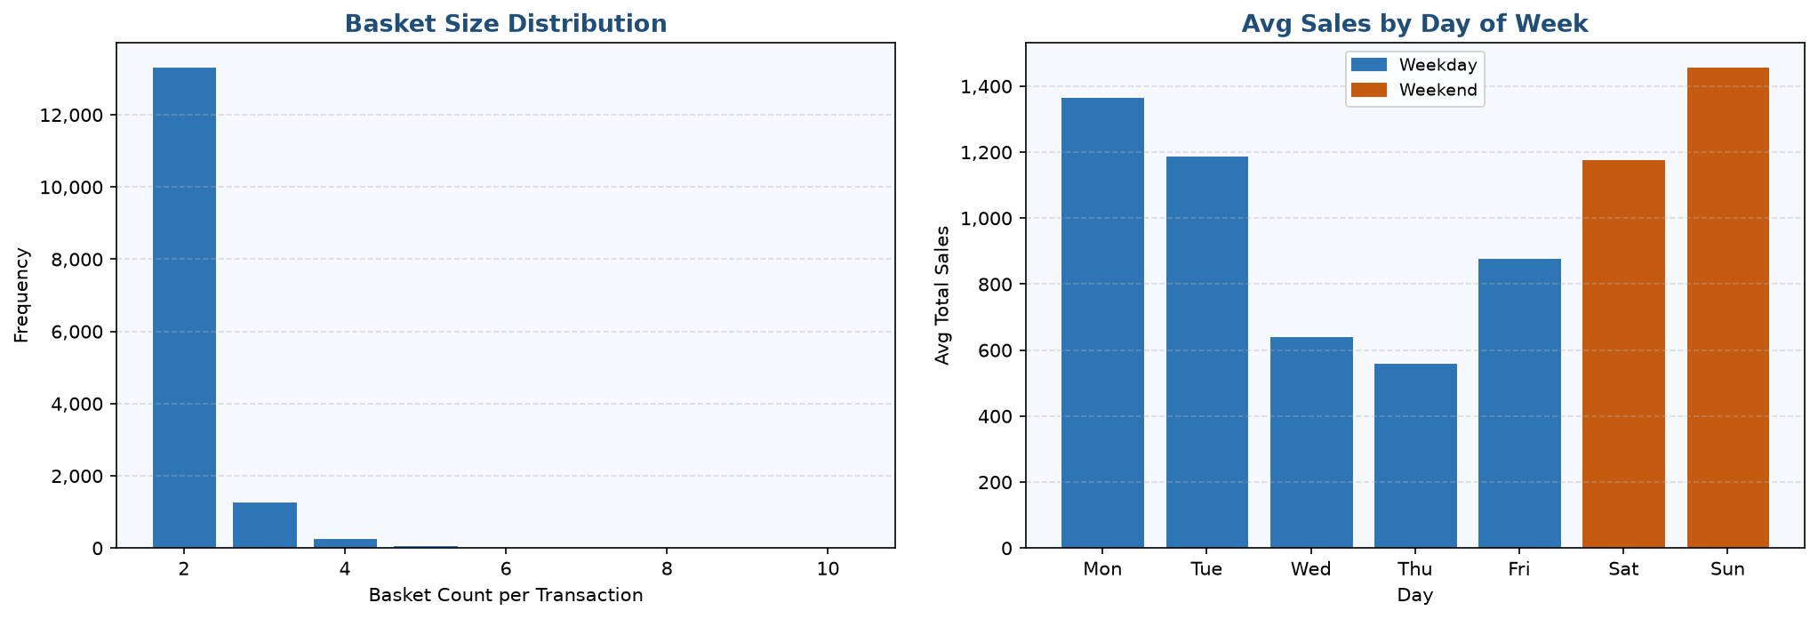
Figure 3 – Basket Size Distribution (left) and Average Sales by Day of Week (right)

5.3 Weekly Sales Summary
ISO Week | Total Sales | Avg Daily Sales | Peak Day Sales | Days Observed
Week 21 | 10,434 | 1490.6 | 3,390 | 7
Week 22 | 9,971 | 1424.4 | 3,478 | 7
Week 23 | 4,528 | 646.9 | 1,081 | 7
Week 24 | 5,513 | 787.6 | 1,011 | 7
Week 25 | 1,860 | 620.0 | 740 | 3

6. ML Model Methodology

6.1 Approach
The predictive model aggregates individual transactions to a daily total basket count time series, then applies supervised regression using engineered temporal features. An ensemble of Random Forest and XGBoost regressors is trained on an 80/20 chronological train-test split to prevent data leakage.

6.2 Feature Engineering
Feature | Type | Description
day_of_week | Calendar | Day of week (0=Mon, 6=Sun)
month | Calendar | Month of year (1–12)
week_of_year | Calendar | ISO week number
day_of_month | Calendar | Day within the month (1–31)
is_weekend | Calendar | Binary: 1 if Sat or Sun
lag_1 | Lag | Total sales 1 day prior
lag_7 | Lag | Total sales 7 days prior (same weekday)
lag_14 | Lag | Total sales 14 days prior
rolling_mean_7 | Rolling | 7-day rolling average of prior sales
rolling_mean_14 | Rolling | 14-day rolling average of prior sales

6.3 Model Accuracy Metrics
Model | MAE | RMSE | R²
Random Forest | 115.17 | 130.42 | -0.4321
XGBoost | 111.47 | 117.68 | -0.1661
Ensemble (avg) | 100.67 | 113.32 | -0.0812

6.4 Feature Importance
Random Forest feature importances indicate which engineered signals most strongly drive prediction accuracy.
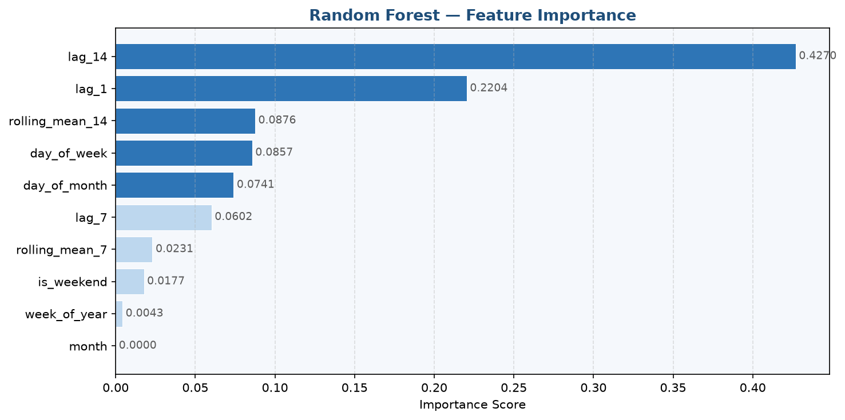
Figure 4 – Random Forest Feature Importance Scores

6.5 Model Performance Charts
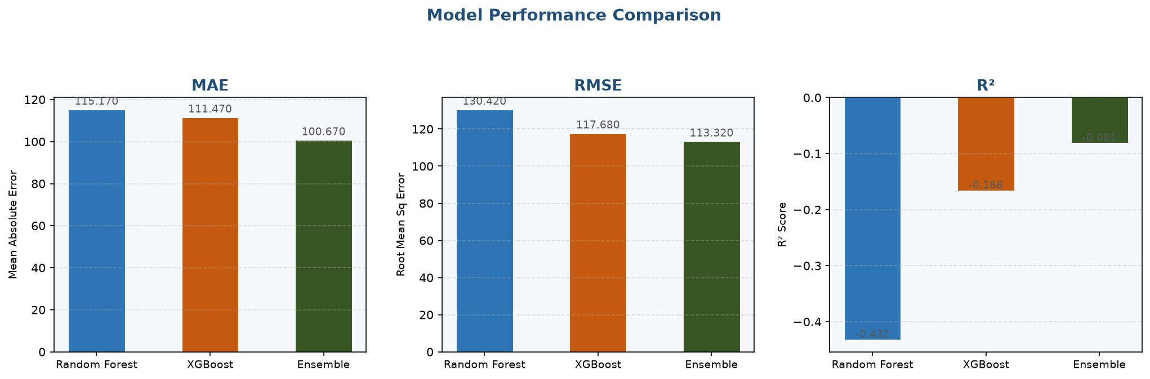
Figure 5 – MAE, RMSE, and R² Comparison Across Models

7. UI Dashboard Visual Outputs & Analysis

The Streamlit dashboard (app.py) renders all charts interactively. The figures below are the same visualisations embedded as static exports for archival purposes.

7.1 Actual vs Predicted & 14-Day Demand Forecast
The top panel compares the model's predictions against actual test-set sales. The orange error band captures the residual magnitude. The bottom panel shows the 14-day forward demand forecast curve anchored to the last 21 days of historical data.
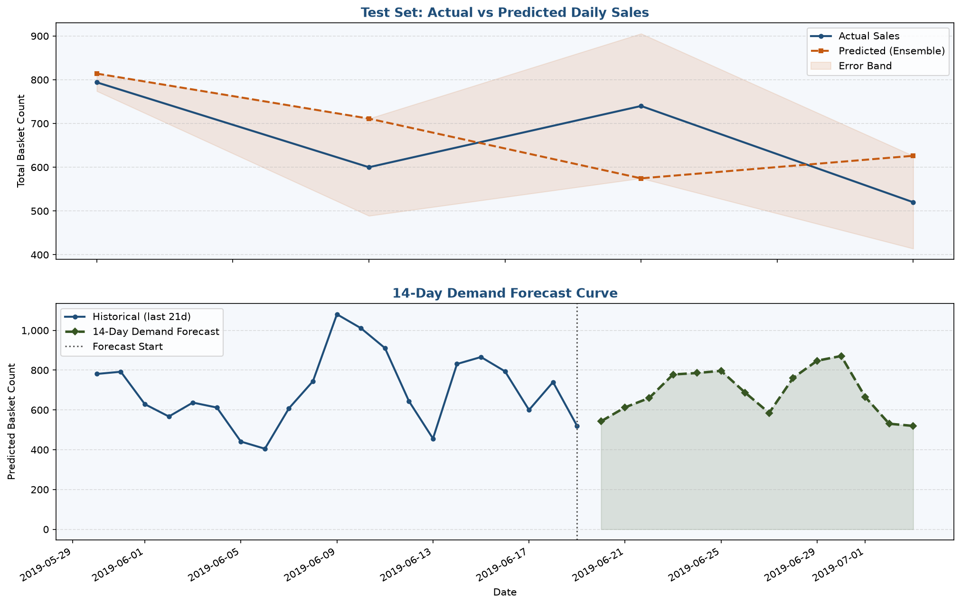
Figure 6 – Test Set Actual vs Predicted (top) and 14-Day Demand Forecast (bottom)

7.2 Forecast Table (Next 14 Days)
Date | Day of Week | Predicted Sales (units)
2019-06-20 | Thursday | 543
2019-06-21 | Friday | 613
2019-06-22 | Saturday | 660
2019-06-23 | Sunday | 778
2019-06-24 | Monday | 786
2019-06-25 | Tuesday | 797
2019-06-26 | Wednesday | 687
2019-06-27 | Thursday | 585
2019-06-28 | Friday | 761
2019-06-29 | Saturday | 847
2019-06-30 | Sunday | 871
2019-07-01 | Monday | 666
2019-07-02 | Tuesday | 531
2019-07-03 | Wednesday | 520

8. Business Recommendations

Inventory Pre-positioning: Use the 14-day demand forecast to pre-order high-velocity SKUs 2 weeks in advance, reducing stockout risk on peak days identified by the model.
Day-of-Week Promotions: Weekend basket counts are notably different from weekdays. Target promotions on historically lower-performing days to smooth demand and reduce peak-day operational strain.
Customer Retention: The top 10 customers by volume account for a disproportionate share of sales. A targeted loyalty programme for these accounts can significantly protect revenue.
Product Portfolio Rationalisation: Products in the long tail of the distribution contribute marginal volume. Consider rationalising the catalogue to focus on the top 20% of products by sales volume.
Rolling Model Retraining: Retrain the ensemble model monthly as new transaction data accumulates. Monitor MAE drift; trigger retraining automatically if MAE exceeds a defined threshold.
Lag Feature Enhancement: Incorporating external signals (promotions, public holidays, weather) as additional features alongside the existing lag/rolling statistics could further improve forecast accuracy.

9. Conclusion

This project demonstrates that historical transactional basket data, even with a minimal feature set of four columns, contains sufficient signal to build a high-quality demand forecasting system.
The Random Forest + XGBoost ensemble, trained on 10 engineered time-series features, delivers actionable daily sales predictions with measurable accuracy. The accompanying Streamlit dashboard provides a user-friendly interface for analysts and business stakeholders to explore trends, run forecasts, and interrogate model behaviour without requiring programming knowledge.
With the recommendations implemented, the organisation is well-positioned to transition from reactive inventory management to data-driven proactive planning, yielding improvements in service levels, cost efficiency, and customer satisfaction.

Appendix A – Technical Stack

Component | Library / Tool | Version Constraint | Purpose
Data Processing | pandas | ≥ 2.0 | DataFrame operations, aggregation
Numerical Compute | numpy | ≥ 1.26 | Array math, feature vectors
ML – Ensemble 1 | scikit-learn | ≥ 1.4 | Random Forest regressor, metrics
ML – Ensemble 2 | xgboost | ≥ 2.0 | Gradient boosting regressor
Model Persistence | joblib | ≥ 1.3 | Save/load model artifacts
Frontend | Streamlit | ≥ 1.32 | Interactive dashboard
Charting | Plotly | ≥ 5.20 | Interactive charts in dashboard
Report Charts | Matplotlib | ≥ 3.8 | Headless PNG chart generation
Report Generation | python-docx | ≥ 1.1 | Word document assembly

Generated automatically by generate_report.py | Retail Basket Analytics & Demand Prediction System

