**CS231A: Computer Vision,**

**From 3D Reconstruction to Recognition Homework #0**

**(Winter 2023) Due: Sunday, January 15**

**Bryan Mbanefo**

On to the problems!

**1 Basic Matrix/Vector Manipulation (20 points)**

(e) Without using a loop, multiply each row of M element-wise by a. Briefly explain the logic

of your code in your written report.

* **First I transpose the matrix a and then use np.tile() to expand the dimensions of matrix a to match that of matrix M.**
* **From there we can perform element wise multiplications.**
* **Then transpose the result to match the original dimensions of M**

(f) Without using a loop, sort all of the values of the new M from (e) in increasing order and plot

them in your report. Briefly explain the logic of your code in your written report.

* **Used the np.sort function to sort the values of the matrix**

Figure 1: Sorted Matrix in Increasing order

**2 Basic Image Manipulations (40 points)**

Do the following by filling out p2.py:

(c) Add the images together and re-normalize them to have minimum value 0 and maximum

value 1. Save and include this image in your report.

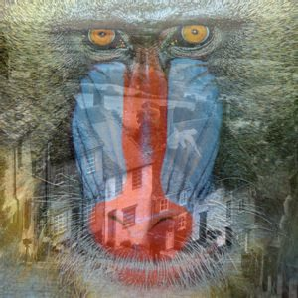

Figure : Problem 2 Part c

(d) Create a new image such that the left half of the image is the left half of image1 and the

right half of the image is the right half of image2. Save and include this image in your

report.

Figure : Problem 2 part D

(e) Using a for loop, create a new image such that every odd numbered row is the corresponding

row from image1 and the every even row is the corresponding row from image2 (Hint: Re-

member that indices start at 0 and not 1 in Python). Save and include this image in

your report.

Figure : Problem 2 part E

(f) Accomplish the same task as part e without using a for-loop (the functions reshape and tile

may be helpful here). Briefly explain the logic of your code in your written report.

* **Starting from row 0 insert every second row from image 2 to the new image.**
* **Starting from row 1, insert every second row in image 1 to the new image.**
* **This way we can insert even and odd for image 2 and 1 respectively.**

Figure : Problem 2 part F

(g) Convert the result from part f to a grayscale image. Save and include the grayscale

image in your report.

Figure : Problem 2 part G

**3 Singular Value Decomposition (40 points)**

Do the following by filling out p3.py:

(b) Save and Include the best rank 1 approximation of the (grayscale) image1 in your

report.

Figure : Problem 3 part B

(c) Save and Include the best rank 20 approximation of the (grayscale) image1 in

your report.

Figure : Problem 3 part C