Manuel Barajas

Part 1:

void main(int argc , char * argv[])

{

int i,sum=0;

if(argc < 3)

{

printf("Not enough numbers to add up!");

exit(1);

}

for(i=1;i<argc;i++)

sum = sum + atoi(argv[i]);

printf("%d",sum);

}

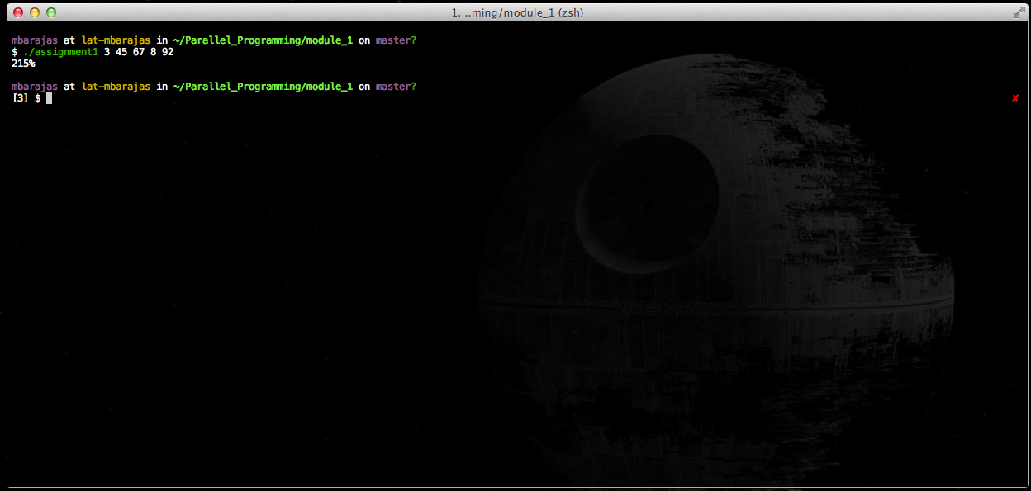

Part 2:

#include <pthread.h>

#define THREADS 2

#define ARRAYSIZE 6

#define ITERATIONS ARRAYSIZE / THREADS

int sum=0;

int numArray[ARRAYSIZE];

pthread_mutex_t sum_mutex;

void *thread_sum(void *tid)

{

int start;

int *mytid;

int end;

int mysum=0;

mytid = (int *) tid;

start = (*mytid * ITERATIONS);

end = start + ITERATIONS;

int i;

for (i=start; i < end ; i++) {

mysum = mysum + numArray[i];

}

pthread_mutex_lock (&sum_mutex);

sum = sum + mysum;

pthread_mutex_unlock (&sum_mutex);

pthread_exit(NULL);

}

void main(int argc, char *argv[])

{

int i;

for(i=0; i<argc; i++){

numArray[i] = atoi(argv[i]);

}

pthread_t threads[THREADS];

pthread_attr_t attr;

pthread_mutex_init(&sum_mutex, NULL);

pthread_attr_init(&attr);

pthread_attr_setdetachstate(&attr, PTHREAD_CREATE_JOINABLE);

int tids[THREADS];

for (i=0; i<THREADS; i++) {

tids[i] = i;

pthread_create(&threads[i], &attr, thread_sum, (void *) &tids[i]);

}

for (i=0; i<THREADS; i++) {

pthread_join(threads[i], NULL);

}

printf ("%d", sum);

pthread_attr_destroy(&attr);

pthread_mutex_destroy(&sum_mutex);

pthread_exit (NULL);

}

