Address XT for PalmOS®

by Handydev
Version 1.72
Last Updated: November 13, 2008

User's Manual

Table of Contents
1. Introduction 3
1.1 Contents 3
1.2 Technical requirements 3
1.3 Installing Address XT 3
1.4 Mapping Address XT to hardware “Address Book” button 3
1.5 Contacts application compatibility 4
2. Application overview 5
2.1 Enhanced Address List on high resolution – capable devices 5
2.2 New sorting options 6
2.3 Purge category 6
2.4 Enter company data 7
2.5 General options 8
2.6 Address List Options 9
2.7 Connecting with a Contact 10
2.8 Color Options 11
2.9 Number of records in Category 11
2.10 Manage XT integration 11
2.11 Recent Contacts feature 12
2.12 Birthday List 13
2.13 Contact Links 14
2.14 Contact Photos 15
3. Registering Address XT 16
4. Change Log 17
5. End User License Agreement (EULA) 22
6. Copyright notices 23

1. Introduction
Thank you for trying out Address XT®, a powerful replacement for the standard address book application. It offers handy new features while keeping user interface as close as possible to user interface of built-in address book. In addition, Address XT uses standard databases for 100% compatibility with your existing applications.
Address XT integrates with Manage XT by Handydev to allow easy modification of large groups of contacts.

1.1 Contents
The distribution archive contains following files:

AddressXT.prc The Address XT program file
pnoJpegLib.prc Image library.
AddressXT.pdf User's manual in PDF format
Readme.txt Installation and release notes

1.2 Technical requirements
Address XT runs on Palm Treo Treo 650,Palm Centro smartphones and on Palm Tx, Z22, Zire 31, 72, Tungsten E, E2, T3, T5, LifeDrive PDA's.

1.3 Installing Address XT
AddressXT.prc needs to be installed on your PalmOS ® - powered device to use the software. Usually this is done using Palm Install Tool. Please refer to the documentation that came with your handheld for instructions on how to use the Palm Install Tool.
You should install pnoJpegLib.prc in order to view contact photos.
On the first run Address XT will be configured using default settings optimized for your device. You can change settings later in Option screens. Additionally the application will ask you to map it to hardware button or Phone Favorites button (you can also change this setting later in the Button Options screen).

1.4 Mapping Address XT to hardware “Address Book” button
If your PalmOS device is equipped with hardware buttons, you can map the hardware “Address Book” button to start Address XT application. To do so, start Address XT and select “Button Options...” in the Options menu. Check or uncheck “Map to Hardware Button” checkbox to enable or disable key mapping to Address XT.

1.5 Contacts application compatibility
Address XT is compatible with all the extended text fields of the Contacts application.

Address XT lets you view and edit all the extended fields offered by the Contacts application, except for the “Photo” field. You can view contact photos, but you can't edit them with current Address XT version. Use your desktop software or the Contacts application to assign photo to a contact. Future versions of Address XT will support photo editing in-house.
On devices that do not have photo support in the built-in Contacts application you will need to set contact photos using your desktop software (Palm Desktop, for example).

Address XT does not currently support the anniversary and ringtone fields available on some models. However, such support will be added in future versions.

2. Application overview
Address XT resembles standard Contacts in many ways. Here we will explain only the extended features of Address XT.

2.1 Enhanced Address List on high resolution – capable devices
Address XT® allows to effectively increase quantity of information visible in Address List by up to 100% or even more. Just select a smaller font in Address List Font Options to enable this feature.
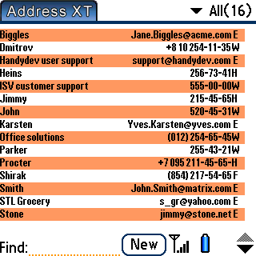
Fig 2.1.1 - Address List in "small fonts" mode
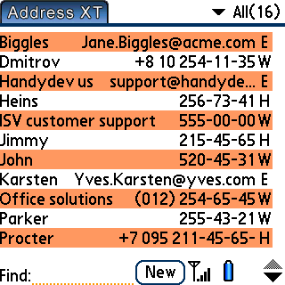
Fig. 2.1.2 – Address List in standard mode

2.2 New sorting options
Address XT introduces 4 new Address List sorting options, as can be seen on Fig. 2.2.1

Fig. 2.2.1 – Sorting options in the Address List options screen
These options affect how the Address List will look like. For example, if you choose
“Company, Title” sorting option, all the contacts will be sorted by company, and then by title. Also, these fields will be displayed in Address List view.
Choose “Contact Names only” to prevent phone numbers and other contact information from appearing in Contacts List. D-Pad Search turns PDA-style contact lookup with right/left buttons.

2.3 Purge category
Address XT features a Purge category menu command which can be accessed from Address List "Record" menu. It lets you quickly delete all records from current category.
Be careful using this option!

2.4 Enter company data
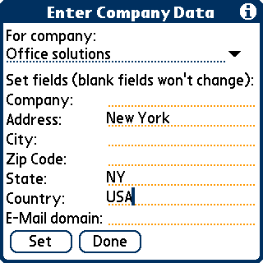
“Enter company data” command allows you to quickly set various fields for all the contacts working in a selected company.
Fig. 2.4.1 – Enter Company Data screen
Suppose some company, where you have a couple of contacts, has just moved to another city or changed its e-mail domain. Instead of re-typing the same info for every contact, you just go to “Enter Company Data” screen, select a company that moved, and enter all the fields that have changed. Press the “Set” button – and all the contacts working in the company will be updated.
Enter Company Data screen can be accessed from Address List “Record” menu.
Note that entering a new e-mail domain changes only the part of e-mail address that's after the '@' sign. For example, setting the e-mail domain to “sw.ny.us.com” will change e-mail address “smith@wst.org” to “smith@sw.ny.us.com”
You can set up Address XT to replace only empty fields. This option is set from the Enter Company Data screen Options menu (“Preferences…” item).

2.5 General options
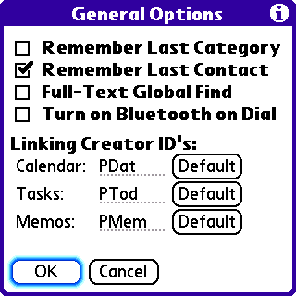
Figure 2.5.1 - General Options screen
When the “Remember Last Contact” option is set, Address XT will open the last contact if you exited Address XT while viewing it, or will scroll to that contact if you exited from Address List.
Here is an example of what Full-Text Global Find option does:
When searching for a string 'mit' (using the System Find), Address XT will always find records like “John Mitts” where one of the fields starts with the string you are searching for. However, if the Full-text search option is on, Address XT will also find entries like “Albert Gormitter” or “Alice Smith” where the search string can be located in any part of address fields.
Note that Global Find is always caseless.

"Turn on Bluetooth on Dial" option, if checked, will attempt to turn Bluetooth on every time you dial a contact. It is available on all Bluetooth-equipped PDA's.

The “One-Handed Search” option, when available, lets you turn off contact lookup by letter using 5-Way Navigator or 4-Way JogDial.

Linking options let you set up which applications will open contact links. To revert to a default application, tap the corresponding “Default” button.
To determine Creator ID for the application that should open links, use file-management utility like Filez. Note that third-party applications may not support opening a link from Address XT. If an application with a specified Creator ID can't be found, link will be opened using a default application for that link type.

2.6 Address List Options

Fig 2.6.1 – Address List Options

Tap “Resort now” to force database resort using selected sort mode.
You can enable and set up the Recent Contacts feature from this screen.
D-Pad Search enables browsing through contact name letters by left/right buttons.
Touch Mode makes rows in Address List 20% larger in height.

2.7 Connecting with a Contact
To connect with a contact, tap you standard dialing key on a smartphone, or open a contact and press “right” on the 5-way navigator on PDA's.
To set up connection options, use Connect Options menu item in the Options menu.
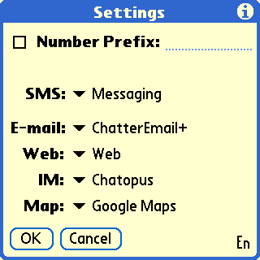
Fig. 2.9.1 – Connect options screen

2.8 Color Options
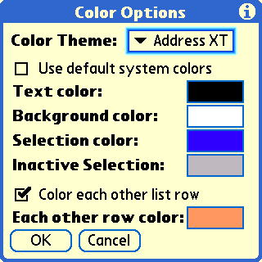
Fig. 2.10.1 – Color Options screen.
You may set application colors using the Color Options. It is accessible from the Options menu in Address List, Contact and Contact Edit forms.
Set your custom text, background and selection colors in the Color Options or check “Use default system colors” to revert to the standard color scheme.
Check the “Color each other list row” checkbox to select color for each other Address List row.
If your device supports colors, you may select one of pre-defined color themes from a corresponding list.

2.9 Number of records in Category
Address XT displays number of records in current category. The number is displayed in the upper-right corner of the Address List.

2.10 Manage XT integration
Address XT integrates with Manage XT to allow you to easily modify large groups of records. If Manage XT is found in your handheld RAM, it can be started from the Record menu of the Contacts List screen.

2.11 Recent Contacts feature
The Recent Contacts feature allows you to view the list of recently opened contacts and easily access any recent record.
The Recent Contacts feature can be enabled or disabled by "Options – Address List Options…" menu of the contacts list screen. You may also select the number of stored recent contacts.
If you check "Always display all entries", you will access all recent contacts from any category. Otherwise, only recent contact entries which belong to current category will be displayed.
If "Always display all entries" checkbox in the Recent Options is selected, Note that recent contacts are shown for current category. To view all recent contacts, you should select the 'All" category first.
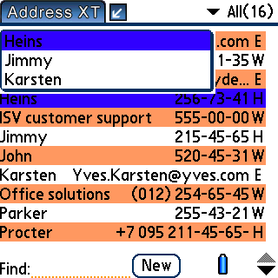
Fig. 2.11.1 – Address List with Recent Contacts

2.12 Birthday List
The "Birthday List" feature (Fig. 2.14.1) lets you view list of birthdays for any selected month.
To use it, select "Birthday List" from the Record menu of Address XT's list of contacts. Tap on any record in Birthday List to open it.
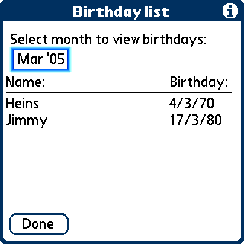
Fig. 2.12.1 – Birthday List

2.13 Contact Links
You can link any number of Tasks, Memos, Appointments or other Contacts to a contact.
To edit contact links, tap “Record” menu in the Edit View and select “Record Links” (Fig. 2.15.1)
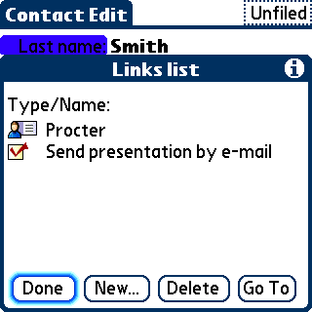
Fig. 2.13.1 – Links List
In the Links List, tap “New…” to add a link, tap “Delete” to delete a link and tap “Go To” to go to a link.
You can access record links easily in Address List and Address View by tapping a paperclip icon near its name (Fig. 2.15.2). Tap a link in the list to go to it.
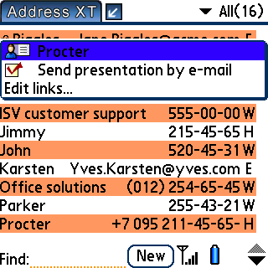
Fig. 2.13.2 – links popup in the Address List
Links information is stored in a separate database named “LinksDB2”. If you delete Address XT from your device, links information will be also deleted. If you choose to reinstall Address XT, you can restore links information by installing “LinksDB2.pdb” file which is backed up to your Palm Desktop user directory during each HotSync.

2.14 Contact Photos
Address XT features read-only support of contact photos. Note that currently Address XT can only display already set contact photos, you can’t edit or remove contact photo using Address XT (later Address XT versions will fully support contact photos).

3. Registering Address XT
Address XT is free to try for 30 days without any nag screens. After this time period ends, you will not be able to run Address XT without registering your copy. During trial period, you may open the About Screen to see how many trial days you have left.
To register Address XT, write down your HotSync name which is mentioned in the About Screen of Address XT and complete purchase on the web site where you’ve downloaded Address XT, or on the web site mentioned in the Readme.txt file included with this distribution.

When asked for your HotSync name, enter it correctly. HotSync name entry is case-sensitive! Shortly after you payment is processed, you will receive e-mail letter with registration confirmation. Then, you should open the Address XT About Screen again, tap “Register” and enter your registration code.
If you've correctly entered your Serial Number, the About screen, when opened again, will not mention that this application version is not registered, and you will be able to use Address XT for any time period.

4. Change Log
22 March, 2004 – Address XT version 1.0 released.
25 March, 2004 – Address XT version 1.02 released.
Fixed Fatal Alert on pushing the JogDial/5-Way Navigator when no record is selected.
Fixed rare wrong JogDial/5-Way Navigator behavior.
28 March, 2004 – Address XT version 1.03 released.
Fixed sorting screw-up after using the standard Address Book.
30 March, 2004 – Address XT version 1.04 released.
Fixed registration problems.
1 April, 2004 – Address XT version 1.05 released.
Added support for Sony Clie 320*480 and 480*320 screen resolution.
Added JogDial/5-Way Navigator support in Notes screen.
Fixed minor bug in Enter Company Data screen.
3 April, 2004 – Address XT version 1.06 released.
Fixed font selection in Address Edit screen.
Fixed screen resizing on Sony Clie devices in Address Edit screen.
6 April, 2004 – Address XT version 1.07 released.
Added button options in the Address List screen.
14 April, 2004 – Address XT version 1.08 released.
Added birthday field compatibility with Contacts application (Tungsten E/T3).
15 April, 2004 – Address XT version 1.09 released.
Added one-hand search using 5-Way Navigator.
17 May, 2004 – Address XT version 1.10 released.
Added 320*480 and 320*480 screen resolution support for PalmOne/Tapwave Zodiac devices.
Fixed compatibility issues with Contacts application.
Fixed minor screen issues on high-resolution Sony Clie devices.
21 May, 2004 – Address XT version 1.11 released.
Added color "note" icon.
Fixed switching to small fonts in address list bug.
Fixed PalmOS 5.0 High-Density display support bugs.
24 May, 2004 – Address XT version 1.12 released.
Added “E-Mail To Contact” feature.
2 June, 2004 – Address XT version 1.13 released.
Added compatibility with Treo 600 5-Way Navigator.
6 June, 2004 – Address XT version 1.14 released.
Added Quick Dial button in Contact View.
UI improvements.
7 June, 2004 – Address XT version 1.15 released.
Improved Graffity 2 compatibility in address lookup.
15 June, 2004 – Address XT version 1.16 released.
Improved Zire 72 Contacts application support.
18 June, 2004 – Address XT version 1.17 released.
Fixed startup problems with empty address book on PalmOS 5 devices.
24 June, 2004 – Address XT version 1.18 released.
Fixed fatal alert on setting birthday field with Contacts application installed.
26 June, 2004 – Address XT version 1.19 released.
Added Contacts-style scrolling mode for 5-Way Navigator.
5 July, 2004 – Address XT version 1.20 released.
Added Color Settings.
Fixed small bugs in Enter Company Data and in Note screens.
6 July, 2004 – Address XT version 1.20a released.
Fixed fatal alert on soft-reset.
8 July, 2004 – Address XT version 1.20b released.
Fixed birthday reminders.
9 July, 2004 – Address XT version 1.21 released.
Allowed to set any available font in “Small fonts” mode.
13 July, 2004 – Address XT version 1.22 released.
Added “Remember Last Contact” option.
19 July, 2004 – Address XT version 1.23 released.
Enhanced Color Options.
Fixed search bug.
21 July, 2004 – Address XT version 1.24a released.
Improved “Each other row” coloring.
Added display of number of records in category.
Miscellaneous bugfixes.
24 July, 2004 – Address XT version 1.24b released.
Color setting bugs fixed.
2 August, 2004 – Address XT version 1.25 released.
Added Manage XT integration.
Small bugfixes.
10 August, 2004 – Address XT version 1.26 released.
Fixed issue with return key.
Fixed birthday notifications for deleted records.
Fixed one-handed search issues.
27 October, 2004 – Address XT version 1.3 released.
Added Recent Contacts feature.
29 October, 2004 – Address XT version 1.3a released.
Fixed problems using Recent Contact.
4 November, 2004 – Address XT version 1.31 released.
Enhanced Recent Contacts options.
11 November, 2004 – Address XT version 1.32 released.
Improved Dial Number user interface.
Reduced screen flicker on 320x480 resolution screens.
Small bugfixes.
21 November, 2004 – Address XT version 1.32a released.
Fixed fatal alert on low-resolution devices.
Fixed Contacts-style scrolling bug.
2 December, 2004 – Address XT version 1.32b released.
Fixed color settings bug on grayscale devices.
11 December, 2004 – Address XT version 1.32c released.
Fixed locks on devices with dynamic input area.
UI improvements and fixes.
19 December, 2004 – Address XT version 1.33 released.
Birthday list feature added.
14 January, 2005 – Address XT version 1.35 released.
Enhanced Contacts application compatibility.
Minor bugfixes.
17 January, 2005 – Address XT version 1.36 released.
Improved one-handed search using 5-way navigator.
Fixed DIA issues.
20 January, 2005 – Address XT version 1.37 released.
Fixed “Clear Birthday date/reminder” bug.
Visual improvements.
27 February, 2005 – Address XT version 1.38 released.
Fixed DIA bugs on sending/beaming records.
Fixed color settings bugs.
Fixed record editing bugs on some devices.
Introduced trial 30-day period instead of nag screens.
23 March, 2005 – Address XT version 1.39 released.
Improved Tungsten C/W support.
Improved Treo support.
Performance improvement on large databases.
Bugfixes.
1 April, 2005 – Address XT version 1.39a released.
Further performance improvement.
Enhanced Company Data feature.
Added in-application help.
16 April, 2005 – Address XT version 1.40 released.
Added contact links feature.
Bugfixes.
17 April, 2005 – Address XT version 1.40a released.
Improved contact links feature.
Bugfixes.
21 April, 2005 – Address XT version 1.40b released.
Improved JogDial/5-Way Navigator support.
Bugfixes.
24 April, 2005 – Address XT version 1.40d released.
Improved compatibility with Tungsten E2 and Treo 650 SPRINT with 1.08 update.
Bugfixes.
25 April, 2005 – Address XT version 1.41 released.
Added ability to link with appointments.
Bugfixes.
4 May, 2005 – Address XT version 1.42 released.
Improved Treo 650 hardware buttons handling.
Improved one-handed search with 5-way navigator.
Fixed birthday import from Contacts.
Fixed record edit scrolling on some devices.
22 May, 2005 – Address XT version 1.43 released.
Fixed compatibility issues with Treo 650 (all versions) and Tungsten T5.
Minor bugfixes.
14 June, 2005 – Address XT version 1.44 released.
Added full keyboard navigation support for Treo 600, 650, Tungsten T5 and LifeDrive.
Fixed some NVFS-related bugs.
23 June, 2005 – Address XT version 1.45b released.
Added ability to send Messages to contact on Treo smartphones.
Bugfixes.
5 July, 2005 – Address XT version 1.45c released.
Fixed screen refresh on Clie devices.
Fixed issues with contact links.
Improved registration UI.
14 July, 2005 – Address XT version 1.46 released.
Improved one-handed search.
Fixed PalmOS 4.0 issues.
Reduced startup time.
12 August, 2005 – Address XT version 1.47 released.
Greatly improved one-handed search.
Improved Contact Lookup.
Bugfixes.
6 September, 2005 – Address XT version 1.50 released.
Added photo support on Zire 72, Treo 650, Tungsten T3, Tungsten T5, Tungsten E, Tungsten E2, LifeDrive Mobile Manager devices.
Added option to turn off One-Handed search.
Added Birthday List sorting.
Performance improvements.
UI improvements.
Bugfixes.
8 September, 2005 – Address XT version 1.50b released.
Improved One-Handed Search speed.
Fixed record beaming/sending problems.
Fixed category beaming/sending problems.
Fixed purge category issue.
18 September, 2005 – Address XT version 1.50c released.
Fixed linking issues on some devices.
Fixed Enter Company Data not working on some devices.
Minor UI improvements.
Improved Dial List dialog on Treo.
Fixed Dial List contact name format.
Fixed Recent Contacts issues.
Removed screen flicker on links edit in Contact View.
19 September, 2005 – Address XT version 1.50d released.
Fixed birthday alert issues.
Fixed startup issues on some devices.
1 October, 2005 – Address XT version 1.50e released.
Improved Five-Way Navigation Support.
Improved Contact Edit text case auto-selection.
Fixed compatibility issues with 3rd-party dialers on Treo smartphones.
4 October, 2005 – Address XT version 1.50f released.
Fixed Tap-Dialing not working on some devices.
Fixed SMS not available on Treo.
Minor UI improvements.
17 October, 2005 – Address XT version 1.51 released.
Added Color Themes.
Fixed problems with empty database on NVFS devices.
Fixed Color Options bugs.
Fixed Treo-related Dial dialog bug.
Added Z22 compatibility.
7 November, 2005 – Address XT version 1.52 released.
Added scrolling with Option button on Treo smartphones.
Updated with latest pnoJpegLib library version.
Fixed navigation behavior in “New Link” form.
Fixed button options on Treo 600.
Fixed 5-Way Navigator scrolling problems in Contacts List.
Fixed IM type selection bug.
Fixed Autumn color Theme.
Fixed category selection bug in Contacts Edit screen on some devices.
Fixed bug deleting a record with links.
Fixed reset while linking 2 appointments to a contact.
Fixed memory leak while linking appointment.
New application icons.
20 November, 2005 – Address XT version 1.52a released.
Improved start-up speed on devices with Contacts application pre-installed.
25 November, 2005 – Address XT version 1.53 released.
Added resort ability.
Improved options UI.
Fixed fatal alert on startup on some devices.
15 December, 2005 – Address XT version 1.54 released.
Added linking options.
Improved DIA support.
Fixed custom fields rename bug on some devices.
7 January, 2006 – Address XT version 1.55 released.
Added Mapopolis integration.
Added SMS support on some Palm devices.
Added delimiter setting in Address List Options.
Fixed contact creation bug on DIA devices.
Fixed accented characters entry in lookup field.
Fixed linking bugs.
Fixed dialing bugs.
12 January, 2006 – Address XT version 1.55a released.
Fixed menu bug in Contact View and Contact Edit screens.
15 January, 2006 – Address XT version 1.56 released.
Contact links are 2-way now.
Improved registration.
Fixed note title display bug.

31 January, 2006 – Address XT version 1.57 released.
Reduced application size.
Phone type list can now be opened with keyboard on devices with 5-Way Navigation.
Massive DIA fixes and improvements for devices with HR+ (Palm, Sony, Tapwave, Garmin).
Fixed dialing problems.
Fixed contact links display bug.
Fixed note title display bug.
Fixed Color Options bug.
3 February, 2006 – Address XT version 1.57a released.
Default phone types in Contact Edit now conform to built-in software.
Improved SMS sending.
Fixed problems deleting contact on some devices.
Fixed Custom fields renaming from Edit screen bug.
Fixed 5-Way Lookup Problems.
Added field switching with Tab and Shift-Tab on Tungsten C.
10 February, 2006 – Address XT version 1.57b released.
Fixed beaming problems.
13 February, 2006 – Address XT version 1.57c released.
Added support for DIA on Xplore PalmOS 4 smartphones.
Reduced screen flicker.
Fixed recent contacts list height.
16 February, 2006 – Address XT version 1.58 released.
Improved Mapopolis support.
Added “Map to Favorites” option on Treo smartphones.
Improved sorting speed.
Last edited record is now remembered in “Remember Last Contact” and “Recent Contacts” features.
Further reduced screen flicker.
Default settings are now set up on a fresh install.
17 February, 2006 – Address XT version 1.58a released.
Added Advanced Find option to Address List Options.
Bugfixes.
19 March, 2006 – Address XT version 1.60 released.
Added TomTom Navigator integration.
Added battery level display on non-Treo devices.
Added "Turn on Bluetooth on Dial" option for non-Treo devices with bluetooth.
Birthday reminder is now visible in Address List screen.
Improved Edit screen and Enter S/N screen on Treo's.
Improved E-Mail to Contact and Contact Map screens.
Fixed DIA issues.
Fixed button mapping on Tx.
Fixed beaming issues.
Fixed stability issues on Treo's.
23 March, 2006 – Address XT version 1.61 released.
Added lookup field in Contacts Link Selection.
Fixed DIA issues on on Phone Lookup from Note.
Fixed resets on contact edit on newest devices.
Other bugfixes.
4 April, 2006 – Address XT version 1.61a released.
Advanced find setting now affects One-Handed Search.
Fixed bluetooth dialing.
Fixed application startup error on some old devices.
Fixed Enter Company Data bugs.
Removed One-Handed Search screen flicker.
18 April, 2006 – Address XT version 1.61b released.
Enter Company data, Birthday list, Birthday alarms now respect private status of records.
Improved support of applications that skin PalmOS.
Improved masked records handling in Address List.
Fixed navigation issues in Contact Edit.
3 May, 2006 – Address XT version 1.62 released.
Added Kyocera support.
Improved default e-mail application handling.
UI improvements.
Bugfixes.
10 May, 2006 – Address XT version 1.62a released.
Improved startup speed on some devices.
Fixed issues with Japanese OS.
Minor Treo-related improvements in Contact Edit.
Recent Contacts list now respects private status of records.
Bugfixes.
28 May, 2006 – Address XT version 1.62b released.
Treo 700p compatibility.
Improved DIA support.
Bugfixes.
15 June, 2006 – Address XT version 1.62c released.
Fixed Treo 700p support.
1 July, 2006 – Address XT version 1.62d released.
Bugfixes.
7 September, 2006 – Address XT version 1.62e released.
Fixed phone number filtering on dial.
Fixed phone type changes not saved on newer devices.

5 October, 2006 – Address XT version 1.63 released.
Zip code order in Contact View is now determined by country settings.
Bugfixes.
5 December, 2006 – Address XT version 1.63b released.
Bugfixes.
2 July, 2008 – Address XT version 1.7 released.
Support for all Treo and Centro smartphones.
Added support for all standard Mail, Web, IM, Map applications.
Added birthday Calendar integration.
Improved navigation and search.
Improved startup speed.
Numerous bugfixes.
22 October, 2008 – Address XT version 1.71 released.
Added “Contact Names Only” option in Contacts List.
Returned the “D-Pad Search” option.
Fixed double strokes in Find.
Fixed incorrect delimiter in Address List.
13 November, 2008 – Address XT version 1.72 released.
Added “Touch mode” option in Contacts List.
Returned the “Scroll by pages” option.
Bugfixes.

5. End User License Agreement (EULA)
This End User License Agreement is a legal agreement between you and Handydev Software for the "Address XT" application. This application includes computer software ("SOFTWARE"), as well as any accompanying documentation ("DOCUMENTATION"). By installing and running the SOFTWARE, you agree to be bound by the terms of this License Agreement. If you do not agree to the terms of this agreement, you may not use the SOFTWARE.
FREE TRIAL
Handydev Software grants you a non-exclusive license to use the SOFTWARE free of charge for 30 days, counting from first time you run the SOFTWARE, for the purpose of evaluating whether to purchase an ongoing license to use the SOFTWARE. After this time period you will not be able to run the SOFTWARE. When you purchase the software and enter the Serial Number that you received after purchase, you won't any longer be reminded to purchase the software.
GRANT of LICENSE
Subject to the payment of applicable license fees, Handydev Software grants to you a non-exclusive license to use the SOFTWARE under the following conditions:
a) You may install and use only one copy of the SOFTWARE at any given time.
b) You may not reverse engineer, decompile, or disassemble the SOFTWARE.
c) You may not modify or redistribute the SOFTWARE.
d) Handydev Software may terminate this agreement if you fail to comply with the terms and conditions therein. In such event, you must delete all copies of the SOFTWARE and DOCUMENTATION.
COPYRIGHT
The SOFTWARE is protected by copyright laws, and international copyright treaties, as well as other intellectual property laws and treaties. All title and copyrights in and to the SOFTWARE and DOCUMENTATION are owned by Handydev Software.
LIMITED WARRANTY
The SOFTWARE and DOCUMENTATION are sold "AS IS", without warranty as to their performance, merchantability, or fitness for any particular purpose. The entire risk as to the results and performance of this program is assumed by you.
In no event shall Handydev Software be liable for any damages whatsoever arising out of the use of or inability to use the SOFTWARE or DOCUMENTATION.

6. Copyright notices
All mentioned trademarks are properties of their respective owners.
Portions of Address XT are copyrighted by PalmSource or its subsidiaries.
pnoJpegLib is © 2004, Stefan Stolz, Based on the work auf Yves Piguet and the Independent JPEG Group

