Short Bio.

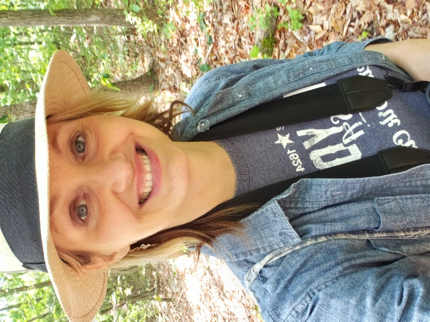

Meredith Barges, MDiv, PhD (ABD)

Meredith Barges is a bird-friendly building policy researcher and advocate. Through her work, she helps people to appreciate the complex lives of birds and how our decisions about building and development affect birds and ecosystems. As the former policy researcher for the award-winning Yale Bird-friendly Building Initiative, she co-authored Building Safer Cities for Birds: How Cities Are Leading the Way on Bird-Friendly Building Policy (2023). In 2023, she co-led a successful statewide campaign to adopt Public Act No. 23-143, Connecticut’s “Lights Out bill,” which requires state agencies to turn off unnecessary nighttime lights for birds. The bill is expected to save Connecticut $1.6 million annually. Meredith also supports local initiatives to adopt stronger lighting rules. In 2024, she helped advocates in Greenwich to pass the most comprehensive municipal outdoor lighting law in Connecticut. She is currently completing a PhD in Environmental Studies at SUNY School of Environment, focused on municipal bird-friendly building policymaking. She holds a master's degree in history from the University of Chicago and a Master of Divinity from Yale University.

