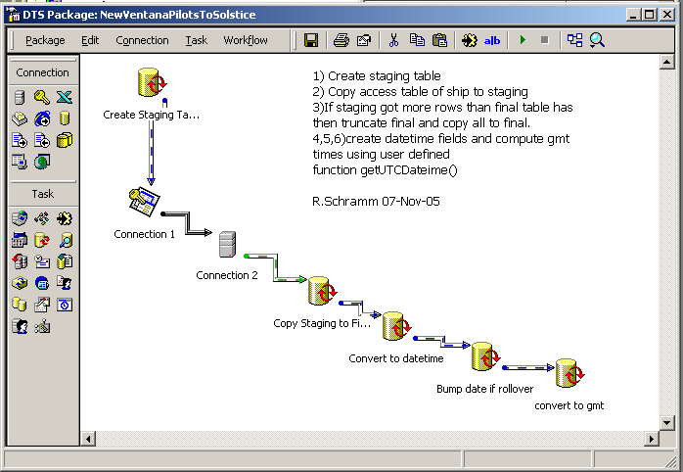

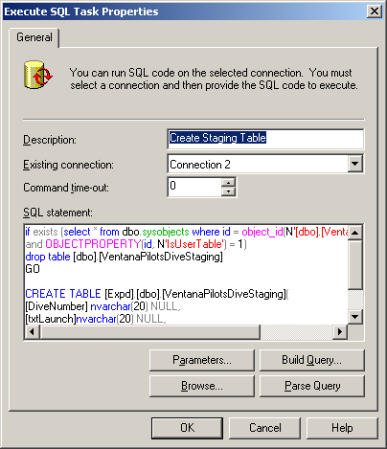

if exists (select * from dbo.sysobjects where id = object_id(N'[dbo].[VentanaPilotsDiveStaging]')
and OBJECTPROPERTY(id, N'IsUserTable') = 1)
drop table [dbo].[VentanaPilotsDiveStaging]
GO

CREATE TABLE [Expd].[dbo].[VentanaPilotsDiveStaging](
[DiveNumber] nvarchar(20) NULL,
[txtLaunch]nvarchar(20) NULL,
[txtRecover] nvarchar(20) NULL,
[Date] nvarchar(20) NULL,
gmtStart datetime NULL,
gmtEnd datetime NULL)
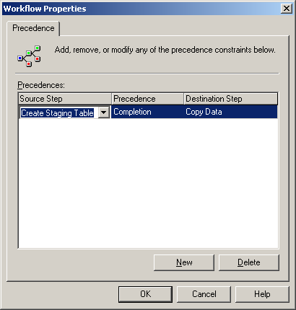

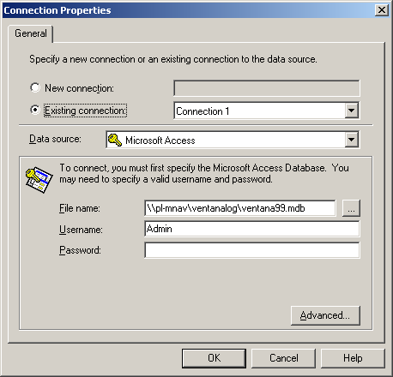

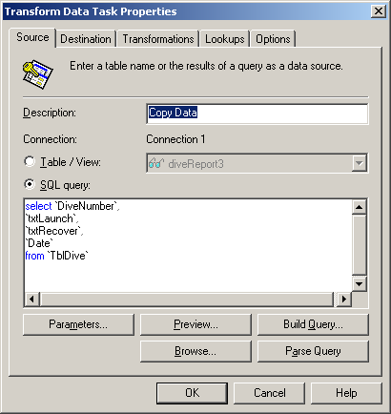

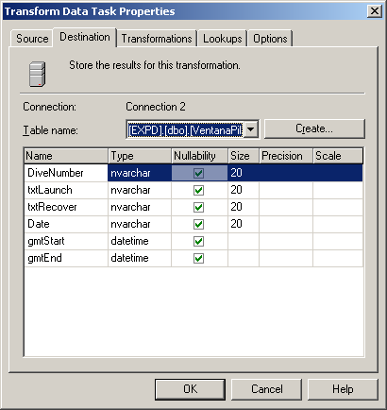

note table is VentanaPilotsDive

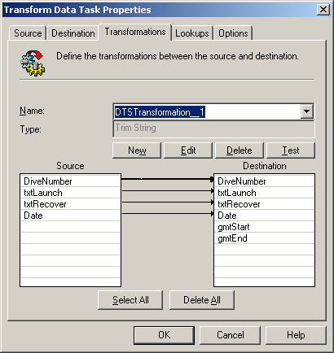

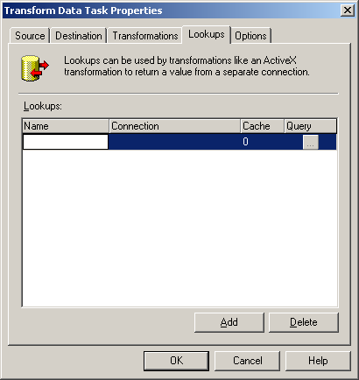

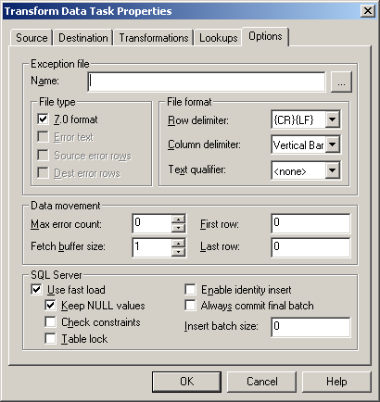

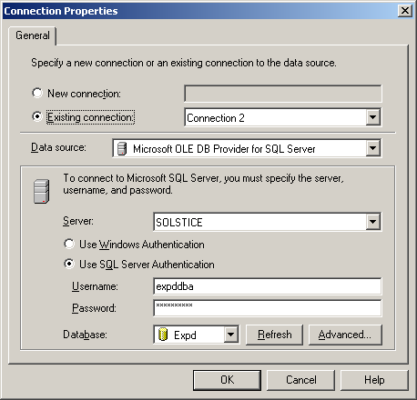

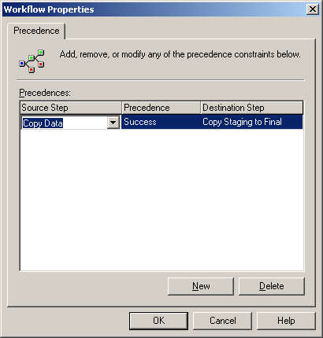

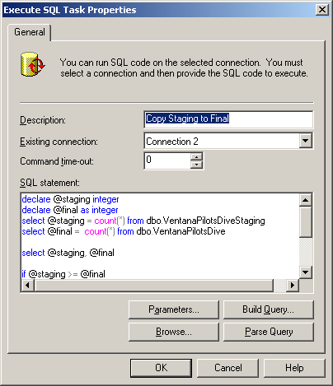

declare @staging integer
declare @final as integer
select @staging = count(*) from dbo.VentanaPilotsDiveStaging
select @final = count(*) from dbo.VentanaPilotsDive

select @staging, @final

if @staging >= @final
begin

delete from dbo.VentanaPilotsDive
insert dbo.VentanaPilotsDive select * from dbo.VentanaPilotsDiveStaging

end

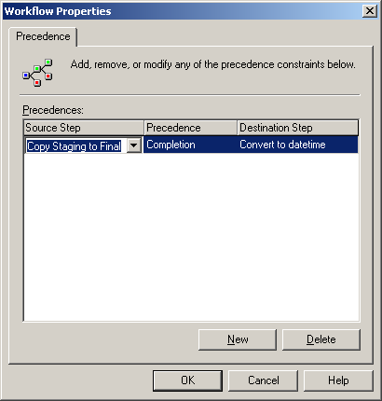

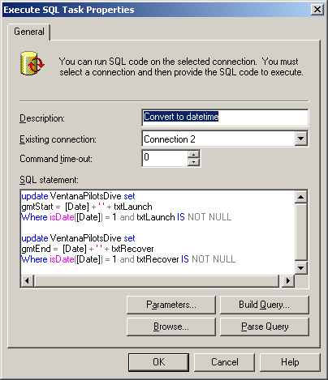

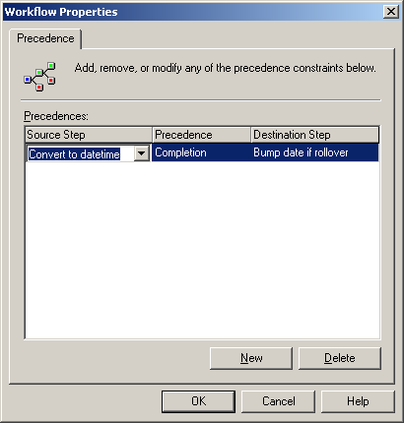

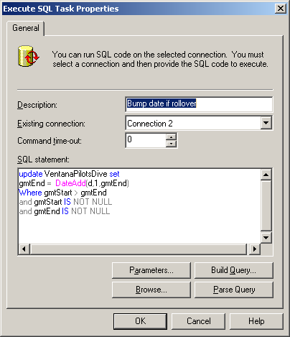

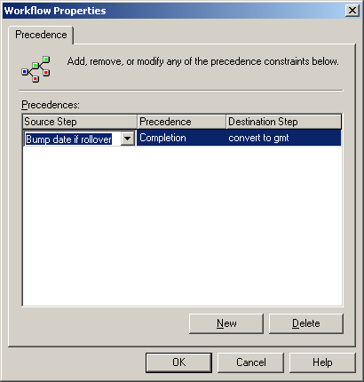

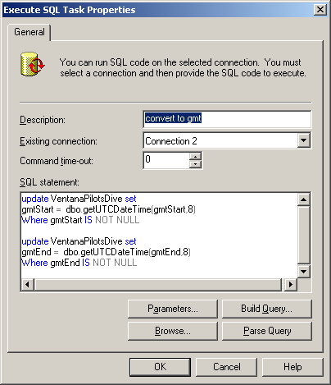

Requires user defined function in EXPD… that everyone can execute…..

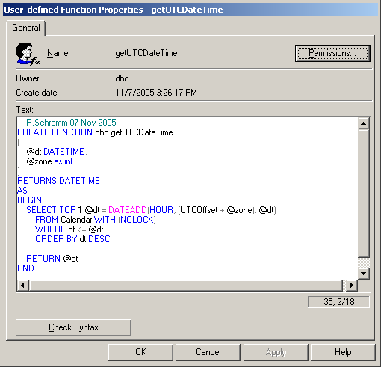

and the calendar table…….

CREATE PROCEDURE [dbo].[AdminGenerateCalendarTable] AS
---R.Schramm 07-Niv-2005
CREATE TABLE dbo.Calendar
(
dt SMALLDATETIME PRIMARY KEY CLUSTERED,
UTCOffset smallint
)
GO

CREATE PROCEDURE [dbo].[AdminPopulateCalendarTable] AS
---R.Schramm 07-Nov-2005
-- populate with data
DECLARE
@dt SMALLDATETIME,
@off smallint

SELECT
@dt = '19880101',
@off = 0
---- start in Jan w/offset=0

SET NOCOUNT ON

WHILE @dt <= '20301231'
BEGIN
-- have we hit the first SUnday in April?
IF DATENAME(dw, @dt)='Sunday'
AND DATEPART(DAY, @dt) <= 7
AND DATENAME(MONTH, @dt) = 'April'
SET @off = -1

-- have we hit the last Sunday in October?
IF DATENAME(dw, @dt)='Sunday'
AND DATEPART(DAY, @dt) >= 25
AND DATENAME(MONTH, @dt) = 'October'
SET @off = 0

INSERT Calendar(dt, UTCOffset) VALUES(@dt, @off)

SET @dt = @dt + 1
END
GO
