**ECE569**

**Homework 1- Device Query**

**Individual Submission**

**Objective**

The purpose of this assignment is to introduce the student to the CUDA hardware resources along with their capabilities. The student is not expected to understand the details of the code, but should understand the process of compiling and running code that will be used in subsequent modules.

**Deliverable**

**Locate the “questions.txt” file in labs/hw1/DeviceQuery folder, insert your answers and submit the “questions.txt” file on D2L to the designated folder on D2L.**

**Setting Up Your Environment**

If you are using a windows machine, and if you want editors with GUI then you may want to download “Xming X Server for Windows” and launch XMing first.

Connect to hpc.arizona.edu (Refer to 1-setting_up_hpc_accounts document) and then connect to ocelote.

**Ocelote Flow**

Create the following folders for setting up the lab environment. Please note that the text in “Courier New” font indicate the commands you will be running at the shell prompt.

Use putty to login to hpc.arizona.edu, and then:

$ocelote –X

Make sure Xtunneling, x11 enabled is enabled in your putty configuration!!

When XMing is running in the background, you will be able to launch visual profiler (nvvp), text editors of your choice such as “gedit” with the X11 tunneling enabled. I find “gedit” simple and convenient way of code editing.

$gedit&

Ok, let’s build our directories for the assignments. In your putty shell on Ocelote:

$ mkdir ece569

$ mkdir ece569/build_dir

Copy the "labs" folder posted on d2l in hw1 into the ece569/ fodler. You may want to use WinSCP for copying the entire folder conveniently. After copying the fodler, you should have build_dir and labs directories in your 569 folder.

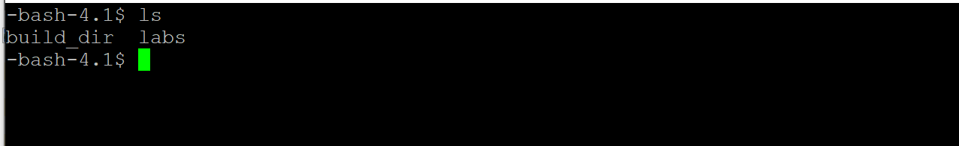

Change your home directory to ece569/build_dir

$ cd ece569/build_dir

Then run the following tow commands:

$module load cuda91/toolkit/9.1.85

$CC=gcc cmake3 ../labs

You should see the following screen flow.

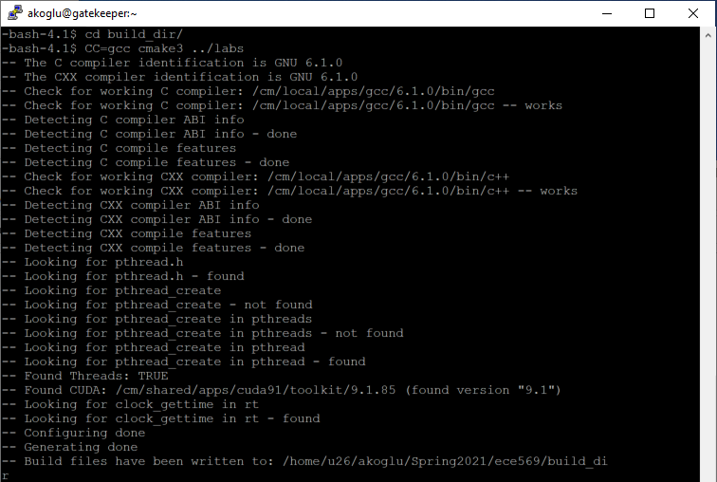

Then run the following command:

$make

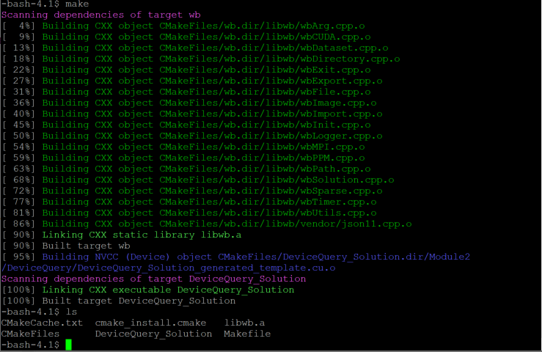

The makefile compiles and generates the executable “DeviceQuery_Solution in the build-dir directory. A template file for running the jobs on ocelote is given in the “labs” folder named “run.pbs”

$ls

With this command, you should see the following files in your build_dir directory:

CMakeCache.txt CMakeFiles cmake_install.cmake DeviceQuery_Solution libwb.a Makefile

Assuming you are in the build_dir directory copy the run.pbs file from the labs folder into your current build_dir directory

cp ../labs/run.pbs ./

This script is needed to launch your jobs on the HPC system. Go over the pbs document to see the types of commands issued.

Later when you want to customize your scripts you may want to use the pbs script builder here:

<https://jobbuilder.hpc.arizona.edu/>

Before executing the script, open the run.pbs, locate the line that shows as (line number 35 in run.pbs):

cd ~akoglu/Spring2021/ece569/build_dir

and set the correct path for your “build_dir”

Your group should show as “ece569”. (line 12 in run.pbs)

$qsub run.pbs

After submitting your job, you will see a promt similar to the following:

1734798.head1.cm.cluster

Above line shows the process id for you to monitor your job. “qpeek” is the command for checking the status. After the job has been completed, you will see the list of files in your build_dir as:

$ls

CMakeCache.txt cmake_install.cmake devicequery.o1734798 DeviceQuery_Solution Makefile

CMakeFiles devicequery.e1734798 devicequery_output.txt libwb.a run.pbs

After completion, “devicequery_output.txt” will include P100 GPU information.

**Note that the source code “template.cu” is located in the labs/hw1/DeviceQuery**

**The code provided queries the GPU hardware on the system. Do not concentrate on the API calls, but on functions starting with `wb`. The `wbLog` function logs hardware features.**

**In the same folder you will find the file “questions.txt”. Insert your solutions and submit the questions.txt file on D2L to the designated folder on D2L.**

Refer to these useful links:

running jobs

<https://docs.hpc.arizona.edu/display/UAHPC/Running+Jobs>

<https://public.confluence.arizona.edu/pages/viewpage.action?pageId=86409309>

pbs script builder

<https://jobbuilder.hpc.arizona.edu/>

[**https://public.confluence.arizona.edu/pages/viewpage.action?pageId=86409309#RunningJobswithPBS(OceloteandElGato)-ScriptBuilder**](https://public.confluence.arizona.edu/pages/viewpage.action?pageId=86409309#RunningJobswithPBS(OceloteandElGato)-ScriptBuilder)

In case needed library paths are:

/cm/shared/modulefiles/cuda91/toolkit/9.1.85

/cm/shared/apps/cuda91/sdk/9.1.85

/cm/shared/apps/cuda91/toolkit/9.1.85

/cm/local/apps/gcc/6.1.0/bin/gcc

**Running xming from windows environment and using gedit for coding under ssh client**

* launch xming on the windows system
* open ssh client,
* connect to hpc.arizona.edu
  + (make sure to enable X11 tunneling in SSH client)
* Ocelote –X // need -X for tunneling
* to edit: gedit filename &