®

UQM TECHNOLOGIES, INC.

User and Installation
Manual

Including:

SR218 High Torque Brushless DC Motor
DD40-400LWB, 400V Inverter/Controller

7501 MILLER DRIVE, FREDERICK, COLORADO 80530
PHONE (303)278-2002, FAX (303)278-7007
WWW.UQM.COM
Table of ContentS
1 Introduction 4
1.1 Packing List 5
1.2 Overview of Manual 5
1.3 System Features 6
2 Installation 7
2.1 Possible Catastrophic Installation Problems 7
2.2 Inverter Installation 7
2.3 Motor Installation 7
2.4 EMI/ RFI of UQM Technologies Brushless PM Motor Drives. 9
3 Electrical Connections 10
3.1 Controller Power Cable Connections 11
3.2 Motor Connections 12
3.3 Controller Connections User Interface 19-pin Amphenol Connector 12
3.4 Resolver / Hall and Motor Temperature Cable 18
3.5 Traction Battery Power Connection 18
3.6 Grounding Requirements 19
4 Liquid Cooling System 19
4.1 Liquid-Cooled System Setup 19
4.2 Installation Tips 21
4.3 Flow Rate vs. Pressure Drop 21
5 Basic Operating Instructions 21
5.1 Basic Dynamometer Operating Instructions 22
5.2 Basic Electric Vehicle Operating Instructions 22
5.3 Hand Control Functions 23
6 Serial Port Communications and System Status 24
6.1 Serial Port Outputs 24
6.2 System Configuration 29
6.3 system behavior on inverter fault 41
6.4 OTHER INFORMATION FOR USING THE 2812 DSP 42
7 Troubleshooting 43
7.1 Installation Troubleshooting 43
7.2 System Troubleshooting 44
8 System Operation 46
8.1 System Overview 46
8.2 Torque and Power Profiles 46
8.3 Limit Features 47
Appendix A: HiTor System Specifications 50
Appendix B : Inverter Dimensions 51
Appendix C: Motor Dimensions 52
Appendix D Soft Start Guidelines 53
Appendix E: User Interface Schematic Hand Control 55
Appendix F: First stage I/O Circuits of User Interface 56
Appendix G: CAN 57
1 Parameter Definitions 61
1.1 CONTROL PARAMETERS 61
1.2 INFORMATIONAL PARAMETERS 62
1.3 Informational Status Parameters 62
2 Parameter Group Definitions 63
2.1 ELECTRIC DRIVE STATE – Used in Torque and Speed Control Configurations 63
2.2 ELECTRIC DRIVE STATE – Used in hand Control Configuration when DRIVE is not ready 63
2.3 ELECTRIC DRIVE STATE – Used in hand Control Configuration when DRIVE is ready 63
2.4 ELECTRIC DRIVE TEMPERATURE 63
2.5 ELECTRIC DRIVE COMMAND – Used for Speed Control Configuration 63

Introduction

Thank you for your purchase of a UQM™ Motor and Inverter/Controller package. Please notify UQM Technologies immediately if any damage has occurred during shipment. PLEASE READ THIS ENTIRE MANUAL BEFORE APPLYING VOLTAGE TO THE SYSTEM.

This system is a state-of-art, standard package specifically designed for high performance drive applications. The package consists of a high performance 35 kW Brushless DC motor, a 400 VDC high-power liquid-cooled inverter and a full-featured digital signal processor controller. The system is a ready to use, powerful, lightweight, rugged and reliable system based upon years of developing and manufacturing motors and controllers for electric drive systems.

The system provides many easily incorporated features required to develop a customized, high performance drive application. The system is capable of fully regenerative, four-quadrant, bi-directional, torque controlled operation. The DSP controller is user programmable to allow for user flexibility. The system also maximizes system reliability by minimizing hazardous conditions.

This manual gives a broad description of this package. It is highly recommended that you read through these instructions to familiarize yourself with the operation and installation of the package. Please feel free to contact the Applications Department at UQM Technologies, Inc. if you have any questions regarding installation, application, or service.

WARNING:

DANGEROUS VOLTAGES, CURRENTS, AND ENERGY LEVELS EXIST IN THIS PRODUCT. EXTREME CAUTION SHOULD BE EXERCISED IN THE APPLICATION OF THIS EQUIPMENT. ONLY QUALIFIED INDIVIDUALS SHOULD ATTEMPT TO INSTALL, SET-UP, AND OPERATE THIS EQUIPMENT.

WARNING:

INCORRECT MOTOR AND CONTROLLER WIRING CAN CAUSE CATASTROPHIC FAILURE. PROPER CONNECTION OF MOTOR CABLES, HALL-EFFECT CABLES, AND TEMPERATURE CABLES IS NECESSARY FOR SAFE OPERATION. DO NOT SWAP MOTOR WINDINGS TO REVERSE DIRECTION.

Packing List

Quantity | Item
1 | SR218 high torque brushless PM liquid-cooled motor
1 | DD40-400LWB liquid-cooled inverter/controller
1 | Rotor position signal cable with a 15-pin connector on each end
1 | Hand Control and cable with 19-pin Amphenol connector
1 | User and Installation Manual
1 | 508 mm (20 in) long copper tape (25.4 mm) wide
1 | Spare 19-pin Amphenol connector for customer use
1 | 3/8-24 Lifting Eye

Overview of Manual

- Sections 1 thru 4 cover the installation of the drive system in a vehicle or on a dynamometer.

- Section 5 covers the drive system basic operating instructions.

- Section 6 covers serial port communications and system status.

- Section 7 covers troubleshooting procedures.

- Section 8 describes the DSP system operation and limits.

System Features

• Lightweight, high power, high efficiency.

• Electronic phase advance incorporated to allow a wider range of constant power and higher operating speeds.

• 47hp (35 kW) peak power rating.

• Wide speed range with a maximum speed of 4800 rpm.

• Liquid cooling allows a compact system.

• DSP based controller provides optimum performance.

• Closed-loop torque control.

• Motor over current protection.

• Motor over speed protection.

• Motor over temperature protection.

• Inverter over temperature protection.

• Rotor over temperature protection.

• Battery over voltage protection.

• Battery under voltage protection.

Installation

The installation of the drive system in a vehicle or dynamometer is fairly straightforward, but the user should be cautious when installing the drive system.

Possible Catastrophic Installation Problems

Any of the following errors will void the warranty:

• Reversal of the input voltage to inverter

• Rotor position cable wrapped around motor leads

• Lack of liquid cooling

• Shorted motor leads

• Obstruction of the motor shaft during acceleration

- Opening the inverter or motor cases

Inverter Installation

Mounting dimensions of the liquid-cooled inverter/controller are shown in Appendix B. The inverter may be mounted in any orientation. The inverter should be secured using the four mounting studs on the corners of the case. Securely fasten all connections with locking hardware and assure that they cannot vibrate loose. Cables should be routed to avoid unnecessary binding and premature wear. Do not locate connections in close proximity with any surface or connector which could short the motor leads inadvertently.

Motor Installation

Mounting dimensions of the water-cooled HV SR218 are shown in Appendix C. The primary mount for the motor is the 0.500 inch holes that are tapped for 1/2 - 13 UNC bolts holes located on side opposite of the end with the power cables. However care must be taken that the mounting bolt do not protrude through the housing and contact the rotor. The actual bolt lengths are dependent on the mounting surface used in the application, and the maximum bolt hole depth in the motor housing is 0.750 inches. Make sure that the motor is securely mounted to a rigid surface when used in any drive system. Make sure that the motor is securely mounted to a rigid surface when used in any drive system. NOTE: The motor case is not a structural member and will not bear structural loads. Exercise care when mounting the motor to assure that all moving parts are not constrained and proper clearances are observed. All pulleys, gears, and drive mechanisms mounted to the motor shaft should be properly secured.

Note: A separate 6 AWG (minimum) ground wire (not included) should connect the motor case to the inverter case. Bus ground must not be tied to the chassis or the motor and inverter cases. Please see Section 3.6 for more information on grounding requirements.

The hose connections for the motor should be located on the top side of the motor, or within 45 degrees from the top. (See Section 2.3 Motor Installation).

COOLANT "IN" TO THE MOTOR MUST BE CONNECTED TO THE MOTOR COOLANT FITTING MARKED AS "INLET". THE "INLET" FITTING IS THE "TALLER" OF THE TWO COOLANT FITINGS AND IS LOCATED NEAREST TO THE TERMINATION HOUSING.

See Section 4.0 and Figure 4.1-1 for more information on the recommended coolant system setup.

WARNING:

HIGH VOLTAGE AND TEMPERATURE MAY BE PRESENT ON THE INVERTER, MOTOR OR BATTERY. MOUNT THESE UNITS AND THEIR CONNECTION TERMINALS IN SAFE LOCATIONS TO PREVENT DAMAGE OR INJURY.

EMI/ RFI of UQM Technologies Brushless PM Motor Drives.

It should be understood that the drive systems manufactured by UQM Technologies, Inc. are prototype drives designed and manufactured for the purpose of evaluating the feasibility of electric drive vehicle applications. UQM Technologies, Inc does not imply that these drives have been tested or pass EMI RFI standards as set forth by any of the regulatory agencies. It should be understood that EMI and RFI from UQM Technologies, Inc. drives could interfere with radio transmissions and/or reception.

Some precautions can be taken to reduce the level of electromagnetic emissions from the drive system when installed into a vehicle. They include, but are not limited to the following suggestions:

- Keep the motor controller and the drive motor as close as possible to one another in the installation. This reduces the power connector length, thus reducing the length of the radiating antenna.
- Keep all of the high power motor leads as close together as possible in the routing from the controller to the motor. This will reduce the open loop area of the radiating element.
- Use a heavy gauge ground strap from the motor case to the case of the controller. The motor windings will couple energy to the case of the motor through the inter-winding capacitance. This will in turn cause increased emissions from the drive if not returned to the source.
- Shielding of the motor leads should be done to reduce the emissions from the high power leads. It is recommended that this shielding be done with a highly permeable material, such as braided steel. Most of the emissions are electromagnetic in nature, caused by the high currents required by these drives.
- When shielding the high power conductors, do not wrap the sensor wires for the rotor position sensor into your high power shielding. The Rotor position sensor wires have their own shield, and covering them within the high power shield will only induce noise into the sensor wires that could possibly cause other problems within the system.
- While shielding of the DC leads from the energy source to the controller has not been proven to reduce the emissions from the drives systems, care should be taken to route the high power conductors in such a way to reduce the loop area and length. Running conductors side by side will reduce the loop area, and thus the emissions.
- Above all remember that the high power DC and motor phase leads to and from the controller are moving several hundred amperes, and routing of any of these wires next to other control or signal wires will provide a coupling path for the emissions from these drives. Great care should be taken to insure that proper grounding and shielding techniques are used when building your prototype vehicle.

Due to the differences in each of our customer’s applications there is no way that we can ensure compliance with any of the EMI RFI standards set forth by the governing agencies. Compliance with these standards must be met by the vehicle manufacturer.

Electrical Connections

The motor and controller electrical connections are shown in Figure 3.0-1. Power cables connected to the motor are factory-installed. The following sections describe the motor and controller connections. Ensure that the input voltage is not connected before making any connections.

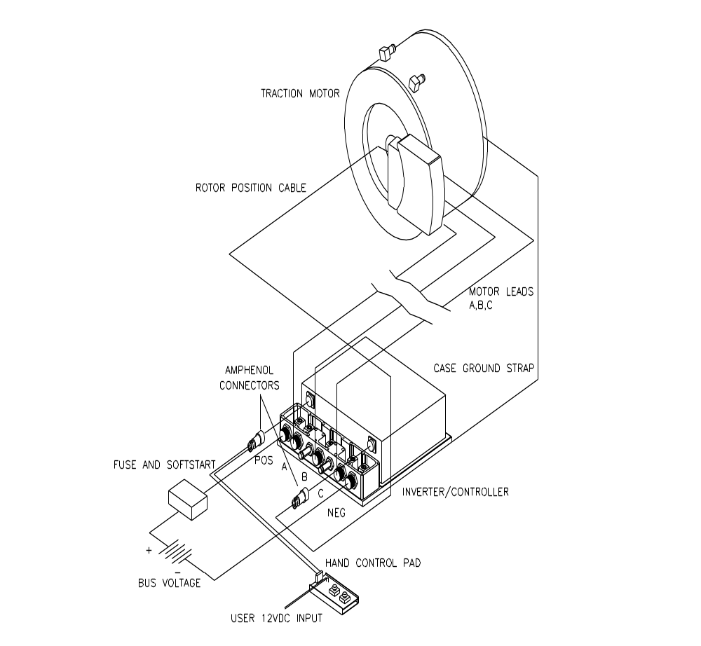

Figure 3.0-1: System Electrical Connections

Controller Power Cable Connections

Figure 3.1-1 shows an exploded view of the inverter/controller connections. Before connecting any cable to the DD40-400LWB inverter, the terminal cover must be removed. Also, the ends of the five power cables (POS, NEG, A,B,C) must be stripped back (1 in maximum) and have a layer of copper tape wrapped over the wire strands to prevent fraying. See Figure 3.1-1.

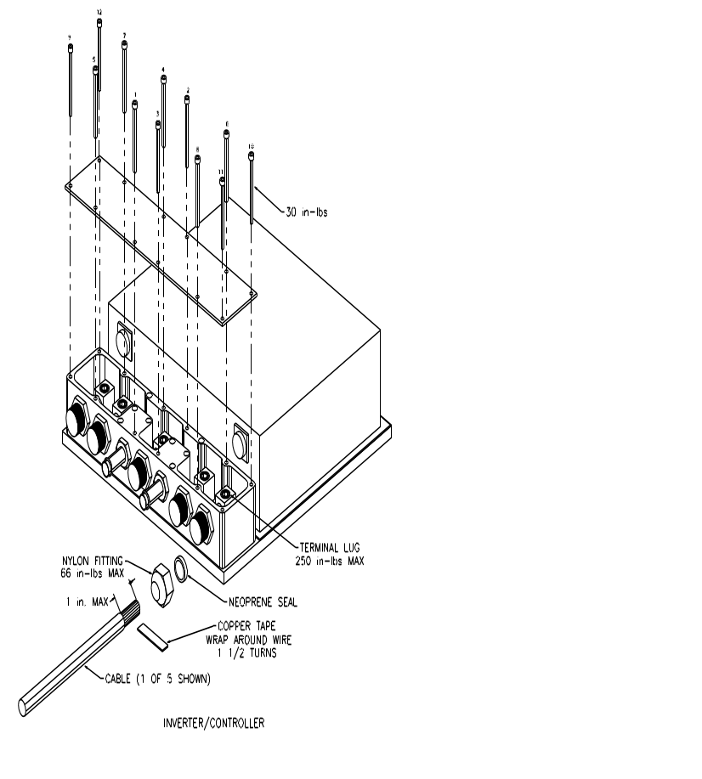

Figure 3.1-1: Power Cable Connections

Motor cables A, B, and C should be connected to the respective labeled motor lead terminals in the inverter. The Battery cables POS and NEG should be connected to their respective inverter terminals. Install all the cables with the water-tight fittings and seal as shown in Figure 3.1-1. Caution: Do not over tighten the terminal lugs or water tight fittings. The connection hardware recommended tightening torques are shown in Figure 3.1-1. Tighten the cap screws securing the cover in the sequence shown in Figure 3.1-1 to ensure that the gasket is pressed evenly to ensure water sealing of the cover.

Motor Connections

There are three motor leads on the motor labeled A, B, and C. These motor leads connect to the inverter to their respective labeled terminals. If any lead is connected to the wrong terminal, the motor will not run and damage may occur.

WARNING:

DO NOT ATTEMPT TO SWAP MOTOR WINDINGS TO REVERSE DIRECTION. DO NOT CONNECT OR DISCONNECT MOTOR LEADS OR ROTOR POSITION CABLE IF INPUT VOLTAGE IS APPLIED.

Controller Connections User Interface 19-pin Amphenol Connector

A user interface 19-pin Amphenol connector is available for remote operation of the system. For test purposes, a user interface hand control pad is provided with the system.

The hand control pad consists of a direction switch, an enable switch, an accelerator potentiometer, and a brake potentiometer. These signals simulate common control signals on a vehicle, and they are fully described below.

Before connecting the user interface control pad, ensure that the direction switch is at FORWARD position, and enable switch is at the DISABLE position. Both acceleration and brake potentiometers should be fully counterclockwise (minimum value). The user interface control pad attaches to the controller through a ribbon cable that is provided, to the 19-pin Amphenol connector on the inverter/controller.
WARNING:

The user interface CONTROL PAD is for testing purposes only. DO NOT USE THE CONTROL PAD IN A VEHICLE.

User Interface I/O Signals

Please note that all user interface control signals are isolated from the high voltage DC bus and should not be referenced in any way to the high voltage DC bus supply.

The user interface connector is a 19-pin bayonet Amphenol connector. The input/output signal descriptions are listed below for the pins that are used on the 19-pin connector.

Vcc_user (+5 V): (Output, Pin A)

This voltage supply is intended to provide the user with the necessary voltage level used on the accelerator, brake, enable, direction, and key start signals. This supply can source 50 mA of current. This line is referenced to the "GND_user" pin.

GND_user: (Output, Pin B)

This is the internal logic control card ground reference point associated with all pins that are used in the "User Interface Connector".

He_out: (Output, Pin C)

This signal represents the RPM of the motor.

Enable: (Input, Pin D)

This is an alternative way to zero the desired torque command. This pin has a pull-up resistor (10 kΩ) and therefore it is not necessary to switch this pin to Vcc_user to enable the system. If this pin is open or tied to the Vcc_user the system is enabled, and the Accelerator and Brake signals are used to determine the desired torque command. If the pin is shorted to GND_user, the desired torque command is 0 N·m. The maximum signal input current shall not exceed 0.5 ma.

Direction: (Input, Pin E)

The desired motor direction is defined with this pin. This pin has an internal pull-up resistor (10 kΩ) and therefore it is not necessary to switch this pin to Vcc_user to change to a forward rotation. Open or switched to Vcc_user is a forward rotation and shorted to GND_user is a reverse rotation. The maximum current through the short is 0.5 ma.

Drive_ready: (Output, Pin F)

This is used to drive an LED which will indicate when the software has been initialized correctly, without any errors. This signal is powered by the external 12 V supply. The maximum signal output shall not exceed 5 ma.

Spare (Pin G)

GND_user (GND): (Pin H) Same as Pin B

GND_serial (GND): (Pin J) Serial GND (same reference point as GND_user)

GND_user (GND): (Pin K) Same as Pin B

Brake: (Input, Pin L)

The Brake is a 0.5 to 4.5 V input signal, referenced to GND_user. 0.5 V implies a 0% torque command, and 4.5 V implies a -100% torque command. If this signal is less then 0.25 V or greater then 4.75 V the system will error and generate a zero torque command.

Accelerator: (Input, Pin M)

The Accelerator is a 0.5 to 4.5 V input signal, referenced to GND_user. 0.5 V implies a 0% torque command, and 4.5 V implies a 100% torque command. If this signal is less then 0.25 V or greater then 4.75 V the system will error and generate a zero torque command.

+xx VDC: (User Input, Pin N)

External User (xxVDC) input. The Microprocessor recognizes this input as “key on” or “key off”. This input voltage is a low voltage source that powers the internal Microprocessor through the User input Pin N. If there is no voltage source not present, then “key off” is assumed and the system will not operate.

Note: Key on/off signal is software configurable. The key on signal must be programmed "ALWAYS TRUE" if this input is not connected to a voltage source, or the system will not operate. SEE section 6.2 "System Configuration"

Spare (Output, Pin P)

Ctrl_link: (Input, Pin R)
WARNING: WHEN USING MORE THAN ONE INVERTER/CONTROLLER SYSTEM TO DRIVE A VEHICLE, ALL CTRL_LINK PINS MUST BE CONNECTED TOGETHER TO PREVENT FAILURE TO OTHER SYSTEMS WHEN ONE SYSTEM FAULTS.

This signal is used in multiple inverter/controller systems. Connect the Ctrl_link pins of all inverters together. Whenever one inverter has a fault, the Ctrl_link pins will be pulled low. The torque command for all inverters will be zero until the rpm is below base speed. The inverters must be powered down, then up again to clear this fault. This feature can be turned on and off through the system configuration menu, user input menu or ctrl link menu.

CAN_L: (Pin S) Low (CAN Optional)

CAN_H: (Pin T) High (CAN Optional)

Serial: (Pin U) User RxD serial receive

Serial: (Pin V) User TxD serial transmit

A User Interface Hand Control Panel is provided with the system for testing purposes only. DO NOT USE THE USER INTERFACE PANEL IN A VEHICLE except for troubleshooting your system wiring. This panel utilizes all of the signals described above and may be used as a sample guide for the wiring of your system.

Two drawings relating to the User Interface are included in Appendix E and F. The first shows the schematic of the hand control panel. The second is the schematic of the first stage input and output circuits inside the microprocessor, of the user interface pins. The hand control panel is provided for test purposes only and should not be used in a vehicle.
Table 3.3-1: List of User Interface Control Signals

Name | Signal | I/O port | Pin # of 40-Pin Hand Control connector | Pin # of 19-Pin Amphenol bayonet connector
Vcc_user | +5 VDC |  | 1 | A
GND_user | GND |  | 2 | B
HE_OUT | 100 μs pulses, 90 pulses per motor rotation | HE_OUT | 3 | C
Enable | 5 V = Enable input command  0 V = Disable input command | USER-PE0 | 4 | D
Direction | 5 V = Forward  0 V = Reverse | USER-PE1 | 5 | E
Drive Ready | LED Indicator | USER-POUT0 | 12 | F
Spare | NO CONNECTION |  |  | G
GND_user | GND |  | 14 | H
GND_serial | GND |  | 15 | J
GND_user | GND |  | 21 | K
Brake | 0.5 to 4.5 V = 0 to -100 % of torque profile | USER-AD0 | 22 | L
Accelerator | 0.5 to 4.5 V = 0 to 100% of torque profile | USER-AD1 | 23 | M
+xx VDC | USER_xxV INPUT | INPUT | 24 | N
Spare | NO CONNECTION |  |  | P
Table 3.3-1: List of User Interface Control Signals (con't)
Name | Signal | I/O port | Pin # of 40-Pin Hand Control connector | Pin # of 19-Pin Amphenol bayonet connector
CTRL_LINK | Used when there are two or more controllers in a vehicle. | CTRL-LINK | 26 | R
CAN_L | Low (CAN optional) | CAN_L | 28 | S
CAN_H | High (CAN optional) | CAN_H | 29 | T
Serial | Receive | USER-RxD | 30 | U
Serial | Transmit | USER-TxD | 31 | V

Resolver / Hall and Motor Temperature Cable

The rotor position cable is supplied separate from the motor and controller. There are 15 pin circular Amphenol connectors on each end, however there are pins on one end and sockets on the other. The end with the pins goes toward the controller and the sockets go to the motor. This is done so that the cable can not be reversed in the system.

DO NOT ATTEMPT TO LENGTHEN OR SHORTEN THE CABLE IN THE FIELD. CONTACT UQM TECHNOLOGIES IF THE CABLE IS TO SHORT OR TO LONG FOR THE APPLICATION.

WARNING:

Do not route the Rotor position cable with the motor power leads. This may cause a catastrophic failure.

Traction Battery Power Connection

WARNING:

Your system may be configured for rotation when input voltage is applied. Before applying input voltage, ensure that the shaft and/or anything connected to the shaft has sufficient area for rotation. Always disconnect input voltage before making or removing any other connections.

The battery or power supply is connected to the inverter terminals marked POSITIVE and NEGATIVE. Connections should be made observing the correct polarity.

The inverter is designed to have an operating voltage range as specified in Appendix A: "System Specifications". DO NOT APPLY MORE THAN THE SPECIFIED RATED VOLTAGE TO THE AMPLIFIER OR DAMAGE WILL OCCUR.

The system can provide the rated peak power when the input voltage is in the range of the specified normal operation voltage, the output power de-rates below the normal operation voltage.
WARNING: DO NOT CONNECT EITHER THE POSITIVE OR NEGATIVE BUS TO THE CHASSIS OR CASES OF THE MOTOR OR INVERTER. CATASTROPHIC DAMAGE MAY OCCUR. PROVIDE SUFFICIENT INSULATION ON ALL POWER TERMINALS FOR SAFETY.

If the system is being tested on a dynamometer, the power supply must be capable of delivering and accepting energy. If the power supply cannot accept regenerated energy, the voltage will quickly exceed the maximum rated input voltage limit.

The ripple voltage on the power supply should be less than 10 V peak to peak, at all current levels.

Before applying input voltage, ensure that the shaft and/or anything connected to the shaft has sufficient area for rotation. Always disconnect input voltage before making or removing any connections.

The DC bus POS supply line must pass through an in-line fuse and power disconnect switch or breaker prior to connection to the inverter. Proper sizing of the fuse and power disconnect switch or breaker is necessary and in the interest of safety, the power disconnect switch or breaker control should be located where it is accessible to the operator of the vehicle. All electrical conductors must be covered and insulated.

When the bus is energized and the power disconnect switch is closed, a rush of current can be expected due to the charging of the capacitors within the inverter. This can be avoided by using a soft start circuit to slowly charge this capacitor before closing the power disconnect switch. A SOFT START CIRCUIT IS RECOMMENDED FOR INPUT VOLTAGES ABOVE 100V DC. Soft start guidelines are provided in Appendix D.

Grounding Requirements

The cases of the inverter and motor must be wired together with 6AWG copper wire and may or may not be tied to chassis. THE BUS POSITIVE OR NEGATIVE MUST NOT BE TIED TO THE CHASSIS OR THE CASES OF THE INVERTER OR MOTOR. The User Interface Reference Ground must be isolated from the DC bus.

If your system has a auxiliary battery, the negative of the auxiliary battery may or may not be connected to chassis. The User Interface Reference Ground may be connected to an auxiliary battery negative. Do not connect the DC bus POS or NEG to the auxiliary battery or the user interface reference ground.

Liquid Cooling System

Liquid-Cooled System Setup

The Electric Vehicle Driveline package requires a liquid-cooling system. The recommended liquid-cooling setup is shown in Figure 4.1-1.

The coolant ports in the motor and controller are o-ring sealed, so that they can be changed by the customer to fit their various applications. From the SAE 1926 port there are several options that can be supplied from the factory, or purchased and changed by the customer.

For proper performance and to achieve rated power the coolant loop must meet the following requirements.

Coolant flow rate of 7.5 l/min (2 gal/min) to 23 l/min (6 gal/min)
Maximum coolant loop pressure is 13 psi.
Coolant temperature range -20˚C to 50˚C.
Maximum coolant temperature is 55˚C.

A coolant flow rate of 7.5 l/min (2 gal/min) will have a pressure drop of approximately 1.8 psi due to the controller and motor. This does not include additional fittings, valves or plumbing.

It should be noted in Figure 4.1-1 that the coolant should go from the radiator through the pump to the controller. Then from the controller to the motor and back to the radiator. Try as hard as we might the electronics are still more heat sensitive than the wires in the motor and as such need the coolant as cool as possible. While the system can operate at maximum rated coolant temperatures, the operating life of the controller will be longer if the coolant is kept below that temperature.

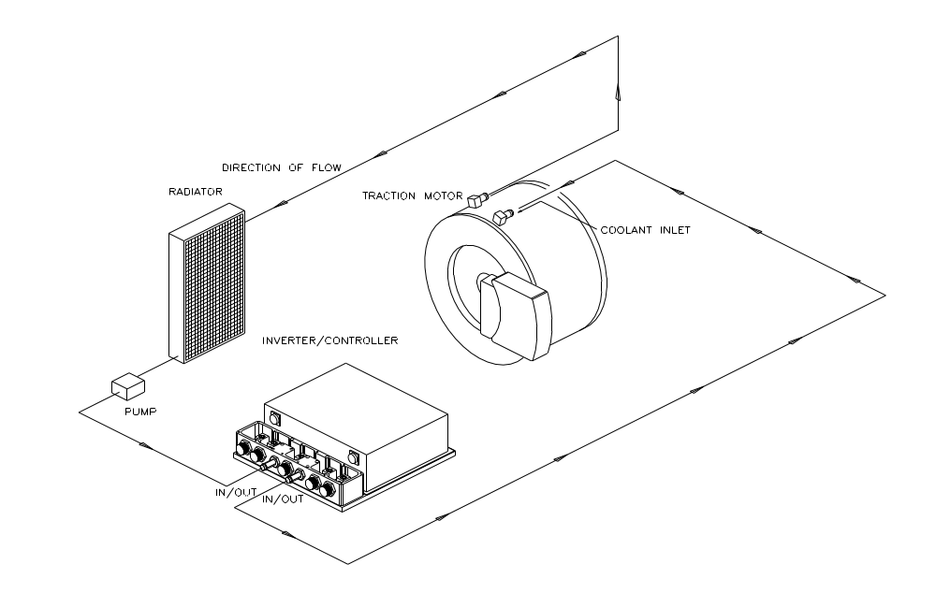

Figure 4.1-1: Suggested Cooling System Connection Scheme

Installation Tips

- The radiator fill port should be higher than the motor and controller.

- The hose connections for the motor should be located on the top side of the motor, or within 45 degrees from the top. (See Section 2.3 Motor Installation).

- For the inverter, either hose connection can be used as coolant in or out.

- For the coolant connection to the motor, COOLANT "IN" MUST BE CONNECTED TO THE MOTOR COOLANT FITTING MARKED AS "INLET". THE "INLET" FITTING IS THE "TALLER" OF THE TWO COOLANT FITINGS AND IS LOCATED NEAREST TO THE TERMINATION HOUSING.

Flow Rate vs. Pressure Drop

Table 4.3-1: Flow Rate vs. Pressure Drop

SR218 and DD40-400LWB LIQUID COOLED SYSTEM

FLOW  RATE  gal/min | MOTOR psi | INVERTER  psi
1 | 0.0 | 0.5
2 | 0.2 | 1.8
3 | 0.5 | 3.5
4 | 1.1 | 6.2
5 | 1.7 | 9.3
6 | 2.3 | 13

Basic Operating Instructions

The drive system can either be operated on a dynamometer or in a vehicle. Instructions are given for both. Prior to applying power ensure that the drive system is properly secured, nothing is in the way of the rotating shaft, and that all connections are made to the motor and controller. Also be sure that there is coolant in the system and that it is flowing through both the motor and controller.

Basic Dynamometer Operating Instructions

WARNING: OPERATE MOTOR SLOWLY DURING FIRST TIME STARTUP.

If the system is being tested on a dynamometer, the power supply must be capable of delivering and accepting energy. If the power supply cannot accept regenerated energy, the voltage will quickly exceed the maximum voltage limit rating of the control, and may cause damage to the controller or power supply.

The system should be connected as shown in Figure 3.0-1. Turn the accelerator and brake potentiometers to 0, fully counterclockwise. Flip the Enable/Disable switch to the disable position. Turn up the DC input bus voltage source to the desired operating voltage. This must be greater than the Minimum Bus Voltage (set for each customer’s specific battery). The hand control “drive ready” LED should be on (if User_xxV is connected, see Section 5.3 ).

The system should be fully operational. Turn the Enable/Disable switch to the ENABLE position. Slowly turn the accelerator potentiometer clockwise. The motor should begin to rotate. If the motor does not rotate when the potentiometer has been turned 30 degrees, then there is a problem. (See the Troubleshooting Section 7 in this manual). Be careful if the motor is unloaded, because the torque command will drive the motor to the maximum rated rpm very quickly. Turn the accelerator potentiometer counter clockwise, and the brake potentiometer clockwise to stop the motor.

5.2 Basic Electric Vehicle Operating Instructions

We are assuming that the electric vehicle is equipped with batteries and a soft start circuit. These instructions are written assuming the user is debugging the vehicle system with the hand held control pad. Do not use the control pad for vehicle operation. If the drive motor is connected to the drive wheels, then jack the drive wheels off the ground. The system should be connected as shown in Figure 3.0-1. Turn the accelerator and brake potentiometers to 0, fully counterclockwise. Flip the Enable/Disable switch to the DISABLE position.

Normal Operation
Turn the Enable/Disable switch to the ENABLE position. The system should be fully operational. The drive ready LED on the control pad should be illuminated (if User_xxV is connected, see Section 5.3). Slowly turn the accelerator potentiometer clockwise. The motor should begin to rotate. If the motor does not rotate when the potentiometer has been turned 30 degrees, then there is a problem. (See the Troubleshooting Section 7 in this manual.) Be careful if the motor is unloaded, because the torque command will drive the motor to the maximum rated rpm limit very quickly. Turn the accelerator potentiometer counter clockwise, and the brake potentiometer clockwise to stop the motor.

5.3 Hand Control Functions

Appendix E contains a circuit diagram of the hand control. Some of the functions of the other pins on the hand control will be explained in more detail. For an explanation of each pin, see Section 3.3 on User Interface signals.

User_xxV Input: (Optional) (Refer to Appendix A for rated voltage) The external User_xxVDC input can be used as a “key on” and “key off” signal. If the User_xxV voltage supply is not present, then “key off” is assumed and the system will not operate. If the key on signal is not used with the hand control, the key on/off parameter must be programmed "ALWAYS TRUE" or the system will not operate. SEE section 6.2 "System Configuration" for information on configuring the key signal.

Note: the Drive ready LED will not function without the external User_xxVDC input.

The external user (User_xxVDC) supply input signal can be applied to the hand control P2 header, Pins 4 and 17. See Section 3.3 on user interface, and Appendix E for more information.

Note: Do not connect the high voltage DC bus POS or NEG to the user voltage interface reference ground. See Section 3.6 for more information on grounding requirements.

Enable Switch
Once the power is up, the control pad can be used to control the motor. Turn the enable switch to the ENABLE position. If the enable switch stays at the DISABLE position, the desired torque level will be forced to zero within the software program. This switch simulates the Neutral drive mode in the vehicle.

Direction Switch
The DIRECTION switch simulates DRIVE and REVERSE signals on an automatic transmission vehicle. It sets the direction of motor shaft rotation. The Electric Vehicle Drive system performance is optimized for motor rotation in both directions. The software will only allow phase advance in the forward direction, so the speed will be limited in the reverse direction.

Serial Port Communications and System Status

Serial Port Outputs

The software interface routine will provide some system information through the serial communication port. The communication protocol is VT100 emulation with a user selectable baud rate (19200 to 115200), 8 data bits, no parity, and 2 stop bits. The data is sent in ASCII format. Any communication software package, such as the HyperTerminal utility in Microsoft Windows, can be used to display and capture the data.

A typical output of the serial port into the Windows HyperTerminal Utility is shown in Figure 6.1-1. The outputs have been split under 4 headings: feedback, status, system, and messages. Each of the entries under these headings is listed in Tables 6.1-1 through 6.1-4 on the following pages. The computer must be in the Windows Terminal Utility with the serial port connected before the microprocessor is turned on.

The outputs are updated continuously. The output rate depends upon the baud rate. The outputs are not updated simultaneously. In general, an item name will blink and be displayed as white text on black background when the parameter it is displaying has crossed its lower limit and the value will blink and be displayed as white text black background when the parameter exceeds its upper limit. The error codes are listed in Table 6.1-4. The time of the last error is output in the last column. Below is a list of commands that can be entered to view more information. All commands must be followed by the <ENTER> key.

clear To clear the maximum and minimum saved parameters.
ss To refresh screen.
cls To refresh screen.
ch To clear the status history.
config Do not config at high voltage; only config with 12V input. To change certain system parameters permanently (see 6.2).

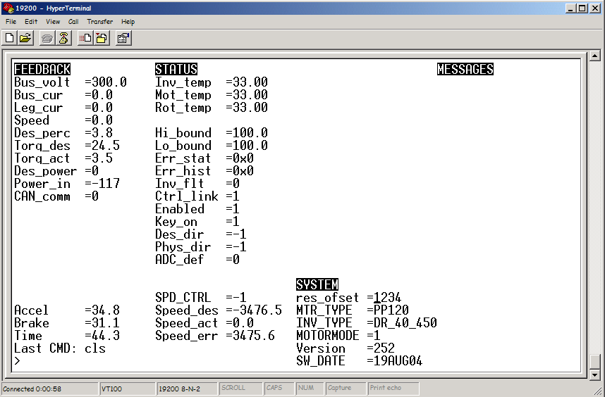

Figure 6.1-1: Typical Output of Serial Port in Windows Hyperterminal

Table 6.1-1: List of feedback Parameters
Name | Abbreviation | Units | Description
Bus Voltage | bus_volt | V | bus voltage
Bus Current | bus_cur | A | bus current
Leg Current | Leg_cur | A | leg current
Motor Speed | Speed | rpm | motor speed
Desired Percentage | Des_perc | % | Based on accel, brake, high bound, low bound, maximum motoring torque and maximum regening torque.
Desired Torque | Torq_des | Nm | based on desired percentage, speed, and high_bound
Actual Torque | Torq_act | Nm | calculated from leg current or bus current, bus voltage, speed, and loss
Desired Power | Des_pow | kW | Desired power
Input Power | Power_in | kW | bus current times bus voltage
CAN communication | CAN_comm |  | status of the CAN communications  0 = Not receiving CAN signal  1 = receiving CAN signal  Blinking if CAN signal is lost.
Accelerator | Accel | % | input command
Brake | Brake | % | input command
Time | Time | s | time
Last Command | Last CMD |  | last command entered

Table 6.1-2: List of Status Parameters
Name | Abbreviation | Units | Description
Inverter Temp | inv_temp | ºC | Inverter thermistor
Motor Temp | mot_temp | ºC | Winding thermistor
Rotor Temp | rot_temp | ºC | Hall card thermistor near the rotor
Safety High Bound | Hi_bound | % | Used to limit the desired percentage due to a safety limit
Safety Low Bound | Lo_bound | % | Used to limit the desired percentage due to a safety limit
System Status | Sys_stat |  | Displays current hexadecimal error status of the system. Refer to error codes (Table 6.1-4)
Status History | Stat_his |  | Displays hexadecimal error codes that occurred after last clear history (ch) command.
Inverter Fault | Inv_flt |  | 1=inverter module fault  0=no fault
Control Link | Ctrl_link |  | 1=external system is not faulted  0=external system is faulted
Enable | enabled |  | 1= system enabled  0 = system disabled  The enable switch is coming from the analog input. If CAN is ON, both the analog input and the CAN enable bit are needed to enable the system.
Key on | key_on |  | External xxVolts on/off  Can be set to always on in config.
Desired direction | des_dir |  | 1=Forward 0= Reverse
Physical Direction | phys_dir |  | 1=Forward  0=Reverse
ADC default | ADC_def |  | 1=use ADC default values. Contact UQM Technologies, Inc. for assistance.  0=use programmed ADC values
Speed Control | SPD_CTRL |  | 1=speed control  0=torque control
Speed Desired | Speed_des | rpm | Desired speed
Speed Actual | Speed_act | rpm | Actual speed
Speed Error | Speed_err | rpm | Desired speed - Actual speed

Table 6.1-3: List of System Parameters
Name | Abbreviation | Description
Resolver offset | res_ofset | Resolver offset
Motor Type | MTR_TYPE
Inverter Type | INV_TYPE
Motot mode | MOTORMODE | 1 = motor mode  0 = generator mode
Version | Version1 | Software version
Date | SW_DATE | Software date in ddmmmyy
Table 6.1-4: List of Error Codes

Error Code | Name | Description
1000 | Over Bus Voltage Pin | error should only occur if batteries were disconnected during regeneration
800 | Over Bus Voltage | error should only occur if batteries were disconnected during regeneration
400 | Over Motor Velocity | error should only occur if motor was spun no load at a large command
200 | Over Secondary Bus Voltage | error will occur normally during large deceleration’s as the control software tries to keep the bus voltage below this level
100 | Over Secondary Motor Velocity | error will occur if vehicle is coasting down a large hill faster than the maximum set rpm limit
80 | Over Inverter Temp | error will occur if allowable duty cycle is exceeded
40 | Over Motor Temp | error will occur if allowable duty cycle is exceeded
20 | Over Rotor Temp | error will occur if allowable duty cycle is exceeded
10 | Under Bus Voltage | will occur if microprocessor is powered and inverter is not
8 | Direction | Commutation direction does not equal commanded direction
4 | Over Bus Current | Over the maximum bus current
2 | Over Leg Current | Over the maximum leg current
1 | Over Current Counter Pulses | Over allowable percentage of leg current faults
1-800  #  @Time | How the error codes are displayed | 1-800 = Error Codes Above  # = number of occurrences since last updated  @Time = time stamp of last occurrence

Table 6.1-5: Microprocessor Status Messages
Status Message | Interpretation
KEY ON | External xxV supplied to the microprocessor.
CTRL_LINK | External system has inverter fault.
FAULT | System has inverter fault.
ERR: ADC NOT CAL | Analog to digital converter is not calibrated. Contact UQM Technologies, Inc. for assistance.
Bad Input Message | The last command entered was a non-existent command or there was a spelling error or it was not entered in the correct format. Refer to Section 6.1 for the list of commands.

System Configuration

System configuration allows the user to change certain system parameters by the use of a menu driven user interface. In order to use the system configuration command, the user must be connected to the controller serial port in a terminal program as described in Section 6.1.

Note: In order to enter system configuration the velocity must be zero. High voltage should be removed.

Type config at the terminal to enter system configuration menu.

Type x to go up a menu level. At the top level this command will exit System Configuration with an option to save the present configuration.

CAN Communications (Optional):
The system can be in one of two states, analog or CAN control. In analog control the drive signals come in via the acceleration and brake command. In CAN control the drive signals come in via the CAN interface. To enable either option follow the steps below.
1. Select General System (menu #7).
2. Select the CAN Communication menu (menu #3).
- 4 parameters are tunable in the CAN menu:
- CAN communication, 3 choices: disabled (default), enabled, automatic.
Disabled : CAN is ignored and the sytem is listening to analog controls.
Enabled : Analog controls are ignored and the system is listening to CAN.
Automatic : the system is listening to analog controls until a valid CAN control message is received.
- Drive Mode, 4 choices: speed, power, torque, automatic. Default is undefined.
Speed : setting the system to respond upon CAN speed control messages. (see Appendix G for message description).
Power : Not available.
Torque : setting the system to respond upon CAN hand control messages. (see Appendix G for message description).
Automaitc : Setting the system to respond upon the last message received (speed or hand)
- CAN master network address : (1-255), sets the address of the master in decimal (no hex characters).
- CAN Network Address : (1-255), sets the address of the system in decimal (no hex characters).
- Type x to exit
- Save the changes before exiting system config.

Change Battery Voltage and Battery Current:
- Select battery.
- Select minimum voltage, maximum voltage, nominal voltage, maximum current.
- Change to the desired value and go to step 2.
- Type x to exit.
- Save the changes before exiting system config.

Enable Creep Torque:
- Select motor.
- Select enable creep torque.
- Change to the desired value.
- Type x to exit.
- Save the changes before exiting system config.

Change Accel 100%, Accel 0%, Brake 100% Torque:
- Select torque/speed.
- Select accel 100%, accel 0%, or brake 100%.
- Select any of the speeds and change the torque.
- Type x to exit, type x to exit.
- Save the changes before exiting system config.

Change Regen Values:
- Select regen.
- Select and change to the desired value.
- Type x to exit.
- Save the changes before exiting system config.

Make KEY_ON Always True/False:
- Select user input.
- Select key always on menu.
- Change to the desired value.
- Type x to exit, type x to exit.
- Save the changes before exiting system config.

Change Baud Rate
- Select general system.
- Select serial communication menu.
- Select baud rate and change to the desired value.
- Type x to exit, type x to exit.
- Save the changes before exiting system config.

Change direction polarity
- Select user input.
- Select motor_direction_polarity_flag and change to the desired value..
- Type x to exit, type x to exit.
- Save the changes before exiting system config.

Change D/A Voltage and Current Ranges:
Not All Customers Have External D/A Outputs.
- Select user output.
- Select voltage or current.
- Select and change to the desired value.
- Type x to exit, type x to exit.
- Save the changes before exiting system config.

Setting Resolver Offset:
The resolver offset for a particular motor can be found on the motor nameplate.
- Select general system.
- Select DSP, Inverter, Motor and Resolver Offset Menu.
- Select resolver offset.
- Enter a number between 0 - 4095.
- Type x to exit.
- Save the changes before exiting system config.

*Since this is a critical parameter additional checks are performed to prevent the system being run with the wrong offset value. If system config is erased then before executing software the system will display the currently stored resolver offset value and also prompt the user to enter it.

EXAMPLES OF CHANGING THE TORQUE/SPEED PROFILE

The torque/speed profile could be changed for any number of reasons, here are a few examples as a guide. At any time, the user can select reset to default to get back to the original factory settings. Note that at a given speed the torque value in the Accel 100 Menu must be greater than the torque in the Accel 0% menu which must be greater than torque in the Brake 100% menu.

Limited Torque of a Drive Train Component
In this case the maximum motoring torque could be reduced to prevent premature failure of the limiting drive train component. The overall power is not reduced, only the torque.
Shown below is a case where the torque was limited to 500 N·m.

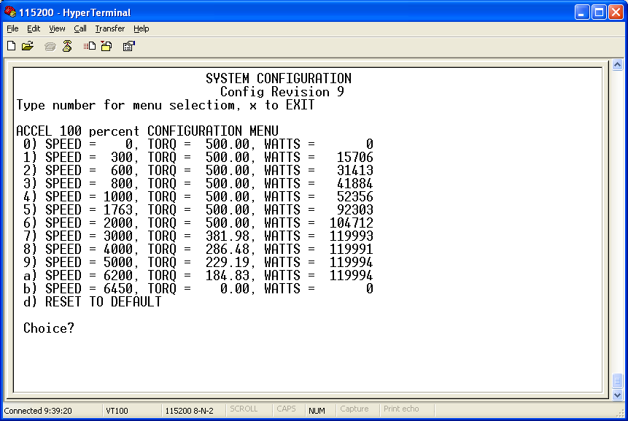
Figure 6.2.1-1: System Configuration Example - Limited Torque

Limited Speed of a Drive Train Component
In this case the maximum motoring torque could be reduced to 0 before the critical speed of the limiting drive train component. The torque could be further reduced negative above the critical speed. Below is shown a case where the torque above 2000 rpm would be 0 N·m.

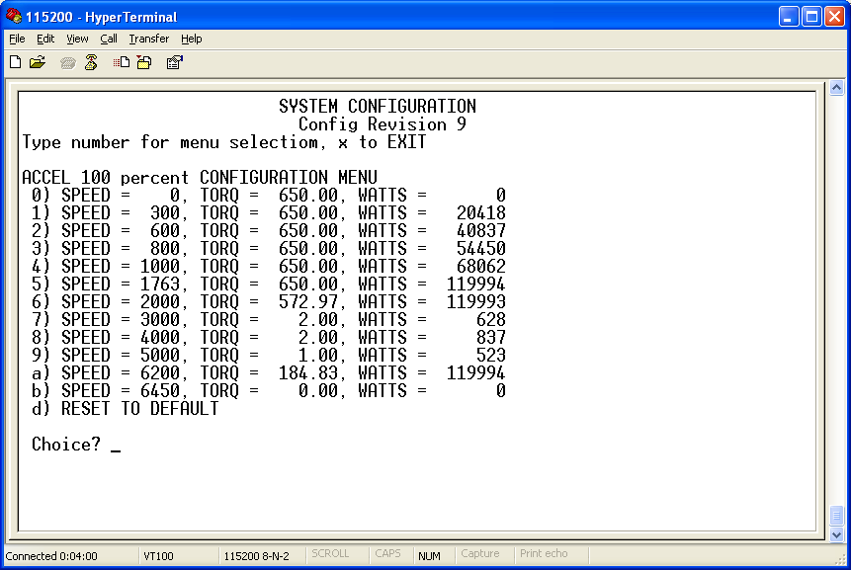
CANNOT CHANGE THE TORQUE VALUE FOR SPEED 6200 AND 6450.

Figure 6.2.1-2: System Configuration Example - Limited Speed

Creep to Simulate Automatic Transmission
In this case the vehicle will have a positive torque with a 0% accelerator input. To accomplish this, the desired torque is input at the zero speed option of the ACCEL 0% menu. (Note: the creep flag must be enabled in the Motor Menu first.) This torque should be reduced to zero as the speed is increased. WARNING: VEHICLE WILL MOVE WITH NO ACCELERATOR INPUT. The maximum limit on the positive torque in the ACCEL 0% Menu is 100 N·m.

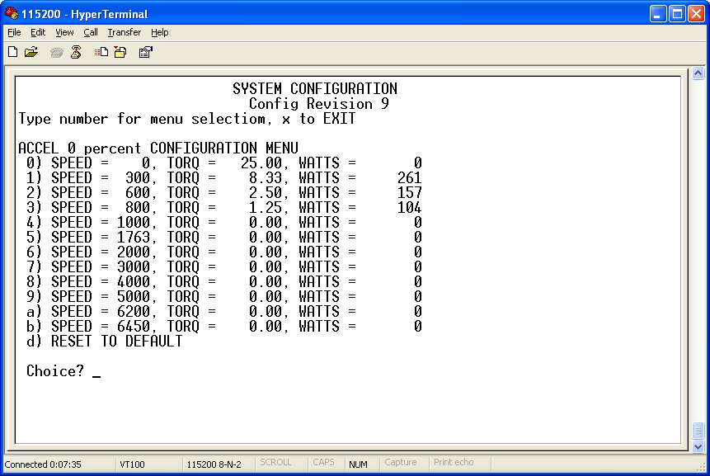
Figure 6.2.1-3: System Configuration Example - Creep Positive Torque

Regeneration on 0% Accelerator to Simulate Compression Braking of an Internal Combustion Engine (ICE)
In this case the vehicle should slow down with a 0% accelerator input. To accomplish this, the negative desired torque is entered at the desired speed option of the ACCEL 0% menu. WARNING: VEHICLE COULD SLIP ON ICE WITH NO BRAKE INPUT. Shown below is a –100 Nm regen torque from 6000 to 2000 rpm, reducing to 0 N·m at 1000 rpm.

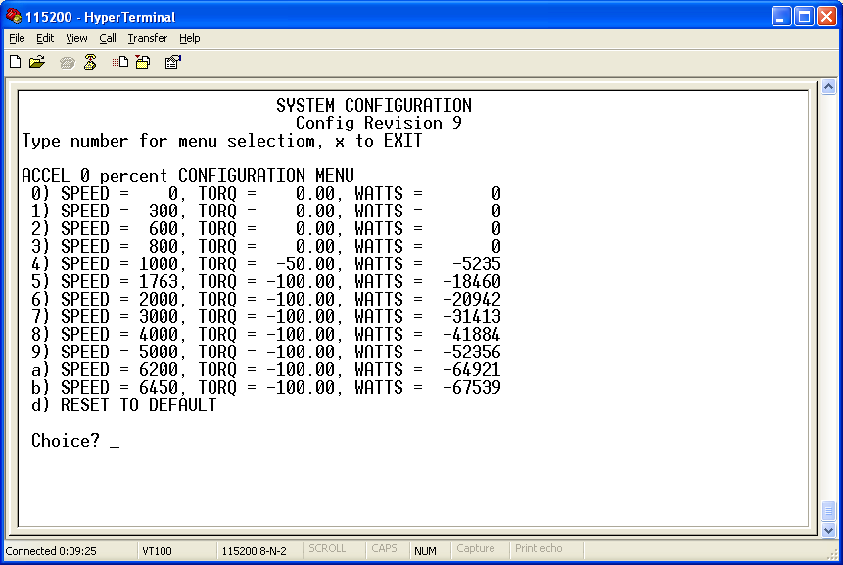
Figure 6.2.1-4: System Configuration Example - Regen on 0% Accel Input

Reduction of Large Braking Torque Near 0 Speed
The vehicle can abruptly stop at slow speeds due to the large desired braking torque, and the inability of the drive system to actually reach this torque. (See the regeneration specification sheet near zero speed). The slow speed maximum braking torque should be reduced to give the desired effect. To accomplish this, the negative desired torque is entered at the desired speed option of the BRAKE 100% menu. Shown below is 0 N·m at 0 rpm and increasing to –550 N·m at 1000 rpm. Note: The desired negative torque needs to be 10% greater than the actual negative torque (i.e. desire –550 N·m and actual is
- 500 N·m).

CANNOT CHANGE THE TORQUE VALUE FOR SPEED 6200 AND 6450.
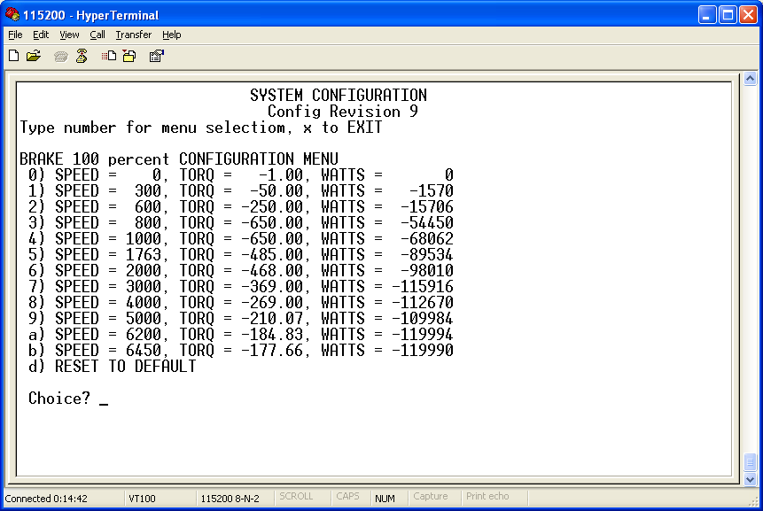
Figure 6.2.1-5: System Configuration Example - Braking Torque

UNDERSTANDING THE REGEN PARAMETERS

Why the Code was Developed

The regen parameters were added to the code to regulate the regen power at the desired maximum bus voltage and eliminate an objective condition of cycling between regen and no regen when the battery voltage reaches its maximum. The conditions that this addresses are:
- When the voltage goes over the desired maximum bus voltage and reaches the maximum inverter voltage, then the microprocessor takes action to prevent damage of the components inside the inverter. This action stops regeneration quickly.
- When the over voltage is no longer present, the system will increase the regen current which could cause another over voltage condition, starting a limit cycle.

Graph of the Internal Algorithm to Help in Understanding the Regen Parameters

The graph below is in reference to the default regen parameter values (shown above).

EQU 1) Regen Power = Old Regen Power +Gain*(Min[ (MaxBusVoltage-BusVoltage),LimVolt Error])
EQU 2) Regen Power = Old Regen Power + Gain*Extra Gain*(MaxBusVoltage-BusVoltage)

Regen Power

Time
Voltage Less Than Max Bus Voltage. Current >
-5 A.
Regen Power = Init Regen =
20000 W

Voltage Less Than Max Bus Voltage. Current < -5 A.
Use EQU 1.

Max Regen Power Reached
=
100000W
Voltage Greater
Than Max Bus Voltage. Use EQU 2.
Min Regen Power Reached
=
2000 W
System went from regen mode to motor mode. Regen Power resets to Init Regen =
20000 W

Figure 6.2.2-1: Reference Graph for System Regen Parameters

Discussion
The relative rate of increasing to decreasing the regen power can be accomplished with the extra gain. The rate of increase can be controlled by the allowable voltage error, and the gain. The equation is run every 7 ms, so for the default regen parameters, the fastest the regen power can increase is 4.0 Gain*10.0 V Limit on Error/7 ms = 400 W/0.007 s = 5714 W/s. The minimum regen power must be able to generate the minimum regen current or it will get stuck at the minimum regen power.

Values to Defeat This Safety Feature
If this safety feature is not desired, then increase the initial regen power and max regen power to the desired values. Raising these values greater than the values in the BRAKE 100% menu does not increase the maximum regen power. The gain should be set to 0 to prevent the system from lowering the regen power.

Interaction of the Brake Input, BRAKE 100% Menu, and Regen Power
The brake input (0 to 100%) and the BRAKE 100% menu will determine the desired regen power. This will be limited to the allowable regen power as shown in this routine.

Interaction of the Allowable Regen Power Decreasing and Over Voltage Safety
The over voltage safety is a separate safety system to help prevent over voltage. It will increase low bound from –100.00% to 0% as the over voltage persists. Therefore, the brake input command will be limited to the percentage in low bound, which will lower the desired regen power. At the same time the allowable regen power is decreasing.

system behavior on inverter fault

In the event of an inverter fault (Screen item Inv_flt will blink and be displayed as white text on black background; FAULT = 1 message will show in the MESSAGES column) the behavior of the system depends on whether it is being used as a motor or a generator.

Motor Mode:
When a fault first occurs the system will immediately limit high and low bounds to 50% and clear the fault after a 100ms delay. If the fault reoccurs the system will clear it a second time after a 1s delay, high and low bounds are still limited to 50%. If a fault occurs after this the system will not clear the fault. The limiting of high and low bounds to 50% can be reset only by cycling power to the system.

Generator Mode:
When the system is being used as a generator it will clear faults continuously after a 100ms delay, no limiting of high and low bounds is done in this mode.

OTHER INFORMATION FOR USING THE 2812 DSP

- If the value field on the screen blinks then the value is too high.
- If the name field blinks then the value is too low

- The direction polarity can be changed by a value stored in the non-volatile RAM.
To change direction polarity:
- Type config at the terminal to enter system configuration menu.
- Select user input.
- Select motor_direction_polarity_flag and change to the desired value.
- Type x to exit, type x to exit.
- Type s to save changes.

- Any menu selection in system configuration (see section 6.2) should be followed by the <ret> key.
- Values are in engineering units and do not have to be scaled.

CAUTION
- Do not attempt to config the system at high voltage

- Each motor has a specific resolver offset – make sure you change the resolver offset in the code when moving an inverter to a different motor

Troubleshooting
Note: When troubleshooting the system, always connect the serial port to Terminal to get system status information (See section 6.1).

Installation Troubleshooting

1. All connections are completed, and the motor does not spin smoothly or does not run at all.

If the motor does not run at all, first check all power supplies (Both the high voltage traction drive and low voltage auxiliary power ). If all power supplies comply with system requirement, check the motor lead and Hall-effect cable connections on the inverter. The motor will fail to spin smoothly or not spin at all if the motor leads are not connected as labeled.

2. The motor spins in the opposite direction as indicated on the user interface control pad.

Check the motor lead connections on the inverter. DO NOT ATTEMPT TO SWAP MOTOR LEADS TO REVERSE MOTOR DIRECTION FOR NORMAL OPERATION. IT MIGHT RESULT IN SEVERE SYSTEM DAMAGE.

Contact UQM Technologies, Inc. The motor may not be set up for the direction that is required for your application.

3. Motor has intermittent operation or jerky operation.

Connect the motor case to the inverter case. This will require removing the black anodizing (if applicable) from a portion of both cases and connecting a 6AWG wire directly from one to the other (See Section 3.6).

System Troubleshooting

Listed below are some of the problems the user may encounter, and the possible cause. If you cannot solve the problem, then contact the Applications Department at UQM Technologies. Before contacting the Applications Department, connect the serial port to the Terminal, turn on the system, and record all of the variables and error codes (See Section 6.1). This is usually all that is necessary to debug the system.

Drive_Ready LED Does Not Come on
- External User_xxV not connected - see Section 5.3
- Bus voltage may be less than the minimum bus voltage (check MinVBus, Error code 10, under voltage).
- Enable Switch is in the disable position. (Status Screen column 2, row 11 enable=DIS). Move enable switch to the enable position.

Drive_Ready LED is on but the Motor Does Not Spin
- No accelerator command. (accel=0 even though knob or potentiometer is turned on).
- The brake potentiometer is turned fully clockwise, instead of fully counter clockwise. (brake=10000).
- Motor output shaft is locked.
- What are the accel and brake commands? (Status screen column 1, row 21&21).
- What are the hi_bound and lo_bound values? (Status screen column 2, row 6&7).
- Error is limiting hi_bound and lo_bound. (hi_bound=0).

Motor Spins But is Very Erratic
- The case of the motor is not connected to the case of the inverter. (See Section 3.6).
- The shield of the Hall-effect cable is connected to the motor case.
- The voltage ripple on the bus power supply is excessive. Check the bus current signal output of the serial port. If the motor is not spinning, then this signal should be greater than -2 A and less than 2 A, and should be constant. (Use MV and MI commands to display and clear the max and min values, see Section 6.1).

System Error Pin
- During operation this pin indicates a serious fault with the IGBT module. Something is not connected correctly, or the module has failed. Check for shorted motor leads, no cooling, and over voltage. Contact the Application Department at UQM, noting the conditions when the problem occurred (i.e. Ambient temperature, acceleration/deceleration, uphill/downhill, etc.). The only way to clear this fault is to power down the inverter and then power it up again (Status screen INV_FLT=FLT).

Erratic Behavior during Regeneration
- Power source is not accepting the regenerated current, causing the bus voltage to quickly increase. The software must take drastic measures to prevent an over voltage. Use the serial port to note the bus voltage and bus current, and the error codes. An error code of 800 implies that the voltage is getting dangerously high.

Intermittent Operation on a Hill or during a Locked Rotor Condition
- The software is detecting a locked rotor condition and is protecting the power devices from overheating (Error code 1 or 2). See Section 8.3 on limit routines for a further explanation.

System Configuration Menu Comes Up
- Serial EEPROM was erased - call factory for directions

System Operation

8.1 System Overview

The UQM Electric Drive System consists of a Brushless PM motor; a high-power liquid-cooled inverter, with an internal DSP controller. Figure 8.1-1 shows the block diagram of the system.

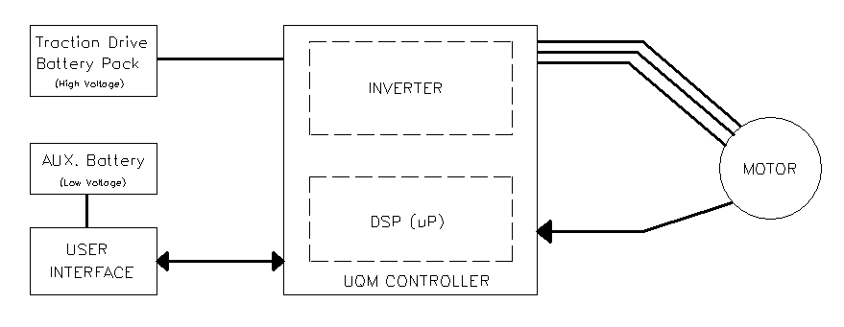

Figure 8.1-1: Block Diagram of Electric Vehicle Drive System

Torque and Power Profiles

The system has a software interface routine used to compute the desired command torque based on the accelerator and the brake signals. In this software routine, the accelerator and brake signals simply cancel each other.

Both accelerator and brake signals represent desired percentage torque with respect to the full torque profile shown in Figure 8.2-1. The accelerator signal is treated as positive command torque, and the brake is treated as negative command torque. The resultant command torque is the sum of these two signals as following:

Command torque = Accelerator + Brake

Where
Accelerator ≥ 0 %, and Brake ≤ 0 %.

Torque (Nm)
Motor Speed (RPM)
0
MaxTorque
0
MaxSpeed
Base Speed
Command
Constant torque
region
50 %
100 %
MaxPower
Constant power
region

Figure 8.2-1: The Torque Profile for 100% Input Command Level

Figure 8.2-1 shows the torque curve used to calculate the desired output torque based on the given input command percentage. The profile shows the command torque profile running at 100% and 50% command level. It displays the relationship between the command torque and the motor speed. The base speed determines the line between the constant torque region and the constant power region. Note: If the calculated percentage torque is less than 100 %, the profile is scaled down proportionally based on the percentage command input.

Please note that the figure does not imply that the torque is the determining factor for the motor speed because the system load is required to determine the motor speed. The figure, however, does suggest that the output torque may vary based on the motor speed during the constant power region. In the constant torque region, there is no direct correlation between the output torque and the motor speed. The output torque is determined only by the input command.

Limit Features

Limits
The system provides built-in limit features to minimize any hazardous condition. It regulates command torque signal when a system condition is close to its limit such as over motor current, over/under battery voltage and over motor speed.

All limit features are implemented in the microprocessor controller. The system is protected from over/under bus voltage, over motor/inverter temperatures, over bus current, over leg current, and over speed. All these system conditions are divided into three priority levels as shown in Table 8.3-1. First priority is the highest priority, and third priority is the lowest priority.

Table 8.3-1: List of Limit Conditions with Respect to Priority Levels
Priority Level | Limit condition
First priority | over bus voltage
Second priority | over motor speed  under bus voltage
Third priority | over motor temperature  over controller temperature  over bus current  over leg current

Whenever any of the listed system warnings occur, input desired torque would be confined within two torque boundary limits: high and low bounds. Depending on the level of priority, each system warning will affect the two bounds differently. Figure 8.3-1 shows how high and low bounds are being affected by each level.

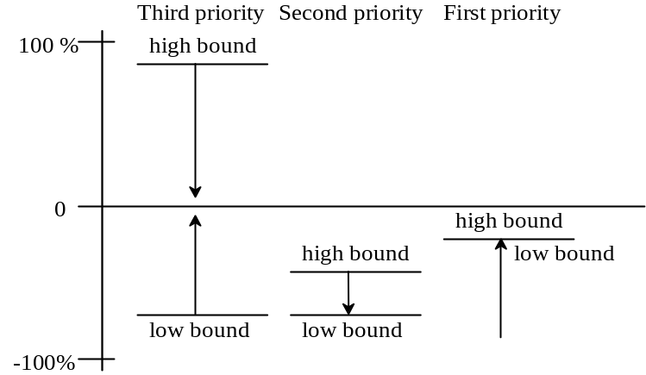

Figure 8.3-1: High and Low Bounds Change at Different Priority Levels

The third priority level brings both high_bound and low_bound toward zero percent. Only the largest delta drive (delta_drive) calculated from the third priority group is used to compute the high_bound and low_bound.

high_bound = 100 % - delta_drive
low_bound = -100 % + delta_drive

The second priority manipulates the high_bound and is used for over motor speed and under voltage protection. In under voltage, the high bound will be limited to 0%. In over motor speed, the high_bound can push the low_bound toward -100 % if full regeneration is necessary to prevent the motor from an over speed condition.

The first priority is dedicated to over bus voltage protection. It can override both boundaries set by other priority levels. It can force the low_bound to push the high_bound over the zero percent line and cause the system to switch from regenerating to motoring mode. Figure 8.3-1 shows a case where high_bound is set to negative torque by the over motor speed condition. If over bus voltage also occurs, the low_bound will force the high_bound toward positive torque to alleviate the over bus voltage condition.

Locked Rotor
This software routine will determine if a locked rotor condition exists. The purpose of this code is to protect the power devices in the inverter, and safely give the user as much current as possible.

Software Watchdog Timer
In addition to all limit protection discussed above, a software watchdog timer is also enabled. If the watchdog timer is not cleared periodically, the system will be reset automatically.

Under Voltage
If Bus voltage drops below the under voltage setting in the system configuration, the system will reset. The serial output, Windows HyperTerminal Screen will refresh when the system resets.

Appendix A: HiTor System Specifications

SR218 Motor
Dimensions
 | Length | 11.825 in | 301 mm
 | Diameter | 11.00 in | 280 mm
 | Weight (w/o cables) | 89 lb | 40 kg
Performance
 | Motoring power (peak) | 47 hp | 35 kW
 | Motoring torque (peak) | 308 lb·ft | 418 N·m
 | Regeneration power (peak) | N/A | N/A
 | Max. speed | 4800 rpm

DD40-400LWB Inverter/Controller
Dimensions
 | Length | 14.96 in | 380 mm
 | Width | 14.37 in | 365 mm
 | Height | 4.69 in | 119 mm
 | Weight | 35.0 lb | 15.9 kg
Operating Voltage
 | Nominal input range | 280 to 380 V dc
 | Full performance voltage input range | 280 to 380 V dc
 | Minimum voltage limit | 240 V (with derated power output)
 | Input current limitation | 225 A
Inverter Type
 | Control type | 3-phase brushless dc
 | Applicable max current | 600 A peak
 | Power device | IGBT module half bridge x 3
 | Switching frequency | 20 kHz
 | Standby power consumption (inverter and microprocessor) | 17 W
Liquid Cooling System
 | Minimum inlet coolant flow (Glycol or equivalent) |  | 7.5 l/min
 | Max inlet temp of controller | 160 ºF | 71 ºC
 | Inner diameter of hose | 5/8 in | 16 mm
 | Max inlet pressure | 13 psi
TMS2812 Microprocessor (Internally Packaged)
 | Nominal input voltage (User_xxVDC) | 12 Vdc
 | Input supply voltage range | 8 to 15 Vdc
 | Input supply current range | 0.3 to 0.5 Adc
Specifications subject to change without notice.

Appendix B : Inverter Dimensions
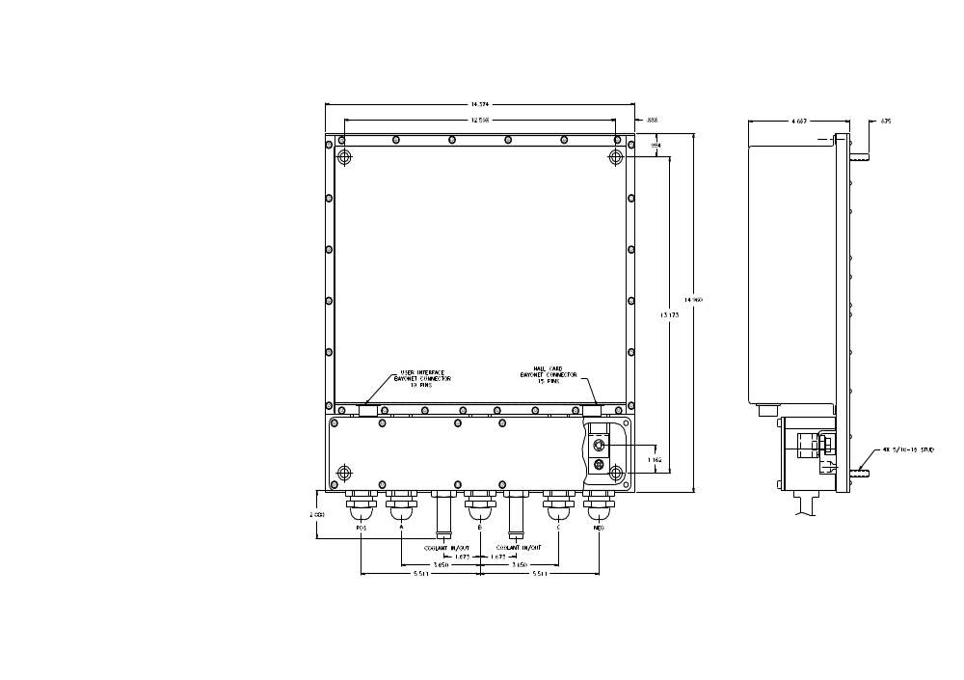

Appendix C: Motor Dimensions

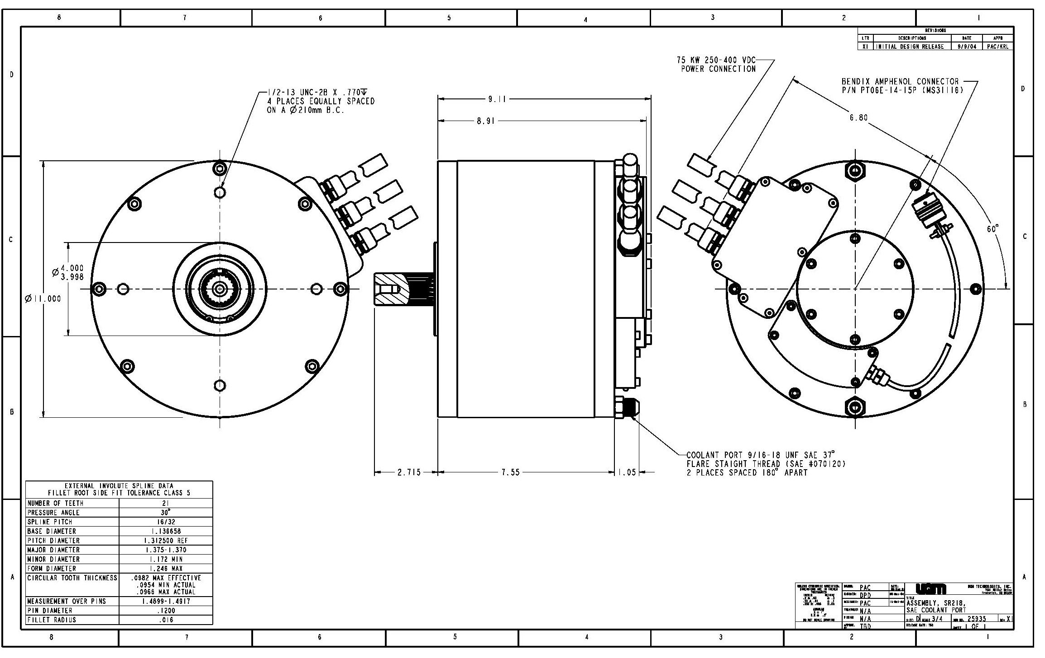

Appendix D Soft Start Guidelines

A soft start circuit (NOT INCLUDED) must be used to avoid high inrush currents to the inverters caused by charging the internal capacitance. This high current would decrease the life of the Y2 contactor and the internal inverter capacitors.

A resistor (R1) and a small contactor (Y1) are used to charge the internal inverter capacitors before the main contactor (Y2) is closed to avoid high inrush currents. The R1 resistor should be selected to charge the capacitors in 100 to 750 milliseconds. When selecting the charge resistor size the standby current of the inverter must be considered. The typical standby power is approximately 10 watts. We must also be concerned with the final value of voltage that is reached, with the standby power drain of the inverter. If the resistor is too high of a value the voltage drop across the resistor will be too large and the desired charge voltage will not be reached. The R1 resistor and Y1 contactor must also be sized to handle a full load, worst case shorted inverter until the F1 fuse opens. The F1 fuse size should be selected to open if more than 1 second of time is required to charge the internal inverter capacitors. Fuse F2 and contactor Y2 must be sized to handle the voltage and current of the inverter.
Main Start
DD40-400LWB
Inverter/Controller
F1
R1
Y1
Y2
F2
POS
BUS
POS
Soft Start
NEG
NEG
7290uF

The soft start circuit is operated by closing contactor Y1 when the vehicle key is turned on. A voltage sense circuit external to the DR40-400LWB controller (not shown) should be used to measure the rate of change of the voltage on the inverter Capacitors. When the voltage on the inverter is determined to be within 10% of the voltage of the DC power, then contactor Y2 should close and the system is ready to operate.

Recommended components for soft start circuit for DR40-400LWB.

Y1 contactor 20 A, 400 V DC Kilovac or Aromat
Y2 contactor 400 A , 400 V DC Kilovac or Aromat (need economizer card)
F1 Fuse 5 to 8 A, 400 V DC rated
F2 Fuse 400 A , 400 V DC rated
R1 Resistor 25 Ω , 200 W

Appendix E: User Interface Schematic Hand Control
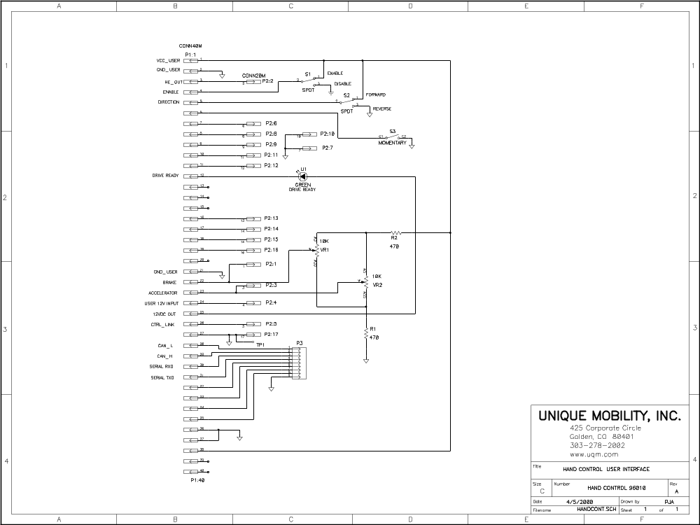

Appendix F: First stage I/O Circuits of User Interface
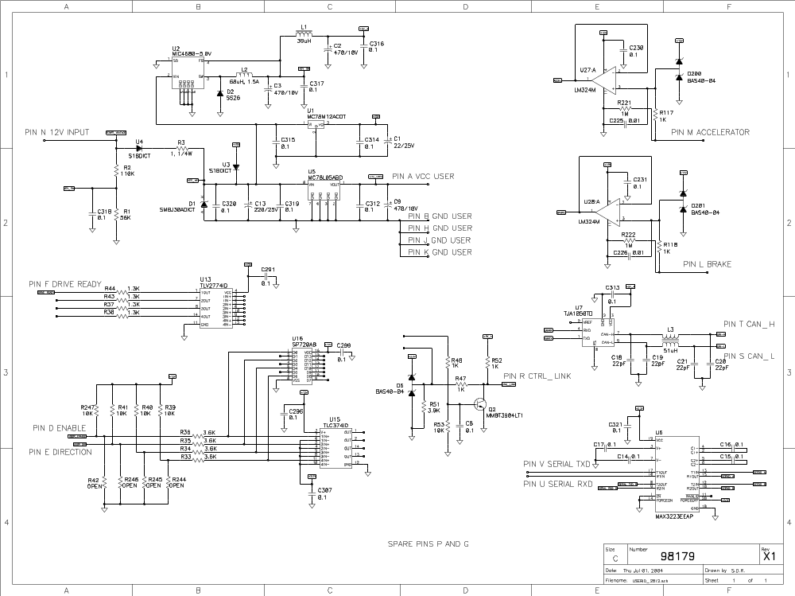

Appendix G: CAN
UQM TECHNOLOGIES INC.
PP120 CAN Document
Version 1.01 8/12/04

CAN COMMUNICATION SUMMARY

Overview:
This brief description should be used in conjunction with the UQM 380/SR218/SR286 Users Manual. The CAN protocols are based on the J1939 specification. Please refer to the SAE J1939 documents for more detailed information. Extended (XTD) 29 bit identifiers are used. The Protocol Data Unit (PDU format) for all the messages is 239 (0xEF), which is the proprietary messages. The priority scheme is that 0 is the highest priority and 7 is the lowest. The master controller is the users system controller and must have a CAN network address of 1 (0x01). The CAN network address on the UQM system is configurable to any address 2-255. Use a RS232 link to program each UQM controller to a different CAN Address (see users manual or type config <ret>, select general system configuration, enable the CAN, select a desired CAN address, save the configuration changes, power down system). Each piece of UQM hardware must have a unique CAN address, making each piece of UQM hardware a separate CAN node. Messages are transmitted at 250 kbits/sec. For a detailed message description, see the appendix located at the back of this document.

All the information in this document is preliminary and is subject to change.

1. UQM380/SR218/SR286 CAN COMMAND MESSAGES

One identifier is used for receiving control commands from the master controller. For example, ASSUME the CAN address has been specified to 10 (0x0A) and the system controller is 1 (0x01). After specifying the CAN address, the hardware calculates a corresponding XTD identifier using a convention of [RXNODE],[TXNODE] -> In this case the final 4 bytes in the XTD identifier are [0A01].

Identifier “ 0x18EFxxxx “

Therefore, in this example the complete command identifier is: “ 0x18EF0A01 “, where we ASSUMED the CAN address on the UQM system was set to 10 (0x0A).

The first 3 bits of the identifier indicate the priority of this message. The priority is binary 110 or priority 6.
The UQM380/SR218/SR286 hardware is capable of receiving three types of commands: Power Command (not available), Torque/Speed Command, Hand controller Commands.

1 a) Power drive Command
(not available)
1 b) Torque/Speed drive Command

Torque/Speed Command [0x20]
The priority of this message is 4.
Priority 4 Identifier “ 0x10EFxxxx “, torque/speed drive command.

This command issues a requested speed command (2 bytes) , a requested percent torque (1 byte) and an enable MDU command (1 bytes). The requested speed goes from –16064 rpm to 16064 rpm with the negative sign referring to the reverse direction. The requested percent torque allows the user to select the desired torque percentage from 0 to 100%. This can be used for a virtual clutch.
If the least significant bit of the Enable MDU command byte is set to zero, the system is considered as disabled and will not react to any speed/torque command. If this if the least significant bit of this byte is set to one, then the system is considered as enabled and ready to operate on speed/torque command.
The enable bit is coupled with the analog enable bit. You need both the CAN enable MDU bit and the analog enable bit to be ON in order to enable the system.
Reference section 2.3 for more information.

1 c) Torque controller drive command

Torque controller Command [0x26]
The priority of this message is 3.
Priority 3 Identifier “ 0x0CEFxxxx “, torque controller drive command.

This command issues a requested accelerator torque percentage (1 byte) and a requested brake torque percentage (1 bytes). Each of these percentages can go from 0 to 100.
The next byte is used to send an enable Motor Drive Unit (MDU) command. If the least significant bit is set to zero, the system is considered as disabled and will not react to any accelerator nor brake command. If this if the least significant bit of this byte is set to one, then the system is considered as enabled and ready to operate on accelerator or brake commands.
The Motor Direction Command byte controls the direction of the motor. If the least significant bit of this byte is set to 1, the motor will go in direction 1, if it is set to 0, the motor will go in direction –1. This bit is coupled with the direction bit in the config menu. In the config menu, the user is allowed to define whether 1 defines a clockwise rotation of the motor or not.
The enable bit is coupled with the analog enable bit. You need both the CAN enable MDU bit and the analog enable bit to be ON in order to enable the system.
Reference section 2.4 for more information
2. UQM380/SR218/SR286 CAN STATUS MESSAGES

Two identifiers are used to send status messages from the UQM controller. For example, assume the CAN address has been specified to 10 (0x0A). The system controller is assumed to be 1 (0x01). After specifying the CAN address, the hardware calculates a corresponding XTD identifier using a convention of [RXNODE],[TXNODE] -> In this case the final 4 bytes in the XTD identifier are [010A].

Priority 6 Identifier “ 0x18EFxxxx “, Drive Temperatures
Priority 4 Identifier “ 0x10EFxxxx “, Electric Drive State

Therefore, for the above example, the identifiers are “ 0x18EF010A “ and ““ 0x10EF010A “, respectively. Once communication has been established (i.e. a valid command has been received by the controller), the status commands will be sent repeatedly.

2 a) Priority 4 Messages
Electric Drive State [0x10]
This status contains actual speed (2 bytes), torque (1 byte), voltage (1 byte), current (1 byte), and system status (2 bytes). This command is sent every 100 ms. This data is used for monitoring purposes only, since the resolution isn’t high enough and the speed isn’t fast enough for control purposes.
Reference section 2.1 for more information.

2 b) Priority 6 Messages
Electric Drive Temperatures [0x11]

This message contains the temperatures for the inverter heat sink, rotor, and stator. This command is sent every 1 second.
Reference section 2.2 for more information.
General Guidelines

Messages are sent constantly from host.
Once a valid command is sent to the microprocessor, a valid command must be sent every 1 second or the system issues a watchdog error, which will make the CAN_comm blink on the HyperTerminal screen. The only way to get out of a CAN watchdog error is to reset the micro processor.
The valid commands are: torque/speed drive command, hand controller drive command. and CAN watchdog commands.

If 200 of the same type of low level CAN errors occur before the microprocessor receives a valid CAN command, this causes the microprocessor to disable the system. System error is set according to 1.3.2. Please refer to Intel’s 82527 reference manual for a more complete description of each of these errors.

If the error counter in the 82527 reaches the limit of 96, the system issues a “CAN WARNING STATUS” message. If the error counter in the 82527 reaches 256, then the 82527 takes itself offline and the system issues a “CAN BUS OFF STATUS” message. The only way to recover from the CAN BUS OFF is to reset the microprocessor. Please refer to Intel’s 82527 reference manual for a more complete description of each of these errors.

UQM Proprietary Vehicle Application Layer

Parameter Definitions

CONTROL PARAMETERS

Electric Motor Speed
Data Length: 2 bytes
Resolution: 0.50 rpm/bit gain, -16064 rpm offset
Data Range: -16064 rpm to +16064 rpm
Type: Measured or Command

Electric Motor Torque
Data Length: 1 byte
Resolution: 5 N·m/bit gain, -625 N·m offset
Data Range: -625 N·m to +625 N·m
Type: Measured

Electric Motor Percent Torque
Data Length: 1 byte
Resolution: 0.4%/bit gain, 0% offset
Data Range: 0% to 100%
Type: Command

Bus Voltage
Data Length: 1 byte
Resolution: 2 V/bit gain, 0 V offset
Data Range: 0 to +500 V
Type: Measured

Bus Current
Data Length: 1 byte
Resolution: 4 A/bit gain, -500 A offset
Data Range: -500 A to +500 A
Type: Measured

Accelerator percent torque
Data Length: 1 byte
Resolution: 0.4%/bit gain, no offset
Data Range: 0% to 100%
Type: Command

Brake percent torque
Data Length: 1 byte
Resolution: 0.4%/bit gain, no offset
Data Range: 0% to 100%
Type: Command

Enable MDU Command
Data Length: 1 byte
Type: Command
Bit: 8 Reserved
7 Reserved
6 Reserved
5 Reserved
4 Reserved
3 Reserved
2 Reserved
- Enable bit

Direction Command
Data Length: 1 byte
Type: Command
Bit: 8 Reserved
7 Reserved
6 Reserved
5 Reserved
4 Reserved
3 Reserved
2 Reserved
1 Direction bit

INFORMATIONAL PARAMETERS

Inverter Heat Sink Temperature
Data Length: 1 byte
Resolution: 1 ºC/bit gain, -40 ºC offset
Data Range: -40 ºC to +210 ºC
Type: Measured

Rotor Temperature
Data Length: 1 byte
Resolution: 1 ºC/bit gain, -40 ºC offset
Data Range: -40 ºC to +210 ºC
Type: Measured

Stator Temperature
Data Length: 1 byte
Resolution: 1 ºC/bit gain, -40 ºC offset
Data Range: -40 ºC to +210 ºC
Type: Measured

Informational Status Parameters

System Error
Data Length: 2 bytes
Type: Status
Reference: 2.1
Bit: 16 Inverter Fault
15 Open Rotor Temperature
14 Open Motor Temperature
13 Open Inverter Temperature
12 Over Voltage Alarm
11 Over Speed Alarm
10 Over Voltage Warning
9 Over Speed Warning
8 Inverter Over Temperature
7 Motor Over Temperature
6 Rotor Over Temperature
5 Under Voltage Warning
4 Direction Protection
3 Bus Over Current
2 Leg Over Current
1 Over Current Count

Parameter Group Definitions

DA = Destination Address

ELECTRIC DRIVE STATE – Used in Torque and Speed Control Configurations
Transmission repetition rate: 100 ms
Data length: 8 bytes
Data page: 0
PDU format: 239
PDU specific: DA
Default priority: 4
Byte: 1 Command 0x10
2,3 Actual Speed 1.1.1
4 Torque 1.1.2
5 Voltage 1.1.4
6 Current 1.1.5
7,8 System Error 1.3.1

ELECTRIC DRIVE STATE – Used in Torque Control Configuration when DRIVE is not ready
Transmission repetition rate: 100 ms
Data length: 8 bytes
Data page: 0
PDU format: 239
PDU specific: DA
Default priority: 4
Byte: 1 Command 0x80 Drive not ready
2,3 Actual Speed 1.1.1
4 Torque 1.1.2
5 Voltage 1.1.4
6 Current 1.1.5
7,8 System Error 1.3.1

ELECTRIC DRIVE STATE – Used in Torque Control Configuration when DRIVE is ready
Transmission repetition rate: 100 ms
Data length: 8 bytes
Data page: 0
PDU format: 239
PDU specific: DA
Default priority: 4
Byte: 1 Command 0x81 Drive ready
2,3 Actual Speed 1.1.1
4 Torque 1.1.2
5 Voltage 1.1.4
6 Current 1.1.5
7,8 System Error 1.3.1

ELECTRIC DRIVE TEMPERATURE
Transmission repetition rate: 1 s
Data length: 8 bytes
Data page: 0
PDU format: 239
PDU specific: DA
Default priority: 6
Byte: 1 Command 0x11
- Inverter Heat Sink Temperature 1.2.1
- Rotor Temperature 1.2.2
- Stator Temperature 1.2.3
  - Reserved

ELECTRIC DRIVE COMMAND – Used for Speed Control Configuration
Data length: 8 bytes
Data page: 0
PDU format: 239
PDU specific: DA
Default priority: 4
Byte: 1 Command 0x20
2,3 Requested Speed 1.1.1
- Requested Percent Torque 1.1.3
- Enable MDU command 1.1.8
6-8 Reserved

  - HAND CONTROLLER DRIVE COMMAND – Used for Torque Controller Control Configuration
Data length: 8 bytes
Data page: 0
PDU format: 239
PDU specific: DA
Default priority: 3
Byte: 1 Command 0x26
2 Accelerator Requested Percent Torque 1.1.6
3 Brake Requested Percent Torque 1.1.7
4 Enable MDU Command 1.1.8
5 Motor Direction Command 1.1.9
6-8 Reserved

