# CMSC 345

### Software Design and Development

# Fall 2013

# **User Interface Design Document**

**Code to Joy:**

Matthew Barteau

Benjamin Walsh

Sean Hutchinson

Amanda Hartman

Xuanzhu Zhu

John Pham

**Customer:**

Vishnugopal Rajamanickam

#### 

#### **Table of Contents**

Page

## 1. Introduction 3

1.1 Purpose of This Document

1.2 References

2. User Interface Standards 3

3. User Interface Walkthrough 4

4. Data Validation 11

Appendix A **–** Team percent contribution, Team sign-off, Customer acceptance 12

## 

## 

## 

## 

## 

## 

## 1. Introduction

1.1 Purpose of This Document

The purpose of this document is to convey what the user interface will look like. It will describe the order of the screens and the different paths possible for the user to see. It explains the layout that we will use when developing MappingMaestro.

1.2 References

* System Requirements Specification

**2. User Interface Standards**

Titles will be displayed at the top and centered. They will be the largest font on the screen, so that they are easily identifiable. Fonts will be chosen so that they are easy to read by the user.

The information that must be entered by the user will be displayed in a way that it must be entered as it is read, from left to right and top to bottom. Any buttons to press to submit information will be on the right-hand side of the screen.

Error messages will generally be displayed under the component that it references. Most of the error messages are going to be found at the very bottom panel of the screen.

Colors will be chosen to be contrasting, so that anyone can read this application, including people who may be colorblind. Since it is a mapping application, we will choose colors in blues and greens.

**3. User Interface Walkthrough**

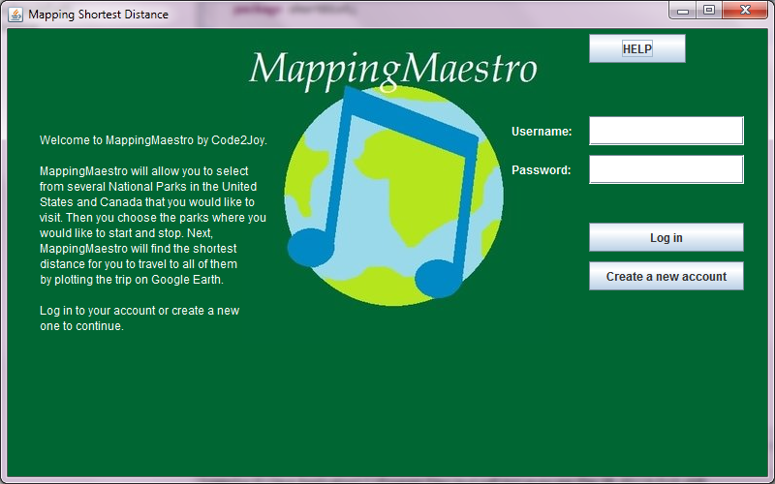

Figure 1

The user is greeted with the screenshot in Figure 1. This is the login screen where the user will enter his username and password if he has account. If the username and password are correct, the user will then be presented with Figure 3 if he is an administrator or Figure 8 if he is not. If the username and password are incorrect, the user will be shown a warning message in red. If the user does not have an account, he can push the “Create a New Account” button, where they will then see Figure 2.

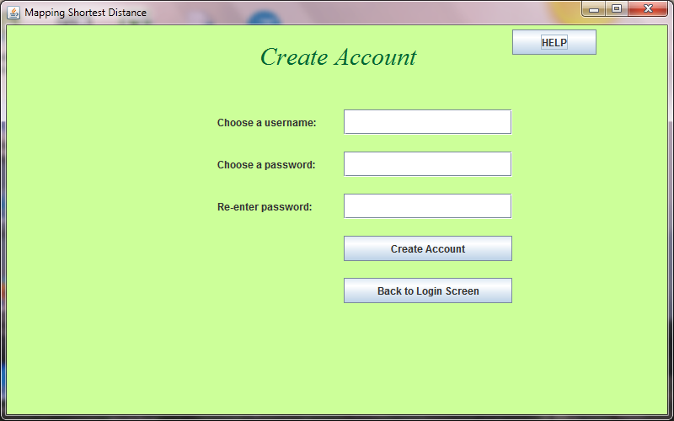

Figure 2.

The user creates a new account on this screen. He enters the necessary information, then presses “Create Account”. If the username has not been used before and the passwords match, the user is presented with Figure 8. If any information entered is not allowed, the user is shown a red warning message until he enters an account that is accepted.

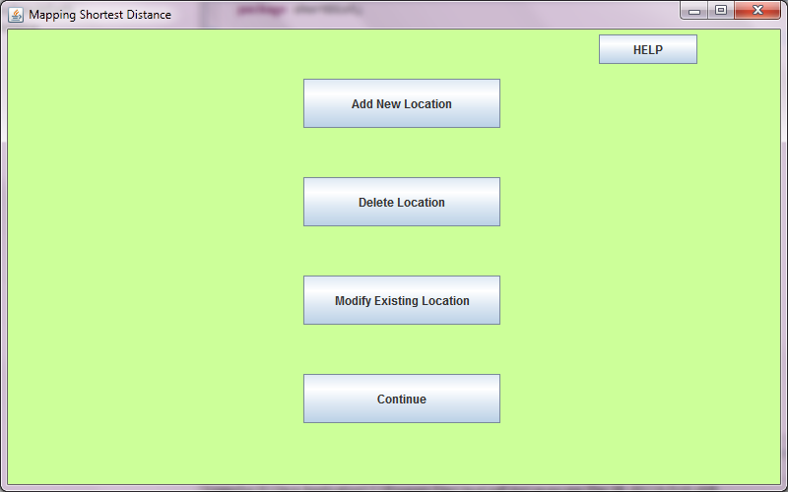

Figure 3

If the user is an administrator, he is shown Figure 3. He can modify the locations used in the application by clicking on the buttons. If he chooses to add a new location, he will be shown Figure 4. To delete a location, Figure 5 appears. If he wishes to modify one of the existing locations, the application will divert to Figure 6. If he does not want to make any changes, he can click “Continue” to go to Figure 8.

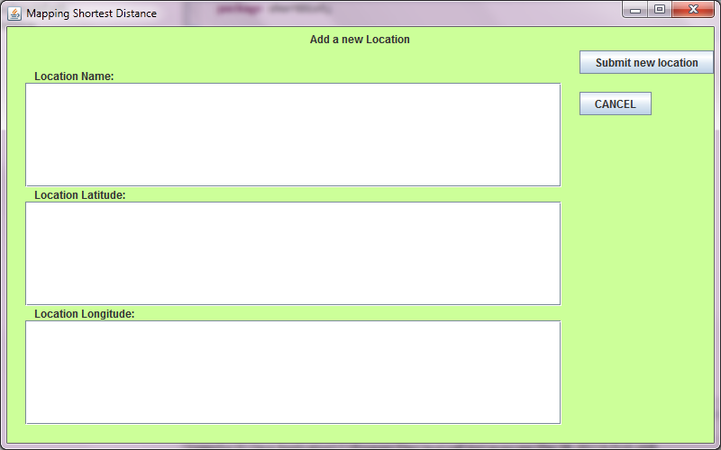

Figure 4

In Figure 4, the administrator can add a new location to be mapped. He must enter valid information in each field, or he will see an error message at the bottom of the screen. If all information is accepted, the user is redirected to Figure 3.

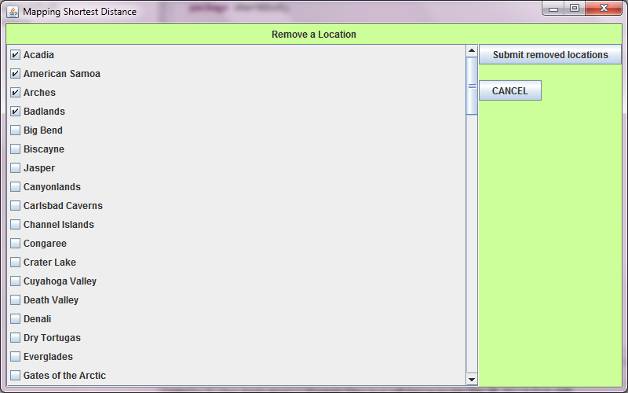

Figure 5

At Figure 5, the user can click as many checkboxes as he would like, which correspond to the locations he would like to remove. Whether or not any checkboxes have been selected, the user is shown Figure 3 when he clicks “Submit removed locations”. If he does not select any locations, none are removed. Clicking “CANCEL” in Figure 4, 5, or 6 results in no change to locations and redirection to Figure 3.

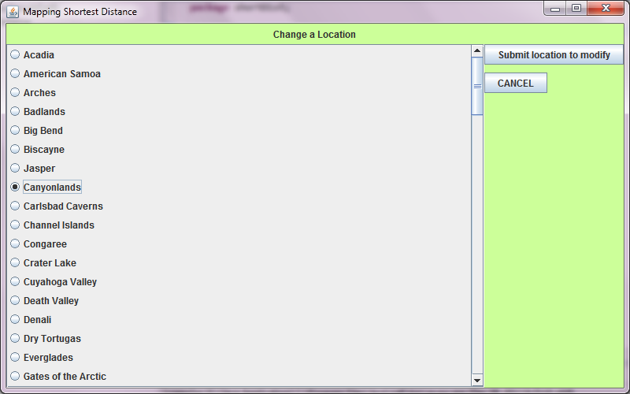

Figure 6

At Figure 6, the user can change a location. Here he must choose which one he would like to modify or he will see an error message at the bottom of the screen when he clicks “Submit location to modify”. If he changes his mind, he may click “CANCEL” to return to Figure 3. Otherwise, he will see Figure 7.

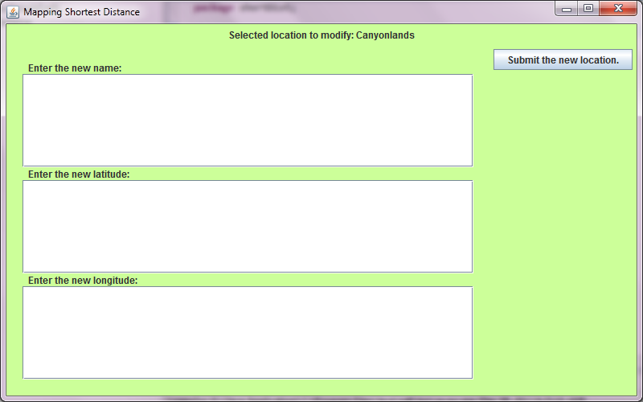

Figure 7

At Figure 7, the user must enter the new information for the location he chose in Figure 6. Note that here there is no way to cancel the editing, so if the user does not wish to modify the selected location, he must re-enter the current information in each field, then click “Submit the new location” to reveal Figure 3.

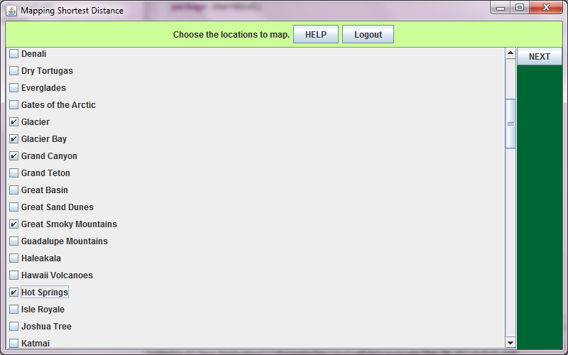

Figure 8

In Figure 8, the user will be given a list of options to choose for locations he would like to visit. He must choose at least two locations before pushing the “next” button. Otherwise, he will be shown an error message until he clicks two or more checkboxes. If the user chooses to end the session or change to a different account, he may push “logout” to go back to figure 1.

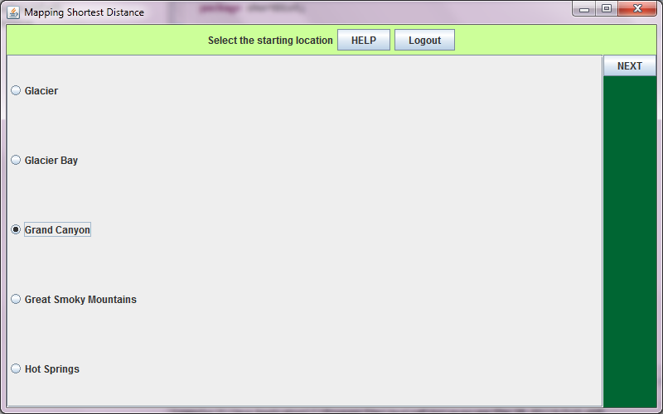

Figure 9

In Figure 9, the user chooses the starting location for the route the application will map. If he does not choose any location, and clicks “NEXT”, he is shown an error message at the bottom of the screen until he does. He is then shown Figure 10.

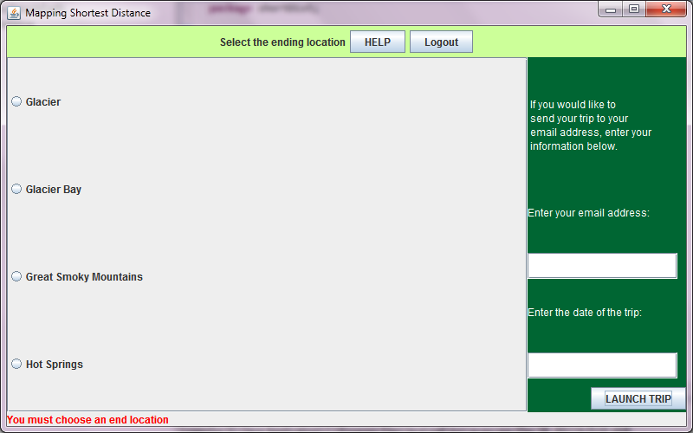

Figure 10

The user chooses the ending location of his chosen route in Figure 10. Figure 10 has an example of the error messages shown at the bottom of the screen when the user does something that is not allowed. Also on the right-hand panel in Figure 10 is where the user can enter his information to send an email to himself to remind himself of the trip planned. If he does not enter anything in that panel, or enters an incorrect email address, no email will be sent. When “LAUNCH TRIP” is clicked and all information on the screen is accepted, the application opens Google Earth and the route is plotted in Figure 11.

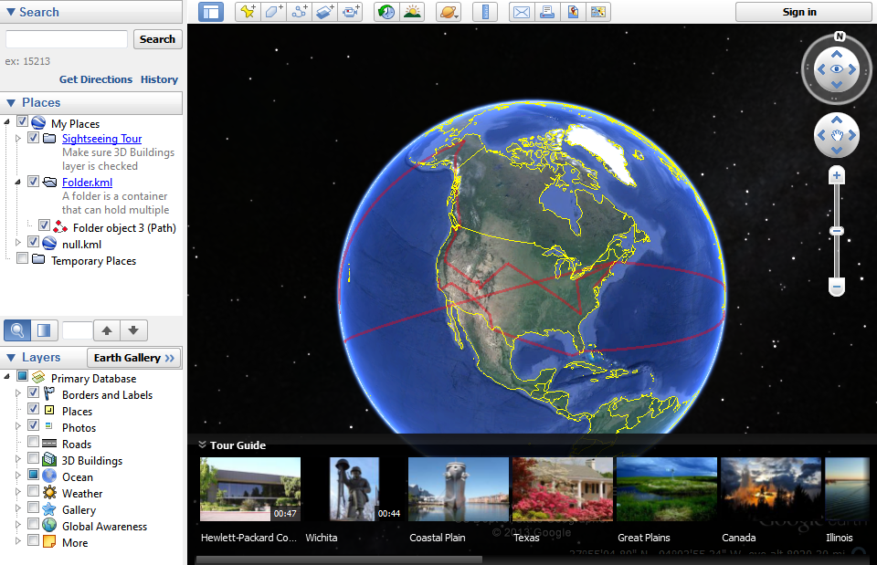

Figure 11

In Google Earth in Figure 11, the user sees the shortest distance route with all the locations he selected. The path is marked in red. Also the left-hand panel shows each location point, which can be clicked on to zoom to that location. When the user exits from Figure 11, he is logged out and sent back to Figure 1.

**4. Data Validation**

* Figure 1
  + Username
    - Format: string
    - Must be a username from an existing account
  + Password
    - Format: string
    - Must be the correct password for the username
* Figure 2
  + Username
    - Format: string
    - May not be the same username as an existing account
  + Password1
    - Format: string
  + Password2
    - Format: string
    - Password1 and Password2 must match
* Figure 4
  + Location Name
    - Format: string
  + Latitude
    - Format: double
    - Must be between -90 and 90
  + Longitude
    - Format: double
    - Must be between -180 and 180
* Figure 7
  + Location Name
    - Format: string
  + Latitude
    - Format: double
    - Must be between -90 and 90
  + Longitude
    - Format: double
    - Must be between -180 and 180
* Figure 10
  + Email Address
    - Format: string
  + Date
    - Format: string

**Appendix A –** Team percent contribution, Team sign-off, Customer acceptance

**Sign off Agreement Between Customer and Contractor:**

The customer and the contractors agree to the development of standalone desktop application which will find the shortest distance between given locations. It will have a feature for future trips as per Vishnugopal Rajamanickam. If any future changes are made to the User Interface Design document or if any additional features are proposed, we will notify the developers and their customer via e-mail or in person of the conducted changes and proposals.

Amanda Hartman ________________________ _____________

Comments: ______________________________________________

Sean Hutchinson ________________________ _____________

Comments: ______________________________________________

Matthew Barteau ________________________ _____________

Comments: ______________________________________________

Xuanzhu Zhu ________________________ _____________

Comments: ______________________________________________

John Pham _________________________ _____________

Comments: ______________________________________________

Benjamin Walsh _________________________ _____________

Comments: ______________________________________________

Customer:

Vishnugopal Rajamanickam __________________________ ______________

Comments: ______________________________________________

**Team Review Signoff**

I agree that I have read the above document and reviewed its content. If I do not agree with anything pertaining to the content or format of the document, I will write it in the comments section below.

**Members of the Team: Signatures: Date:**

Amanda Hartman ________________________ _____________

Comments: ______________________________________________

Sean Hutchinson ________________________ _____________

Comments: ______________________________________________

Matthew Barteau ________________________ _____________

Comments: ______________________________________________

Xuanzhu Zhu ________________________ _____________

Comments: ______________________________________________

John Pham _________________________ _____________

Comments: ______________________________________________

Benjamin Walsh _________________________ _____________

Comments: ______________________________________________