CMSC 345

Software Design and Development

Fall 2013

User Interface Design Document

Code to Joy:
Matthew Barteau
Benjamin Walsh
Sean Hutchinson
Amanda Hartman
Xuanzhu Zhu
John Pham

Customer:
Vishnugopal Rajamanickam

Shortest Distance
Code to Joy
User Interface Design Document

Table of Contents

Page

1. Introduction 3

  - Purpose of This Document
  - References

2. User Interface Standards 3

3. User Interface Walkthrough 3-4

4. Data Validation 4

Appendix A – Team percent contribution, Team sign-off, Customer acceptance 5-7

1. Introduction

1.1 Purpose of This Document

The purpose of this document is to convey what the user interface will look like. It will describe the order of the screens and the different paths possible for the user to see.

  - References

- System Requirements Specification

- User Interface Standards

Any information required by the user will generally be positioned on the left-hand side of the screen. Titles will be displayed at the top and centered. Any extra buttons to press will be on the right-hand side of the screen. Fonts will be easily read, and colors will be contrasting.

- User Interface Walkthrough


Figure 1

The user is greeted with the screenshot in figure 1. This is the login screen where the user will enter his username and password or press the New User button. If the username and password are correct, the user will then be presented with figure 2.

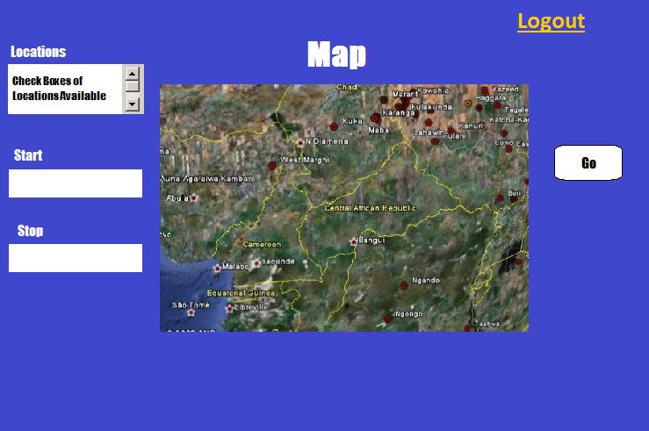
Figure 2

In figure 2, the user will be given a list of options to choose for locations he would like to visit. Of the locations the user chose in the first box, he has to then choose the start and stop locations. Once that is accomplished, the user may press “Go”. If any of the aforementioned are incomplete, the user will see an error message, which is not shown here. Otherwise, the user’s route will be calculated and displayed on the map. If the user chooses to end the session or change to a different account, he may push “logout” to go back to figure 1.

- Data Validation

Figure 1 – Username
Format: string, maximum of 50 characters

Figure 1 – Password
Format: string, maximum of 50 characters

Appendix A – Team percent contribution, Team sign-off, Customer acceptance

Sign off Agreement Between Customer and Contractor:
The customer and the contractors agree to the development of standalone desktop application which shall find the shortest distance between given locations. It shall have a feature for future trips as per Vishnugopal Rajamanickam. If any future changes are made to the User Interface Design document or if any additional features are proposed, we shall notify the developers and their customer via e-mail or in person of the conducted changes and proposals.

Amanda Hartman ________________________ _____________

Comments: ______________________________________________

Sean Hutchinson ________________________ _____________

Comments: ______________________________________________

Matthew Barteau ________________________ _____________

Comments: ______________________________________________

Xuanzhu Zhu ________________________ _____________

Comments: ______________________________________________

John Pham _________________________ _____________

Comments: ______________________________________________

Benjamin Walsh _________________________ _____________

Comments: ______________________________________________

Customer:

Vishnugopal Rajamanickam __________________________ ______________

Comments: ______________________________________________

Team Review Signoff
I agree that I have read the above document and reviewed its content. If I do not agree with anything pertaining to the content or format of the document, I shall write it in the comments section below.

Members of the Team: Signatures: Date:
Amanda Hartman ________________________ _____________

Comments: ______________________________________________

Sean Hutchinson ________________________ _____________

Comments: ______________________________________________

Matthew Barteau ________________________ _____________

Comments: ______________________________________________

Xuanzhu Zhu ________________________ _____________

Comments: ______________________________________________

John Pham _________________________ _____________

Comments: ______________________________________________

Benjamin Walsh _________________________ _____________

Comments: ______________________________________________

