EQUITY RESEARCH | INITIATING COVERAGE
Consumer Staples, Beverages (Spirits) • India
UNITED SPIRITS LIMITED
a Diageo plc Group company
RECOMMENDATION  HOLD / NEUTRAL | TARGET PRICE  ₹1,348 | UPSIDE  +1.7%

Tickers | NSE: UNITDSPR • BSE: 532432
Current Market Price (CMP) | ₹1,326
12-Month Target Price | ₹1,348
52-Week Range | ₹1,210 - ₹1,489
Market Capitalisation | ₹96,453 crore (~US$11.3 bn)
Enterprise Value | ₹93,726 crore
Shares Outstanding | 72.74 crore (Face value ₹2)
Free Float | ~44% (Diageo holds ~56%)
Valuation Basis | 60% EV/EBITDA, 20% P/E, 5% EV/EBIT, 15% DCF
Investment Horizon | 12 months

Analyst: Senior Equity Research Analyst, CFA
Date of Publication: 25 June 2026
Disclaimer: Prepared for academic / capstone and illustrative research purposes per CFA Institute research-reporting standards. This is NOT investment advice and NOT a solicitation to buy or sell any security. Financial forecasts and valuation outputs are sourced from the uploaded model (United Spirits Excell.xlsx) and the United Spirits FY2025 Integrated Annual Report; market/industry/macro context is from public-domain references cited inline. Third-party content has been paraphrased for compliance with licensing restrictions.

1. Investment Summary
We initiate coverage on United Spirits Limited (USL) with a HOLD / NEUTRAL rating and a 12-month target price of ₹1,348, implying ~1.7% upside to the current market price of ₹1,326. USL is, in our view, the highest-quality large-cap proxy for India's structural spirits-premiumisation theme, but after a multi-year re-rating, the current valuation already discounts the bulk of that optimism. The risk-reward is balanced; we would accumulate on weakness below ~₹1,150 and trim above ~₹1,500.
Investment Thesis (Key Points)
- Premiumisation is the durable growth engine. Prestige & Above (P&A) brands now contribute ~89-90% of net sales value (NSV), up from ~70% five years ago. With Indian premium/luxury spirits growing at low-double-digit rates vs mid-single-digit mainstream, USL can sustain ~9-10% NSV growth even with only mid-single-digit volume growth.
- Unrivalled brand portfolio and Diageo backing. A full-ladder portfolio, McDowell's No.1, Royal Challenge, Signature, Antiquity through Black Dog, Black & White, Godawan, Johnnie Walker, Singleton, Tanqueray, Don Julio, Smirnoff, backed by parent Diageo plc (~56%).
- Structural margin expansion. EBITDA margin rose from ~13% (FY23) to ~18% (FY26) and is modelled to reach ~20% by FY30E on mix, operating leverage and productivity.
- Fortress balance sheet and high returns. Net cash (net debt/EBITDA ~ -1.2x), ROCE/ROE ~20-23%, asset-light model, ~70% dividend payout.
- Crystallised optionality, the RCB monetisation. March 2026: USL completed the ₹16,660 crore all-cash sale of the Royal Challengers Bengaluru franchise to an Aditya Birla-led consortium, value not captured in our model-derived target and a source of potential capital return / re-rating.
Why HOLD rather than BUY
Our blended fair value of ₹1,348 sits essentially level with the market price. The DCF value of ₹642 is well below the market price; the valuation is sustained almost entirely by rich relative multiples (~37-39x forward EV/EBITDA, ~52x trailing P/E). This is justified by quality and growth but leaves a thin margin of safety, the business case and the valuation case diverge.
Valuation Summary (per uploaded model)
Methodology | Implied Value/Share (₹) | Weight | Contribution (₹)
EV/EBITDA (FY27E, peer median) | 1,411 | 60% | 846
P/E (FY27E, peer median) | 1,675 | 20% | 335
EV/EBIT (FY27E, peer median) | 1,408 | 5% | 70
DCF (FCFF, 2-stage) | 642 | 15% | 96
Blended Target Price |  | 100% | 1,348

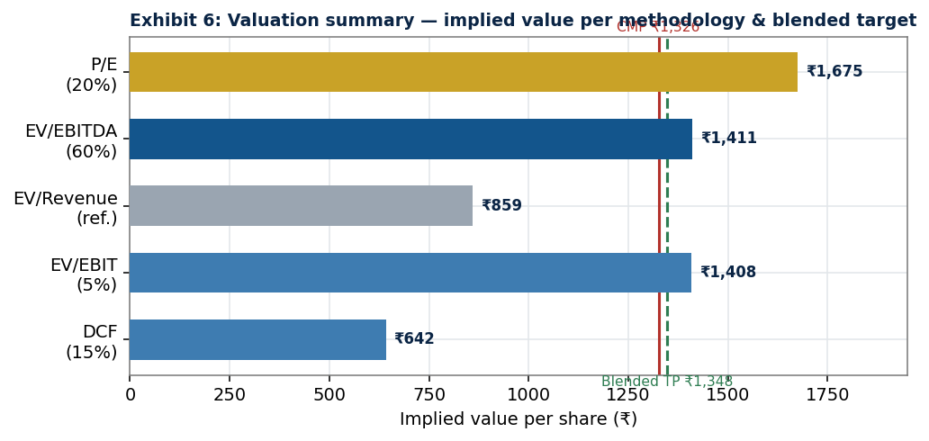
Exhibit 6: Valuation summary, implied value per methodology & blended target.
Key Risks
Adverse state excise/tax actions; pricing-approval lags vs input inflation; intensifying premium competition (Pernod Ricard, Radico Khaitan, a recapitalised Tilaknagar Industries, Allied Blenders); customer/geographic concentration (a single state corporation ~30% of revenue); ENA/grain, glass and scotch-concentrate cost volatility; valuation de-rating risk; and ESG/health-policy headwinds.

2. Company Overview
2.1 History and Ownership
United Spirits Limited is India's largest beverage-alcohol (alcobev) company and the local operating company of Diageo plc, the world's leading premium-spirits group. USL traces its lineage to the McDowell & Co. and UB spirits businesses consolidated under the erstwhile UB Group; Diageo acquired control in 2013 (a landmark ~US$1.9 bn transaction, then India's largest in the sector) and currently holds ~56% of equity, with the balance ~44% free float. The company is listed on the NSE (UNITDSPR) and BSE (532432), with 72.74 crore shares (₹2 face value).
2.2 Business Segments
- Beverage Alcohol (~96%+ of net sales): the core IMFL franchise, whisky, brandy, rum, vodka and gin across the full price ladder.
- Sports (discontinued): the RCB IPL/WPL franchise via RCSPL, classified held-for-sale and fully divested in March 2026 (see §2.7).
Within beverage alcohol: Prestige & Above (P&A), the growth/margin driver, was ~89% of NSV in FY25; Popular is mass-market and deliberately de-emphasised (a tranche was franchised/slump-sold in FY2023).
2.3 Product Portfolio, Key Brands
Tier | Representative Brands
Lower / Mid Prestige | McDowell's No.1 (whisky/brandy/rum), Royal Challenge
Upper Prestige | Signature, Antiquity, Royal Challenge American Pride
Premium Scotch | Black & White (fastest-growing primary Scotch globally; India largest market), Black Dog
Luxury / Imported (Diageo) | Johnnie Walker, The Singleton, Don Julio (tequila), Tanqueray (gin), Cîroc, Ketel One, Captain Morgan, Baileys
Indian Craft / Luxury Malt | Godawan (India's most-awarded artisanal single malt, 85+ accolades)
White Spirits / New-to-World | Smirnoff (incl. flavours), McDowell's X Series (gin/vodka/rum)
Craft (via Ventures) | Greater Than & Hāpusa gin (NAO Spirits)

2.4 Manufacturing Footprint
Asset-light and geographically dispersed: owned distilleries/bottling units plus tie-up/contract manufacturing and franchisee bottlers across ~40+ facilities. Because alcohol is a State subject with inter-state movement restrictions, production is largely in-state. Asset turnover (~7x) and capex (~1-2% of NSV) reflect this capital-light structure; an ongoing supply-agility programme drives structural cost savings.
2.5 Distribution Network
USL reaches 70,000+ retail outlets. India's route-to-market is state-controlled: in many states USL sells to government beverage corporations (e.g., TASMAC), creating customer concentration, a single state customer is ~30% of revenue, a structural risk typical of the industry.
2.6 The Diageo Relationship
As Diageo's India arm, USL gains access to the global luxury portfolio, R&D/marketing and responsible-drinking frameworks, conservative treasury/governance, and a global premiumisation playbook. India is a structural bright spot within Diageo's portfolio at a time the parent has cut global guidance (see §5 and §12).
2.7 Recent Strategic Developments
- RCB divestiture (completed March 2026): USL sold 100% of RCSPL for ₹16,660 crore (~US$1.7-1.9 bn) all-cash to a consortium led by the Aditya Birla Group (with The Times of India Group, Bolt Ventures, Blackstone/BXPE). The franchise was ~17% of market cap; brokerages widely viewed the exit as value-unlocking.
- NAO Spirits acquisition / Ventures: Through Diageo India Ventures, USL invested in craft start-ups, NAO Spirits (Greater Than, Hāpusa gin), Pistola, Sober, Quaffine (FY25: ₹18 cr secured loan to NAO plus equity). Rationale: low-cost early exposure to fast-growing craft/new-to-world categories, strengthening the premiumisation funnel toward younger consumers.

3. Industry Analysis
3.1 Market Structure and Size
India is the world's third-largest alcobev market by volume and the largest whisky market. Total IMFL volumes are ~410 million cases (2024, IWSR) and the broader alcohol market roughly US$50-70 billion, growing ~6% CAGR. The IMFL spirits market is an oligopoly: USL (Diageo) and Pernod Ricard India lead, followed by Allied Blenders, Radico Khaitan, Tilaknagar Industries and Globus Spirits, plus regional players.
3.2 Porter's Five Forces
Force | Intensity | Assessment
Threat of New Entrants | Low | High barriers: 30+ state excise regimes, capital/working-capital intensity (maturation), advertising bans, entrenched distribution.
Supplier Power | Moderate | ENA/grain, scotch concentrate, glass and packaging can spike (glass/ENA hit FY23). Scale + Diageo sourcing offset.
Buyer Power | High | State corporations control pricing/RTM and cap MRP; ~30% revenue concentration in one customer amplifies this.
Threat of Substitutes | Moderate | Beer, wine, country liquor, low/no-alcohol; premiumisation shifts consumers toward branded premium spirits.
Competitive Rivalry | High & rising | Pernod, Radico, ABDL and a recapitalised Tilaknagar (Imperial Blue). USL competes on value share and brand equity.

Net assessment: high entry barriers and structural premiumisation are attractive, but buyer power (state control) and rising rivalry cap pricing freedom and returns, supporting premium-but-not-unlimited multiples.
3.3 Premiumisation, The Structural Growth Driver
P&A IMFL and premium beer are growing at low-double-digit rates vs mid-single-digit mainstream (JM Financial, Sep-2025). Luxury spirits are only ~3% of cases sold but >20% of industry profits (IWSR). Financial implication for USL: with a ~89-90% P&A mix, each point of mix enrichment and price/mix gain flows disproportionately to gross and EBITDA margins, the mechanism behind our modelled ~46%→48% gross and ~18%→20% EBITDA margin path. Value growth, not volume growth, is the engine.
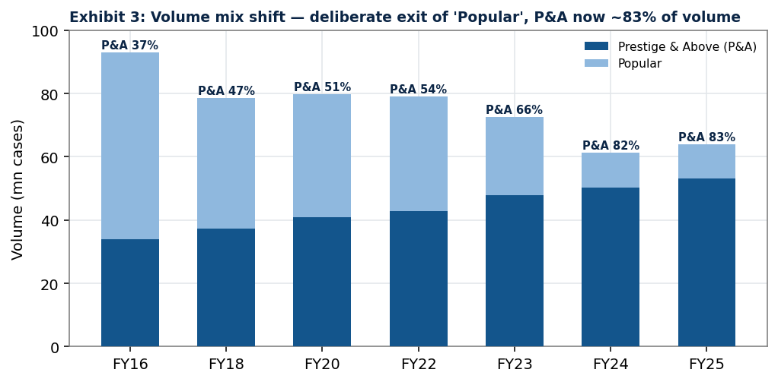
Exhibit 3: Volume mix shift, deliberate exit of 'Popular'; P&A now the overwhelming majority of volume and value.
3.4 State Regulation, Taxation and Distribution Barriers
Alcohol sits outside GST and is a State subject: each state controls licensing, pricing approvals, label registration, RTM and excise duty (a pass-through). Hence the topline is best tracked on Net Sales Value (NSV = revenue net of excise). Key 2025-26 developments:
- Karnataka Alcohol-in-Beverage (AIB) excise (effective 11 May 2026): first Indian state to adopt alcohol-content-based duty within rationalised slabs, deregulating price-fixation so producers set prices by market/alcohol content; targets ~₹45,000 cr excise revenue, transitioning over 3-4 years. As Karnataka is ~17% of national whisky volumes, greater pricing freedom is a structural positive for premium players, though the transition adds near-term uncertainty.
- Prohibition / RTM risk: dry states (Gujarat, Bihar) and periodic RTM reversals (Delhi, Andhra Pradesh) remain the principal regulatory tail risks.

4. Economic and Macro Analysis
Macro Indicator | Reading | Source
India real GDP growth FY26 | +7.7% (Q4 +7.8%); nominal +8.9% | MoSPI / Economic Survey
FY27 GDP projection | 6.8-7.2% (Economic Survey); RBI ~7.4% | PRS / RBI
Status | Fastest-growing major economy (4th yr) | Economic Survey 2025-26
Demographics | Large young legal-drinking-age base; rising urbanisation | n/a

Transmission to spirits demand. India's combination of ~9% nominal GDP growth, an expanding middle class, rising disposable incomes, rapid urbanisation, and a young aspirational legal-drinking-age cohort creates a powerful structural tailwind for value-led alcobev consumption. Per-capita consumption is low by global standards, leaving a long runway. Growth is increasingly 'drinking better, not more', favouring USL's premium mix. The main macro risk is a discretionary-spending slowdown (high food inflation or weak urban sentiment) prompting down-trading that disproportionately affects the upper-premium tier.
5. Competitive Positioning
USL is the #1 spirits company in India by volume and a value leader. Below we benchmark USL against listed peers on the metrics in the uploaded model (FY26 actuals; United Breweries as a beer reference). Tilaknagar Industries is discussed qualitatively (not in the model's comparable set).
5.1 Peer Comparison (FY2026)
Company | NSV (₹cr) | EBITDA (₹cr) | EBITDA % | Mkt Cap (₹cr) | EV (₹cr) | EV/EBITDA | P/E
United Spirits | 12,467 | 2,279 | 18.3% | 96,453 | 93,726 | 41.1 | 52.5
Radico Khaitan | 6,050 | 1,038 | 17.1% | 50,274 | 50,883 | 49.0 | 81.5
United Breweries (beer ref.) | 9,240 | 824 | 8.9% | 35,605 | 36,350 | 44.1 | 86.2
Allied Blenders & Distillers | 3,923 | 542 | 13.8% | 17,640 | 18,635 | 34.4 | 77.0
Peer median | n/a | n/a | n/a | n/a | n/a | 44.1 | 81.5

ROE/ROCE: USL ~20-23% (model), the highest-quality return profile in the peer set on a scale-adjusted basis.
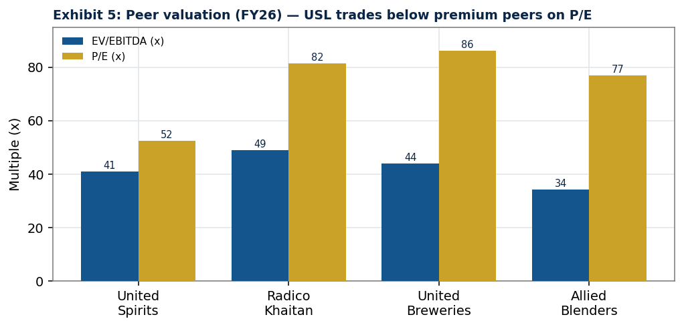
Exhibit 5: Peer valuation (FY26), USL trades below premium peers on P/E.
5.2 Competitor Assessment
- Radico Khaitan, fastest-premiumising challenger; strong FY26 (Q3 EBITDA margin ~17%, gross ~47%; luxury value growth ~50% YoY) on Rampur, Jaisalmer, After Dark. Trades at a premium (~49x EV/EBITDA).
- Allied Blenders (ABDL), record FY26 (revenue +11.5%, EBITDA +28.5% to ₹568 cr, margin +163 bps to 14.4%; adj. PAT +36%), pushing premiumisation (ICONiC). Lower-margin but improving fast.
- Tilaknagar Industries, brandy leader (Mansion House) that acquired Pernod's Imperial Blue whisky for ~₹4,150 cr EV (completed Dec-2025), India's largest alcobev deal since Diageo-USL (2013), intensifying mid-premium whisky competition.
- United Breweries (reference), India's beer leader (Heineken-controlled); a substitute/wallet competitor rather than a direct spirits peer.
- Diageo plc (parent), supplies USL's premium/luxury portfolio and global capabilities; its global softness contrasts with India's strength.
Positioning verdict: USL has the broadest portfolio, deepest distribution, strongest returns (ROCE ~22%) and most defensive (net-cash) balance sheet, but cedes some top-line growth optics to Radico and faces a re-energised Tilaknagar. Its value-share-over-volume-share strategy is the right one for a premiumising market.

6. Financial Analysis (Historical, FY2017-FY2026)
All figures consolidated, NSV (net-of-excise) basis, ₹ crore. Source: United Spirits Excell.xlsx and FY2025 Integrated Annual Report.
6.1 Income Statement Trends
Metric | FY22 | FY23 | FY24 | FY25 | FY26
Net Sales Value (NSV) | 9,712 | 10,612 | 11,321 | 12,069 | 12,467
NSV growth % | n/a | +9.3% | +6.7% | +6.6% | +3.3%
Gross profit | 4,032 | 4,109 | 4,779 | 5,209 | 5,793
Gross margin % | 42% | 39% | 42% | 43% | 46%
EBITDA | 1,595 | 1,417 | 2,000 | 2,236 | 2,279
EBITDA margin % | 16% | 13% | 18% | 19% | 18%
EBIT | 1,291 | 1,134 | 1,725 | 1,953 | 1,990
PAT (reported) | 811 | 1,126 | 1,408 | 1,582 | 1,838
PAT margin % | 8% | 11% | 12% | 13% | 15%

Read-through. NSV grew every year while total volume fell (from ~79 mn cases in FY22 to ~64 mn in FY25), a direct consequence of the Popular exit and premiumisation; topline is now realisation-led. Gross margin recovered sharply from the FY23 input-cost trough (39%) to ~46% by FY26. FY26 results were corroborated by reported numbers, consolidated NSV ₹12,467 cr (+7.7%), Q4 PAT +28% YoY, Q4 EBITDA beating estimates.
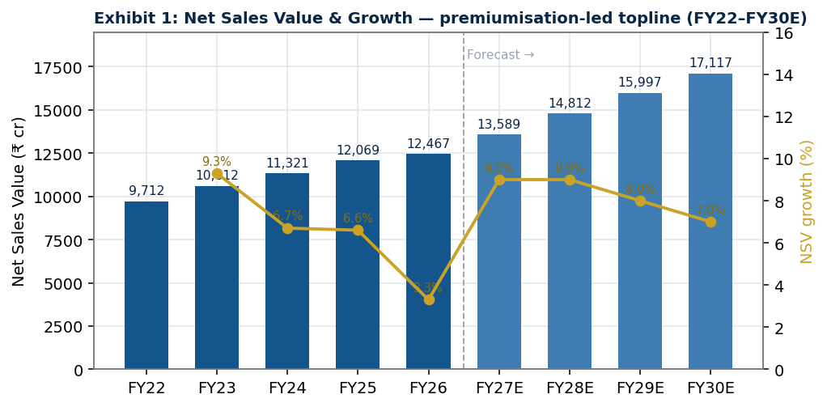
Exhibit 1: Net Sales Value & growth, premiumisation-led topline (FY22-FY30E).
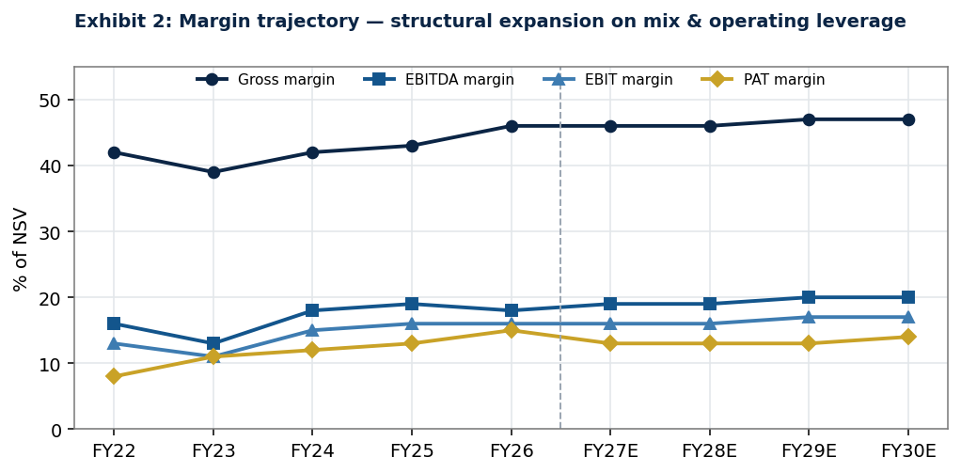
Exhibit 2: Margin trajectory, structural expansion on mix & operating leverage.
6.2 Balance Sheet, Leverage and Capital Structure
Metric | FY22 | FY23 | FY24 | FY25 | FY26
Debt/Equity (x) | 0.13 | 0.04 | 0.05 | 0.07 | 0.05
Net debt/EBITDA (x) | -0.01 | -0.67 | -0.81 | -1.08 | -1.20
Current ratio (x) | 1.42 | 1.76 | 1.93 | 2.00 | 2.07
Interest coverage (x) | 14.7 | 10.9 | 22.7 | 21.9 | 12.6
Cash & treasury (₹cr) | 282 | 1,139 | 1,868 | 2,903 | 3,134

USL deleveraged to a net-cash position (~₹3,134 cr at FY26, net debt/EBITDA ~ -1.2x), reflecting strong cash generation and Diageo's conservative treasury. This fortress balance sheet underpins the dividend and provides ample flexibility, now augmented by ₹16,660 cr of RCB proceeds.
6.3 Working Capital
Steady-state assumptions: receivables ~97 days, inventory ~135 days, payables ~104 days. Inventory is structurally high (whisky maturation); receivables are elevated by dependence on state corporations. This is a working-capital-intensive model and the principal drag on free-cash conversion.
6.4 Cash Flow and Cash Conversion
Operating cash flow was ~₹1,459 cr in FY26; capex is consistently small (~₹180-330 cr p.a.). Healthy CFO, low capex and ~70% dividend payout make USL a reliable cash compounder, though working-capital build in growth years moderates free-cash conversion in any given year.
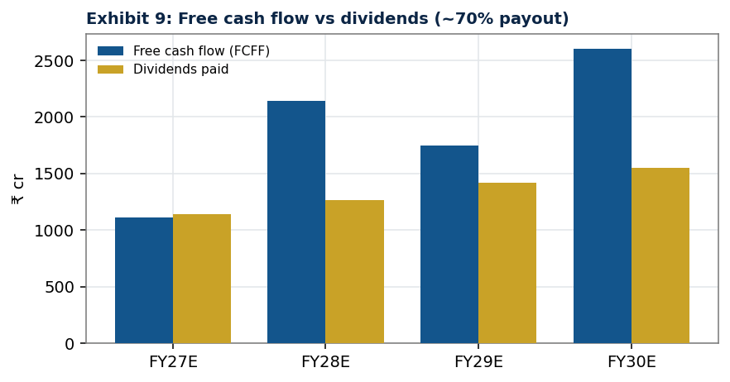
Exhibit 9: Free cash flow vs dividends (~70% payout).

7. Forecast Analysis (FY2027E-FY2030E)
FY2026 is the last actual; forecasts are the continuing beverage-alcohol business per the uploaded model.
₹ crore | FY26 | FY27E | FY28E | FY29E | FY30E
Net Sales Value (NSV) | 12,467 | 13,589 | 14,812 | 15,997 | 17,117
NSV growth % | +3.3% | +9.0% | +9.0% | +8.0% | +7.0%
EBITDA | 2,279 | 2,547 | 2,851 | 3,159 | 3,465
EBITDA margin % | 18.3% | 18.7% | 19.2% | 19.7% | 20.2%
EBIT | 1,990 | 2,170 | 2,433 | 2,700 | 2,965
PAT | 1,838* | 1,709 | 1,891 | 2,119 | 2,318
EPS (₹) | 25.3* | 23.5 | 26.0 | 29.1 | 31.9

*FY26 PAT/EPS include one-off/discontinued-operation items; FY27E reflects normalised continuing operations, hence the optical YoY dip.
7.1 Revenue Drivers
- Premiumisation & mix: continued P&A salience gains (toward ~90%+ of NSV) and trade-up within categories drive realisation growth.
- Volume: mid-single-digit, now the Popular-exit drag has lapped.
- Pricing: state-by-state increases; Karnataka AIB deregulation could improve pricing freedom over time.
- New products: white spirits (Smirnoff/X Series), luxury malts (Godawan), craft (NAO) extend the funnel.
7.2 Margin Drivers
EBITDA margin expands ~40-50 bps p.a. (18.3%→~20.2%) on mix enrichment (gross margin ~46%→48%), operating leverage, and supply-agility savings (partly reinvested in A&P). We stop short of the >22% margins implied by bulls, given state-gated pricing and rising competition.
7.3 Key Model Assumptions
Assumption | Value | Basis
Effective tax rate | 25% | Normalised
Dividend payout | 70% | Held at FY26 level
Receivable / Inventory / Payable days | 97 / 135 / 104 | 10-yr / 3-yr medians
Capex | ~1-2% of NSV | 4-5 yr median
Depreciation useful life | 16 years | ~1/6.2% avg
Treasury yield | market yield on deposits/MFs | n/a

8. Valuation
We adopt the uploaded model's blended methodology, emphasising relative multiples (forward-looking, market-anchored) with a DCF cross-check.
8.1 DCF Valuation (FCFF, 2-stage)
Parameter | Value
Risk-free rate (10-yr G-Sec) | 7.0%
Equity risk premium (Rm - Rf) | 4.0%
Adjusted beta (0.67 × 0.89 + 0.33) | 0.92
Cost of equity (CAPM) = WACC (debt negligible) | 11.0%
Terminal growth (g) | 6.0%
Sum of PV of explicit FCFF (FY27-34) | ₹11,269 cr
PV of terminal value | ₹32,721 cr
Enterprise Value | ₹43,990 cr
(+) Cash / (-) Debt | +₹3,134 cr / -₹407 cr
Equity Value | ₹46,717 cr
Shares outstanding | 72.74 cr
DCF Value per Share | ₹642

Honest finding: even on supportive inputs, the DCF yields ~₹642, well below the market price. High working-capital intensity depresses free-cash conversion, and the market implicitly applies a lower discount rate / higher perpetual growth than our base case. The DCF therefore functions as a valuation floor, hence its 15% blend weight.
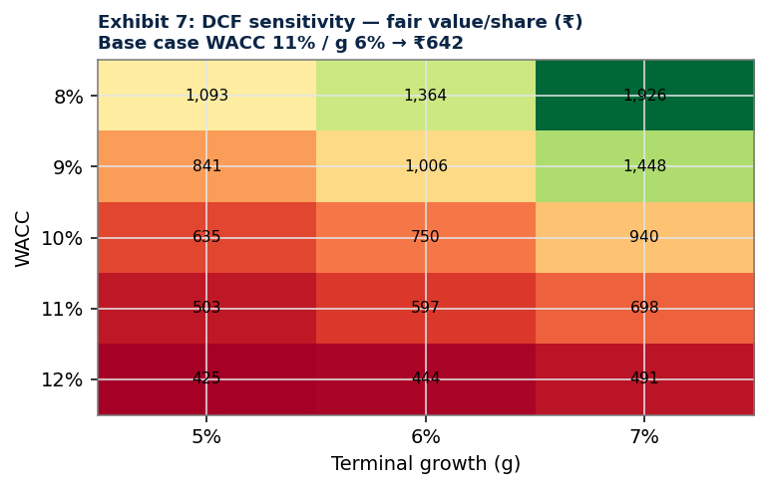
Exhibit 7: DCF sensitivity, fair value/share (₹). Base case WACC 11% / g 6% → ₹642.
8.2 Relative Valuation
Multiple | Peer median (x) | Implied Value/Share (₹)
EV/EBITDA | 39.2 | 1,411
P/E | 71.3 | 1,675
EV/EBIT | 45.9 | 1,408
EV/Revenue (reference) | 4.4 | 859

Peer selection: Radico Khaitan, United Breweries and Allied Blenders. Premium/discount justification: USL trades at a discount to the fastest-growing premium peer (Radico) on P/E but a premium to mass-market peers, appropriate given USL's leadership, mix and superior returns, while its slower headline growth caps the premium. Multiples frame USL as fully, but not egregiously, valued.
8.3 Target Price Methodology and Weights
Method | Weight | Rationale
EV/EBITDA | 60% | Capital-structure-neutral; the market's primary lens for staples; most reliable cross-peer metric.
P/E | 20% | Captures earnings power / equity-investor lens.
EV/EBIT | 5% | Secondary cross-check on operating value.
DCF | 15% | Long-horizon intrinsic anchor; down-weighted due to terminal-value sensitivity and WC-driven FCF volatility.

Justification of the DCF/relative split (15% / 85%): (i) forecast visibility, multi-year cash flows for a state-regulated, WC-intensive business carry wide confidence intervals, making the DCF terminal value highly sensitive; (ii) industry maturity, a deep set of listed, actively-traded Indian alcobev comparables makes market multiples informative; (iii) reliability of market multiples, for a high-quality, widely-followed staple, traded multiples capture the premiumisation/quality premium better than a single discount-rate assumption. A more DCF-weighted analyst would arrive at a lower fair value.
Method | Implied (₹) | Weight | Contribution (₹)
EV/EBITDA | 1,411 | 60% | 846
P/E | 1,675 | 20% | 335
EV/EBIT | 1,408 | 5% | 70
DCF | 642 | 15% | 96
Blended Target Price |  |  | 1,348

8.4 Upside not in the Target, RCB Proceeds
The model-derived ₹1,348 target does not capitalise the ₹16,660 crore RCB sale proceeds (~17% of market cap). Net of taxes/leakage and depending on redeployment (special dividend, buyback or core reinvestment), this is a material upside option and a key reason we rate HOLD rather than Reduce.

9. ESG Analysis
USL's ESG agenda, 'Spirit of Progress' (aligned to Diageo's global framework), is a genuine competitive and risk-mitigation asset (FY2025 Integrated Annual Report).
9.1 Environmental
- Water: ~54% improvement in water used per litre of spirit distilled vs FY2020; ~671k kilolitres consumed; 'Preserve Water for Life' stewardship, replenishment and regenerative agriculture (Godavari Initiative).
- Energy & emissions: 99% renewable energy in direct operations (since FY2020); ~93% reduction in absolute Scope 1 & 2 GHG vs FY2020 (Scope 2 market-based ~zero after i-RECs).
- Net Zero roadmap: Net Zero in direct operations by 2030; across the value chain by 2050.
9.2 Social
- Responsible drinking: ~0.7 million people educated (Act Smart India on underage drinking; DRINKiQ).
- People: ~2,400+ employees, ~86% retention, ~89% engagement, ~28% women's representation; active inclusion & diversity initiatives.
9.3 Governance
- Diageo governance standards and board oversight; robust corporate-governance framework; Diageo Marketing Code and consumer-information standards; conservative treasury policy.
9.4 Impact on Valuation & Risk
Strong ESG execution reduces regulatory/reputational tail-risk in a sector under perennial health/policy scrutiny, supports premium-brand equity, and is consistent with the low beta in our WACC. We assign no explicit valuation premium but view USL's ESG leadership as supportive of multiple durability and a lower cost of capital over time.
10. Risk Analysis
10.1 Risk Matrix
Risk | Likelihood | Impact | Mitigant
Regulatory / RTM disruption (policy reversals, prohibition) | Medium | High | Diversification across 30+ states; Diageo compliance
Excise / tax increases not passed through | Med-High | Med-High | Premium mix, pricing power, AIB freedom (Karnataka)
Raw-material inflation (ENA/grain, glass, scotch) | Medium | Medium | Scale sourcing, supply-agility savings, productivity
Competitive pressure (Pernod, Radico, Tilaknagar, ABDL) | High | Medium | Portfolio breadth, distribution, value-share focus
Consumer down-trading (macro slowdown) | Medium | Med-High | Full price-ladder portfolio; mass-to-premium funnel
Currency / import cost (scotch concentrate) | Medium | Low-Med | Local production; partial hedging
Customer concentration (~30% one state corp.) | Structural | Medium | Industry-wide norm; receivables management
ESG / health-policy headwinds | Medium | Medium | ESG leadership; responsible-drinking programmes
Valuation de-rating (rich multiple) | Medium | High | Quality, growth, RCB cash optionality

10.2 International / Global Risk Context
USL is a domestic IMFL business (limiting direct US-tariff exposure), but the global backdrop matters: IWSR data show global beverage-alcohol volumes fell ~2% in 2025 (third straight year), premiumisation has 'stalled'/fragmented amid macro pressure, and US tariffs cut Scotch exports to the US ~15% by volume. Parent Diageo cut FY26 guidance on US/China weakness and tariffs, reduced its dividend (Feb-2026), and is pursuing selective disposals (the RCB exit fits this). Implication: India stands out as a structural growth engine within a stagnant global spirits market, a relative positive for USL, though scotch-concentrate costs and parent-level strategy shifts bear watching.

11. Investment Recommendation
Recommendation | HOLD / NEUTRAL
12-Month Target Price | ₹1,348
Current Market Price | ₹1,326
Expected Total Return | ~+1.7% price + ~1.0% dividend yield ≈ ~3%
Investment Horizon | 12 months

Rationale. USL is a best-in-class, structurally advantaged compounder, the cleanest large-cap proxy for Indian spirits premiumisation, with a net-cash balance sheet, ~22% ROCE and a multi-year margin runway. However, the business case and the valuation case diverge: at ~37-39x forward EV/EBITDA and ~52x trailing earnings, the stock already discounts years of double-digit growth and margin expansion. Our blended fair value of ₹1,348 sits essentially at the market price, and the DCF floor (₹642) underscores how much rests on sustained premium multiples.
Why USL deserves a premium to mass-market peers (but not to Radico). USL warrants a premium over ABDL/Globus for leadership, portfolio breadth, ~89-90% P&A mix, superior returns and balance-sheet strength. It trades at a discount to Radico Khaitan, whose faster top-line and luxury growth command a higher multiple, a gap we view as fair given USL's larger, more mature base.
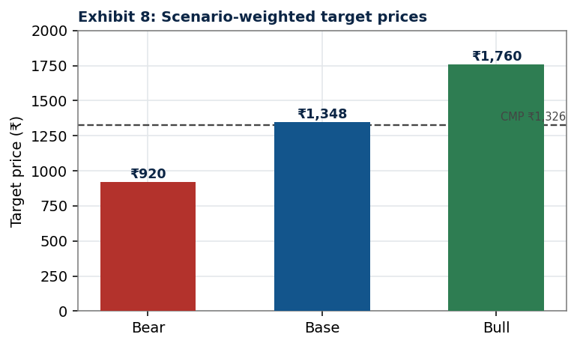
Exhibit 8: Scenario-weighted target prices.
Scenario | Key assumptions | Target (₹) | vs CMP
Bull | Vol +6%, realisation +6%, EBITDA margin →~24%, lower WACC, RCB cash redeployed accretively | ~1,760 | +33%
Base | Vol +4-4.5%, realisation +5%, margin →~20%, WACC 11%/g 6% | 1,348 | +1.7%
Bear | Vol +2.5%, realisation +4%, margin stalls ~17%, de-rating, adverse excise | ~920 | -31%

Action. Hold core positions for compounding and the un-modelled RCB-cash optionality. Accumulate below ~₹1,150; trim above ~₹1,500. Catalysts to monitor: redeployment of RCB proceeds (special dividend / buyback), Karnataka AIB pricing outcomes, P&A volume momentum, input-cost trajectory, and Diageo's August-2026 global strategy refresh.

12. Appendices
Appendix A, Integrated Income Statement (₹ cr, NSV basis)
 | FY22 | FY23 | FY24 | FY25 | FY26 | FY27E | FY28E | FY29E | FY30E
NSV | 9,712 | 10,612 | 11,321 | 12,069 | 12,467 | 13,589 | 14,812 | 15,997 | 17,117
COGS | 5,681 | 6,503 | 6,542 | 6,860 | 6,674 | 7,406 | 7,999 | 8,558 | 9,072
Gross profit | 4,032 | 4,109 | 4,779 | 5,209 | 5,793 | 6,183 | 6,814 | 7,439 | 8,045
EBITDA | 1,595 | 1,417 | 2,000 | 2,236 | 2,279 | 2,547 | 2,851 | 3,159 | 3,465
EBIT | 1,291 | 1,134 | 1,725 | 1,953 | 1,990 | 2,170 | 2,433 | 2,700 | 2,965
PAT | 811 | 1,126 | 1,408 | 1,582 | 1,838 | 1,709 | 1,891 | 2,119 | 2,318

Appendix B, Key Ratios
 | FY24 | FY25 | FY26 | FY27E | FY28E | FY29E | FY30E
Gross margin | 42% | 43% | 46% | 46% | 46% | 47% | 47%
EBITDA margin | 18% | 19% | 18% | 19% | 19% | 20% | 20%
ROE | 21% | 21% | 22% | 19% | 19% | 20% | 21%
ROCE | 23% | 23% | 21% | 22% | 22% | 23% | 23%
Net debt/EBITDA | -0.8 | -1.1 | -1.2 | -1.1 | -1.0 | -1.1 | -1.1

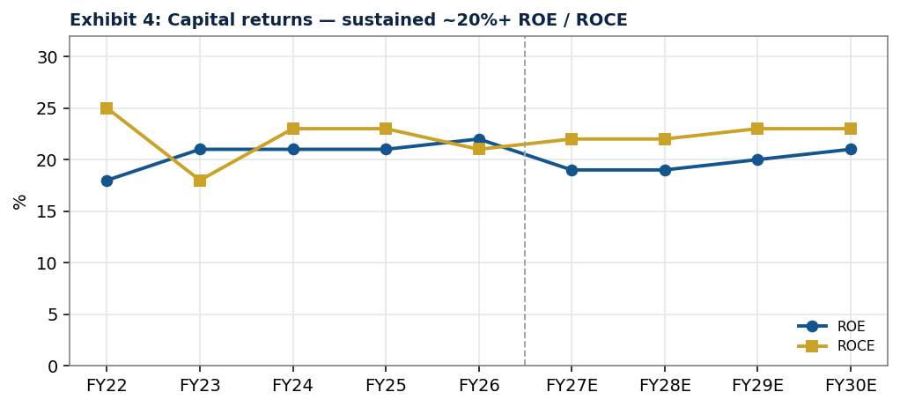
Exhibit 4: Capital returns, sustained ~20%+ ROE / ROCE.
Appendix C, Cash Flow Summary (₹ cr)
 | FY26 | FY27E | FY28E | FY29E | FY30E
CFO | 1,459 | 1,292 | 2,345 | 1,957 | 2,831
Capex | (181) | (204) | (222) | (240) | (257)
Dividends paid | (1,263) | (1,145) | (1,267) | (1,420) | (1,553)

Appendix D, Sources
Primary (per analyst mandate): United Spirits 'United Spirits Excell.xlsx' financial model (DCF, Comps, Valuation Summary, P&L, Balance Sheet, Cash Flow, Ratio Analysis, Beta); United Spirits Annual Reports FY2017, FY2019, FY2021, FY2023 and FY2025 Integrated Annual Report.
Secondary (public domain, cited inline): Diageo India / Diageo plc investor communications; IWSR; The Hindu; Economic Times; Livemint/Mint; Financial Express; Hindustan Times; NDTV Profit; Reuters; Outlook Business; The Spirits Business; Quartr; PRS / Economic Survey 2025-26; MoSPI; RBI.
All third-party content paraphrased/summarised for compliance with licensing restrictions. This document is an educational research report and does not constitute investment advice.

