Project Plovdiv 2.0 user manual
Miroslav Batchkarov, August 2009, modified July 2012

General
This application is based on two separate pieces of software. The first one was developed under the York Transit Bursary Scheme under the supervision of Dr Daniel Franks, and the second at the University of Sussex under Dr Istvan Kiss. It is not intended for detailed modelling or efficient calculations but rather as a supplementary course resource. Our main goals throughout the development process were simplicity and ease of use as well as mathematical and biological correctness.
The application is distributed under a three-clause BSD license. This allows unlimited redistribution for any purpose as long as its copyright notices and the license's disclaimers of warranty are maintained. The license also contains a clause restricting use of the names of contributors for endorsement of a derived work without explicit prior permission. Please report any bugs you discover to the developers. If you find this piece of software useful are welcome to contribute to it.

User interface

Top toolbar: Mouse modes
The mouse is the single most important input method used in the application. To allow the user full control over the workings of the program, the mouse can operate in four different modes.
- Selection mode: this mode allows the user to select vertices and change their characteristics (see Vertex data).
  - Left- clicking a vertex will select it
  - Left- clicking the background will deselect all vertices
  - Ctrl + left click over a vertex will select it and move it the the centre of the screen
  - Shift + left click will select multiple vertices
  - Click and drag will draw a selection rectangle- when the mouse button is released, all vertices inside the rectangle are selected.
- Editing mode: allows the user to create vertices and edges
  - Left clicking anywhere on the screen will create a new vertex at that location
  - Dragging a line from a vertex to another will connect them with an undirected edge, unless they are already connected or you are trying to connect a vertex to itself
  - Holding Shift while performing 2. will create a directed edge
- Transforming mode: changes the way the graph is drawn (also see Layouts)
  - Dragging will move the graph
  - Ctrl + drag will skew the graph
  - Shift + drag will rotate the graph
- Annotation mode: this mode allows the user to draw annotations on the screen, for example for teaching or demonstration purposes. In this mode an additional tool bar will appear at the bottom of the screen, allowing control over the way the annotations are created
  - Dragging will create a new annotation with the selected shape, colour and position relative to the other elements in the graph
  - Shift + left click over an annotation will delete it
  - Right click anywhere on the screen will let the user enter some text, which will be drawn on the scree. Please note: clicking the right mouse button in annotation mode overrides the default behaviour of the right mouse button (see below)
The following actions work in all mouse modes:
- Scrolling the mouse wheel up will zoom out and scrolling down will zoom in
- Right clicking a non- selected vertex will allow you to remove it or modify its characteristics (see Vertex data)
- Right clicking a selected vertex will pop up a context- sensitive menu, which allows you to create edges as well as to modify the vertex characteristics (see Vertex data)

Top tool bar: Zoom level
Clicking the Zoom in button will magnify the view. The Zoom out button does the opposite.

Top tool bar: Simulation controls
Once a disease transmission simulation has been started, this toolbar can be used to control it. The Do simulation step button will perform a single step. The Run button will start the simulation and will then change to Pause. The Pause button can be used to temporarily pause the simulation--- it can be resumed by clicking Run. The stop button permanently terminates the current simulation.
The Enable visualisation checkbox can be used to disable the visualisation. This makes the simulation considerably faster.

Bottom tool bar: graphs statistics
The bottom tool bar displays statistics for the whole graph, such as the average clustering coefficient, the average degree, etc.

Bottom tool bar: Detailed statistics window
This window contains more details for the graph as a whole, such a vertex and edge count, global clustering coefficient, average shortest path length, etc. In this window you can also see a plot of the degree distribution, which can be either on a linear or on a log-log scale.

Right tool bar: Node statistics
This tool bar displays information about the selected node. If you select a number of vertices other than one, all fields will read “0.0”.

Loading and saving graphs: File > Load and File > Save
Currently the application will only read the UCINET DL file format, in which the graph can be represented in either matrix of edge list format. It is also capable of reading labels (separate or embedded). When saving, graph structure and the labels will be preserved and the format used is DL full matrix. No other information about the graph will be saved.

Generating graphs: File > Generate
The program currently employs the following algorithms:
- Rectangular lattice: a lattice in which each vertex has for local connections
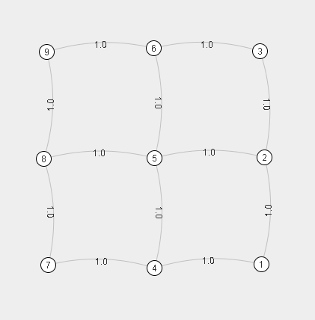
- Hexagonal lattice: a lattice with six local connections per vertex
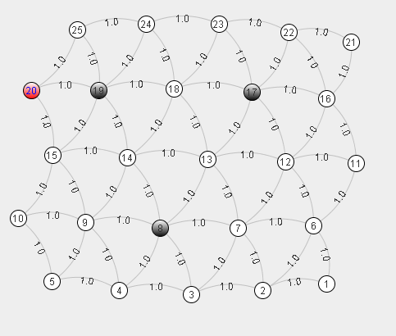
- Barabasi- Albert scale- free generator: Starts with a single vertex an creates the specified number of vertices, attaching them to existing ones based on the principle of preferential attachment.
- Small world generator- starts with a circular lattice of the specified size, connecting each vertex it its k closest neighbours on each side. Then traverses all edges, and rewires some of them with probability p.

Layouts: The Change Layout menu
If the graph looks cluttered or unordered, try changing the layout. Different algorithms will produce different results, and sometimes dynamic algorithms, when applied on the same graph more than once, can produce significantly different results. Some algorithms will work better than others on certain types of graphs.. This is still an open research area, so there is no optimal layout- try which one looks best for you.

Labels: The Label edges/vertices menu
Each element of the graph has a unique id associated with it. It can be displayed alongside a vertex or an edge together with statistical information about it. This includes degree, local clustering coefficient, betweenness centrality, distance from the currently selected vertex or .dl label. DL labels are persistent- they are saved together with the graph structure, while all other information is lost.

Saving to a screenshot
To save the what is currently on the screen to a jpg file, go to View> Save to .jpg

Saving layouts-- feature temporarily disabled
Most layouts are calculated by randomized algorithms and in general a layout applied on graph will not look the same. To prevent this from happening, you can save the layout for a specific graph to a file and re-load it later. To do that, you need to create a graph and then save it to a .dl file by clicking File> Save to .dl. The program will now ask if you want to save the layout as well. If you select Yes, a file with the same name and .layout extension will be created in the same directory. Your data is now saved and the program can be safely closed. Next time you load this graph you will be prompted if you want to load the layout.

