Blog Web API

**The Task**:

Create a basic multi-user blog web API.

**What we did**:

**requirements:**

1. We used ASP.NET Core 3, Entity Framework Core
2. We used SignalR for the real-time part.
3. We used the code first approach, and we created all the migrations needed to create the database.
4. We added some random data for testing, and included the seeds in the.
5. All API endpoints returns JSON results.
6. On the API we handled the following errors:
   1. Blog post not found.
   2. Validation errors (Determining the validation rules is left for your judgment).
7. We enabled paging on all actions that returns a list of blogs.
8. We documented the API endpoints using swagger (swashbuckle)
9. We added Authentication and Authorization to the API using JWTs.
10. We used the Default Identity to login to the blogs system.

**Create a RESTful API to perform the following actions:**

1. Listing blog posts
2. Getting a single blog post
3. Adding a blog post
4. Deleting a blog post
5. Updating a blog post

**Real-time monitor**:

We using SignalR to notify the user for the new blog, update blog and delete blog, then we refresh directly the blogs table and add new data on it.

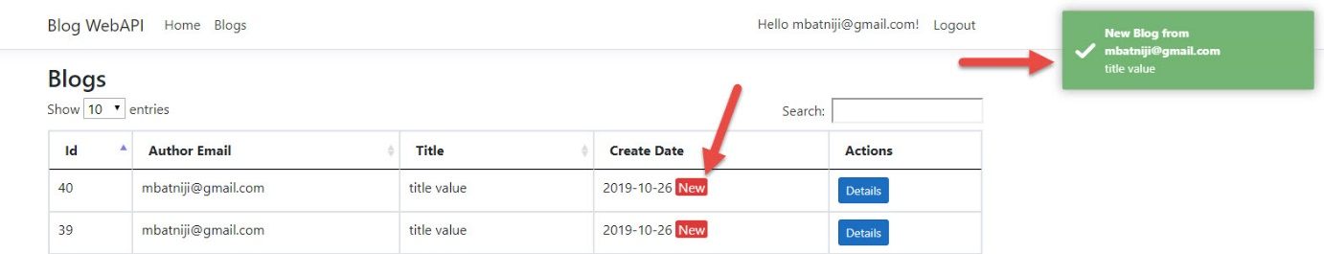

**How to login at the first time**:

1. When you click on register it will check for the database if it not created it will open the following page to allow you create the database.

**Click on “Apply Migration” button.**

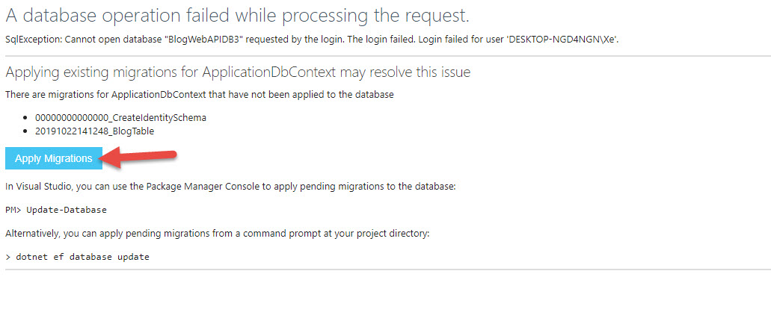

When the process is done it will show as the image below, then you should refresh the page.

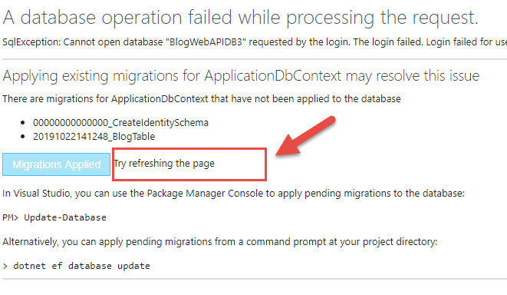

1. Click on register button to open the registration form.

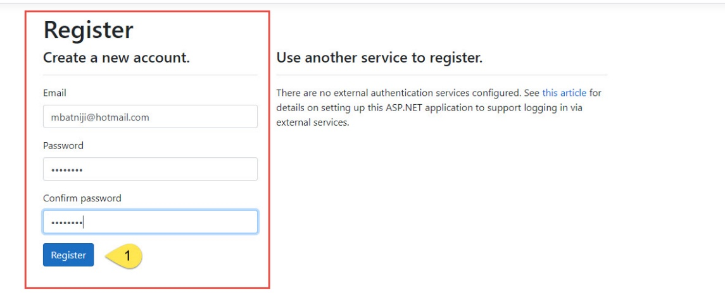

1. Click on confirm to confirm the email.

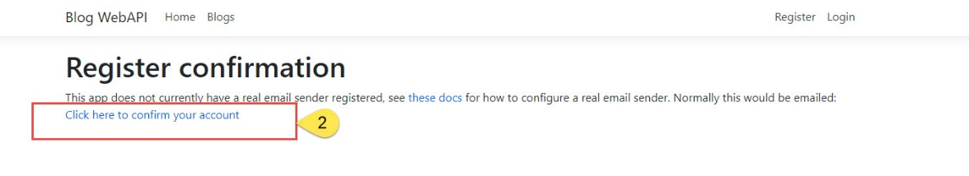

1. Login to the system by click on login button.

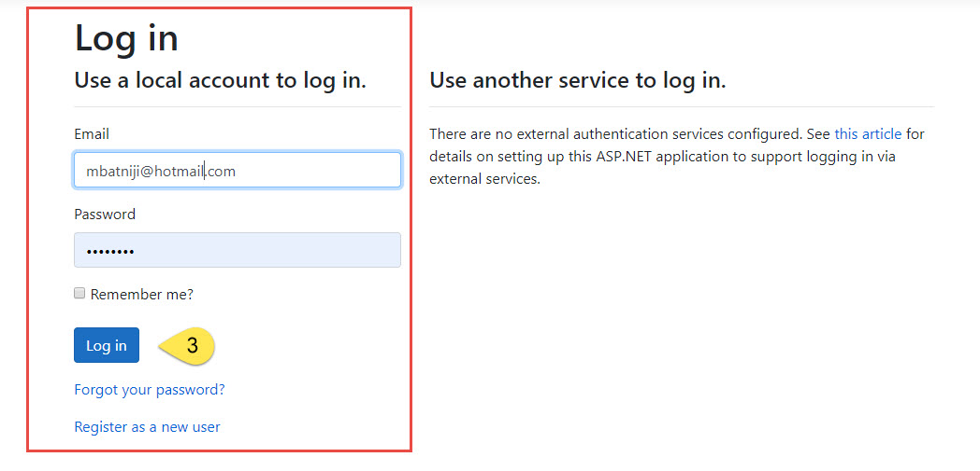

1. Open the blogs page by click on the blogs label or from the menu as shown below.

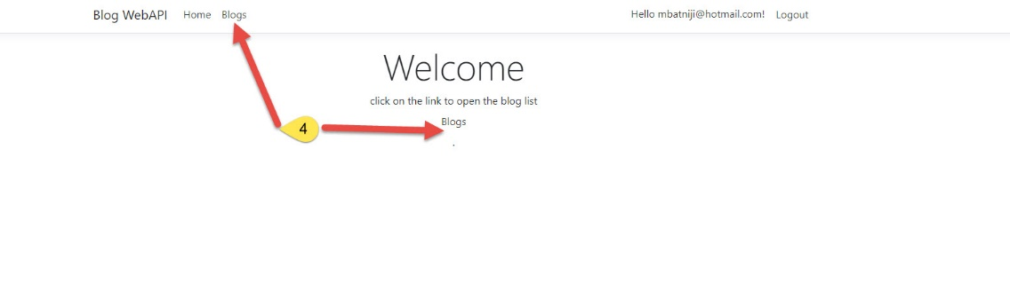

**To use the API**:

To use the API, you can open the swagger page or using the postman app.

The postman app:

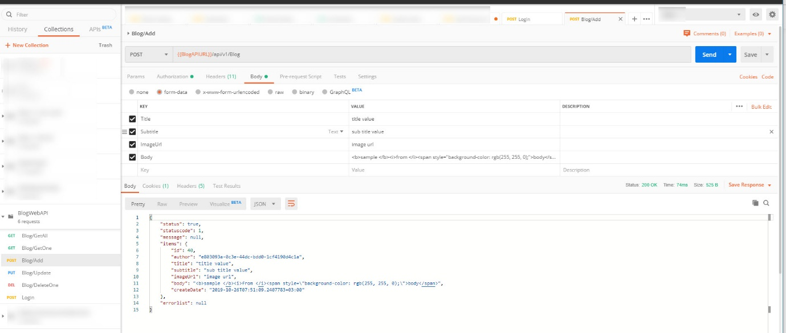

Swagger: (*ProjectURL*/swagger/index.html)

