3.8

c)

R code:

sum_y = 16/(16+58) + 9/(9+90) + 10/(10+48) + 13/(13+57) + 19/(19+103) + 20/(20+57) + 18/(18+86) + 17/(17+112) + 35/(35+273) + 55/(55+64)

sum_z = 12/(12+113) + 1/(1+18) + 2/(2+14) + 4/(4+44) + 9/(9+208) + 7/(7+67) + 9/(9+29) + 8/(8+154)

ny_prod = (16+58) * (9+90) * (10+48) * (13+57) * (19+103) * (20+57) * (18+86) * (17+112) * (35+273) * (55+64)

nz_prod = (12+113) * (1+18) * (2+14) * (4+44) * (9+208) * (7+67) * (9+29) * (8+154)

ny = c((16+58),(9+90), (10+48), (13+57), (19+103), (20+57), (18+86), (17+112), (35+273), (55+64))

nz = c((12+113), (1+18), (2+14), (4+44), (9+208), (7+67), (9+29), (8+154))

y = c(16/(16+58), 9/(9+90), 10/(10+48), 13/(13+57), 19/(19+103), 20/(20+57), 18/(18+86), 17/(17+112), 35/(35+273), 55/(55+64))

z = c(12/(12+113), 1/(1+18), 2/(2+14), 4/(4+44), 9/(9+208), 7/(7+67), 9/(9+29), 8/(8+154))

posterior_theta_y <- (rbeta(1000,sum_y+0.5, sum(ny-y)+0.5))

posterior_theta_z <- (rbeta(1000, sum_z+0.5, sum(nz-z)+0.5))

hist(posterior_theta_y,col = 'blue', xlab = ('Posterior distribution of theta_y given y'))

hist(posterior_theta_z,col = 'red', xlab = ('Posterior distribution of theta_z given z'))



d)

Rcode:

diff_post_thetay_thetaz <- posterior_theta_y - posterior_theta_z

hist(diff_post_thetay_thetaz, col = 'green', xlab = ('Posterior mu_y - mu_z'))



3.12

b)

Rcode:

t = seq(1,10,by=1)

y = c(24,25,31,31,22,21,26,20,16,22)

mod <- lm(y~t)

summary(mod)

alpha_mean <- mod$coefficients[1]

alpha_sd <- coef(summary(mod))[1, 2]

beta_mean <- mod$coefficients[2]

beta_sd <- coef(summary(mod))[2, 2]

# alpha and beta follow independent normal distribution

alpha.grid=seq(alpha_mean-3*alpha_sd, alpha_mean+3*alpha_sd, length=100)

beta.grid=seq(beta_mean-3*beta_sd, beta_mean+3*beta_sd, length=100)

p=matrix(NA, 100, 100)

evaluate_dist=function(alpha, beta){

product_alpha_beta_dist = dnorm(alpha, alpha_mean, alpha_sd)*dnorm(beta, beta_mean, beta_sd)

return(product_alpha_beta_dist)

}

for (i in 1:100){

for (j in 1:100){

p[i,j]=evaluate_dist(alpha.grid[i], beta.grid[j])}}

image(alpha.grid,beta.grid,p)

points(alpha_mean,beta_mean,pch=3)

contour(alpha.grid, beta.grid, p,xlab = "alpha",ylab = "beta",add=TRUE)

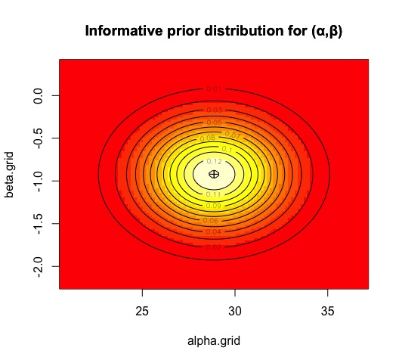

f)

Rcode:

alpha.grid=seq(20, 40, length=100)

beta.grid=seq(-2.0, 0.5, length=100)

evaluate_postdist=function(alpha, beta){

post_dist = exp(-(10*alpha+sum(beta*t)) + sum(y*log(alpha+beta*t)))

return(post_dist)}

z=matrix(NA, 100, 100)

for (i in 1:100){

for (j in 1:100){

z[i,j]=evaluate_postdist(alpha.grid[i], beta.grid[j])}}

image(alpha.grid,beta.grid,z,xlim=c(20, 40), ylim=c(-2.0, 0.5))

points(alpha_mean,beta_mean,pch=3)

contour(alpha.grid, beta.grid, z,xlab = "alpha",ylab = "beta", add=TRUE)

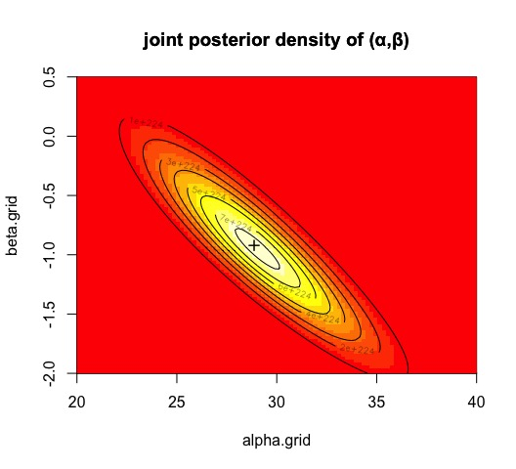

#1000 draws from posterior

pa <- rowSums(z) # marginal on alpha

ns <- 1000 # #samples

alpha.s <- beta.s <- numeric(ns)

for (s in 1:ns) {

ia <- sample.int(100, 1, prob=pa) # sample alpha

ib <- sample.int(100, 1, prob=z[ia,]) # sample beta | alpha

alpha.s[s] <- alpha.grid[ia]; beta.s[s] <- beta.grid[ib]

}

# add to plot

points(alpha.s, beta.s, pch=19, col='blue', cex=.6, xlim=c(20, 40), ylim=c(-2.0, 0.5))

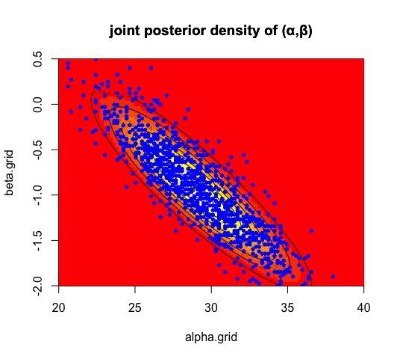

g)

Rcode:

t1 <- 11

post_theta <- alpha.s+ t1*beta.s

hist(post_theta, col = 'blue')



h)

Rcode:

postpred_y <- rpois(1000,alpha.s+ t1*beta.s)

sort_postpred <- sort(postpred_y)

conf_interval_95 <- sort_postpred[c(25,975)]

print(conf_interval_95)

95% predictive interval for the number of fatal

accidents in 1986: [10, 30]