Problem 2.12

b) Code:

N = 1000000;

Z1 = randn(N,1);

Z2 = randn(N,1);

Z = [Z1,Z2]';

L = [3/2,1/2;1/2,3/2];

X = (L*Z);

m_x = mean(X,2);

R_X = (X*X')/N - (m_x * m_x');

Result:

R_X = 2.5018 1.5012

1.5012 2.4981

R_X obtained from implementing the code matches with the one computed theoretically. Thus verified.

c) Empirical Joint pdfs for Z and X:

Code:

figure(1)

pdf2d(Z1,Z2)

figure(2)

pdf2d(X(1,:),X(2,:))

pZ1,Z2 (z1, z2) pX1,X2 (x1, x2)

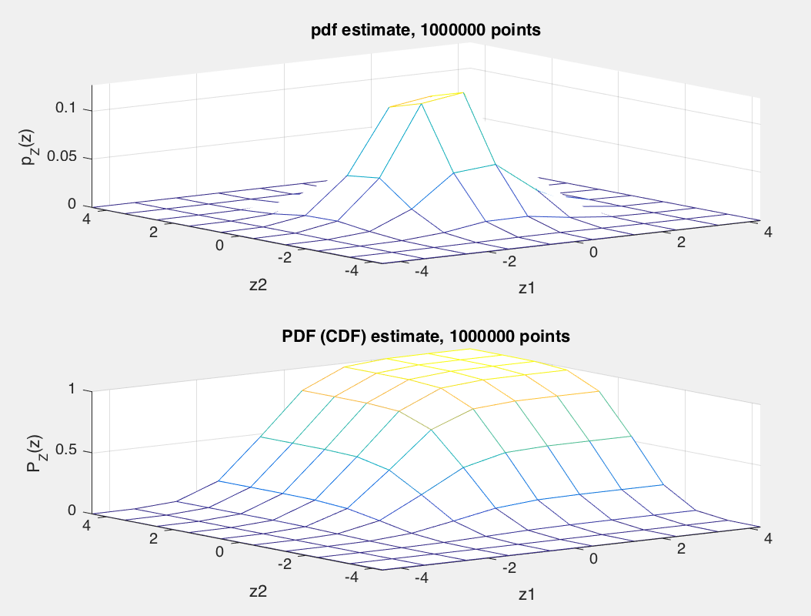 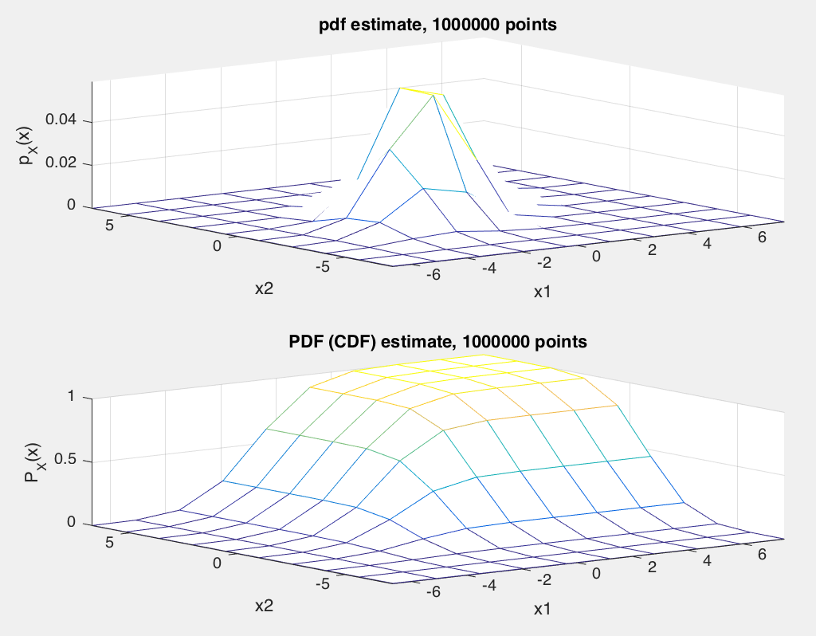

We can see that Z, which is a Gaussian random vector when linearly transformed with L, gives anpther gaussian random vector X.

d) Code to generate a Gaussian random vector X with a given, desired covariance structure RX :

function [X] = covgen(N,R)

% Generates gaussian random vector X with given covariance matrix

% Usage: X = covgen(N,R)

% N: Desired number of sample vectors

% R: covariance matrix of desired X, dimension P*P

% X: Desired gaussian random vector, X=[X1,..,Xp]', each having

% N samples.

L = sqrtm(R);

Z = randn(length(R), N);

X = L*Z;

%% Implement the function with a given R

% R_X = [5/2,3/2;3/2,5/2];

% N= 1000000;

% X = covgen(N,R_X);

%% check answer

%m_x = mean(X,2);

%R_X = (X*X')/N - (m_x * m_x'); % covariance matrix

This code was verified and it worked as expected.

e)

If elements of Z were uniformly distributed random, independent random variables with zero mean and unit variance, linear transformation of Z: X would no longer be a Gaussian random vector. But the covariance will remain unchanged from when Z was Gaussian.

Code:

%% part e: Z is uniformly distributed with zero mean and unit variance

clear all;clc;

N = 1000000;

Z = sqrt(12)*(rand(2,N)-.5);

L = [3/2,1/2;1/2,3/2];

X = (L*Z);

m_x = mean(X,2);

R_X = (X*X')/N - (m_x * m_x');

%figure(1)

%pdf2d(X(1,:),X(2,:))

figure(2)

pdf2d(Z(1,:),Z(2,:))

Result:

R_X = 2.4983 1.4986

1.4986 2.5025

% same as when Z was Gaussian

pZ1,Z2 (z1, z2) pX1,X2 (x1, x2)

