Problem 6.8

1. Plotting the power spectral density of the Gaussian white noise process u of Problem Set No. 5:

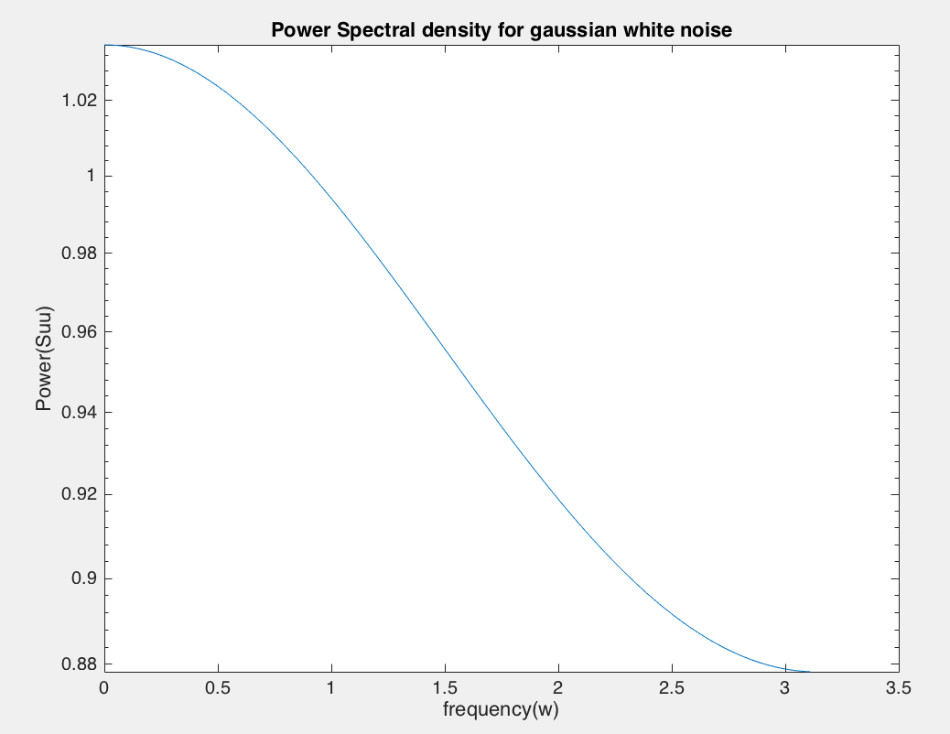

Plot the pole/zero locations of the estimated AR model:

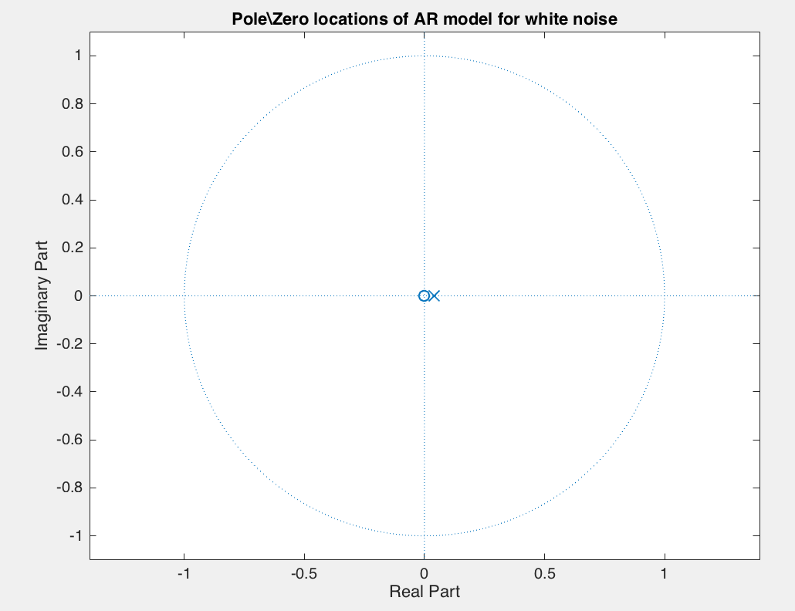

White noise does not depend on its past values. Therefore poles will be close to 0 and zeros will be close to 0 as well.

b. Comparing PSDs of outputs of 5 systems from Problem set 5 obtained from AR model vs their theoretical PSD.

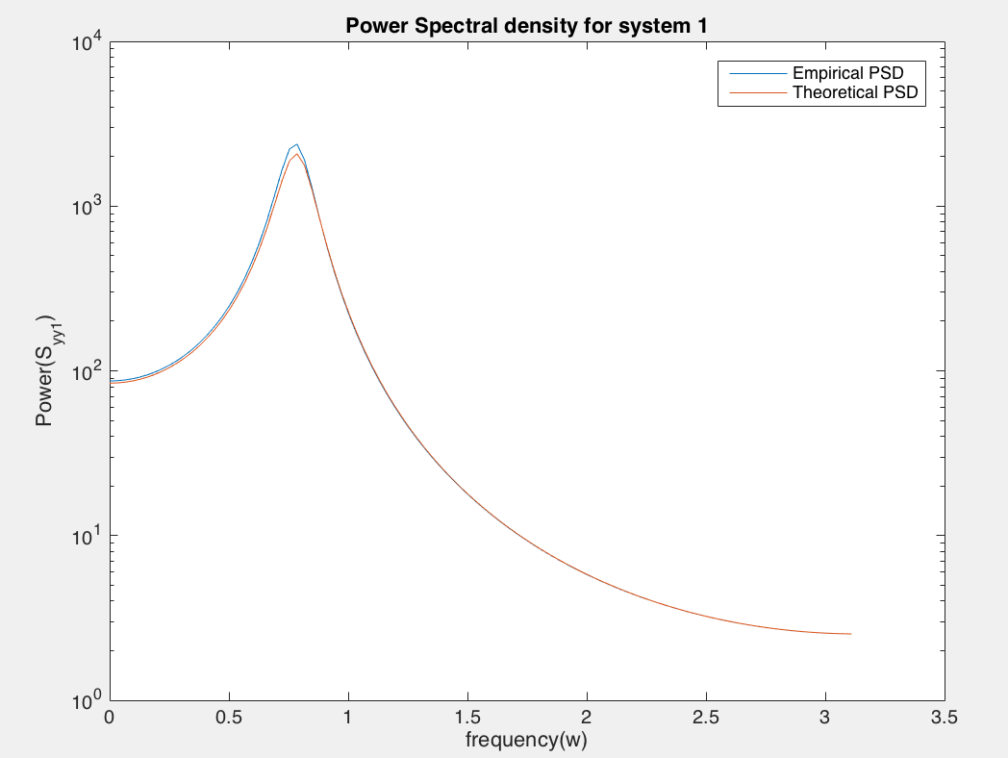 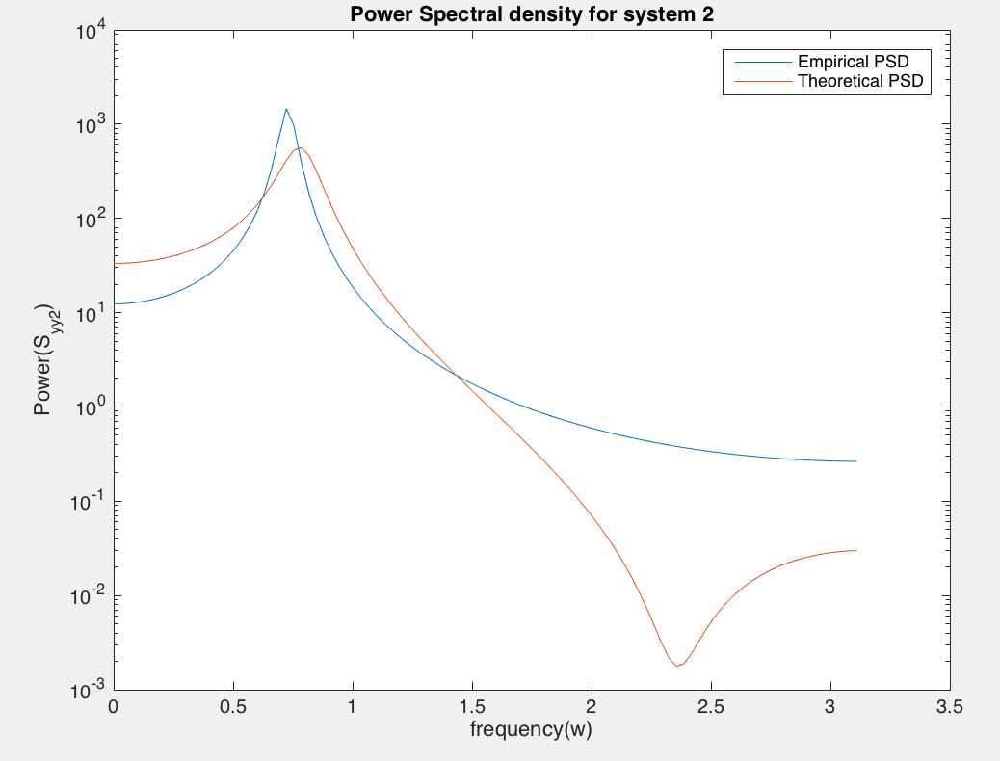

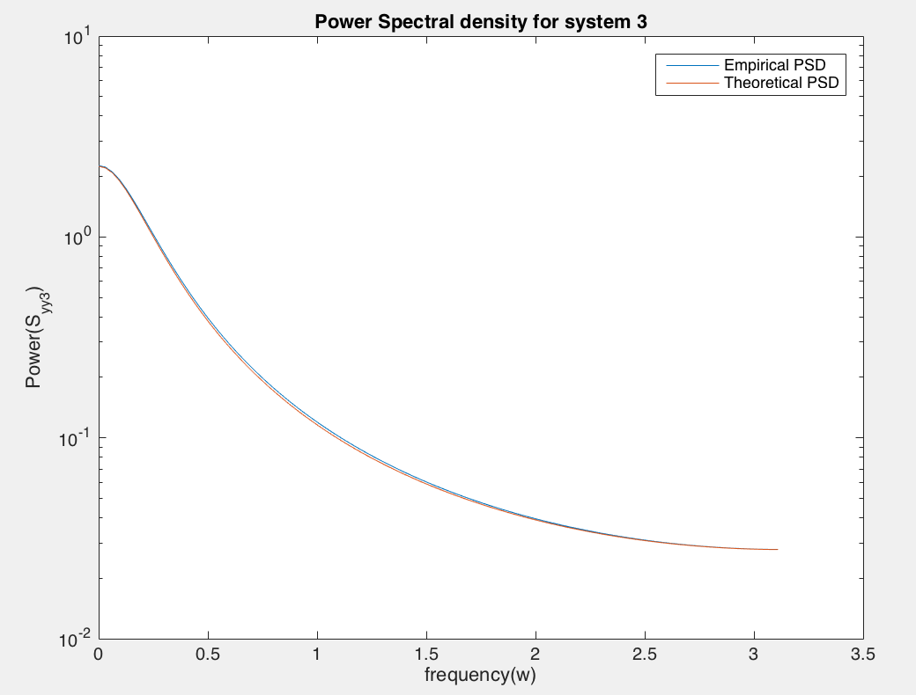 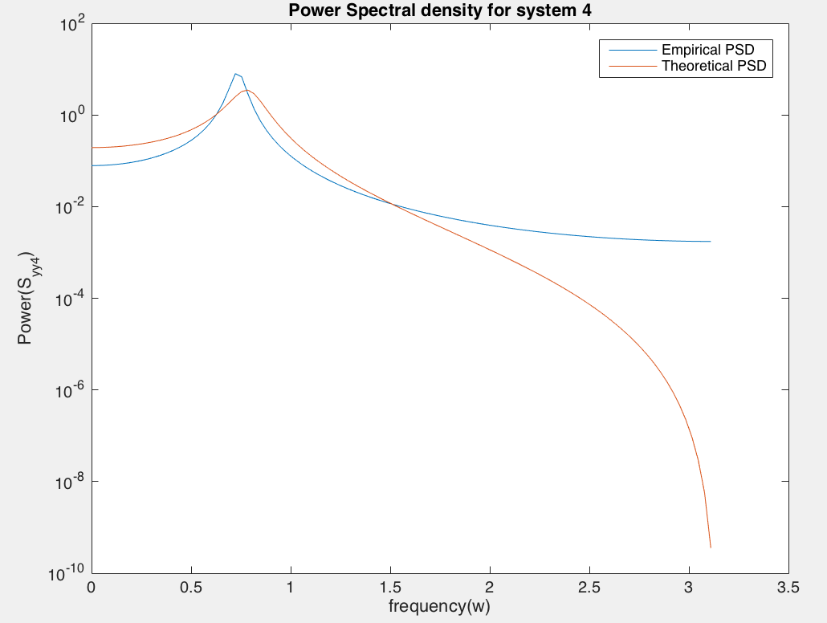

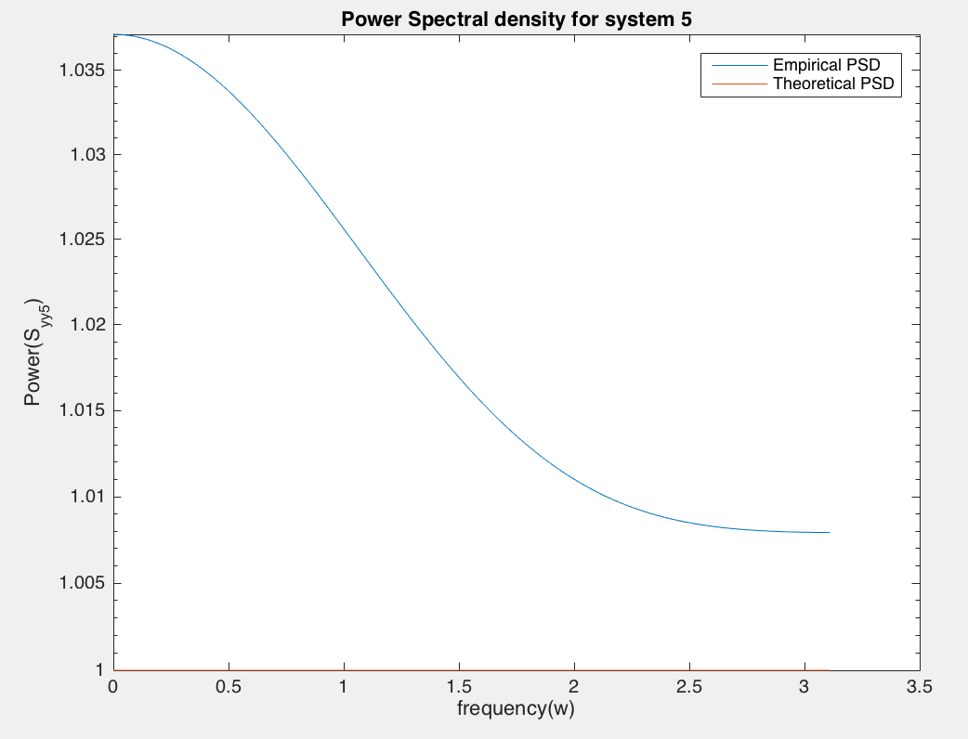

1. Comparing the estimated (higher order AR models) and true power spectral density: for System #0

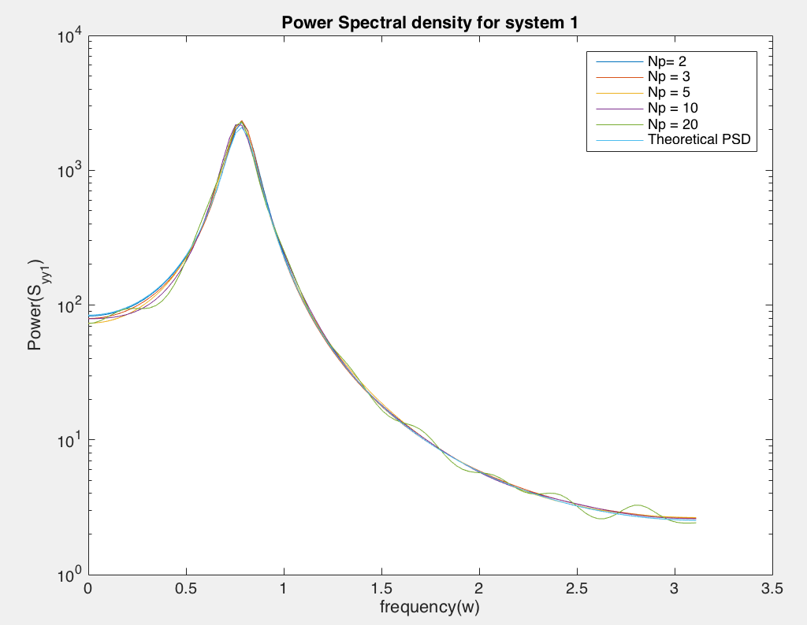

Model seems robust to over-estimation of model order.

Comparing poles and zeros for higher order models with true poles and zeros:

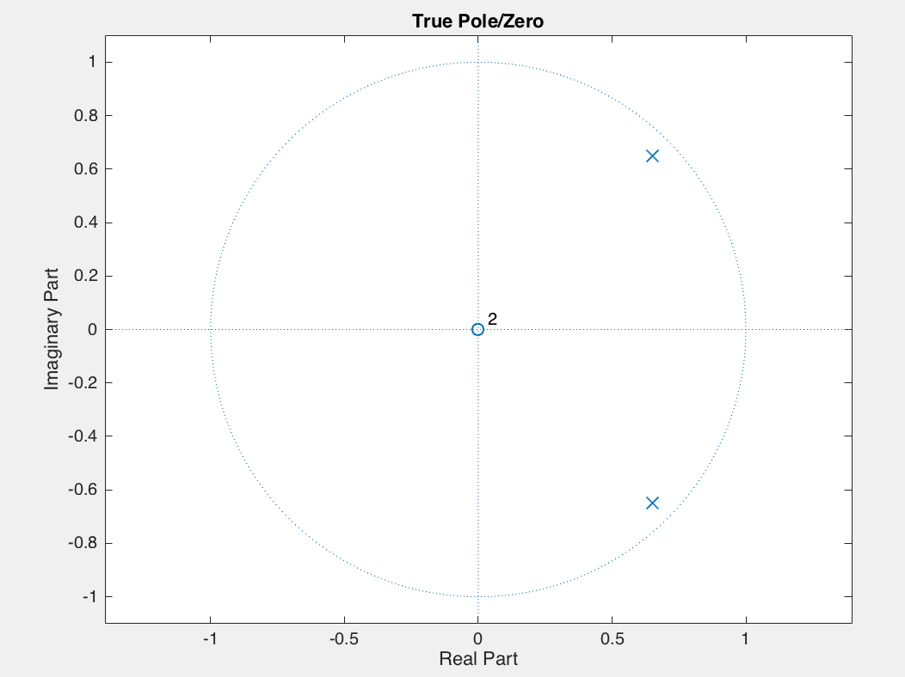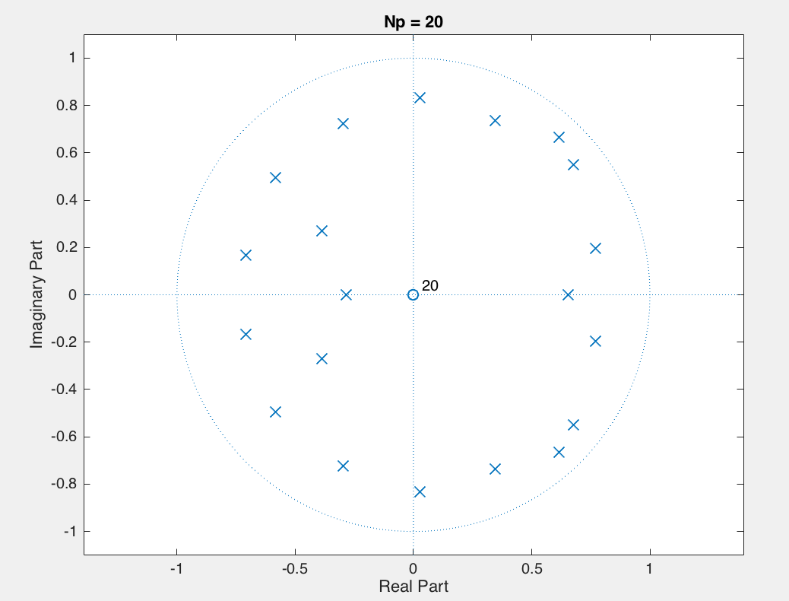

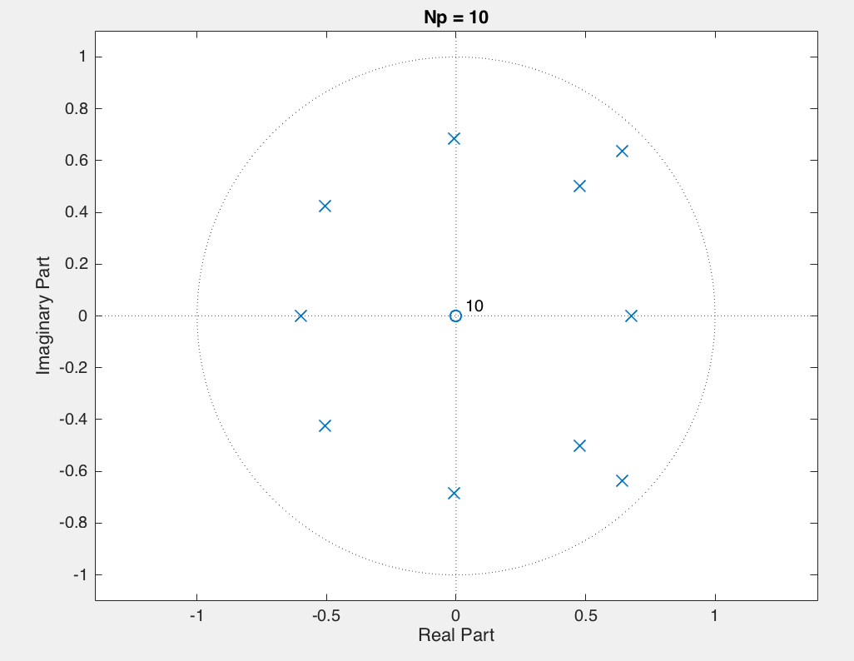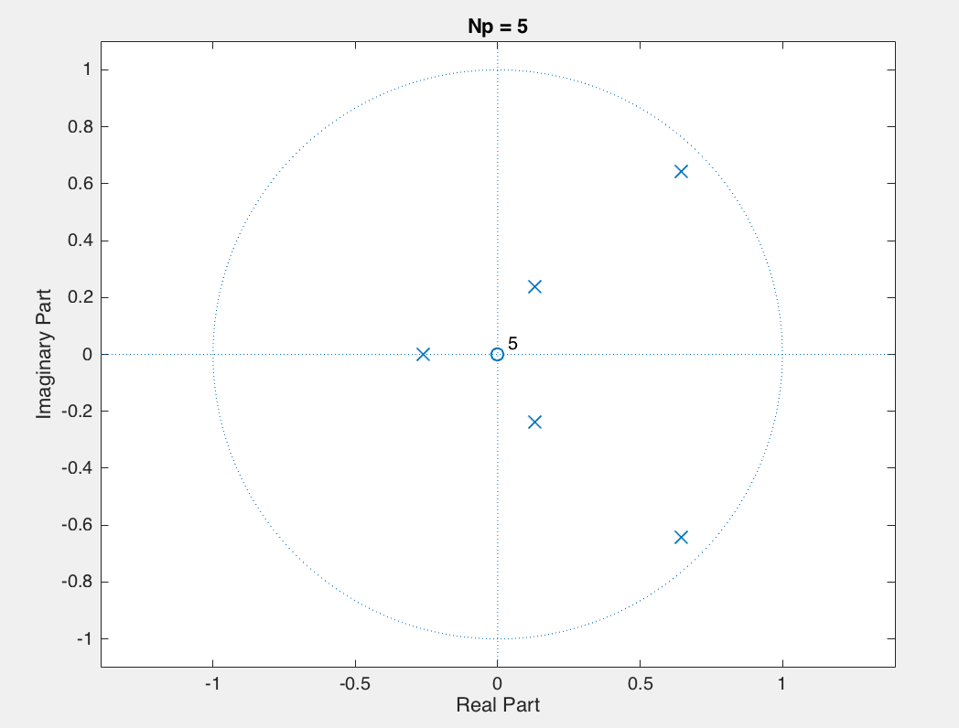

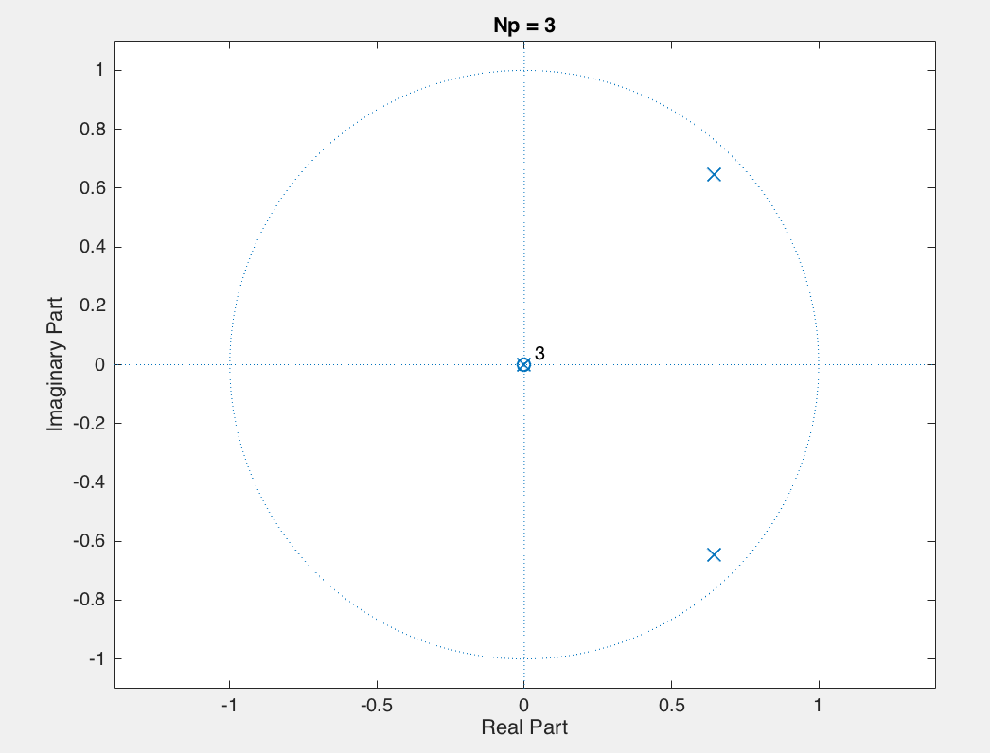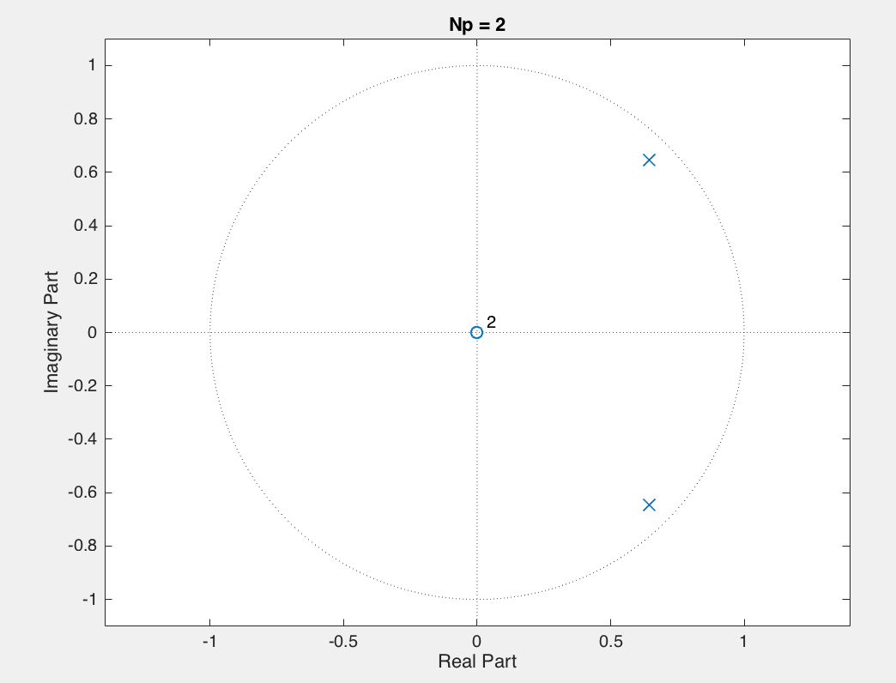

Comparing under-estimated AR model and true PSD: for System # 0

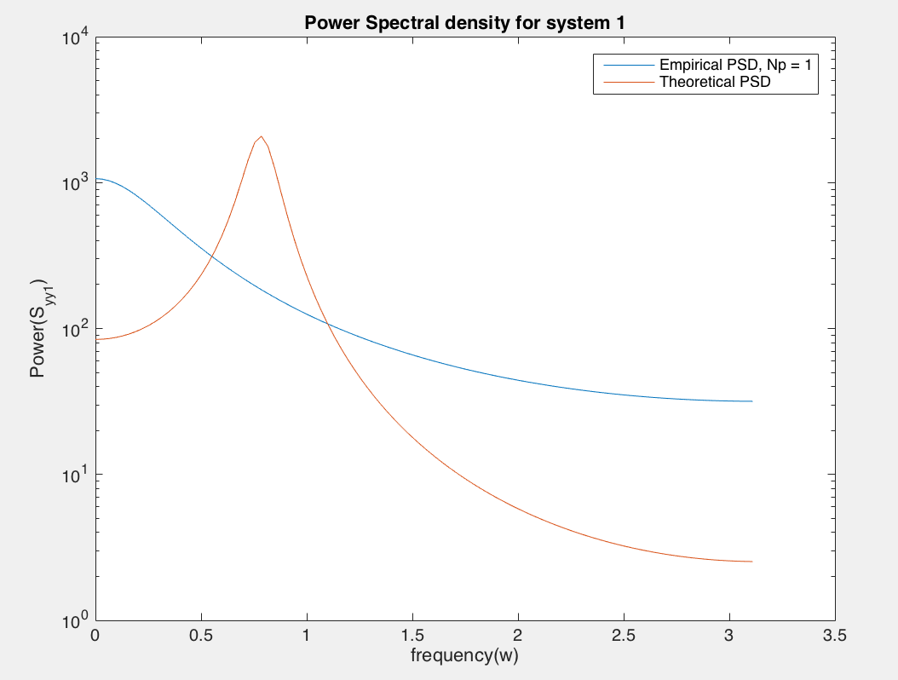

The quality of estimate reduced in lower order AR model. So not robust to under-estimation

1. Comparing the estimated (higher order AR models) and true power spectral density: for System #1

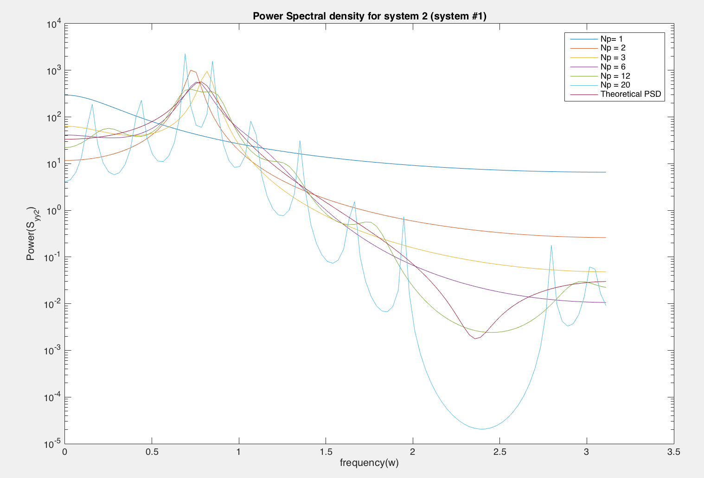

None of the AR models no matter what order are not providing good estimates of PSD compared to the theoretical PSD for System # 1. AR model is not sufficient to model system 1 which has poles as well as zeros. We can see in the pole zero plots below that all the AR models are only estimating the poles of the system since AR model only works for all-pole systems.

