Computer Problem

Problem 7.6

b.

ROC for each of these four detectors for this problem plotted on the same axis:

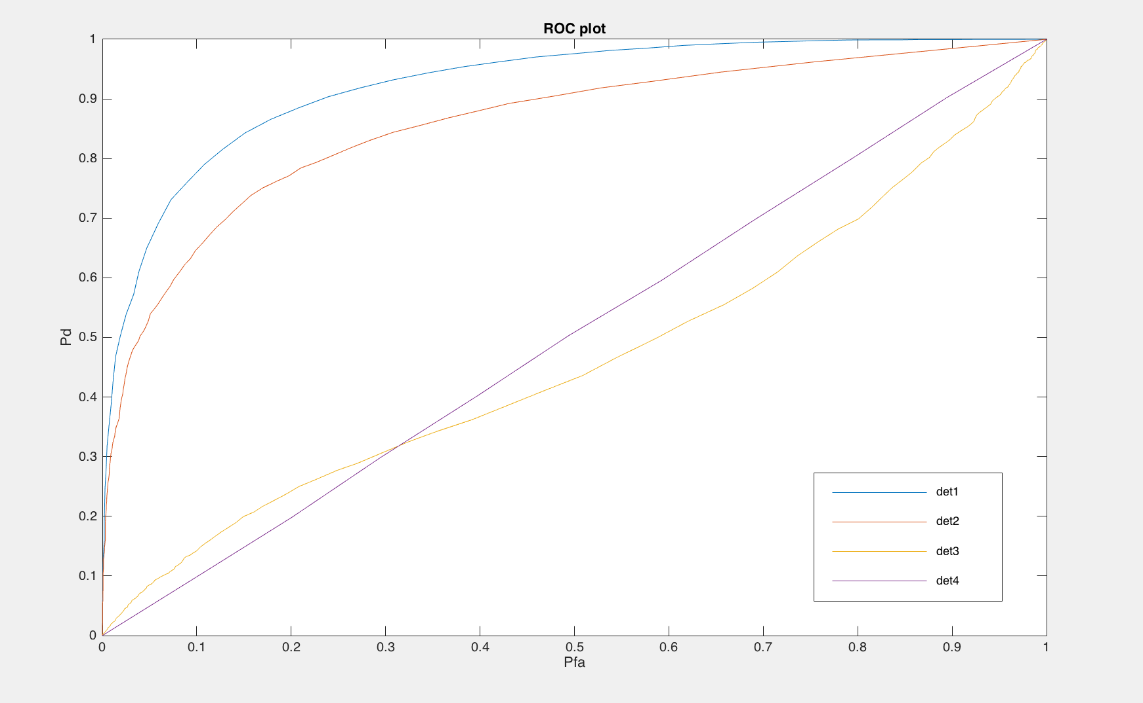

Detector 1 corresponds to the LRT optimal test for this problem. It can also be seen in the figure above. Det 1 has the highest Pd for a fixed Pf compared to other detectors.

c.

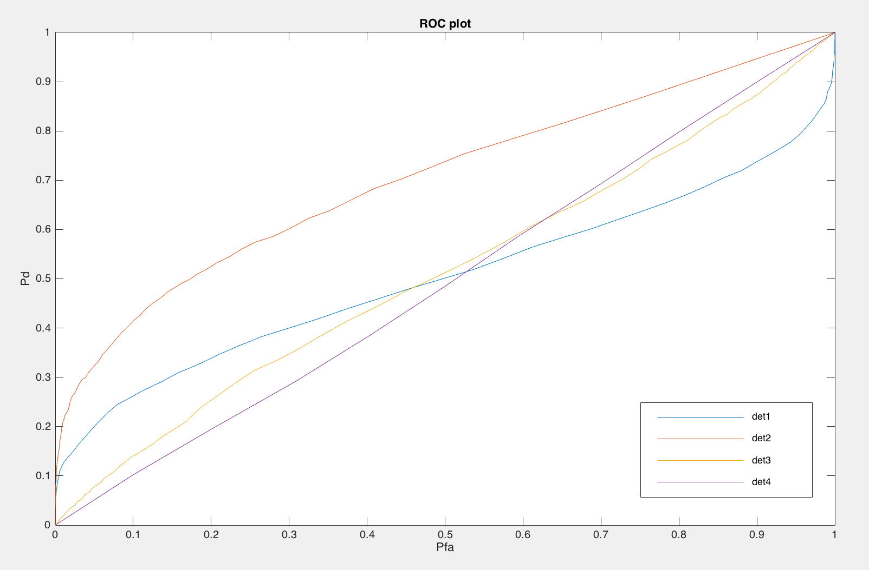

Detector 2 corresponds to the LRT optimal test for this problem. It can also be seen in the figure above. Det 2 has the highest Pd for a fixed Pf compared to other detectors.

d.

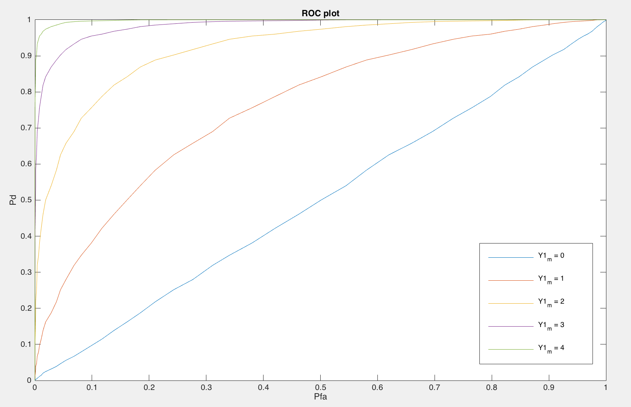

Comparing the ROCs for this detector 1 applied to Problem A as the mean m (i.e. the constant) under H1 is varied from 0 to 4.

Difference in means has to be atleast 2 to achieve PD ≈ .9 at a PF = 0.2

As the noise level is varied from 0 to 4, ROC curve becomes better.

Modelling noise as Cauchy noise instead of Gaussian. And comparing ROCs for detector 1 as the mean under H1 varies from 0 to 4.

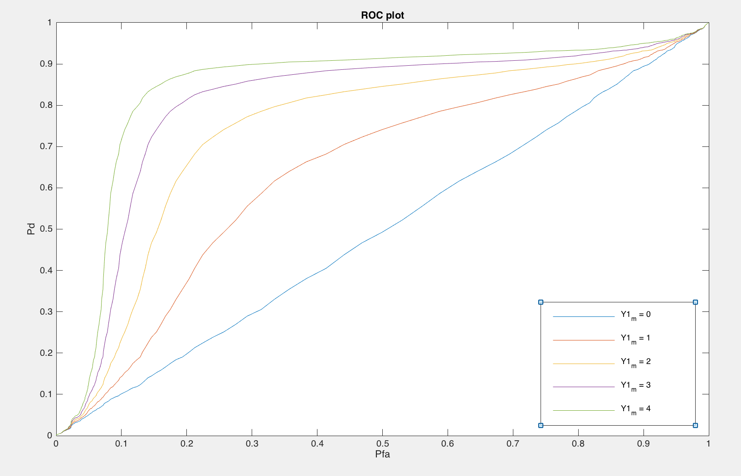

In the presence of Cauchy noise, difference in means has to be atleast 4 to achieve PD ≈ .9 at a PF = 0.2. ROC curves deteriorate when we are wrong about the noise model.