Computer Problems

Problem 8.8

1. Plotting the matched filter output Z for noise free case:

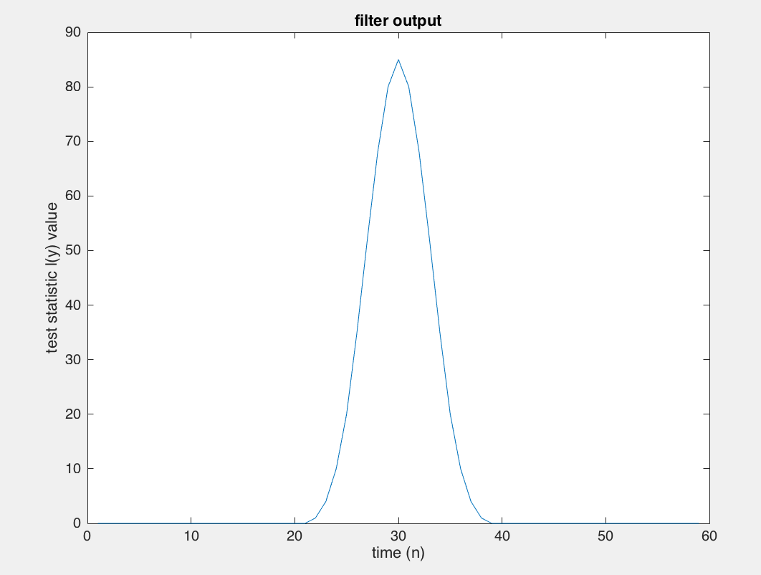

In the absence of noise the peak of the filter output is the value of the test statistic ell = 85 and occurs at n= Ns = 30 as seen in the above figure.

1. Plotting observed signal under H0 and H1: Y0 and Y1

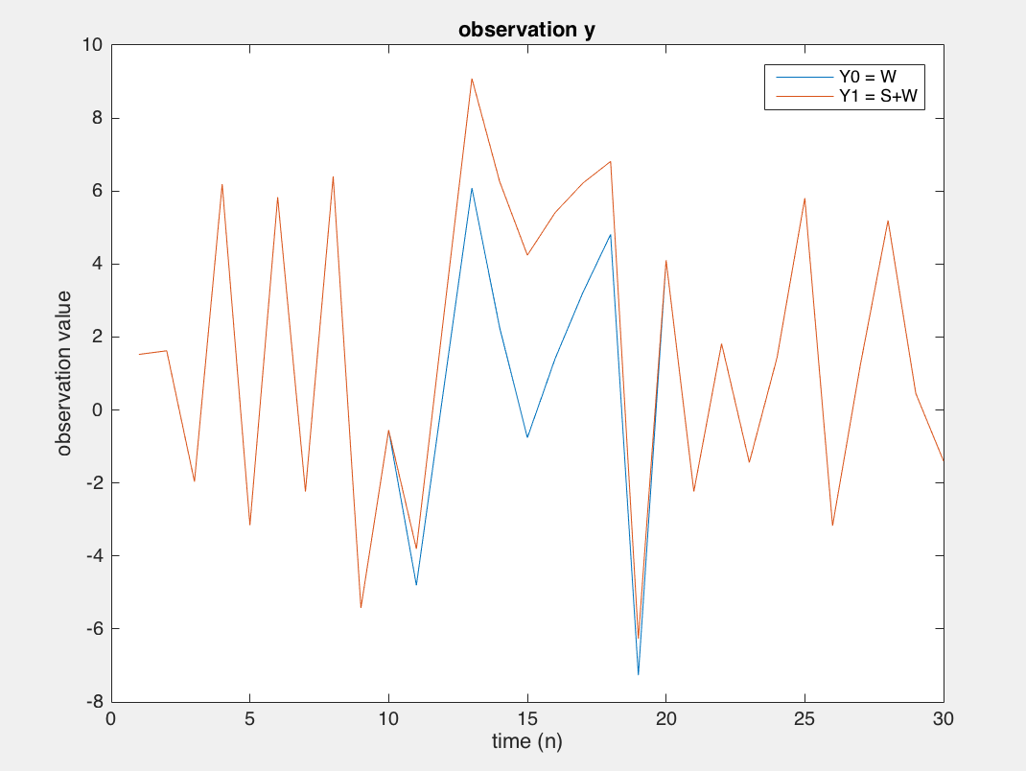

Just looking at this plot, we cannot say which contains the signal and which only noise, because of the high noise level.

Plotting filter outputs Z0 and Z1:

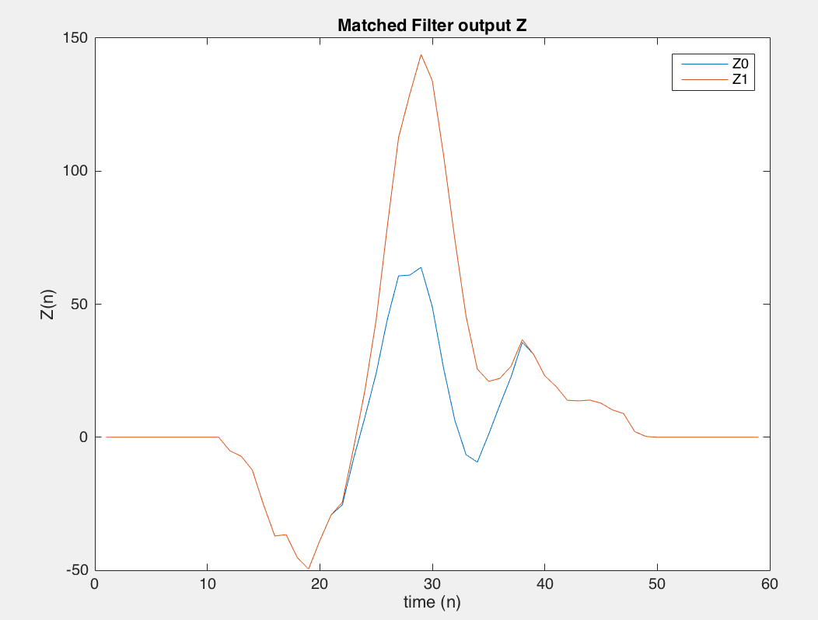

Values of Z(n) at time n = Ns = 30 for Z0 and Z1 are well seperated.

Repeat the experiment a few times:

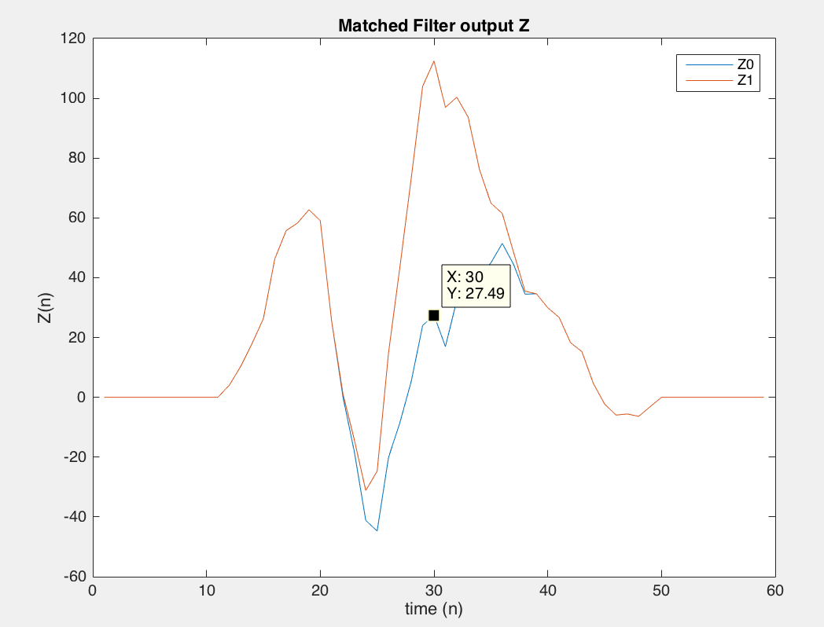 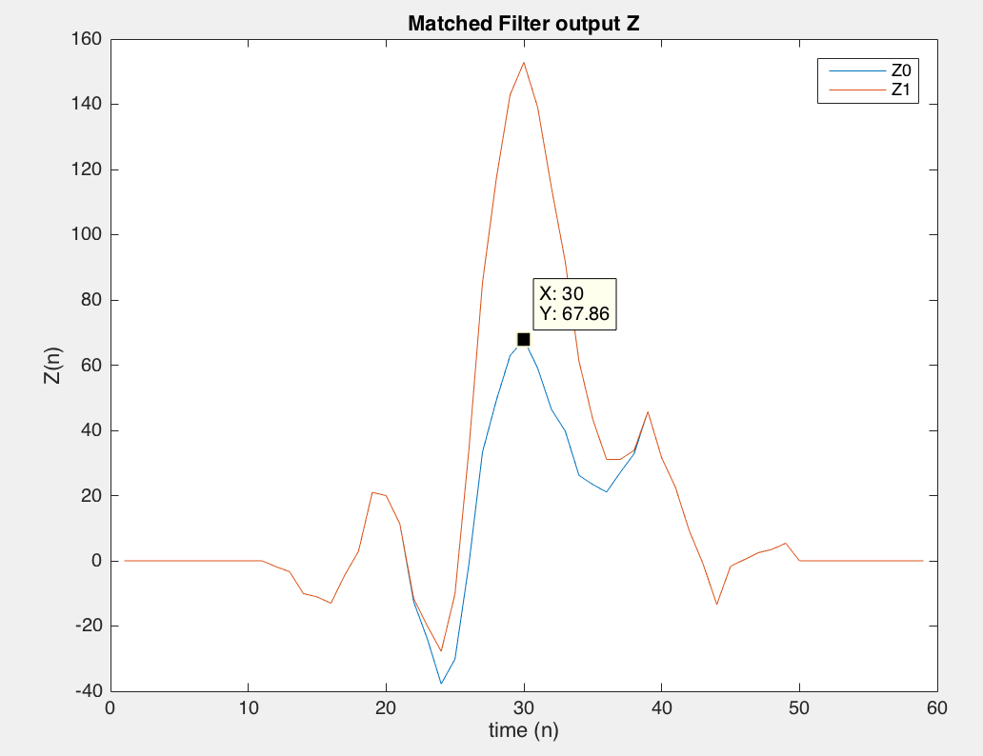

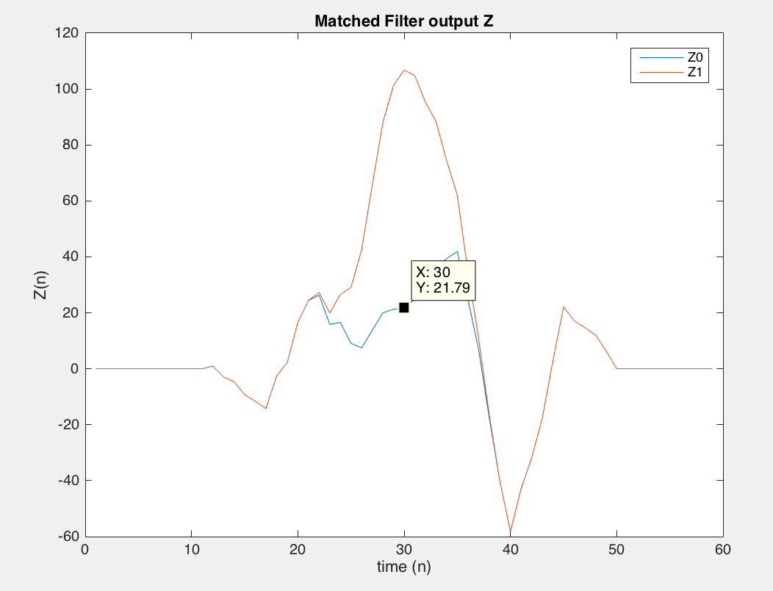 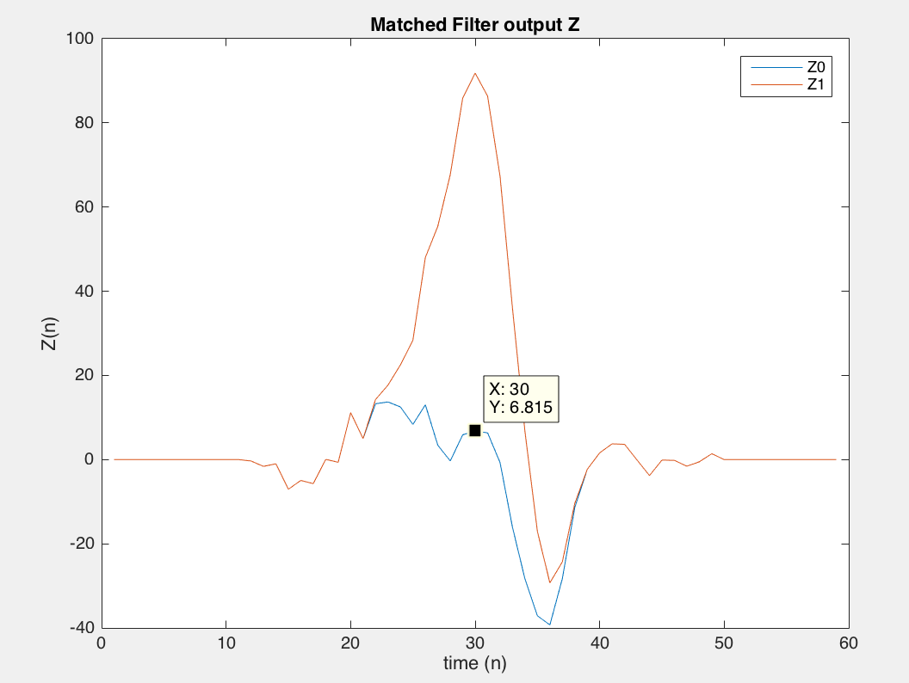

From the above figures, looking at the value of Z0 and Z1 at n = Ns = 30, It indeed seems true that for good performance we want gamma = 42.5.

Problem 8.9

b.

Plotting X targets:

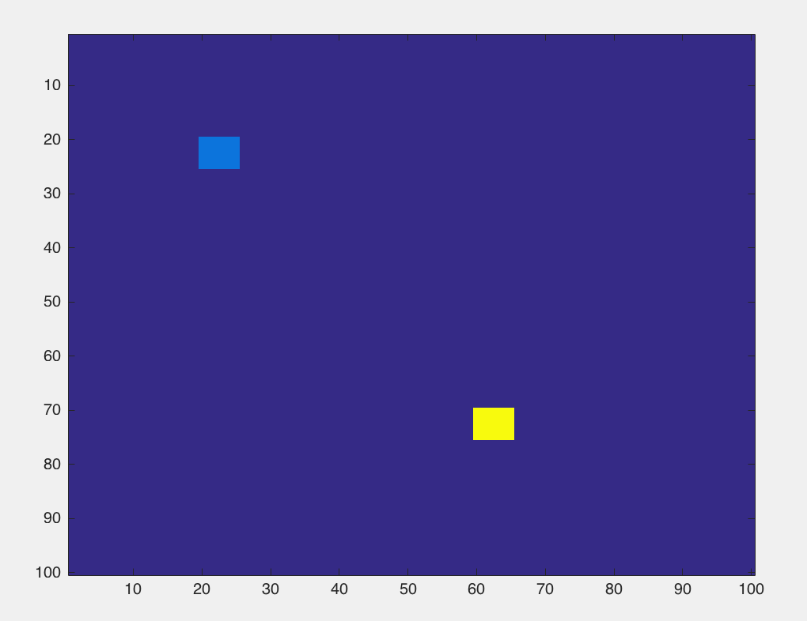

Plotting Y:

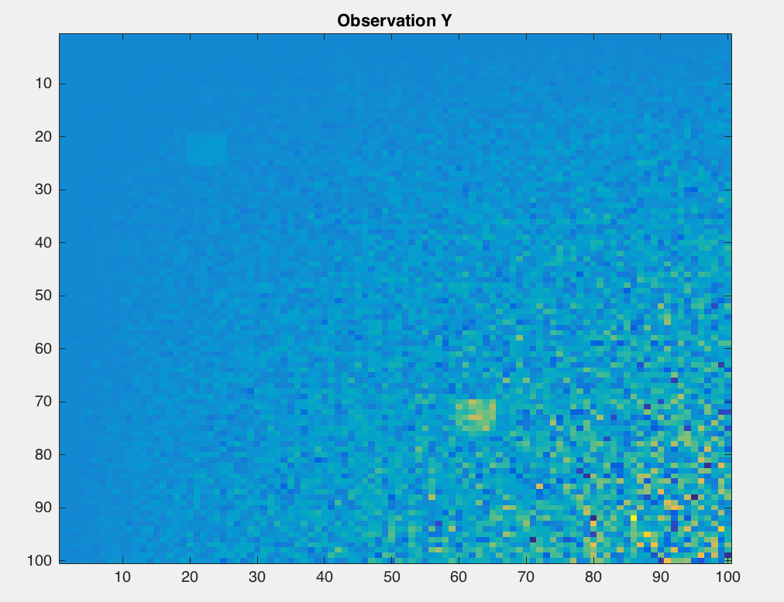

Targets are visible but covered with a lot of noise so difficult to see.

Plotting few rows of Y:

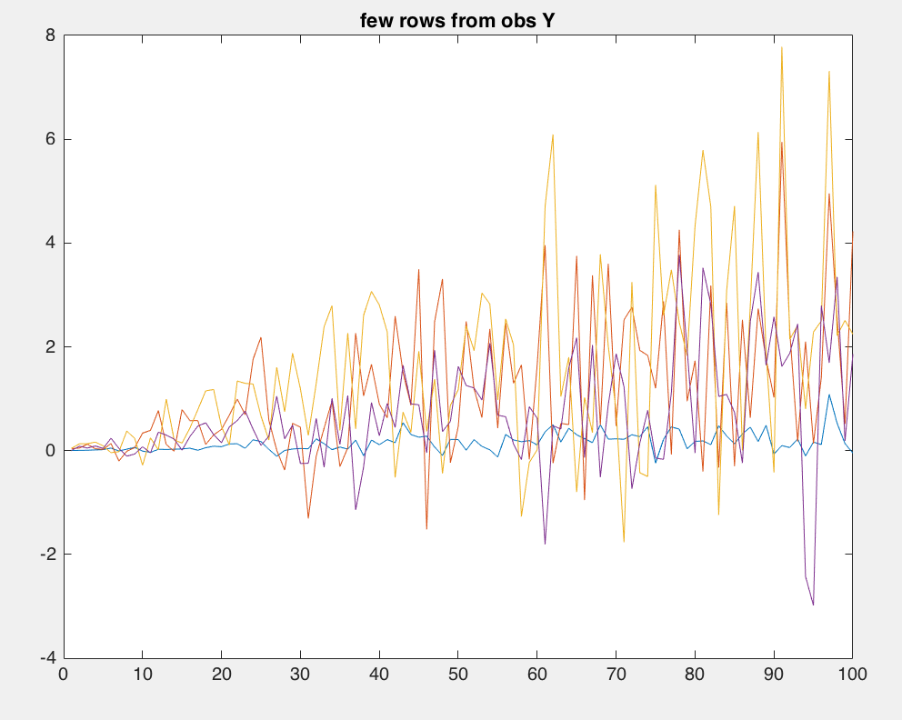

The mean and variance seems to differ a lot between different rows of Y. So single threshold will not be useful.

Plotting Z:

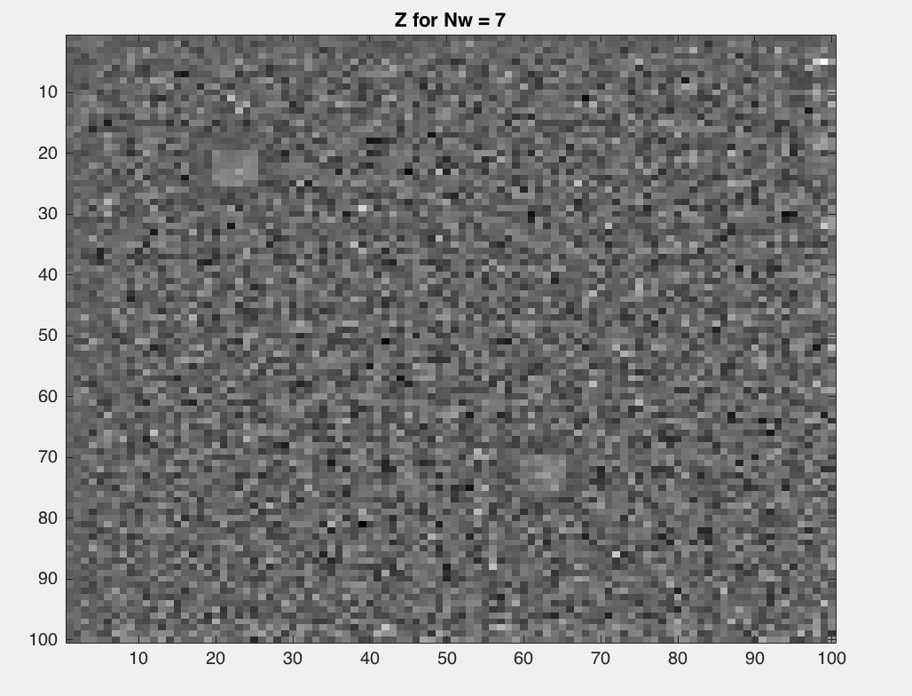 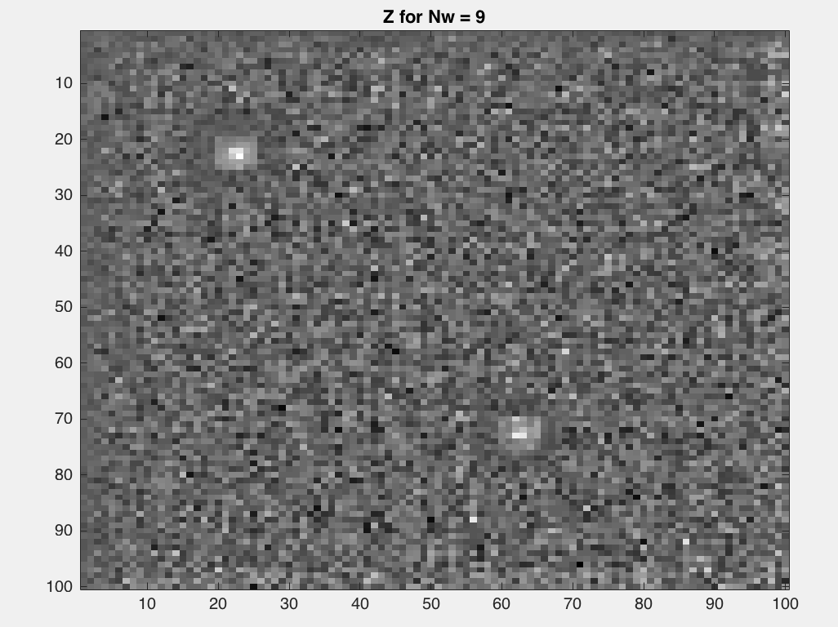

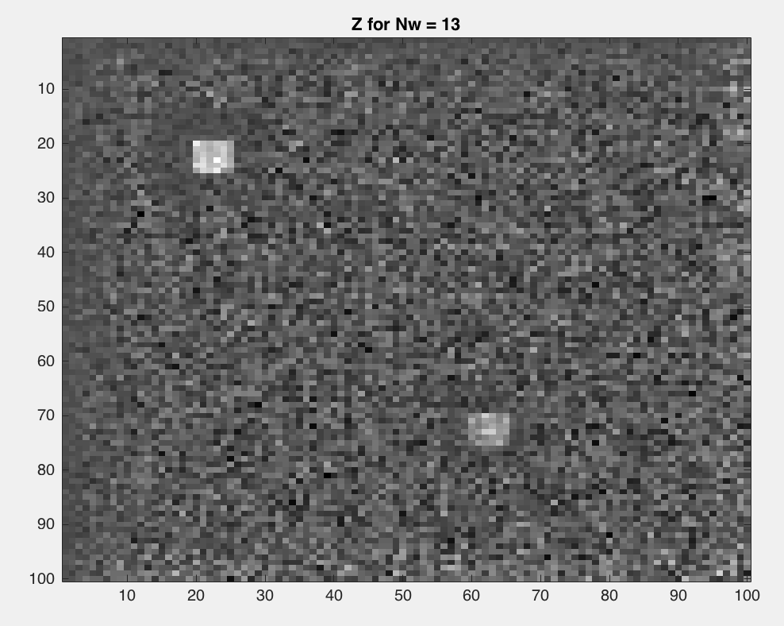 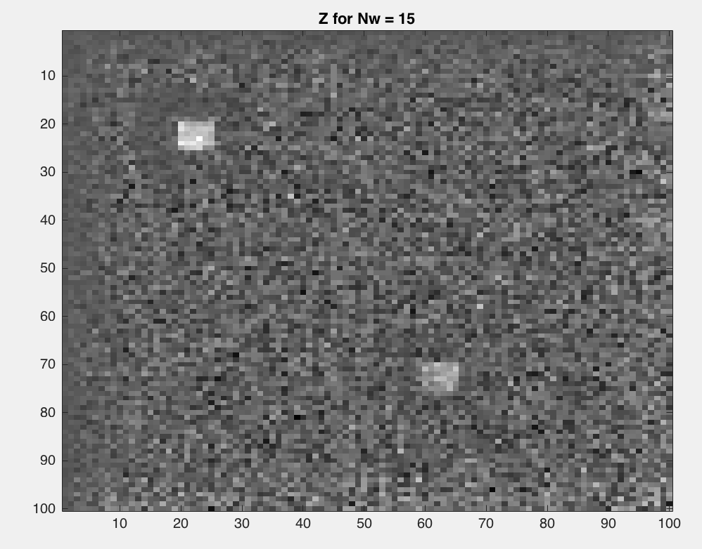

Larger the window, better the ability to detect the target.

Combination of Nw = 15 and Z>-2.35 works the best, but background has values above this threshold so difficult to isolate the background from target completely.

