Problem 9.10

a)

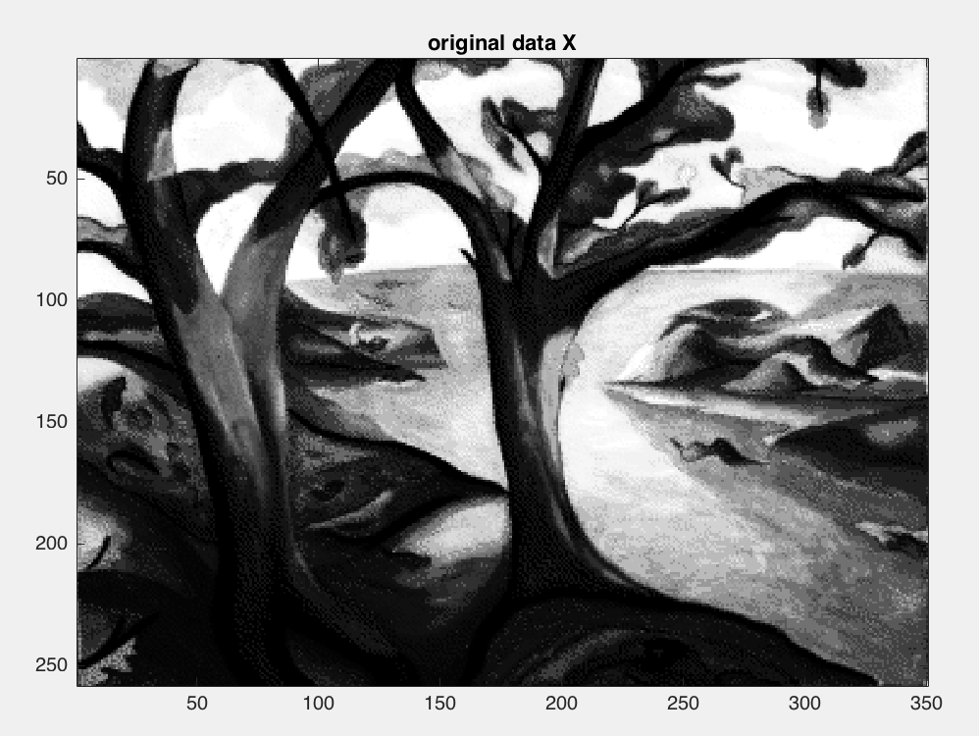 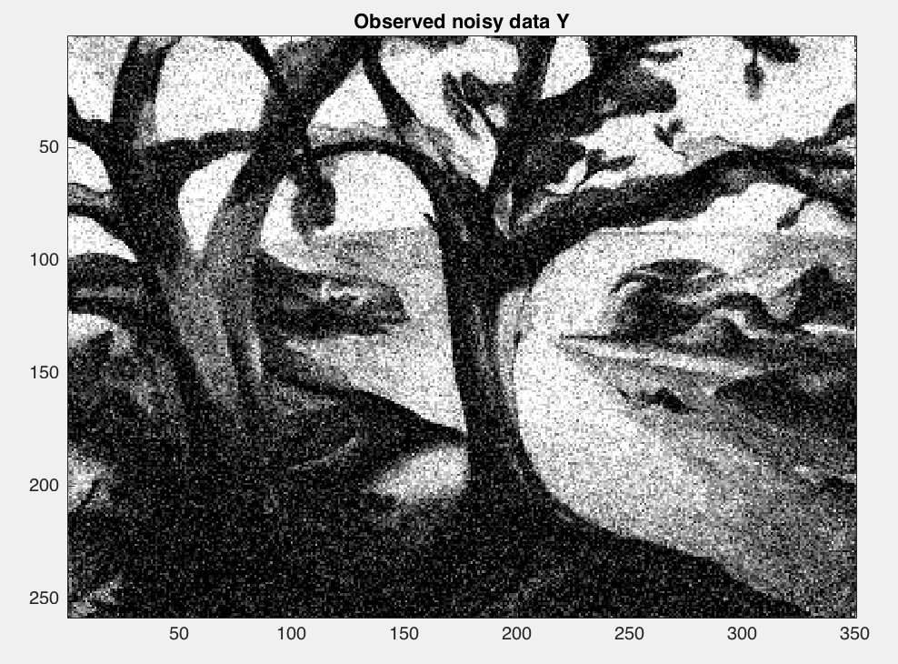

MSE_Y = 396.5855

c)

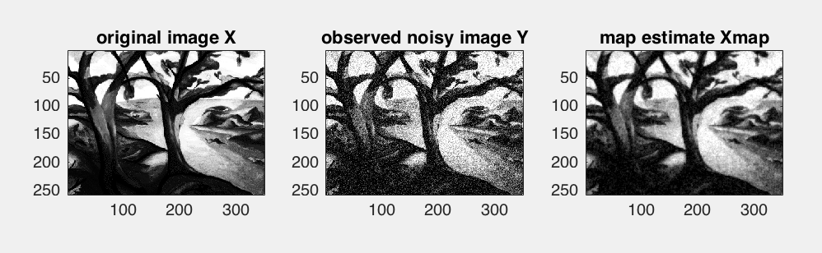

MSE_Xmap = 87.1861

MAP estimate is much better compared to noisy image in terms of its MSE. Also in appearance, Xmap is better and less noisier than observed noisy image Y. Compared to original image X, Xmap looks blurred and lacking finer details. This approach definitely reduces the noise in the image but is not able to restore the original image much, instead we get a blurred version of the original image. Some noise still exists.

Problem 9.11

a)

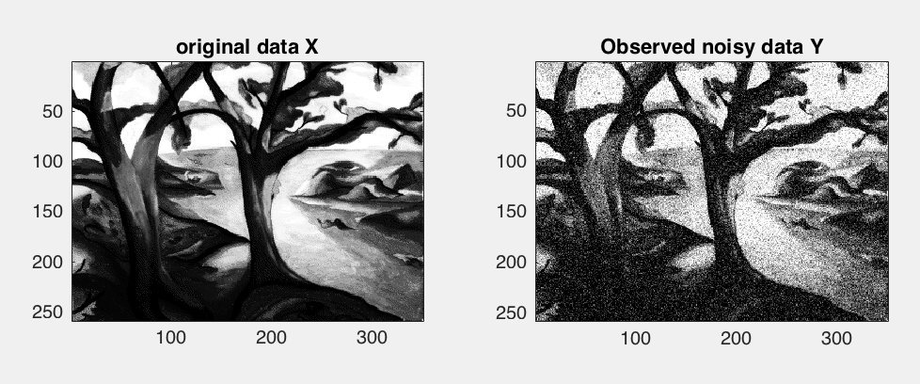

Rxx(n1,n2) seems reasonable. Highly correlated with itself.

c)

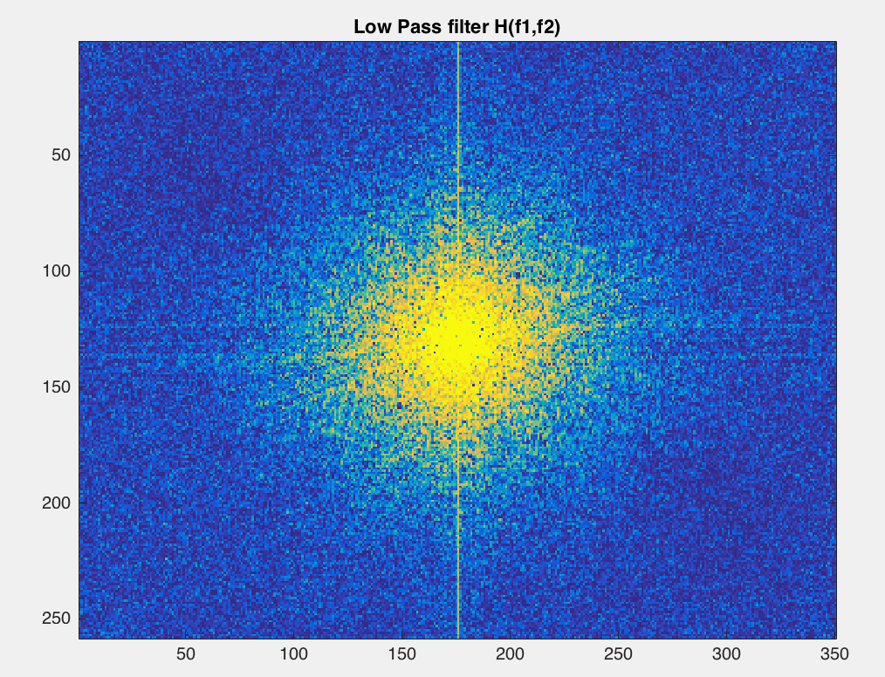

This is a low pass filter

d)

MSE_Xwf = 71.3233

Wiener filtered estimate is definitely better than MAP estimate when compared the MSE for both.

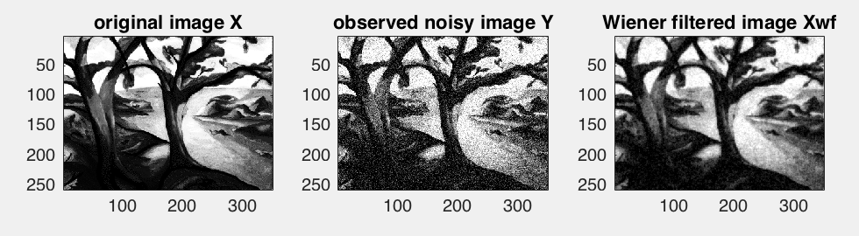

Relative to the original image, these restored MAP or wiener-filtered estimates seem blurry. Lacking the finer details present in original image and the image contrast.