**Problem 1.9**

b) Program randcau.m to generate Cauchy random variables:

function [Y] = randcau(N)

% Usage: [Y] = randcau(N)

% Creates N Cauchy random variable

% N: number of random variables to be created

% Y: vector of cauchy random variables transformed from X: U[0,1]

X = rand(N,1);

P_inverse_x = tan(pi*(X-0.5));

Y = P_inverse_x;

Plot of a few thousand Cauchy random variables to see the impulsive behavior:

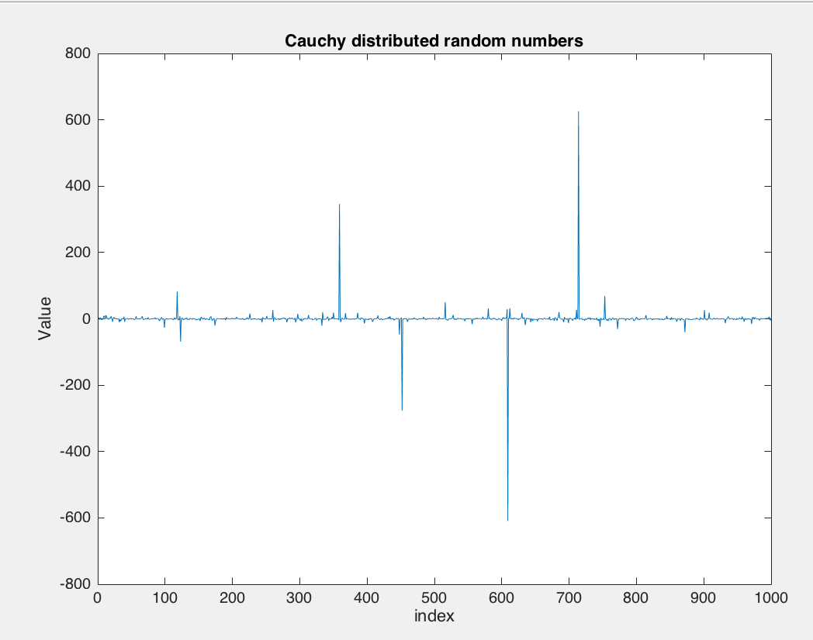

pdf of Cauchy random variables: Heavy tailed nature of the Cauchy RV is seen in the plot below, with sizeable probability mass in the tails of the distribution going till -600 or 600, far away from the peak which is at 0. Impulse at the mean also suggests less mass at the mean.

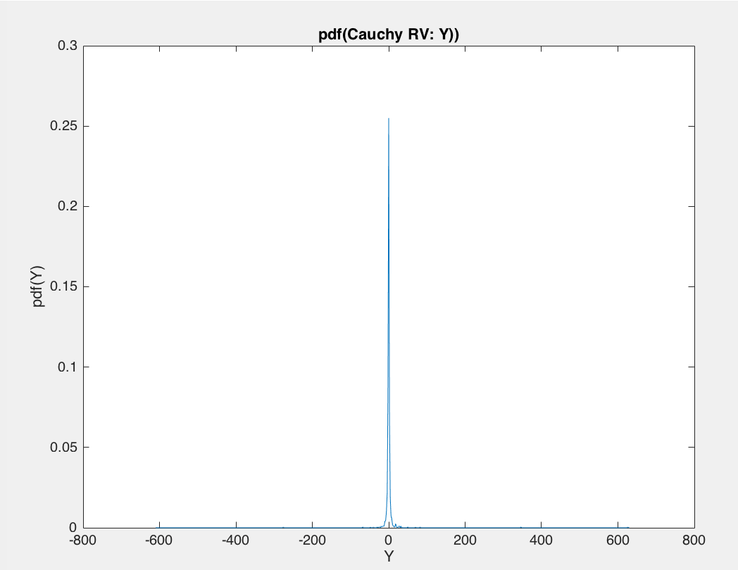

c) We can generate generate zero mean, unit variance Gaussian random variables from uniform random variables using central limit theorem.

Scheme:

1. Generate N iid RVs, each RV containing n unformly distributed random numbers.
2. Compute sample means for each of these N iid RVs.
3. If n is large enough, the sample means M are normally distributed with mean m and std dev sigma
4. (Vector M – mean(M))/std(M) = Y -> N(0,1). All numbers in vector Y will be normally distributed with mean approximately 0 and std deviation 1.

Code:

function [Y] = randgauss(N)

% Usage: [Y] = randgauss(N)

% Creates N Gaussian distributed random numbers

% N: number of random variables to be created

% Y: vector of Gaussian random variables:N[0,1],transformed from X: U[0,1]

X = rand(N,1000);

mean_X = mean(X,2);

mean_mean = mean(mean_X);

std_mean = std(mean_X);

standard_normal_Y = ((mean_X - mean_mean)/std_mean);

Y = standard_normal_Y;

Result:

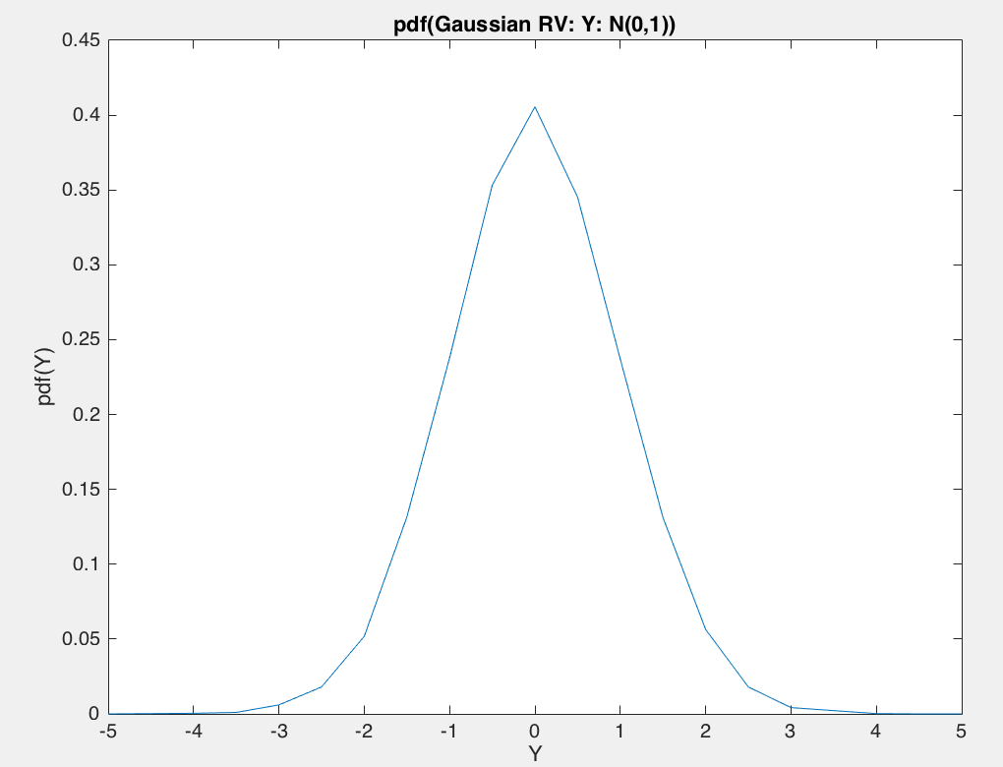

**Problem 1.10**

a)

i. Plots of empirical joint pdf pXi,Yi (xi , yi) and CDF PXi,Yi (xi , yi):

x1,y1: x2,y2:

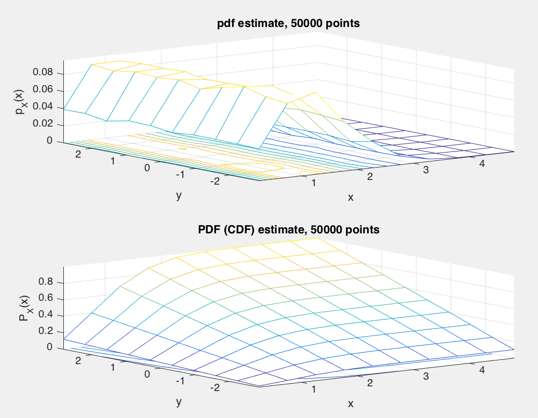 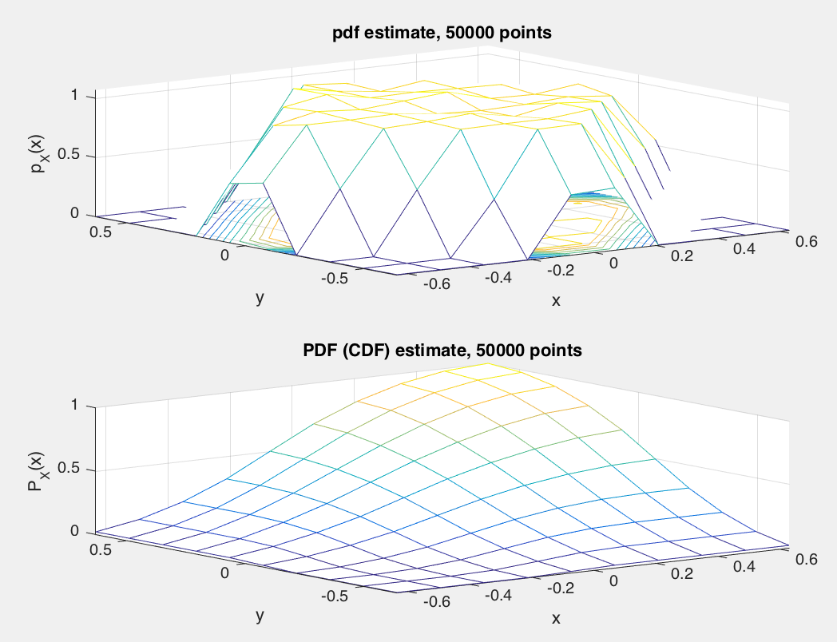

x3,y3: x4,y4:

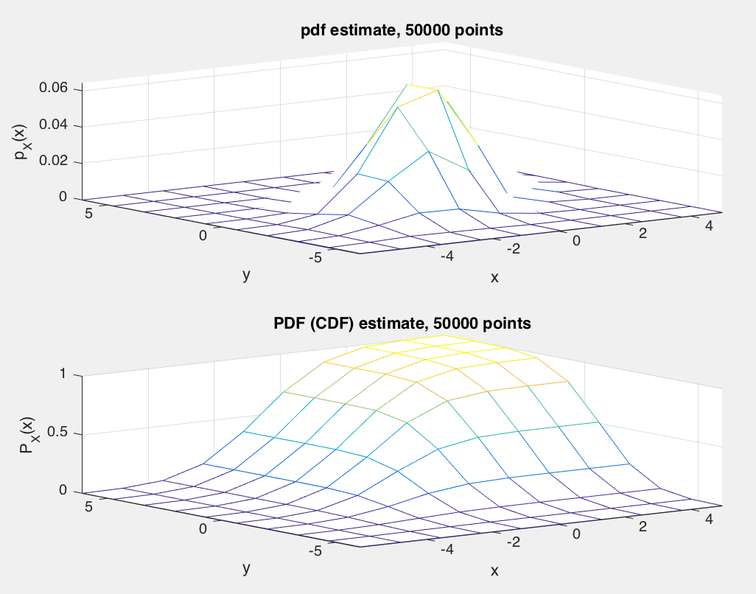 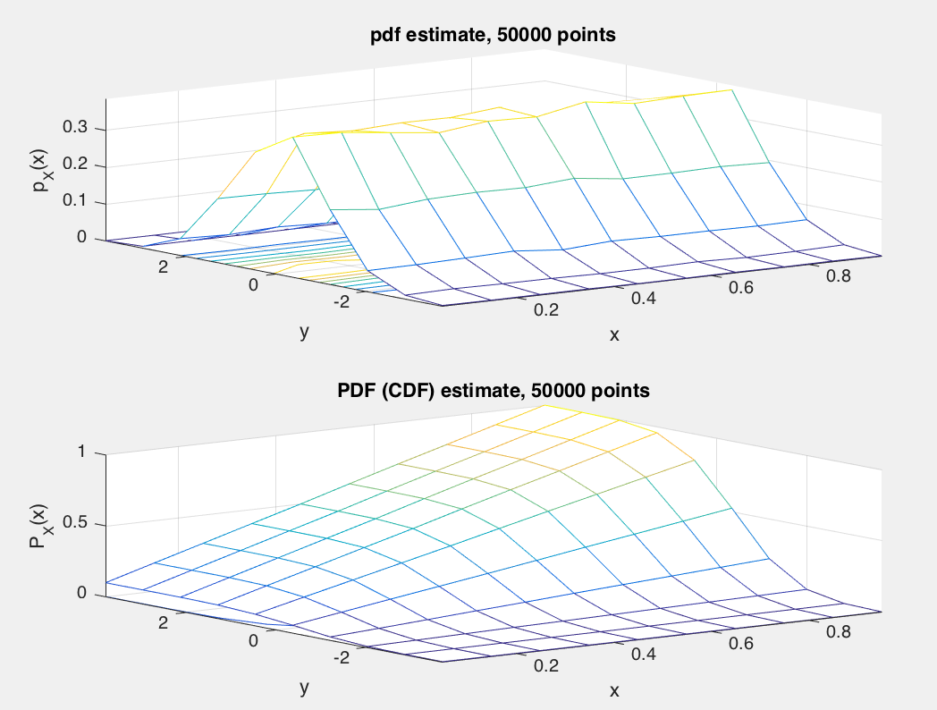

ii. Plots of empirical marginal distributions pXi (xi) and pYi (yi).

x1: y1:

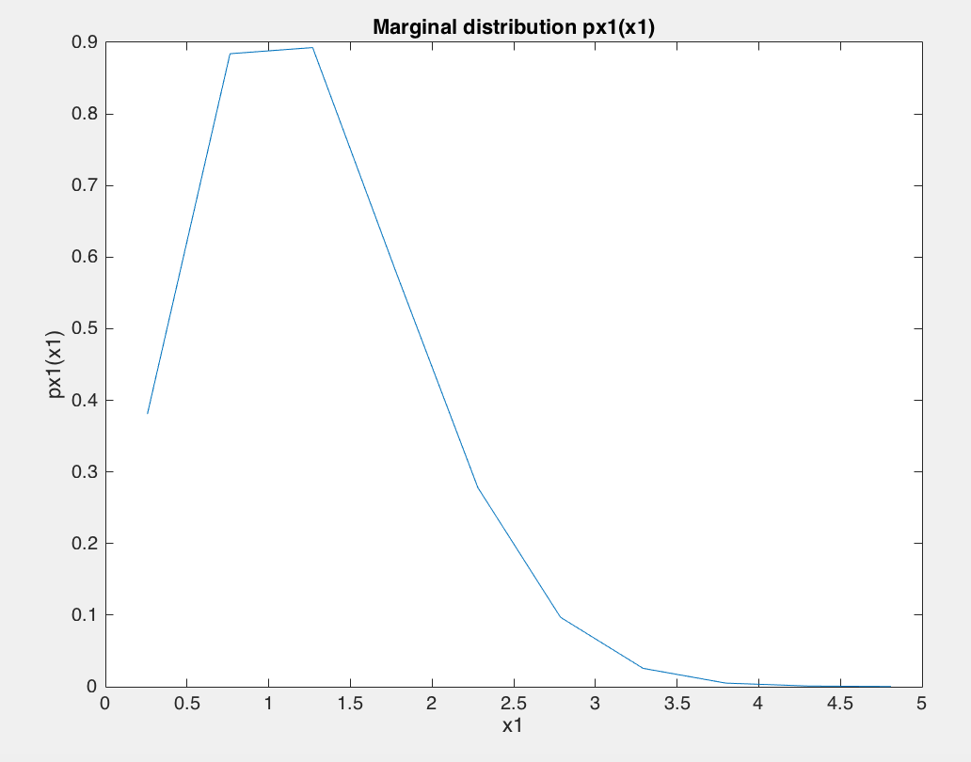 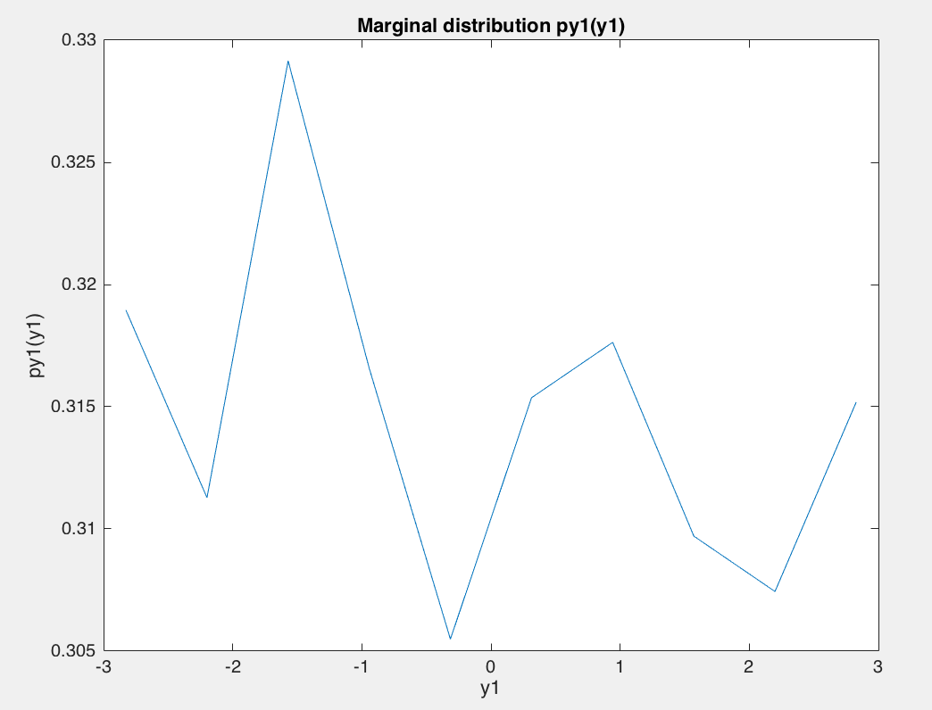

x2: y2:

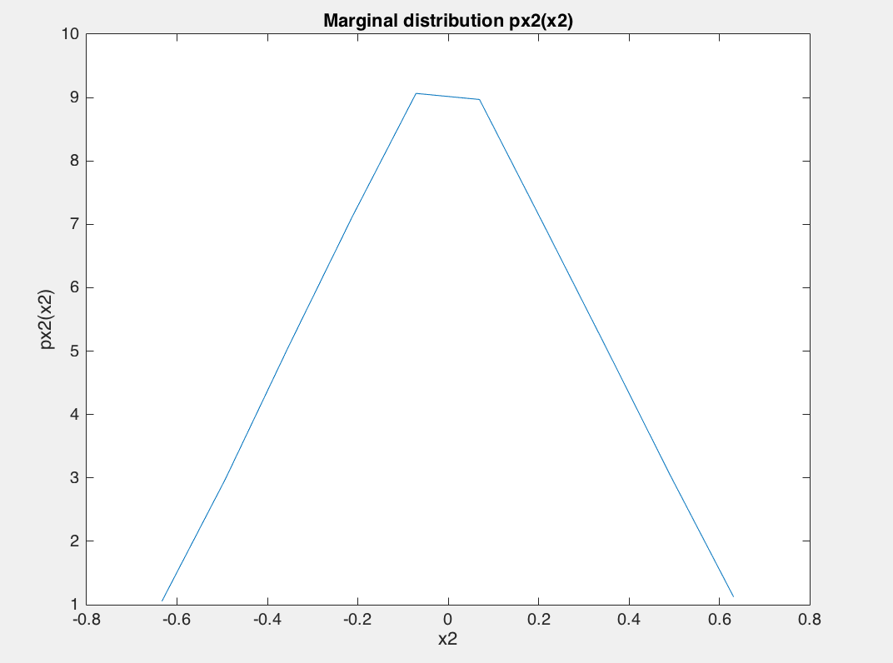 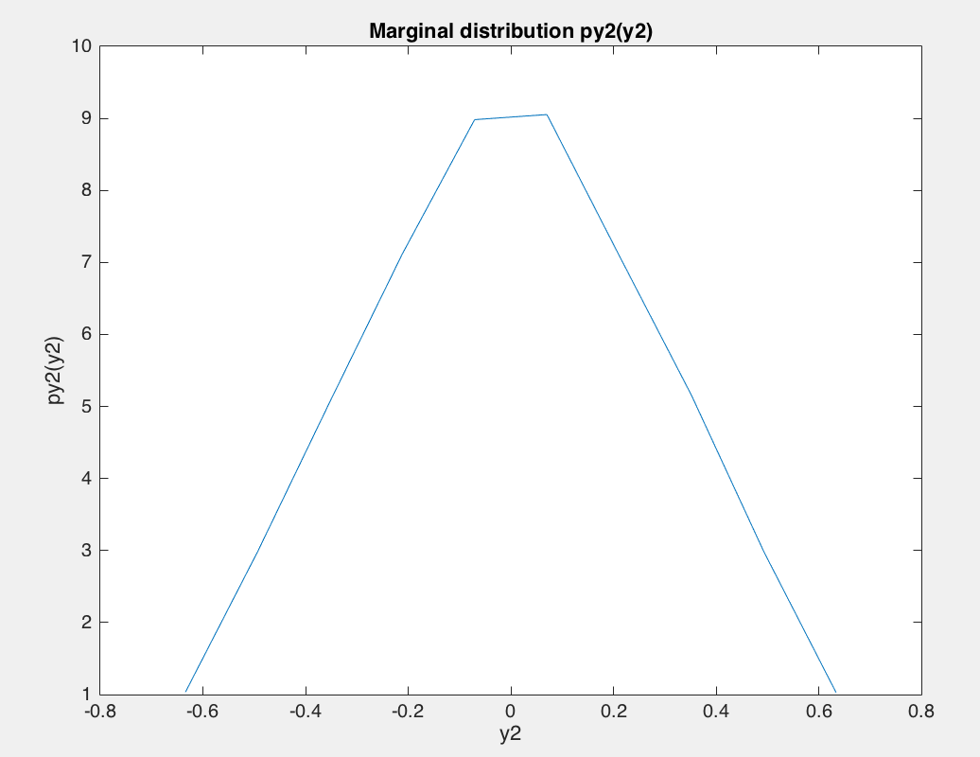

x3: y3:

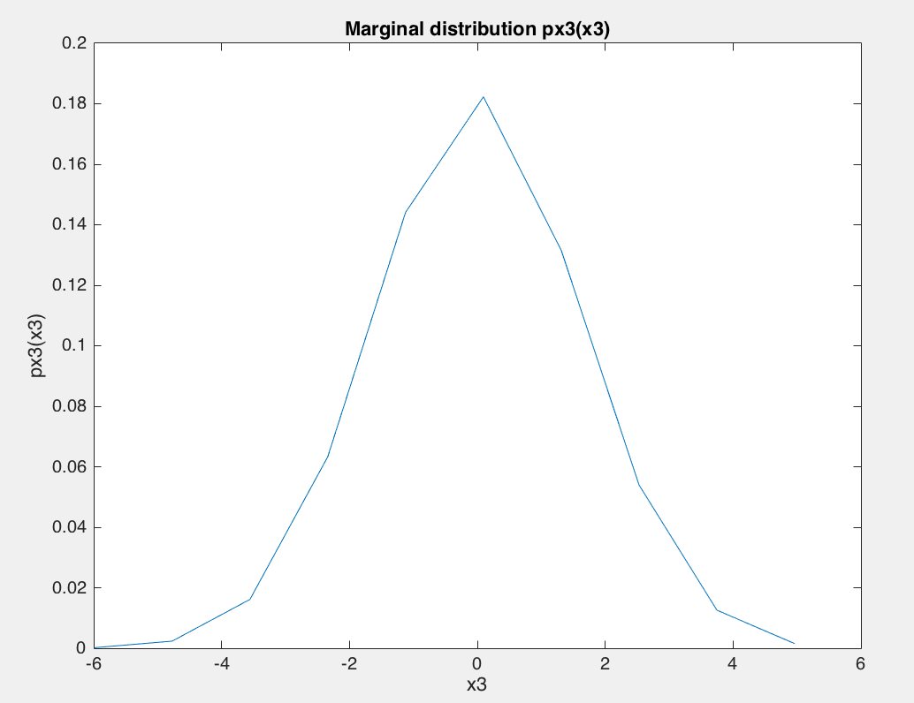 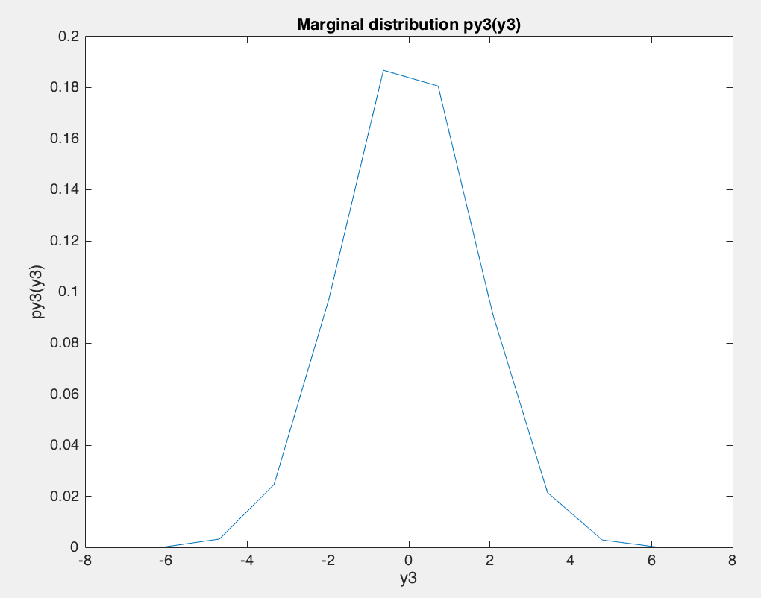

x4: y4:

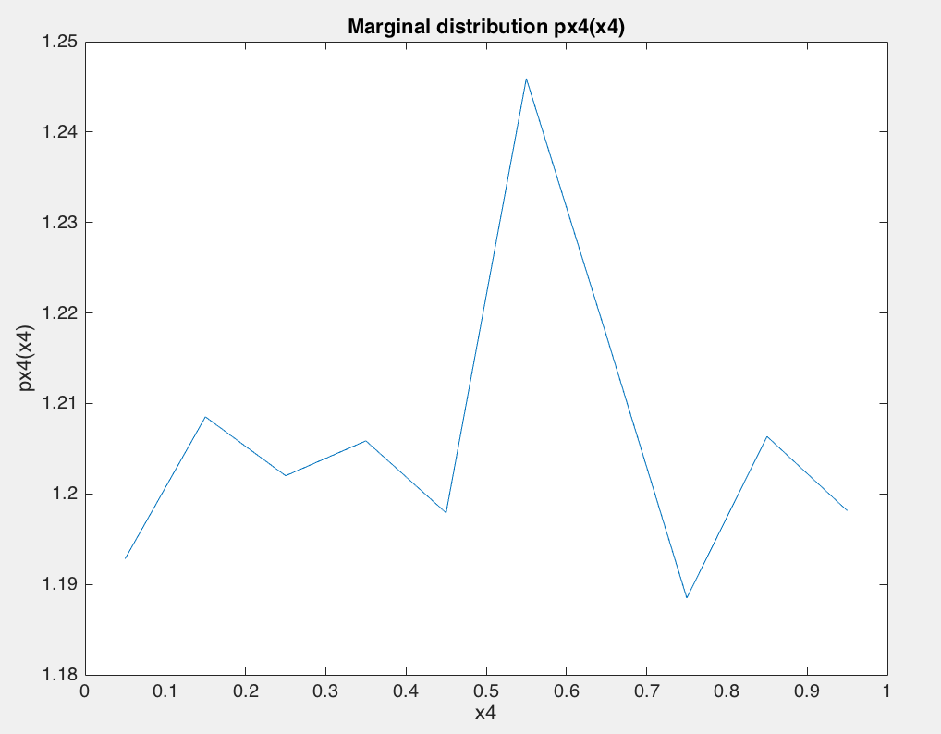 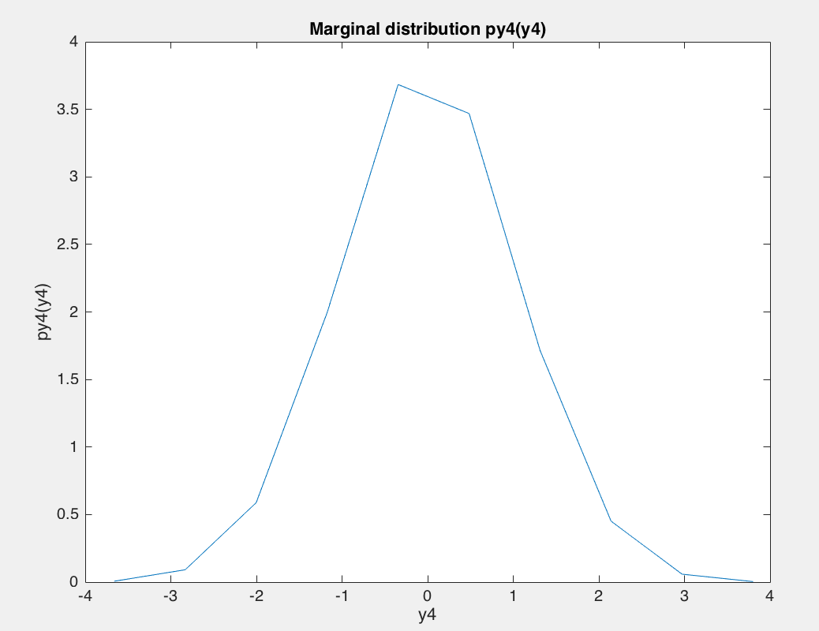

iii. Empricial covariance matrix & correlation coeeficient :

cov1 = 0.4309 -0.0003 corr1 = -2.3623e-04

-0.0003 3.2938

cov2 = 0.0835 -0.0003 corr2 = -0.0041

-0.0003 0.0828

cov3 = 2.4706 1.4910 corr3 = 0.6005

1.4910 2.4953

cov4 = 0.0829 0.0011 corr4 = 0.0039

0.0011 1.0009

Aprroximated E[XiYi] : cov(Xi,Yi)+ (mean(xi)*mean(yi))

E[x1y1] = -0.0183

E[x2y2] = -3.4144e-04

E[x3y3] = 1.4911

E[x4y4] = 0.0025

Plots of empirical conditional pdf:

X1:

pXi|Yi (xi |yi = .5) pXi|Yi (xi |yi = .75)

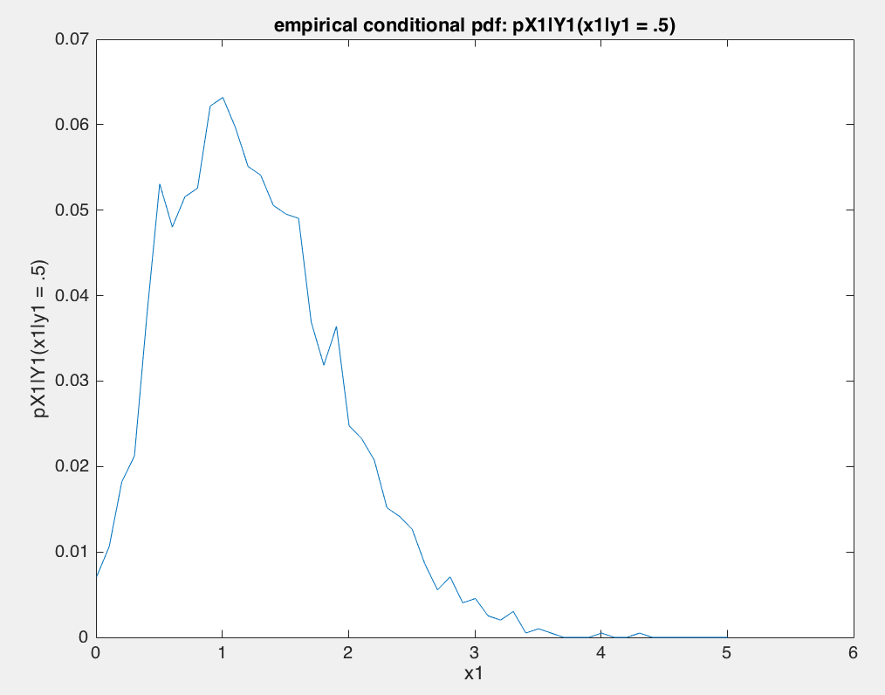 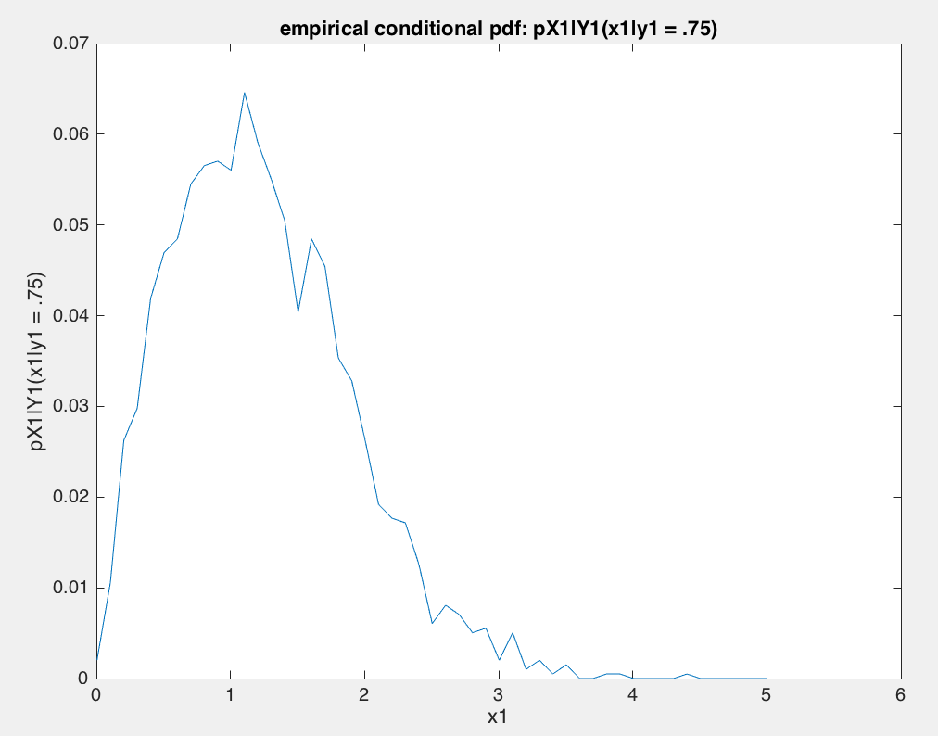

X2:

pXi|Yi (xi |yi = .5) pXi|Yi (xi |yi = .75)

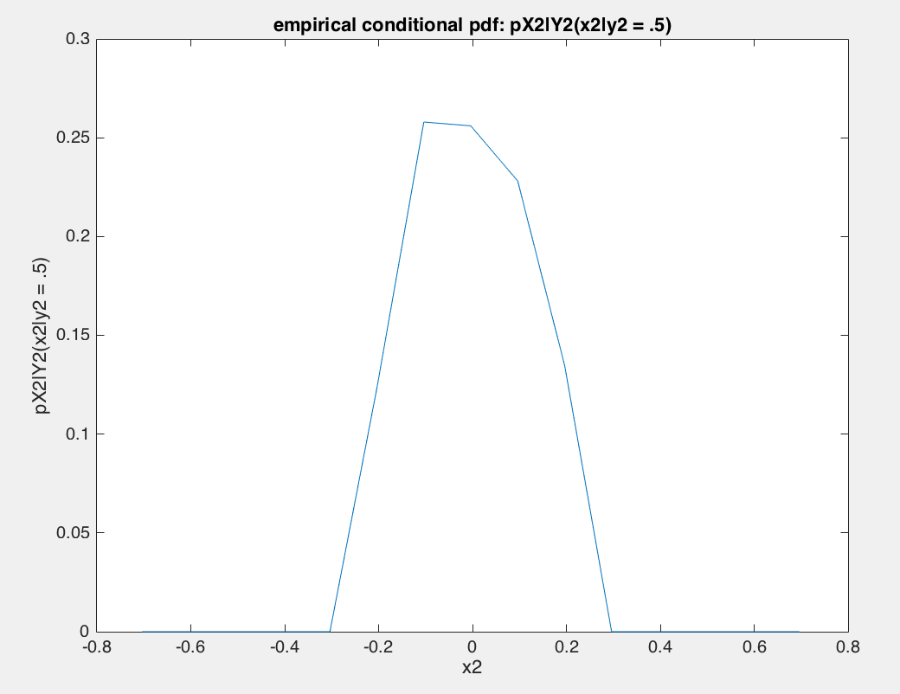 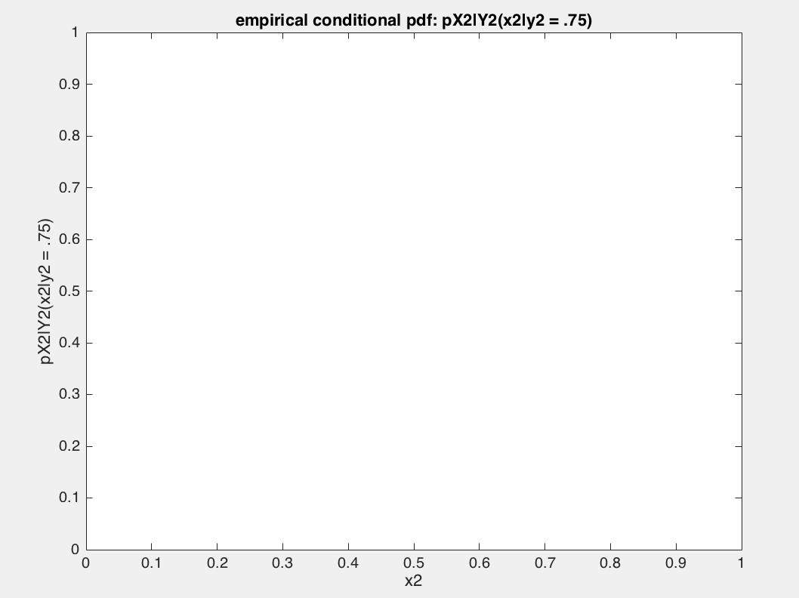

X3:

pXi|Yi (xi |yi = .5) pXi|Yi (xi |yi = .75)

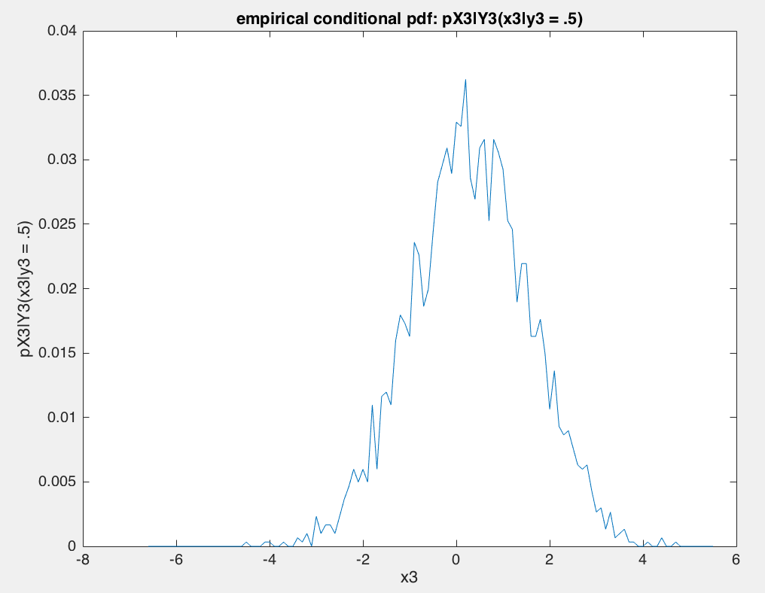 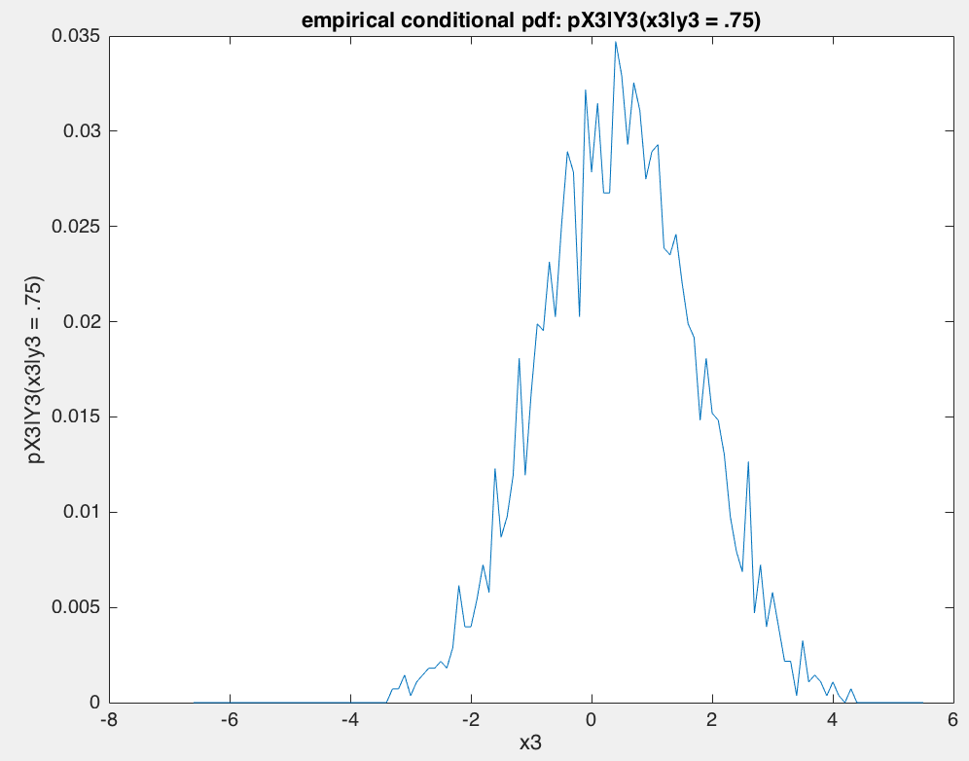

X4:

pXi|Yi (xi |yi = .5) pXi|Yi (xi |yi = .75)

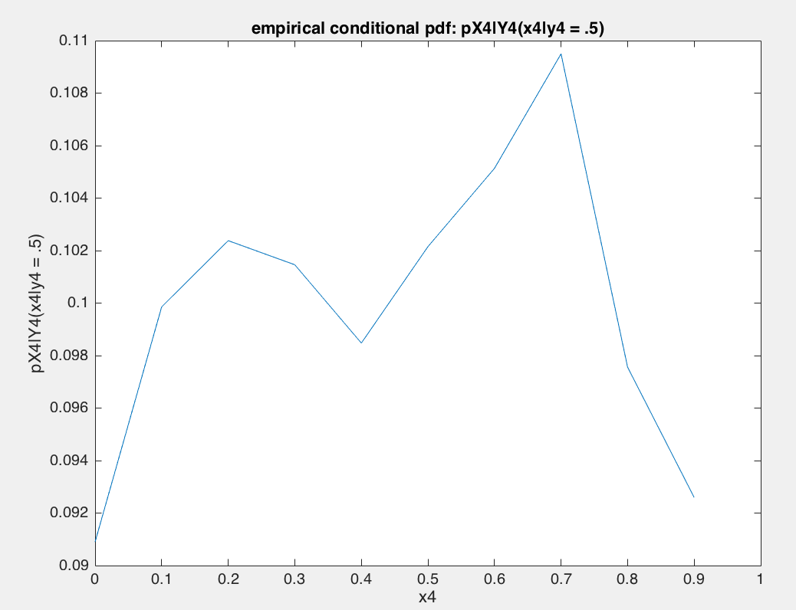 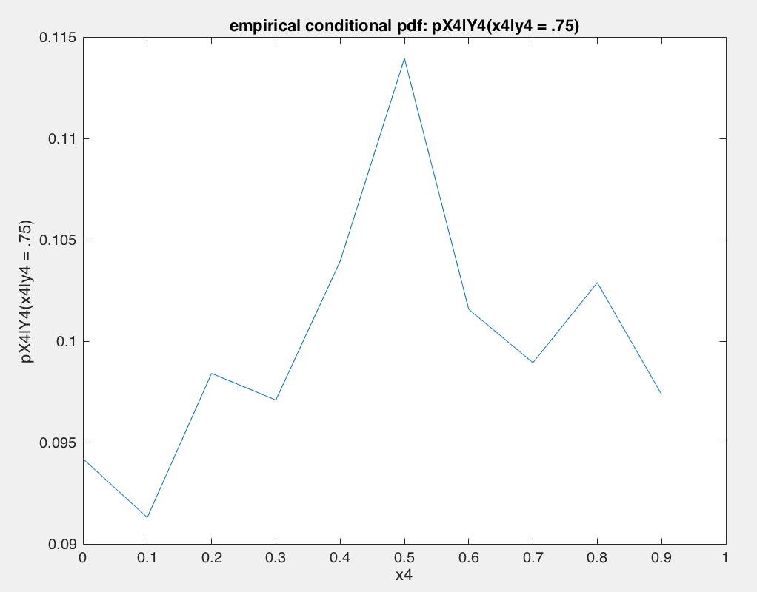

b)

1st, 2nd and 4th sets came from uncorrelated RVs as their covariance is almost or near zero. 1st set is independent as Pxi,yi(xi,yi) – Pxi(xi)Pyi(yi) ~ 0 for set 1.