Turn OFF the following functions of Reference Camera and Target Camera (AK-HC3800/HC3500A). ① Knee/Auto Knee ② White Clip ③ DTL(H/V Detail)

1- Signal level at 70 IRE(https://www.streamingmedia.com/Producer/Articles/ReadArticle.aspx?ArticleID=102457&PageNum=2)

2- Half zoom

3- Between 4 - 5.6 lens aperture(https://www.cnrood.com/en/amfile/file/download/file_id/1290/product_id/1170/)

4- Saw adjustment: Saw and parabola adjustments can be made both horizontally and vertically (horizontal adjustments made when viewing a horizontal sweep, vertical adjustments made when viewing a vertical sweep).

Start by making horizontal adjustments to the Green channel by selecting G from the PMW-300K1’s Shading CH option, and adjusting the H SAW and H PARA parameters as needed (Figure 11, below). You should be watching adjustments live on the monitor to determine how much of each you should apply. Once you’re happy with the green channel, move on to red, and finally blue. You should end up with the waveforms looking as straight as possible. From there, adjust the monitor to display a vertical sweep, and make adjustments to the V SAW and V PARA fields as needed, again in the order of green, red, blue.

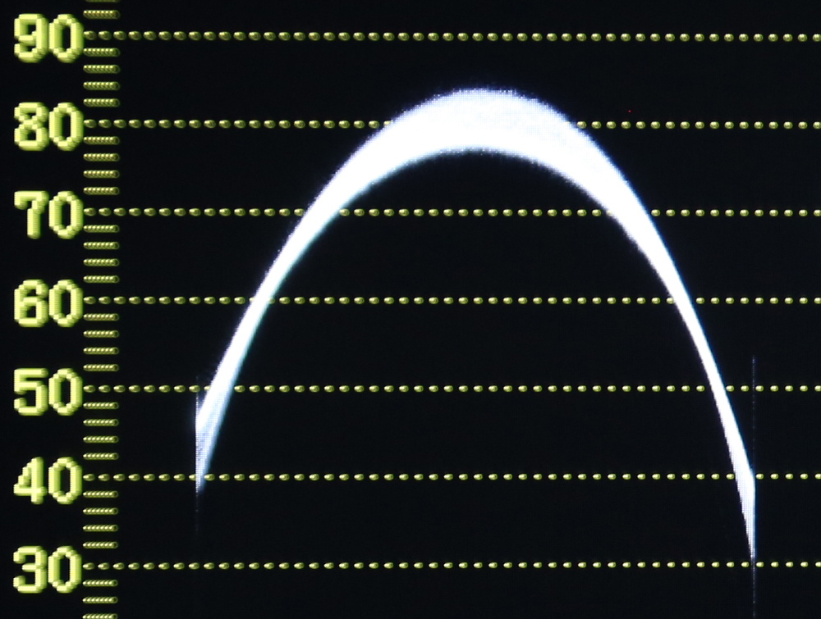

**Parabola adjustment.**

Saw adjustment (**Figure 10, below**): A saw adjustment affects the angle of an already straight waveform. In this example, the saw adjustment would be used to bring the right side of the waveform up, and the left side of the waveform down.

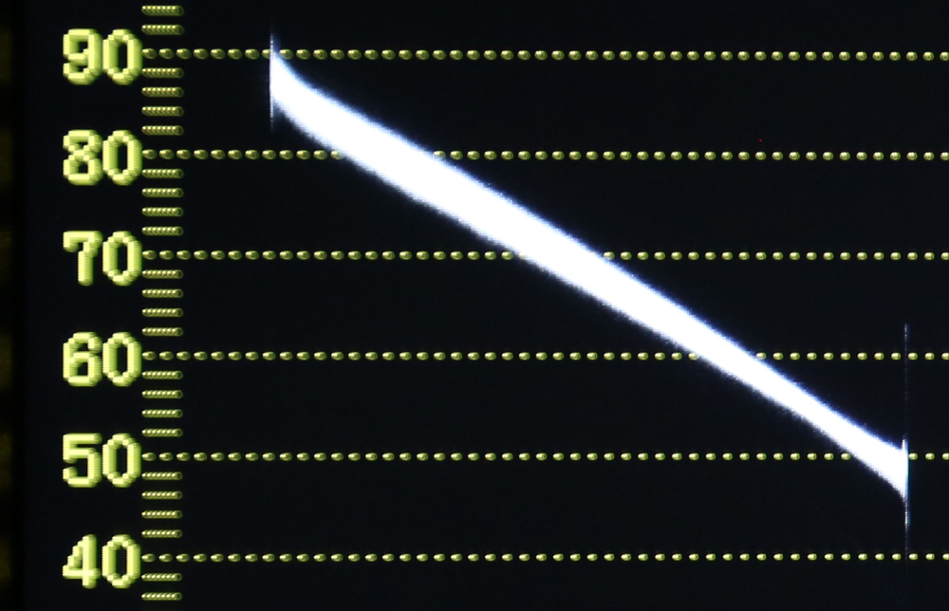

**A Saw adjustment.**

Saw and parabola adjustments can be made both horizontally and vertically (horizontal adjustments made when viewing a horizontal sweep, vertical adjustments made when viewing a vertical sweep).

Start by making horizontal adjustments to the Green channel by selecting G from the PMW-300K1’s Shading CH option, and adjusting the H SAW and H PARA parameters as needed (**Figure 11, below**). You should be watching adjustments live on the monitor to determine how much of each you should apply. Once you’re happy with the green channel, move on to red, and finally blue. You should end up with the waveforms looking as straight as possible. From there, adjust the monitor to display a vertical sweep, and make adjustments to the V SAW and V PARA fields as needed, again in the order of green, red, blue.

When the waveforms for all color channels are as straight as possible both vertically and horizontally, lens shading is complete.

5- Multi-matrix adjustment to make the dot exactly in the center

6- Use blackgamma, If steps for low-brightness areas are not the same level, set BLACK GAMMA to ON and make adjustments using its R/M/B.

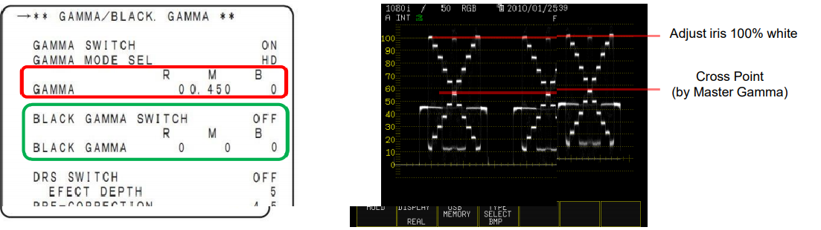

Multi-camera Set up for High End Production

(https://www.youtube.com/watch?v=dnT-zRhWVK4&list=PLHfMXQ0y9NdPqty4W0_HugBXmauzULN0Q&index=3)

1- Iris down the camera, adjust the black values in the red and blue channels by taking green channel as reference.

2- Pull the iris level up to 100 IRE to see the white values of the channels. Adjust the blue white channel and red white channel to the values as close to green channel as possible.

3-1- Signal level at 70 IRE(https://www.streamingmedia.com/Producer/Articles/ReadArticle.aspx?ArticleID=102457&PageNum=2)

2- Half zoom

3- Between 4 - 5.6 lens aperture(https://www.cnrood.com/en/amfile/file/download/file_id/1290/product_id/1170/)

4- Saw adjustment: Saw and parabola adjustments can be made both horizontally and vertically (horizontal adjustments made when viewing a horizontal sweep, vertical adjustments made when viewing a vertical sweep).

Start by making horizontal adjustments to the Green channel by selecting G from the PMW-300K1’s Shading CH option, and adjusting the H SAW and H PARA parameters as needed (Figure 11, below). You should be watching adjustments live on the monitor to determine how much of each you should apply. Once you’re happy with the green channel, move on to red, and finally blue. You should end up with the waveforms looking as straight as possible. From there, adjust the monitor to display a vertical sweep, and make adjustments to the V SAW and V PARA fields as needed, again in the order of green, red, blue.

5- Multi-matrix adjustment to make the dot exactly in the center

6- By making adjustments to Master GAMMA (M), adjust Gch cross point to the reference camera.

If Rch and Bch levels are different from Gch, adjust R GAMMA and B GAMMA (R, B) to be the same level as Gch.

Change the IRIS from “CLOSE” to “OPEN” and then back to “CLOSE” so as to confirm that the Grayscale waveform is the same at each level.

If steps for low-brightness areas are not the same level, set BLACK GAMMA to ON and make adjustments using its R/M/B.

Make further adjustments until steps of Grayscale are the same as the reference camera as much as possible in

the end.

6- Use blackgamma, If steps for low-brightness areas are not the same level, set BLACK GAMMA to ON and make adjustments using its R/M/B.

Multi-camera Set up for High End Production

(https://www.youtube.com/watch?v=dnT-zRhWVK4&list=PLHfMXQ0y9NdPqty4W0_HugBXmauzULN0Q&index=3)

1- Iris down the camera, adjust the black values in the red and blue channels by taking green channel as reference.

2- Pull the iris level up to 100 IRE to see the white values of the channels. Adjust the blue white channel and red white channel to the values as close to green channel as possible.

3- The black chip in the grayscale card in the base line must be the same for red and blue channel considering green channel, if not the same then flare compensation is needed! To iris the camera up to the 1 or 1 and half stop to see the flare levels(black chip)

4- To correct the gamma differences between red and blue channel, cross points of the channels are adjusted to the same level with green channel with changing red and blue gamma values.

(https://eww.pass.panasonic.co.jp/pro-v/support/content/guide/EN/Color_Match_CAM_ver.1_0_0.pdf)

1- Signal level at 70 IRE(https://www.streamingmedia.com/Producer/Articles/ReadArticle.aspx?ArticleID=102457&PageNum=2)

2- Half zoom

3- Between 4 - 5.6 lens aperture(https://www.cnrood.com/en/amfile/file/download/file_id/1290/product_id/1170/)

4- Saw adjustment: Saw and parabola adjustments can be made both horizontally and vertically (horizontal adjustments made when viewing a horizontal sweep, vertical adjustments made when viewing a vertical sweep).

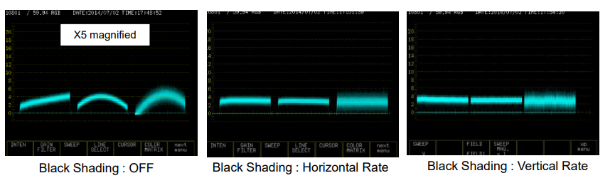

Start by making horizontal adjustments to the Green channel by selecting G from the PMW-300K1’s Shading CH option, and adjusting the H SAW and H PARA parameters as needed (Figure 11, below). You should be watching adjustments live on the monitor to determine how much of each you should apply. Once you’re happy with the green channel, move on to red, and finally blue. You should end up with the waveforms looking as straight as possible. From there, adjust the monitor to display a vertical sweep, and make adjustments to the V SAW and V PARA fields as needed, again in the order of green, red, blue.

5- Multi-matrix adjustment to make the dot exactly in the center

6- By making adjustments to Master GAMMA (M), adjust Gch cross point to the reference camera.

If Rch and Bch levels are different from Gch, adjust R GAMMA and B GAMMA (R, B) to be the same level as Gch.

Change the IRIS from “CLOSE” to “OPEN” and then back to “CLOSE” so as to confirm that the Grayscale waveform is the same at each level.

If steps for low-brightness areas are not the same level, set BLACK GAMMA to ON and make adjustments using its R/M/B.

Make further adjustments until steps of Grayscale are the same as the reference camera as much as possible in

the end.

6- Use blackgamma, If steps for low-brightness areas are not the same level, set BLACK GAMMA to ON and make adjustments using its R/M/B.

Multi-camera Set up for High End Production

(https://www.youtube.com/watch?v=dnT-zRhWVK4&list=PLHfMXQ0y9NdPqty4W0_HugBXmauzULN0Q&index=3)

1- Iris down the camera, adjust the black values in the red and blue channels by taking green channel as reference.

2- Pull the iris level up to 100 IRE to see the white values of the channels. Adjust the blue white channel and red white channel to the values as close to green channel as possible.

3- The black chip in the grayscale card in the base line must be the same for red and blue channel considering green channel, if not the same then flare compensation is needed! To iris the camera up to the 1 or 1 and half stop to see the flare levels(black chip)

4- To correct the gamma differences between red and blue channel, cross points of the channels are adjusted to the same level with green channel with changing red and blue gamma values.

03.04.19

<http://www.xdcam-user.com/2014/08/exposing-and-using-slog2-on-the-sony-a7s-part-one-gamma-and-exposure/>

Coming back to Rec-709 and conventional TV’s and monitors. If we want a piece of white paper to look bright and white on a TV we would record it and then show it at somewhere around 85% to 95% of the screens full brightness range. This doesn’t leave much room for things brighter than a white piece of paper! Things like clouds in the sky, a shiny car, a bright window or a direct light source such as a lamp or other light.  In order to make it possible for S-log2 to record a much greater dynamic range the recording level for white and mid tones is shifted down. Instead of recording white at 85%-95%, when using S-log2 or S-Log3 it is recommended by Sony that white is recorded at around 60%. For S-Log2 Middle grey moves down too, instead of being recorded at 42%-43% (the normal level for Rec-709) it’s recorded at just 32% with S-Log2 (S-log3 uses 41%).

14.04.19

Normally the gamma curve used in the camera is designed to match the gamma curve used by the TV or monitor. This way the contrast range of the camera and the contrast range of the display will be matched. So the contrast on the TV screen will match the contrast of the scene being filmed and the picture will look “normal”. However the limited dynamic range may mean that very bright or very dark objects cannot be accurately reproduced as these may exceed the gammas dynamic range.