https://wolfcrow.com/what-is-display-gamma-and-gamma-correction/

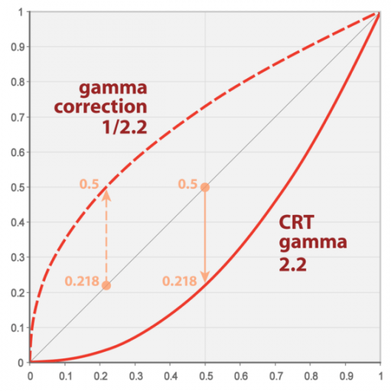

**What are gamma curves?**

All conventional cameras use gamma curves. The gamma curve is there to make the images captured easier to manage by making the file size smaller than it would be without a gamma curve. When TV was first developed the gamma curve in the camera made the signal small enough to be broadcast by a transmitter and then the gamma curve in the TV set (which is the inverse of the one in the camera) expanded the signal back to a normal viewing range. The current standard for broadcast TV is called “Recommendation BT-709”, often shortened to Rec-709. This gamma curve is based on standards developed over 60 years ago and camera technology has advanced a lot since then! Even so, almost every TV and monitor made today is made to the Rec-709 standard or something very similar. Many modern cameras can capture a brightness range, also known as dynamic range, that far exceed the Rec-709 standard.

**Exposing White and Middle Grey.**

Coming back to Rec-709 and conventional TV’s and monitors. If we want a piece of white paper to look bright and white on a TV we would record it and then show it at somewhere around 85% to 95% of the screens full brightness range. This doesn’t leave much room for things brighter than a white piece of paper! Things like clouds in the sky, a shiny car, a bright window or a direct light source such as a lamp or other light.  In order to make it possible for S-log2 to record a much greater dynamic range the recording level for white and mid tones is shifted down. Instead of recording white at 85%-95%, when using S-log2 or S-Log3 it is recommended by Sony that white is recorded at around 60%. For S-Log2 Middle grey moves down too, instead of being recorded at 42%-43% (the normal level for Rec-709) it’s recorded at just 32% with S-Log2 (S-log3 uses 41%).

By recording everything white (ie a white piece of paper) and darker in a  lower range, we free up  lot of extra space above the white recording level, within the full recording range, to record all those bright highlights in any scene that would be impossible to record with conventional gammas where there is only 10% to 20% from white at 90% to the peak of the recording range at 100 to 109%.

For each stop we raise the exposure level you will have 1 stop (which is the same as 6db) less noise. So the final images will have half as much noise for each stop up you go. This is a result of exposing the image brighter and as a result not needing to raise the levels in post as far as you would if exposed at the normal level.

The noise reduction gain by shooting between one and 2 stops over is certainly beneficial. The down side to this though is that we are reducing the over amount of exposure headroom.

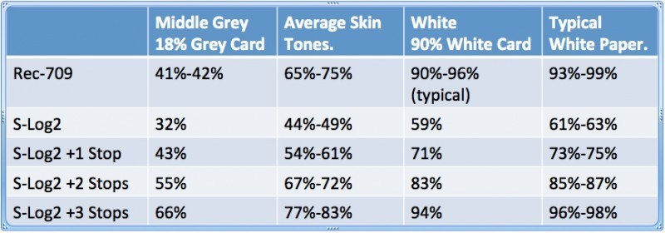

The challenge of course is determining where your exposure actually is. Fortunately as we have seen, provided you in the right ball park, S-log2 is quite forgiving, so if you are a little bit over exposed it’s probably not going to hurt your images much. If you have a waveform monitor then you can use that to set your exposure according to the table below. If you don’t have proper white or grey cards you can use a piece of normal white paper. Although slightly less accurate this will get you very close to where you want to be. Do note that white paper tends to be a little brighter than a dedicated 90% reflectivity white card. If you don’t have any white paper then you can use skin tones, again a bit less accurate but you should end up in the right zone.

https://www.sony.com/electronics/support/res/manuals/W001/W0014771M.pdf

What is a gamma curve?

Gamma curves show the relationship between the input signal level and the output signal level. The camera converts the brightness signal from the subject into an electrical signal and sends the electrical signal to the display monitor, which converts that signal back to a brightness signal and reproduces the subject as an image. The input signal level is the level of the brightness signals from the subject and the original image, whereas the output signal level is the level of the brightness signal output by the camera or display monitor. In order to faithfully reproduce a subject in video images, the output signal level needs to be largely proportional to the input signal level, as shown in the straight line below. But the fluorescent material characteristics of a CRT (cathode-ray tube) cause the output signal level from CRT monitors to curve as shown below. This represents the gamma curve of CRT monitors. The camera’s video gamma curve plots the opposite curve. For this reason, the properties of the camera and CRT monitor can be offset to faithfully reproduce and display the original subject. The inherent characteristics of an LCD (liquid crystal display) cause the output signal level from LCD monitors to be largely proportional to the input signal level. However, because the camera is designed for CRT monitors, LCD monitors and OLED (organic light-emitting diode) monitors mimic the CRT’s gamma curve.

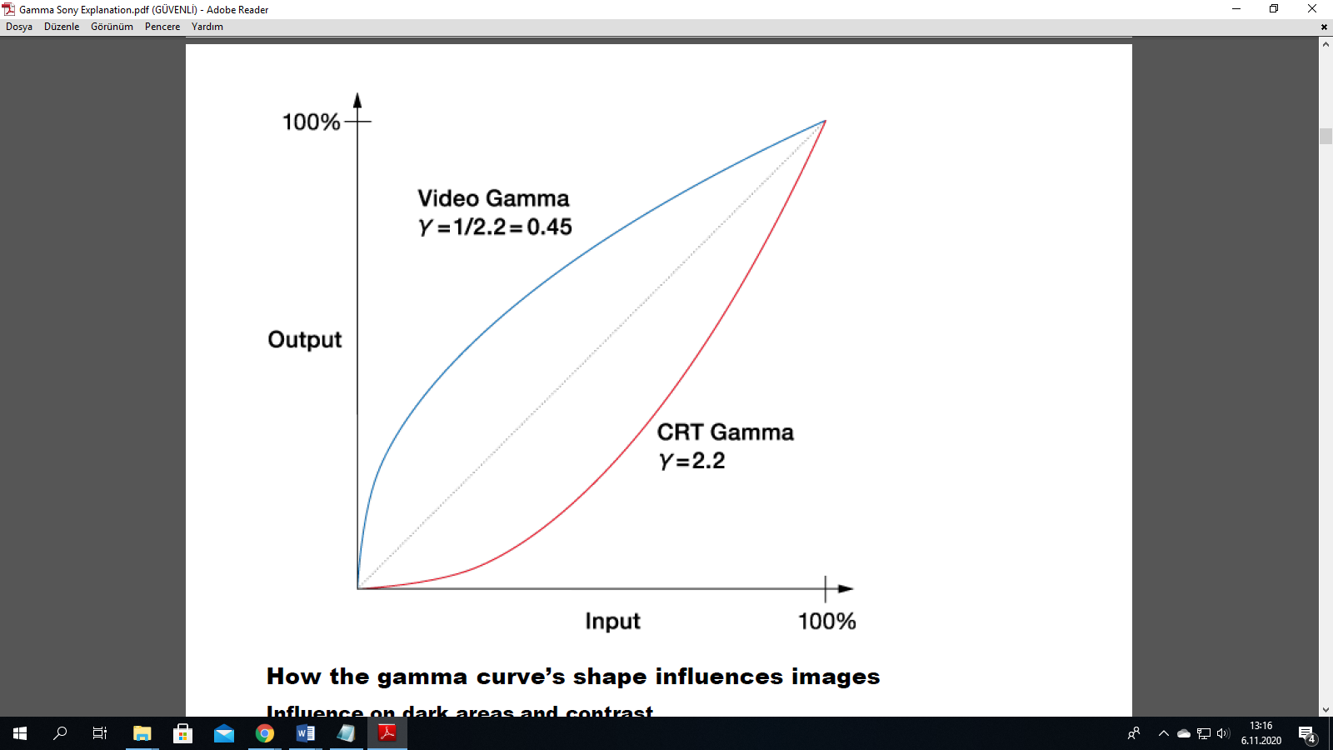

How the gamma curve’s shape influences images Influence on dark areas and contrast High-end cameras have a function to slightly change the shape of the gamma curve for dark areas of the image, known as Black Gamma. Changing the gamma curve shape lets you dramatically alter the atmosphere of the image by strengthening or weakening the shading, or contrast, of the image. What is knee correction? Cameras are, in general, not good at clearly capturing a scene that contains extremely different luminance levels, such as one object in bright sunlight and another in the shade. If you set the right exposure for the object in the shade, the object under the sun will be captured too brightly and appear as a plain white object without texture or gradation. Knee correction is a function necessary to keep these kinds of images with a large disparity in luminance levels within the standard range of video signal levels. Just as Black Gamma influences contrast in dark image areas, knee correction deals with contrast in image areas with high luminance levels. CCD and CMOS sensors can handle an extremely bright input signal. To output it as a video signal, however, we need to keep the signal within the standard range for video. For this reason, the signal output level is kept lower than the signal input level in high-luminance areas that generate input signals over a certain level. In the chart below, the line bends like a knee at a certain point in the high-luminance range. This is called the knee point. The line extending from the knee point is called the knee slope. By changing the position of the knee point and the inclination of the knee slope, contrast in the high-luminance range can be altered. The breadth of input signal levels that a system can process is called the dynamic range.

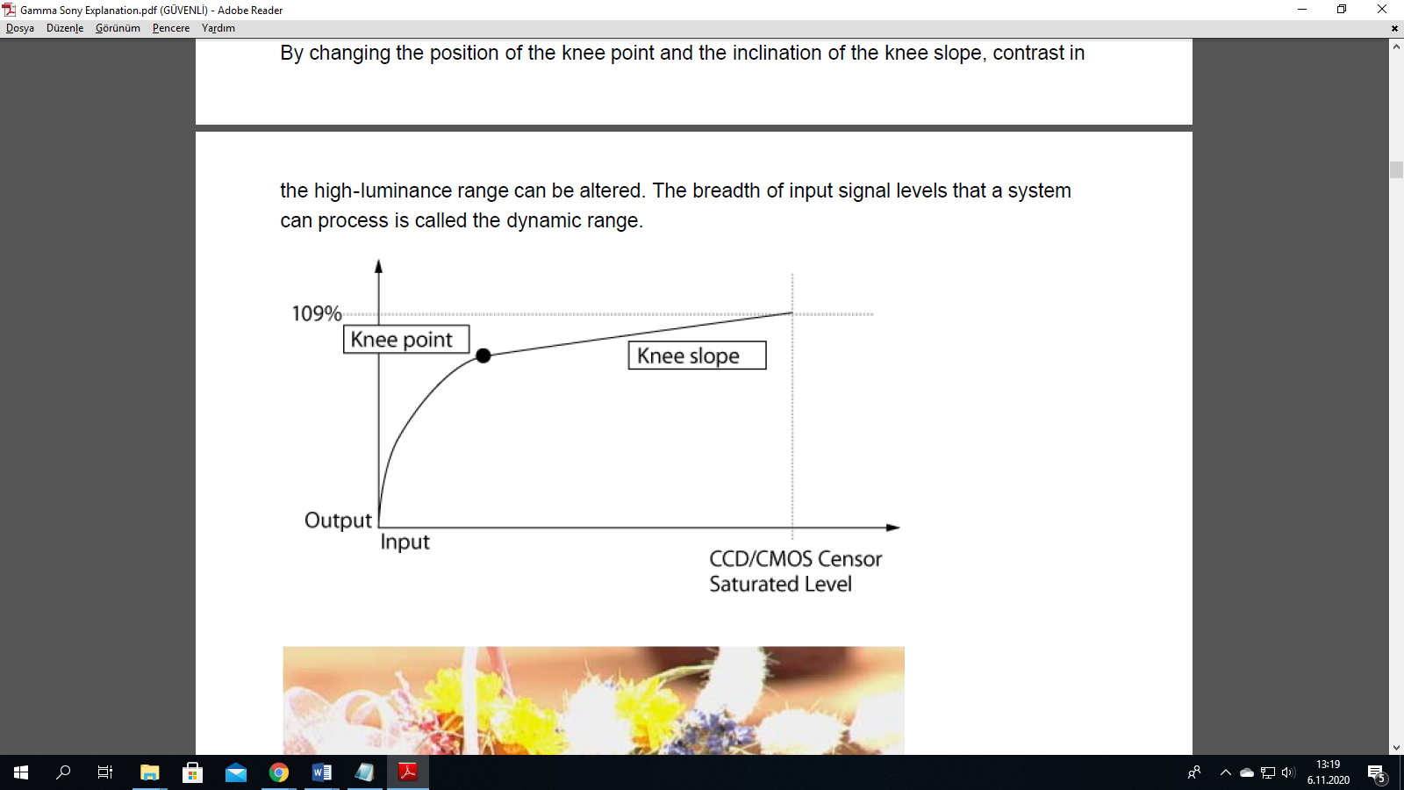

What is S-Log?

The S-Log2 gamma curve is optimized to the dynamic range of the CMOS sensor.

In order to bring out the contrast in highlights as much as possible, the sensor output has

been extended to 1300% of the dynamic range. Although some color grading work is

required, the S-Log2 gamma curve is an effective way to preserve highlight gradations that

would otherwise be lost, thereby providing greater exposure latitude in recording.

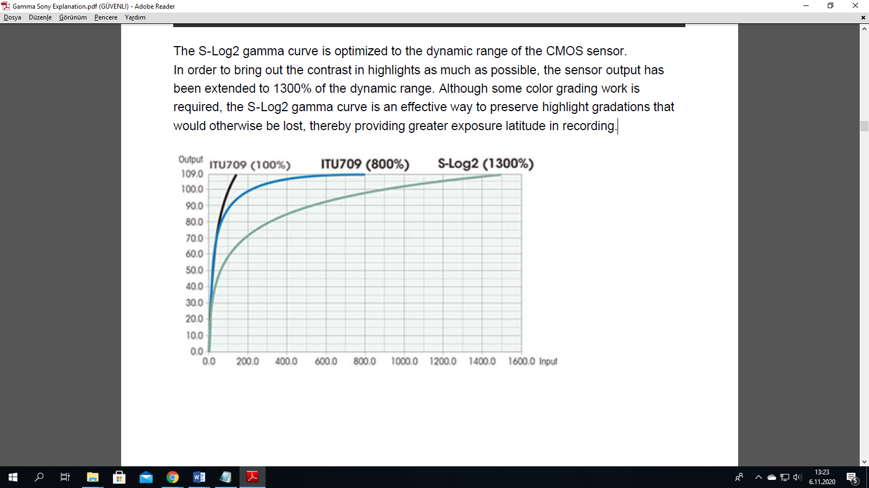

[ITU709(800%)]

[ITU709(800%)] is a gamma curve for easily assessing the level of gradation when

grading an image recorded using [S-Log2] to ITU709.

When you adjust the shooting exposure with [Gamma] set to [S-Log2] and then switch

[Gamma] to [ITU709(800%)], a low-contrast image will be displayed with ITU709 contrast

applied. Although [ITU709(800%)] applies higher contrast as compared with the S-Log

gamma curve, it may be difficult to assess gradations in high-luminance areas. Switch to

[ITU709(800%)] as necessary based on the image you want to assess.

**Color Space**

This product’s Picture Profile uses the concept of a color space based on three dimensions;

Hue, Saturation and Luminance.

**Detail**

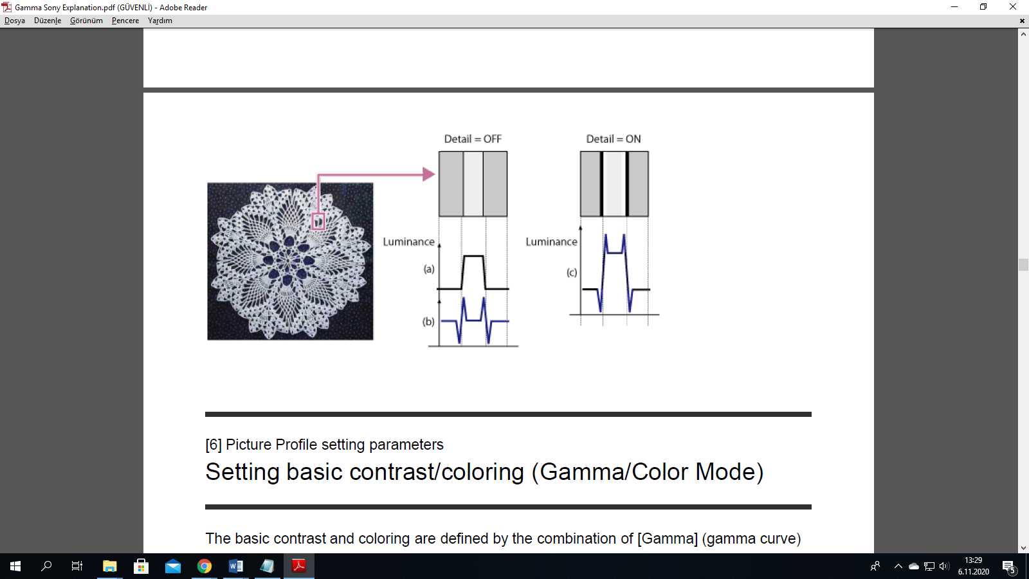

Detail is a type of signal processing that emphasizes image edges. In the example below,

there is a large luminance variation between the lace pattern and the background. In the

charts below, whose vertical axes represent luminance, (a) shows the change in luminance

levels in the image section inside the red square. The Detail function generates (b) from (a).

(b) serves as the basis of the detail signal and combines with (a). The resulting (c)

represents (a) with the detail signal applied, emphasizing both the white and black edges in

the image.

Because the Detail function emphasizes image outlines and makes the image look sharper,

it is sometimes referred to as the Sharpness function.

**Gamma**

Movie Standard gamma curve for video

Still Standard gamma curve for still images

**Cine1**

Softens the contrast in darker image areas and emphasizes gradation

changes in lighter image areas, producing a subdued tone overall

(equivalent to HG4609G33)

**Cine2**

Similar results to [Cine1] but optimized for editing with up to 100% video

signal (equivalent to HG4600G30)

**Cine3**

Stronger contrast between dark and light image areas and greater

emphasis on black gradation changes (compared to [Cine1] and [Cine2])

**Cine4**

Stronger contrast than [Cine3] in darker image areas; compared to

[Movie], has less contrast in darker image areas and more contrast in

lighter image areas

**ITU709 ITU709** gamma curve (low-light gain of 4.5)

**ITU709(800%)** Gamma curve for checking scenes recorded using [S-Log2]

**S-Log2** Gamma curve for [S-Log2]. This setting is selected when some grading work will be performed after recording.

**Color Mode**

**Movie** Color tones for [Movie] gamma curve

**Still** Color tones for [Still] gamma curve

**Cinema** Color tones for [Cine1] gamma curve

**Pro** Color tones similar to standard Sony broadcast camera image

quality (used in combination with [ITU709] gamma curve)

**ITU709 Matrix ITU709** color tones (used in combination with [ITU709] gamma

curve)

Black & White Sets the saturation to 0 for recording in black and white

**S-Gamut**

Setting based on the assumption that some grading work will be

performed after recording. Used when [Gamma] is set to [SLog2].

S-Gamut is a color space unique to Sony that provides a

wide color space equivalent to film cameras. However, the SGamut

setting on this camera does not support the whole

color space of S-Gamut; it is intended to achieve color

reproduction equivalent to S-Gamut.

**Adjusting contrast (Black Level/Black Gamma/Knee)**

**Black Level**

This function adjusts the black level of the image.

**Parameters Settings**

**Black Level –15 to +15**

As an image effect, you can emphasize the color black to create an image that gives a

powerful impression, or you can weaken black to give the image a soft impression. Shifting

Black Level in the minus direction emphasizes the black color in the image, while changing

the level in the plus direction weakens the black color.

If you want to simulate an old film, or capture winter morning fog, the black level value

should be increased. If you decrease the value, gradations in dark areas will be smoothed

out, making the areas appear in crisp black.

When using multiple fixed cameras to shoot the same subject from different angles, the

balance between subject and background often varies. This balance variation may cause the

black color in the subject to appear different when cameras are switched. However, this is an

optical illusion. If it occurs, you can correct it by adjusting Black Level to make the black color

look the same.

**Black Gamma**

This function lets you alter the shape of the selected gamma curve and adjust gradations in

dark image areas.

**Parameters Settings**

Black Gamma > Range Wide / Middle / Narrow

Black Gamma > Level –7 to +7

[Range] controls the luminance range that Black Gamma influences. The [Narrow] setting

keeps the range close to black, while the [Wide] setting extends the range to gray. [Range]

should be set narrower when you want to control the quality of dark areas. If you want to

adjust the overall image tone, [Range] should be set wider. At first, it may be a good idea to

start from the [Narrow] setting.

Increasing the [Level] value brightens the image, whereas decreasing the value makes the

image darker. For example, if you set [Range] to [Narrow] and decrease the [Level] value,

you can create an image with dark areas that are similar to the ones seen in films. Unlike

Black Level, Black Gamma Level adjusts luminance subtly.

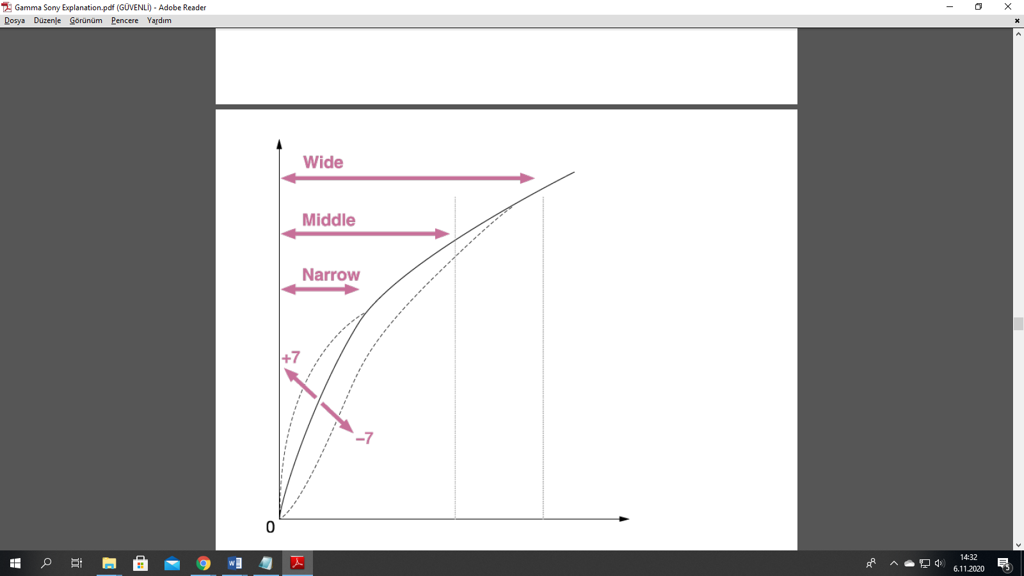

**Knee**

This function sets the knee point and slope for video signal compression to prevent overexposure

by limiting signals in high intensity areas of the subject to the dynamic range of

your camera.

First, select whether to set the knee point and slope automatically or manually in [Mode], and

then adjust each setting.

**Parameters Settings**

Knee > Mode Auto / Manual

Knee > Auto Set > Max Point 90% to 100%

Knee > Auto Set > Sensitivity High / Mid / Low

Knee > Manual Set > Point 75% to 105%

Knee > Manual Set > Slope –5 to +5

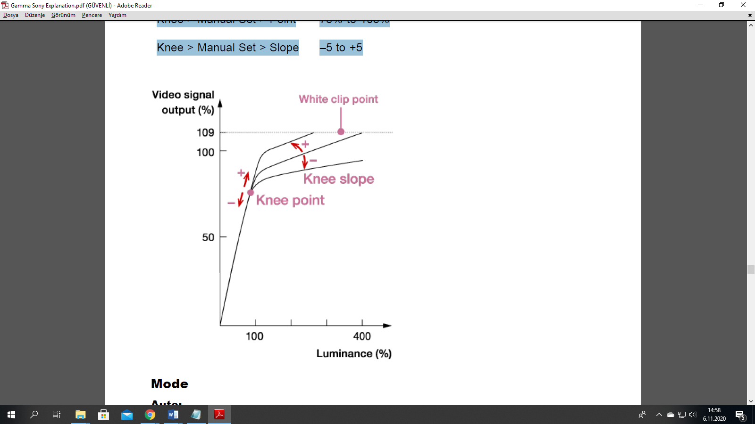

**Mode**

**Auto:**

Automatically adjusts the knee based on what is selected in the following settings (when

[Movie] or [ITU709] is selected in [Gamma]).

**[Max Point]** determines the maximum knee point level (white level). The knee slope is

automatically adjusted according to the Max Point setting. The standard is to keep it at

100%. A lower setting will turn white grayish, while a higher setting will discard gradations

in high luminance areas.

**[Sensitivity]** changes the luminance level at which the knee’s automatic adjustment starts.

When set to [Low], the knee’s automatic adjustment starts at lower input signal levels

than normal. When set to [High], the knee’s automatic adjustment starts at higher input

signal levels than normal.

When a parameter other than [Movie] or [ITU709] is selected in [Gamma], the gamma

curve will not exceed the White clip point and over-exposure rarely occurs. When [Mode]

is set to [Auto] with these settings, the Knee function is disabled. If you want to enable the

Knee function, set [Mode] to [Manual].

**Manual:**

Sticks to settings based on the following selections.

**[Point]** sets the position of the knee point output level.

**[Slope]** determines the inclination of the knee slope.

A negative slope setting results in a gentler knee slope angle. This expands the dynamic

range, but reduces the ability to produce rich gradations. A positive slope setting makes

the knee slope inclination steeper. This shrinks the dynamic range, but bolsters the ability

to express gradations. When [Slope] is set to +5, the Knee function is disabled.

Set [Point] and [Slope] in [Manual Set] in combination. If you select a higher setting for

[Point] and a gentler setting for [Slope], you can obtain video-like sharp highlight effects. If

softer film-like highlight effects are desired, select a lower setting for [Point] and a steeper

setting for [Slope]. In practical terms, move [Point] and [Slope] up and down in opposite

directions while checking the gradations in high luminance areas until you find the ideal

settings.

**V/H Balance**

This function regulates the balance between Vertical (V) detail and Horizontal (H) detail.

**Vertical (V)** detail boosts image edges by expanding them upward and downward. Horizontal

**(H) detail** emphasizes image outlines by thickening them to the left and right.

The results of detail processing may appear differently depending on the TV, computer

display or other type of display monitor. Adjust [V/H Balance] as needed.

To emphasize the impression of a subject that has many horizontal elements, such as a

human face (with eyes and mouth), you can increase the proportion of Vertical (V) detail

by lowering the setting (selecting a lower set value).

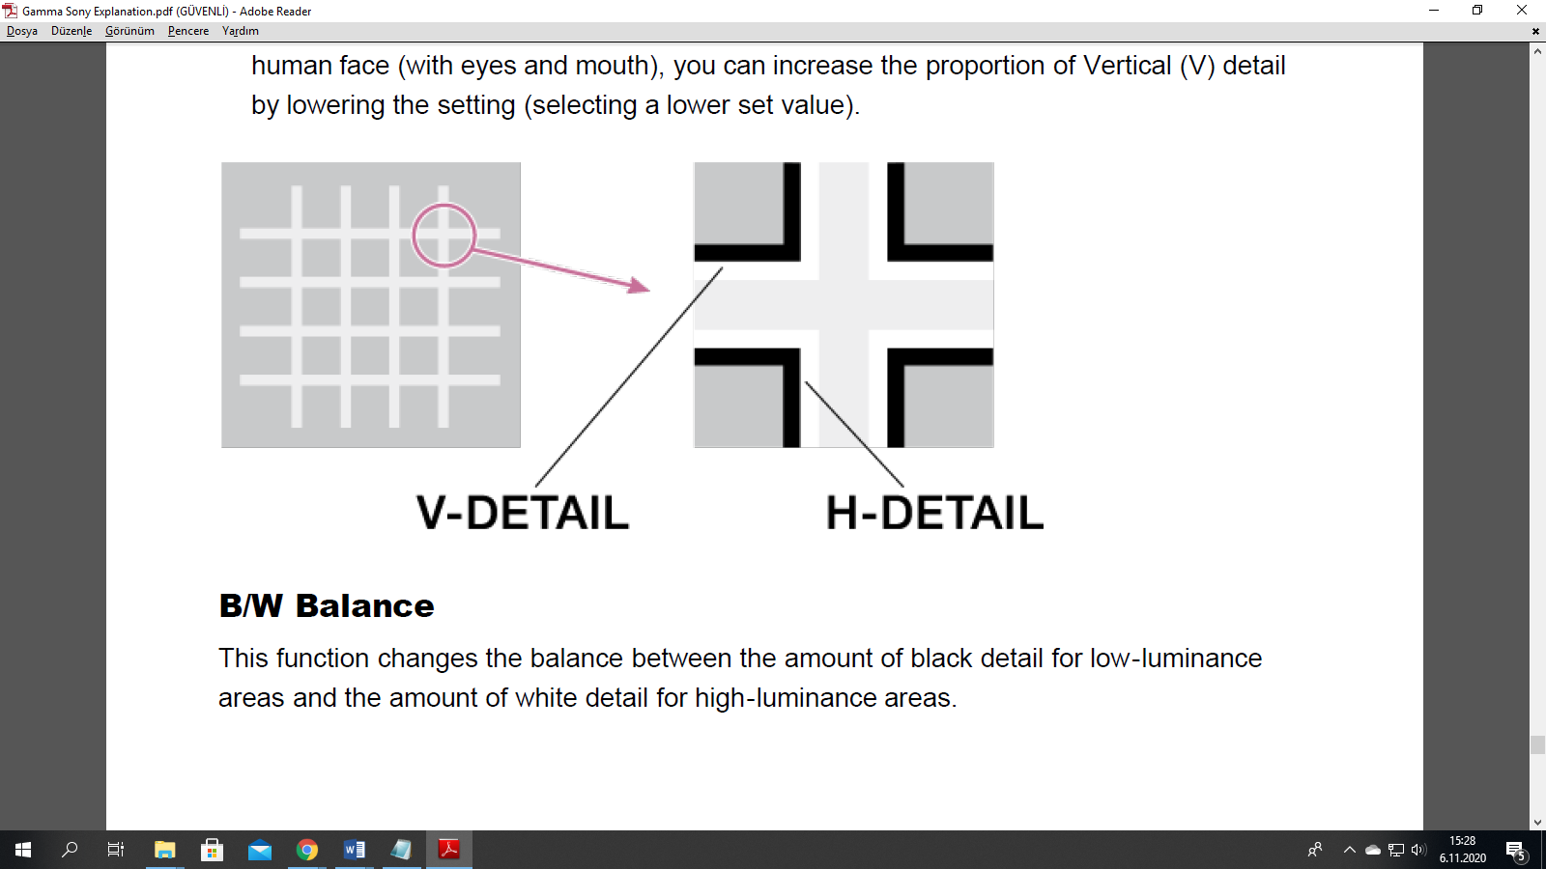

B/W Balance

This function changes the balance between the amount of black detail for low-luminance

areas and the amount of white detail for high-luminance areas.

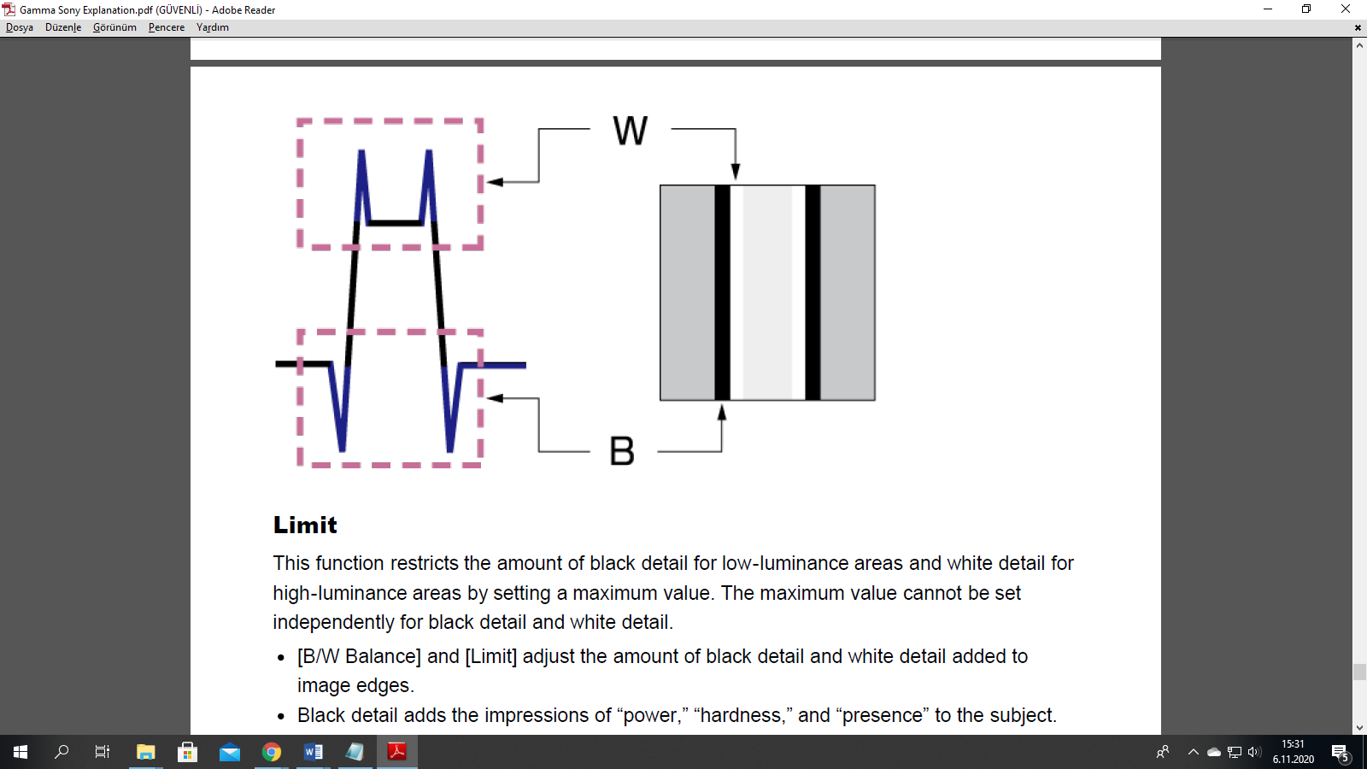

**Limit**

This function restricts the amount of black detail for low-luminance areas and white detail for

high-luminance areas by setting a maximum value. The maximum value cannot be set

independently for black detail and white detail.

**[B/W Balance] and [Limit]** adjust the amount of black detail and white detail added to

image edges.

Black detail adds the impressions of “power,” “hardness,” and “presence” to the subject.

But it may bring undesirable effects because it emphasizes wrinkles and pores.

White detail gives the subject a “clean” and “glossy” impression. You can increase the

proportion of white detail and reduce that of black detail when shooting jewelry and glass

objects to heighten their clarity and translucence.

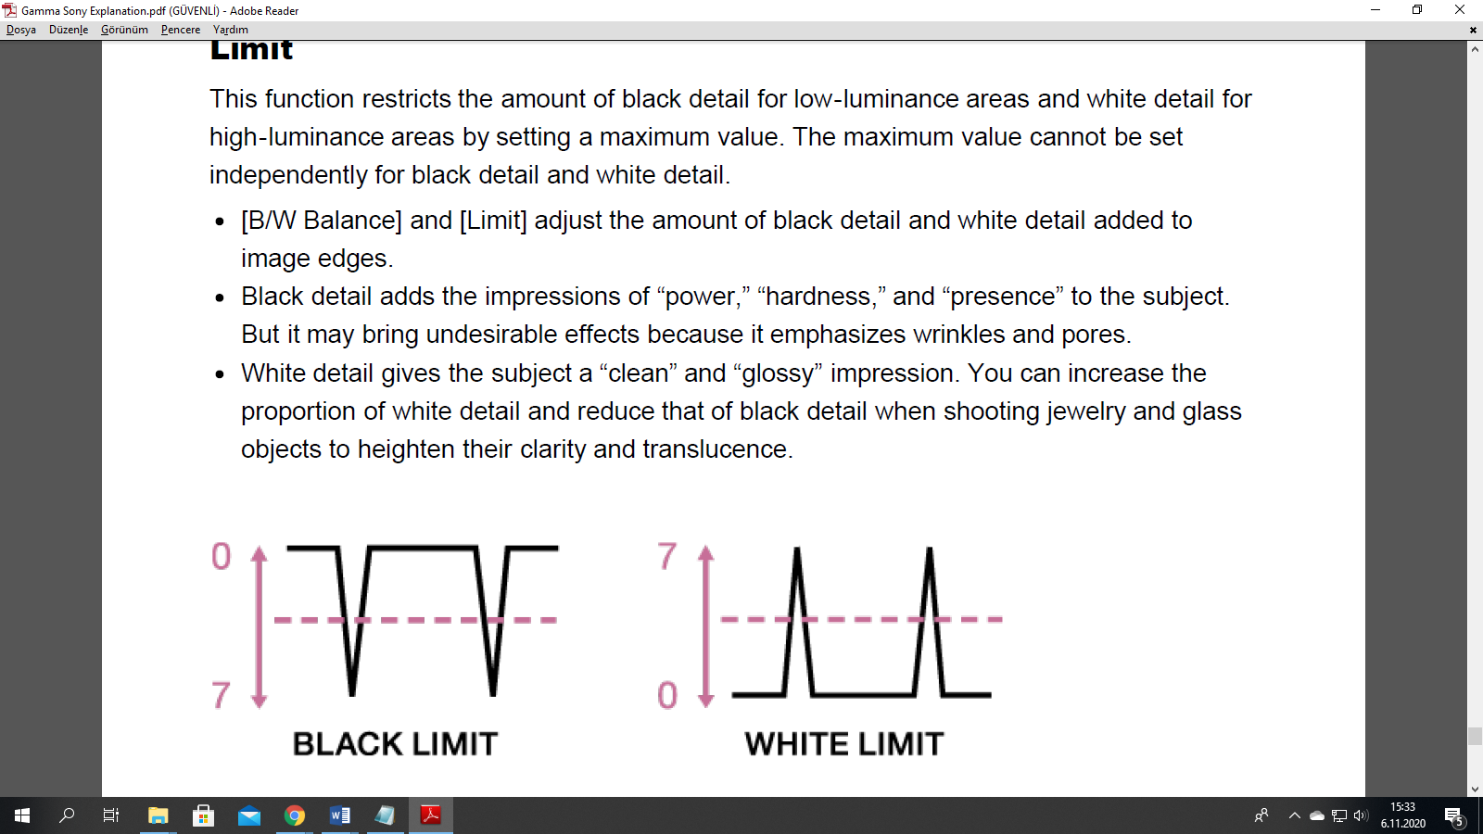

**Crispening**

This function reduces detail that accompanies visual noise to prevent noise from being

emphasized.

You can use this function when you want to apply detail processing to the subject while

keeping noise as unnoticeable as possible.

**Hi-Light Detail**

This function adjusts the detail level for bright subjects.

You can use this to emphasize the edges of a bright subject in front of a high-luminance

background.

**What is Log C?**

The Log C curve is a logarithmic encoding of the scene, meaning that the relation between exposure measured in stops and the signal is constant over a wide range. Each stop of exposure increases the signal by the same amount. The overall shape of the Log C curve is similar to the exposure curves of film negatives. Because of fundamental differences between a sensor and negative film, however, the color characteristics remain different.

Log C actually is a set of curves for different EI values/ASA ratings. Each curve maps the sensor signal, corresponding to 18% gray scene luminance, to a code value of 400 in a 10 bit signal. A 10 bit signal offers a total code value range of 0 to 1023. The maximum value of the Log C curve depends on the set EI value. The reason is quite simple: When the lens is stopped down, by one stop for example and the EI setting is increased from, say, 800 to 1600, the sensor will capture one stop more highlight information. Since the Log C output represents scene exposure values, the maximum value increases.

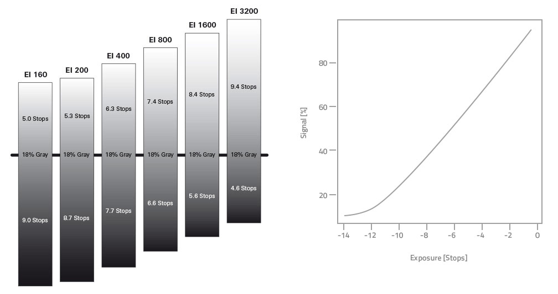

<https://www.arri.com/en/learn-help/learn-help-camera-system/camera-workflow/image-science/log-c>

ARRI cameras record and output images in Log C wide gamut color space. Log C images can transport all color information and high dynamic range captured by ARRI’s camera sensors.

**Log C** is a so-called scene-based encoding. The signal level increases by a fixed amount with each increase of exposure measured in stops. This encoding, which uses an ARRI-specific wide gamut color space, is similar to files from a film scan and ideal to carry image information.

To correctly display Log C material on an HD or UHD monitor (Rec 709/Rec 2020) or in a digital projection (P3), it needs to be tone-mapped and transformed into the target color space. This image conversion can be performed using a 3D Look Up Table (3D LUT).

Nevertheless, Log C is and will be under continuous development to keep up with the demands of current cinema technology.

**Video encoding**

Rec 709/2020 is a display-based encoding using RGB primaries specified in ITU Recommendation BT.709/2020 and can be directly output to standard HDTV/UHDTV displays without any conversion.

The material can be processed by most HD/UHD video production gear in realtime, which enables short production times. Rec 709/2020, however, provides somewhat reduced choices in color grading and, due to a more contrasty characteristic, cannot hold as much highlight information as the much flatter Log C curve.

To enable productions to shoot in Rec 709 color space without the sacrifice of too much highlight information, ARRI provides a special Low Contrast Characteristic (LCC) Look File that can be applied to change the standard Rec 709 output.

<https://www.arri.com/en/learn-help/learn-help-camera-system/frequently-asked-questions/frequently-asked-questions-on-color#accordion-44064>

Rec 2020 is a wider color space than Rec 709, which is the current industry standard for HD. Rec 2020 promises more brilliant images, though only new display technology is able to show these. Traditional Rec 709 displays (like TVs or ordinary computer displays) can’t display Rec 2020.

While Rec 709 (short for Recommendation ITU-R BT.709) is the encoding color space for HDTV, Rec 2020 is the encoding color space for UHD. The primary colors lie on the spectral locus and it is thus possible to have more saturated colors in images. (It does not mean, however, that all colors look more saturated. When properly converted, a Rec 709 image will look exactly the same when displayed on a Rec 2020 display.)

Rec 2020 is an encoding standard. A TV or display may not support the full gamut. Nevertheless, it will correctly display the colors within its physical gamut. To get the “Premium” logo of the UHD Alliance, for example, a TV needs to support a minimum of 90% of the P3 gamut.

**One or definition for Log C**

The Log C curve is a logarithmic encoding of the scene, meaning that the relation between exposure measured in stops and the signal is constant over a wide range. Each stop of exposure increases the signal by the same amount. The overall shape of the Log C curve is similar to the exposure curves of film negatives. Because of fundamental differences between a sensor and negative film, however, the color characteristics remain different.

Log C actually is a set of curves for different EI values/ASA ratings. Each curve maps the sensor signal, corresponding to 18% gray scene luminance, to a code value of 400 in a 10 bit signal. A 10 bit signal offers a total code value range of 0 to 1023. The maximum value of the Log C curve depends on the set EI value. The reason is quite simple: When the lens is stopped down, by one stop for example and the EI setting is increased from, say, 800 to 1600, the sensor will capture one stop more highlight information. Since the Log C output represents scene exposure values, the maximum value increases.

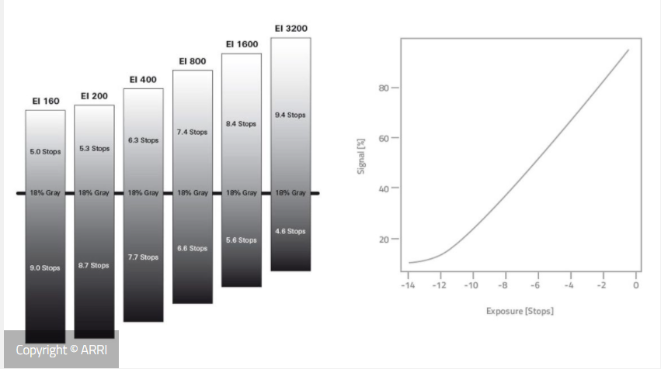

This is not an error! You have chosen to record in “Log C” – ARRI’s native color encoding. Opposed to a straight encoding to a “video” image (in REC 709 color space) Log C maintains more details in the lowlight as well as in the highlight areas. Log C is also referred to as the camera negative as it is unprocessed footage.

That being said, Log C does not help to accelerate your production. If you’re on a tight schedule keep in mind that an additional rendering step has to take place before the footage can be delivered to a customer. In that case we recommend to shoot in REC 709. Color correction can be skipped in that case, but is still possible although in a limited way.

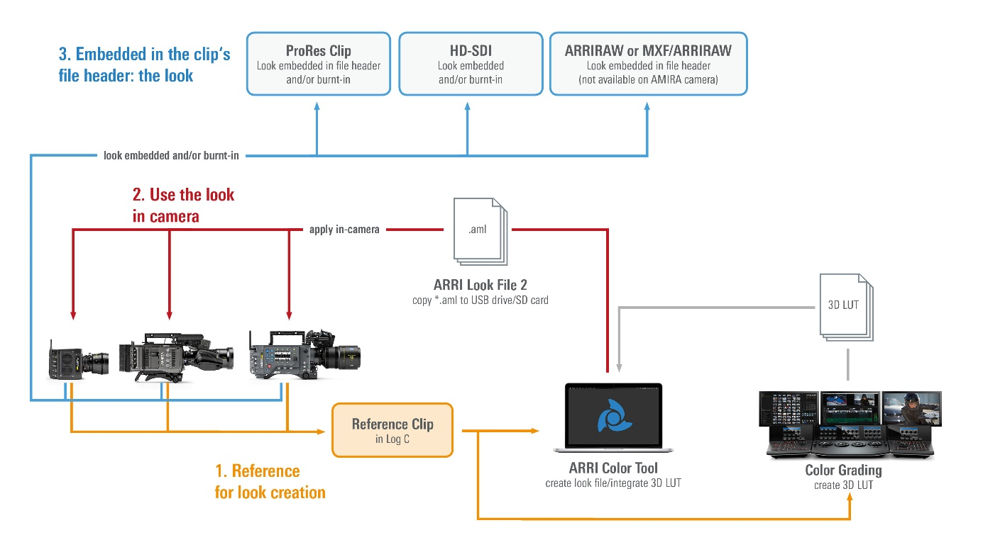

https://www.flatpanelshd.com/focus.php?subaction=showfull&id=1566562819

