**A Project Report On**

### Estimation And Prediction Of Hospitalization And Medical Care Costs

**Team Leader:**

M B.BHANU PRAKASH

**Team Member’s:**

 Kesulappagari Chakradhar

 K C.Vinitha

Kesulappagari Madhu

Giraka Lokesh

**Under the Guidance of:**

**V.SHEKAR**

**Associate Professor**

KUPPAM ENGINEERING COLLEGE

**(Approved by AICTE, Affiliated to JNTUA, Accredited by NBA & ISO 9001:2008 Certified)**

**Project Report Format:**

## 1. Introduction:

1.1Overview

A Brief Description About Your Project

1.2Purpose

The use of this project.What Can be Achieved using this.

**2**. **Define Problem And Understanding**

**Theoretical analysis**

2.1Blockdiagram

Diagrammatic overview of the project.

2.2Hardware/Software Designing

Hardware and software requirements of the project

1. **Result :**

Final findings (Output)Of the project along with screenshots.

1. **Advantages & Disadvantages:**

List of advantages and disadvantages of the proposed solution

1. **Applications:**

The areas where this solution can be applied

1. **Conclusion:**

Conclusion summarizing the entire work and findings.

## 7 Future scope:

Enhancements that can be made in the future.

**INTRODUCTION**

**Data analytics**

is the process of extracting valuable insights from complex datasets to drive decision-making and achieve business goals. It involves collecting, cleaning, analyzing, and visualizing data to identify patterns, trends, and correlations. With descriptive, diagnostic, predictive, and prescriptive analytics techniques, organizations can gain a competitive edge, optimize operations, and enhance performance. Data analytics is applicable across various industries and enables data-driven decision-making, improved efficiency, and innovation

How Data Analytics Works

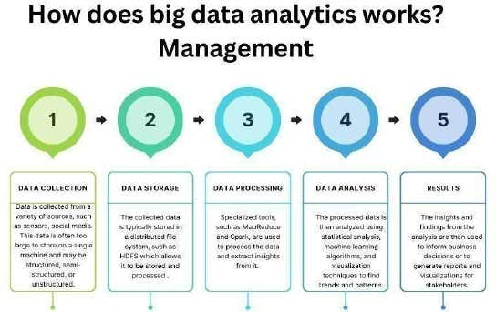

Data analytics is a process that involves collecting and cleaning data, performing exploratory analysis, building models, evaluating their performance, extracting insights, and making informed decisions. It begins with data collection and preparation, followed by exploratory analysis to understand the dataset. Models are built and evaluated, and insights are extracted for decision-making. The process is iterative, and advanced techniques like machine learning may be used.

**Data analytics**

enables organizations to derive valuable insights and drive positive outcomes

**PROJECT OVERVIEW**

The goal of this project is to assess and forecast the cost of hospitalization and medical treatment using data analytics techniques. The procedure entails gathering and preparing complete healthcare data, performing exploratory analysis, engineering pertinent characteristics, creating predictive models using machine learning algorithms, assessing model performance, and coming up with practical conclusions. The project intends to improve cost estimation, optimize resource allocation, and assist healthcare providers, insurers, and policymakers in making decisions**.**

**PROJECT FLOW**

1. Data Collection: Gather relevant data from various sources.

2. Data Preprocessing: Clean and prepare the data for analysis.

3. Exploratory Data Analysis (EDA): Gain insights and understand relationships in the data.

4. Feature Engineering: Extract important features from the data.

5. Model Selection: Choose appropriate modeling techniques.

6. Model Training: Train the selected models using a training set.

7. Model Evaluation: Assess model performance using appropriate metrics.

8. Model Optimization: Fine-tune models to improve performance.

9. Cost Estimation and Prediction: Use optimized models to estimate and predict costs.

10. Model Deployment and Monitoring: Implement models in a production environment and monitor performance

**PURPOSE THE OF THE PROJECT**

The purpose of a project focused on the estimation and prediction of hospitalization and medical care costs is to provide valuable insights and information for various stakeholders in the healthcare industry, including hospitals, insurance companies, policymakers, and patients. Here are some specific objectives and purposes of such a project:

**Cost Management and Planning:** Hospitals and healthcare facilities can use cost estimation and prediction models to better manage their resources and plan for future expenditures. This helps in optimizing budget allocation, staffing, and resource allocation.

**Pricing and Billing:** Healthcare providers can use cost predictions to set fair and transparent prices for their services, which can lead to more informed decisions by patients and insurance companies when it comes to choosing healthcare options.

**Insurance Premium and Calculation:** Insurance companies can benefit from accurate cost predictions to determine appropriate premium rates for various health insurance policies. This helps in maintaining financial stability and competitiveness in the insurance market.

**Patient Education:** Patients can make informed decisions about their healthcare choices if they have estimates of potential hospitalization and medical care costs. This can lead to better financial planning and healthcare decision-making.

**Policy and Regulation**: Policymakers and government agencies can use cost prediction models to develop and refine healthcare policies, such as reimbursement rates for specific medical procedures or drug pricing regulations.

**Research and Resource Allocation**: Cost prediction can aid in healthcare research by providing insights into the financial impact of specific medical conditions or treatments. Researchers can use this information to prioritize research efforts and allocate resources effectively.

**Risk Assessment:** Healthcare organizations and insurance providers can use cost prediction models to assess the financial risk associated with certain patient populations, conditions, or treatments. This helps in developing risk mitigation strategies.

**Quality Improvement:** Hospitals can use cost data to identify areas where cost-effective improvements in healthcare quality can be made, ultimately leading to better patient outcomes at lower costs.

**Fraud Detection:** Predictive models can also help in detecting potential fraud or billing errors by identifying unusual or outlier cost patterns.

**Emergency Preparedness:** Hospitals and healthcare systems can use cost estimation models to plan for emergencies and pandemics, ensuring they have the necessary resources to handle unexpected surges in patient volumes.

To achieve these purposes, a project on the estimation and prediction of hospitalization and medical care costs typically involves data analysis, statistical modeling, machine learning, and the use of historical healthcare data. It may also require collaboration between healthcare professionals, data scientists, and policy experts to ensure that the models and predictions align with real-world healthcare scenarios and needs.

**THEORETICAL ANALYSIS**

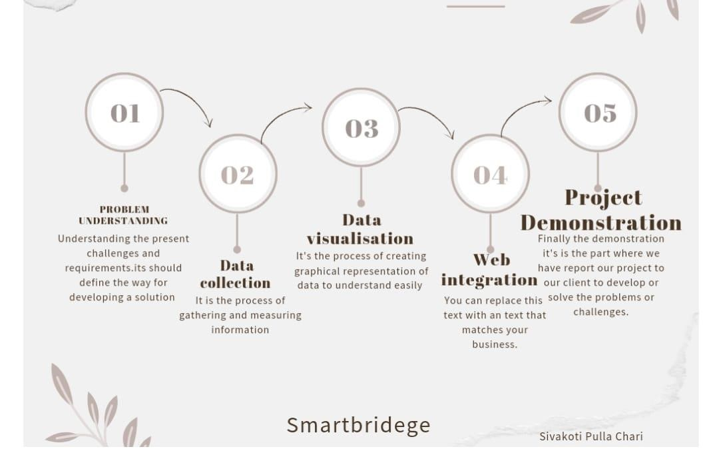

Diagrammatic overview of the project.

**Hardware/Software Designing**

Designing hardware specifically for Dissecting The Digital Landscape: A Comprehensive Analysis Of Social Mediawould involve creating a system capable of collecting, processing, and storing data related to data sets. Here's a general outline of the hardware components and considerations for such a system:

Data Storage:

Cloud-Based Storage: To handle large volumes of data, a cloud-based storage solution (e.g., Amazon S3, Google Cloud Storage) can be utilized. This ensures scalability and accessibility from multiple locations.

**Hardware and software requirements of the project Windows 11 pc IBM**

**Cognos Cloud 365 days Cloud Trail**

**RESULTS:**

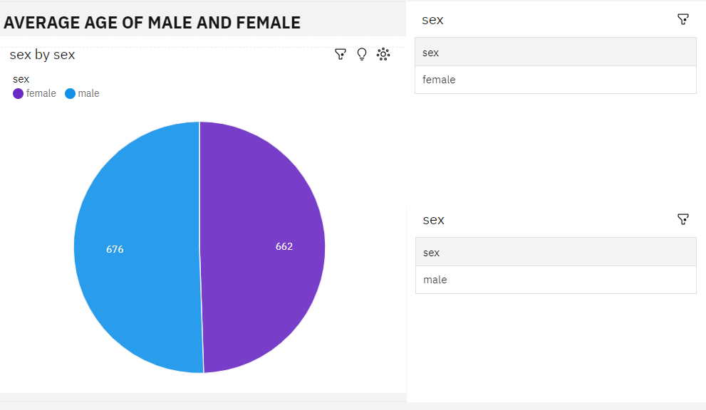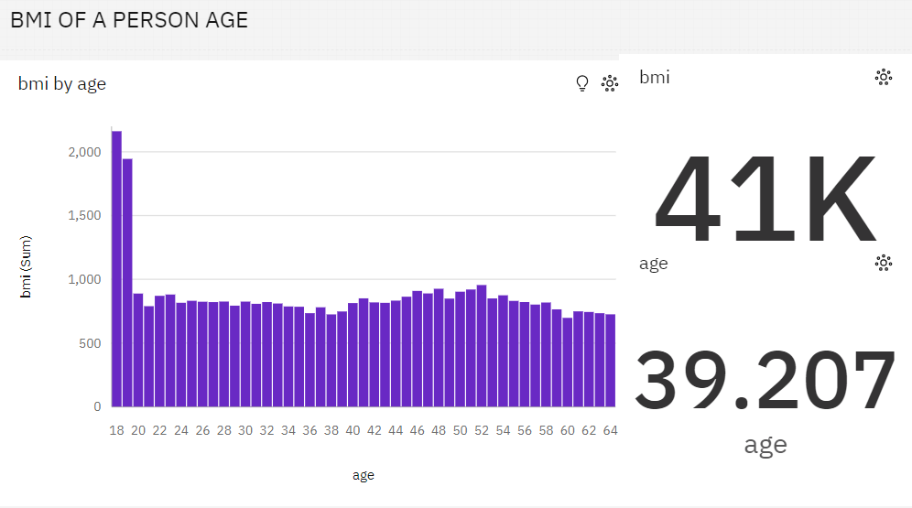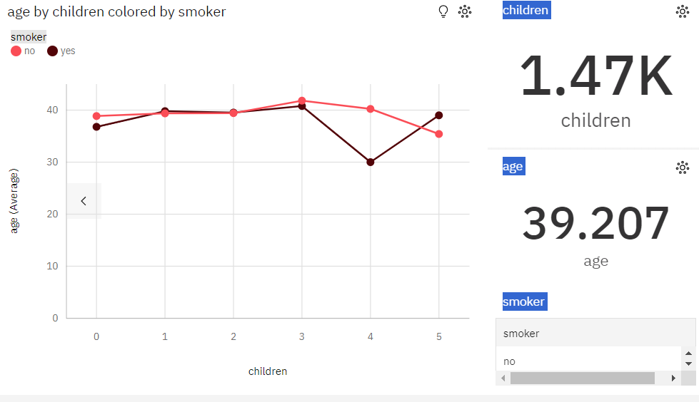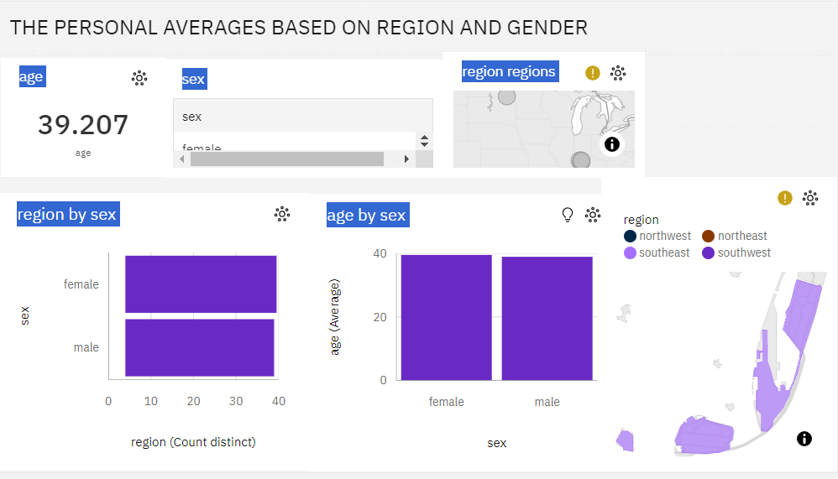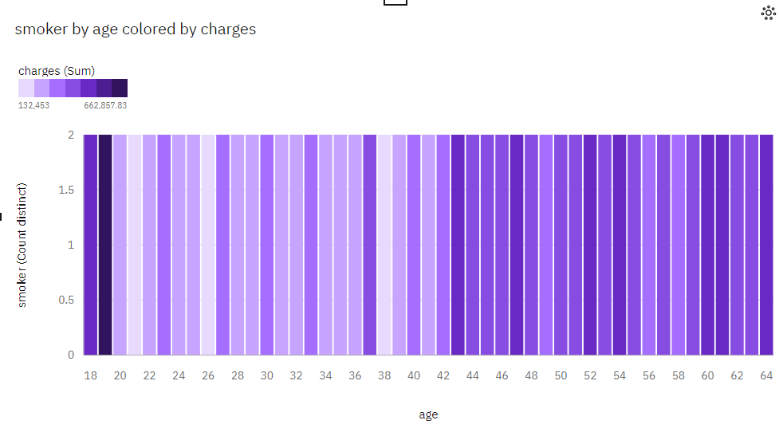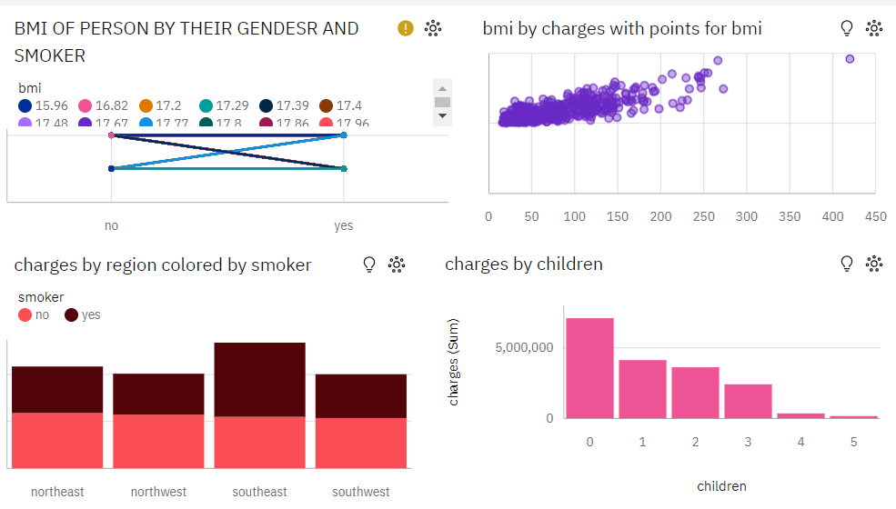

**Video Link:**

https://us3.ca.analytics.ibm.com/bi/?perspective=story&pathRef=.my_folders%2FStory%253A%2BESTIMATION%2BAND%2BPREDICTION%2BOF%2BHOS%255BPITALIZATION%2BAND%2BMEDICAL%2BCARE%2BCOST&action=view&sceneId=-2&sceneTime=0

**CHALLENGES**:

Estimating and predicting hospitalization and medical care costs is a complex task that comes with several challenges, many of which are inherent to the healthcare industry and the nature of healthcare data. Here are some of the key challenges associated with this endeavor:

**Data Quality and Availability:** Healthcare data can be incomplete, inconsistent, and vary in quality. Ensuring that data used for cost estimation is accurate and comprehensive can be challenging, as healthcare records may be fragmented across different systems and providers.

**Data Privacy and Security:** Healthcare data is sensitive and subject to strict privacy regulations, such as the Health Insurance Portability and Accountability Act (HIPAA) in the United States. Maintaining patient privacy while working with healthcare data requires rigorous safeguards and compliance with regulations.

**Complexity of Healthcare Services:** The wide range of medical services, treatments, and procedures makes it challenging to develop accurate cost prediction models. Variability in healthcare services and their associated costs can be significant.

**Patient Heterogeneity:** Patients have unique medical histories, genetics, and lifestyle factors that can affect their healthcare costs. Accounting for this heterogeneity in prediction models can be complex.

**Temporal Dynamics:** Healthcare costs can change over time due to factors like inflation, changes in medical technology, and shifts in healthcare policies. Keeping models up-to-date and relevant is a constant challenge.

**Unpredictable Events:** Healthcare costs can be influenced by unpredictable events such as disease outbreaks (e.g., COVID-19), natural disasters, and mass casualty incidents. These events can disrupt existing cost models and predictions.

**Provider Variability:** Different healthcare providers and facilities may have varying cost structures, billing practices, and levels of efficiency. These variances can make it difficult to generalize cost estimates.

**Billing and Coding Complexity:** Medical billing and coding practices can be intricate, and errors or inconsistencies in these processes can lead to inaccurate cost estimates.

**Limited Historical Data:** In some cases, there may be limited historical data available for certain medical conditions or treatments, making it challenging to build robust prediction models.

**Ethical Considerations:** Determining how to use cost prediction models ethically, especially when making decisions about patient care or resource allocation, can be a complex ethical dilemma.

**Interdisciplinary Collaboration:** Effective cost estimation and prediction in healthcare often require collaboration between healthcare professionals, data scientists, economists, and policymakers. Coordinating efforts among these diverse stakeholders can be challenging.

**Regulatory Changes:** Changes in healthcare regulations, insurance policies, or reimbursement rates can have a significant impact on cost predictions, necessitating continuous model adjustments.

**Explanatory Transparency:** Interpretability and transparency of prediction models are crucial, especially when making decisions that affect patient care. Balancing the accuracy and interpretability of models can be a challenge.

Addressing these challenges often requires a combination of advanced data analytics techniques, ongoing data validation and quality improvement efforts, close collaboration between domain experts and data scientists, and a thorough understanding of the healthcare system's nuances. Additionally, adapting to the evolving healthcare landscape and regulatory changes is essential for accurate and relevant cost estimation and prediction in healthcare.

Top of Form

.

**ADVANTAGES & DISADVANTAGES :**

**Advantages of Estimation and Prediction of Hospitalization Cost Management:**

**Cost Optimization:**

Estimating and predicting hospitalization costs can help healthcare providersoptimize their resource allocation, reduce unnecessary expenses, and identify areas where cost-saving measures can be implemented.

**Financial Planning:**

Accurate estimation and prediction of hospitalization costs enable better financial planning for healthcare organizations. It allows them to forecast future expenses, allocate budgets accordingly, and make informed decisions about resource allocation.

**Patient Empowerment:**

Providing patients with estimated hospitalization costs in advance empowers them to make informed decisions about their healthcare. It enables them to understand the financial implications of different treatment options, choose cost-effective alternatives, and plan for their out-of-pocket expenses.

**Billing Transparency:**

Estimating and predicting hospitalization costs promotes billing transparency by providing patients with clear and accurate cost breakdowns. It helps patients understand the services they receive, the associated charges, and facilitates discussions with insurance providers

**Improved Revenue Management:**

Accurate cost estimation and prediction enable healthcare providers to bill patients and insurance companies more effectively, reducing billing errors and minimizing revenue leakage. It improves revenue management and contributes to the financial stability of healthcare organizations.

**Disadvantages of Estimation and Prediction of Hospitalization Cost Management:**

**Complex Data Modeling:**

Estimating and predicting hospitalization costs involve complex data modeling techniques that require expertise in data analysis and machine learning. It may require skilled professionals and sophisticated algorithms to handle and process large volumes of healthcare data accurately.

**Data Accuracy and Variability:**

The accuracy of cost estimation and prediction heavily relieson the quality and availability of data. Variability in healthcare costs, medical procedures, insurance coverage, and individual patient characteristics can introduce challenges and affect the accuracy of predictions.

**Ethical Considerations:**

Estimating and predicting hospitalization costs may involve handling sensitive patient information, raising ethical considerations related to data privacy and security. Proper measures need to be in place to ensure compliance with privacy regulations and protect patient confidentiality.

**Changing Healthcare Landscape:**

The healthcare industry is constantly evolving, with changing regulations, insurance policies, and reimbursement structures. Estimation and prediction models need to be regularly updated and adjusted to account for these changes and maintain their accuracy.

**Uncertainties in Healthcare:**

Healthcare costs can be subject to uncertainties, such as unexpected medical complications, changes in treatment plans, or unforeseen events. Estimation and prediction models should consider these uncertainties and provide a range of cost estimates to account for potential variation

**CONCLUSION:**

we provided a new linear regression that can easily demonstrate the reasons for producing a certain forecast regarding potential healthcare expenses, which is a useful capacity in the healthcare area. The linear regression algorithm is used to estimate the healthcare costs of the patients such as obesity (BMI) using certain devices such as smart phones and smart devices. For estimation, by the use of linear regression, supervised learning performs more accurately. By providing comprehensive evidence, regression methodology can be effectively used for prognosis in conjunction with the dataset. The domain and time accuracy will determine the prediction model and the estimation of healthcare expenses. The proposed method reduces the risk of over fitting, and also, training time is less. This method is effective in estimating the healthcare costs of patients with an accuracy rate of 97.89%. The extensive tests on a real- time world database have confirmed the efficiency of our method

**FUTURE SCOPE :**

Installing a mini-camera inside a smart device for improved security can further improve this system by allowing parents to view live footage on their phone in an emergency.