**Invites/links of various platforms**

1. **Slack**: Join our Slack team with your @[asu.edu](http://asu.edu/) email:

<https://ser517team.slack.com/signup>

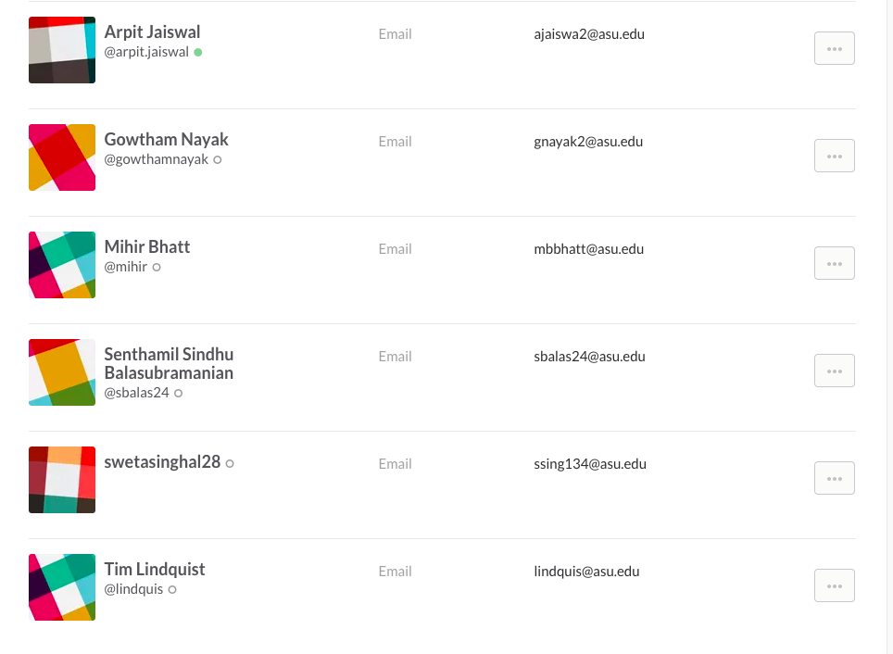

1. **Github**: <https://github.com/swetasinghal28/IHO>

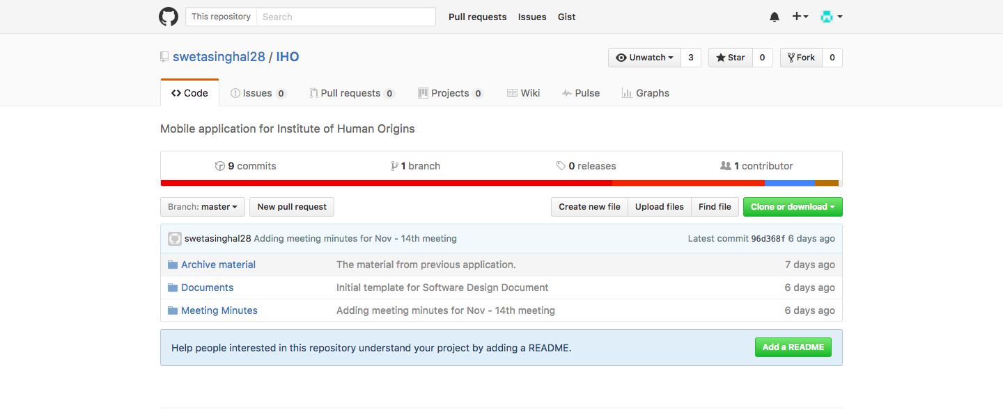

**3. Taiga**: <https://tree.taiga.io/project/swetasinghal28-iho/>

