**MOBILE SYSTEMS FOR INSTITUTE OF HUMAN ORIGINS**

Timothy Lindquist

Bhatt, Mihir; Jaiswal, Arpit; Nayak, Gowtham; Sentamil, Sindhu; Singhal, Sweta

The department of Human Origin needs aims at bridging social, earth and life approaches to the most important question concerning the course cause and timings of events in the human career over the deep time. Toward this direction the sponsor needs us to build a Mobile Application on Android and iOS which helps it to better serve its purpose. Application will provide latest developments in the field of study of human origin. This mobile application will have several screens which provide information regarding News and Events, Field notes, Gallery for showcasing the research work accomplished so far etc.

This solution is important as the scientists working on the research attend many conferences and distributing paper based pamphlets for the work done and future goals is expensive in terms of resources and also environment. This will spread knowledge and information in an efficient way and enthusiast participants can keep a track of the work done by the department. Applications will also provide information about various scientist’s working on various projects and photographs of the discovered fossils.

Design a native application on Android & iOS for the ASU Institute of Human Origins (IHO). We are also required to build a desktop application based on Java Swing that can make changes to the content of the application like News feeds, Event details, Gallery of recent finding and information on various scientist. Facilitate users to view the content and information provided by ASU IHO offline. The expectation is to deliver an app on both the platforms with smooth transition between different pages. The app should be designed keeping in mind that user should have easy access to the necessary pages. Also it is necessary to redirect the user from the application to the IHO web page form within the app when necessary. This benefits both the user and the Institute of Human Origin since the web page can get more web views and the user can get comprehensive information about the Institute.

**Requirements and Schedule**

**REQ 1. The user should be able to login and logout of the desktop application.**

|  |  |  |
| --- | --- | --- |
| **Task** | **Due date** | **Status** |
| User table in desktop app database | February 12 | **new** |
| GUI for login and password request | February 12 | **new** |
| Create credentials for new users | February 12 | **new** |
| Java class for authentication of key | February 12 | **new** |
| GUI for failure on authentication | February 12 | **new** |

**REQ 2. The user should be able to navigate back and forth in the application, similar to that of mobile application navigation.**

|  |  |  |
| --- | --- | --- |
| **Task** | **Due date** | **Status** |
| GUI (buttons) to navigate in app | March 19 | **new** |
| Controller for navigation between screens | March 19 | **new** |

**REQ 3. The user should be able to enter the new/modified content in the given UI component corresponding to that of the application.**

|  |  |  |
| --- | --- | --- |
| **Task** | **Due date** | **Status** |
| GUI for uploading new content. | March 19 | **new** |
| Java class to modify or add new content | March 19 | **new** |

**REQ 4. The user should be able to save the newly added content without submitting to the server.**

|  |  |  |
| --- | --- | --- |
| **Task** | **Due date** | **Status** |
| Data table in desktop application. | March 19 | **new** |
| Java class to save content on table. | March 19 | **new** |
| GUI to view the uploaded content | March 19 | **new** |

* **REQ 5. The user should be able to submit the newly added content to the server.**

|  |  |  |
| --- | --- | --- |
| **Task** | **Due date** | **Status** |
| Connection between desktop and server | March 19 | **new** |
| Java class to update content from data table to server | March 19 | **new** |
| GUI to submit data to server | March 19 | **new** |

**REQ 6.** **The user should be able to submit pictures in landscape and portrait mode, restricted to pre-decided optimal sizes, to the server.**

|  |  |  |
| --- | --- | --- |
| **Task** | **Due date** | **Status** |
| Java class to verify the size of the picture | April 16 | **new** |
| Separate table for storing images | April 16 | **new** |

* **REQ 7. Field Notes – Inside New Science tab all latest publications must be visible on top of the list.**

|  |  |  |
| --- | --- | --- |
| **Task** | **Due date** | **Status** |
| Update newscience screen xml to change display | February 12 | **new** |
| Add controller class to incorporate changes view. | February 12 | **new** |

* **REQ 8. Who is Lucy - Fix problems with Who is Lucy tab. Need to fix the pop-up issue and alignment with Lucy.**

|  |  |  |
| --- | --- | --- |
| **Task** | **Due date** | **Status** |
| New Lucy image component | February 12 | **new** |
| controller to handle pop | February 12 | **new** |

* **REQ 9. Connect - The Connect tab must have all social media handles at one place – Twitter, Facebook, Vimeo, YouTube, Instagram.**

|  |  |  |
| --- | --- | --- |
| **Task** | **Due date** | **Status** |
| Add social media images in xml | March 19 | **new** |
| controller to redirect to appropriate media | March 19 | **new** |

* **REQ 10. Becoming human - Need to add “Ask an anthropologist?” label to this tab. Also reduce the bar size.**

|  |  |  |
| --- | --- | --- |
| **Task** | **Due date** | **Status** |
| Update xml tab to introduce label and bar size | March 19 | **new** |

* **REQ-11: Donate - Need to update the Donate link.**

|  |  |  |
| --- | --- | --- |
| **Task** | **Due date** | **Status** |
| Update donate link to new one | March 19 | **new** |
| Update xml to change logo of the donate button | March 19 | **new** |

* **REQ-12: News and Events - Need to remove the interim page and directly point it to the link of news and event website of IHO.**

|  |  |  |
| --- | --- | --- |
| **Task** | **Due date** | **Status** |
| Delete interim xml file | April 16 | **new** |
| Update controller to point to correct screen | April 16 | **new** |

* **REQ-13: News and Events – Add a feature story page, which goes to an interim page and then a IHO website link.**

|  |  |  |
| --- | --- | --- |
| **Task** | **Due date** | **Status** |
| New feature story xml | April 16 | **new** |
| Web view to redirect to IHO website | April 16 | **new** |

* **REQ-14: Travel and Learn – Need to remove Scroll. Add read more which points to the IHO travel page link directly.**

|  |  |  |
| --- | --- | --- |
| **Task** | **Due date** | **Status** |
| Update xml of travel n learn | April 16 | **new** |
| Web view to redirect to IHO travel page | April 16 | **new** |

**Software Design**

**Class Diagram**

1. Swing Java application

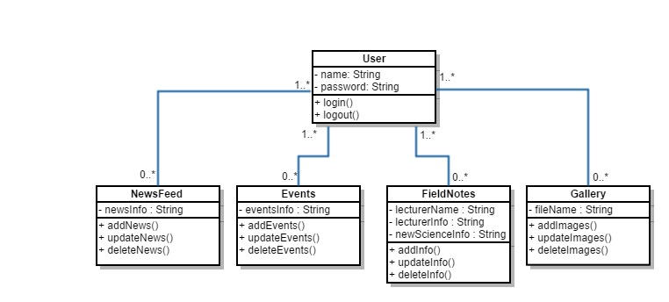

1. iOS/Android application

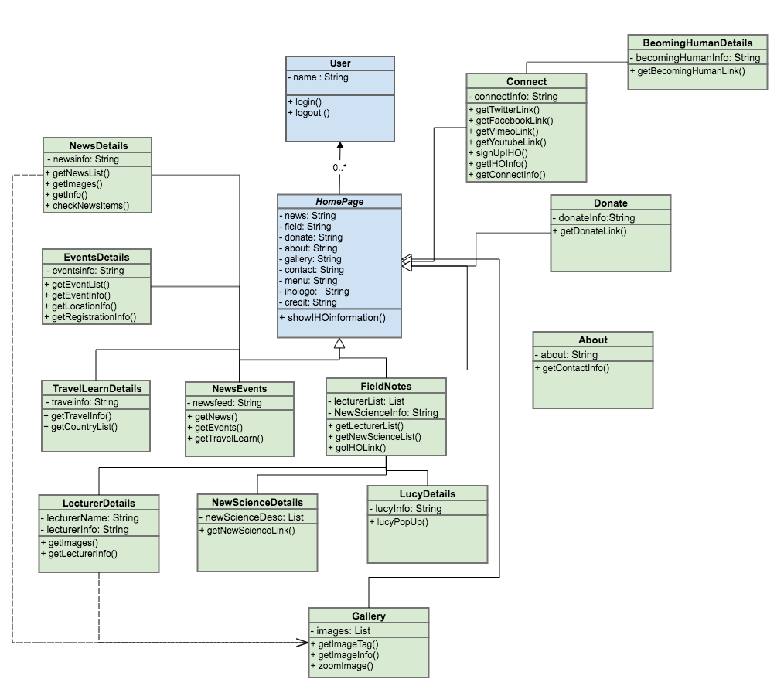

**Class Diagram:**

1. Swing Java application



1. Android/iOS application

