**CLIENT-SERVER CASES (PART ONE)**

**NOTE: For all subsequent images, the server is on the left and the two clients are on the right.**

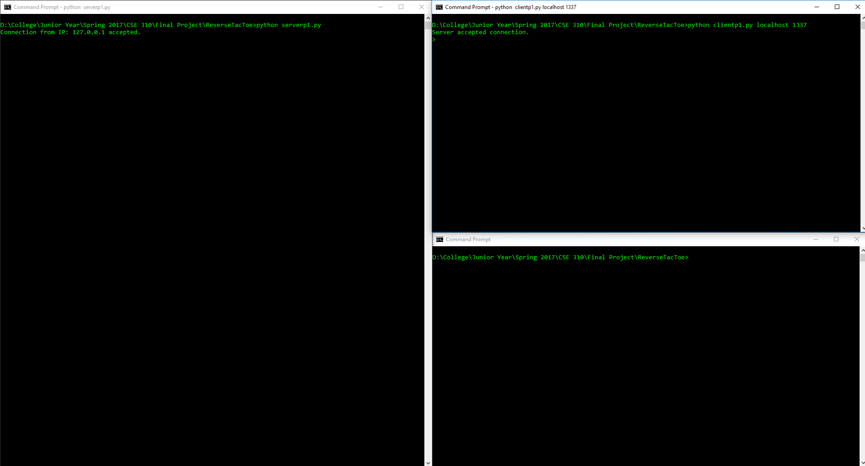

Figure 1: Server started and one client successfully connected

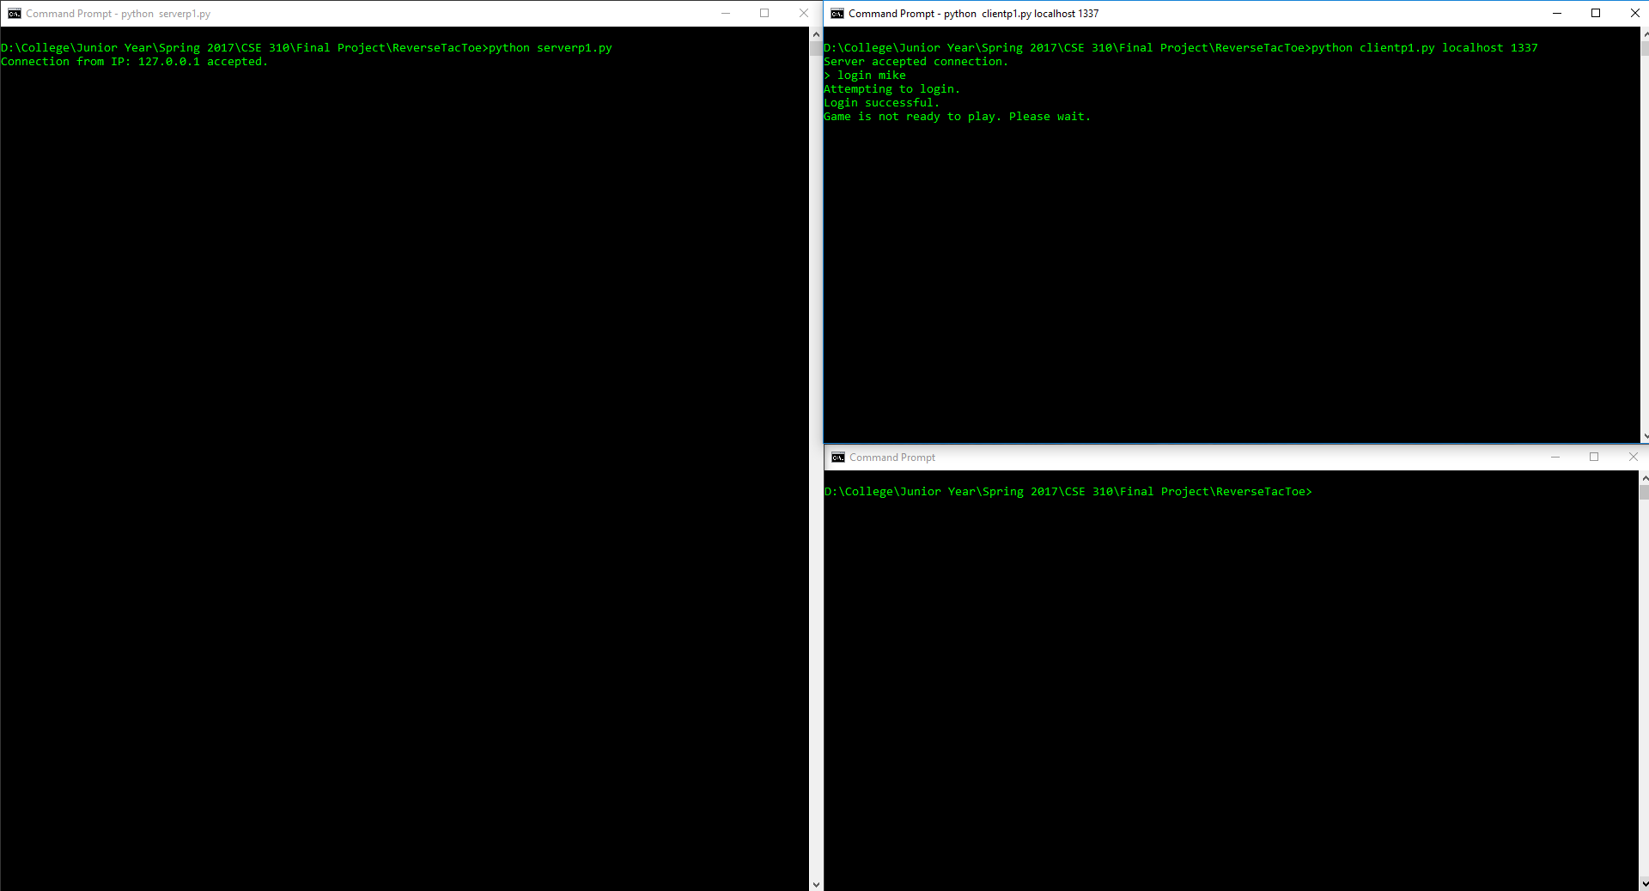

Figure 2: Connected client successfully logs in with userId: mike

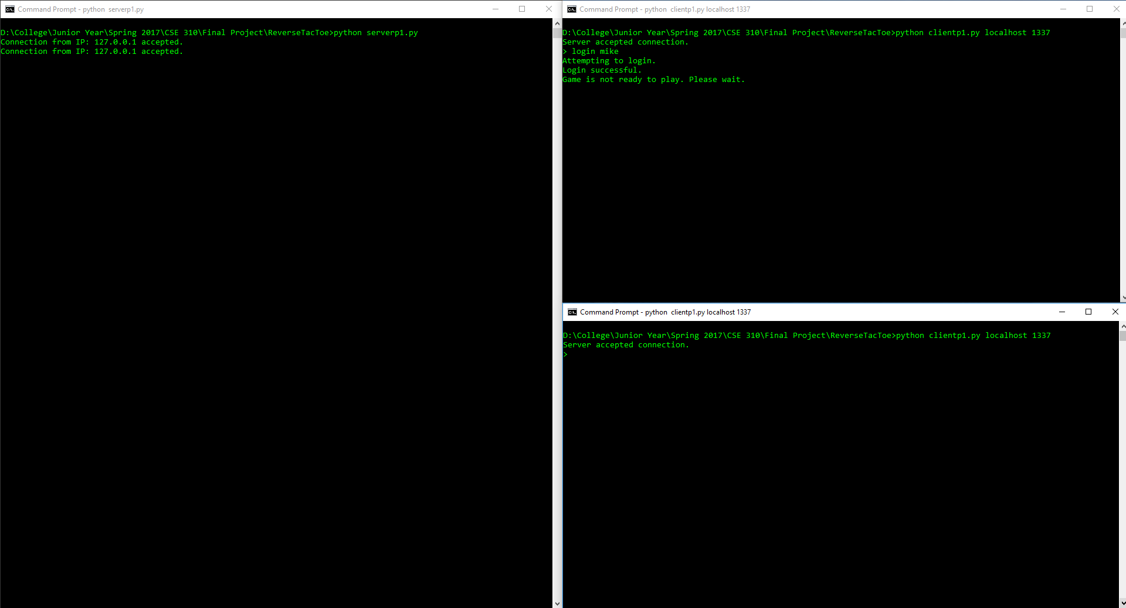

Figure 3: Second client successfully connected

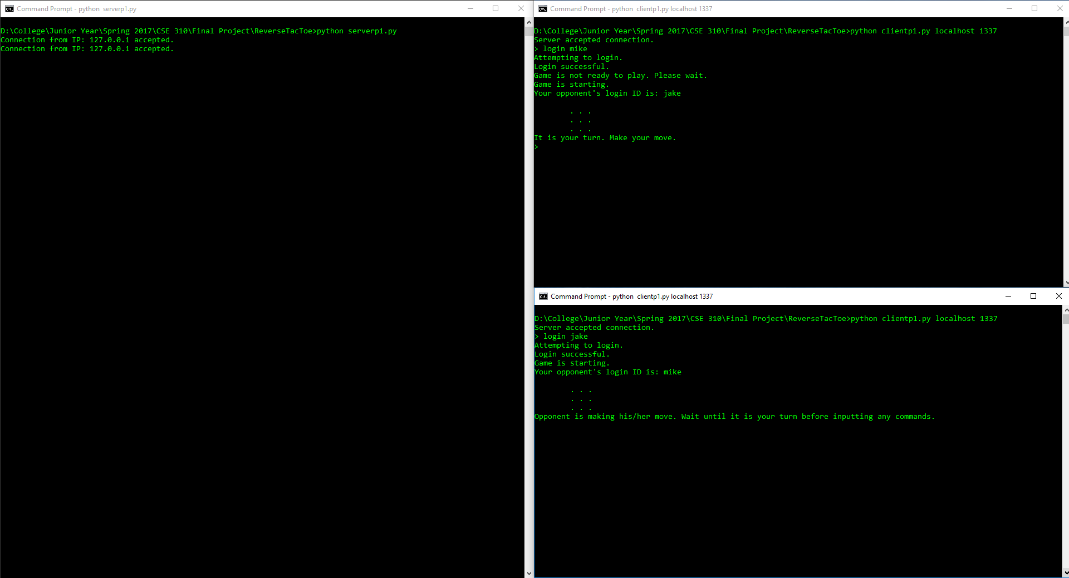

Figure 4: Second client successfully logs in – players are auto-matched and game is started

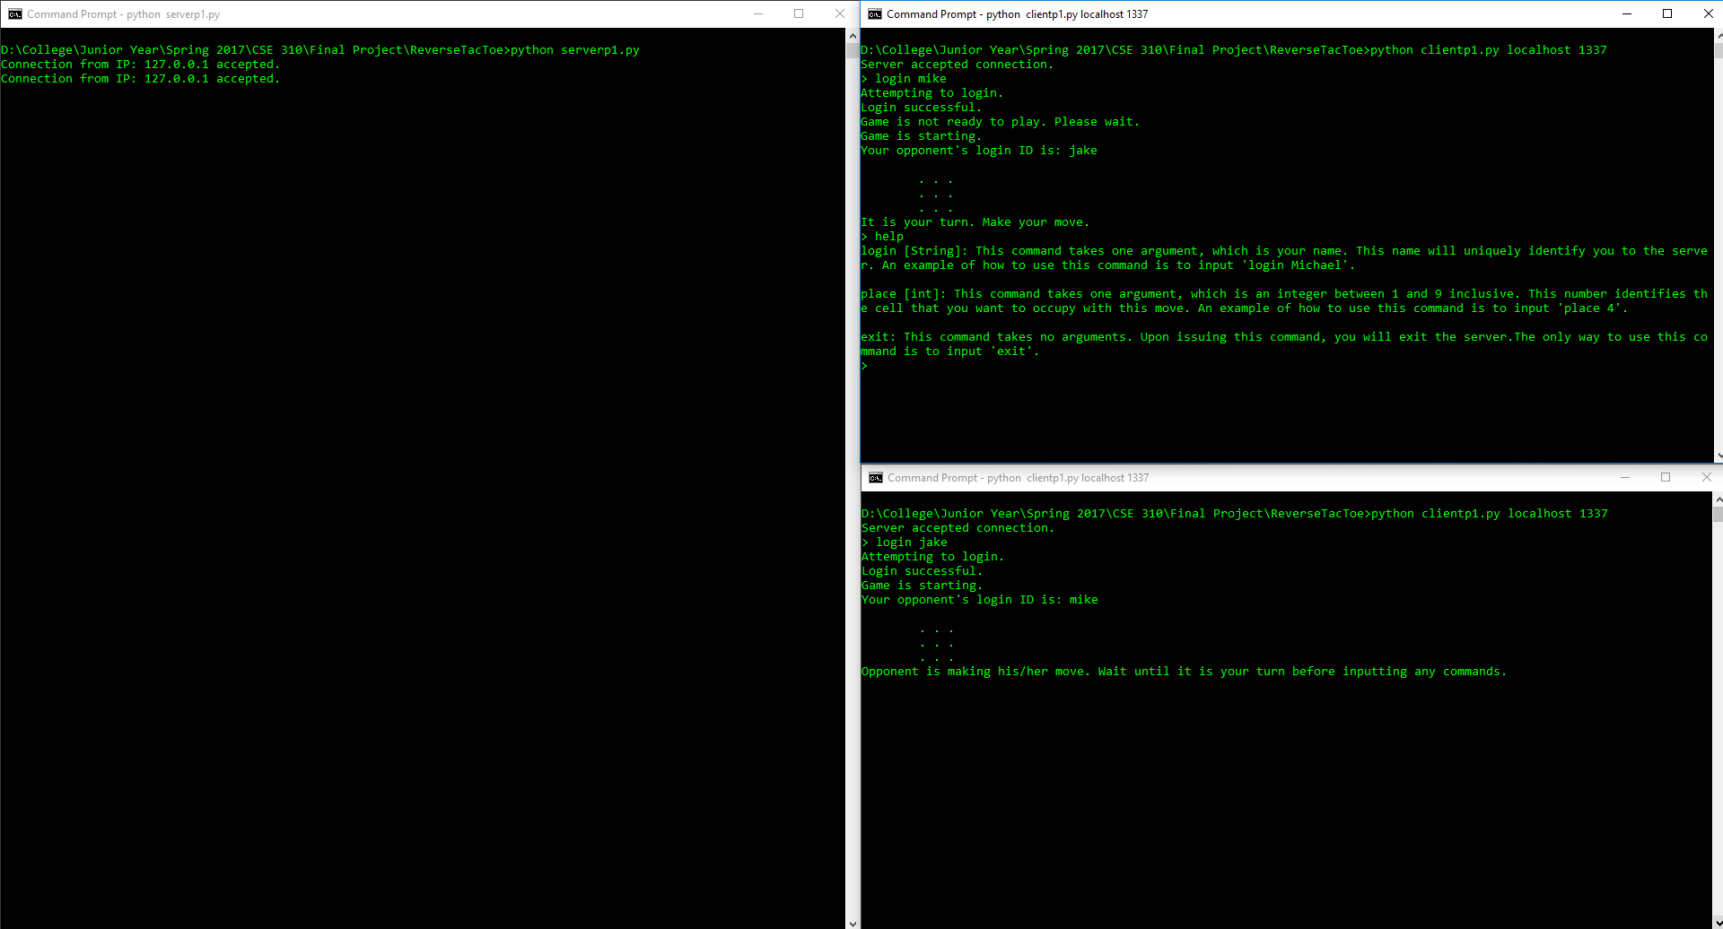

Figure 5: Help command is used mid-game

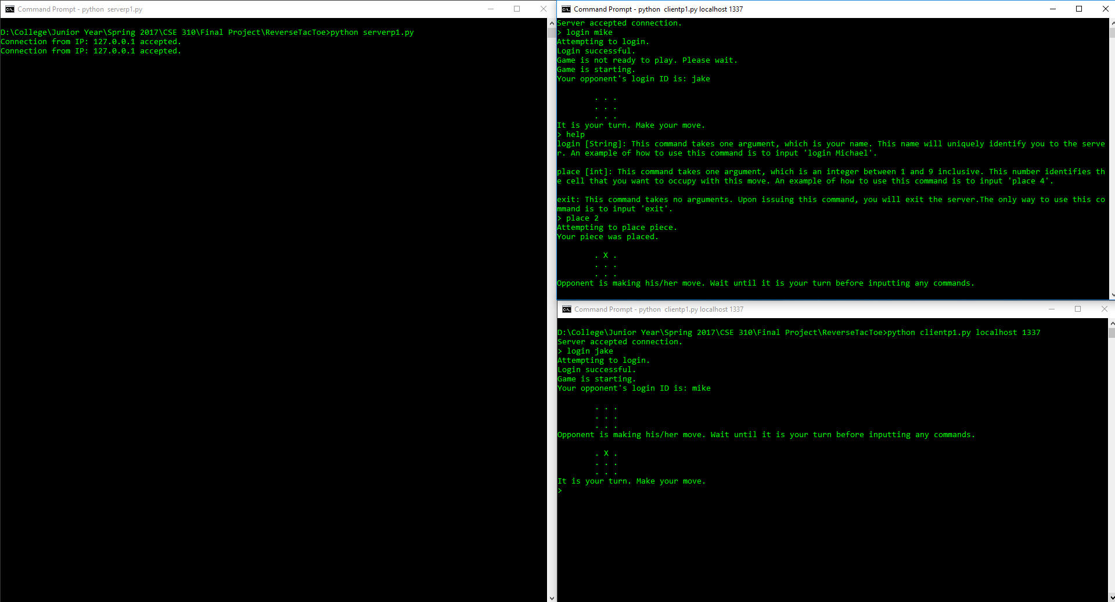

Figure 6: First client makes a move and the board is updated to reflect it

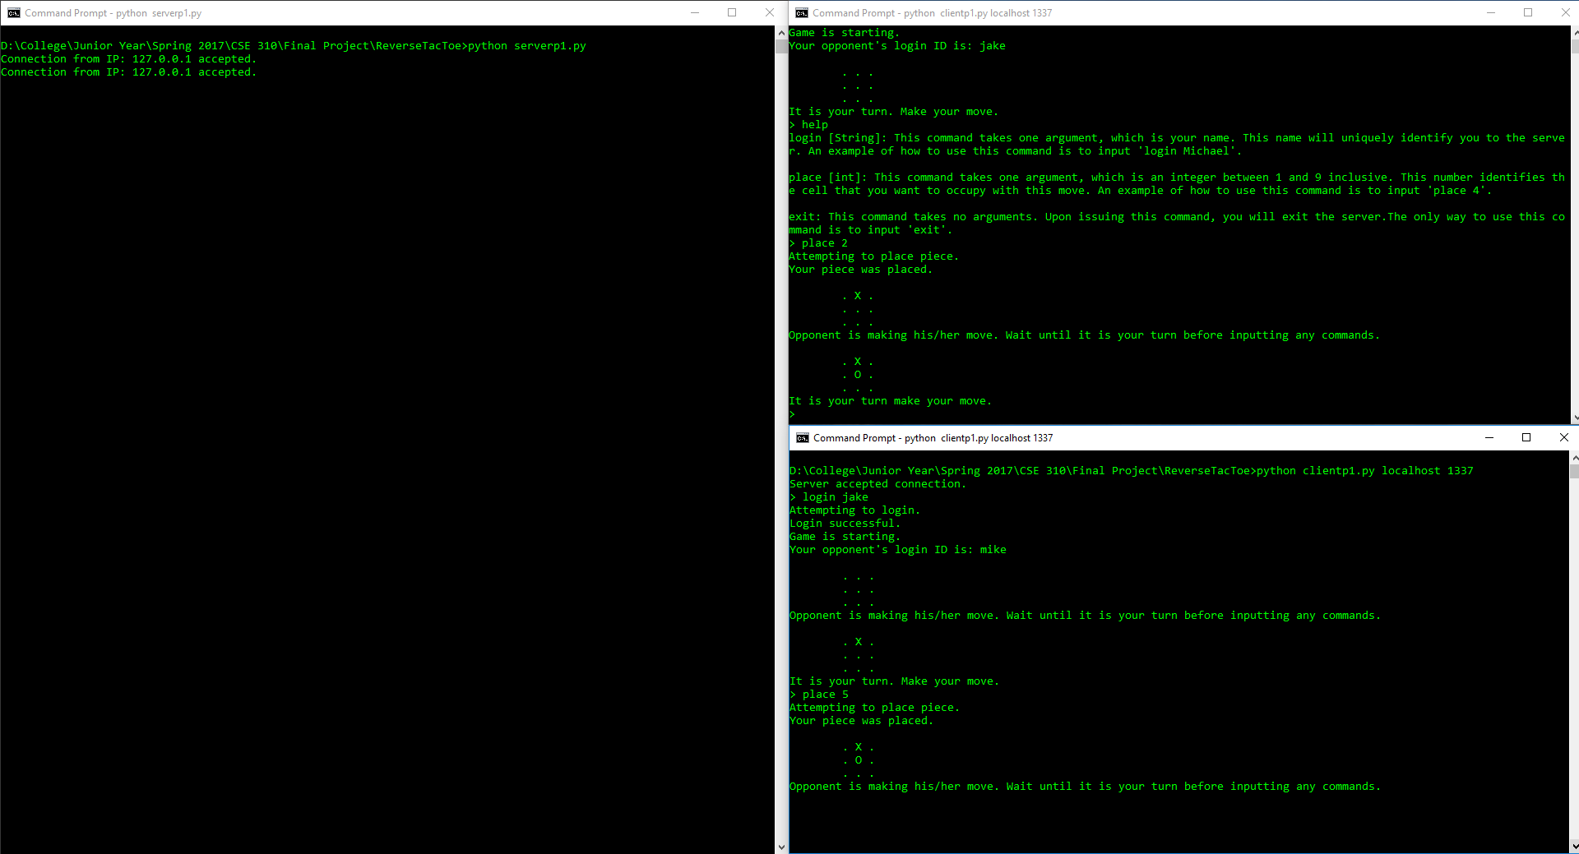

Figure 7: Second client makes a move and the board is updated to reflect it

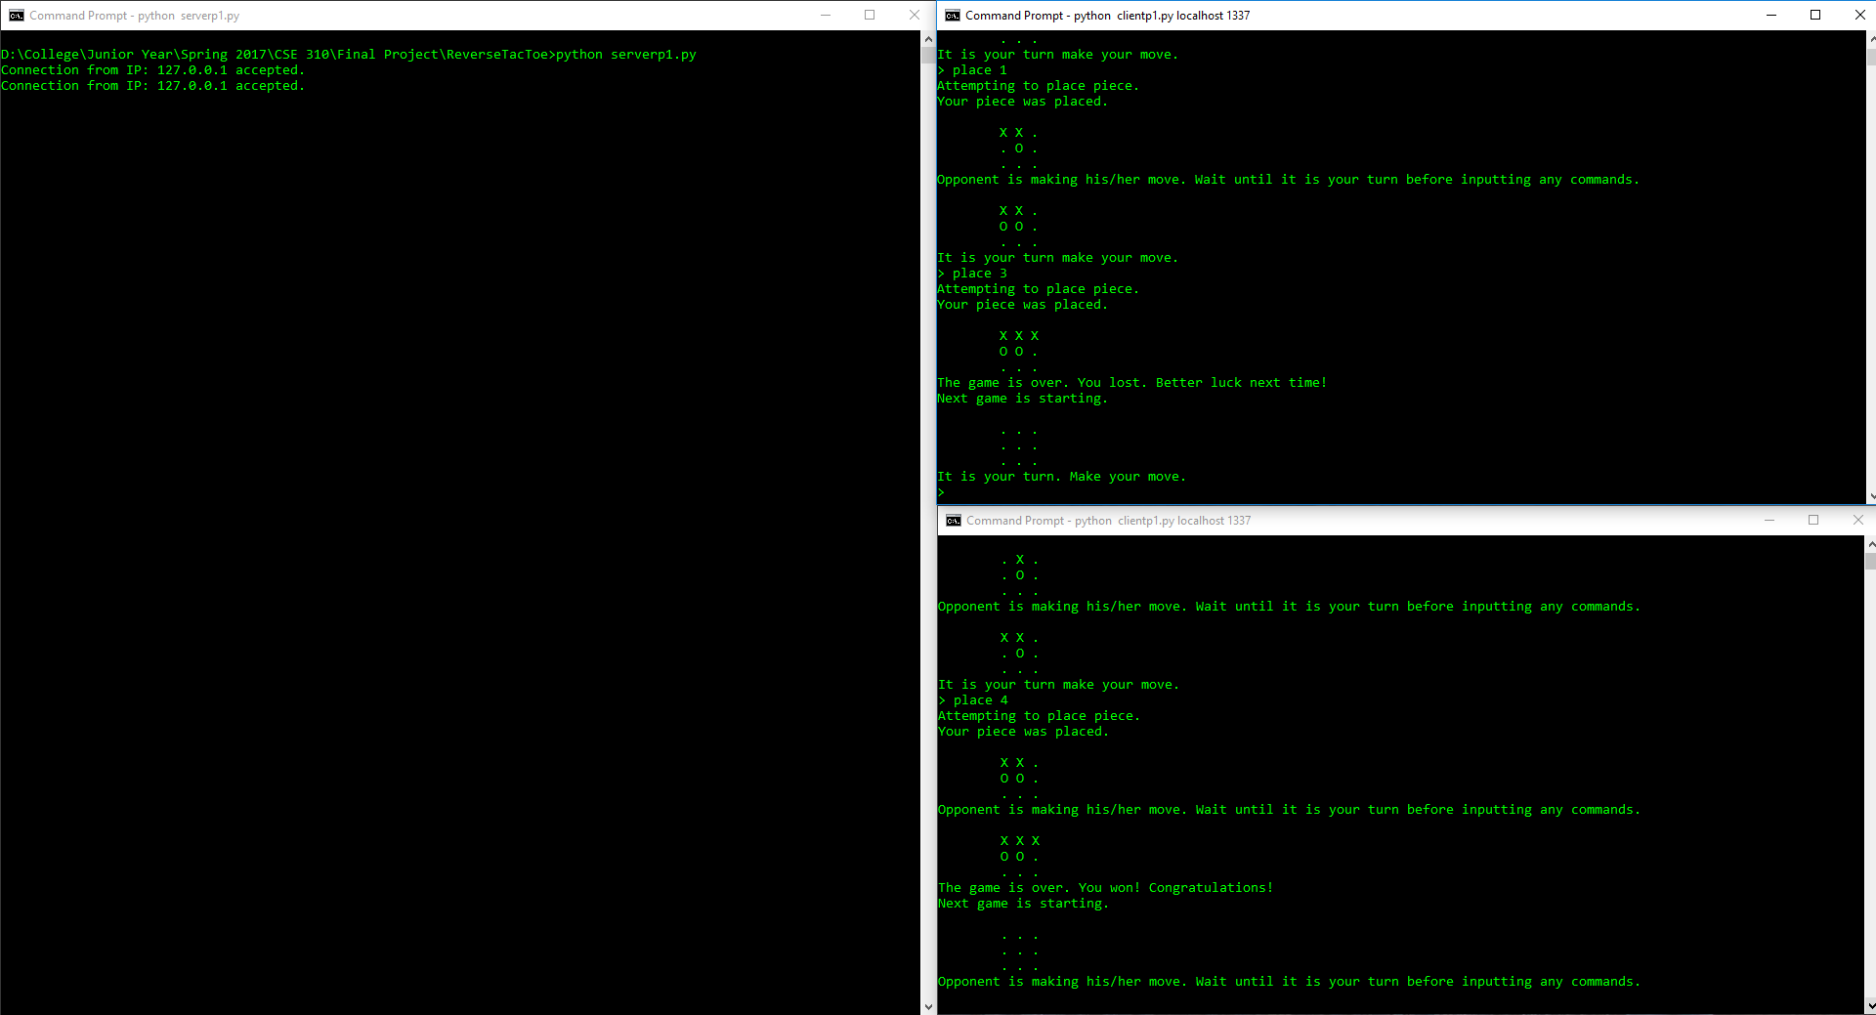

Figure 8: Game is finished – first client loses. Game then restarts

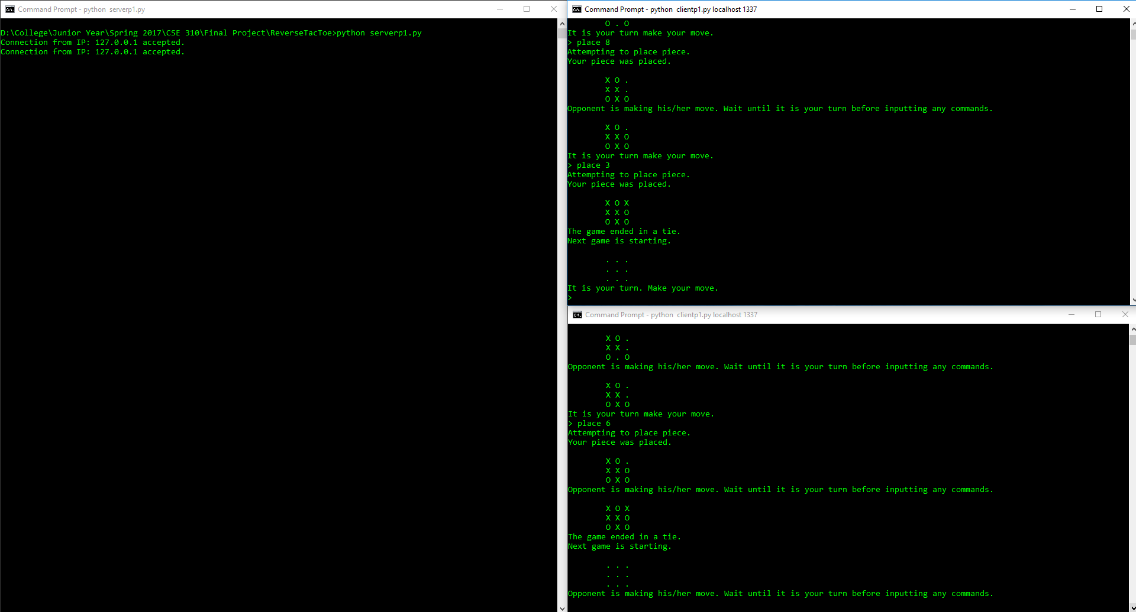

Figure 9: Game is finished – clients tie. Game is then restarted

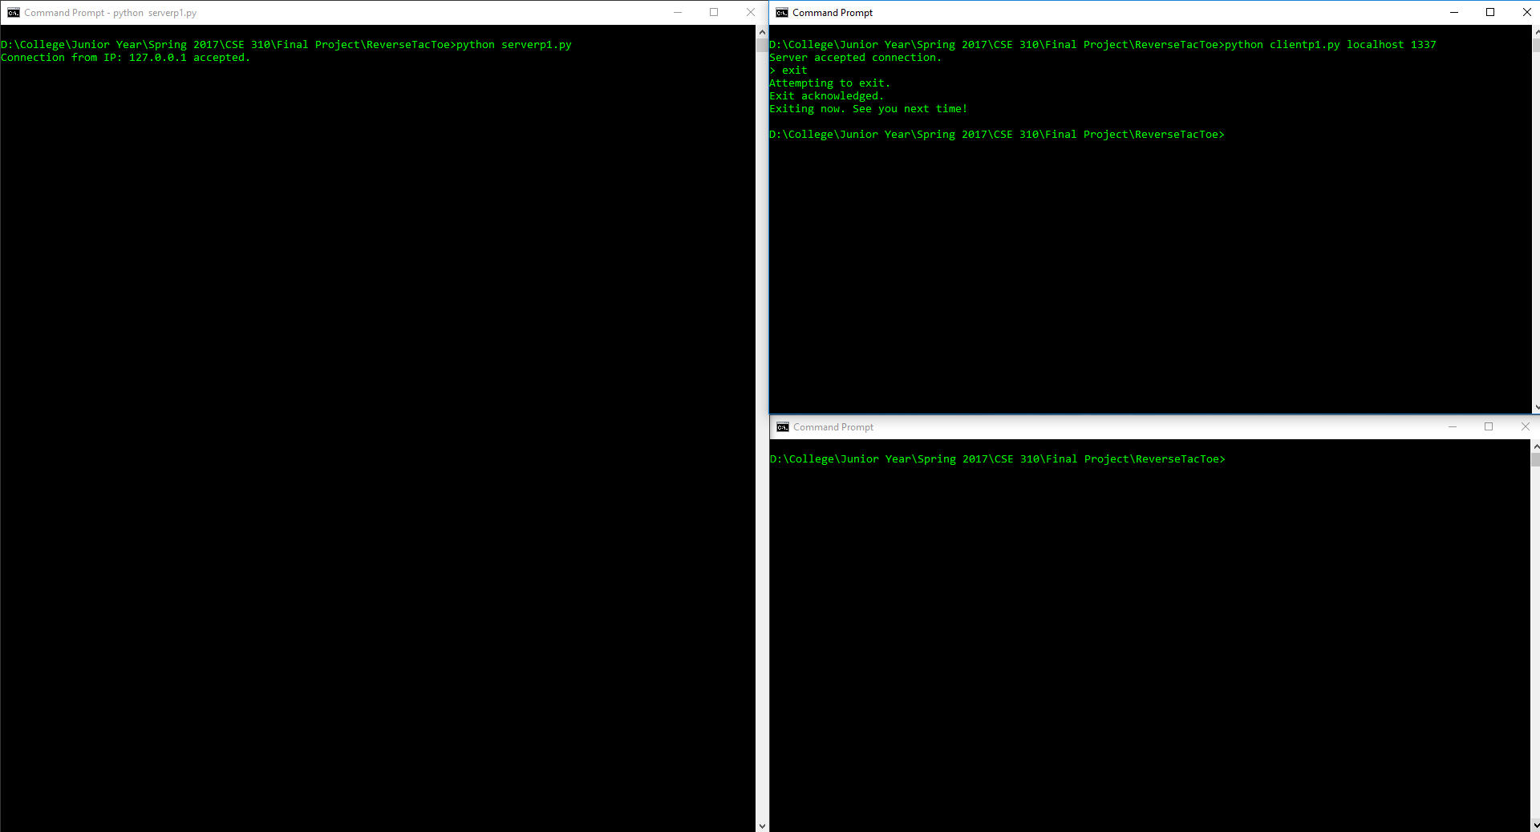

Figure 10: First client immediately exits after connecting

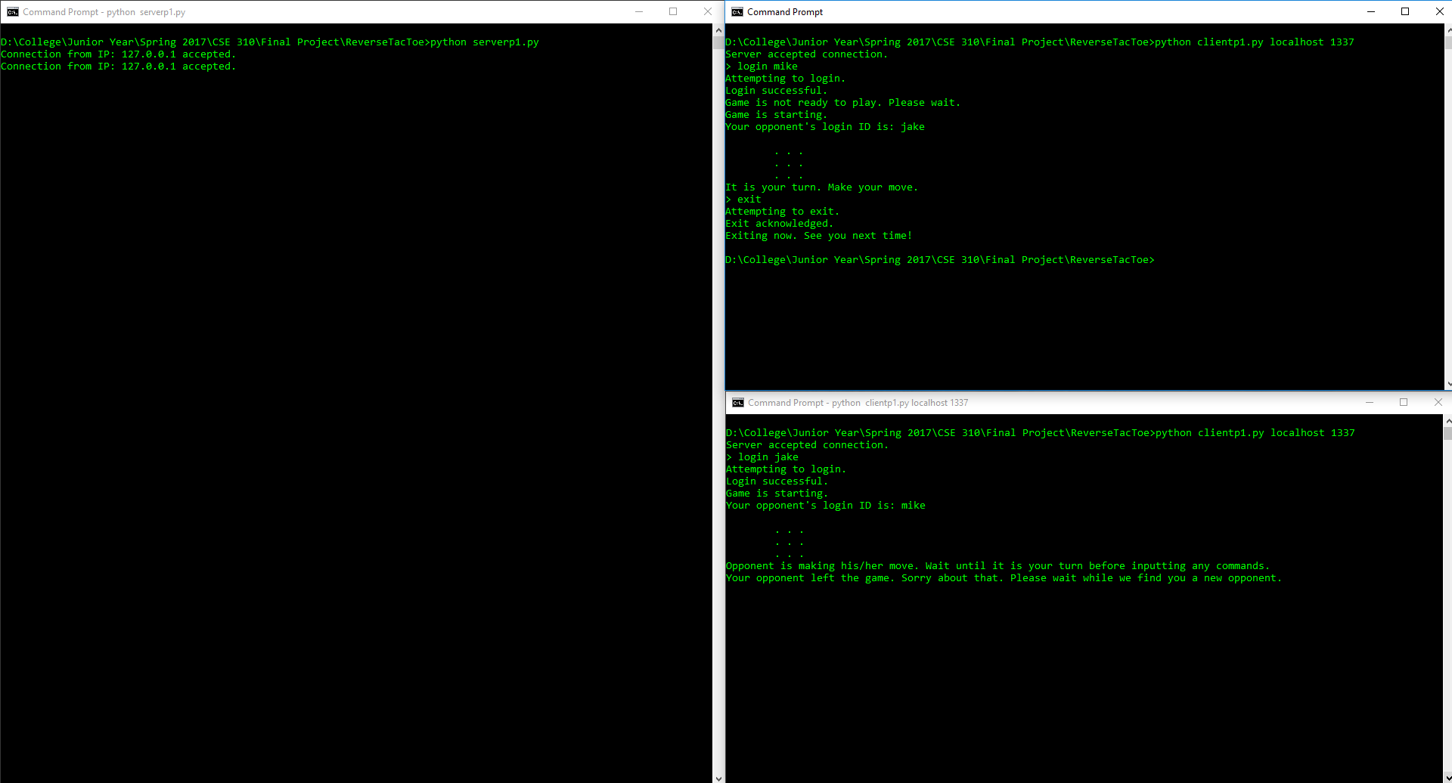

Figure 11: First client exits mid-game – second client waits for new opponent

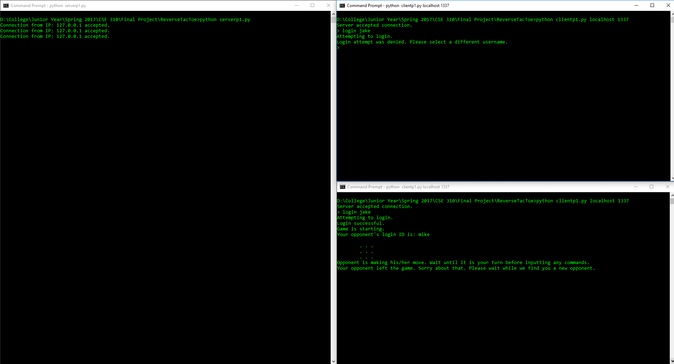

Figure 12: First client unsuccessfully tries to login with a username already in use

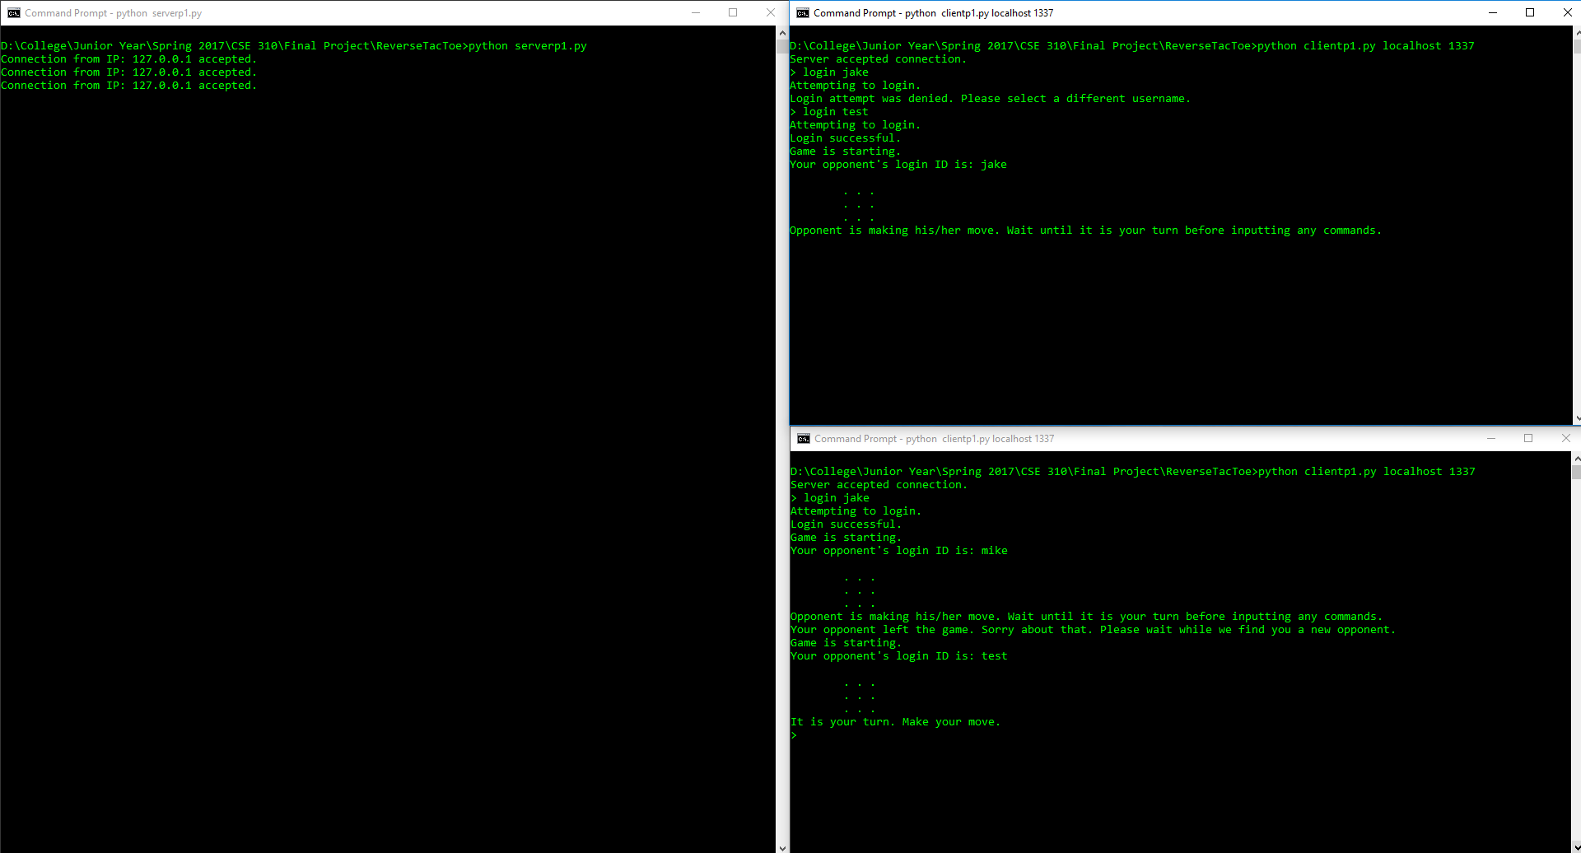

Figure 13: First client logs in and is auto-matched with existing player (after initial exit)

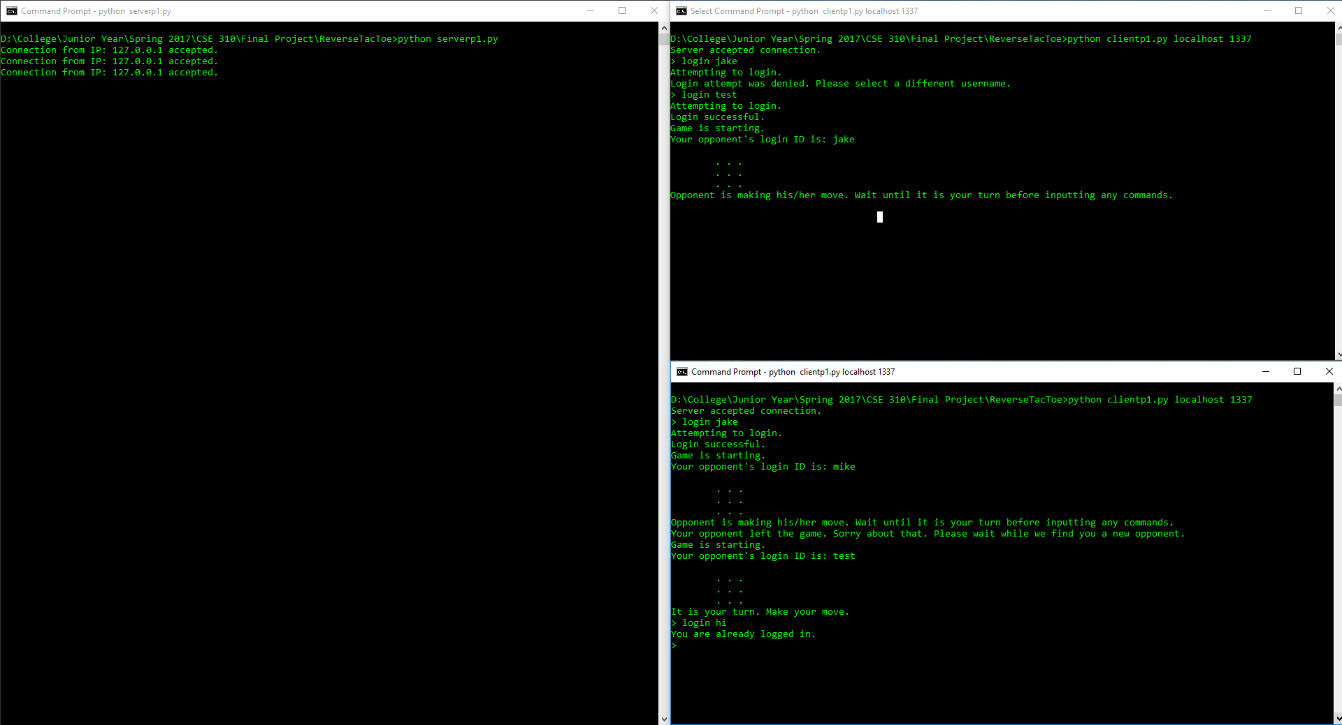

Figure 14: Second client unsuccessfully tries to login while already logged in