Securing people, cars and homes from trees potentially falling due to strong winds

To secure these elements from falling trees caused by strong winds, it is sufficient to build metal structures as in the following image:

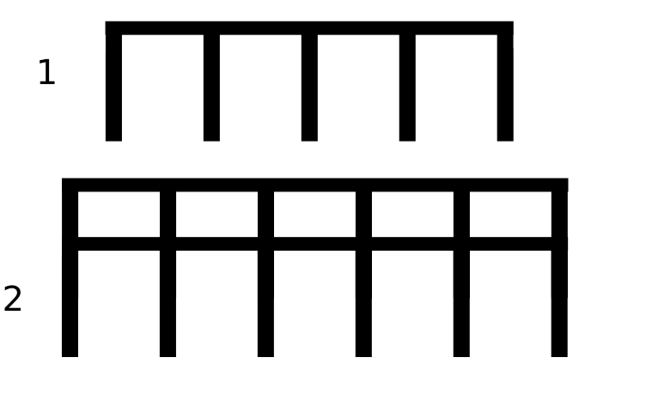
Structure type 1 is simply a structure suitable for shorter trees than structure 2. These are just conceptual examples. The point is that by placing a metal barrier between the trees and other elements at risk from falling trees, it is possible, with little expense, to protect the life of the trees that have taken decades to grow, and at the same time to protect people and objects at risk from falling trees. Of course, if these elements also have foundations, this clearly contributes to their solidity.
Please note that in the case of extremely large trees, it is still possible to place reinforcements to ensure that the collapse of the trunk does not cause the collapse of the metal structure.
Thanks to Google Translate for the translation.
This information is released into the public domain.

