**How to download/install SA-SAMS for the first time?**

**Step 1:** Open your browser (Internet Explorer).

**Step 2:** Type in: <http://www.thutong.doe.gov.za>

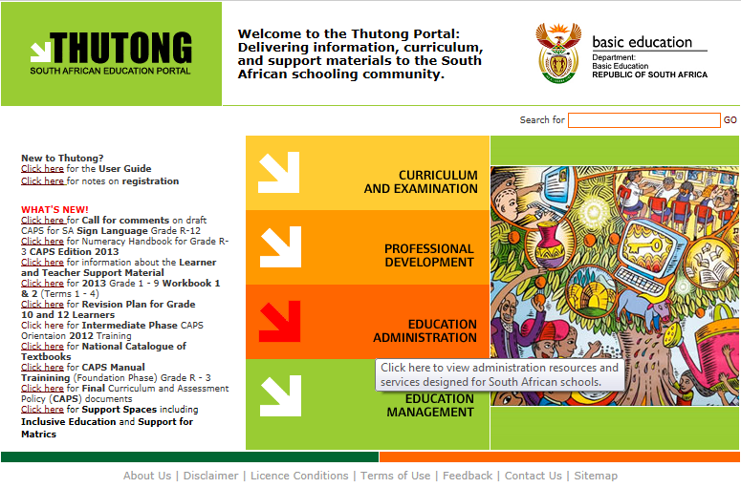

**Step 3:** Select **Education Administration**

**Step 4:** On the right side under SA-SAMS Installation File, select **Setup File (Installing SA-SAMS for the first time).**

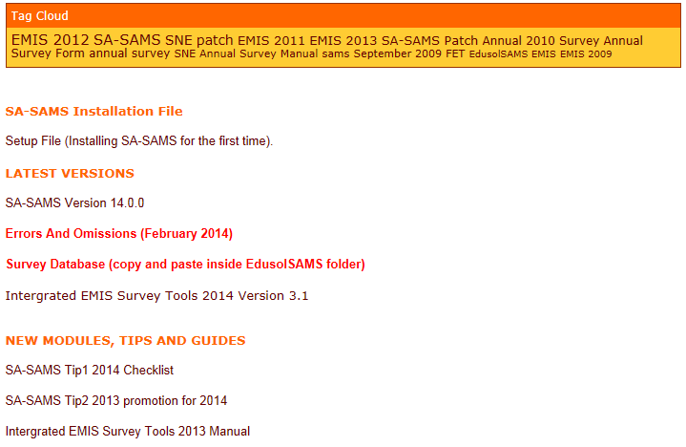

**Step 5:** A window will pop out at the bottom of the window select **save**.



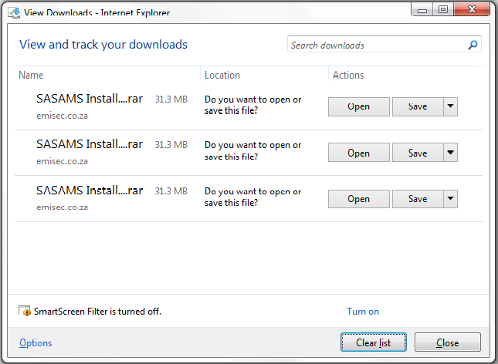

**Step 6:** A zipped folder will be downloaded into your downloads folder.

2.png

**Step 7:** Right click on the folder and select **Extract Here.**

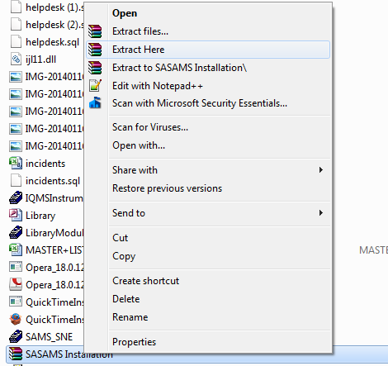

**Step 8:** This will create a folder named **SA-SAMS Installation.**

4.png

**Step 9:** Open the folder and click on **Setup** this will open the installation window. Click on **OK** to proceed.

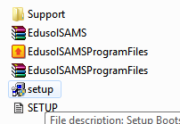

**Step 10:** After completion of **Step 9** click on **EdusolSAMSProgramFiles**  this will open the installation window. Click on **install**. This insures that all files are installed. **NB: Once done you can download the latest patch and here:** [**http://www.thutong.doe.gov.za/ResourceDownload.aspx?id=49022&userid=-1**](http://www.thutong.doe.gov.za/ResourceDownload.aspx?id=49022&userid=-1)

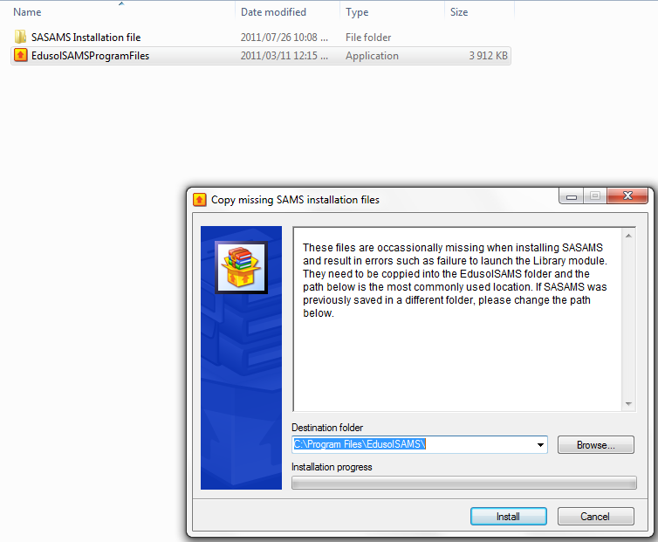

**Update to latest patch:**

**Step 12:** Go to-

[**http://www.thutong.doe.gov.za/Default.aspx?alias=www.thutong.doe.gov.za/administration**](http://www.thutong.doe.gov.za/Default.aspx?alias=www.thutong.doe.gov.za/administration)

## Step 13: On the right side under LATEST VERSIONS, double click SA-SAMS Version 17.1.0 to start download.

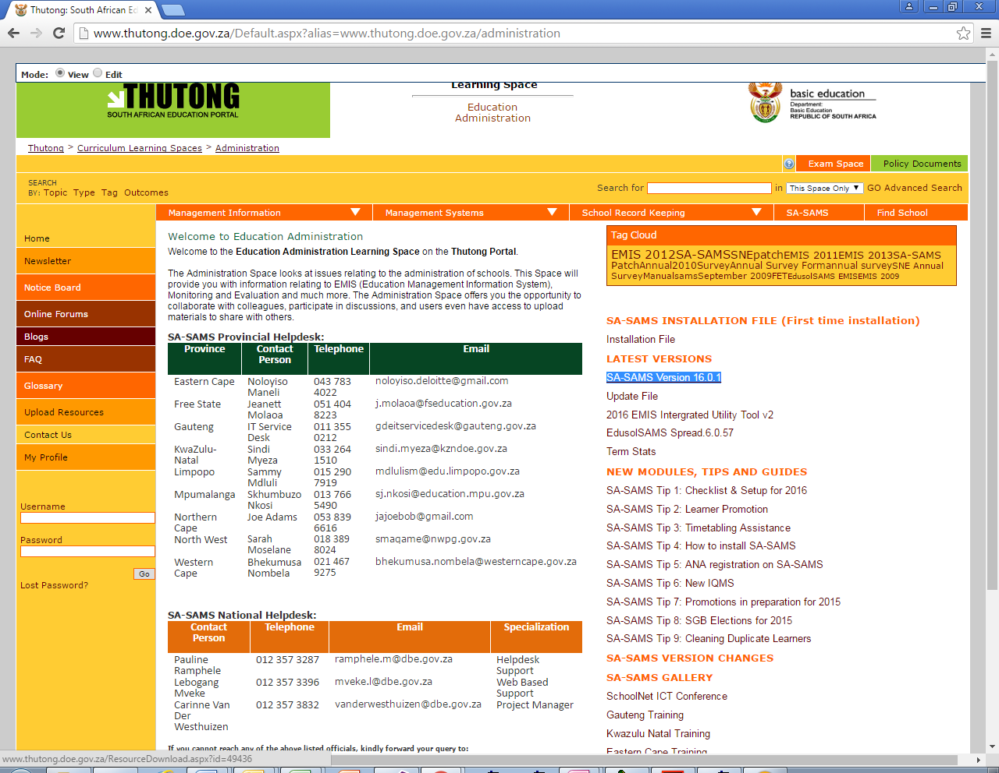

**Step 14:** Once download is done, extract the folder and make sure it is in the same location as your SA-SAMS installation.

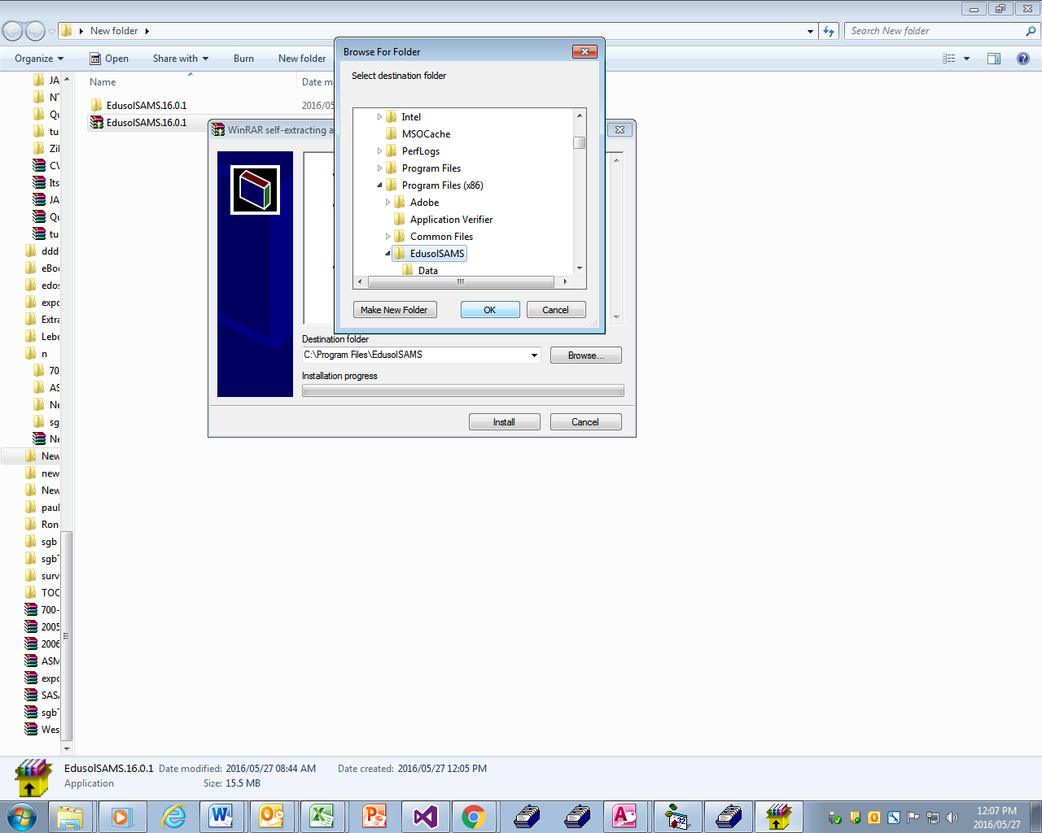

**Step 15:** Make your directory **C:\Program Files (x86)\EdusolSAMS** if you’re using 64-bit operating system, if it’s a 32-bit use the path **C:\Program Files\EdusolSAMS**.

**Install spread:**

* **Step 16:**

[**http://www.thutong.doe.gov.za/Default.aspx?alias=www.thutong.doe.gov.za/administration**](http://www.thutong.doe.gov.za/Default.aspx?alias=www.thutong.doe.gov.za/administration)

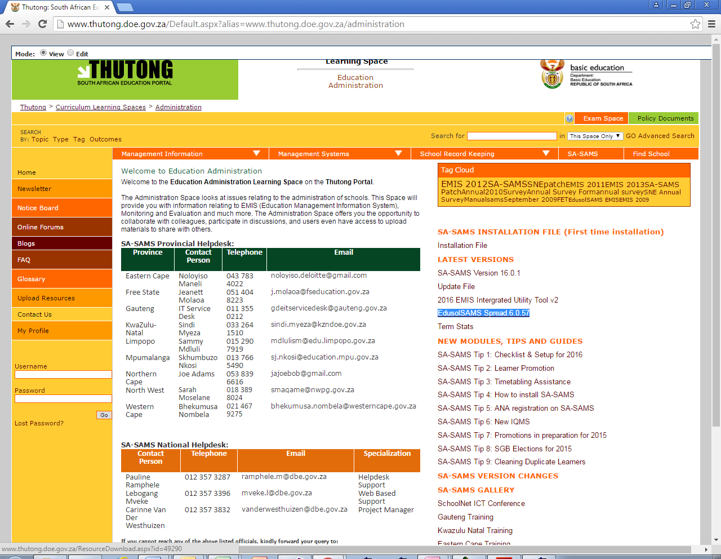

* **Step 17:** On the right side under LATEST VERSIONS, select [EdusolSAMS Spread.6.0.57](http://www.thutong.doe.gov.za/ResourceDownload.aspx?id=49290).
* **Step 18:** Once download is done, extract the folder and make sure it is in the same location as your SA-SAMS installation.
* **Step 19:** Make your directory **C:\Program Files (x86)\EdusolSAMS** if you’re using 64-bit operating system, if it’s a 32-bit use the path **C:\Program Files\EdusolSAMS**.

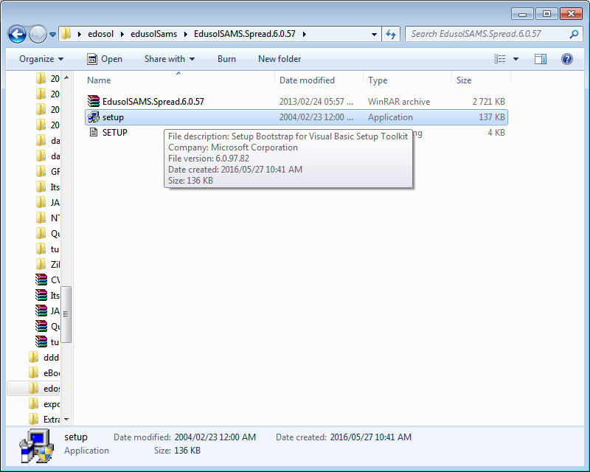

* **Step 20:** Double click on setup to start the installation.
* **Step 21:** Follow the instructions to continue with the installation.
* **Step 22:** Make your directory **C:\Program Files (x86)\EdusolSAMS** if you’re using 64-bit operating system, if it’s a 32-bit use the path **C:\Program Files\EdusolSAMS**.

**CHECKING IF ALL FILES ARE INSTALLED CORRECTLY**

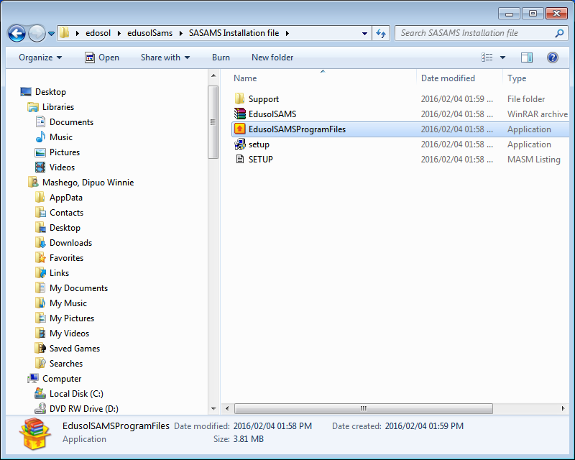

* **Step 23:** Double click on EdusolSAMSProgramFiles to start the installation.

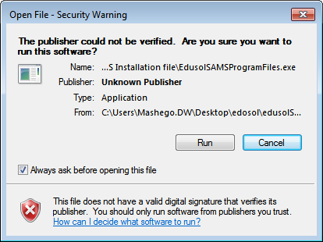

* **Step 24:** Click **RUN** to continue with the installation.

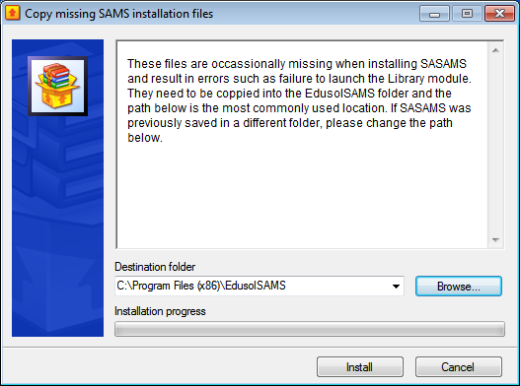

* **Step 25:** Make your directory **C:\Program Files (x86)\EdusolSAMS** if you’re using 64-bit operating system, if it’s a 32-bit use the path **C:\Program Files\EdusolSAMS**.
* **Step 26:** Click **Install** to continue with the installation.