Matthew A Beck

IST659 Project Deliverable

**Part 1: Design** **2**

Project Narrative 2

Data Dictionary 2

Data Questions 3

Entity Relationship Diagram 3

Logical Model Diagram 4

Normalized Model 5

[**Part 2: Implementation**](https://docs.google.com/document/d/1eYOD0k4RUN7ok-umpmdUqCal6Bc4sKuECRO9tG1gm4c/edit#heading=h.spfj7uy2zkwz) **6**

[SQL DDL](https://docs.google.com/document/d/1eYOD0k4RUN7ok-umpmdUqCal6Bc4sKuECRO9tG1gm4c/edit#heading=h.2kprgnbxmo9w) 6

[SQL DML](https://docs.google.com/document/d/1eYOD0k4RUN7ok-umpmdUqCal6Bc4sKuECRO9tG1gm4c/edit#heading=h.wsdi3utu5iag) 16

[INSERT Statements](https://docs.google.com/document/d/1eYOD0k4RUN7ok-umpmdUqCal6Bc4sKuECRO9tG1gm4c/edit#heading=h.4trtr3797uke) 16

[Answers to Data Questions (SQL SELECT Statements)](https://docs.google.com/document/d/1eYOD0k4RUN7ok-umpmdUqCal6Bc4sKuECRO9tG1gm4c/edit#heading=h.2vclphkmrhup) 20

[GUI Prototype](https://docs.google.com/document/d/1eYOD0k4RUN7ok-umpmdUqCal6Bc4sKuECRO9tG1gm4c/edit#heading=h.wpwklx1y3r05) 22

[Reflection](https://docs.google.com/document/d/1eYOD0k4RUN7ok-umpmdUqCal6Bc4sKuECRO9tG1gm4c/edit#heading=h.mx5id0nsesu4) 23

# 

# Part 1: Design

## Project Narrative

My company is made up of a complex hierarchical structure with many business leaders overseeing one or many departments. Historically, success metrics and their associated visual representation have varied significantly from one area of the business to the other. The goal of my project is to link these metrics to the vital questions of the business in an extensible framework that can be easily accessed and updated by question askers and those responsible for answering. By simplifying both the collection and display of these metrics and their associated metadata, I can help leaders in the business focus on driving action instead of sifting through dense analytic reports.

## Data Dictionary

After conducting interviews with several business leaders and studying available frameworks for metric collection, I chose to document the following entities

|  |  |  |
| --- | --- | --- |
| **Entity** | **Attribute** | **Properties** |
| User | User | Required. Name of Employee, user of the metrics engine |
| Role | Role | Required and Unique. |
| Business Question | Question | Required and Unique. |
| Metric | Metric | Required. |
|  | Description | Explanation of what metric represents |
|  | Direction | Which direction (positive or negative) does the business want the metric to go? |
|  | Population | What groups are represented by this data |
|  | Data Steward | Who is responsible for maintaining this metric |
|  | Reference | Link to where more information on the metric can be found. |
| Metric Value | Value | Required. Recorded value of a metric |
|  | Date Entered | Date value entered the system |
|  | Period | Period of time from which a value was captured |
| Benchmark | Benchmark | Required. Business-determined value for an appropriate benchmark for a given metric |
|  | Entry Date | Date benchmark was entered the system |
|  | Valid From | Should benchmarks later be changed, a timestamp of when a given benchmark was first used |
|  | Valid To | Should benchmarks later be changed, a timestamp of when a given benchmark ceased being used. |
| Forecast | Forecast | Forecasted value for a linked metric |
|  | Period | Period of time for which a forecast was made |
|  | Entry Date | Date forecast was entered the system |
|  | Valid From | Should forecasts later be changed, a timestamp of when a given forecast was first used |
|  | Valid To | Should forecasts later be changed, a timestamp of when a given forecast ceased being used. |

|  |  |
| --- | --- |
| Business Rules | |
| A user has exactly one role  A role may be held by many users  A role belongs to only one supervisory organization at a time  A supervisory organization contains many roles  A role may ask one or many business questions  A business question may be asked by one or many roles  A business question may be answered by one or many metrics  A metric may answer one or many business questions  A metric may have one or many benchmarks (over time)  A benchmark may be used for exactly one metric  A metric may represent one or many metric values  A metric value may be used for exactly one metric  A metric may produce many forecasts  A forecast is produced for exactly one metric | |

The relevant stakeholders for this project are, for a given department:

**Executive** - Primary audience for business KPIs, reviews them with managers to gauge department performance

**Manager** - Relies on KPIs to measure their department’s performance, reviews with executives, analysts, and staff.

**Analyst** - Helps identify trends and produces reporting for managers to use in conversations with executives.

**Staff** - Individuals who generate the actual business output measured by KPIs.

## Data Questions

Some questions this database must be able to answer:

1. How many roles and users are linked to a given business question?
2. Which business questions does a particular role need to ask?
3. What is our current company performance, based on the questions we care about, and relative to our benchmarks?
4. For each of our metrics, how did our actuals compare with our forecasts?
5. Which employees (users) can answer a given business question?

## Entity Relationship Diagram

When connected via relationships, the ERD is found on the following page. To manage the scope of this project, I have chosen to limit the database with the assumption that the database as presented will only contain data for one department. After the approach is piloted within the business, this framework can be expanded to accept a “department” entity.

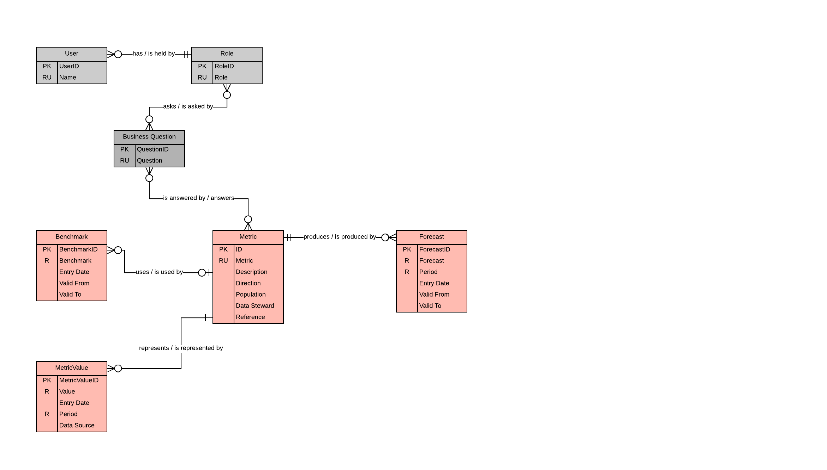

## Logical Model Diagram

In order to convert this conceptual ERD to a logical model, I did the following:

1. Reframed the existing entities as tables, renamed fields to be more system-friendly and added surrogate keys where necessary.
2. Assigned data types to fields listed in the data dictionary
3. Mapped relationships
   1. Established primary and foreign keys, documented the relevant constraints
   2. Created associative tables for the relationship between roles and business questions, and between business questions and their respective metrics.

Following these steps produced the following diagram:

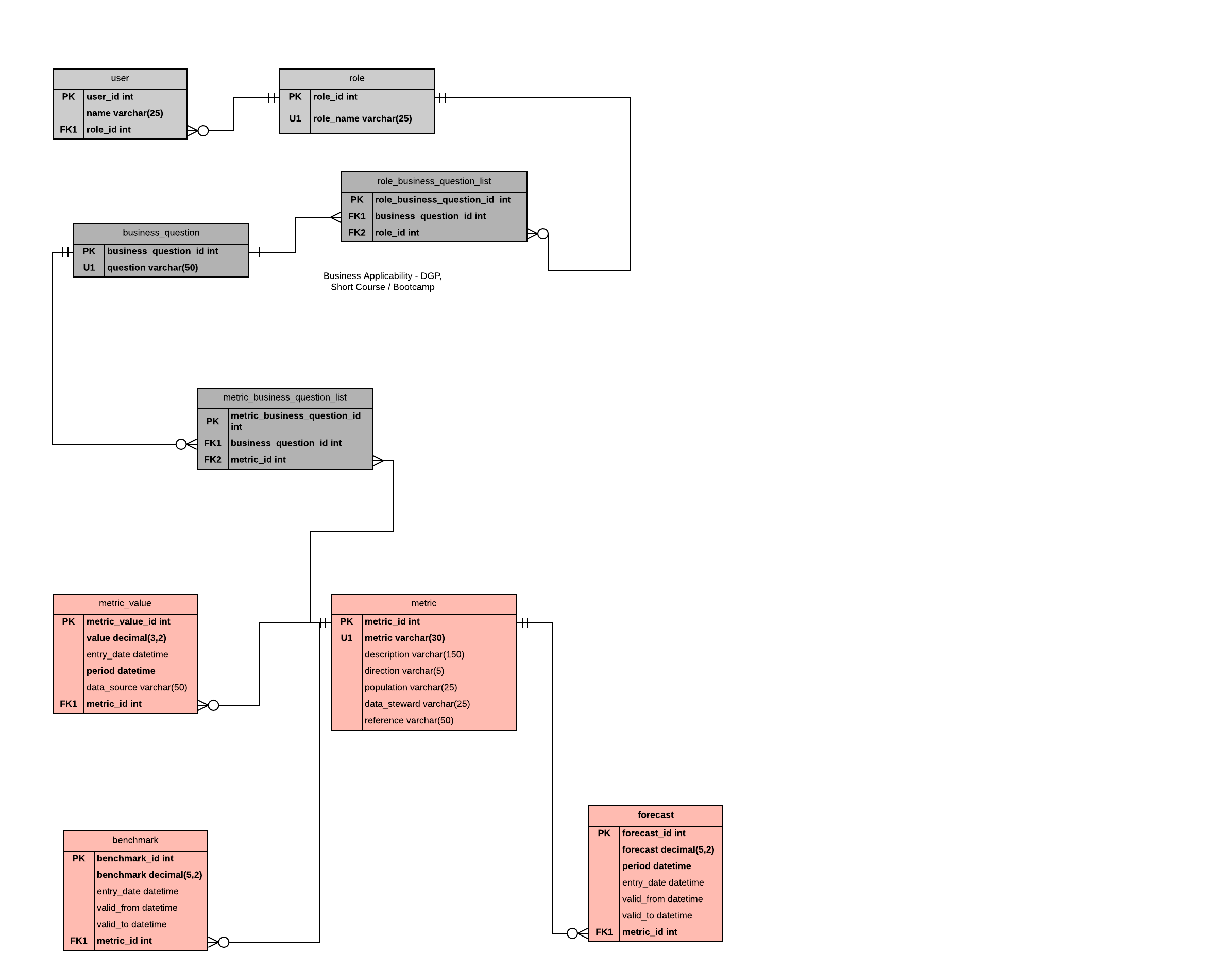

## Normalized Model

The effort to create the logical model resulted in relations in third-normal form, so no further normalization was required.

# Part 2: Implementation

## SQL DDL

/*

Author : Matt Beck

Course : IST659 M400

Term : October, 2019

*/

/*

Drop the tables first, if they exist

Dropped in reverse order of creation to avoid any problems with

foreign key references

Using DROP method

*/

DROP TABLE IF EXISTS forecast

DROP TABLE IF EXISTS metric_value

DROP TABLE IF EXISTS benchmark

DROP TABLE IF EXISTS metric_business_question_list

DROP TABLE IF EXISTS metric

DROP TABLE IF EXISTS role_business_question_list

DROP TABLE IF EXISTS business_question

DROP TABLE IF EXISTS [user]

DROP TABLE IF EXISTS [role]

DROP FUNCTION IF EXISTS bq_count_roles

DROP FUNCTION IF EXISTS bq_count_users

DROP FUNCTION IF EXISTS max_benchmark

DROP FUNCTION IF EXISTS derive_latest_value

DROP FUNCTION IF EXISTS next_forecast

DROP PROCEDURE IF EXISTS dbo.add_new_benchmark

DROP PROCEDURE IF EXISTS dbo.add_new_forecast

DROP PROCEDURE IF EXISTS dbo.add_new_mbq_mapping

DROP PROCEDURE IF EXISTS dbo.add_new_metric

DROP PROCEDURE IF EXISTS dbo.add_new_question

DROP PROCEDURE IF EXISTS dbo.add_new_rbq_mapping

DROP PROCEDURE IF EXISTS dbo.add_new_role

DROP PROCEDURE IF EXISTS dbo.add_new_user

DROP PROCEDURE IF EXISTS dbo.delete_mbq_mapping

DROP PROCEDURE IF EXISTS dbo.delete_rbq_mapping

DROP PROCEDURE IF EXISTS dbo.delete_user

DROP PROCEDURE IF EXISTS dbo.update_existing_benchmark_value

DROP PROCEDURE IF EXISTS dbo.update_existing_forecast_value

DROP PROCEDURE IF EXISTS dbo.update_metric_value

DROP PROCEDURE IF EXISTS dbo.update_question

DROP PROCEDURE IF EXISTS dbo.update_role_name

DROP PROCEDURE IF EXISTS dbo.update_user_name

DROP VIEW IF EXISTS bq_role_user_counts

DROP VIEW IF EXISTS business_questions_by_role

DROP VIEW IF EXISTS company_performance

DROP VIEW IF EXISTS forecast_actual_comparison

DROP VIEW IF EXISTS bq_employee_lookup

/*

Creating Tables for Database

*/

-- Creating the Role table

CREATE TABLE [role] (

--Columns for the Role table

role_id int identity,

role_name varchar(25) not null,

--Constraints on the role Table

CONSTRAINT PK_role PRIMARY KEY (role_id),

CONSTRAINT U1_role UNIQUE(role_name)

)

--End Creating the Role Table

GO

-- Creating the User table

CREATE TABLE [user] (

--Columns for the User table

user_id int identity,

name varchar(25) not null,

role_id int not null,

--Constraints on the User Table

CONSTRAINT PK_user PRIMARY KEY (user_id),

CONSTRAINT FK1_user FOREIGN KEY (role_id) REFERENCES role(role_id)

)

--End Creating the User Table

GO

-- Creating the business_question table

CREATE TABLE business_question (

--Columns for the Role table

business_question_id int identity,

question varchar(100) not null,

--Constraints on the role Table

CONSTRAINT PK_business_question PRIMARY KEY (business_question_id),

CONSTRAINT U1_question UNIQUE(question)

)

--End Creating the business question Table

GO

-- Creating the role_business_question_list table

CREATE TABLE role_business_question_list (

--Columns for the role_business_question_list table

role_business_question_id int identity,

business_question_id int not null,

role_id int not null,

--Constraints on the role_business_question_list Table

CONSTRAINT PK_role_business_question_list PRIMARY KEY (role_business_question_id),

CONSTRAINT FK1_role_business_question_list FOREIGN KEY (business_question_id) REFERENCES business_question(business_question_id),

CONSTRAINT FK2_role_business_question_list FOREIGN KEY (role_id) REFERENCES role(role_id)

)

--End Creating the role_business_question_list table

GO

--Creating the metric table

CREATE TABLE metric (

metric_id int identity,

metric varchar(30) not null,

description varchar(150),

direction varchar(5),

population varchar(25),

data_steward varchar(25),

reference varchar(50),

CONSTRAINT PK_metric PRIMARY KEY (metric_id),

CONSTRAINT U1_metric UNIQUE(metric)

);

--End Creating the metric Table

GO

-- Creating the metric_business_question_list table

CREATE TABLE metric_business_question_list (

--Columns for the metric_business_question_list table

metric_business_question_id int identity,

business_question_id int not null,

metric_id int not null,

--Constraints on the metric_business_question_list Table

CONSTRAINT PK_metric_business_question_list PRIMARY KEY (metric_business_question_id),

CONSTRAINT FK1_metric_business_question_list FOREIGN KEY (business_question_id) REFERENCES business_question(business_question_id),

CONSTRAINT FK2_metric_business_question_list FOREIGN KEY (metric_id) REFERENCES metric(metric_id)

)

--End Creating the role_business_question_list table

GO

--Creating the metric_value table

CREATE TABLE metric_value (

--Columns for metric value table

metric_value_id int identity,

value decimal(3,2) not null,

entry_date datetime default GetDate(),

period datetime not null,

metric_id int not null,

--Constraints on the metric_value table

CONSTRAINT PK_metric_value PRIMARY KEY (metric_value_id),

CONSTRAINT FK1_metric_value FOREIGN KEY (metric_id) REFERENCES metric(metric_id)

)

--End Creating the metric_value table

GO

--Creating the benchmark table

CREATE TABLE benchmark (

--Columns for benchmark table

benchmark_id int identity,

benchmark decimal(5,2) not null,

entry_date datetime default GetDate(),

valid_from datetime,

valid_to datetime,

metric_id int not null,

--Constraints on the benchmark table

CONSTRAINT PK_benchmark PRIMARY KEY (benchmark_id),

CONSTRAINT FK1_benchmark FOREIGN KEY (metric_id) REFERENCES metric(metric_id)

)

--End Creating the benchmark table

GO

--Creating the forecast table

CREATE TABLE forecast (

--Columns for forecast table

forecast_id int identity,

forecast decimal(5,2) not null,

period datetime,

entry_date datetime default GetDate(),

valid_from datetime,

valid_to datetime,

metric_id int not null,

--Constraints on the forecast table

CONSTRAINT PK_forecast PRIMARY KEY (forecast_id),

CONSTRAINT FK1_forecast FOREIGN KEY (metric_id) REFERENCES metric(metric_id)

)

--End Creating the forecast table

GO

--Functions

--Create function for counting the number of roles based on a business question (or abstract to allow the user to include table name)

CREATE FUNCTION bq_count_roles(@bqID int)

RETURNS int AS

BEGIN

DECLARE @returnValue int --matches the function's return type

/*

Get the count of roles for the provided question and

assign that value to @returnValue.

*/

SELECT @returnValue = COUNT(DISTINCT role_id) FROM role_business_question_list rbq

WHERE rbq.business_question_id = @bqID

--Return @returnValue to the calling code.

RETURN @returnValue

END

GO

--Create function for counting # of Users based on business question provided

CREATE FUNCTION bq_count_users(@bqID int)

RETURNS int AS

BEGIN

DECLARE @returnValue int --matches the function's return type

/*

Get the count of users for the provided question and

assign that value to @returnValue.

*/

SELECT @returnValue = COUNT(DISTINCT u.user_id) FROM role_business_question_list rbq

JOIN [role] r ON rbq.role_id=r.role_id

JOIN [user] u ON u.role_id=r.role_id

WHERE rbq.business_question_id = @bqID

--Return @returnValue to the calling code.

RETURN @returnValue

END

GO

--Create function for pulling the most recent value for a given metric

CREATE FUNCTION derive_latest_value(@metric_id int)

RETURNS decimal(5,2) AS --COUNT is an integer, so shall it be returned

BEGIN

DECLARE @returnValue decimal(5,2) --match function return type

DECLARE @max_period datetime

select @max_period = MAX(period) from metric_value WHERE metric_id = @metric_id;

/*

Pull the latest value from the metrics table, with the ID provided.

*/

WITH CTE_latest_value

AS

(

SELECT

mv.*,

ROW_NUMBER() OVER(PARTITION BY mv.metric_id ORDER BY IIF(mv.period >=@max_period,1,2) ASC) rnk

FROM

metric_value mv

)

SELECT @returnValue = value FROM CTE_latest_value WHERE rnk = 1 and metric_id = @metric_id

--Return @returnValue to the calling code.

RETURN @returnValue

END

GO

--Create function for pulling the most recent benchmark for a given metric

CREATE FUNCTION max_benchmark(@metric_id int)

RETURNS decimal(5,2) AS --COUNT is an integer, so shall it be returned

BEGIN

DECLARE @returnValue decimal(5,2) --match function return type

/*

Collect the maximum benchmark value, given the provided metric ID

and assign that to the return value.

*/

SELECT @returnValue = MAX(benchmark) FROM benchmark

WHERE benchmark.metric_id = @metric_id and valid_to IS NULL

--Return @returnValue to the calling code.

RETURN @returnValue

END

GO

--Create function for pulling the predicted forecast for a given metric

CREATE FUNCTION next_forecast(@metric_id int)

RETURNS decimal(5,2) AS --COUNT is an integer, so shall it be returned

BEGIN

DECLARE @returnValue decimal(5,2) --match function return type

DECLARE @next_forecast_period datetime

select @next_forecast_period = MIN(period) from forecast f

WHERE metric_id = @metric_id and period > GETDATE();

/*

Collect the next upcoming forecast, given the provided metric ID

and assign that to the return value.

*/

WITH temp_latest_value

AS

(

SELECT

mv.*,

ROW_NUMBER() OVER(PARTITION BY mv.metric_id ORDER BY IIF(mv.period >=@next_forecast_period,1,2) ASC) rnk

FROM

metric_value mv

)

SELECT @returnValue = value FROM temp_latest_value WHERE rnk = 1 and metric_id = @metric_id

--Return @returnValue to the calling code.

RETURN @returnValue

END

GO

--Stored Procedures

/*

Stored Procedure for updating a metric value

Stored Procedure for updating a benchmark value

Stored Procedure for updating a forecast

Stored Procedure for updating a role name

Stored Procedure for updating a user name

Stored Procedure for updating a business question

Stored Procedure for adding a new user

Stored Procedure for adding a new role

Stored Procedure for adding a new metric

Stored Procedure for adding a new metric value

Stored Procedure for adding a new benchmark

Stored Procedure for adding a new forecast

Stored Procedure for adding a role to question mapping

Stored Procedure for adding a metric to question mapping

Stored Procedure for deleting a user

Stored Procedure for deleting a role to question mapping

Stored Procedure for deleting a metric to question mapping

*/

--Create Stored Procedure for updating a metric value

CREATE PROCEDURE update_metric_value(@metric_id int, @period datetime, @value decimal(5,2))

AS

BEGIN

UPDATE metric_value SET [value] = @value

WHERE metric_id = @metric_id AND period = @period

END

GO

--Create Stored Procedure for updating an existing benchmark value, in the case of entry error.

CREATE PROCEDURE update_existing_benchmark_value(@benchmark_id int,@metric_id int, @period datetime, @benchmark decimal(5,2))

AS

BEGIN

UPDATE benchmark SET benchmark = @benchmark

WHERE metric_id = @metric_id AND benchmark_id = @benchmark_id

END

GO

--Create Stored Procedure for updating a forecast, in case of entry error.

CREATE PROCEDURE update_existing_forecast_value(@metric_id int, @period datetime, @forecast decimal(5,2))

AS

BEGIN

UPDATE forecast SET forecast = @forecast

WHERE metric_id = @metric_id AND [period] = @period

END

GO

--Create Stored Procedure for updating an existing role name

CREATE PROCEDURE update_role_name(@old_role varchar(25), @new_role varchar(25))

AS

BEGIN

UPDATE [role] SET role_name = @new_role

WHERE role_name = @old_role

END

GO

--Create Stored Procedure for updating an existing user name

CREATE PROCEDURE update_user_name(@old_name varchar(25), @new_name varchar(25))

AS

BEGIN

UPDATE [user] SET name = @new_name

WHERE name = @old_name

END

GO

--Create Stored Procedure for updating an existing business question

CREATE PROCEDURE update_question(@bq_id int, @new_question_lang varchar(25))

AS

BEGIN

UPDATE business_question SET question = @new_question_lang

WHERE business_question_id = @bq_id

END

GO

--Create Stored Procedure for adding a new forecast

CREATE PROCEDURE add_new_forecast(@metric_id int, @forecast decimal(5,2), @period datetime, @valid_from datetime = NULL ,@valid_to datetime = NULL) AS

BEGIN

--Update valid_to timestamp to ensure that the most recent forecast is used

--in the table

UPDATE forecast SET valid_to = GetDate()

WHERE metric_id = @metric_id and valid_to IS NULL

--Ensure valid_from timestamp is from today's date.

SELECT @valid_from = GetDate()

-- Now we can add the row using an INSERT Statement

INSERT INTO forecast (metric_id,forecast,period,valid_from,valid_to)

VALUES(@metric_id,@forecast,@period,@valid_from,@valid_to)

--Now return the @@identity so the calling code knows where

--the data ended up

RETURN @@identity

END

GO

--Create Stored Procedure for adding a new benchmark

CREATE PROCEDURE add_new_benchmark(@metric_id int, @benchmark decimal(5,2), @valid_from datetime = NULL ,@valid_to datetime = NULL) AS

BEGIN

--Update valid_to timestamp to ensure that the most recent forecast is used

--in the table

UPDATE benchmark SET valid_to = GetDate()

WHERE metric_id = @metric_id and valid_to IS NULL

--Ensure valid_from timestamp is from today's date.

SELECT @valid_from = GetDate()

-- Now we can add the row using an INSERT Statement

INSERT INTO benchmark (metric_id,benchmark,valid_from,valid_to)

VALUES(@metric_id,@benchmark,@valid_from,@valid_to)

--Now return the @@identity so the calling code knows where

--the data ended up

RETURN @@identity

END

GO

--Create Stored Procedure for adding a new user

CREATE PROCEDURE add_new_user(@name varchar(25), @role_name varchar(20)) AS

BEGIN

DECLARE @role_id INT

SELECT @role_id = role_id FROM [role] WHERE role_name=@role_name

-- Now we can add the row using an INSERT Statement

INSERT INTO [user] (name, role_id)

VALUES(@name, @role_id)

--Now return the @@identity so the calling code knows where

--the data ended up

RETURN @@identity

END

GO

--Create Stored Procedure for adding a new role

CREATE PROCEDURE add_new_role(@role_name varchar(25)) AS

BEGIN

--Adding the row using an INSERT Statement

INSERT INTO [role] (role_name)

VALUES(@role_name)

--Now return the @@identity so the calling code knows where

--the data ended up

RETURN @@identity

END

GO

--Create Stored Procedure for adding a new business question

CREATE PROCEDURE add_new_question(@question varchar(100)) AS

BEGIN

--Adding the row using an INSERT Statement

INSERT INTO business_question (question)

VALUES(@question)

--Now return the @@identity so the calling code knows where

--the data ended up

RETURN @@identity

END

GO

--Create Stored Procedure for adding a new metric

CREATE PROCEDURE add_new_metric(@metric varchar(30),@description varchar(150) = NULL,@direction varchar(5) = 'Up',

@population varchar(25) = '',@data_steward varchar(25)='Data Science',

@reference varchar(50) = "http://log.blog.docs") AS

BEGIN

--Adding the row using an INSERT Statement

INSERT INTO metric (metric,description, direction,population,data_steward,reference)

VALUES(@metric,@description, @direction,@population,@data_steward,@reference)

--Now return the @@identity so the calling code knows where

--the data ended up

RETURN @@identity

END

GO

--Create Stored Procedure for mapping roles to questions

CREATE PROCEDURE add_new_rbq_mapping(@role_id int, @bq_id int) AS

BEGIN

--Adding the row using an INSERT Statement

INSERT INTO role_business_question_list (role_id,business_question_id)

VALUES(@role_id,@bq_id)

--Now return the @@identity so the calling code knows where

--the data ended up

RETURN @@identity

END

GO

--Create Stored Procedure for mapping questions to metrics

CREATE PROCEDURE add_new_mbq_mapping(@metric_id int, @bq_id int) AS

BEGIN

--Adding the row using an INSERT Statement

INSERT INTO metric_business_question_list (metric_id,business_question_id)

VALUES(@metric_id,@bq_id)

--Now return the @@identity so the calling code knows where

--the data ended up

RETURN @@identity

END

GO

--Create Stored Procedure for deleting a user

CREATE PROCEDURE delete_user(@user_id int,@name varchar(25)) AS

BEGIN

--Deleting the user using a DELETE Statement. Requiring both name and ID to

--ensure deletion is the desired action.

DELETE FROM [user]

WHERE name=@name and user_id = @user_id

END

GO

--Create Stored Procedure for deleting a role-to-question mapping

CREATE PROCEDURE delete_rbq_mapping(@role_id int,@bq_id int) AS

BEGIN

--Deleting the user using a DELETE Statement. Requiring both ID's

--ensure deletion is the desired action on the right fields.

DELETE FROM role_business_question_list

WHERE role_id=@role_id and business_question_id = @bq_id

END

GO

--Create Stored Procedure for deleting a metric-to-question mapping

CREATE PROCEDURE delete_mbq_mapping(@metric_id int,@bq_id int) AS

BEGIN

--Deleting the user using a DELETE Statement. Requiring both ID's

--ensure deletion is the desired action on the right fields.

DELETE FROM metric_business_question_list

WHERE metric_id=@metric_id and business_question_id = @bq_id

END

GO

--Creating Views

/*

View for Count of roles, users per Business Question

View for List of business questions asked by a given roles

View for averages of metrics

View for metric, value, benchmark, forecast

View for establishing available ranges for each metric

*/

--

--View 1 - How many roles and users are associated with the available business questions?

--Creating View for Counts of roles, users

CREATE VIEW bq_role_user_counts AS (

SELECT question

, dbo.bq_count_roles(bq.business_question_id) as role_count

, dbo.bq_count_users(bq.business_question_id) as user_count

FROM business_question bq

)

GO

--View 2 - What are the questions asked by a given business role?

--Creating View for List of Business Questions

CREATE VIEW business_questions_by_role AS (

SELECT role_name

, question as questions_asked

FROM business_question bq

JOIN role_business_question_list rbq ON rbq.business_question_id=bq.business_question_id

JOIN [role] r ON rbq.role_id=r.role_id

--WHERE r.role_name='Executive'

)

GO

--View 3 - What are the rolling averages for each metric, listed by their associated business question?

--Creating View 3

CREATE VIEW company_performance AS (

SELECT question

,m.metric

, AVG(value) as overall_value

, dbo.max_benchmark(m.metric_id) as overall_benchmark

, AVG(dbo.max_benchmark(m.metric_id) - value) as difference_from_benchmark

, dbo.next_forecast(m.metric_id) as next_forecast

FROM metric_value mv

JOIN metric m ON m.metric_id=mv.metric_id

JOIN metric_business_question_list mbq ON m.metric_id=mbq.metric_id

JOIN business_question bq on bq.business_question_id=mbq.business_question_id

GROUP BY question,metric,m.metric_id

)

GO

--View 4 - How did our actuals compare to our forecast?

--Creating View 4

CREATE VIEW forecast_actual_comparison AS (

SELECT m.metric

, AVG(f.forecast) as forecast_average

, AVG(mv.value) actual_average

,AVG(mv.value - f.forecast)*100 as difference_from_forecast

FROM metric m

JOIN metric_value mv ON m.metric_id=mv.metric_id

JOIN forecast f ON f.metric_id = m.metric_id AND mv.period = f.period

GROUP BY metric

)

GO

--View 5 -Which employees are responsible for which business questions?

-- Creating View 5

CREATE VIEW bq_employee_lookup AS (

SELECT

u.name

,bq.question

FROM business_question bq

JOIN role_business_question_list rbq ON rbq.business_question_id=bq.business_question_id

JOIN [role] r ON rbq.role_id=r.role_id

JOIN [user] u ON u.role_id=r.role_id

)

GO

## SQL DML

### INSERT Statements

--Insert into role table

INSERT INTO [role]

(role_name)

VALUES

('Executive'),

('Manager'),

('Analyst'),

('Staff')

--End role table insertion

GO

--Insert into user table

INSERT INTO [user]

(name,role_id)

VALUES

('Haleigh Musslewhite',1),

('Barbi Barbary',2),

('Ignace Veldens',3),

('Schuyler Beldum',4),

('Pauli Wherry',1),

('Caryl Jarrell',2),

('Brodie Auten',3),

('Alane Poveleye',4),

('Skylar Claw',1),

('Corny Immings',2),

('Aluin Rayer',4),

('Aluino Sheraton',2),

('Krystyna Crocetti',3),

('Ayn Jecks',4),

('Karrah Eisenberg',2),

('Cullie Gehrts',4),

('Arv Busby',4),

('Thorny Arp',4),

('Olly Savory',4),

('Clarie Prose',4)

--End role table insertion

GO

--Insert into business question table

INSERT INTO business_question

(question)

VALUES

('At what rate are we generating new leads?'),

('How is the sales funnel performing?'),

('How many visits does our website get?'),

('How are email campaigns performing?'),

('How do our sales forecasts compare to management targets?'),

('What is our total cost of acquisition?'),

('How satisfied are our clients?')

--End business question table insertion

GO

--Insert into role/business question list table

INSERT INTO role_business_question_list

(business_question_id,role_id)

VALUES

(1,1),(1,2),(1,3),(1,4),(2,1),(2,2),(2,3),(3,2),(3,3),(3,4),(4,2),(4,3),(4,4),(5,1),(5,3),(6,1),(6,3),(7,1),(7,3),(7,4)

--End role/business question list table insertion

GO

--Insert into metric table

INSERT INTO metric

(metric,description,direction,population,data_steward,reference)

VALUES

('Lead Generation Rate','Velocity of new leads into the sales funnel','Up','Leads','Sales Operations','https://referencepage.io'),

('Sales Funnel Performance','Rate of Sales made relative to previous year','Up','','Sales Operations','https://bloglines.com/dui/proin/leo/odio.xml?partu'),

('Quarterly Website Visits','# of Website visits in a quarter','Up','Web Visitors','Web Sales','http://oakley.com/felis/sed/interdum/venenatis.xml'),

('Website Visit Return Rate','# of users who return to the website','','Web Visitors','Web Sales','https://purevolume.com/morbi.json?accumsan=neque&t'),

('Forecast-to-Target Ratio','Ratio of our forecasted performance relative to company targets','Down','','Sales Analytics','https://storify.com/id/consequat/in/consequat/ut/n'),

('TCA Rate','Rate of Total Cost of acquiring a sale','Down','','Sales Analytics','http://amazonaws.com/ut/massa.jpg?semper=consectet'),

('Client Satisfaction','% of clients who report they are satisfied with their product','Up','',NULL,'https://bluehost.com/elementum/nullam/varius/nulla'),

('Email Open Rate','% of sent emails that were opened','Up',NULL,'','https://parallels.com/posuere/cubilia/curae/donec/'),

('Email Click Rate','% of sent emails where user clicked the link','Up','Email List','',NULL)

--End metric table insertion

GO

--Insert into metric/business question list table

INSERT INTO metric_business_question_list

(business_question_id,metric_id)

VALUES

(1,1),

(2,2),

(3,3),

(3,4),

(4,8),

(4,9),

(5,5),

(6,6),

(7,7)

--End metric/business question list table insertion

GO

--Insert into metric value table

INSERT INTO metric_value

(value,period,metric_id)

VALUES

(0.51,'2019-01-01 05:00:00',1),

(0.99,'2019-02-01 05:00:00',1),

(0.57,'2019-03-01 05:00:00',1),

(0.51,'2019-04-01 05:00:00',1),

(0.69,'2019-05-01 05:00:00',1),

(0.75,'2019-06-01 05:00:00',1),

(0.14,'2019-07-01 05:00:00',1),

(0.93,'2019-08-01 05:00:00',1),

(0.71,'2019-09-01 05:00:00',1),

(0.55,'2019-01-01 05:00:00',2),

(0.96,'2019-02-01 05:00:00',2),

(0.67,'2019-03-01 05:00:00',2),

(0.78,'2019-04-01 05:00:00',2),

(0.62,'2019-05-01 05:00:00',2),

(0.33,'2019-06-01 05:00:00',2),

(0.64,'2019-07-01 05:00:00',2),

(0.26,'2019-08-01 05:00:00',2),

(0.14,'2019-09-01 05:00:00',2),

(0.46,'2019-01-01 05:00:00',3),

(0.93,'2019-02-01 05:00:00',3),

(0.87,'2019-03-01 05:00:00',3)

--(truncated)

--End metric value table insertion

GO

--Insert into benchmark table

INSERT INTO benchmark

(benchmark,valid_from,valid_to,metric_id)

VALUES

(0.6,'2019-01-01 05:00:00',NULL,1),

(0.8,'2019-01-01 05:00:00',NULL,2),

(0.5,'2019-01-01 05:00:00',NULL,3),

(0.4,'2019-01-01 05:00:00','2019-05-31 05:00:00',4),

(0.6,'2019-06-01 05:00:00',NULL,4),

(0.65,'2019-01-01 05:00:00',NULL,5),

(0.72,'2019-01-01 05:00:00',NULL,6),

(0.60,'2019-01-01 05:00:00','2019-06-30 05:00:00',7),

(0.70,'2019-01-01 05:00:00',NULL,7),

(0.75,'2019-01-01 05:00:00',NULL,8),

(0.38,'2019-01-01 05:00:00',NULL,9)

--End benchmark table insertion

GO

--Insert into forecast table

INSERT INTO forecast

(forecast,period,valid_from,valid_to,metric_id)

VALUES

(0.91,'2019-01-01 05:00:00','2019-01-01 05:00:00',NULL,1),

(0.12,'2019-04-01 05:00:00','2019-01-01 05:00:00',NULL,1),

(0.56,'2019-07-01 05:00:00','2019-01-01 05:00:00',NULL,1),

(0.96,'2019-10-01 05:00:00','2019-01-01 05:00:00',NULL,1),

(0.21,'2019-01-01 05:00:00','2019-01-01 05:00:00',NULL,2),

(0.72,'2019-04-01 05:00:00','2019-01-01 05:00:00',NULL,2),

(0.02,'2019-07-01 05:00:00','2019-01-01 05:00:00',NULL,2)

--(truncated )

--End benchmark table insertion

GO

--Demonstrate Stored Procedures at work:

--Updating Existing Metrics

EXEC update_metric_value 1, '2019-08-01 05:00:00', 0.63

--Adding a new forecast

DECLARE @new_forecast_id INT

EXEC @new_forecast_id = add_new_forecast 1, 0.85, '2020-01-01 05:00:00'

SELECT * FROM forecast WHERE forecast_id = @new_forecast_id

GO

--Adding a new user

DECLARE @new_user_id INT

EXEC @new_user_id = add_new_user 'Wendy Williams', 'Manager'

SELECT * FROM [user] WHERE user_id = @new_user_id

GO

--Adding a new role

DECLARE @new_role_id INT

EXEC @new_role_id = add_new_role 'Senior Staff'

SELECT * FROM [role] WHERE role_id = @new_role_id

GO

--Adding a new question

DECLARE @new_question_id INT

EXEC @new_question_id = add_new_question 'How is our employee productivity?'

SELECT * FROM business_question WHERE business_question_id = @new_question_id

GO

--Adding a new metric

DECLARE @new_metric_id INT

EXEC @new_metric_id = add_new_metric 'Employee Productivity Rate'

SELECT * FROM metric WHERE metric_id = @new_metric_id

GO

--Add new role-to-business-question mapping

DECLARE @new_mapping_id INT

EXEC @new_mapping_id = add_new_rbq_mapping 5,8

SELECT * FROM role_business_question_list WHERE role_business_question_id = @new_mapping_id

GO

--Add new metric-to-business-question mapping

DECLARE @new_mapping_id INT

EXEC @new_mapping_id = add_new_mbq_mapping 10, 8

SELECT * FROM metric_business_question_list WHERE metric_business_question_id = @new_mapping_id

GO

/*

Could perform these actions, but the intention is to use a GUI to update

benchmarks and forecasts.

--Add new forecasts for 2020

EXEC add_new_forecast VALUES

--Add new benchmark for the new employee productivity rate

EXEC add_new_benchmark VALUES

*/

--Deleting a user, where in this instance we've terminated Wendy's employment.

EXEC delete_user 21, 'Wendy Williams'

/*

Including these two queries to demonstrate that the mappings can be deleted at will.

--Deleting a metric-to-question mapping

EXEC delete_mbq_mapping 10, 8

--Deleting a role-to-question mapping

EXEC delete_rbq_mapping 5, 8

*/

/*

There are only a select few use cases for deletion in this database - most values

should only be updated to ensure the business can track what has been done

before. Historical data is *important*.

*/

## Answers to Data Questions (SQL Select Statements)

**--1. How many roles and users are linked to a given business question?**

SELECT * FROM bq_role_user_counts

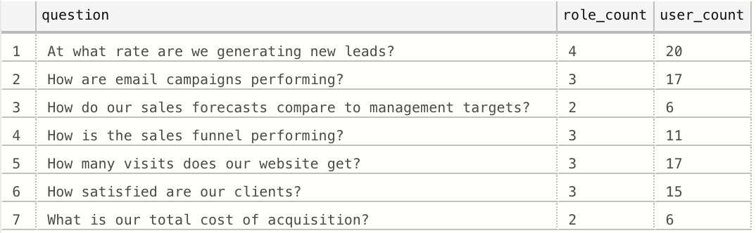

**--2. Which business questions does a particular role need to ask?**

SELECT * FROM business_questions_by_role ORDER BY role_name;

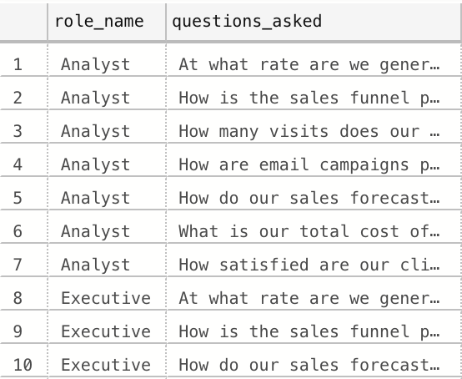

**3. What is our current company performance, based on the questions we care about, and relative to our benchmarks?**

SELECT * FROM company_performance ORDER BY difference_from_benchmark DESC;

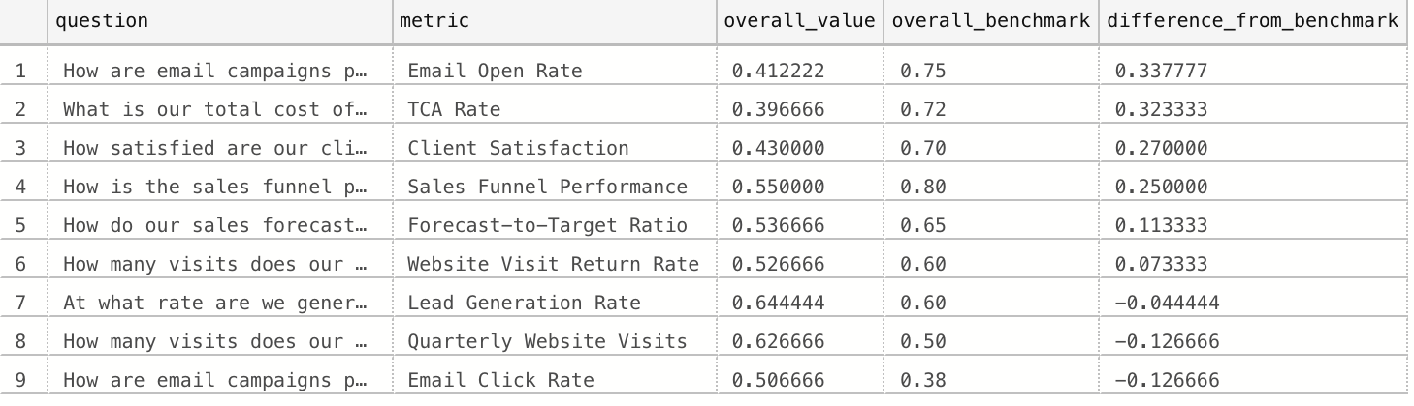

**4. For each of our metrics, how did our actuals compare with our forecasts?**

SELECT * FROM forecast_actual_comparison ORDER BY difference_from_forecast DESC;

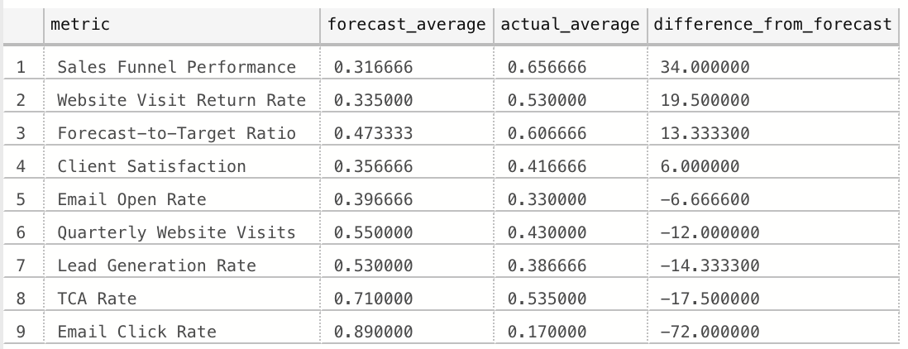

**5. Which employees (users) can answer a given business question?**

SELECT * FROM bq_employee_lookup ORDER BY name;

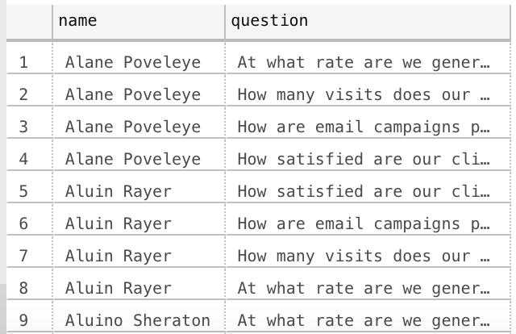

## 

## 

## 

## GUI Prototype

Form 1 - The Metrics Manager. This view allows users to update their assigned metrics, while also having a filter so a user only receives the metrics for which they are responsible.

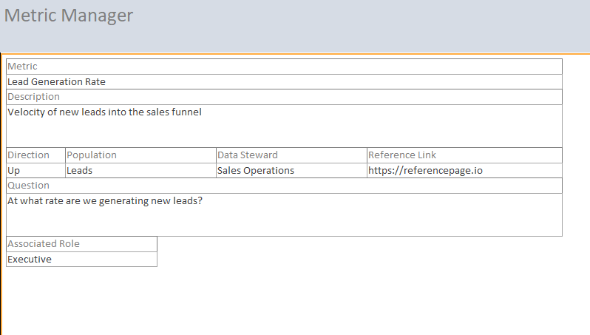

Form 2 - Benchmark Overview. This allows users to update the database with new benchmarks while keeping the former benchmark data.

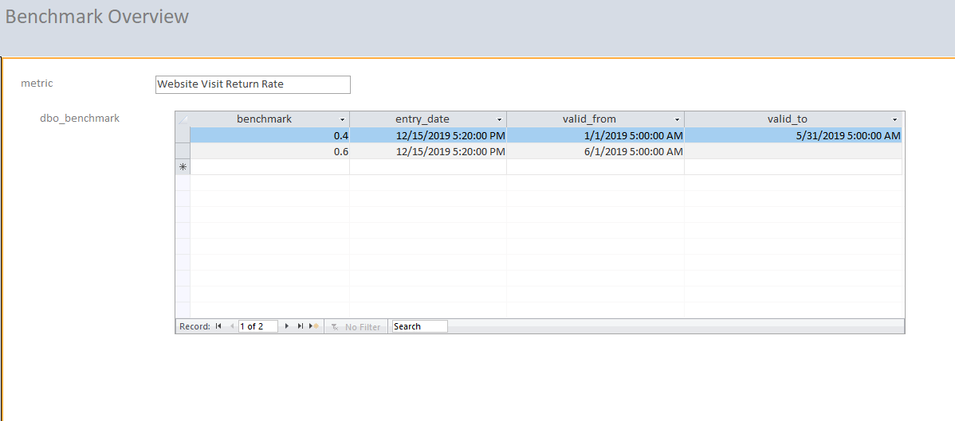

Form 3 - Metric to Forecast View

This view allows users to directly compare actual values with the forecasts created and also allows them to update accordingly.

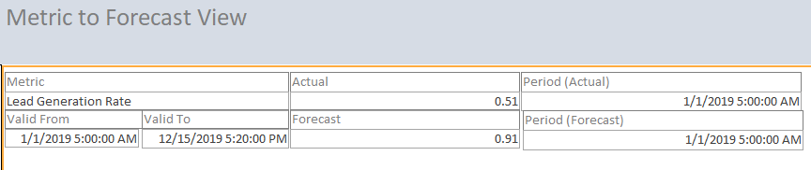

Form 4 - Performance Overview - Provides a metric-level overview of the company’s performance respective to the user’s role and question.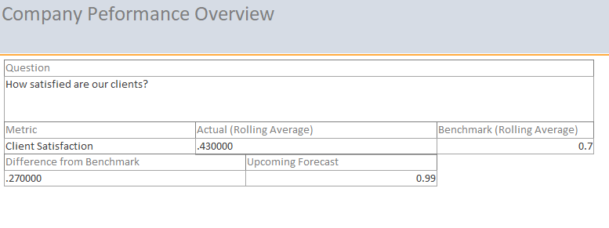

## Reflection

I came into this project assuming that database creation and implementation was extremely complex and difficult to abstract and automate. What I’ve discovered is that an excellently laid-out design actually frees you substantially later on to allow your database to be both developer and user-friendly. In my personal work I’ve only ever worked with data warehouses like Amazon Redshift clusters. Knowing that I can set up something more small-scale and begin to solve problems all on my own at a low cost is really quite incredible.

The next time I’m asked to take build a database for a client with no/ill-designed data solutions, I will begin the project by thinking of what it would take to develop a solution that would allow me to hand it off with little-to-no onboarding required. I understand now that it’s possible to build a strong framework that’s easy to maintain, even with simple database design tools. The most important aspect is drafting an intelligent design that adheres to the principles we learned in this class.