Madeline Becker

Jonathan Hough

Humidity is a quantity representing the amount of water vapor in the atmosphere or a gas. An extreme low rate of humidity or an extremely high rate of humidity can be dangerous in many ways.

A human body has different reactions to levels of humidity. When the humidity is high, there is already an abundance of water vapor in the air, so when our body sweats, the sweat does not evaporate. In contrast, when the humidity is low, there is less water vapor in the air, so our sweat is evaporated more easily (Wonderopolis). Since humidity plays a large role in the temperature that we think we feel, we decided to explore this further.

We are wondering if humidity has anything to do with sicknesses coming about in the colder months, and, if so, if there is a correlation between temperature and humidity. In the case of a strong correlation, this could help someone prone to illnesses know the advantages and disadvantages to living in a state with a generally warmer climate versus living in a state with a generally colder climate. This topic especially interests us, living in the midst of the Blacksburg weather, we have been able to witness first-hand how the weather, and more specifically colder seasons, can affect your lives.

Nearly anyone familiar with Blacksburg, Virginia is aware that the weather can be quite unpredictable, but that our summer months are steaming hot and our winter months are frigid and snowy. Speaking for not only myself, but Jonathan as well, we have suffered through tonsillitis and bronchitis three times this past year at college, so we felt that the colder months might have had something to do with this.

During our search for how people have addressed this problem in the past, we didn’t find much. While there are many resources online about the effects of humidity, or the effects of temperature, we found almost nothing about the relationship between temperature and humidity.

In Atlanta, Georgia, studies have said that there is a necessity for high humidity during the colder months of the year. A lack of humidity during these colder months has many consequences. Some of the major ones are breathing issues, cracking furniture and floors, dry skin/nose/lips, and sicknesses. We were more focused on the sickness aspect, as we felt it related more with our experiences in Blacksburg.

We decided to research weather in Atlanta, Georgia. For our dataset, we wanted to find temperature and humidity information. At first, we thought we could just use data from the weather app, but soon came to the realization that this wouldn’t work, considering we needed data from months prior to the current date.

After some extensive Googling, we found a site that has the history of weather in the United States, dating all the way back to 2009. On this site, you can see the weather info of any day, any state, at 12 am, 6 am, 12pm, and 6pm. To be consistent, we observed the weather patterns of Atlanta, Georgia midday, at 12 pm, from January 1st, 2018 to March 31st 2018. We chose these months, because they are the colder months of the year as 2018 transitioned to Spring. We wrote down the high temperature, low temperature, and humidity rates by hand, then plugged them into an Excel sheet. The variables we used were date, high temperature, low temperature, and humidity rate. We then converted our Excel spreadsheet into a comma-separated values file, so that we could use it for the coding for our project, then compare the temperatures and the humidity rates to address our problems.

As we’ve been taught in class, we used Jupyter to further research the relationship between our data. We merged the two files, one including the high temperatures and humidity rates, and the other including the low temperatures and humidity rates. This resulted with one big list, so we went ahead and converted the list into a dictionary. From this dictionary that we had created, we found a summary of the data, so we computed the mean, max, min, and quartiles for each key within the dictionary.

The results of this summary for the high temperatures were a mean of 58.14, a min of 25, a first quartile at 50.5, a median at 59, a third quartile at 65.6, and a max of 81, all in degrees Fahrenheit. For the low temperatures, we produced a mean of 52.96, a min of 19, a first quartile at 45, a median at 54, a third quartile at 61, and a max of 77, also all in degrees Fahrenheit. Lastly, for humidity, we computed the data and found it to have a mean of 54.84, a min of 16, a first quartile at 33, a median at 49, a third quartile at 74, and a max of 100, all in rates by percentages. These results give us a slight idea of how our variables line up with one another.

We decided that a scatterplot would be a proper visualization for our problem, so we could observe the relationship between temperature and humidity. After producing two scatterplots, one of the high temperatures versus humidity and one of the low temperatures versus humidity, we were surprised to see what looked to be nearly no correlation between the variables. To further examine this, we went on to include a line of best fit on both of the graphs, which only solidified our previous observations that there is barely any correlation that can be seen.

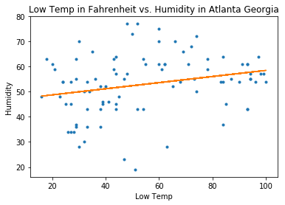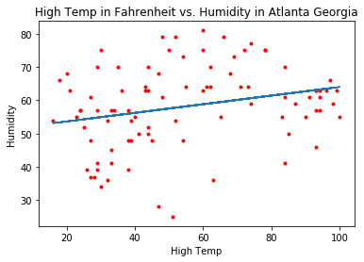We decided to double check the significance and find the correlation coefficients of the graphs. For the plot comparing high temperatures and humidity rates, we found a correlation coefficient of 0.239751. Likewise, for the plot comparing low temperatures and humidity rates, we found a correlation coefficient of 0.263109. From the graphs and these correlation coefficients, we can say that there is insufficient evidence to show that there is any significant correlation between temperature and humidity in Atlanta, Georgia.

As can be seen in the scatterplots, temperature has nearly no effect on humidity. Therefore, the consequences due to a lack of humidity are not related to temperature, and can happen year-round. Unfortunately, people that may think that living in a certain state with high temperatures is the reason for their humidity-related illnesses is incorrect. However, if you struggle with sicknesses related to high humidity, there are many things you can do to reduce your chance of illness. You could install vent fans, run a dehumidifier, put out houseplants meant to absorb moisture from the air, avoid taking hot showers, and much more (State Farm).

However, these results still left us confused as to why it feels hotter when it is more humid outside. This is due to what humidity does to our human bodies. When the humidity rate is high, the air is already full of water vapor, so our sweat doesn’t evaporate. This causes us to feel hotter than the actual temperature outside. On the other hand, low humidity rates can cause us to feel colder than the actual temperature outside, because the dry air, lacking as much water vapor, causes the sweat to evaporate faster (Wonderopolis).

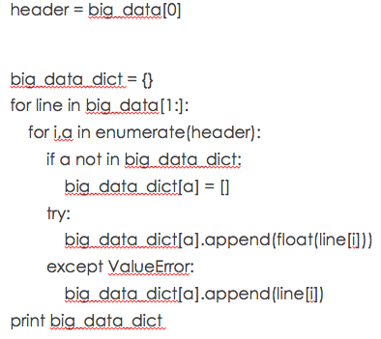Some code that we found challenging is pictured to the right. The difficulty was that when we merged it, it merged into one big list. At first, we didn’t realize why the code wasn’t producing the correct visualizations, but then we figured out that the code that we needed to produce our summaries and graphs required a dictionary, rather than a list. This code appended each value in the list into the keys of a dictionary that we needed.

If we were to do this problem again, we might research a state with a more diverse weather history. Atlanta, Georgia has a warm climate, so it is generally warm for the entire year. We could also try comparing more than two states, or even observing how different countries compared, instead of just staying inside of the United States. Another graph we could produce in the future is a side-by-side box plot, which would have given us the opportunity to run an ANOVA test, and truly see the variation between the means and determine if there is a significance. However, we are happy with the visualizations that we produced and the results that we found, which we were able to answer our problem with.

**Citations**

What Is Humidity? (n.d.). Retrieved from https://wonderopolis.org/wonder/what-is-humidity

Writer, S. F. (2018, April 03). Conquer Home Humidity Problems with These Tips - Simple

Insights - State Farm. Retrieved from https://www.statefarm.com/simple-

insights/residence/conquer-home-humidity-problems-with-these-tips