16,000 words

notes at end

Chapter 4

Empirical waves of adaptations

Adaptive evolutionary explanations are familiar to all of us. It is a cliché to explain the giraffe’s long neck as an adaptation for browsing among the tree tops. But the scientific legitimacy of adaptive explanations is controversial, and it became inflamed about thirty years ago when Stephen Jay Gould and Richard Lewontin published “The Spandrals of San Marco and the Panglossian Paradigm: A Critique of the Adaptationist Programme.” This paper has generated more discussion than any other single paper in the philosophy of biology, and the controversy remains unresolved.
This chapter defends the scientific legitimacy of adaptive explanations in a new way. The controversy over adaptationism is so persistent in part because the most fundamental challenge raised by Gould and Lewontin has not been directly addressed. Instead, responses typically concede Gould and Lewontin’s fundamental criticism: the lack of an empirical test for whether it is proper to seek an adaptive explanation to begin with (see below). So, a new empirical way to tell whether something is an adaptation would provide a new defense of adaptationism. In this chapter I explain such a test and illustrate it in two computational evolving systems.

The problem of adaptationism

I must first clarify some key concepts. The notion of how well an organism fits or is adapted to its environment is the organism’s adaptedness in that environment. This notion is typically made more concrete as the organism’s propensity to survive and reproduce or the organism’s fitness relative to other organisms. A trait is adaptive (in an environment) just in case it benefits the organism (in that environment), i.e., it increases the organism’s propensity to survive or reproduce. Optimal traits are those that (in the context and given a set of constraints) could not be more adaptive.
In order to explain the notion of an adaptation, it is helpful to distinguish selection of a trait from selection for the trait (Sober 1984). Consider an analogy involving not natural selection but a simple causal sorting process. Suppose there is a tray full of black and white marbles, with the black marbles made of iron and the white marbles made of plastic. If a strong magnet is held over the tray, the black ferrous marbles will be “selected” by the magnet. This illustrates “selection” of black marbles but not “selection” for black marbles, for the marbles were not “selected” because they were black; their color was irrelevant. At the same time, this is an example of “selection” for ferrous marbles, for being ferrous was what caused those marbles to be “selected.” Now consider the operation of natural selection in an analogous situation. An inherited trait persisting in a varying population because of its benefit to survival or reproduction is an example of natural selection for a trait. By contrast, mere selection of a trait is when natural selection causes a trait to persist but not because of its beneficial effects. Genetic hitchhikers (discussed below) illustrate selection of but not for a trait.
Now we can distinguish two notions of adaptation. The first kind of adaptation is a trait produced by the process of natural selection for that trait. For example, the whale’s fins are an adaptation for swimming. The trait persists due to natural selection because of its function in swimming; it is a product of the process of natural selection.
Not all adaptive traits are adaptations. As Williams pointed out generations ago (1966), it is far more difficult to determine that some trait is an adaptation than that it performs some adaptive function. The notion of being an adaptation is backward looking; it concerns the explanation for how the trait came to be there. The notion of being adaptive focuses on the present; it concerns what benefits the trait happens to bestow, regardless of whether that benefit plays any role in the explanation of the trait’s presence.
The second kind of adaptation is the process of producing adaptations, as when we speak of the adaptation of a population to its environment by means of natural selection, sometimes called adaptive evolution. The fundamental problem of adaptationism (I shall suggest) is to provide an empirical test for detecting when the evolutionary process produces adaptations.
There is a controversy about how far back into the past selective explanations must reach for a trait to be an adaptation. Gould and Vrba (1982) called attention to this issue with the neologism ‘exaptation’, which refers to an item that now performs one function but which originated to perform either a different function or no function. (The traditional biological term for these items is ‘preadaptation’.) Some think that an adaptation for some function must have originally arisen by natural selection to perform that function. For these people exaptations are not adaptations (Gould and Lewontin 1978, Gould and Vrba 1982, Sober 1984). Others think that it is sufficient for a trait to be an adaptation if its recent persistence is due to natural selection. For these people an exaptation can be an adaptation (Brandon 1990, Kitcher 1993, Godfrey-Smith 1994b, Sterelny and Griffiths 1999).
Behind this semantic disagreement about whether exaptations are “adaptations,” everyone agrees that exaptations exist and that natural selection can maintain an item because of the function it now performs, even if the item did not originate for that reason. As a matter of semantics, I view exaptations as a special subset of adaptations, because I view anything maintained because of selection for a function as an adaptation. Regardless of their semantic classification, exaptations highlight that items can acquire new functions and be maintained by natural selection because of those new functions. Any attempt to explain the process of adaptive evolution must allow and explain exaptations. (Exaptations arise again below.)
Traits of individual organisms are the paradigm example of adaptations, the products of natural selection. A trait is adaptive only relative to an environment, and that environment typically includes other evolving organisms. So the environment for adaptation might itself be changed by the process of adaptive evolution. We can apply the property of being an adaptation to other levels of analysis by averaging over traits and individuals. In particular, below I will talk of genotypes (a complete set of traits) as adaptations and as adaptive. A genotype is adaptive if on average individuals with that genotype are adaptive. A genotype is an adaptation if it is persists through the action of natural selection, that is, if on average the individuals with that genotype have been selected for their possession of that genotype, i.e., if the traits in that genotype are adaptations.
Later in this chapter some more terminology will become central. An adaptive explanation of a trait explains its existence or persistence as a result of adaptive evolution, i.e., by means of natural selection for that trait. An adaptive explanation of a trait presumes that the trait is an adaptation, of course, and I will call this the adaptive presupposition of the adaptive explanation. Finally, adaptationism is the thesis that the activity of pursuing adaptive explanations of the existence and nature of biological traits is a normal and legitimate part of empirical science. (I sometimes refer to adaptationism as empirical adaptationism, to emphasize how it differs from other theses about adaptations.)
Adaptationism has meant different things to different people. Historically, most of the discussion of adaptationism has concerned the use of optimality models (and related models) for explaining adaptations (e.g., Dupré 1987, Orzak and Sober 1994, Orzack and Sober 2001). But the thesis of adaptationism transcends optimality and concerns any kind of adaptive evolutionary explanation. Even if optimality is regularly violated, adaptive evolutionary explanations are part of the normal legitimate fabric of empirical biology.

Elliot Sober (Sober 1987, 1993, Orzack and Sober 1994) has carefully defined a thesis that he calls “adaptationism” but it differs from what I mean by that term. Sober’s thesis is that adaptive explanations are sufficient to explain most (nonmolecular) traits in most populations—a thesis which could fairly be called panadaptationism (not Sober’s term). Panadaptationism is a strong thesis in two ways: (1) it entails that natural selection explains most (nonmolecular) traits in most populations, and (2) it claims that natural selection plays the only important role in the explanation of those traits. My thesis of adaptationism entails neither (1) nor (2). The practice of giving adaptive explanations can be a normal and legitimate part of empirical science without most traits of most organisms being explained primarily by natural selection. Adaptationism requires only that some traits can be explained as adaptations through empirical methods. Unlike panadaptationism, adaptationism is pluralistic; it allows other factors besides natural selection to play a dominant role in explaining many traits. What adaptationism requires, though, is that the adaptive explanations be part of normal empirical science. Panadaptationism is interesting empirical thesis that I expect will remain an open question for many years. In contrast we can settle adaptationism today.
We need to distinguish adaptationism from two additional theses. One is the claim—which I call limited adaptationism—that natural selection is the only satisfactory explanation of some limited set of traits. The special traits often are especially striking products of evolution such as complex adaptive structures like the eye or the brain. Richard Dawkins (1987) is a good example of this view. Limited adaptationism is consistent with and tends to be supported by panadaptationism. Strictly speaking, adaptationism takes no stand on which specific traits are adaptations; it just requires that we can distinguish adaptations from non-adaptations and support adaptive explanations with normal empirical science. Adaptationism lets the adaptive chips fall where they may and has empirical science identify them.
A further claim—sometimes called methodological adaptationism—holds that the best way to come to understand evolutionary phenomena is by assuming the prevalence of adaptations and looking for good design in order to, among other things, notice deviations from such designs and thereby to infer evolutionary constraints. This view can be found in Maynard Smith’s discussions involving optimization models: “in testing a model we are not testing the general proposition that nature optimizes, but the specific hypotheses about constraints, optimization criteria, and heredity” (Maynard Smith 1978, quoted in Dawkins 1982, p. 49). In contrast, adaptationism itself does not claim that it is heuristically valuable to view nature through adaptive lenses. Rather, it claims that the appropriate empirical lenses reveal how natural selection actually shapes evolutionary processes.
I am not criticizing panadaptationism and limited and methodological adaptationism. Rather, I am distinguishing them from adaptationism itself. I think that the fundamental challenge for adaptationism raised by Gould and Lewontin has not been appreciated in part because panadaptationism, limited adaptationism, and methodological adaptationism have distracted attention from the central issue—which is adaptationism itself.

“The Spandrals of San Marco and the Panglossian Paradigm” called attention to various problems with adaptationism. It is largely uncontroversial that some traits are adaptations; the problem is to identify them or, more generally, to distinguish adaptive evolution from other kinds of evolutionary processes. Gould and Lewontin aim to reign in adaptive explanations where they are inappropriate. To achieve this goal, one needs some principled and rigorous way to tell when adaptive explanations are needed. Gould and Lewontin raise two related worries about the prospect of accomplishing this goal.
Their first worry is that people who use adaptive explanations do not sufficiently justify them over their alternatives. And there are significant alternatives to adaptive explanations, such as appeals to architectural constraint or genetic drift. For example, tooth size is architecturally constrained to be proportional to body size. So there is no need to seek an adaptive explanation for why the teeth of a large ape like the gorilla are larger than those of a small monkey like the rhesus. Furthermore, teeth grow more slowly than the other bones in the body, so it would be wrong to look for an adaptive explanation for the proportionately smaller than teeth of gorillas compared to smaller mammals (Lewontin 1977, p. 81). The architectural explanation suffices in these cases. Gould and Lewontin object that the alternatives to adaptive explanations get only lip-service. If one adaptive explanation fails, this simply leads to the proposal of another. They criticize this as adaptive “just-so” story telling, constrained by only our imagination. With enough ingenuity, any trait can be given an adaptive explanation. The presupposition that a trait is an adaptation is not called into question or tested but treated as untestable. As Lewontin puts it, “the adaptationist program makes of adaptation a metaphysical postulate that … cannot be refuted” because the presupposition that a trait is an adaptation is never questioned (Lewontin 1978/1985, p. 76).
One could directly address this problem if one had some method for distinguishing which traits are the result of natural selection and thus require adaptive explanation. On this issue, Gould and Lewontin raise a deeper and more threatening worry: that the presupposition that a trait is an adaptation is not just treated as untestable but actually is untestable. This complaint is that in general there is no way to settle whether or not a trait is an adaptation. To be sure, it might be relatively uncontroversial that some specific traits are adaptations, but those cases are the exception. Part of the problem is that there is a thicket of alternatives to adaptive explanations and each of these alternatives has a thicket of instances. How can we possibly make a principled decision about when it is appropriate to single out the adaptationist branch? Gould and Lewontin summarize the situation thus:

We would not object so strenuously to the adaptationist programme if its invocation, in any particular case, could lead in principle to its refutation for want of evidence. We might still view it as restrictive and object to its status as an argument of first choice. But if it could be dismissed after failing some explicit test, then alternative would get their chance. (1979, pp. 258f).

The fundamental challenge for adaptationism raised by Gould and Lewontin, then, is to find some empirical test for adaptations.

One might suspect that the problem for adaptationism is just blanket verificationism of the sort espoused logical positivists early last century. This would make the problem uninteresting because verificationism has been completely discredited. Virtually no one today would hold the practice of normal empirical science hostage to a priori verificationism. However, the problem for adaptationism cannot be dismissed this easily. It is grounded in concerns that specifically apply to adaptive explanations. Those who reject blanket verification still have to explain how the presupposition of adaptive explanations can be empirically verified. The fundamental challenge is to provide some empirical test for whether traits are adaptations.

The canonical response

“The Spandrals of San Marco and the Panglossian Paradigm” attracted a swarm of responses by both biologists and philosophers. Although the responses differ from one another in various ways, many of them share the same basic form. In fact, this basic form of response is wide-spread enough that it could fairly be called “canonical.” The basic form of the canonical response is to concede that there is no general empirical test for adaptations but it explain that away as normal empirical science. Here I will illustrate this response with Richard Dawkins and Daniel Dennett, and at the conclusion I will do the same with Elliott Sober.
Dawkins defends more than one thesis about adaptationism (recall the distinctions above), so we must first sort out these tangents. Dawkins notes that assuming that a trait is an adaptation—indeed, an optimal adaptation given the assumption that a certain set of constraints exist—can be a useful heuristic procedure, a productive working hypothesis for generating testable predictions (Dawkins 1982). If these predictions are confirmed, this can both support the original assumption and provide evidence about the actual constraints in the evolutionary process. The point to notice here is that methodological adaptationism consciously and deliberately takes no stand on whether the item in question is actually an adaptation. Instead, it explores what could be inferred if we assume that this presupposition were true. So, methodological adaptationism fails to take the Gould and Lewontin bull by the horns. It does not address the fundamental problem.
Dawkins also defends limited adaptationism when he emphasizes that complex organs and behavior are quite likely to be adaptations. “The working hypothesis that they must have a Darwinian survival value [i.e., that they are adaptations] is overwhelmingly strong” (1982, p. 43). He similarly supports limited adaptationism when he states that he “shall only be concerned with those aspects of morphology, physiology, and behavior of organisms that are undisputedly adaptive solutions to problems” (1983a, p. 17). Almost everyone will grant that some traits are obviously adaptations, but limiting attention only to undisputed adaptations leaves a lot unexplained. Limited adaptationism side-steps the fundamental challenge to adaptationism by restricting its interest only to uncontroversial adaptations. So to the extent that limited adaptationism is Dawkins’s concern, he again ignores the fundamental challenge to adaptationism.
Dawkins addresses the challenge to adaptationism itself when he considers traits that might conceivably not be adaptations. He defends adaptationism by pointing out that it is possible to test rival adaptive hypotheses by ordinary scientific methods, noting that “hypotheses about adaptation have shown themselves in practice, over and over again, to be easily testable, by ordinary, mundane methods of science” (Dawkins, 1983b, pp. 360f).
To appreciate Dawkins’s defense, recall the distinction between specific and adaptive hypotheses. A specific adaptive hypothesis is a claim to the effect that a trait is an adaptation for the specific adaptive function X, where X is fully specified. Example: large primate testes are an adaptation for producing more sperm. A general adaptive hypothesis claims that a trait is an adaptation, but it does not specify its adaptive function; this is just the presupposition that the trait has an adaptive explanation. Example: large primate testes are an adaptation.
Now, note that Dawkins’s response concerns specific adaptive hypotheses. He wants to explain the specific adaptive functions of traits. Dawkins’s central point is that specific adaptive hypotheses have observable consequences, so they entail empirical predictions and thus could be tested. Dawkins illustrates this point with primate testes size. As it happens, primate testes size scales roughly but not exactly with body size. If testes weight is plotted against body weight, there is considerable scatter around the average line.

A specific adaptive hypothesis is that in those species in which females mate with more than one male, the males need bigger testes than in those species in which mating is monogamous or polyganous: A male whose sperms may be directly competing with the sperms of another male in the body of a female needs lots of sperms to succeed in the competition, and hence big testes. Sure enough, if the points on the testis-weight/body-weight scattergram are examined, it turns out that those above the average line are nearly all from species in which females mate with more than one male; those below the line are all from monogamous or polygynous species. The prediction from the adaptive hypothesis could easily have been falsified. In fact it was borne out… (1983b, p. 361)

This is an example of the empirical evidence corroborating the specific adaptive hypothesis. In some other cases the hypotheses fail corroboration. This illustrates one way in which biology tests specific adaptive hypotheses.

Note, though, that Dawkins does not address the fundamental problem of adaptationism. That problem is about the testability of general adaptive hypotheses—hypotheses to the effect that some trait is an adaptation. We should ask if Dawkins’s point that specific adaptive hypotheses are testable provides any reason to think that general adaptive hypotheses are also testable. Now, the observable consequences of a specific adaptive hypothesis depend on the specific function hypothesized. Different functions may well entail different predictions. For example, the hypothesis that large primate testes are an adaptation for temperature regulation would entail a quite different prediction about where species fall in the testis-weight/body-weight scattergram. By contrast, the general hypothesis that large testes are an adaptation for something or other entails no prediction about where species fall in the scattergram. So, a general adaptive hypothesis inherits no observational consequences from specific hypotheses. For this reason, Dawkins admits that general adaptive hypotheses are untestable. “It is true that the one hypothesis that we shall never test is the hypothesis of no adaptive function at all, but only because that is the one hypothesis in this whole area that really is untestable” (1983b, p. 361). Dawkins here is explicitly conceding the fundamental challenge to adaptationism raised by Gould and Lewontin: there is no general empirical test for adaptations. This is a defining feature of the canonical response to Gould and Lewontin.
Dawkins makes some headway against the problem of adaptationism for those traits with a corroborated specific adaptive hypothesis. Evidence for a specific function is a fortiori evidence that a function exists. So corroborating a specific adaptive hypothesis also corroborates the general hypothesis that the trait is an adaptation. But when there is no specific corroborated adaptive hypothesis for a trait—and this is the typical situation—Dawkins concedes the fundamental complaint against adaptationism.
Daniel Dennett offers a principled reason for embracing the untestability of adaptive presuppositions. He gives many examples of adaptive stories that are “too obviously true to be worth further testing” (1995, p. 246). This is limited adaptationism, and as such it ignores the problem of adaptationism. Dennett also embraces a sweeping position near to panadaptationism, saying that adaptationism “plays a crucial role in the analysis of every biological event at every scale from the creation of the first self-replicating macromolecule on up” (1995, p. 238). But this also is no help with the problem of adaptationism. Dennett emphasizes that reverse engineering explains adaptations. Reverse engineering is typically applied to artifacts. It is the search for the reasons for an artifact’s features, the reasons why it was engineered to have those features. Biological adaptations are not artifacts literally designed by some creator, of course, but Dennett points out that they are nevertheless crafted by natural selection, and this is enough for reverse engineering to work.

Darwin’s revolution … permits [reverse engineering] to be reformulated. Instead of trying to figure out what God intended, we try to figure out what reason, if any, ‘Mother Nature’—the process of evolution by natural selection itself—‘discerned’ or ‘discriminated’ for doing things one way rather than another. … [E]ven at the molecular level, you just can’t do biology without doing reverse engineering. (1995, p. 213).

Note that reverse engineering aims to try to discover the specific functions of parts. This aim presumes that the trait in question is designed by natural selection, i.e., that it is an adaptation. This presumption is not something that reverse engineering can test. When engaged in reverse engineering, if one specific adaptive hypothesis fails, your job is to keep searching for the best alternative specific adaptive hypothesis.

Reverse engineering and methodological adaptationism have similar benefits. Given the assumption that something is an adaptation or, indeed, optimally designed, we can test different hypotheses about selective forces, heritable factors, etc., by seeing if optimality predictions given those constraints match what we observe. “The bootstrapping evidence that we have in fact located all the important constraints relative to which an optimal design should be calculated is that we make that optimizing calculation, and it turns out to be predictive in the real world” (1983, p. 353). So Dennett views adaptationism as a useful explanatory strategy. He likens it to “intentional stance” instrumentalism (Dennett 1971) with regard to the mind.

Adaptationism and mentalism (intentional systems theory) are not theories in one traditional sense. They are stances or strategies that serve to organize data, explain interrelations, and generate questions to ask Nature. Were they theories in the ‘classical’ mold, the objection that they are question begging or irrefutable would be fatal, but to make this objection is to misread their point. (1983, p. 353)

Dennett admits that adaptive presuppositions are virtually untestable, but he sees this not as a flaw but as a harmless property of all research strategies.

Dennett, like Dawkins, illustrates the canonical response to Gould and Lewontin. He concedes that there is no general empirical test for adaptations, but explains this away as normal science. In fact, Dennett views any general test for adaptationism as misguided pre-Darwinian essentialism. “We commit a fundamental error if we think that if we want to indulge in adaptive thinking we need a license and the only license could be the possession of a strict definition of or criterion for a genuine adaptation” (1995, p. 247). The next section produces an empirical criterion of just this sort.
The common, canonical, response to Gould and Lewontin is unsatisfactory. It is too weak because it concedes Gould’s and Lewontin’s fundamental criticism and agrees that there is no general test for adaptations. I think we should make no such concession. Plenty of traits are not adaptations, and adaptive evolution is not always the right explanation. So we need a test for adaptations to tell when adaptive explanations are in the offing. I part company with the canonical response precisely where it agrees with Gould and Lewontin: on whether there is a general empirical test for adaptations.

The evolutionary activity test

I will argue that it is possible to test adaptive presuppositions empirically. I think this test is the first satisfactory solution to the fundamental problem of adaptationism. My argument will be constructive. I will test adaptive hypotheses in evolving systems. The variety of illustrations should help suggest how the test can be applied to other systems. The issue is whether adaptive presuppositions are testable in principle. As Sober notes (1987, 1993), the issue is what tests are possible, not whether anyone actually carries out the tests. The testability of adaptive presuppositions does not prevent people from treating them as untestable.
My method involves collecting and analyzing “evolutionary activity” information from an evolving system. Norman Packard and I developed and applied this method over a number of years with the help of students and colleagues.
From an abstract point of view an evolving system consists of a population of items with inherited features. (The system might contain many different kinds of evolving entities, at different levels of analysis. I use the term ‘item’ for maximum generality. The items come from a wide range of possibilities, ranging from individual alleles to whole genotypes and beyond.) The items all participate in a cycle of birth, life and death. Innovations are introduced into the population through genetic operations like mutation and crossover. Everything else being equal, adaptive innovations tend to be inherited through the generations because of their beneficial effect on survival or reproduction. Maladaptive or neutral innovations tend to either disappear over generations or persist silently.
The fundamental idea behind the evolutionary activity test is that we can detect whether an item is an adaptation by observing the extent to which it persists in the face of selection pressures. Resistance to selection is the characteristic feature of adaptations. Whenever an item is active or expressed, natural selection has an opportunity to provide feedback about its adaptive value, its costs and benefits. If it persists and spreads through a population when it is repeatedly active, and especially if it is much more active than one would expect if it had no adaptive value, then we have positive evidence that the item is persisting because of its adaptive value. This is, we have positive evidence that it is an adaptation. Note that this evidence might imply nothing about the item’s specific adaptive function.
To apply this method, one must collect information about the extent to which items have been subjected to selection pressure and, thus, the extent to which their adaptive value has been tested. Since an item is subjected to selection pressure only when it is active or expressed, rather than passive and unexpressed, I call this data evolutionary “activity” or “expression” information. It is simple to collect and display evolutionary activity data for many kinds of items in many kinds of systems. For example, we can measure the activity of individual genes, clusters of genes, phenotypic traits or capacities of individual organisms, or the full sets of features that define genotypes or phenotypes. Technical papers with plenty of details are cited in the footnotes. Here I will provide a brief general summary and some illustrations of the methods involved.
The evolutionary activity method aims to identify innovations that make a positive difference in the life of the items that posses them. In general, an innovation makes a positive difference if it persists and continues to be active. So, with some simple bookkeeping, we can keep an historical record of the current activity of each item at each time. An item’s cumulative activity comes from incrementing its current activity over its current lifetime. If the item is inherited during reproduction, its cumulative activity continues to be incremented by the child’s current activity. In this way we build a count of each item’s cumulative activity over its entire history in the population.

Many (e.g., G. C. Williams 1966, and R. M Burien 1992) have emphasized that adaptation is a historical concept; something is an adaptation not in virtue of what function it performs but in virtue of its causal etiology. This historical dimension is part of what has made adaptations especially difficult to identify. So it is worth emphasizing that evolutionary activity information is historical information. The cumulative activity of an item at a given time is not determined solely by its intrinsic state at that moment. It is also affected by all its activity over its previous history in the evolving system. In particular, an item’s cumulative activity is the sum (or integral) of the extent to which it has been tested by selection over its previous history in the evolving system. Every time an item is exposed to natural selection, natural selection provides feedback about the item’s adaptive value. So, an item will not continue to be tested by natural selection unless it has passed previous tests. So, the amount that an item has been tested by selection reflects how well tested it is, how successful it has been at passing the tests. In general, items that are sufficiently well tested by selection must be persisting because of selection for their adaptive value, so they must be adaptations.
How “well tested” must something be to become an adaptation? Natural selection is not instantaneous. Merely having been subject to natural selection is no proof of being an adaptation. Maladaptive items must stand in the face of selection for some time before natural selection can drive them from the system. Only items that have been exposed to some natural selection can be evaluated for adaptive value. The process of natural selection sometimes involves repeated trials. So the mere fact that an item has been exposed to some selection is no guarantee that it is an adaptation. When using evolutionary activity information to gauge an item’s resistance to natural selection, there is usually some noise in the data caused by nonadaptive items. We need some way to filter out this nonadaptive activity noise.
To solve the noise problem we must figure out how much evolutionary activity nonadaptive items could have. So we must ask how activity will accrue to an item that persists only due to nonadaptive factors like random drift or architectural necessity. A general way to measure the expected evolutionary activity of nonadaptive items is to construct a neutral model of the target system—that is, a system that is similar to the target in all relevant respects except that none of the items in it has any adaptive significance. (Concrete examples are described below.) The activity that items accumulate in the neutral model provides a null hypothesis for the target system. The neutral model activity accumulations show us how much activity to expect if items in a system like the target have no adaptive significance. The no-adaptation neutral model is a filter that we can apply to screen off nonadaptive noise. If we observe significantly more evolutionary activity in the target system than in its neutral shadow, we know that this “excess” activity cannot be attributed to nonadaptive factors. It must be the result of natural selection, so the items must be adaptations for something.
The essential motivation for this method is not new. William Wimsatt pointed out that using neutral (random selection) models in biology as null hypotheses is “common and important” (1987, p. 28). David Raup makes especially effective use of neutral models in paleontology. For example, Raup wondered whether the extinction of the trilobites could be explained simply as bad luck, analogous to a gambler’s ruin in a fair game, so he constructed a neutral model in which trilobite cladogenesis is “a purely random process with average rates of speciation and extinction no different from the averages for other organisms” (1987, p. 123). He found that probability of the trilobites going extinct due to bad luck was vanishingly small. This illustrates the essential features of my test for adaptations. But from the other direction, if something persists much longer than we would expect due just to chance, this implies it is persisting due to positive selection.
Kimura’s neutral theory of molecular biology (Kimura 1983; also see below) is also often used as a null hypothesis, against which the action of natural selection is gauged. Kimura’s neutral theory predicts that molecular changes with little or no adaptive significance will occur much more rapidly. This reasoning, but run in the other direction, is the rationale behind my test: We can find significant adaptations by detecting those changes that persist longer than chance could explain.
At the molecular level my test for adaptations has implications for the relative rates at which introns and exons change. Chromosomes consist of two kinds of genetic segments: those that are unexpressed, called introns, and those that are expressed, called exons. Introns change more quickly than exons, presumably because the introns have little or no function and so are unconstrained by their function. The so-called “molecular clock”—the background rate of change of genetic molecules—ticks at the rate of change for introns. Exons can be discriminated in part by the fact that they change more slowly than the molecular clock. My neutral models are analogous to the molecular clock. They provide what you might call a “gene” or “genotype” clock. In each case, comparison with these neutral “clocks” are used to discern when natural selection is retaining some evolutionary novelty longer than would be expected just from the operation of the clock.
So far I have been describing the method in very general terms and concentrating on its motivation and rationale. To apply this method in a practical context one must make two issues concrete. First, one must settle which kind of item to observe. Activity bookkeeping relies on being able to tell when items are added or subtracted from the system. In my examples below the items are whole genotypes or individual alleles. A genotype’s addition into or subtraction out of an evolving system corresponds to its origination or extinction in the system. A new allele is added to an evolving system through some process like mutation, and it is subtracted from the system when the last individual in the allele’s lineage dies.
Second, one must find some way to operationalize the notion of being tested by selection. There is more than one way to do this. In the case of genotypes competing for survival, one measure of a genotype’s resistance to selection is its concentration in the population. The greater the genotype’s concentration, the more feedback that selection can provide about how well adapted it is. A genotype’s evolutionary activity at a given moment, then, would be the sum (or integral) of its concentration during its history in the system up to that moment. This quantity reflects the full historical extent to which the genotype has been tested by selection. In the case of alleles competing for representation in the genome, natural selection tests an allele when the allele is expressed or used. Natural selection can provide feedback about an allele’s adaptive value only when the allele is actually used. So, the sum (or integral) of its historical expression or use up to that point measures its historical resistance to selection.
Evolutionary activity data can be analyzed in different ways to reveal different things about the process of adaptive evolution. I will illustrate how evolutionary activity data highlights various kinds of phenomena, including competitive exclusion, neutral variation, and random genetic drift. My first example concerns evolutionary activity of genotypes in a simple artificial evolutionary system called Evita.

Visualizing evolutionary activity of genotypes

The Evita system is analogous to a population of self-replicating strands of RNA. It consists of a population of self-replicating strings competing for space. These strings are computer programs written in a customized assembly language and residing in computer memory. The programs make copies of themselves while being subject to mutations, and they run the risk of “dying” when space gets too crowded.
Evita is inspired by the famous artificial life system Tierra (Ray 1992), but it is much simpler because it disallows the kind of interactions that lead to parasitism and the other interesting evolutionary phenomena observed in Tierra. Evita’s simplicity makes it an especially simple and clear illustration of how graphing evolutionary activity reveals a system’s evolutionary dynamics.
The system is initialized with a single human-written program placed randomly on a virtual rectangular grid in computer memory. This program is designed in such a way that when it executes it copies each of its instructions into a neighboring spot on the grid, thereby producing a new copy of the program. Then this “offspring” and its parent both start executing, and each makes another copy of itself. This pattern repeats indefinitely. When space in computer memory is running low and a reproducing program cannot find an unoccupied neighboring grid location, one of the oldest neighbors is randomly selected and “killed,” and the offspring takes the space just vacated. No other interaction between programs is permitted.
In each update of the system the program at each occupied grid spot executes a fixed number of instructions. This processing time is allocated in a way that is unbiased by spatial position; hence, no organism gains an advantage from its location on the grid. In fact, the only advantage grid position can provide is the relative fitness of the surrounding population: your fitness depends on your reproduction rate relative to your neighbors. So competition in this system is spatially localized.
Innovations enter the system through mutations, which are point mutations. They can fall on any existing program at any time, as if caused by cosmic-rays. When a mutation strikes an instruction in a program, the instruction is replaced by another instruction chosen at random with equal probability from the entire instruction set. If the mutation rate is too low, there is no significant genetic change in the population. If the mutation rate is too high, the population dies out almost immediately because no successfully reproducing creature can survive the bombardment of mutations long enough to reproduce. With a moderate mutation rate, though, new kinds of programs are continually spawned. Many of these are maladaptive, reproducing slowly if at all. But some reproduce more quickly than their neighbors, and these tend to spread through the population, causing the population of programs to evolve over time.
There is a clear distinction between genotype and phenotype in Evita. A given genotype is simply a string of assembly language code. If two programs differ in even one instruction they have different genotypes. But two programs might have exactly the same behavior—the same phenotype—even though they have different genotypes. The reason for this is that the only behavior of these programs, the only thing they “do”, is reproduce, and the only relevant difference between the behaviors is the speed with which they reproduce. Thus, any two genotypes that reproduce at the same rate have the same phenotype, no matter how different their genotypes.
The distinction between genotype and phenotype becomes important whenever programs contain unused or unimportant instructions. If a program includes instructions that never execute, these instructions can mutate freely without affecting the operation of the program; multiple genotypes—without phenotype distinction and so with exactly the same fitness—may then evolve through random genetic drift.
Evita is explicitly designed so that the programs interact only by competing for space. On average, programs that reproduce faster will supplant their more slowly reproducing neighbors. A program's rate of reproduction depends only on its genotype. Here, we measure reproduction rate of a genotype as the reciprocal of the number of instructions that must be executed for an instance of that genotype to reproduce, on average. So, a genotype that uses half as many instructions to reproduce as a second genotype will have twice the reproduction rate of the second. A genotype's reproduction rate is the sole determinant of the expected rate at which programs with that genotype will produce offspring. Most significant adaptive events in Evita are changes in reproduction rate, so for present purposes we simply equate a genotype's fitness with its reproduction rate.
Two types of genetic changes can affect a genotype's reproduction rate: change in the length of the program and change in algorithm used by the program. Since a change in length increases or decreases the number of instructions that must be copied, it usually changes the reproduction rate. Since adaptation is driven mainly by reproduction rate, shorter programs have a higher fitness, everything else being equal. In fact, a program typically gains a four-time-step decrease in reproduction time for each instruction that it drops. But things are sometimes different. To see why, consider a typical copy loop (code on the left, comments on the right):

nop0 # a marker
dec # decrement the (BX) register
copy # copy an instruction
ifnz # if register (BX) not zero,
jmp-b # jump back to the complement of the next marker
nop2 # a marker, the complement of the marker nop0

An archetypal copy-loop algorithm change is unrolling the loop. Well known to assembly language programmers, it involves reducing the time spent in a loop by reducing the loop overhead. That is, by doing more within the actual loop code, one can reduce the number of times the loop is iterated, thus reducing the number of instructions that do not actually copy data but merely control the flow around the loop. Here is an example of how the previous copy loop can be made more efficient by unrolling the loop:

nop0
dec
copy
dec # this second copy command
copy # is contained in the loop
ifnz
jmp-b
nop2

Unrolling the loop can lead to a significant increase in the speed of execution. Comparing the two examples, above, in the first loop one copy is performed every four instructions, while in the second loop two copies are performed in the space of six instructions, resulting in a 50% increase in speed even though the second algorithm uses 30% more code.
In order to discern how much of Evita’s genotype activity can be attributed to the genotypes’ adaptive significance, we must create a “neutral shadow” of Evita (recall the discussion of neutral models above). The crucial property of Evita’s neutral shadow is that its evolutionary dynamics are like Evita’s except that a genotype’s presence or concentration or longevity in the shadow population cannot be due to its adaptive significance—for it has no adaptive significance.
Evita’s neutral shadow consists of a population of nominal “programs” with nominal “genotypes” which exist at grid locations, reproduce and die. These are not real programs and genotypes; they contain no actual instructions. Their only properties are their location on the grid, their time of birth, the sequence of reproduction events (if any) they go through, and their time of death. Each Evita run has its own corresponding neutral shadow (actually, an indefinite number of them, a qualification I will usually ignore). Events in an Evita run sometimes cause corresponding events in its neutral shadow, but events in a neutral shadow never affect the Evita run (hence, the ‘shadow’ terminology).
The frequency of mutation events in the neutral shadow is patterned exactly after the Evita run. Whenever a mutation strikes a shadow “program” it is assigned a new “genotype.” The timing and number of birth and death events in the neutral shadow is also patterned exactly after the Evita run. The key difference is that, while natural selection can affect which programs reproduce in Evita, all selection in the neutral model is random. It works as follows: Whenever there is a birth in Evita, there is a birth in the neutral shadow. The oldest neighboring shadow “program” dies and the new child occupies the newly emptied grid location, just like in Evita. But while natural selection typically affect which Evita program reproduces (those that are more fit), random selection determines which neutral shadow “program” reproduces. In the neutral shadow, every “program” in the population always has an equal probability of being the lucky one to reproduce. Shadow children inherit their parent’s “genotype” unless there is a mutation, in which case the shadow child is assigned a new “genotype.”
The evolutionary dynamics in the neutral shadow consists of a random walk in genotype space. Genotypes arise and go extinct, and their concentrations change over time, but the genotype dynamics are at best weakly linked to adaptation through the reproduction rate copied from Evita. Since the neutral shadow genotypes have no adaptive significance whatsoever, none of their features like longevity and concentration—and evolutionary activity—can be attributed to their adaptive significance. At the same time, by precisely shadowing the births, deaths, and mutations in Evita, the neutral shadow lets us see the expected evolutionary activity a genotype in a system exactly like Evita except for being devoid of natural selection. The neutral shadow defines a null hypothesis that specifies the evolutionary activity that we could expect to see due just to non-adaptive factors such as chance (e.g., random genetic drift) or necessity (e.g., the system's underlying architecture). By screening off Evita’s nonadaptive evolutionary dynamics we can determine which aspects of Evita’s behavior are due to adaptations. This difference will show up vividly when we graph the evolutionary activity in Evita and in its neutral shadow.

Figure fig-2waves about here

A graph of Evita’s evolutionary activity shows how evolutionary activity of the genotypes (on the y-axis) varies as a function of time (on the x-axis). The most evident feature of such graphs is the presence of myriad lines or waves (as I will call them), clearly evident in the figures below. Each wave corresponds to a single genotype and shows how that genotype's evolutionary activity varies over time. The slope of a given genotype's activity wave at a given time is the same as the genotype's concentration in the population at that time. This explains why the waves invariably arise from the x-axis and thence move up and to the right, as illustrated by the two isolated waves in Figure fig-2waves. When a new genotype enters the population, a new wave will arise from the x-axis. As the genotype's concentration in the population grows (or shrinks) over time, the slope of the wave increases (or decreases). When the genotype finally goes extinct, the slope of its wave falls to zero and the wave ends. In this way, a genotype's activity wave reflects its changing concentration throughout its history in the population.
Examining some Evita evolutionary activity graphs will make it clear how the graphs depict a evolutionary phenomena. In the Evita activity graphs shown here, the Evita system parameters were all identical except for mutation rate and elapsed time. Each genotype in a given run is given a unique name of the form Nxxx, where N is a number indicating the genotype's length and xxx is a three-character string (in effect, a base 52 number) indicating the genotype's order of origination among genotypes of that length. For example, 32aac is the third length 32 genotype to arise in the course of a given run.
These evolutionary activity graphs depict the history of the genotypes in a given Evita run. The ancestral genotype always corresponds to the wave that arises out of the origin (see any of the figures). When the ancestral genotype is driven to extinction by another genotype, the ancestral wave ends as one or more new significant waves arise. Whenever one genotype drives another to extinction, a new wave arises as an earlier one dies out. Multiple waves coexist in the graph when multiple genotypes coexist in the population, and genotypic interactions that affect genotype concentrations are visible as changes in the slopes of waves. In general, the dominating genotype(s) during a given epoch of evolution appear as dominating wave(s) during that period of the activity diagram.

Figure fig-neutral about here

The most important point to stress first is how the significant waves in these diagrams correspond to significant adaptations among the genotypes. We can see this most clearly by comparing an Evita evolutionary activity graph with an activity graph of its neutral shadow. Figure fig-neutral shows an evolutionary activity graph from both Evita (top) and its neutral shadow (bottom). The activity scale (y-axis) in these two plots is roughly comparable, except that activity on the bottom is expanded by a factor of three to make the neutral model activity easier to see. These graphs are strikingly different. Leaving aside the ancestral wave, the highest waves in the Evita are orders of magnitude higher than those in the neutral analogue. This is clear evidence of how the size of a genotype's evolutionary activity waves in Evita reflects the genotype's adaptive significance. In the normal model, at each time one or a few genotypes enjoy a special adaptive advantage over their peers, and this is reflected by their correspondingly huge waves. The change in dominant waves reflects a new adaptation out competing the prior dominant adaptations. In the neutral analogue, by contrast, a genotype's concentration reflects only dumb luck, so no genotype activity waves rise significantly above their peers.

Figure fig-mu=1 about here

The evolutionary activity graph in Figure fig-mu=1 is dominated by five waves corresponding to the five most populous genotypes over the course of the run. Miscellaneous low-activity genotypes that never claim a substantial following in the population are barely visible along the bottom of the activity plot. Comparing the origin of the waves with the average population fitness shows that each of the significant new waves corresponds to a genotype that has a significant fitness advantage over its predecessors. Closer examination of those genotypes discloses those adaptive advantages. The first significant new wave is caused by genotype 33aad, which reproduces much faster than the ancestral genotype 37aaa due to its shorter length. The next significant evolutionary activity wave, the largest one in the graph, is caused by genotype 33aak; this genotype is the same length as 33aad but it can reproduce faster because it has a shorter copy loop. Notice the kink in 33aak's wave at about time step 2000. Magnifying the low-activity waves at that time shows that this kink is simultaneous with the start of another wave—the fourth main wave in this plot, due to genotype 31aab which is still shorter in length. The post-kink slope in 33aak's wave is slightly less than that of 31aab's wave, and in fact genotype 31aab's shorter length gives it only a slight fitness advantage (about 1%) over genotype 33aak. Finally, the fifth significant wave is caused by a genotype, 30aab, which reproduces faster than genotype 31aab due to its slightly shorter length. This activity graph clearly highlights those genotypes with a significant adaptive advantage over their peers. In addition to births and deaths of significant genotypes, we clearly see the dynamics of competitive exclusion between the major genotypes in the evolving system.

Figure fig-mu=2 about here

Figure fig-mu=2 is an evolutionary activity graph from an Evita run with a slightly higher mutation rate. The main activity waves in this graph correspond to the main fitness jumps, as in the previous graph. Closer analysis reveals that the major adaptive events consist of shortening a genotype's length or copy loop. But there are two interesting exceptions to this pattern, leaving a characteristic signature in the activity waves.

Figure fig-mu=2.blowup about here

First, notice that the second fitness jump corresponds to a cluster of seven similar genotypes (33aap, 33aaq, 33aar, 33aas, 33aat, 33aau, 33aav) which all arise at about the same time and which together contribute to a dense cloud of activity waves. Figure fig-mu=2.blowup is a blowup of this cloud of waves. These genotypes differ from each other only by mutations at an unexpressed locus, so they all use exactly the same algorithm and are neutral variants of one another—different genotypes with exactly the same phenotype. The unexpressed locus was created by a mutation which produced a non-template instruction inside the template surrounding the copy loop, saving one executed instruction per loop traversal and thus significantly increasing fecundity. Once this mutation has occurred, almost any other mutation at the same locus creates another non-template instruction with an identical fitness benefit, so a cloud of neutral variants quickly grows. Since these neutral variants have exactly the same fitness advantage over their predecessors, and since they all are just one mutation away from each other, they engage in adaptive interactions with competing genotypes effectively as a single higher-level phenotype. If the evolutionary activity data from these neutral variant genotypes were pooled and graphed as a single phenotype, they would constitute a single salient wave on a par with the other salient waves.
Second, notice that the fourth salient wave (due to genotype 32abl) does not correspond to a significant fitness jump. The fact that the waves from 32aaV and 32abl coexist for a long time (about 1000 time steps), rather than one quickly driving the other to extinction by competitive exclusion, indicates that they are nearly neutral variants. In fact, the fitness of the second wave (32abl) exceeds that of the first wave (32aaV) by about only 0.5%, for 32abl has a mutation which causes a single instruction to be skipped, for a net savings of one instruction per reproduction event. The interactions among the three salient waves between time steps 4000 and 5000 have a similar explanation. They are a significant improvement (5% fitness advantage) over the genotypes that they drive extinct, but they differ from one another by much less (under 2% fitness difference).

Figure fig-mu=2long about here

If this run is extended significantly further (Figure fig-mu=2long), we continue to see competitive exclusion between genotypes when the origination of one genotype wave causes the end of another, and we also continue to see neutral variants when significant genotype waves persist simultaneously for a significant duration.

Figure fig-mu=10 about here

When we increase the mutation rate an order of magnitude, we see a new phenomenon. Classic competitive exclusion dominates during the first 2000 time steps, but evolution then reaches an equilibrium and the bulk of the subsequent evolutionary change consists of random drift among selectively-neutral genotypes—the sort of neutral evolution emphasized by Motoo Kimura (1983). The difference between these kinds of evolutionary phenomena is clearly indicated in the different quality of the activity waves. A genotype winning at competitive exclusion typically causes a relatively smooth and sigmoidal-shaped wave (although the bottom of the wave will be truncated if it's concentration rises extremely fast). By contrast, random drift causes waves that are much more wiggly because the wave's slope randomly rises and falls as the genotype's concentration wanders up and down. This difference can be clearly seen in Figure fig-2waves. The sigmoidal wave in Figure fig-2waves is 32abl from Figure fig-mu=2, which arose through competitive exclusion. The wiggly wave in Figure fig-2waves is taken from the random genetic drift in the middle of Figure fig-mu=10.

Figure fig-mu=40 about here

A final Evita activity graph (Figure fig-mu=40) shows how Evita’s long-term adaptive dynamics are hard to predict. Competitive exclusion dominates the first 3000 time steps of the run; some is evident in sigmoidal wave, but some is hidden in low-lying clouds of neutral variants. Next, the rather wiggly waves signal that over half of the run consists of random genetic drift among more or less neutral variants with minute differences in fitness. It is interesting to note that genotype 24aNR takes two more instructions to reproduce and so is slightly less fit, than the genotype (24avp) which it supplants. This illustrates how marginal fitness improvements do not always win the day during random drift. At about two-thirds the way through the run we see the emergence of a new genotype (24bxI) which totally dominates the rest of the run. Genotype 24bxI has a huge fitness advantage (about 20%) over its competitors because it has acquired the ability to “unroll the loop'” (recall the discussion above). The run ends in a period of evolutionary equilibrium, with a variety of new genotypes coexisting with the original loop-unroller. The wiggly waves suggests that this is random genetic drift of neutral variants of the loop-unrolling genotype.
With very little interaction among “organisms” and a relatively fixed and predictable fitness function (replication rate is the one key to success), Evita makes it especially simple to see the crux of my test for adaptations among genotypes. My overall argument is that the evolutionary activity method provides a feasible empirical test for adaptations. Further examples will show how this test can be applied to other situations. For example, in Evita we focused on whole genotypes. In a moment we will consider an example that concentrates on individual genes.
The main lesson to learn from this example in Evita is simple: Significant evolutionary activity waves are adaptations—genotypes that are persisting and spreading through the population because of their relative adaptive value. Natural selection is promoting them because of their relative reproduction rate; they flourish because of selection for this.
The evidence for the main lesson is direct and compelling. It has three parts. First, new significant waves coincide with significant jumps in average population fitness. This shows that the new genotype spreading through the population and making the new wave is an adaptive advantage over its predecessors. Second, microanalysis of the genotypes in the new waves reveals the specific adaptation that each involves. We can easily understand how the genetic novelties in the genotypes had an adaptive advantage over their competition. Third, in a neutral model in which chance and architectural necessity are allowed full reign and natural selection is debarred by fiat, no genotype stands out enough to make a significant wave. So, the major evolutionary activity waves in Evita could be produced only by continual natural selection of those genotypes, and natural selection of the genotypes must be due to selection for their adaptive value.
Clouds of neutral variants are an exception to this main lesson, but they are an exception that proves the rule. The different waves that make up the cloud in Figure fig-mu=2 (detail in Figure fig-mu=2.blowup) are not different adaptations but the same adaptation. Their genotypes differ, but they express the same adaptive phenotype. This shows that new significant waves might not be new phenotypic adaptations. New significant waves are still adaptations, for they are persisting because of their adaptive value, but they are all different genotypic instances of the same phenotypic adaptation. If a cloud contains enough neutral variants, each individual wave might be small enough that it would not be significantly different from the waves produced in a neutral model. The neutral variants in Figure fig-mu=2.blowup stand out from neutral activity waves, but not by a lot. (The neutral model produces waves like the “little hairs” along the bottom of the Figure.)
It is possible for a new adaptation to be lost in a big enough cloud of neutral variants. This shows that this test for adaptations can have false negatives; adaptations might not all be detected. False negatives can happen when we apply the test to items at a suboptimal level of analysis. In Evita, adaptations are not really genotypic but phenotypic, so the phenotype is a better level of analysis for seeing the dynamics of adaptive evolution in Evita. However, for practical reasons we have looked at activity in Evita at the level of the genotype (because it is simple to get the data). If we computed and graphed the evolutionary activity of phenotypes, then the new adaptations would stand out much more. Graphing activity of the appropriate items reveals the cleanest picture of how evolution produces adaptations. In fact, comparing activity for different items is a way to discover which items are undergoing adaptive evolution. However, when it is impractical or inconvenient to collect activity information for the right items, related items usually provide a clear enough picture of most adaptations. For example, in Evita adaptation concerns phenotypes primarily and genotypes only secondarily (because of neutral variants), but the genotype activity in the figures above is a pretty clear picture of how phenotypes adapt.
Note that this method reveals which genotypes are adaptive without in general showing what makes them adaptive. For example, inspection of Figure fig-mu=1 shows that the first major new wave produced by genotype 33aad is an adaptation but it does not show what it is about 33aad that makes it better than its peers. We can usually discover a genotype’s adaptive advantage by independent microanalysis; for example, we discovered that 33aad was shorter and so reproduced faster. But we use the wave diagrams to discern first which genotypes are the adaptations and so are worthy of investigation. It goes without saying that this test has no panadaptive implications or presuppositions. There are many maladaptive genotypes in Evita; their activity creates the “little hairs” along the bottom of the wave diagrams. Furthermore, if Evita’s mutation rate is too high or too low, then natural selection fails to work (see chapter XX). In either case, there are plenty of evolutionary activity waves but they are not significantly different from neutral activity waves, so none are adaptations. The evolutionary activity test lets the adaptive chips fall where they may.

Visualizing evolutionary activity of genes

So far we have been looking at evolutionary activity of Evita genotypes. But it many cases it is more natural to consider individual genes as adaptations. We will see that, just as with genotypes, so with genes: Significant evolutionary activity waves are the sign of adaptations.
I will illustrate gene-level adaptations in a second artificial evolving system: Packard’s Bugs model. This system is excellent for observing the adaptive significance of individual genes. The genes encode sensory-motor rules, so they are easy to interpret and nicely illustrate my test. Also, it is impossible for maladaptive agents to survive for even briefly in this model, so there is no significant nonadaptive noise to filter—another useful simplification.
The Bugs model was devised by Norman Packard as a system in which macro-level evolutionary dynamics emerge implicitly from an explicit micro-level agent interactions. The model consists of a population of agents with evolving sensory-motor functionality. The agents’ survival hinges on their sensory-motor genes, for these genes control how local sensory information cues behavior. Finding resources requires contextually appropriate behavior patterns. Thus, information processing and resource processing are the two internal processes that dominate the agents’ lives. An agent’s continued existence depends enhancing its sensory-motor functionality by coordinating those two processes. Since the requirements of sensory-motor functionality may well alter as the context of evolution changes, continued viability and vitality requires that sensory-motor functionality can adapt in an open-ended, autonomous fashion. Packard’s model attempts to capture an especially simple form of this open-ended, autonomous evolutionary adaptation.

The model consists of a finite two-dimensional world with resources and a population of agents. The agents exist in a spatial grid, sensing the resources in their local environment, moving as a function of what they sense, ingesting the resources they find, and reproducing or dying as a function of their internal resource supply. The model's spatial grid has wrap-around boundaries, so the world is a toroidal lattice. If you keep going “west” in a straight line, you will eventually end up back where you started. Besides the agents, all that exists in the world are 60 tiny square blocks of resources. Each block is 3 sites on a side, so it consists of 9 square sites of food. The resource blocks are randomly scattered over the world, separated from one another by a resource-less “desert.” As the agents ingest the resources they are immediately replenished from an external source, so the distribution of tiny blocks is static in space and time. Nevertheless, the agents constantly extract and expend resources by living and reproducing, so the agents are resource “sinks.”
Adaptation is resource driven since the agents need a steady supply of resources to survive and reproduce. Agents interact with the resource field at each time step by ingesting the resources (if any) found at their current location and storing it in their internal resource reservoir. To survive agents must continually refill this reservoir, for existing and moving expend resources. This continual resource consumption represents the internal metabolic processes that keep the agents alive. If an agent’s internal resource supply drops to zero, it dies and disappears from the world.
Each agent moves each time step. Its ability to find resources depends on its sensory-motor functionality—that is, the way in which its perception of its local environment affects its behavior. This sensory-motor functionality is genetically encoded in a table of rules of the form:

IF environmental condition E is sensed THEN do behavior B.

The table of rules constitutes a sensory-motor map. An important feature of the environment is that each world site can contain only one agent at a time. So, if one agent tries to move to a site that another agent already occupies, the former agent makes a random walk to the first free site it finds.
The agents have a limited range of sensory states and behaviors. An agent can sense whether there are resources (but not the other agents) in each of the five sites centered on its present location in the lattice—its so-called von Neumann neighborhood. Since in principle each of these five sites can either contain or be devoid of resources, the agents can discriminate 2⁵=32 different environmental conditions. But since the world is scattered with 3x3 blocks of food, in practice agents detect only 14 different conditions (SEE FIGURE OF 15 ENVIRONMENTAL CONDITIONS). In other words, the agents are typically in one of 14 sensory states. An agent’s behavioral repertoire is limited to straight jumps between one and fifteen sites in the eight compass directions (north, northeast, east, etc.), for a total of 15x8=120 different possible behaviors. So, the genotype encoding an agent's sensory-motor functionality consists of a genetically hardwired movement for each detectable environmental condition. These genotypes are extremely simple, amounting to nothing more than a table of sensory-motor rules. Nevertheless, the space in which adaptation occurs is vast, consisting of 120¹⁴ or about 10³² distinct possible genotypes.

The sensory-motor functionality in the population of agents can evolve when the agents reproduce. An agent reproduces (asexually) if its resource reservoir fills up. The parent produces one child, which starts life with half of its parent's resource supply. The child also inherits its parent's sensory-motor map, except that mutations may change the behaviors linked to some of the sensory states. In the extreme case in which the mutation rate is set to the maximal level, a child's entire sensory-motor map would be chosen at random. (In the results shown here the mutation rate produced about one mutation per reproduction event on average.)
In a single time step the model has each agent in turn complete the following sequence of events: sense its von Neumann neighborhood, move to the new location dictated by its sensory-motor map (and if it is occupied randomly walk to the first unoccupied site), consume any resources found at its new location, expend the resources needed to survive and move, and finally reproduce (or die) if its resource reservoir is full (or empty). A given simulation starts with randomly distributed agents containing randomly chosen sensory-motor strategies. As time progresses, the population's size and genetic constitution changes according to the contingencies with which the agents find resources. Agents with maladaptive strategies tend to find few resources and thus to die, taking their sensory-motor genes with them; but agents with adaptive strategies tend to find sufficient resources to reproduce, spreading their sensory-motor strategies (with some mutations) through the population. Thus, on an evolutionary time scale, the process of natural selection implicitly adapts the population’s sensory-motor strategies to the contingencies of its environment.
All macro-level evolutionary dynamics produced by this model ultimately are the result of explicit micro-level mechanisms acting on external conditions. The model dynamics explicitly controls only local micro-level states: resources are locally replenished, an agent’s genetically encoded sensory-motor strategy determines its local behavior, an agent’s behavior in its local environment determines its internal resource level, an agent’s internal resource level determines whether it survives and reproduces, and genes randomly mutate during reproduction. Each agent is autonomous in the sense that its behavior is determined solely by the environmentally sensitive dictates of its own sensory-motor strategy. On an evolutionary time scale these sensory-motor strategies are continually refashioned by the historical contingencies of natural selection. The model generates macro-level evolutionary dynamics only as the indirect product of an unpredictably shifting agglomeration of directly controlled micro-level events (individual actions, births, deaths, mutations).
Agents with different strategies have a hard time surviving on the same 3x3 block because the available real estate is so limited. They tend to collide and this bumps one of them off the block into the resource desert. Once in the desert, an agent will move in a straight line (doing whatever behavior is genetically encoded at its desert locus) until it finds and colonizes another resource block or perishes. Thus, the agents on a given 3x3 block typically all follow exactly the same behavioral strategy. They are all in a holding pattern, chasing one another around the tiny block. The patterns are simple cycles that jump through a sequence of sites on the block. (There is a complication: sometimes strategies include steps from sites outside the cycle back into the cycle. These steps “drain” the bugs back into the cycle if they get bumped out of it, so I call them “drains.” I’ll return to them below.) The simplest cycles (period 2) consist of jumping back and forth between two sites on a block. The next simplest strategy (period 3) cycles through a triple of sites. The most complex strategy would cycle through all nine sites on the block.
Everything else being equal, behavioral strategies with higher periods have a selective advantage. Since a 3x3 block contains 9 distinct sites, it can support at most a period 9 strategy. A period N strategy has room for at most N-1 agents (one of the agents must move first and its destination must be free). Longer period strategies can support larger populations because they can exploit more of the available energetic resources. All agents on blocks gather resources and reproduce at the same rate, so a block with a larger population will produce offspring at a higher rate. Once a cycle is full of agents, children can no longer fit on the block with their parents, so they are bumped into the resource desert. A block with a full cycle continually produces children which migrate through the desert until they colonize new blocks or perish. Thus, full blocks with larger-period strategies will have a higher population, and so they will produce children more quickly and so exert greater migration pressure. This means that longer-period strategies enjoy a selective advantage throughout the scattering of tiny resource islands.
Thus, the typical adaptation in the Bugs model is an extension of the period of an existing strategy, which allows the population to exploit more of the available resource sites. Over evolutionary time, then, the cyclic strategies tend to increase in period through natural selection. Observed population level nicely reflects the fitness of the genotypes in the population in resource-driven and space-limited models like Packard’s Bugs. In a world with 60 tiny resource blocks, for example, a period N strategy that is distributed across the blocks can support N-1 agents per block, for a total population around 60*(N-1). As higher period strategies evolve, the population level typically shows striking punctuations, increasing by about 60 each time.
We can read these adaptive phenomena in gene-level evolutionary activity wave diagrams. In these diagrams, each gene in each bug has an activity counter, but we can increment activity with a procedure that is more sensitive to selection pressure. Each time a bug senses its local environment and moves according to its genetically encoded sensory-motor map, it uses one of its genes. We simply increment a gene’s activity counter each time that gene is used, that is, each time the bug uses the sensory-motor rule in which that gene is encoded. Natural selection can provide feedback on a sensory-motor gene only when it is expressed, and our activity counters are simply counting the number of times a gene has been expressed. When a child is inherits genes from its parent, it also inherits the parent’s activity values for those genes, unless there is a mutation in which case that gene’s activity value is reset to zero. In this way, a gene’s activity count records its exposure to selection pressure over its life in the gene pool. A mutation that confers a significant advantage—e.g., one that lengthens a cycle period—will tend to be persistently used through many generations, so it will leave a significant wave in the activity graph.

Figure scatter.9.11 about here

Figure scatter.12.2 about here

In this model with the present evolutionary activity counting scheme, an activity wave’s slope reflects the frequency with which the gene is being used. Since the sensory-motor strategies are cycles, the frequency with which a given gene is used is inversely proportional to the length of the cycle, and the slope of the wave is simply the reciprocal of the cycle length. You can see this by comparing the activity waves in Figures scatter.9.11 and scatter.12.2. Figure scatter.9.11 shows the activity wave from a period two cycle, and the wave has a slope of 1/2. In this case, only one agent lives during the course of the entire run (the 2-cycle involved a quite large jump, back and forth from one block to another, and the magnitude of the jump exacted a severe metabolic cost). The activity wave in Figure scatter.12.2 is a period three cycle, and its slope is 1/3. You can see the population level grow during the course of this run, as the 3-cycle agents colonize more and more of the 3x3 blocks.

Figure scatter.10.2 about here

A period-lengthening adaptation is clearly evident in Figure scatter.10.2. The initial adaptation is a 2-cycle, and the activity of the genes for this strategy make up the first wave (with slope 1/2). This 2-cycle consists of these two genes: (a) If you are in the middle of a block, move up one step. This rule will put you in the middle of the top row of the block. (b) If you are in the middle of the top row of a block, move down one step. This rule will put you back in the middle of the block. (See Figure 10.2.cycles.) You can see the population level rise and then plateau at around 60 as the agents colonize the 60 little 3x3 resource blocks.

Figure 10.2.cycles about here

An interesting detail in the evolutionary activity diagram occurs at this juncture. A little after all the blocks are colonized, the main wave spreads out a bit and eventually splits into two roughly parallel waves. At the same time, a very low slope wave arises from the bottom of the diagram. These changes are caused by a fortuitous rule that allows some of the agents bumped into the desert next to the block to jump back into the middle of the block. This rule has the form: (b’) If you are in the desert next to the top edge of the block, jump down two steps. This will land you in the middle of the block. The front part of the main wave is the activity for the gene (a) described in the text, the back part of the main wave is the activity for gene (b) described in the text, and the low slope wave is the activity for gene (b’). Thus, the low slope wave corresponds to an infrequent period-two strategy in which rule (a) is followed by being bumped into the desert (so rule (b) is not used), followed by use of rule (b’). Note that the use of rule (a) approximately equals the use of both rules (b) and (b’).

The second major event in the evolutionary activity wave diagram occurs about two thirds of the way into the run, when the second major wave originates. Note that the slope of the second wave is about 1/3 and that the population level makes a big jump up to around 120. All these clues point to what happened: genetic innovations generated a period-three cycle and it subsequently spread across all the resource blocks. This 3-cycle consists of two mutations: First, gene (b) is replaced with gene (c): If you are in the middle of the top row of a block, go one step to the right. This will place you in the block’s upper right corner. The second mutation produced gene (d): If you are in the block’s upper right corner, go one step on the diagonal down and to the left. This will place you back in the middle of the block. (See Figure 10.2.cycles.) Replacing gene (b) with (c) and (d) expands the (a, b) 2-cycle into the (a, c, d) 3-cycle.

Figure scatter.10.14 about here

Figure 10.14.cyclesequence about here

We can see a series of similar period-lengthening adaptations in Figure scatter.10.14, in which the main features are labelled. Each major new wave has lower slope and it corresponds to a major jump in population level, as the population goes from a 2-cycle to a 3-cycle, then to a 4-cycle, and then to a 5-cycle. Figure 10.14.cyclesequence diagrams the genes involved in these adaptations. As the genes in shorter cycles are incorporated into longer cycles, you can see kinks in their activity waves (second and third major waves) as their slope falls from 1/3 to 1/4 to 1/5. This diagram shows a new feature at the first period-lengthening adaptation. In this case, when the 2-cycle is replaced by a 3-cycle, the 3-cycle genes do not conflict with one of the 2-cycle genes, so that gene remains in the population as a virtually unexpressed vestigial rule. (It drains into the new 3-cycle.) It traces a horizontal line in the activity diagram since it no longer accrues new usage.
Our examination of evolutionary activity waves of individual genes supports the same lesson as with genotypes: Significant waves correspond to significant adaptations—genes that are persisting and spreading over generations because of their adaptive value. They are flourishing in the gene pool through the operation of natural selection. Furthermore, this is selection for the genes, not just selection of the genes, as we can see by the jumps in population level that match big new waves and by microanalysis of how the new genes are period-lengthening adaptations. Although we use microanalysis of the specific adaptations to confirm the lesson that significant waves are significant adaptations, we can exploit this lesson without delving into which adaptation each wave involves. Activity wave diagrams show us when new adaptations arise without revealing or depending on information about what that adaptation is. In general, the existence of a new significant wave reveals that the adaptive presupposition is true—natural selection is operating—without supporting any specific adaptive hypothesis. In some cases we can do more than this. For example, in the Bugs activity wave diagrams the slope of a new wave typically indicates the period of the cyclic strategy in which a given gene participates, so new waves which lower the slopes of existing waves signal a period-lengthening adaptation. But even without knowing this, we know that a new wave is a new adaptation.
We can confidently interpret evolutionary activity waves in Packard’s Bugs model (as described here) as adaptations even without comparison with a neutral model. This is because agents lacking the genes for a cyclic strategy quickly die and so add negligible activity to the system. Filtering with a neutral model would cut off the “little hairs” along the bottom of the activity wave diagram, but in this case the “little hairs” are so minuscule that we can ignore them. So the Bug gene activity data needs no neutral filtering.
The Bugs illustrated how altering a system’s parameters can magnify nonadaptive noise. If we decrease the mutation rate until the system never encounters new beneficial genes, then its activity waves would look like a neutral model. The same holds if we increase the mutation rate so much that the system cannot retain beneficial genes. This underscores how the activity method does not prejudice the question whether natural selection is operating. As I put it above, the method lets the adaptive chips fall where they may and shows where, if anywhere, they are. In some predictable cases (such as when the rate at which genetic variation is being generated is lethally high or absolutely zero), no new adaptations will be produced. So, it is not the case that general adaptive hypotheses are universally true.

Generalizing the evolutionary activity test

Testing for genotype- and gene-level adaptations in Evita and the Bugs illustrates the evolutionary evolutionary activity solution to the problem of adaptationism. The examples triangulate a general method for testing for adaptations. The sign that an evolutionary process is creating adaptations is that its activity data is significantly higher than what you would expect if selection were random. If activity waves rise above the noise generated in an appropriate random selection neutral model, then you know the corresponding items are adaptations (modulo complications about hitchhikers and genetic drift, discussed below) even though you may have little or no knowledge about what those adaptations are. It shows that some adaptive explanation is needed but it silent about the merits of any specific explanation. That is, you have evidence for a general adaptive hypothesis even if you have no evidence for any specific adaptive hypothesis.
This evolutionary activity test applies to evolutionary systems across the board, and it applies across levels of selection. We have seen it applied to whole genotypes and to individual genes, and it is easy to generalize it to other possible targets of natural selection. Our discussion of neutral variants in Evita generalized the test to phenotypes. The test also easily generalizes to functionally integrated clusters of genes. Evolutionary activity data for the use of cyclic gene sequences, for example, would make the period-lengthening adaptations in Packard’s Bugs model even more evident.
To apply the evolutionary activity method we must choose what items to observe and how to increment their activity. These choices affect how the activity waves looks, so we must remember our choices when interpreting evolutionary activity waves. Here is a very simple example. Consider one locus with three alleles—A, B, and C—and assume there is an adaptive evolutionary cycle among these alleles: Allele A is replaced by allele B, which is replaced by allele C, which is replaced by allele A, which is replaced by allele B, etc. Each of these alleles is an improvement on its predecessor, but none is globally optimal because fitness is context sensitive. If we collected activity data for each instance of each kind of allele and incremented it according to its concentration in the population, the activity diagram would show a continual stream of new waves, as in the top of Figure pgs.allele.instances. This might seem to violate the lesson that new waves indicate new adaptations. The subsequent instances of the alleles are not “new” adaptations but just new instances of “old” adaptations.

Figure pgs.waves about here

This example shows that one must distinguish kinds of alleles from instances of those kinds, and then one must choose which to examine. Those interested in the evolution of new instances of alleles should collect activity data for each instance of each kind of allele (the first instance of A, the second instance of A, …, the first instance of B, the second instance of B, etc.). The resulting data would appear as in the top of Figure pgs.waves. In this case, when evolution produces a new instance of an allele, the activity diagram will show the start of a new wave because it is a new example of the adaptive evolution of an allele instance. So those new waves do correspond to new adaptations. On the other hand, if we are interested in the evolution of new kinds of allele, then we should attach activity counters to each kind of allele (A, B, C). In this case, when evolution produces a new instance of an allele, the activity diagram will show an increase in slope of an existing wave, as in the bottom of Figure pfs.waves. With each turn of the A-B-C cycle, the three waves for A, B, and C would each in turn step upwards and then level out. The only new waves in the diagram would correspond to the origin of the first instance of each kind of allele. As before, the new waves correspond to new adaptations at the level of analysis we have chosen to observe.
Our illustrations of the method have involved artificial evolving systems, mainly because it is so easy to get evolutionary activity data from computer models. It is harder to get analogous data from natural systems but it is possible, and the method applies in the same way, regardless of where the data originated. All that is needed is a time series of current evolutionary activity increments for the item being observed. I have measured evolutionary activity statistics in the fossil record, for example, and compared it with evolutionary activity in Evita, and Packard’s Bugs (Bedau et al. 1997, 1998). In an analogous way, a time series of concentrations of RNA species in RNA evolution in flow reactors could be processed to reveal the activity waves of significant adapting RNA species. The same holds for the evolution of almost any other natural evolving system, such as bacterial ecologies. Collecting the relevant data would be hard, but it is within the realm of possibility today. Automated methods for sequencing genomes and measuring gene expression levels will soon provide an unprecedented, detailed picture of gene-level evolutionary activity in natural systems.
Evolution in some natural systems is too slow or inaccessible to produce the data needed for an evolutionary activity analysis. The only real hurdle to measuring evolutionary activity in natural systems is the practical problem of getting enough of the right kind of historical data. This is the familiar sort of practical difficulty that any empirical science must face.
Let me ward off a possible misunderstanding here. Evita and Packard’s Bugs are not intended to be realistic simulations of particular biological systems. Although I sometimes refer to them as “models,” none are intended to represent another real system. Instead, they are “idea” models, aiming to capture certain abstract principles at work in evolving systems. They are thought experiments—specifically, emergent thought experiments (REF earlier ch). They should be thought of as evolving systems in their own right, with their own idiosyncratic features. So, to study a system’s evolutionary activity, it is not necessary to make a model of a system. Instead, activity data is collected directly from the system, just as we did when studying evolutionary activity in Evita and the Bugs. Evolutionary activity data is a way to visualize and quantify the dynamics of the creation of adaptations produced by evolving systems. It is not a way to “model” evolving systems.
The evolutionary activity test naturally deals with all the key issues in the debate among Gould and Lewontin and their critics. The test does not assume that traits are adaptations; it applies irrespectively of whether they are adaptations. The test detects the role of natural selection. “Just-so” adaptive stories have no place in this test because the specific adaptive hypotheses that they propose are not at issue. What matters is whether the items in question have so much activity that we have strong evidence they are targets of natural selection. The adaptive presupposition is accepted skeptically and only if demanded by the empirical evolutionary activity evidence.

Red herrings

The debate about adaptationism includes a number of red herrings. One virtue of the evolutionary activity test for adaptations is that it neatly ignores these distractions. For example, much of the literature on adaptationism is preoccupied with whether traits are “optimal” for performing their function and whether optimality models support adaptationism. Other worries about adaptationism stem from its apparent commitment to “progress” or foreordained and unvarying goals. But it should be obvious that the evolutionary activity method makes no commitment to progress or foreordained goals, and it is agnostic about optimality.

The reverse engineering task of rating alternative designs as better or worse is another red herring. Dennett instructs adaptationists to “look at designs the way engineers do and rate them as better or worse, on a certain set of assumptions about conditions and needs or purposes” (1983, p. 352). It is often unclear, though, what the relevant conditions and needs or purposes are. Consider Packard’s Bugs model, for example, which is about as simple as evolutionary systems get. It might seem that we have full knowledge of the conditions and needs of the agents in Packard’s model. It certainly is true that studying the computer code will give us complete knowledge of the micro-level details that drive the model. But we might still be ignorant of important emergent properties in the agents’ lives.

For example, we know that cyclic chains of sensory-motor rules are crucial for survival on the little 3x3 blocks, and we know that continual reproduction on the blocks will inevitably lead to some collisions in which agents get bumped out of the sites in their current cycle. We also know that this problem can be solved with additional rules—what I call “drains”—that jump from sites outside the cycle to sites inside the cycle, thus “draining” agents back into the cycle. But without further investigation we don’t know whether being bumped out of a cycle is a significant condition in the agents’ lives, so we don’t know whether drains are important to survival. My point here is that the method of collecting evolutionary activity information avoids all these complications, for this method does not rely on reverse engineering.

Gould and Lewontin complain that adaptationism sometimes conflates an item’s current utility with its reason for origin. This is a problem for those who do not count exaptations as adaptations. Exaptations are traits that now perform a function that is not connected with the reason they originated (recall above). Period-lengthening adaptations in Packard’s Bugs model furnish us with a simple example of an exaptation. Assume that the population is following a 2-cycle with one drain. That is, it has the following three rules:

(a) If you are in the top right corner of a block, go down two steps.
(b) If you are in the bottom right corner of a block, go up two steps.
(c) If you are in the center of a block, go up and to the right on the diagonal one step.

Rules (a) and (b) form a 2-cycle, jumping back and forth between the top and bottom right corners. Rule (c) is a drain that captures any agent that gets bumped into the center site and puts it back into the cycle at the top right corner of the block. Let’s assume that the drain (c) is used as a drain frequently enough that that natural selection preserves it for this draining function. Now, a mutation from rule (b) to rule (b’) will create a 3-cycle:

(b’) If you are in the bottom right corner of a block, go up and to the left on the diagonal one step.

This 3-cycle could well sweep through the population as a period-lengthening adaptation, like the examples we saw above. If this happens, notice that the function of rule (c) will change from a more or less irrelevant drain to a crucial component of the 3-cycle. Lengthening the cycle period has a huge adaptive benefit, so rule (c)’s new function of contributing to the 3-cycle will explain why the trait persists through natural selection. Since rule (c)’s current function is not the reason it arose, it is an exaptation. This change in function will show up as a change in its activity wave for rule (c). As a drain its slope was relatively low, but as part of the 3-cycle its slope will be 1/3.

I mentioned above that I stand with those who classify exaptations among the adaptations, and the activity wave of the exaptation rule (c) explains why. Rule (c) is maintained by natural selection for its crucial rule in the 3-cycle. It persists in the face of mutation pressure as long as it is better than the extant alternatives. So selection for the rule’s adaptive function preserves it, which by definition makes it an adaptation. Its activity wave rises at a rate significantly above what you would expect without selection. This shows that the activity test distinguishes current utility from historical origin, and it focuses on a trait’s continual activity in the population, just as adaptationism requires.

Random genetic drift and neutral evolution

Adaptive explanations are not the only way to account for persistent items in an evolving system. The persistence could be due to genetic drift, architectural constraint, or genetic connections among traits. Gould and Lewontin emphasized that alternatives to adaptive explanations receive only lip service. The activity test alleviates this problem.

Random genetic drift can supplant natural selection in the explanation of certain traits. Genetic drift has been emphasized by the theory of neutral molecular evolution. This theory holds that most of the genetic change at the molecular level is due to chance or random selection among items that are selectively neutral or nearly neutral. Motoo Kimura, the key architect of this theory, provides this summary (Kimura 1983, p. xi):

The neutral theory asserts that the great majority of evolutionary changes at the molecular level, as revealed by comparative studies of protein and DNA sequences, are caused not by Darwinian selection but by random drift of selectively neutral or nearly neutral mutants. The theory does not deny the role of natural selection in determining the course of adaptive evolution, but it assumes that only a minute fraction of DNA changes in evolution are adaptive in nature, while the great majority of phenotypically silent molecular substitutions exert no significant influence on survival and reproduction and drift randomly through the species.

A classic example of neutral evolution is the different extant alleles for hemoglobin (Kimura 1983, §3.1). Obviously, an allele that prevented the normal functioning of hemoglobin would almost certainly be quite deleterious and it would be removed by natural selection. On the other hand, alleles that produced different but functionally equivalent hemoglobin would be selectively neutral, and natural selection would see no difference between them. So if one such allele replaced another, this would reflect only random genetic drift between them, not natural selection.

Drift affects both whole genotypes and individual genes. We saw examples of drift among genotypes in the Evita system. Figure fig-mu=2.blowup shows random genetic drift among a cloud of neutral variant genotypes, differing by mutations at an unexpressed locus. Similarly, the wiggly waves making up the bulk of Figure fig-mu=10 are caused by drift among selectively-neutral genotypes. In Packard’s Bugs the genes that control motion in the desert are largely unused so they tend to evolve by drift. There is also some drift among different cycle drains from the same site. These drifting genes produce little waves along the bottom of activity wave diagrams. Luck has a hand in determining who survives, who dies, who reproduces, and these accidents affect the course of evolution. Drift occurs in virtually all evolving systems, with a force inversely related to population size. It is easy to understand how the accidents have a larger effect in smaller populations.

I should emphasize how evolution in activity neutral models differs from the random genetic drift of neutral evolution. In an activity neutral model, no item has any adaptive value, and selection chooses among them entirely at random. So any evolution among the items is due to pure drift. By contrast, neutral evolution involves a mixture of drift and selection. In genetic drift among selectively neutral alleles, the alleles typically have an adaptive function (recall the hemoglobin example). The vast majority of mutations are lethal or harmful, but the selectively equivalent alleles of neutral evolution typically are beneficial. They all perform some adaptive function equally well and so are selectively equivalent among themselves, but they are not selectively equivalent to the full range of mutations against which they compete. They have a selective advantage over all their deleterious competitors.

A hypothetical scenario can dramatize the point. Drift among selective equivalents involves a population split into two classes: (A) selectively equivalent adaptive alleles, and (B) maladaptive alleles. Class A alleles have a distinct adaptive advantage over class B alleles. When a class A allele is selected during neutral evolution, there are two questions to ask. One is: Why was this class A allele selected rather than some other class A allele? The answer to this question is chance; random selection is the process at work here. A second question is: Why was a class A allele selected rather than some class B allele? The answer to this question is the adaptive advantage of class A alleles over class B alleles. Natural selection explains why the allele was from class A rather than class B. In this way, neutral evolution of selective equivalents involves both drift and selection. On the other hand, pure drift in activity neutral models makes it impossible to divide the alleles in the population into selectively better and worse classes. All alleles in the neutral model are selectively equivalent, because all selection is random.

So, we have two questions about random genetic drift: one for pure drift and one for drift mixed with selection. It is easy to see that the activity test automatically gives pure drift its due. The neutral models are constructed in such a way that drift has completely free reign. All aspects of selection are random, so survival, death, and reproduction events are all due solely to chance rather than positive or negative adaptive fit. The neutral model is a constructive measure of pure drift in the target system. If the activity of items in the observed system is not significantly greater than the activity seen in the neutral model, then we should question whether the items are adaptations. In this way, the activity method carefully separates pure drift explanations from adaptive explanations.

Mixed drift and selection among selectively equivalent but adaptive items also presents no problem for the activity method, but for a different reason. Identifying adaptations is the activity method’s aim. One might worry that significant waves caused by neutral variants are merely the effect of random selection, and so are not new adaptations. But significant activity waves are adaptations, even the waves of neutral variants. The neutral variants are persisting in the system rather than being supplanted by competitors because of their selective advantage. We saw above that neutral evolution is a mixture of natural selection and random drift. Natural selection explains presence of the neutral variants rather than their maladaptive competitors, so the neutral variants are adaptations.

Recall our discussion above of the type/token distinction between kinds of adaptations and instances of adaptations. A new neutral variant is not a new kind of adaptation but a new instance of an extant kind of adaptation. What kind of activity waves we observe depends on what kind of activity data we collect. If we collect activity data for instances (tokens) of genotypes, for example, then new neutral variant instances will generate new activity waves. Each new wave will correspond to a new example of the items under investigation: instances of genotypes. On the other hand, if we collect activity data for the phenotypic equivalence class which lumps together all the neutral variants, then the activity for all the different neutral variant instances will contribute to one and the same activity wave. The creation of a new neutral variant instances will simply increase the activity of that wave. A significant new wave will signal a new kind of phenotypic adaptation.

Neutral evolution might prompt one remaining worry about the activity test. While new waves for new neutral variants may be new examples of adaptations, these new adaptations are not better than previous dominant adaptations; they are selectively neutral and leave the adaptive status quo unchanged. If one thought that new adaptations must be improvements in adaptive design, then new neutral variants would not be adaptations. But it is a mistake to think that new adaptations must better prior adaptations. An item is an adaptation if its persistence is explained by natural selection for some adaptive benefit it provides. Natural selection can preserve an item because of its adaptive value even if it is no better than some of its predecessors. To be an adaptation an item need not improve on all its competitors, as long as it improves on some and flourishes because of this. In neutral evolution, neutral variants flourish because they improve on the transient maladaptive variants produced by genetic operators like mutation. It might be worth reiterating here that activity information is not intended to reflect how good an adaptation is when compared with other possible or actual adaptations. Instead, it is intended to reflect whether the item is an adaptation or not. So, although the presence of significant activity waves does not distinguish between neutral evolution and non-neutral evolution, that is because both involve the creation of adaptations.

Architectural constraints and hitchhikers

Architectural constraints create evolutionary necessities, items present not because of their adaptive value but because the system’s architecture makes alternatives impossible. This issue applies to individual genes and other features of whole organisms, but not to whole genotypes. Architectural constraints in Packard’s Bugs model include the number of genes in an agent and the set of possible agent behaviors (a jump between one and fifteen sites in one of the eight compass directions). It would be a mistake to think that it is a nifty adaptation for agents to have one gene per possible sensory state or to move in the eight compass directions. These features are fixed by the system’s architecture, so no adaptive explanation should be sought for them.

The activity method handles architectural necessities just as it handles pure drift: neutral models screen them off. For example, if we wondered whether the number of Bug genes was an adaptation, we could collect activity data about it in both the Bugs and in a neutral model that shadowed the Bugs architecturally but was driven only by random selection. When we compared the activity data from the two systems, we would see the same patterns, thus establishing that the number of genes is an architectural constraint rather than an adaptation.

A non-adaptive or even maladaptive trait sometimes persists in an evolving system because it is genetically connected with an adaptive trait. If the benefit of the adaptive trait outweighs the cost of the maladaptive trait, selection for the adaptive trait can preserve the maladaptive trait connected with it, causing selection of the maladaptive trait but not selection for it. The challenge for tests for adaptations is to identify the adaptations among all the traits that are selected. One example of the problem is pleiotropy, in which a gene or gene cluster has more than one phenotypic consequence. A special case of pleiotropy is generative entrenchment (Wimsatt 1986), in which genes are connected in a developmental sequence and so the consequences of genetic modifications cascade developmentally downstream. The general mechanism behind these problems is genetic hitchhiking, in which traits are physically connected in genetic material (for example, by being nearby on a chromosome). In this case, selection for one trait can select everything else in the connected genetic material, allowing a maladaptive trait to “hitchhike” along with the adaptation.

The Bugs model provides a simple example of hitchhiking. Assume that a period-lengthening mutation sweeps through the population, and assume that the agent with the mutation also has a “desert drain”—a sensory-motor rule from a site outside the cycle to the resource desert. The desert drain is maladaptive, since it drains agents off of the resource block. But in Packard’s Bugs all genes are on the same “chromosome”. So when agents reproduce, unless there is a mutation at the desert drain gene, it will hitchhike along with the period-lengthening mutation and spread through the population.

Hitchhikers in Bugs agents are rarely expressed. If the hitchhiker were adaptive, then it would provide a benefit if expressed and this benefit would contribute to its persistence in the system, and it would be an adaptation rather than a hitchhiker. Survival is hard enough that any movement that is not helpful is harmful. Furthermore, maladaptive genes are typically lethal, so expressing a maladaptive hitchhiker typically kills the agent, thus removing that hitchhiker from the system. So if we increment a gene’s activity only when it is expressed, as we have in the Bugs activity wave diagrams, hitchhikers will make a negligible contribution to activity data. They will never appear in significant activity waves. The adaptationist program can ignore unexpressed hitchhikers because the question whether a trait is an adaptation arises only for expressed traits. So when the activity method is applied to Packard’s Bugs, hitchhikers present no problem.

Hitchhikers can present a problem in other systems, though, problems that the activity method does not completely solve. A nonlethal hitchhiker can accumulate significantly more activity than found in a neutral model if hitches a ride on a sufficiently adaptive trait. In this case, the activity of the two traits will exceed that of the neutral model. So, the mere fact that a given trait has significant excess activity is no proof that that trait is an adaptation. However, this is positive evidence that either it or some connected trait is an adaptation. A cluster of connected traits with significant excess activity is a sure sign of natural selection and adaptations, even though some of the traits might be hitchhiking. Additional information is needed to distinguish the adaptations from the hitchhikers. So, in the presence of pleiotropy, generative entrenchment, or hitchhiking, the activity method shows when adaptive explanations are needed though it might not identify their subject exactly.

The novelty of the evolutionary activity test

My solution to problem for adaptationism allows adaptive presuppositions to be adjudicated by the normal procedures of empirical science. Some other responses to Gould and Lewontin similarly construe adaptationism as a contingent thesis to be settled by normal empirical biology (e.g., Brandon 1990, West-Eberhard 1992, Sober 1993, Orzack and Sober 1994, and Sterelny and Griffiths 1999). But the evolutionary activity test offers something more than those other responses, because all those other responses are variants of the canonical response (see above). Only the activity test abandons that line. We can see this point nicely if we consider Sober’s version of the canonical response.

The essence of Sober’s response is this. To determine whether natural selection explains some trait in some system, you propose a specific hypothesis about the trait’s adaptive function and then see whether this hypothesis makes empirical predictions that are hold true for the system in question. Developing the hypothesis involves making a simplified model of the factors at work in the system, including such things as the genetic structure of the system and the strength of genetic drift. Consider a simple example concerning the size differences between the sexes (Sober 1993). In many species males are larger than females on average. One hypothesis to explain this is that large relative male size is an adaptation due to sexual selection—larger males tend to win mates. This simple model predicts that relative male size will be proportional to the sex ratio of breeding groups (number of females per male): Males and females should have roughly equal size in monogamous groups, and in polygamous groups male size should increase with the sex ratio. When Clutton-Brock and Harvey (1977) tested this model in a number of primate groups, they found that the sex ratio of breeding groups correlated with the degree to which males were larger than females. Although the model does not explain why and how the data are scattered above and below the best-fitting regression line, the general trend predicted by the model is borne out by the data.

The crucial difference between Sober’s method and the evolutionary activity method is that Sober tests a specific adaptive hypothesis. He constructs a model of the selective forces influencing the specific adaptation, and then checks the predictions of that model. Because Sober is testing a specific model, if the empirical data fail to support that model, he is free to consider and test different models. Failure of some specific adaptive hypotheses does not show that a trait in not an adaptation. So Sober’s method can confirm that a trait is an adaptation by confirming a specific adaptive hypothesis, but it cannot disconfirm all possible specific adaptive hypotheses, so it cannot disconfirm any general adaptive hypotheses. By contrast, the evolutionary activity method directly tests general adaptive explanation hypotheses. Failure to pass the activity test cuts off any further search for an adaptive explanation. So the evolutionary activity method answers the question whether the trait is an adaptation, and it does this without making any assumptions about specific adaptive functions.

Sober implies that a general adaptive claim that there exists an adaptive explanation is not falsifiable for it is an existence claim and “existence claims are not falsifiable in Popper’s sense” (1993, pp. 129). Sober’s argument is that you can confirm that a trait has an adaptive explanation by providing and corroborating one such explanation, but to falsify the claim involves examining and rejecting all possible adaptive explanations, and this in general is impossible. However, the evolutionary activity method does test exactly what Sober says is impossible to test: whether some item deserves an adaptive explanation. The claim that a trait has an adaptive explanation makes a presupposition—that the trait is an adaptation—and it is this presupposition that the evolutionary activity method tests. So, the evolutionary activity method can falsify the existence claim about adaptive explanations by falsifying the presupposition of all such explanations.

It is important here to ward off a potential misunderstanding about models. Sober’s method essentially involves modeling a target system and testing whether the model accurately predicts the target’s behavior. Since the model depends on various assumptions about specific adaptive function, the strength of selection, etc., those assumptions can be revised if the model’s predictions do not describe the target system. In other words, the method is testing the adequacy of a particular representation of the target system. The evolutionary activity method does not test a representation of the system; instead, it gathers activity information from the target system and analyzes it. I used the artificial evolutionary models Evita and the Bugs to develop and explain the activity method. But those models are not representations (“models”) of some natural system. Rather, they are artificially constructed targets that are investigated in their own right. Our concern is whether those systems themselves exhibited adaptive evolution, not whether they adequately represent adaptive evolution in some other system.

So, the evolutionary activity test’s response to the problem of adaptationism is fundamentally different from Sober’s response. The two responses are complementary; they just address different questions. The evolutionary activity response addresses the presupposition of the question that Sober addresses. The same general point applies to other proposals for how to empirically test adaptationism (e.g., Brandon 1990, West-Eberhard 1992, Sterelny and Griffiths 1999), such as checking for correlation between aspects of traits and aspects of the environment, checking the effects on environmental efficiency of altering traits, and comparing the environmental success of naturally occurring variants with respect to traits. These methods can all shed valuable light on whether a trait is an adaptation, but they do so by exploring specific adaptive hypotheses. The evolutionary activity method can be applied whether or not one knows about specific adaptive functions. These other methods complement the evolutionary activity method, which is prior and more fundamental.

Conclusion
The evolutionary activity test directly addresses the fundamental problem of adaptationism raised by Gould and Lewontin. It provides a new empirical method for determining when adaptive presuppositions are true, i.e., a new way to tell when it is appropriate to seek an adaptive explanation, or in other words, a new empirical test for general adaptive hypotheses.
My new response to Gould and Lewontin contrasts with the canonical response. It refutes rather than concedes the fundamental challenge to the testability of general adaptive hypotheses, and it makes the question whether something is an adaptation objective and empirical rather than conceptual and methodological. It does not require or encourage us to treat adaptive presuppositions as if they were true. Indeed, sometimes they are false, and the activity data show this. When activity data justify taking the adaptive stance, the stance is adopted critically and on the basis of empirical evidence against nonadaptive alternatives.
The canonical response defends the status quo in evolutionary biology, urging that adaptationist explanations today (with some exceptions) are largely adequate and legitimate. The evolutionary activity test departs from the status quo, proposing a way to collect a new kind of empirical evidence about whether adaptive explanations are in the offing. This provides a fundamentally new tool with which adaptationists can defend the practice of seeking adaptive explanations. Of course, anti-adaptationists can also use the same tool to show that adaptive explanations are not in the offing. Applying the evolutionary activity test makes no presupposition about whether the traits in question are adaptations; instead, that is precisely what is being tested.
Gould and Lewontin said that they “would not object so strenuously to the adaptationist programme if its invocation, in any particular case, could lead in principle to its refutation for want of evidence” (1979, pp. 258f). The evolutionary activity method provides just the sort of tool Gould and Lewontin sought. Analysis of evolutionary activity data allows us to pursue the adaptationist program critically and constructively.
To Do List (ch. 4)

- call it “empirical adaptationism”
  - this is what G&L are actually raising skepticism about
  - This is what all the standard critics are trying to defend (although typically they do not say so explicitly)
  - this is a key thesis at the heart of the controversy, even though G&L do not explicitly endorse it
- There is a weak “pluralistic” reading of G&L
  - weak, because it is pretty uncontroversial; it would not explain why the critics are all excited
  - this is what G&L explicitly say in their paperthey are defending

- limited adaptationism is fairly uncontroversially true, but side-steps the issue of the truth of empirical adaptationism; strictly speaking, empirical adaptationism does not entail limited adaptationism (because it might turn out that, although adaptive explanations are normal and legitimate, it happens that they are never true)
- panadaptationism implies empirical adaptationism, but it is an issue that is very hard to prove without a huge long argument; also, empirical adaptationism certainly does not entail panadaptationism
- methodological adaptationism takes no stand on empirical adaptationism, although empirical adaptationism tends to imply methodological adaptionism, although for uninteresting reasons
- in the canonical response, the details of the story often vary (reverse engineering for Dennett, certain models for Sober, extreemal theories for Rosenberg, etc.). But the overall pattern is the same
  - the structure of the canonical response explains why the controversy tends to remain: it concedes a fundamental complaint, and must explain away the apparent consequences; this kind of “weasel” position is unstable and unsatisfying
- FIGURES (chapter 4)

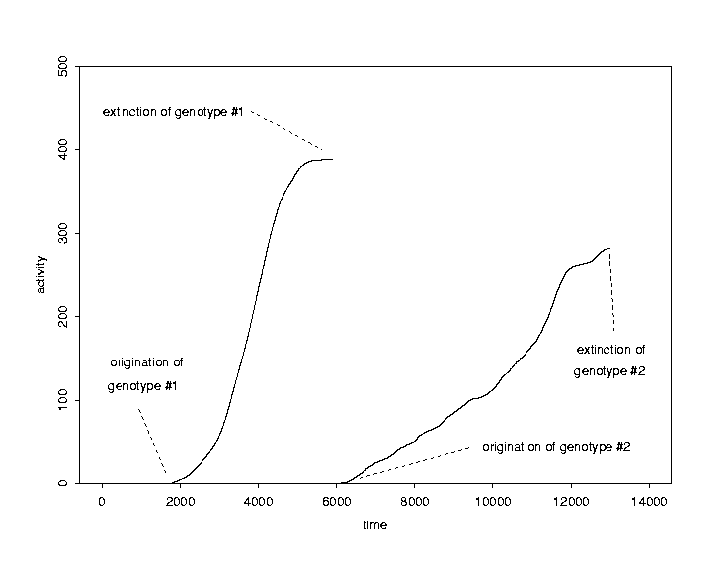
fig-2waves – GET PERMISSIONS

Two evolutionary activity waves. The origination and extinction of each genotype is clearly visible. A genotype's concentration at a given time is proportional to the slope of its activity wave at that time, so the wave's slope increases (or decreases) when the genotype's concentration in the population rises (or falls), and the genotype becomes extinct when the wave's slope falls to zero.
fig-neutral – GET PERMISSIONS

Evolutionary activity waves in Evita (top) and its neutral shadow (bottom). Note that the activity scale on the neutral shadow is inflated by a factor of three, in order to highlight the neutral shadow waves (barely visible along the bottom).
fig-mu=1 – GET PERMISSIONS

An Evita evolutionary activity graph (above) and a corresponding graph of the average population fitness (reproduction rate). Note that the start of a significant new wave corresponds to an increase in fitness.
fig-mu=2 – GET PERMISSIONS

Evolutionary activity graph (above) and average population fitness (below) from another Evita run. The adaptive advantage of the genotypes causing the salient waves is indicated. The start of a significant wave generally corresponds to an increase in fitness. Note the cloud of neutral variants that cause one of the fitness jumps and act in the population like a single phenotype. These neutral variants are more fit than 33aaf because they require one fewer instruction per execution of the copy loop. Note also that the significant wave due to genotype 32abl does not cause a significant fitness increase; it is nearly phenotypically equivalent to 32aaV because it executes only one fewer instruction per reproduction event than 32aaV.
fig-mu=2.blowup – GET PERMISSIONS

Blow up of the evolutionary activity graph in Figure fig-mu=2, showing the neutral variants that cause the fitness increase just after time step 1000.
fig-mu=2long – GET PERMISSIONS

Evolutionary activity graph (above) and average population fitness (below) from extending the run in Figure fig-mu=2 to 20,000 time steps. Genotypes corresponding to some of the salient waves are marked. Note that the salient waves are often the first genotype that is shorter than its competition. The significant coexistence of waves is a sign of selectively-neutral variants. For example, the two simultaneous waves in the middle of the run are due to the neutral variant genotypes 25aaa and 25aac. Other neutral variants are also evident. Except for the waves of neutral variants, the start of each significant wave corresponds to an increase in fitness.
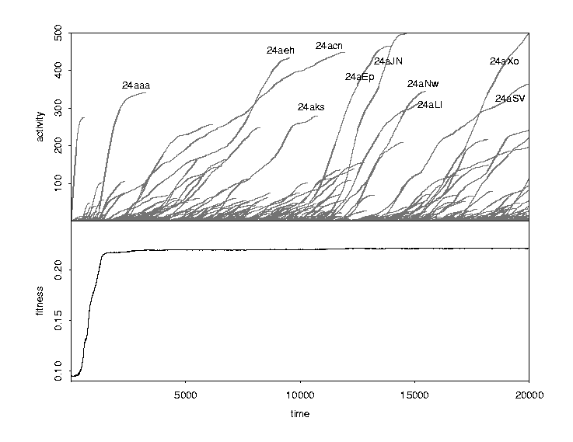
fig-mu=10 – GET PERMISSIONS

Evolutionary activity graph (above) and average population fitness (below) from an Evita run with a significantly higher mutation rate, extended to 20,000 time steps as in Figure fig-mu=2long. Evolution reaches an equilibrium early in this run. The last genotype clearly arising through competitive exclusion is 24aaa. The rest of the evolution seen here is dominated by random genetic drift among selectively neutral genotypes. Some of the neutral variants of 24aaa undergoing random genetic drift are indicated. Note the quite different quality of the sigmoidal activity waves due to competitive exclusion and the wiggly waves due to random genetic drift.
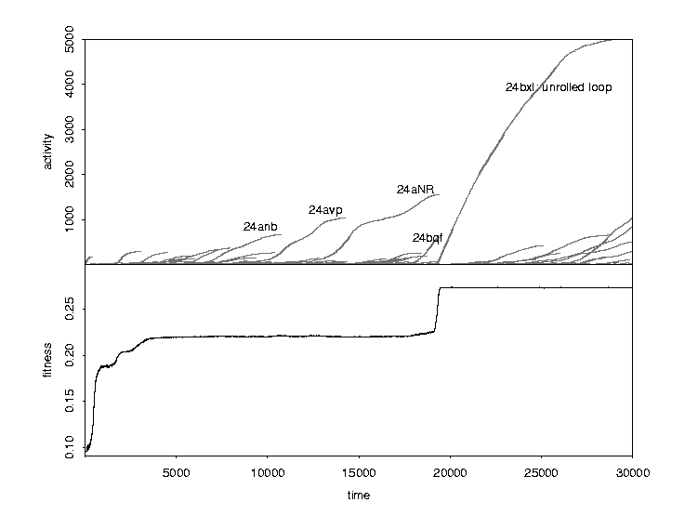
fig-mu=40 -- GET PERMISSIONS

Evolutionary activity graph (above) and average population fitness (below) from an Evita run extended to 30,000 time steps. Competitive exclusion is evident in the first 3000 time steps of the run and at time step 20,000 when genotype 24bxI discovers the loop unrolling algorithm—a qualitative change of algorithm. Most of the other salient activity wave phenomena are random drift of nearly neutral variants; note the substantial periods of flat fitness. The quality of the activity waves signals the difference between adaptively significant evolution (sigmoidal waves) and the genetic change during periods of adaptive stasis (the wiggly waves of neutral variants). Nearly neutral variants are not always exactly neutral. For example, the three significant waves in the middle of the run (prior to the discovery of unrolling the loop) are due to genotypes 24anb, 24avp, and 24aNR, which have fitnesses of 0.222, 0.224, and 0.220, respectively. These fitnesses, though close, are not identical. Nevertheless, note that genotype 24aNR still supplants genotype 24avp even though its fitness is slightly lower (0.220 vs. 0.224). Random genetic drift among nearly neutral variants can swamp slight fitness advantages.

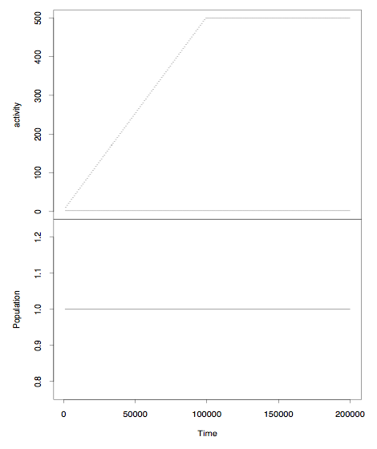

Figure scatter.9.11

Gene evolutionary activity waves and population level in Packard’s Bugs model. In this case, there is only one bug in the population. The single activity wave corresponds to the coordinated use of the sensory-motor genes in a cyclic strategy of period 2. Note that the slope of the activity wave is 1/2. (The horizontal line in the wave at the top of the page is an artifact of the data collection methods used; the activity in that wave continues to rise at a constant rate.)

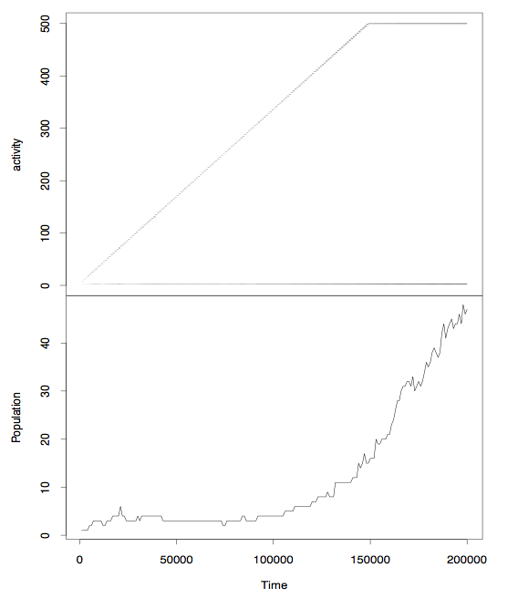

Figure scatter 12.2

Gene evolutionary activity waves and population level in Packard’s Bugs model. The single activity wave is caused by the coordinated use of the genes in a period 3 cycle. Note that the slope of the activity wave is 1/3. As the run continues, the population level eventually rises as the agents following the 3-cycle colonize more and more of the 3x3 blocks. (The horizontal line in the wave at the top of the page is an artifact of the data collection methods used.)

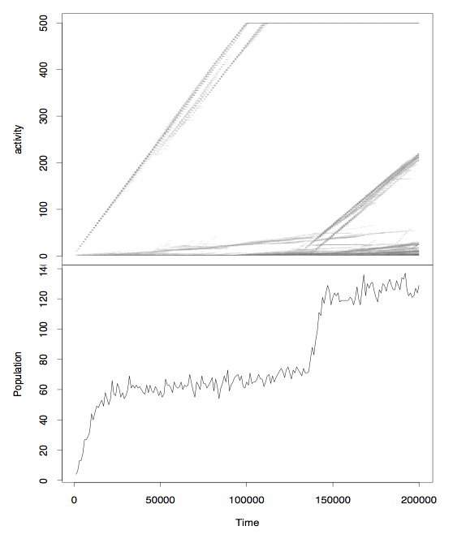
Figure scatter.10.2

Gene evolutionary activity waves and population level in Packard’s Bugs model with 60 3x3 static resource blocks. A period two strategy dominates the first part of the run, but it is replaced by a period three strategy a little before time step 150,000. When the population level reaches about 60 the 2-cycle has spread through all the resource blocks. At about this time, the main wave splits apart a bit and a very low slope wave starts. Both these features are caused by bugs being bumped off the block into the desert along the edge of the block, and subsequently jumping back into the middle of the block. When the 3-cycle arises, two agents can share each block, and the population level rises to about 120. The new activity wave emerging at this point contains the genes for this 3-cycle. (The horizontal line in the wave at the top of the page is an artifact of the data collection methods used.)
Figure 10.2.cycles -- NEED TO MAKE THIS FIG

Top left: The 2-cycle strategy used by the population in the first half of the run shown in Figure scatter.10.2. Using genes (a) and (b), the agents jump back and forth between the middle of the block and the middle of the top row of the block. Top right: The 3-cycle strategy used by the population in the last third of the run shown in Figure scatter.10.2. Using genes (a), (b), and (c), the agents jump from the middle of the block to the middle of the top row, then to the top right corner of the block, and finally back to the middle of the block. Below: the sensory-motor rules encoded in genes (a), (b), (c), and (d).
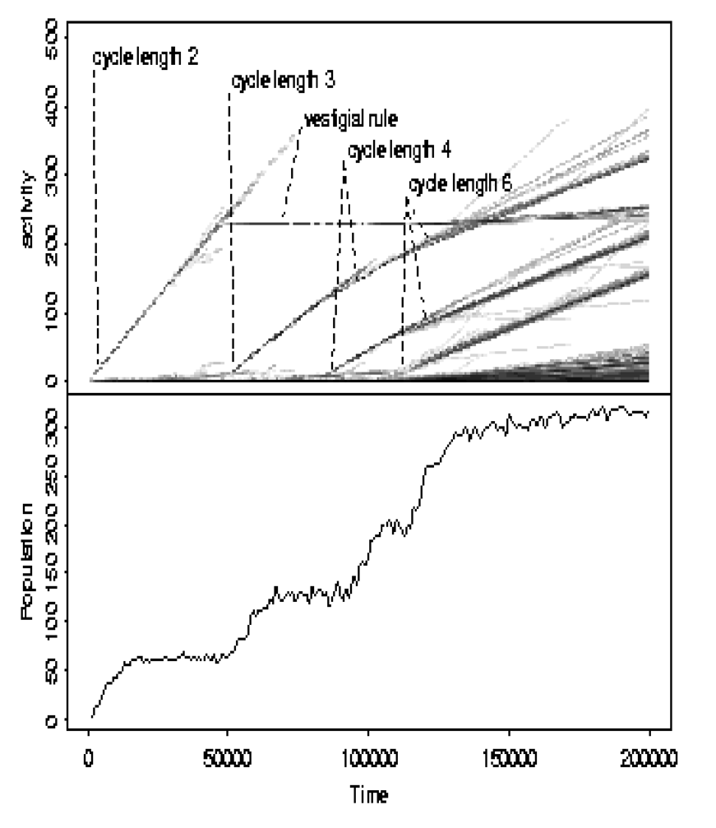

Figure scatter.10.14

Gene token evolutionary activity waves and population level in Packard’s Bugs model with 60 3x3 static resource blocks, showing three period-lengthening adaptations. The first major wave corresponds to the two genes in a 2-cycle. The second major wave is caused by an adaptation that replaces the 2-cycle with a 3-cycle. In this case, one of the genes in the two cycle continue to exist, but it plays no part in the new 3-cycle. It becomes a “vestigial” rule, which is virtually never used. It leaves a horizontal line in the wave diagram (since it accrues no new activity). The third major wave starts when the 3-cycle expands into a 4-cycle. The fourth major wave is an adaptation that turns the 4-cycle into a 5-cycle. As the genes in shorter cycles are incorporated into longer cycles, you can see kinks in their activity waves (second and third major waves). Note that the population level jumps upwards in increments of around 60 with each period-lengthening adaptation, as the new adaptation colonizes the 60 resource islands.
Figure 10.14.cyclesequence – NEED TO MAKE THIS FIG

The genes involved in the sequence of period-lengthening adaptations shown in Figure scatter.10.14.

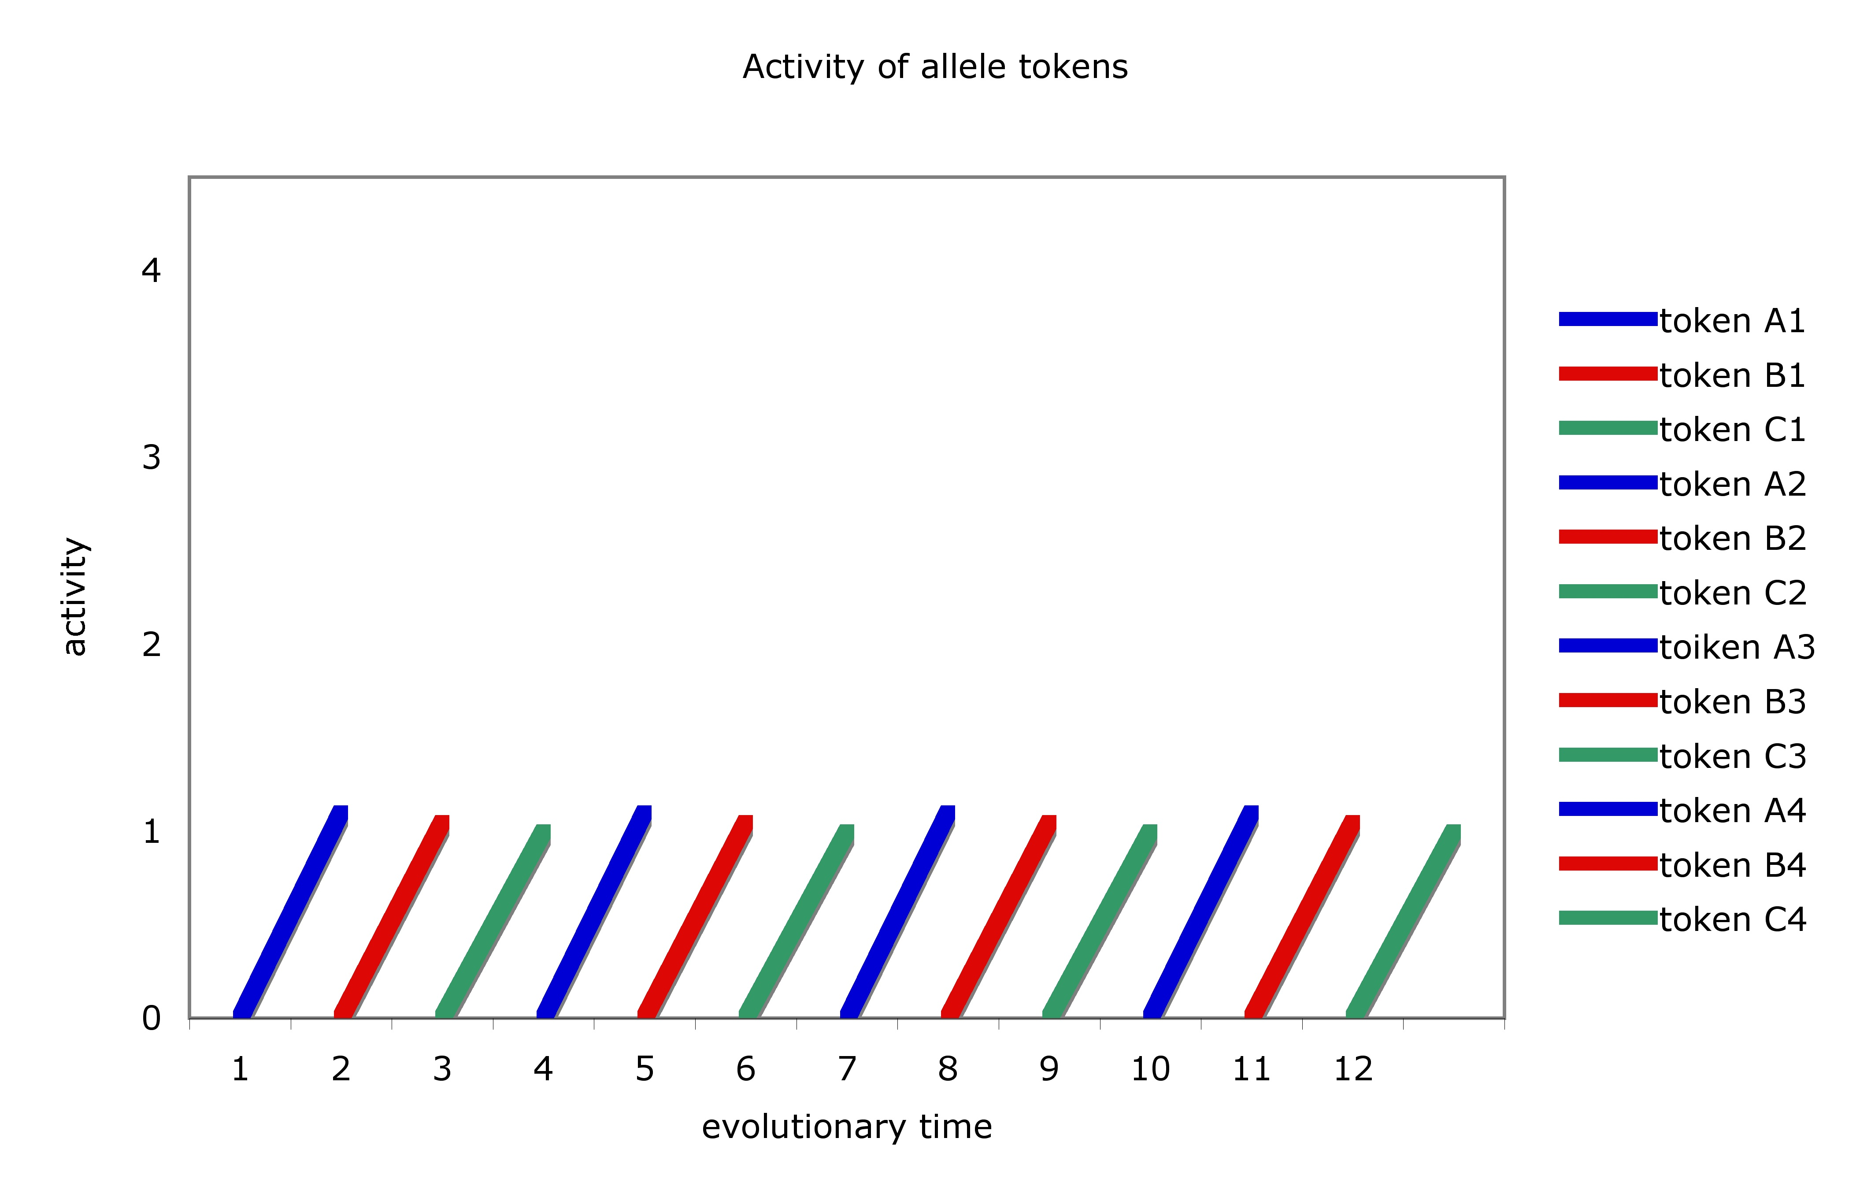
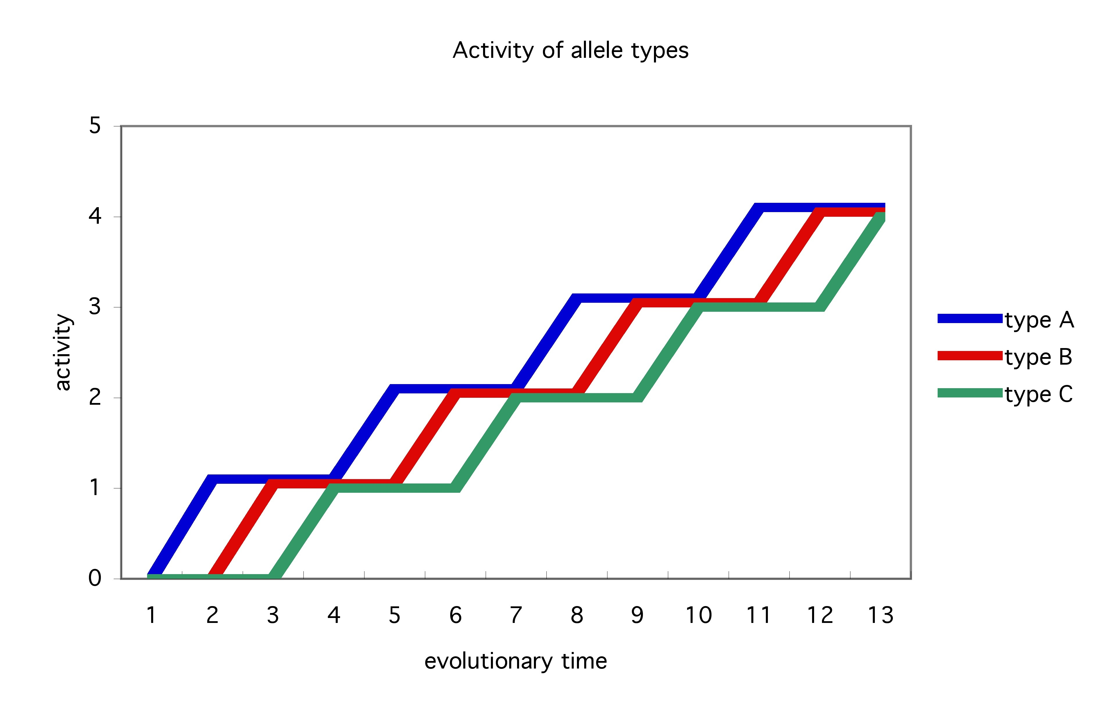

Figure pgs.waves

The phenomena seen in activity wave diagrams varies in characteristic ways depending on the kind of component observed. Compare the waves observed in instances (tokens) and kinds (types) of alleles, when the alleles replace each other in succession because of an adaptive cycle in which allele A is replaced by allele B, which is replaced by allele C, which is replaced by allele A, etc. Above: Activity waves of a sequence of instances (tokens) of alleles: A1, B1, C1, A2, etc. Below: Activity waves of three kinds (types) of alleles: A, B, and C. See text.

NOTES (chapter 4)

Some (e.g., Gould and Lewontin, Williams 1966) have suggested that a trait could be selected for without being an adaptation, but I find Sober (1984) refutation of this suggestion convincing.
Natural selection must be distinguished from so-called “sexual” selection—the process by which a trait is selected for its attractiveness to mates. I side with those who classify sexual selection as a kind of natural selection. So, for me, a product of sexual selection, such as the peacock’s extravagant tail, is an adaptation, even though it is may be detrimental to survival, because it increases reproductive success. For more on the controversy about sexual selection, see Cronin (1992) and Spencer and Masters (1992).
We should not assume that what we ordinarily think of as traits are really traits; this might be an open question.
Strictly speaking, the word “adaptive” is used where some other word like “adaptationist” should be used. For example, adaptive explanations decidedly do not explain why something is merely adaptive; they explain how it is an adaptation. Similarly, adaptive evolution is the creation of adaptations, not merely adaptive items. I will usually follow common usage, however, rather than try to enforce strictly correct but unfamiliar terminology.
Peter Godfrey-Smith (2001) first distinguished these theses. I’ve given some of them new names.
Another kind of alternative explanation follows from the extraneous accidents of reproduction and survival that can cause random fluctuations in traits, especially in smaller populations. When these fluctuations cause traits to randomly drift to fixation or extinction, the trait’s presence or absence is not an adaptation but a product of random genetic drift. Allometry and genetic drift are just two of the possible alternative kinds of explanations: Gould and Lewontin also mention developmental constraints, genetic linkage, epistasis, and pleiotropy.
Dawkins and Dennett are just two illustrations of the canonical response to Gould’s and Lewontin’s fundamental complaint against the adaptationist program; there are many others. Ernst Mayr thinks that evolutionary change is the result of two causal mechanisms: chance and selection. Mayr thinks that, while particular adaptive hypotheses can be falsified, one can never directly prove that chance explains some biological phenomenon or process. Instead, one can show the hand of chance only indirectly and “tentatively” (Mayr 1983, p. 151), by ruling out all adaptive explanations that have been considered so far. As Kitcher puts it, Mayr thinks that selection “is the only game in town” (1985, p. 233). But if it is impossible to test whether chance explains some trait, then it is impossible to settle whether the trait is an adaptation. Thus, the fundamental presupposition of adaptive explanations cannot be tested, so Mayr in effect accepts Gould and Lewontin’s fundamental criticism. But Mayr considers this to be normal scientific practice: “the strategy to try another hypothesis when the first fails is a traditional methodology in all branches of science” (1983, p. 151). Alexander Rosenberg (1985) emphasizes that the theory of natural selection is an extremal theory, like Newtonian mechanics or quantum mechanics, in that it treats the objects in its domain as behaving in such a way as to maximize or minimize the values of certain variables. In the theory of natural selection, the [extremal] strategy is exemplified in the assumption that the environment acts so as to maximize the rate of proportional increase of the fittest hereditarily-similar subset of a species. This strategy is crucial to the success of these theories because of the way it directs and shapes the research and applications that are motivated by the theories. Thus, we hold that a system always acts to maximize the value of some mechanical variable. If our measurements of the value of that variable in a experimental or observational setting diverge from the predictions of the theory and the initial conditions, we never infer that the system is failing to maximize the value of the variable in question. Rather, we assume that our specification of the constraints under which it is actually operating is incomplete. (p. 238) Rosenberg thinks that the extremal character of the theory of natural selection explains and redeems those features of adaptationism that Gould and Lewontin find objectionable. … Gould and Lewontin’s criticism of the adaptationalist program reflects real and unavoidable features of the theory that animates it: The refutation of one adaptationalist “story” does result in the provision of another; the failure to find any is considered a scientist’s failure, not a theoretical falsification…. There is nothing methodologically wrong with constructing a new adaptationalist explanation of a given “form, function, or behavior” when an older one has been rejected; indeed, the theory of natural selection requires it by virtue of its extremal character. (p. 240) Rosenberg’s response exactly fits the canon: He concedes that adaptive presuppositions are not tested but explains this away as normal scientific practice. Note that Mayr’s and Rosenberg’s positions have the characteristic drawback of the canonical response: They do not solve the problem of adaptationism, for neither explains how we can determine when natural selection should be invoked. For example, the extremal character of the theory of natural selection does nothing to indicate when it is appropriate to deploy that theory.
See Bedau and Packard 1992, Bedau 1995, Bedau 1996a, Bedau and Brown 1997, Bedau, Snyder, Brown, and Packard 1997, Bedau, Snyder, and Packard 1998, Bedau, Joshi, and Lilly 1999, Rechtsteiner and Bedau 1999a,b.
John Beatty investigated the use of random drift models in the adaptationism debate, and he concluded that the case for viewing drift as a null hypothesis for natural selection “is, at best, very messy” (1987, p. 54). But he admits that predictions based on drift hypotheses can be standard null hypotheses. For example, the hypothesis that the evolution of some item in some system is primarily a matter of random drift would predict a certain probability distribution of activity data—exactly the distribution produced by a neutral model. The null hypothesis is that the activity observed in the target system will be taken from the same distribution. So, Beatty’s skepticism about drift hypotheses does not undermine the activity test’s use of pure drift models.
Lewontin should support the evolutionary activity test, because he has pointed out (REF??) that observations of allele frequencies can show whether the trait encoded is the result of the process of selection. However, Lewontin does not work out the details of gathering data at different levels of analysis and screening it with neutral models, and using these data to analyze the dynamical details of how successive adaptations arise.
This section is adapted from Bedau and Brown (1999), where further details can be found.
Evita, created by C.Titus Brown, is a simplified version of Tierra (Ray 1992) and its derivative Avida (Adami and Brown 1994).
The probability that a given program suffers a mutation somewhere is proportional to its length. While the probability that a given program is mutated is independent of the size of the population of programs, the probability that a mutation occurs somewhere in the population is obviously proportional to the population size. Typically, mutation rates are specified in terms of 10⁻⁵ mutations per time step: that is, a mutation rate of m would mean that a given codon would mutate on average once every 10⁵/m time steps. This means, for example, that in a run with 1600 creatures with an average length of 30 instructions, a mutation rate of 1 would cause one mutation somewhere in the population approximately every other time step.
Shorter programs are more resistant to mutations (recall above), so a program's length influences its copy fidelity and, thus, its representation in future generations. Thus, reproduction rate is not a perfect measure of evolutionary success. Nevertheless, at the mutation rates used here, evolutionary success overwhelmingly reflects reproduction rate, so our definition of fitness is more than adequate for present purposes. When fitness values are displayed below, we define fitness as 30 times reproduction rate to prevent them from being inconveniently small. So, for example, a genotype that reproduces in 100 instructions has a reproduction rate of 0.01 and a fitness of 0.3.
The grid size was 40 x 40, so when the grid filled up the population consisted of about 1600 self-reproducing programs. I have pruned out irrelevant data about transitory genotypes by graphing only those genotypes that had at least five instances in the population at some time. This removes some of the “little hairs” created by nonadaptive noise.
The other salient difference between the normal and neutral runs—that the ancestral genotype persists about four times longer in the neutral run—is due to the fact that, since the neutral ancestral genotype need never compete with better adapted genotypes, its initial numerical advantage as ancestor carries more weight.
This difference between the normal and neutral activity data can be used to quantify the adaptive evolutionary activity in evolving systems. See below.
Shortly before this the genotype 24bqf acquired a slight fitness advantage by partially unrolling the loop.
The gist of this section can be gleaned from the figures.
See Packard 1989, Bedau & Packard 1992, Bedau, Ronneburg & Zwick 1992, Bedau & Bahm 1994, Bedau 1994, Bedau & Seymour 1994, Bedau 1995, Bedau, Snyder, Brown & Packard 1997.
Actually, two different waves originate close together. Both waves contain activity for exactly the same genes (described in the text). This is a case of two independent originations of the same adaptation.
The same problems can arise at other levels of analysis, such as genotypes. An analogous problem arises when there is a succession of “new” alleles that are neutral variants. This issue is discussed below.
It is probably easier to gather evolutionary activity information about evolution in non-biological natural systems. A wealth of information about cultural and technological evolution is reflected in patent records, financial transaction data, newspaper stories, and the like. Such data are increasingly available in electronic form, making it relatively easy to apply an evolutionary activity analysis.
Evolution in real-world cultural and technological systems is a promising target for this method, since it is relatively easy to get the relevant data.
See, e.g., the papers in Dupré (19XX).
Note that the examples of wave slope changes at period-lengthening events which we saw above are another kind of exaptation. A rule that had a function as part of an N-cycle now has a function as part of an N+1-cycle. The same holds for rule (a) in the present example.
There are various ways in which activity information does discriminate between neutral and non-neutral evolution. We saw above that activity waves in neutral evolution have a characteristic qualitative signature in systems like Evita. The random fluctuations in the concentration of a genotype drifting among neutral variants causes a characteristic wiggly wave form, which is quite different from the characteristic sigmoidal form of non-neutral adaptations. Quantitative analysis of activity data can also discriminate between neutral evolution and non-neutral evolution. A system with a lot of neutral variants will have heightened intensity of activity but lessened extent of activity, in comparison with a similar system that lacks neutral variants, although the sum of intensity and extent of activity in these systems will be the same.
Although Sober focuses on panadaptionism and a variety of weaker theses, his approach naturally generalizes to a defense of adaptationism.
Sober (1993, Orzack and Sober 1994) point out that if you confirm enough specific adaptive hypotheses about individual traits, then you can build up evidence for panadaptationism (and thus for adaptationism). But the process of gathering the requisite evidence would be extremely time consuming, requiring the entire careers of many biologists.
Of course, the activity method does use neutral models to filter the activity information from target systems. Making a neutral model of a target system requires making various assumptions about the target system, for the neutral model must be just like the target except that it has random selection where the target might have natural selection. But once an appropriate neutral model has been constructed, the modelling process is over. The activity method uses the same neutral model to analyze many evolutionary histories in a given target system. This neutral model cannot be revised in response to a failed test of the adaptive presupposition.
For helpful comments or discussion, thanks to Peter Godfrey-Smith, Tom Ryckman, Chris Stephens, Phil Anderson, as well as audiences at the University of Oklahoma, the University of Washington, Washington University, the Center for Humanities at Oregon State University, the Center for Cognitive Studies at Tufts University, the Santa Fe Institute, the first Genetic and Evolutionary Computation Conference, the fourth European Conference on Artificial Life, and Artificial Life VI.

