London Birthday Trip
Tiffany Bediner and Collin Bediner | June 26-29, 2026
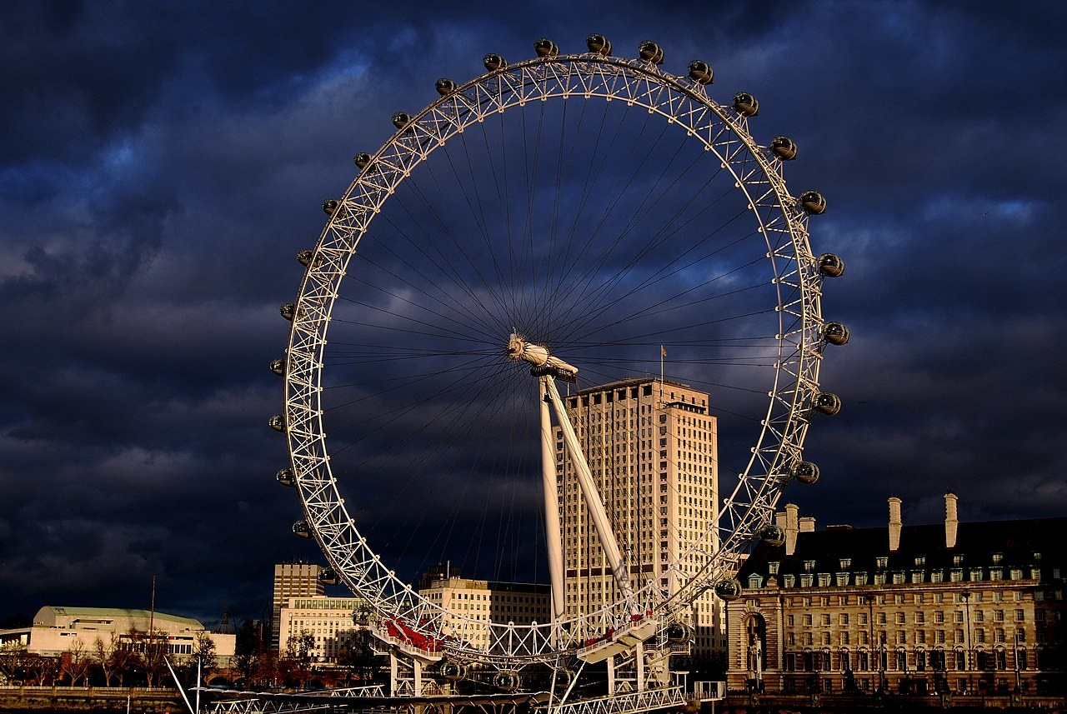

Quick Reference
Travelers: Tiffany Bediner, 20; Collin Bediner, 14
Trip dates: Travel starts Thursday, June 25, 2026; arrive London Friday morning, June 26; depart London Monday, June 29.
Hotel | Holiday Inn Express London - Victoria
Address | 106-110 Belgrave Road, London SW1V 2BJ, United Kingdom
Phone | +44 20 7630 8888
Nearest Tube | Pimlico
Nearby hub | Victoria Station
Emergency | 999
Parent contacts | Parent 1: ____________________ Parent 2: ____________________

Copy / Paste Hotel Address
Holiday Inn Express London - Victoria
106-110 Belgrave Road
London SW1V 2BJ
United Kingdom
Phone: +44 20 7630 8888

Save the hotel in Uber and Google Maps before leaving home. Use Uber or FREENOW when tired; use only Uber, FREENOW, or an official black cab.

To Do Before Travel
- [ ] Order British pounds from Chase
- [ ] Download TripIt
- [ ] Download JetBlue app
- [ ] Download offline maps for London
- [ ] Download TfL Go
- [ ] Download Uber
- [ ] Download FREENOW
- [ ] Apply for UK ETA for Tiffany and Collin
- [ ] Buy Big Bus London hop-on hop-off tickets
- [ ] Buy London Eye tickets
- [ ] Save hotel address as favorite in Uber
- [ ] Save hotel address in Google Maps
- [ ] Save parent travel consent letter on both phones

To Bring
- [ ] Passports
- [ ] International chargers / UK plug adapters
- [ ] Copies of UK ETA confirmations
- [ ] Copy of parental travel consent letter
- [ ] Printed hotel confirmation
- [ ] Printed return flight confirmation
- [ ] Portable phone charger
- [ ] Comfortable shoes
- [ ] Rain jacket or small umbrella
- [ ] Small amount of cash
- [ ] Credit/debit card
- [ ] Medication, if applicable

Ticket Wallet
- Big Bus ticket: ______________________________________________
- London Eye ticket: ______________________________________________
- Flight confirmation: ______________________________________________
- Hotel confirmation: ______________________________________________
- UK ETA confirmations: ______________________________________________
- Parent travel consent letter: ______________________________________________

Transportation Tips
- Use the Tube for most daytime travel.
- Each person needs their own contactless card, phone, or Oyster card.
- Use the same device to tap in and tap out. Do not tap in with a phone and tap out with an Apple Watch or a different card.
- Keep phone battery charged. Use TfL Go and Google Maps.
- Uber is usually cheaper. A black cab may feel easier and more official if available. FREENOW can book black cabs.
- Never accept rides from anyone offering a car on the street. Use only Uber, FREENOW, or an official black cab with a TAXI light.
- Night 1 rule: Do not take the Tube back. Take Uber directly back to the hotel. If Uber is too expensive, confusing, or pickup looks difficult, use FREENOW or an official black cab.

Safety and Common Sense
Stay together. Stay on main streets and main walking routes. Keep phones zipped away when not actively using them. Use Uber or black cab if tired or if it feels late. Do not accept rides from strangers. Save the hotel in Uber and Google Maps. Keep the portable charger charged. Message parents when leaving the hotel, arriving at major stops, and heading back. Carry passport copies, not passports, during daily sightseeing unless otherwise needed. Use the hotel address if you ever need help getting back.

Food Strategy
Do not over-plan restaurants. Most meals should be casual walk-in areas instead of reservations.
- Near hotel: Tachbrook Street / Warwick Way for easy food near the hotel.
- Day 1 dinner: Southbank Centre / Royal Festival Hall for casual walk-in options.
- Day 2 lunch: Borough Market. Walk around first, then choose.
- West End: Chinatown, Soho, Covent Garden, and Seven Dials for casual dinner, snacks, and dessert.
- Day 3 lunch: Camden Market for street food and snacks.

Day 1: Friday, June 26
Victoria, Westminster and South Bank

Main area | Victoria / Westminster / South Bank
Transportation | Walking + Big Bus + Uber home
Food | Casual lunch near hotel; casual dinner at Southbank Centre / Royal Festival Hall
Tickets | Big Bus and London Eye
Night return | Uber directly back to the hotel

Itinerary
1. Eat near the hotel: Walk to Tachbrook Street / Warwick Way for an easy cafe or casual restaurant.
Tachbrook Street Market - Open in Google Maps
2. Start the bus loop: Walk to the Victoria Station / Buckingham Palace Road entrance. Board the Hop-On / Hop-Off Big Bus that matches your ticket.
Victoria Station Buckingham Palace Road entrance - Open in Google Maps
3. Sightseeing loop: Stay on the bus for the main sightseeing loop. You should pass Buckingham Palace / Green Park, Trafalgar Square / Piccadilly, Westminster / Big Ben, and London Eye / South Bank.
4. Westminster photos: Get off near London Eye / Westminster Bridge. Walk: London Eye -> Westminster Bridge -> Big Ben photos -> Parliament Square -> Westminster Abbey exterior -> back to London Eye.
London Eye - Open in Google Maps
Westminster Bridge - Open in Google Maps
Big Ben - Open in Google Maps
Parliament Square - Open in Google Maps
Westminster Abbey - Open in Google Maps
5. London Eye: Ride the London Eye. Aim for a timed ticket around 5:30 PM or 6:00 PM.
London Eye - Open in Google Maps
6. Dinner and river walk: After the London Eye, walk along Queen's Walk. Eat around Southbank Centre / Royal Festival Hall. If you still have energy, continue toward Gabriel's Wharf or Oxo Tower.
Southbank Centre / Royal Festival Hall - Open in Google Maps
Gabriel's Wharf - Open in Google Maps
Oxo Tower - Open in Google Maps
7. Go home: Take an Uber directly back to the hotel. Night 1 return is Uber or black cab, not the Tube.
Hotel - Open in Google Maps

Photo Spots
- Big Ben from Westminster Bridge
- London Eye from Westminster Bridge
- Queen's Walk river views
If You're Tired
If tired after the London Eye, skip the longer Queen's Walk and eat near Southbank Centre / Royal Festival Hall, then Uber directly back to the hotel.

Rain Plan
If raining, still do the London Eye if tickets are booked, then stay around Southbank Centre / Royal Festival Hall for food and indoor cover. Use Uber back to the hotel.

Day 2: Saturday, June 27
Tower Bridge, Borough Market and West End Exploring
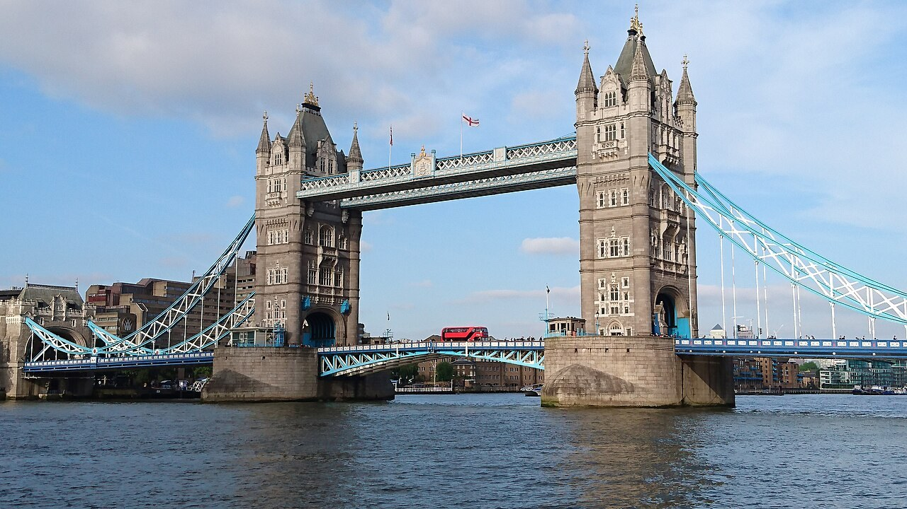
Main area | Tower Hill / Tower Bridge / Borough Market / Covent Garden / Soho / Chinatown
Transportation | Tube + walking; Uber or black cab back if tired
Food | Borough Market lunch; casual dinner in Soho / Chinatown / Covent Garden
Tickets | No tickets planned in advance
Night return | Tube if early and comfortable; Uber or black cab if tired

Itinerary
1. Breakfast: Start with breakfast at the hotel.
2. Tube to Tower Hill: Walk to Pimlico Station. Take Pimlico -> Victoria Station, change at Victoria, then Victoria -> Tower Hill Station. Confirm the easiest route that morning with TfL Go or Google Maps.
Pimlico Station - Open in Google Maps
Tower Hill Station - Open in Google Maps
3. Tower area: Walk around the Tower of London area. No need to buy tickets ahead: see it from the outside, take photos, and enjoy the area without committing to a long tour.
Tower of London - Open in Google Maps
4. Tower Bridge: Walk to Tower Bridge, take photos outside, and walk across for the views. Only buy Tower Bridge tickets if you decide in the moment that you want to go inside.
Tower Bridge - Open in Google Maps
5. Borough Market lunch: Walk from Tower Bridge along the south side of the Thames toward London Bridge / Borough Market. Saturday will be crowded, so walk around first and pick food casually.
Borough Market - Open in Google Maps
London Bridge Underground Station - Open in Google Maps
6. West End exploring: Take the Northern line northbound from London Bridge to Leicester Square. Walk Leicester Square -> Covent Garden -> Seven Dials -> Neal's Yard -> Soho -> Carnaby Street -> Chinatown.
Leicester Square Station - Open in Google Maps
Covent Garden - Open in Google Maps
Seven Dials - Open in Google Maps
Neal's Yard - Open in Google Maps
Soho - Open in Google Maps
Carnaby Street - Open in Google Maps
Chinatown - Open in Google Maps
7. Dinner and return: Dinner in Soho, Chinatown, or Covent Garden. Use the Tube if it is still early and comfortable; use Uber or black cab if tired, late, or pickup is easier.
Hotel - Open in Google Maps

Photo Spots
- Tower Bridge from the south side of the Thames
- Neal's Yard colorful courtyard
- Chinatown gate
- Carnaby Street
If You're Tired
If tired after Borough Market, skip the full Soho / Carnaby Street walk and go straight to Covent Garden and Neal's Yard, then dinner.

Rain Plan
If raining, spend more time around Borough Market, Covent Garden, covered shops, cafes, and Chinatown. Use Tube or Uber between areas as needed.

Day 3: Sunday, June 28
Palace Morning and Camden Daytime Adventure
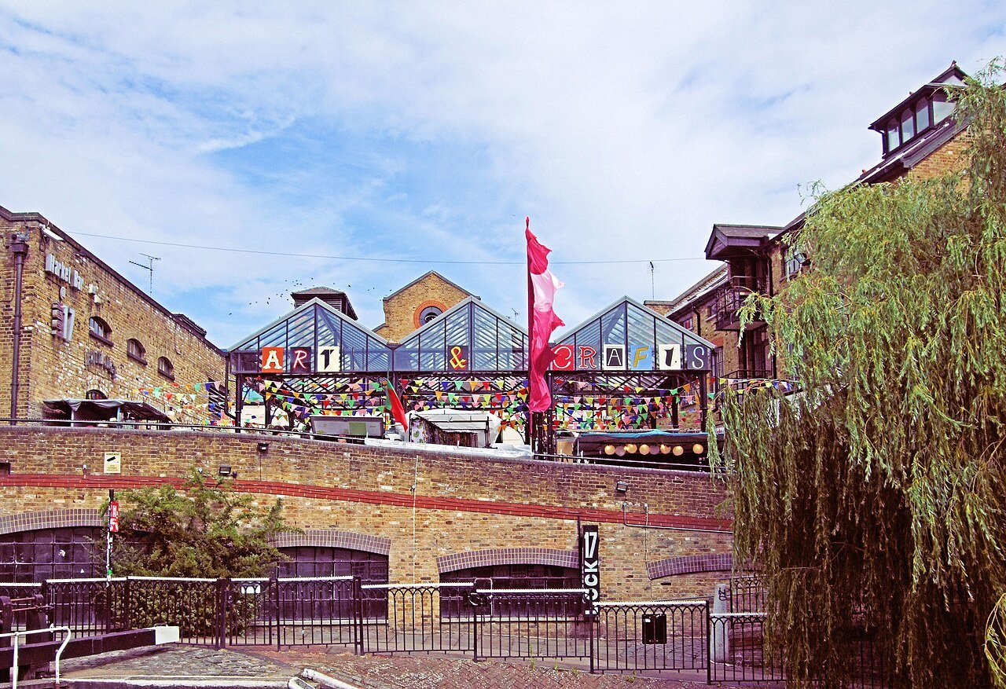
Main area | Buckingham Palace / St. James's Park / Trafalgar Square / Camden
Transportation | Walking + Tube; Uber or Tube back depending on timing and energy
Food | Camden Market lunch; final dinner in Covent Garden, Soho, or near the hotel
Tickets | No fixed tickets
Night return | Keep Camden as a daytime stop; return central before final dinner

Itinerary
1. Breakfast: Start with breakfast at the hotel.
2. Palace photos: Walk or take short transit to Buckingham Palace. See the exterior and gates.
Buckingham Palace - Open in Google Maps
3. Park and Mall walk: Walk through St. James's Park, then walk The Mall toward Trafalgar Square.
St. James's Park - Open in Google Maps
The Mall - Open in Google Maps
Trafalgar Square - Open in Google Maps
4. Tube to Camden: From central London, take the Tube to Camden Town. Use Google Maps or TfL Go for the best route that morning.
Camden Town Station - Open in Google Maps
5. Camden Market lunch: Make Camden Market the daytime anchor. Get lunch and explore the stalls, shops, signs, and street food.
Camden Market - Open in Google Maps
6. Regent's Canal if energy is good: If weather and energy are good, take a short Regent's Canal walk near Camden Lock. Keep it short and easy.
Regent's Canal - Open in Google Maps
7. Final dinner: Return toward central London for final dinner in Covent Garden, Soho, or near the hotel. Use Uber or the Tube depending on timing and energy.
Covent Garden - Open in Google Maps
Soho - Open in Google Maps
Hotel - Open in Google Maps

Photo Spots
- Buckingham Palace gates
- Camden Market signs
- Queen's Walk river views
If You're Tired
If tired, skip Regent's Canal and spend only 1 to 2 hours at Camden Market before returning toward the hotel.

Rain Plan
If raining, shorten the park walk and spend more time in Camden Market covered areas, cafes, and shops.

Departure Day: Monday, June 29
Keep this morning simple. Eat breakfast at the hotel if timing works, double-check passports and phones before leaving the room, and use the JetBlue app plus the flight confirmation for updates. Use the hotel address and saved ride apps if you need help coordinating pickup.

Apps To Download
- Google Maps
- TfL Go
- Uber
- FREENOW
- JetBlue app
- TripIt

Map Link Index
Hotel: Open in Google Maps
Tachbrook Street Market: Open in Google Maps
Victoria Station Buckingham Palace Road entrance: Open in Google Maps
London Eye: Open in Google Maps
Westminster Bridge: Open in Google Maps
Big Ben: Open in Google Maps
Parliament Square: Open in Google Maps
Westminster Abbey: Open in Google Maps
Southbank Centre / Royal Festival Hall: Open in Google Maps
Gabriel's Wharf: Open in Google Maps
Oxo Tower: Open in Google Maps
Pimlico Station: Open in Google Maps
Tower Hill Station: Open in Google Maps
Tower of London: Open in Google Maps
Tower Bridge: Open in Google Maps
Borough Market: Open in Google Maps
London Bridge Underground Station: Open in Google Maps
Leicester Square Station: Open in Google Maps
Covent Garden: Open in Google Maps
Seven Dials: Open in Google Maps
Neal's Yard: Open in Google Maps
Soho: Open in Google Maps
Carnaby Street: Open in Google Maps
Chinatown: Open in Google Maps
Buckingham Palace: Open in Google Maps
St. James's Park: Open in Google Maps
The Mall: Open in Google Maps
Trafalgar Square: Open in Google Maps
Camden Market: Open in Google Maps
Camden Town Station: Open in Google Maps
Regent's Canal: Open in Google Maps

Photo Sources
Hotel area / Pimlico: Wikimedia Commons image source
Big Ben: Wikimedia Commons image source
London Eye: Evans1551, public domain source
Westminster Bridge: Ralf Roletschek, Wikimedia Commons license source
South Bank / Queen's Walk: Wikimedia Commons image source
Tower Bridge: Helen Ilus, Wikimedia Commons license source
Borough Market: Jeong seolah, CC0 source
Covent Garden: Wikimedia Commons image source
Neal's Yard: Paul The Archivist, CC BY-SA 2.0 source
Chinatown: Wikimedia Commons image source
Buckingham Palace: Wikimedia Commons image source
St. James's Park: Wikimedia Commons image source
Camden Market: Jim Linwood, CC BY 2.0 source

