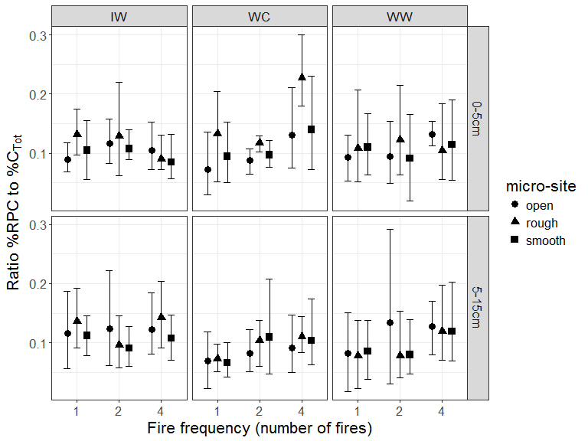

Figure B.1. Ratio of %RPC to %CTot in relation to fire frequency, region and site characteristics shown as mean values (points) with 95% credible intervals. Within each combination, mean %RPC was calculated for each field sample using a Bayesian procedure in which a heavy-tailed distribution (t-distribution with flexible shape parameter) was fitted to five replicate analytical values. This approach ensured that any outlying analytical values for a field sample would be down-weighted in a data-driven manner. Markov Chain Monte Carlo estimation resulted in a set of credible mean %RPC values for each field sample and a corresponding set of ratio values to %CTot from which the means and intervals shown here were derived. Fire frequency was represented as the number of fires (1,2,4) over 30 years prior to sampling 10 years post fire. Regions were characterized as: wet, cool (WC), annual precipitation 1200mm and annual average temperature 12◦C; wet, warm (WW) annual precipitation 1200mm, annual average temperature 16◦C; intermediate precipitation, warm (IW) annual precipitation 1000mm, annual average temperature 16◦C. Soil depth was characterized by two layers (0-5cm; 5-15cm). Micro sites sampled were: adjacent to base of rough barked trees (Rough); adjacent to base of smooth barked trees (Smooth); open patches largely between tree crowns (Open).