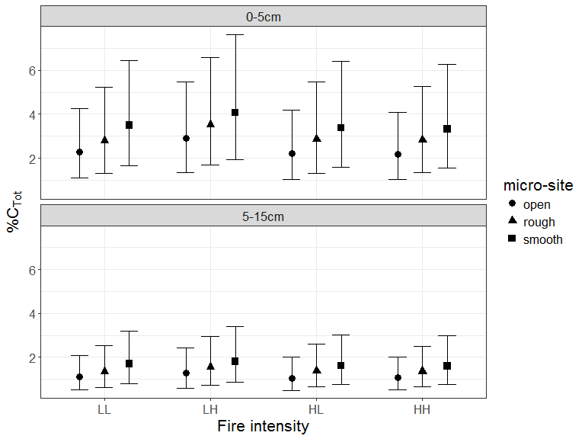

Figure 3. Predicted mean total % C as % mass of soil (with upper and lower 95% credible intervals) from ensemble modelling categorised by fire intensity and site characteristics. Fire intensity was rated low (L), tree crowns unaffected, or high (H), tree crowns affected. Sites selected from two successive fires separated by 8 years (soil collected 10 years post the last fire) yielding four intensity combinations (LL, LH, HL, HH). Soil depth was characterized by two layers (0-5cm; 5-15cm). Micro-sites sampled were: adjacent to base of rough barked trees (Rough); adjacent to base of smooth barked trees (Smooth); open patches largely between tree crowns (Open).